

Module Name: Academic Skills in the Digital Era
Module Code: BMSW4013
Assessment 1: E-Portfolio
Student Name: Ioan Ministru Novac
Student Number: 2109383
Lecturer: Ffion Cumberpatch
Deadline: Friday 27th February 23:59

Word Count: 1786

AI Acknowledgement
I acknowledge the use of Chat GBT (https://chat.openai.com/) on 22/01/2025 to support my research, clarifying topics and discussing ideas.
I confirm that I have not presented any AI-generated text as my own work. I confirm that I have retained copies of drafts, notes, and resources used before and after the use of AI tools.

Table of Contents
COMPONENT 1: DEVELOPMENT OF ACADEMIC SKILLS 3
1. Evaluating Academic Sources Using the CRAAP Test 3
2.Synthesis of Academic Sources 4
3. Identifying a Key Challenge and Opportunity 4
4. Academic Planning 4
References 5
COMPONENT 2: APPLICATION OF ACADEMIC SKILLS 6
1. Introduction 6
2. Challenges for Students in the Digital Era 6
3. Opportunities in the Digital Era 7
4. How Students Can Adapt to Succeed 8
5. Conclusion 9
Reference List 10
COMPONENT 3: POSTER 11
References 14

COMPONENT 1: DEVELOPMENT OF ACADEMIC SKILLS

1. Evaluating Academic Sources Using the CRAAP Test
Source 1: The article under consideration is a peer reviewed article that is available on Google Scholar. The article reviews gamification in online higher education.
- Currency: It was published in 2023 in Springer and is a reflection of the contemporary digital learning situations.
- Relevance: Khaldi et al. (2023) directly touches on the subject of student motivation and engagement in the e learning.
- Authority: Khaldi et al. (2023) have done a systematic search of Scopus and Google Scholar, and the credibility is ensured by publication in a recognised journal.
- Accuracy: The methodology with the inclusion and exclusion criteria is well described. There were thirty-Nine primary studies analysed, which increased reliability.
- Purpose: The article gives an analytical summary of gamification to educate researchers and practitioners.
Source 2: The source is also found on Google scholar and it is a peer reviewed study discussing ChatGPT in higher education.
- Currency: The article was published in 2023, in the ERIC - Education Resources Information Center, and hence is up-to-date on AI developments.
- Relevance: Baskara, R. (2023) is interested in applying ChatGPT in the field of language learning.
- Authority: Baskara, R. (2023) examines its abilities, constraints and pedagogical consequences.
- Accuracy: Advantages, limitations and ethical issues are addressed, creating a balance.
- Purpose: The paper examines implications and provides a research future instead of fostering AI blindly.

2.Synthesis of Academic Sources
Both Khaldi et al. (2023) and Baskara (2023) examine the effect of digital technologies on student engagement in higher education, which implies that motivation needs to be maintained. Khaldi et al. (2023) focus on the aspects of gamification (points, badges and feedback) to increase the level of engagement, whereas Baskara (2023) focuses on ChatGPT as the means of individualised learning and authentic materials. Khaldi et al. concentrate on the design of the structure, but Baskara concentrates on the pedagogical and ethical consequences of digital innovation, demonstrating that digital innovation should be evaluated critically.

3. Identifying a Key Challenge and Opportunity
One of the major problems of both studies is the maintenance of motivation and safeguarding of academic integrity in the online world. Khaldi et al. (2023) associate low engagement with high dropout rates and Baskara (2023) cautions that excessive use of artificial intelligence could undermine genuine learning. Nevertheless, when used critically and strategically, gamification and ChatGPT can provide opportunities to have a personalised, engaging experience to achieve academic success.

4. Academic Planning
Component 2 will specify digital learning and describe the structure. It will examine the challenges and opportunities, such as digital literacy, motivation and critical evaluation. The strategies section will incorporate time management, critical thinking and academic integrity of Cottrell (2021), Bedford and Wilson (2020) and McMillan (2021) in an evident introduction-conclusion structure.
Task | Deadline
Finish research | 1st Week
Draft first section | 2nd Week
Complete first draft | 3rd Week
Final editing | 4th Week

References
Baskara, R. (2023). Exploring the implications of ChatGPT for language learning in higher education. Indonesian Journal of English Language Teaching and Applied Linguistics, 7(2), 343–358.
Khaldi, A., Bouzidi, R., & Nader, F. (2023). Gamification of e learning in higher education: A systematic literature review. Smart Learning Environments, 10(1), 10.

COMPONENT 2: APPLICATION OF ACADEMIC SKILLS

1. Introduction
Higher education is finally shifting to the heart of digital learning, and universities are embracing the use of online platforms, gamified systems and artificial intelligence tools in both teaching and assessment. The trends have transformed the manner in which students search information, access content and demonstrate learning outcomes.
Learning the challenges and the opportunities of the digital era is important because the technological advancement has an impact on motivation, interaction and academic honesty. Poor academic skills could render the students useless in the virtual world.
This report will explain the key challenges students face, and how digital tools can offer as well as evidence based strategies students can adopt to adjust and lastly give a conclusion on how students can cope to succeed in the digital age.

2. Challenges for Students in the Digital Era
One of the significant problems of the digital era is the lack of motivation and interest towards the online learning platforms. Khaldi et al. (2023) include high drop-out and low completion rates in e learning as the list of disadvantages and explain the rates by the absence of interaction and poorly developed digital solutions. In online courses, which lack meaningful feedback, collaboration or active ways of learning, lack of these elements can make students feel isolated and unconnected hence insignificant persistence and academic performance.
The other major concern is the moral and educational implications of artificial intelligence. Baskara (2023) stated that ChatGPT can produce fluent and coherent responses, which does not imply that this system has any sense of complex ideas. This may cause the lack of independent thinking, worsening of analysis, and the emergence of a problem of plagiarism and academic dishonesty because of the excessive use of these means. Students are capable of providing AI generated materials without possessing an idea of what the matter is about.
All these problems have a direct impact on academic performance. To study effectively, McMillan (2021) emphasises that a person should be capable of studying, reading critically, and analysing on their own. Learners will be at risk of acquiring important higher education skills in case digital technologies will be replacing, and not complementing, cognitive effort. Therefore, digital literacy, critical evaluation and ethical consciousness should be improved greatly to become a responsible citizen and succeed in the present academic environment.

3. Opportunities in the Digital Era
Despite these challenges, there exist enormous opportunities of applying the digital tools to enhance learning in higher education. Gamification is an example of motivation boosters that has been identified to be more motivating because it has a structured feedback, level of progress, reward and interactive challenges (Khaldi et al., 2023). Gamified systems can be used to encourage persistence, active engagement and long-term interaction with the motivational theory and in correspondence with particular learning outcomes (Amin et al., 2024). They can also experience a sense of achievement that will contribute towards the confidence of the learners.
The utilisation of artificial intelligence, such as ChatGPT, has a higher likelihood of personalised learning. Baskara (2023) has suggested that such systems can generate natural language contents, practise and specific feedback which can be tailored to individual needs. This type of flexibility can support self-directed learning, extracurricular revision and skill development. AI tools can be utilized to improve accessibility, and this is achieved by offering immediate assistance and flexible learning.
Their value, however, is in their critical and informed application. Cottrell (2021) holds that reflective learning, self-regulation, and strategic planning are the only ways to achieve academic success. The most acceptable instances of the usage of digital technologies are those that help and do not replace cognitive work (Kozyreva et al., 2020). They may be moderately applied to enhance learner autonomy, accessibility, flexibility and overall academic development.

4. How Students Can Adapt to Succeed
First, the students are expected to gain good critical evaluation skills. Cottrell (2021) notes that prior to accepting information, he/ she ought to doubt the sources and analyse arguments and analyse evidence. With the help of the formalised assessment schemes, one can create an active student review of the digital content and artificial intelligence products rather than passive. The specified strategy is a direct answer to the ethical and academic concerns expressed by Baskara (2023), particularly the unreasonable deployment of AI and the risk to the integrity of the academic process. Digital literacy is also capable of assisting students in distinguishing between authentic sources and counterfeit information.
Second, students need to improve time management and self-regulation. Bedford and Wilson (2020) address the significance of planning, goal setting and routines of structured study. In the digital environment where a person can be distracted by social media and various tasks, time and prioritisation help to use these resources on a regular basis. These are the measures that help to address the motivational challenges and the low attendance rates that Khaldi et al. (2023) mention.
Third, students should be strategic in the use of digital tools to enhance learning and not to replace it. According to McMillan (2021), synthesis and reflection increase comprehension through active learning. The gamified platform can be used to support motivation, but the artificial intelligence can provide feedback and practising (Chen et al., 2025). However, it is mandatory that the students are supposed to analyse and work on their own. It is a reflective method of opportunity balancing and reduction of potential risks to academics.

5. Conclusion
Digital era presents some life-threatening challenges and also some positive opportunities to students in tertiary institutions. The reduced communication and ethical concern over artificial intelligence can harm the development of scholars. However, gamification and personalised digital tools may work well in motivating and adaptable with due consideration.
The online world demands a quality piece of academic writing that involves critical analysis and time management and reflection. As soon as these competencies are developed, the students will be capable of adapting to the changes and using the problems with digital opportunities as the means of achieving academic success.

Reference List
Amin, M. M., Shamsuddin, S. N. W., & Hamzah, W. M. A. F. W. (2024). Enhancing engagement in learning management systems using gamification framework. The International Journal of Multimedia & Its Applications, 16(5), 21–31.
Baskara, R. (2023). Exploring the implications of ChatGPT for language learning in higher education. Indonesian Journal of English Language Teaching and Applied Linguistics, 7(2), 343–358.
Bedford, D., & Wilson, E. (2020). Study skills for foundation degrees (3rd ed.). Routledge.
Chen, Y. J., Chen, Z. P., Lai, C. H., & Peng, C. W. (2025). Generative artificial intelligence-based gamified programming teaching system: Promoting peer competition and learning motivation. Engineering Proceedings, 98(1), 9.
Cottrell, S. (2021). Skills for success: The personal development planning handbook (4th ed.). Palgrave Macmillan.
Khaldi, A., Bouzidi, R., & Nader, F. (2023). Gamification of e learning in higher education: A systematic literature review. Smart Learning Environments, 10(1), 10.
Kozyreva, A., Lewandowsky, S., & Hertwig, R. (2020). Citizens versus the internet: Confronting digital challenges with cognitive tools. Psychological Science in the Public Interest, 21(3), 103–156.
McMillan, K. (2021). The study skills book: Your essential guide to university success (4th ed.). Pearson.

COMPONENT 3: POSTER
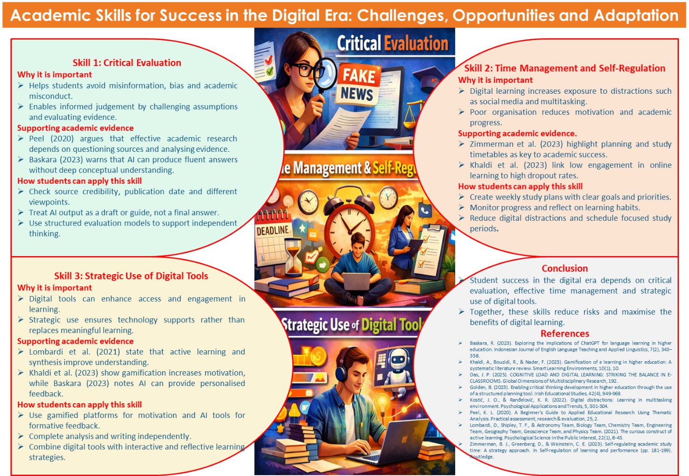
Title: Academic Skills for Success in the Digital Era: Challenges, Opportunities and Adaptation
Skill 1: Critical Evaluation
Why it is important: During the digital age, students are bombarded with loads of information on the internet and content created by artificial intelligence. A lack of effective critical evaluation will also increase the risk of accepting false or biassed content and subsequently misinterpret it and commit academic misconduct. Making critical assessments helps students to challenge assumptions, identify constraints and make informed judgments about their academic work (Golden, 2023).
Supporting academic evidence: Peel (2020) stresses that successful academic research requires questioning the sources and analysing evidence instead of taking information on board. Baskara (2023) also cautions that AI can generate grammatically correct answers without any profound conceptual knowledge, and it is essential to be cautiously examined.
How students can apply this skill: Students are expected to examine the validity of sources, verify the date of publication and compare different perspectives. The output of artificial intelligence is supposed to be more of a draught or a guide than the actual solution. The use of systematic assessment models will promote critical thinking and guard against academic dishonesty.
Skill 2: Time Management and Self-Regulation
Why it is important: Digital learning makes it more flexible and brings more exposure to distractors in the form of social media and multitasking (Kostic & Randelovic, 2022). Lack of proper organisation can make students fail to keep them motivated and progressing in the same direction.
Supporting academic evidence: Zimmerman et al., (2023) emphasize the significance of planning and timetable of studying in order to achieve academic success. Khaldi et al. (2023) also prove a high level of dropout connected with low levels of engagement in online learning, which proves that it is necessary to study disciplined.
How students can apply this skill: Students are expected to make weekly study plan, create achievable goals and priorities. Keeping track of progress and thinking about the learning habits keeps one focused. Reducing the disturbances of digital devices and assigning particular periods of time to research on-line helps in maintaining attention and minimising procrastination.
Skill 3: The Strategic-Use of Digital Tools.
Skill 3: Strategic Use of Digital Tools
Why it is important: Digital technology has the potential to increase the learning experience by being more easy to access and engaging (Das, 2025). The strategic use will make sure that technology is used to help and not to substitute meaningful learning.
Supporting academic evidence: According to Lombardi et al., (2021), active learning and synthesis enhance comprehension. Khaldi et al. (2023) demonstrate that gamification may enhance motivation, whereas Baskara (2023) says that artificial intelligence can serve as a source of such personalised feedback and practice materials.
How students can apply this skill: The student is to use gamified platforms to remain motivated and artificial intelligence tools to receive formative feedback, and do the analysis and writing on their own. Integrating digital materials with interactive learning techniques will encourage, and enhance in-depth learning and accountable scholarly conduct.
Conclusion
The digital age requires critical assessment, proper time management and strategic use of digital tools to ensure student success in the digital age. These academic skills enable students to surpass challenges and take advantage of technological opportunities when used in a wise manner.

References
Baskara, R. (2023). Exploring the implications of ChatGPT for language learning in higher education. Indonesian Journal of English Language Teaching and Applied Linguistics, 7(2), 343–358.
Khaldi, A., Bouzidi, R., & Nader, F. (2023). Gamification of e learning in higher education: A systematic literature review. Smart Learning Environments, 10(1), 10.
Das, J. P. (2025). COGNITIVE LOAD AND DIGITAL LEARNING: STRIKING THE BALANCE IN E-CLASSROOMS. Global Dimensions of Multidisciplinary Research, 192.
Golden, B. (2023). Enabling critical thinking development in higher education through the use of a structured planning tool. Irish Educational Studies, 42(4), 949-969.
Kostić, J. O., & Ranđelović, K. R. (2022). Digital distractions: Learning in multitasking environment. Psychological Applications and Trends, 5, 301-304.
Peel, K. L. (2020). A Beginner's Guide to Applied Educational Research Using Thematic Analysis. Practical assessment, research & evaluation, 25, 2.
Lombardi, D., Shipley, T. F., & Astronomy Team, Biology Team, Chemistry Team, Engineering Team, Geography Team, Geoscience Team, and Physics Team. (2021). The curious construct of active learning. Psychological Science in the Public Interest, 22(1), 8-43.
Zimmerman, B. J., Greenberg, D., & Weinstein, C. E. (2023). Self-regulating academic study time: A strategy approach. In Self-regulation of learning and performance (pp. 181-199). Routledge.

