Ashley Williams
101914@pembrokeshire.ac.uk
Process
Engineering
Practice
Operation of Processes

Table of Contents

Task 1 – Process Equipment 2
Heat Exchangers 2
Task 2 – Knowledge and Understanding of Unit 6
Ultra-Low Sulphur Gasoline Unit 6
Bibliography 8

Task 1 – Process Equipment

Heat Exchangers

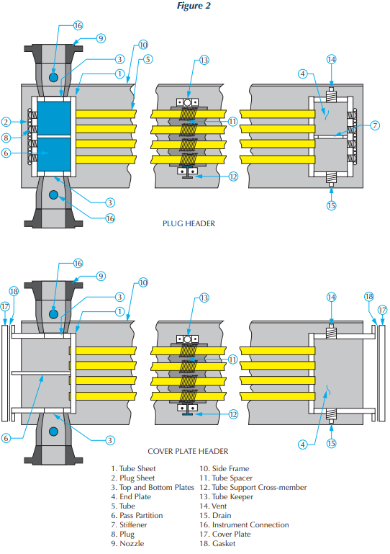
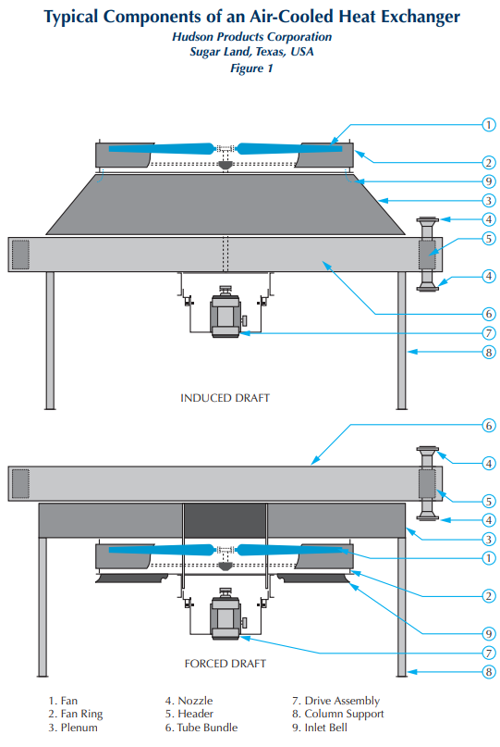
Heat exchangers are utilised for heating, cooling, and condensing on the ULSG (Ultra Low Sulphur Gasoline) unit, as well as many other units at Pembroke Refinery. On the ULSG, condensers are used to condense the overheads produced so they can be used as reflux to help manage the pressure and temperature in the column and to keep the catalyst beds moist to preserve them. The Catalytic Distillation Hydrodesulfurization column (CDHDS) process delivers 80–85% of the feed in over the top as vapour or light ends, necessitating its return to liquid form via the fans into the hot drum/reflux drum. It goes through five banks of tubes with ten fans to accomplish this. These condense the vapour into the reflux drum using ambient air that has been forced upward through finned tubes. The cooling and washing of the beds are then provided by this being pumped back into the column.
Figure 1 – Fin fan layout and cut through
This technique is reasonably basic and is used in many other more commonplace applications, such as cooling systems for automobile engines and air conditioning units. The fins that are affixed to the tubes are intended to increase their surface area and, thus, the amount of heat that may be transferred by the air passing over them. A belt and pulley system powers each of the unit’s fans by the use of electric motors. As a result, the desired speed can be attained by adjusting the pulley diameters, and the belt, rather than the more expensive fan setup, will break if the motor seizes or sustains other damage. The belts are also easily replaced, whereas other parts could take much longer to fix and could involve removal of large pieces of equipment, meaning scaffolding, cranes etc. making the whole job much more expensive.

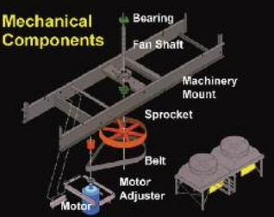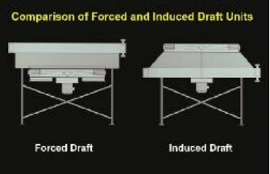
Figure 2 – Drive set up for fan – Comparison between forced/induced

Forced draught and induced draught are the two main types of air cooler fan configurations that are used on site. The fan is typically located below the fan bank in forced draught systems, forcing air up through the bank. Instead of pushing air through the bank, forced draught is installed above the bank and pulls air through. Both configurations have advantages and disadvantages, with the overhead fans on the ULSG unit using a forced draught. Because they hang below the tubes and typically have access platforms permanently installed, forced draught fans are simpler to maintain. For maintenance to be performed on inducer fans, access platforms like scaffolding must be set up. Because of this, maintenance will cost more and take longer to complete.

This equipment frequently fails, and failures can range from minor repairs like replacing a belt, to catastrophic failures like a tube rupture. Both scenarios may only have minor effects because isolations can be constructed, and additional fans can step in if the process circumstances permit. Due to the high temperatures and process stream going through the tube, corrosion will unavoidably happen. To avoid the build-up of salts in the tiny tubes, the boiler feed water is routed into a different area of the unit before the fans. The second stage of the procedure involves removing this from the cold drum's boot. The pressure and temperature requirements for the tubes must be adhered to during use and during maintenance as they were specified during design and manufacturing. The tube banks may need to be vented and cleaned out in order to facilitate welding or section removal while preparing for maintenance. These restrictions must be followed when performing these tasks because going beyond them could result in damage and other problems when using site utilities like steam. Before the system is put back into service, pressure testing is also important to make sure there are no leaks and that the repaired areas are ready for use.

The blades themselves are the physical risks that are present while this setup is in use. These can be nearly 15 feet across and spin at speeds of up to 1000 rpm. Guards and a plenum are in place to keep workers from coming into touch with the blades and to contain them in the unlikely event of a malfunction. This could be caused by bearing failure; therefore, every shift on the daily rounds should inspect the bearings, motors and bearing blocks (if applicable), and maintenance orders should be sent if any are discovered with audible vibrations. To avoid them being started, these fans should be shut off while the stop button is still depressed. Further isolations must be established to stop the fan from being activated automatically or remotely from the panel if work needs to be done. The Lock Out Tag Out (LOTO) system is used for this. This calls for the motor to be physically locked off at the substation, isolated, and secured with locks by each trade group and operation until the task is finished and everyone is satisfied and ready to restart the fan. A tag providing the information about the job and the person who installed the lock will be attached to each lock so they can be reached if necessary.

Task 2 – Knowledge and Understanding of Unit

The refinery's overarching goal is to turn crude oil that is mined from the earth all over the world, into marketable products. It is shipped to the refinery, where it is stored in tanks and prepared for processing. To separate the primary products from the crude oil, the crude oil must first be heated in an atmospheric distillation plant. The lighter products trapped in the heavy bottom products of the crude can be processed into valuable lighter products that can be used in blending and sold. These separate products are further refined using a variety of techniques, such as vacuum distillation and cracking for the heavier products. Some locations have the capacity to refine the crude, removing everything but the solid coke.

Later in the refining process, the unit that will be covered in greater detail receives its input streams from the Fluidized Catalytic Cracking Unit (FCCU). This unit processes heavy residual products from the vacuum distillation unit as well as heavy products made from crude. By breaking the long chain hydrocarbons into shorter chains, lighter products are created. These products include heavy fuel oils, diesels, and light naphtha, that are processed and cleaned for use in petrol products that can be sold for use around the world as fuel in automobiles, aircraft, and other engines as well as other petroleum-based products.

Ultra-Low Sulphur Gasoline Unit

The ULSG unit's goal is to desulfurize FCCU (Fluidized Catalytic Cracking Unit) naphtha products so they can be used as ingredients in petrol blends while minimising olefin saturation and consequent octane loss throughout the unit.
Light cracked naphtha (LCN) is desulphurized in the unit's first section, a catalytic hydrogenation column, and heavier naphtha is separated from the bottoms for further processing. The feeds of LCN and HCN (Heavy Cracked Naphtha) are supplied into the column after being preheated using heating media from a later stage of the process. To remove the sulphur and perform olefin isomerization to maintain a high octane level, desulfurization is done in the column utilising distillation trays and catalyst beds. In order to speed up the reactions and remove the sulphur from the light product rising through the column, hydrogen is also injected to the column.
A take-off from a tray is fed via cooling fans at the top of the column and discharged away as light desulfurized naphtha. The heavier bottom product from the column settles down and moves on to the subsequent stage of increased preheating and hydrodesulfurization by catalytic distillation. In order to transform the sulphide compounds into H2S, which can then be removed, this column contains additional catalyst and hydrogen. The overheads of the column are cooled by serving as the heat source for numerous heat exchangers throughout the process and are used as reflux/feed for the following stage, while the bottom level is kept warm by a fired heater circuit. The overhead system's hydrogen is fed into a compressor, where it is cleaned, recycled, and used for the processes.
The H2S is removed from the next column by heating it and allowing the gas to escape to be retrieved on another unit at the refinery.
To remove any remaining sulphur from the process stream, the bottoms of the stripping column are pumped ahead and warmed once more before entering another hydro-desulfurization section.
After passing through this reactor, the finished product is allowed to settle in a stabilising column to eliminate any remaining hydrogen. This is then removed as desulfurized heavy naphtha from the bottom. This serves as a base ingredient in petroleum products. The naphtha product's sulphur level has been decreased throughout this unit from maybe above 2500ppm to around 10ppm. Over 50% of the site's gasoline pool is made up of naphtha products that are processed through this unit, therefore it's critical that it runs efficiently and removes the sulphur in order to produce fuel that complies with European regulation standards.

Bibliography

Task 1 images - http://files.chartindustries.com/hudson/BasicsofACHEBrochure-Web.pdf - Last accessed 24/04/2023

Ford, J. (2012). Distillation Columns – Internal Reflux Control. Available: https://www.controleng.com/articles/distillation-columns-internal-reflux-control/. Last accessed 26/04/2023

ULSG Information – Valero ULSG Operators Manual & BOT Training Manuals

