ECGE4006P

https://are-children-sat-getting-fat.webador.co.uk/can-we-change-our-thinking?_gl=1*8yfr9b*_ga*MTM3NTEzMjAwMC4xNjgyNDk5ODcz*_ga_E6PZPGE4QM*MTY4Mjg1MDM5Mi4xMC4xLjE2ODI4NTI0MzkuNjAuMC4w

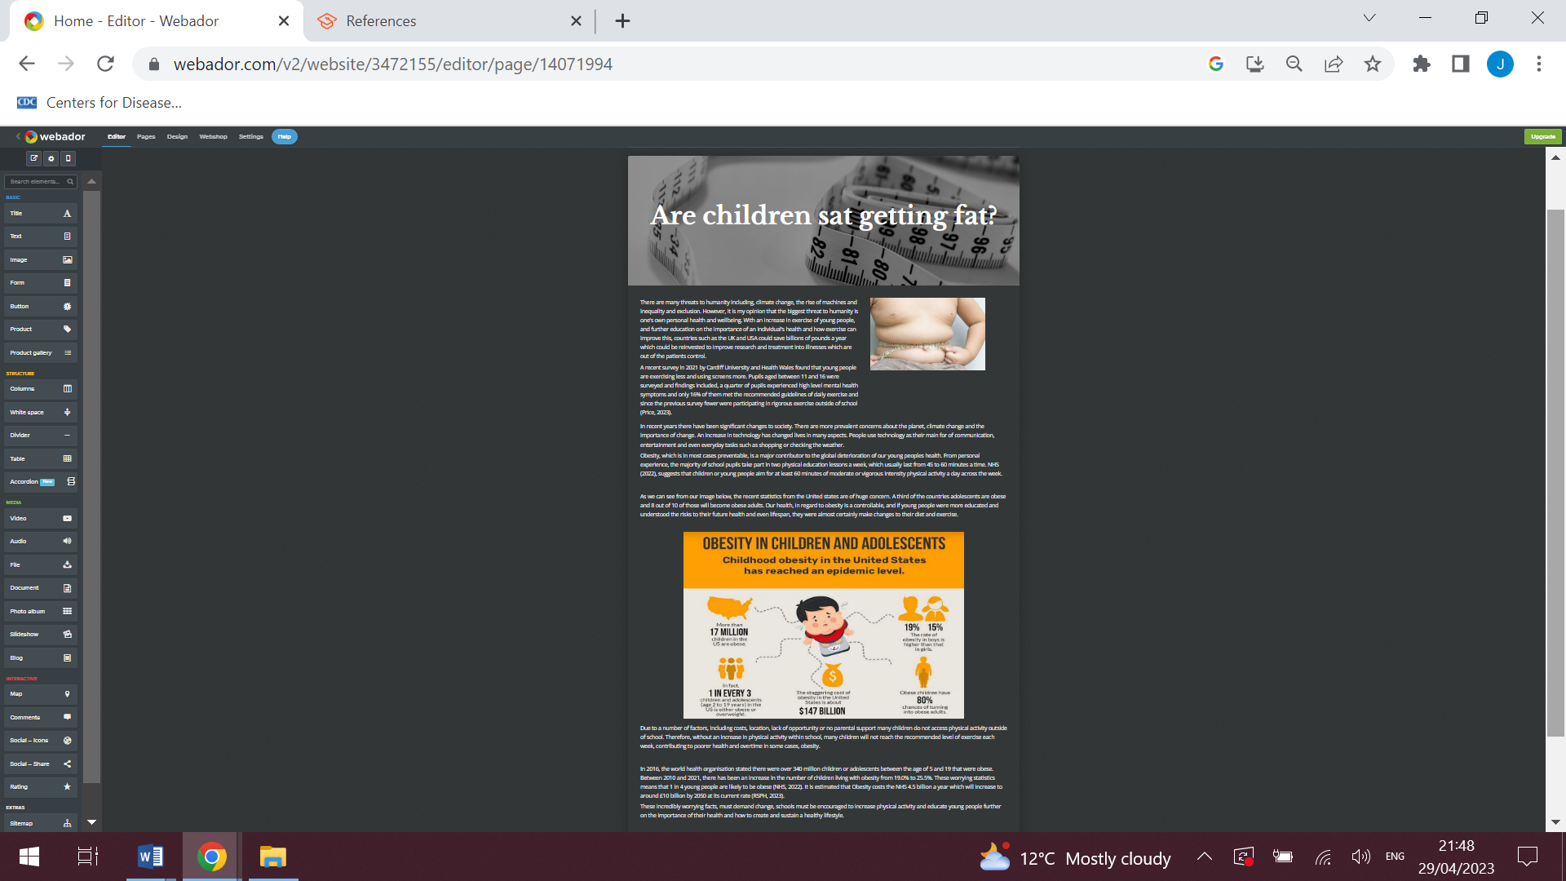
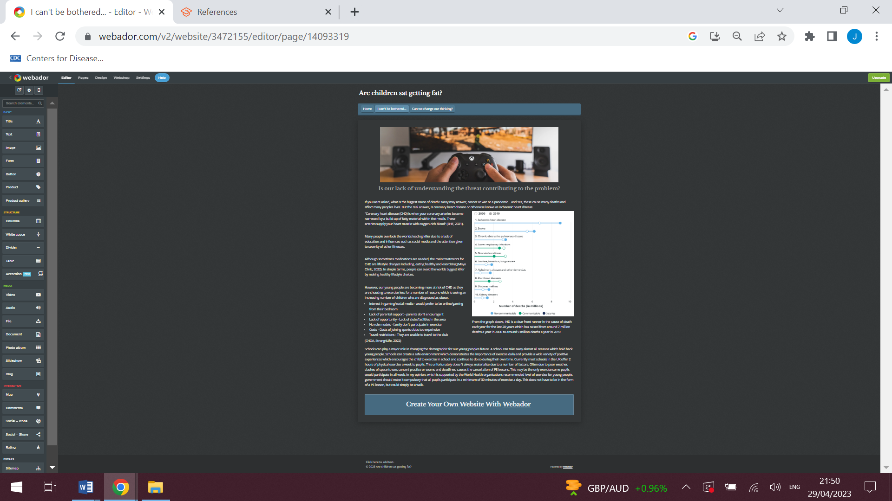

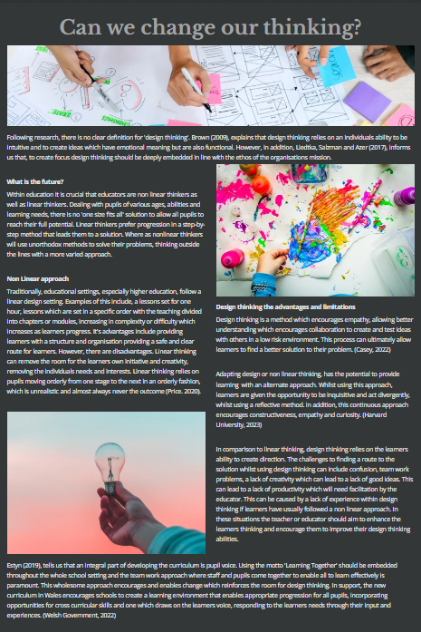
Brown, T. (2009) Change by Design: How Design Thinking Transforms Organizations and Inspires Innovation. Harper Collins.
Casey (2022) “Design Thinking for Teachers (and Students),” Innovation Training | Design Thinking Workshops, 25 May. Available at: https://www.innovationtraining.org/design-thinking-for-teachers/ (Accessed: April 21, 2023).

CHOA, Strong4Life (2022) The Real Reason Your Kid’s Not Physically Active. Available at: https://www.strong4life.com/en/being-active/physical-activity/the-surprising-reasons-some-kids-avoid-physical-activity#:~:text=Certain%20personality%20types%20tend%20to,will%20feel%20even%20less%20comfortable. (Accessed: April 21, 2023).

Estyn (2019) Designing a pupil-led curriculum. Available at: https://www.estyn.gov.wales/effective-practice/designing-pupil-led-curriculum (Accessed: April 21, 2023).

Guthold, R. et al. (2019) “Global trends in insufficient physical activity among adolescents: a pooled analysis of 298 population-based surveys with 1·6 million participants,” The Lancet Child & Adolescent Health, 4(1), pp. 23–35. Available at: https://doi.org/10.1016/s2352-4642(19)30323-2.

Harvard University (2023) Design Thinking in Education. Available at: https://tll.gse.harvard.edu/design-thinking (Accessed: April 21, 2023).

Liedtka, J., Salzman, R. and Azer, D. (2017) Design Thinking for the Greater Good: Innovation in the Social Sector. Columbia University Press.

Mayo Clinic (2022). Coronary artery disease - Diagnosis and treatment - Available at: https://www.mayoclinic.org/diseases-conditions/coronary-artery-disease/diagnosis-treatment/drc-20350619 (Accessed: April 23, 2023).

NHS (2022b) National Child Measurement Programme 21-22. Available at: https://digital.nhs.uk/news/2022/national-child-measurement-programme-21-22 (Accessed: April 20, 2023).
Peter, L. (2022) “Linear vs Non-linear Learning and the Future of Work,” Lepaya EN [Preprint]. Available at: https://lepaya.com/en/linear-and-non-linear-learning/#:~:text=1.-,What%20is%20linear%20learning%3F,gradually%20increases%20as%20you%20progress. (Accessed: April 21, 2023)

Price, B.B. (2023) “Welsh teenagers exercising less and using screens more, survey finds,” BBC News, 6 April. Available at: https://www.bbc.co.uk/news/uk-wales-65188535.

Review of Optometry (2022) “Newly Obese Children Already Have Lower Retinal Vessel Density,” https://www.reviewofoptometry.com/, 21 November. Available at: https://www.reviewofoptometry.com/news/article/newly-obese-children-already-have-lower-retinal-vessel-density (Accessed: April 20, 2023).

RSPH (2023) Childhood obesity. Available at: https://www.rsph.org.uk/our-work/policy/obesity/childhood-obesity.html#:~:text=Childhood%20obesity-,Obesity%20costs%20the%20NHS%20%C2%A34.2%20billion%20a%20year%20and,billion%20a%20year%20by%202050. (Accessed: April 20, 2023).

Welsh Government (2022) Developing a vision for curriculum design - Hwb. Available at: https://hwb.gov.wales/curriculum-for-wales/designing-your-curriculum/developing-a-vision-for-curriculum-design (Accessed: April 21, 2023).

World Health Organization: WHO (2021) “Obesity and overweight,” www.who.int [Preprint]. Available at: https://www.who.int/news-room/fact-sheets/detail/obesity-and-overweight.

