EIA

Background and context
MESS Construction Ltd has been commissioned by ACE Capital Project Ltd to prepare an Environmental Impact Assessment (EIA) scoping report in accordance with the Town and Country Planning (Environmental Impact Assessment) (Wales) Regulations 2017.
The scheme proposes the construction of a mixed-use theatre and performance centre for both local and visiting groups to study and perform. The site will include a parking and drop off area to the Northeast of the site to connect the road to the theatre.

Site Location
The proposed site lies within the town centre of Merthyr Tydfil, adjacent to the River Taff, and opposite Merthyr Tydfil Council offices. It falls under Merthyr Tydfil County Borough Council (MTCBC) planning authority.
The site is a partial brownfield site, previously containing Merthyr Tydfil bus station which has since been demolished and reprofiled. It has an altitude of 171m. The West of the site contains a green space that is currently a right of way through to Newmarket Walk and Victoria St (as seen in figure 1).
The site is of moderate flood risk (from NRW) due to the proximity to the river, however previous hydraulic modelling has taken place recently (2023) showing that there is limited increase in surface water flooding as a result of the demolition of the bus station office block and the reprofiling.
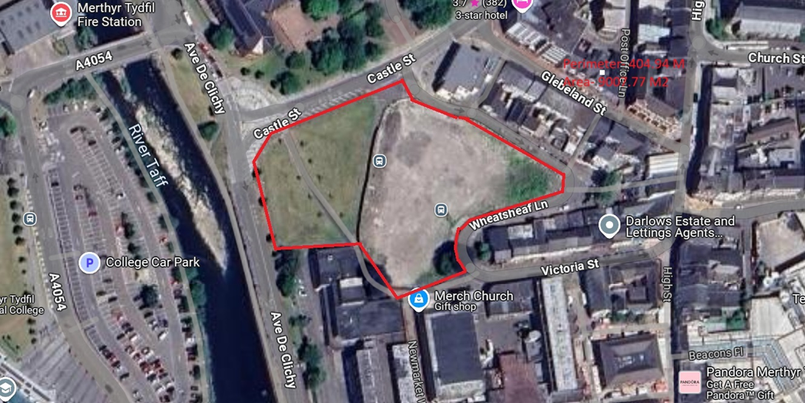
Figure 1 above shows the red line boundary of the site and the EIA.
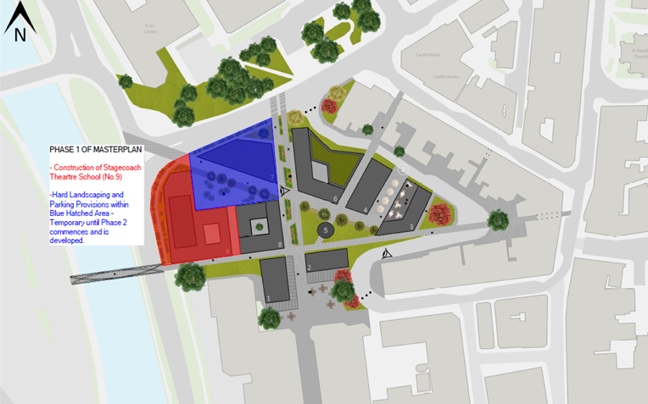
Figure 2 shows the proposed development area including the hard landscaping and parking

EIA Methodology
The Environmental impact assessment (EIA) will assess both the construction and operational phases of the development and will include risks, planning policy context, key impacts, mitigation measures, and residual effects. Each sub-chapter will provide additional information in greater detail.

Socioeconomics
The development proposes an additional source of revenue from a cafe, bar or appropriate alternative as well as the theatre itself. Both of these will provide crucial employment. In the planning stage, this will be under a “worst case” scenario based on limited commercial floorspace, therefore the effects at further stages (detailed design stage) will result in equal or even greater effects with regards to socioeconomical issues.
During the construction and operational phase of the development, direct and indirect employment will be gained, both short term (construction teams) and long term (theatre workers). Additionally, there will be improved public realm and connectivity within the community with a proposed decrease in crime due to the safe space and secure design of the proposed development.
Urban regeneration is often thought to provide positive impacts on the local community, and thus, mitigation measures are not required.

Air Quality
The development will have potential effects on air quality during the construction due to exhaust emissions from vehicles and dust emissions from site activities. Vehicle emissions contain many pollutants including nitrogen, carbon monoxide, hydrocarbons, carbon dioxide and particulate matter thus affecting the air quality as these emissions are dispersed into the atmosphere.
An Air Quality Action Plan (AQAP) may be undertaken to assess the impacts, identify local requirements, and include any financial contributions. A low emission strategy will be undertaken for the Glebeland site development and mitigations will be imposed as required. As outlined in the technical design report, roadside shrubs will be planted in area of higher traffic volume to aid air quality.

Ecology and Biodiversity
This element focuses on ecological receptors including bats, birds and trees.
The site does not lie within a conservation area or site of special scientific interest.
Prior to the demolition of the bus station, Wildwood Ecological carried out a preliminary ecological survey which revealed that no evidence of nesting birds or bats were found within the boundary of the site.
No tree preservation orders are present on the site.
Further investigation should be undertaken to assess the proximity of potential ecological receptors close to the site and within the site.
Mitigation will be taken to reduce any significant impacts on the ecological receptors during construction and operational phases of the construction

Geology and Soils
Due to the rich history of the site, it can be assumed that there is some form of contamination present with the land being previously used as a corn mill in the 1860s with residential use being evidenced later before it became the bus station in the 1960s. It is possible that any previous contamination has been dealt with when the site underwent works to demolish the bus station and reprofile the area.
According to British Geological Survey (BGS, 2023) there is a disused well present on the site with records showing this was evidenced in 1950.
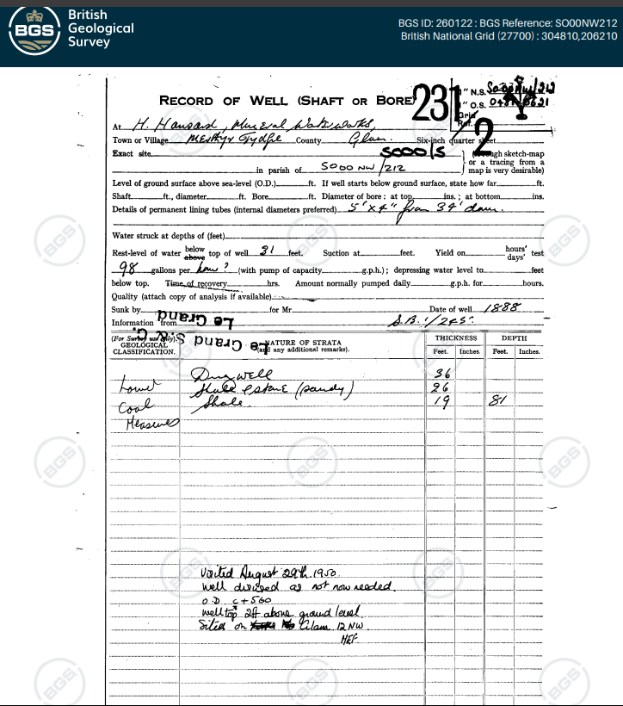
Figure 3- Showing the well record
No evidence of boreholes can be found for the site however, many borehole samples have been taken in the vicinity including at Castle Yard, to the north of Castle Street. These boreholes found that the geology mostly comprised of coarse gravel and boulders with sandy clay to a depth of 6.5m and water struck at 6.5m too. From 6.5m to 7m grey shaly mudstone was encountered. The madeground comprises of hardcore (slag) and a tarmac layer. 3 boreholes were taken at this site, and each borehole sample was made of roughly the same material (with slight discrepancies in depths).
A geotechnical report was undertaken as a result of the demolition of the bus station, with 14 trial pits each a depth of 1.2m being dug. These concluded that the ground was made ground with high levels of cobble. No asbestos was found however, the likelihood of asbestos being present remains high due to the fact that the bus station was constructed during a time where asbestos use was common. Further investigations should be undertaken to determine the presence (or absence) of asbestos.
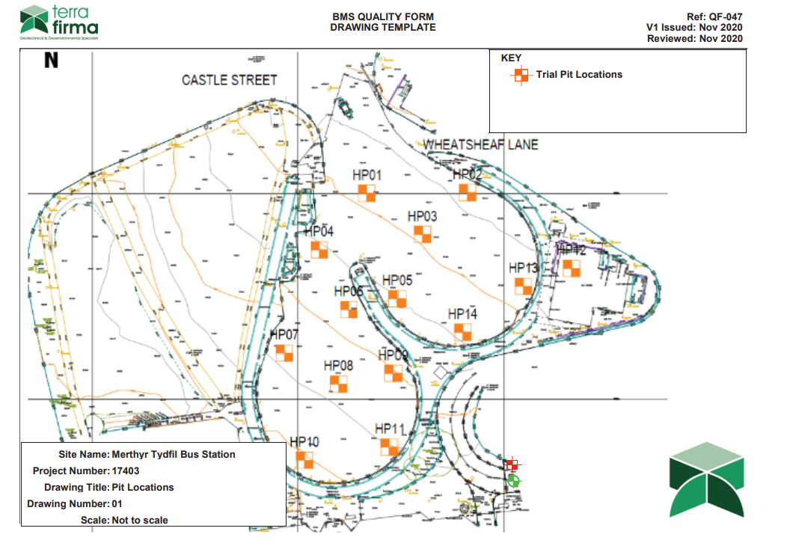
Figure 4- Showing the trial pit locations

Additional data should be collected through targeted site investigations to determine any contamination and thus any risks posed to people, the built environment or groundwater. It is anticipated that this be a planning condition attached to the planning permission.

Historic Environment
The Glebeland site is rich in history, not only due to its previous use as a bus station but evidence suggests that the site was once partially residential with maps from the 1870s showing residential dwellings to most of the site.
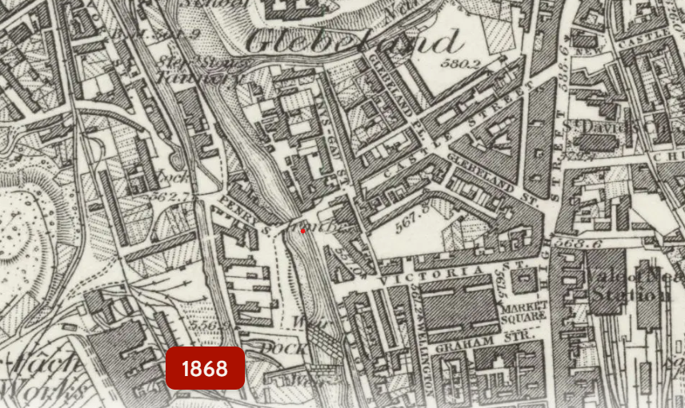
Figure 3- showing urban development on the Glebeland site during the 1860s.
There is also evidence that there was also a corn mill present on the site (Hong Kong Corn Mill) around 1903, as seen in figure 4. Although redeveloped, this has the potential for buried features to remain, and further investigations should be undertaken.
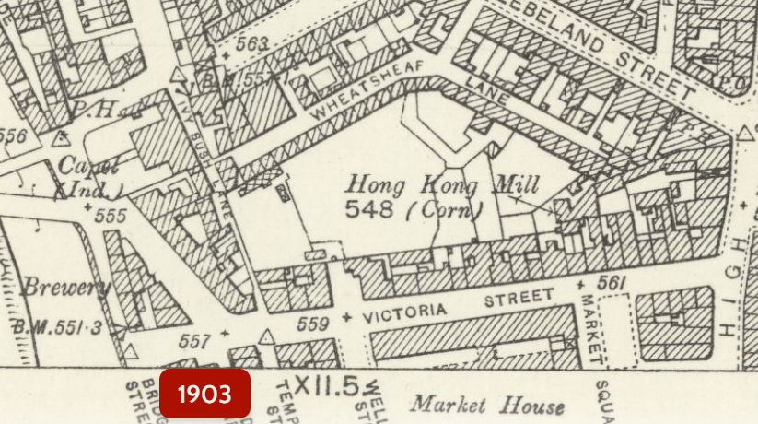

Landscape and Visuals
According to Planning & Environment Decisions Wales (PEDW) the landscape is made up of rocks, water, plants, animals, buildings, and monuments. The landscape is hard to measure as we all react differently to it. Landscape impacts refer to features of fabrics that can be affected such as topography, water bodies, hedgerows, trees, stone walls and green spaces. It also includes the landscape aesthetic qualities including scale, diversity, sense of place and beauty. The impacts can range from total loss of green spaces due to large scale changes to the loss or changes of individual features such as trees or hedgerows.
The current site does not fall under any national or local designation such as AONB or conservation area and therefore, there are no additional sanctions or restrictions imposed on the landscape.
The proposed development only covers a small area of green space on the east of the site where roughly 6 immature trees are located. The remainder of the site is where the disused bus station was demolished. It is currently fenced with security fencing with a vehicle entrance point, providing quite the eyesore for the community. The proposed development design is holistic and will take into account the heritage of the surrounding area.
Temporary impacts to the landscape will affect the site due to the construction and the presence of machinery, work crews, etc. The residual effect should be promising and will enhance the landscape due to the neglected nature of the current landscape.
Years 1 through 15 are often used to describe the effects with year 1 being the worst-case scenario following completion of construction and year 15 being a more average long-term scenario, with most planting being mature after 15 years.

Material Resources and Waste
Mitigation for resources and waste begins with a resource-efficient design of the development to reduce waste and incorporate only the materials that will be required not surplus. This measure is a primary mitigation that does not require any additional action to be taken.
The setting out of a sustainable material procurement route is another primary mitigation measure that encourages circular economy action. Circular economy approaches also include off-site construction and material and product reuse and recycling.
Secondary mitigation involves the correct disposal of waste materials (landfill, incineration, etc), using natural resources, estimating emissions and residue, by type and quantity.
According to IEMA, where primary mitigation measures are in place and can be demonstrated to prevent potentially significant environmental effects, then it may be possible to scope out materials and waste (IEMA.net, 2024).

Noise and Vibration
Noise levels will be carried out sporadically throughout the day to monitor current noise levels which can then be compared to the noise levels during the construction and operational phases of the development. The noise level limits set out under the British Standards will apply throughout the construction phase and all mitigations will be made to reduce the effect on nearby residents. Regulation 10 of the Control of Noise at Work Act 2005 requires all work personnel to be informed about the need to minimise noise and vibration levels and the health hazards as a result of excessive noise.
Protection for workers and residents include the operation of sound measuring equipment, avoidance of unnecessary equipment or machine use, noise screens/barriers that reflect noise, ear protectors for employees, and quieter hours during nighttime (11pm- 7am).
Noise sensitive receptors (NSR) will be identified, informed and mitigations made to ensure limited noise and vibration can be heard/felt.
Community reaction to noise and vibration includes:
Site location- The distance the site is from NSRs as the closer the site, the greater the measures to mitigate noise.
Existing ambient noise levels- The current noise levels will have an impact on the community reaction during development as busier areas or industrial areas will already experience increased noise levels during the working week.
Duration of site operations- Higher levels of noise may be accepted under the condition that it will be for a shorter duration of time compared to lower levels of noise for a longer period.
Noise characteristics- The tones or impulses from machinery or works may make it less acceptable to NSRs as these noises are more disturbing and irritating. These noises can included pile driving and reversing alarms
No significant vibration will be present during the operational phase of the Stagecoach theatre.

Traffic and Transport
Technical advice notice 18 outlines that sustainable development needs to incorporate appropriate provisions for pedestrians, cyclists, public transport, traffic management, and parking. It also includes limits on emissions and improving air quality in the wake of climate change. Additional guidance from Environmental Protection UK and the Institute of Air Quality Management (IAQM) provides information on sustainable design, offsetting emissions, and mitigating impacts of poor air quality.
The proposed development site is located in the town centre where there is a large selection of public transport available, including the nearest train station which is approximately 0.3 miles or a 6-minute walk. The new bus station is also a 6-minute walk, or 0.3 miles. Emphasis on public transportation will be incorporated to reduce carbon footprint and reduce congestion.
The site currently has a public right of way (footpath) running through the west side to Victoria Street. There is a current footpath adjacent to the road which would provide an alternative albeit a slightly longer route. The alternative would be Wheatsheaf Lane to the East of the site. All alternative routes are accessible to all.
Alternatively, the footpath will be amalgamated into the site design and access can be through the site, subject to planning and legal documentation. This method will allow for minimal disruption and only a slight detour as opposed to walking around via Wheatsheaf Lane.
Figure 3- The red line showing the current footpath with the green lines showing alternative routes.
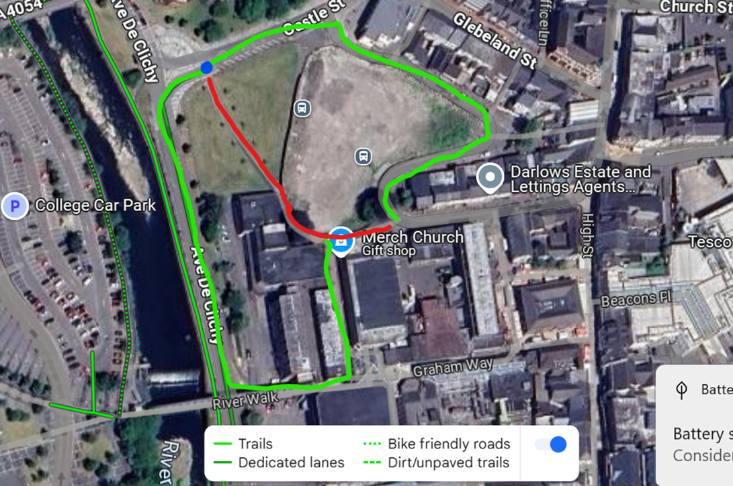
The proposed development includes basement car parking for staff accessible via the existing car park to the rear which is currently used by staff and deliveries for the shopping centre. This private basement car park will allow for direct access to the building for staff and maintenance vehicles. Additional public car parking (size requirements to be confirmed) will be incorporated into the design to allow for ease of access and accommodation for disabled guests as disabled parking will be included. The proposed car parking allowance will meet the demand requirements of the guests, both performing and visiting with additional car parks being found nearby as seen in figure 4 below. These car parks can also be temporarily used for construction workers during the construction phase, where required.
Access and parking for machinery can be utilised via the vehicle access gate to the North where the heavy-duty perimeter fencing is located, blocking access to the public. This west side of the site is not being developed on at the time of the theatre so this relatively flat space can be adequately utilised, with enough manoeuvrability for heavy plant machinery.
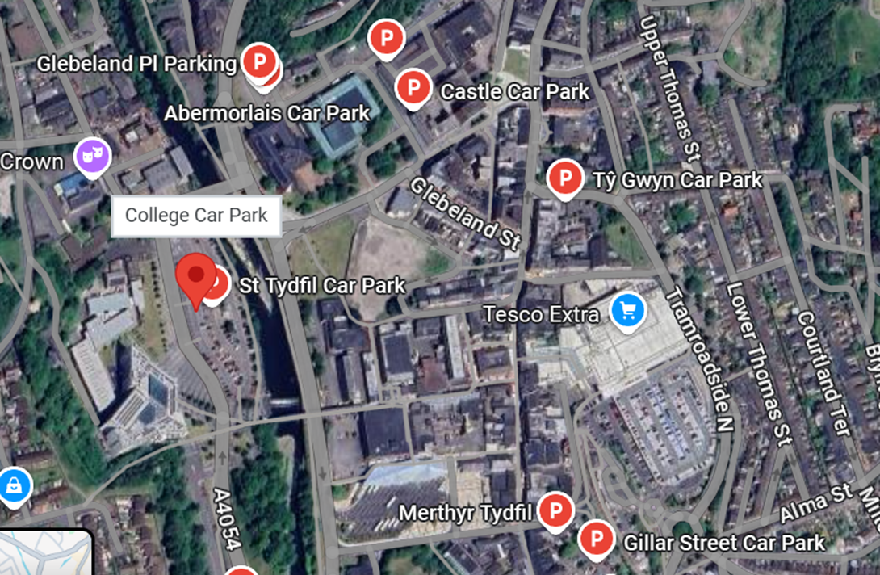
Figure 4- Showing additional, nearby public car parking that can be used when required.

Water
Flood risk refers to the probability and consequences of any potential flooding, whether it be from rivers, surface water or the sea. The probability is given as a percentage annually (1% annual probability equals 1 in 100 chance of flooding each year) with an allowance for climate change given. The site lies entirely within a low or medium risk of flooding from the adjacent river Taff and surface water flooding. The site also falls under zone C2 on the NRW development map. This means that there is limited flood defence in an area of risk of flooding.
The site is of moderate flood risk (from NRW) due to the proximity to the river, however previous hydraulic modelling has taken place recently (2023) showing that there is limited increase in surface water flooding as a result of the demolition of the bus station office block and the reprofiling. This can be evidence on the MTCBC planning portal.
According to TAN15, the development planning application can proceed subject to justification and acceptability of consequences. This includes acceptable consequences for type of use, maintenance costs secured, flood resistant and resilient design, flood emergency plans and procedures, and escape/evacuation routes present.
NRW advised the installation of flood-proofing measures at a nearby development of equal less vulnerable development with the recommendation of flood barriers on all ground floor doors and access points, locating all electrical sockets/ components at a higher level, and implementing flood proofing measures to the internal fabric of the ground flood.
A strategic flood consequence assessment must be undertaken.
Mitigation against flooding will provide both temporary and permanent measures against identified flood risk in both the construction and operational phase including sustainable drainage strategy and standard mitigation measures (protecting groundwater and existing sewage infrastructure).

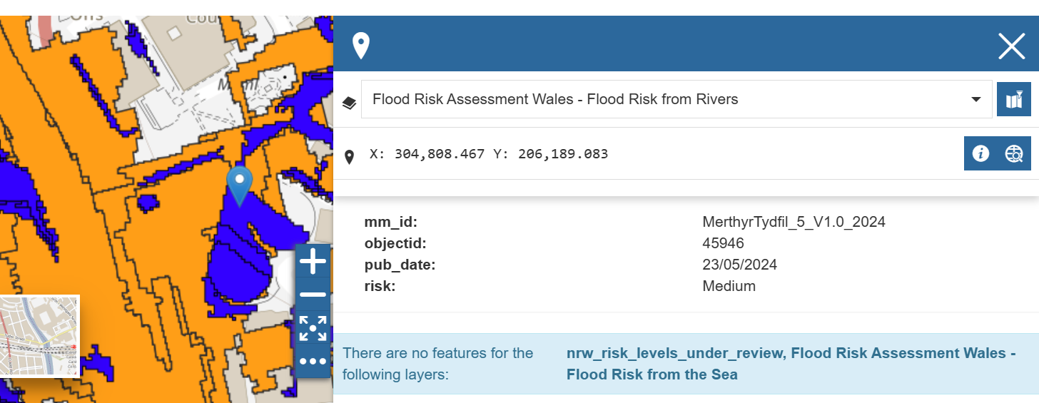
Figure 1- Medium flood risk from rivers (NRW, 2023).
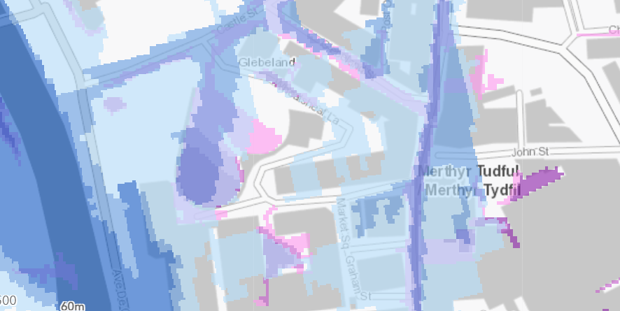
Figure 2- Low to medium risk of flooding from rivers and low/medium risk from small watercourses (NRW).

Reference List
BGS (2023). GeoIndex - British Geological Survey. [online] Bgs.ac.uk. Available at: https://mapapps2.bgs.ac.uk/geoindex/home.html?_ga=2.162112766.330703843.1745169724-2144990093.1745169724 [Accessed 20 Apr. 2025].

Gov.wales. (2024). Environment (Air Quality and Soundscapes) (Wales) Act 2024 | Law Wales. [online] Available at: https://law.gov.wales/environment-air-quality-and-soundscapes-wales-act-2024.
Iema.net. (2024). IEMA - Institute of Environmental Management and Assessment. [online] Available at: https://www.iema.net/content/materials-and-waste-in-environmental-impact-assessment-march-2020/.

Natural Resources Wales (2019). Natural Resources Wales. [online] Naturalresources.wales. Available at: https://naturalresources.wales/?lang=en.
The Environmental Impact Assessment (Agriculture) (Wales) Regulations 2017 Guidance on Scoping, Environmental Statements and EIA Consent Applications. (2019). Available at: https://www.gov.wales/sites/default/files/publications/2021-02/environment-impact-assessment-guidance-on-scoping-environmental-statements-eia-consent-applications.pdf.
‌www.gov.wales. (2019). Environmental impact assessment: guidance | GOV.WALES. [online] Available at: https://www.gov.wales/environmental-impact-assessment-guidance.
‌

‌

