Student Id: 2112412
Student Name: Dolca Mirela Maria
Module: The Global Business Environment
Module Code: LCBB4005

Environment Analysis of Automobile Industry
Executive Summary
This report is focused on the environmental analysis of the Automobile Industry. It analyzes the impact of Covid-19 on the industry. It gives an overview of the forces that affect the global business environment. Thereafter, it presents three theories and relates them with the chosen automobile brand of Porsche, and provides a PESTLE analysis. Finally, it discusses certain factors and strategies for the success and survival of the automobile industry within the context of the current megatrends.
Table of Contents
1. Introduction 4
1.1 Analysis of the impact of Covid-19 pandemic on automobile Industry 4
2. Forces affecting the global business environment concerning the automobile industry 5
3. Application of Theories and Models 7
3.1 Porter’s Diamond Theory 7
3.2 Value Network Model 8
3.3 Five Forces Model 9
3.3.1 Competition in Industry 10
3.3.2 Threat of new entrants 10
3.3.3 Power of Suppliers 10
3.3.4 Power of Customers 10
3.3.5 Threat of Substitute Products 10
4. PESTLE Analysis of UK Automotive Industry 11
5. Factors related to survival and success in the automobile industry concerning megatrends 13
6. Conclusion 14
7. References 15

Introduction
The Automobile sector is built on the foundation of cutting-edge tech and organizations involved in vehicle manufacturing. The pre-pandemic forecasts showed that international car sales were on track to reach 80 million units (Belhadi et al., 2021) but the latest figures show an improvement over it. There is a stark decline in demand for new vehicles in 2020 with South America and Europe being the hardest-hit regions. In April 2020, registrations of new vehicles dropped to a staggering 97% and in September 2020 registrations have reduced by 33% in comparison to 2019 in the UK (Belhadi et al., 2021).

1.1 Analysis of the impact of Covid-19 pandemic on automobile Industry
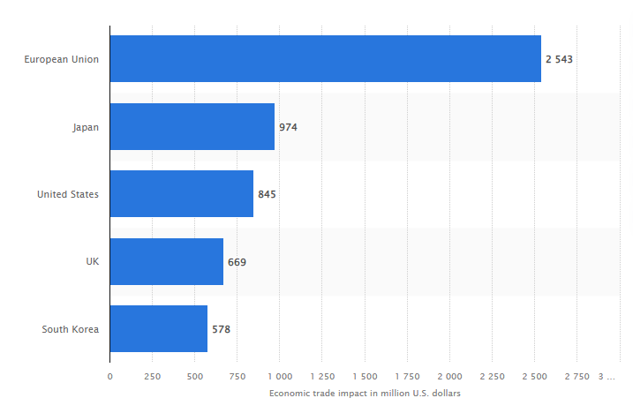
Figure 1: Economic Trade Impact in Automobile Sector Globally
(Source: Statista.com)
The automobile industry is a critical component of the economic growth of a country. The automobile industry has millions of people involved within it with 15 million people in Europe, 8 million in the US, 5 million in China, (Statista, 2021) which highlights the importance of this sector globally. The automobile industry has been affected by factory closures, disruption of the supply chain, and diminishing demand over a while which has led to huge losses for China as its GDP rate was affected negatively. The European Union saw a decline of approx. 2.5 billion US dollars due to a reduction in automobile parts exports from China (Statista, 2021). As a result, due to huge losses during the pandemic, some auto manufacturers had to close their businesses to minimize their losses.
The pandemic has led to several changes within the industry. Some manufacturers decided of waiting out the pandemic while others capitalized on the uncertainty of this global phenomenon through innovative methods. The majority workforce of the industry had to go remote which resulted in diminishing vehicle demands, and fewer people traveling from home to office in vehicles. There was a concern that working from home would result in a lack of productivity, but instead, research suggests that remote work increased the productivity and efficiency of the workers.
Covid has forced the industry to employ a digital mode of communication and has been a great opportunity for global automotive firms to gain greater internal efficiency through video conferences, project management tools, mobile integrated networks, etc. The trend of embracing E-commerce by the companies shows that online purchases grew from 25% to 80% during the pandemic (Statista, 2021).

2. Forces affecting the global business environment concerning the automobile industry
The Covid- 19 pandemic serves as a major force in affecting the global business environment. Due to the pandemic, the global economy suffered huge losses and an economic slowdown led to the shutting down of many businesses. The automobile industry is by far the most affected by it. Vehicle sales saw a decline in 2020 due to a change in the buying behavior of customers. People could not afford high-priced models due to the state of the economy during the pandemic which led to automobile manufacturers suffering huge losses based on car production and retail costs.
A survey of the e-commerce industry for converting global sales suggests car buying attitudes are very low. As per Capgemini, a survey in May 2020 states citizens of UK are 32% have low chances to buy cars from online sites or car showrooms, while respondents from India (44%) and China (49%) claimed that they will buy their cars online in the future. These statistics highlight the reluctance of purchasing cars online (Statista, 2021).
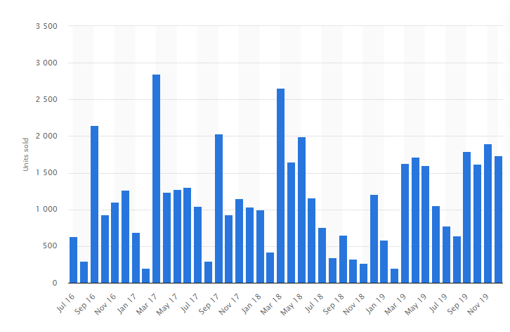
Figure 2: Number of Porsche units sold in the UK (2016-2019)
(Source:Stastita.com)
In the UK, Porsche sales peaked in March and September of each year. This was due to the issuing of new license registration plates and by September 2019, there were 1800 new Porsche registrations in the UK (Statista, 2021). In the face of the pandemic and overall economic conditions, Porsche pursued investments in digitalization and electrification. Porsche delivered 191,547 units worldwide which are 5% less than 2019, (Statista, 2021) but Porsche has managed to keep the drop at a sustainable level in comparison to the rest of the market.

3. Application of Theories and Models

3.1 Porter’s Diamond Theory
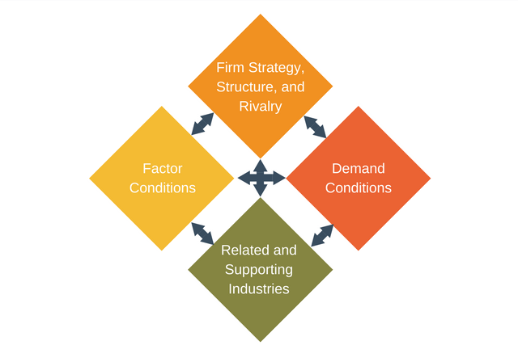
Figure 3: Porter’s Diamond Model Structure
(Source: Liu et al., 2017)
The diamond model structure of Porter is a tool used by the companies for strategizing and developing the competitive edge through Firm Strategies, Structure and Rivalry, Factor conditions which are needed for global expansion. The Porsche Company are able to boost their economic growth in the global economy through constant innovation with the help of these factors (Liu et al., 2017).
Various factor conditions provide a competitive edge to the Porsche company which include natural resources for setting up production plants, capital resources generated within the company, human resources which include skilled workers working within the company, technological innovations to maximize profit and expand into other markets, infrastructure which is vital for an organization's overall growth both locally and internationally (Kharub and Sharma, 2017).
The strategy and structure of the Porsche company set a goal or objective for the company based on which its decisions will be made facilitating its growth. Company strategy is important for focusing on high-quality products and the Managerial system works towards employee growth and development. The company Porsche can predict global trends and consumer behaviour which helps in gaining a competitive edge (Kharub and Sharma, 2017).

3.2 Value Network Model
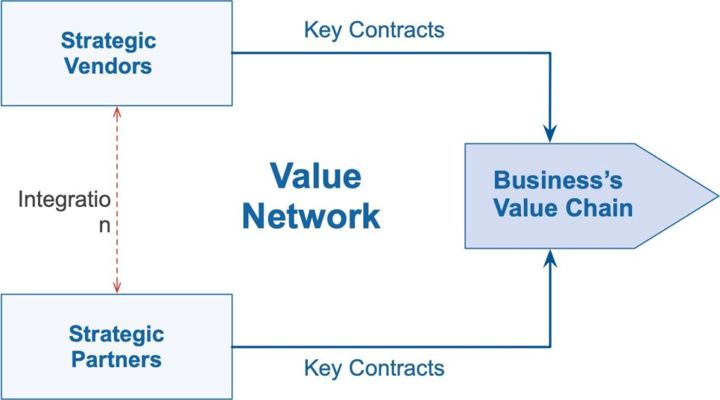
Figure 4: Model of Value Network
(Source: Riasanow et al., 2017)
Value Network model is defined as a set of connections between organizations or individuals which are interacting with each other to benefit the entire network. Members in a value network can exchange information and conduct business with each other. A value network is used for exchange of products and information by its members. There are mapping tools which help depict these networks consisting of nodes (members) and connectors (relationships) (Riasanow et al., 2017).
There are certain benefits that a value network provides to a business or an individual that applies the resources, influence, and insight of the people with which they are connected. A startup may look for external connections like investors to provide the required guidance on the development and growth of the business.
Due to the Covid pandemic, there is a shortage in the production of semiconductor chips which affected luxury car brand manufacturer Porsche. This shortage failed to meet consumer demands and fewer units were manufactured and sold in the whole year. Porsche recovered from these factors through its network connections and used its influence and resources to minimize the losses which would have been significant. By analyzing the pandemic situation they devised strategies to incorporate their business to the wider audience through E-commerce mode of communication (Riasanow et al., 2017).

3.3 Five Forces Model
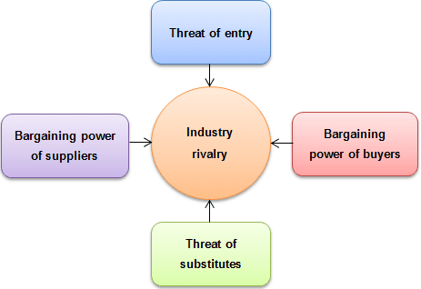
Figure 5: Porter’s Five Forces Model
(Source: Bruijl, 2018)
The Five Forces Model was coined by Michael E. Porter analyzes five competitive forces which include industry competition, potential new industry entrants, power of suppliers, power of customers, and Threats of substitute products. They dictate and shape every industry and help in the identification of an industry's weaknesses. The Five Forces model is used to identify the organizational structure of an industry and determine its strategies (Bruijl, 2018).

3.3.1 Competition in Industry
According to this model, due to the industry competition from giants like General Motors, Chrysler, and Ford. Porsche was in a tight spot but managed to avoid a complete takeover. The public perception of Porsche and its uniqueness of products allows it to sustain its competitive edge.

3.3.2 Threat of new entrants

Due to the economic scaling and high capital requirements paired with strict licensing and legal requirements, the threat of new entrants into the industry seems weak but only a few retail outlets managing to sell this kind of product on the market make the threat strong.

3.3.3 Power of Suppliers
Due to an abundance of suppliers in Porsche's field of operation, the company can purchase raw materials at low cost from suppliers and can switch them at their convenience due to low switching costs which makes the bargaining power of suppliers weak.

3.3.4 Power of Customers
The consumer has fewer firms to choose from within the industry and the variation in products is very high which makes the bargaining power of customers weak.

3.3.5 Threat of Substitute Products
The industry in which Porsche operates has very few products substitutes available which are also of high quality but less affordable in market pricing. The other operating firms sell at a comparatively much lower price than Porsche which negates the switching factor of customers and makes the threat of substitute products weak.

4. PESTLE Analysis of UK Automotive Industry

Dimensions | Factors | Impacts
Political | - Safety Regulations  - Emission Policies | The UK Government strictly enforces strict regulations for safe driving like mandatory wearing of seatbelts while driving.  The government regulates emission policies to control carbon dioxide pollution levels in the environment which results in a clean environment.
Economic | - Gdp decline by 9.9% in 2020 | Due to the Covid-19 pandemic, the UK noticed a sharp decline of 9.9% in its overall GDP growth which led to changes in customer behavior and reluctance in investing in the automobile industry (racfoundation.org, 2021).
Social | - Driving trend Popularity | In the UK, driving is a major part of the daily life of its people and over 77% of households in the UK have a car which leads to the popularity of the automobile industry and its growth.
Technological | - Auto-pilot cars  - Improved Safety | The technological advancements in the UK automobile industry are significant with the likes of Tesla providing auto-pilot car facilities and improving safety which helps in attracting a wide range of customers to the automobile industry.
Environmental | - Carbon emissions | Due to the carbon emissions from several vehicles, as they are a major part of daily life in the UK, the environment suffers greatly. Though the government forces the automobile sector to reduce carbon dioxide levels, an excess amount of cars negates the effort.
Legal | - Licensing Issues  - Brand Copyright issues | The legal licensing issues for an automobile brand and copyright issues make it hard to enter into the automobile market for new entrants. This results in low variation in the automobile industry.

5. Factors related to survival and success in the automobile industry concerning megatrends
There are various industry megatrends in the automobile industry that serve as key factors which are related to the survival and success strategies in the automobile industry. These megatrends help the industry to innovate and grow in the global market sphere and cater to customer-specific demands and accessibility.
Some megatrends include ADAS systems, industrial consolidation, digital retail revolution, etc. For the automobile industry to thrive and recover from its losses during the pandemic they must focus on enhancing their horizons and follow the current trends to stay afloat in the competitive market. Technologies like ADAS or Advanced Driver Assistant Systems help a driver in driving and parking functions (Kalaitzi et al., 2021).
Industrial consolidation involves the merging of two companies into one and in the automobile sector, this trend is running hot with acquisitions left and right by industry giants. Due to the impact of covid 19 on the automobile industry, there is an increase in the demand for e-commerce retailing which resulted in the digital retail revolution. An increasing number of people are looking to the web to identify their vehicle of choice and they can get all the information related to it within the comfort of their home. Many companies within the automobile industry are currently adapting to this online mode of business to reach out to as many customers as possible (Kalaitzi et al., 2021).

6. Conclusion

Through this report, we analyzed several factors related to the impact of the pandemic in the environment of the automobile industry. The major forces are identified and their impact on the automobile industry is analyzed. Some relevant theories are analyzed to get a clear picture in identifying the chosen brand Porsche's various operations and business dealings. The PESTLE analysis of the UK automobile industry is done through various factors such as economic, political, social, and many more. Lastly, the megatrends which contribute to the overall expansion and growth of the automobile industry are analyzed which includes the digital retail revolution that drives the companies to adapt to the new online mode of purchase and selling of vehicles.

7. References
Belhadi, A., Kamble, S., Jabbour, C.J.C., Gunasekaran, A., Ndubisi, N.O. and Venkatesh, M., 2021. Manufacturing and service supply chain resilience to the COVID-19 outbreak: Lessons learned from the automobile and airline industries. Technological Forecasting and Social Change, 163, p.120447.
Bruijl, G.H.T., 2018. The relevance of Porter's five forces in today's innovative and changing business environment. Available at SSRN 3192207.
Kalaitzi, D., Matopoulos, A., Fornasiero, R., Sardesai, S., Barros, A.C., Balech, S. and Muerza, V., 2021. Megatrends and trends shaping supply chain innovation. In Next generation supply chains (pp. 3-34). Springer, Cham.
Kharub, M. and Sharma, R., 2017. Comparative analyses of competitive advantage using Porter diamond model (the case of MSMEs in Himachal Pradesh). Competitiveness Review: An International Business Journal.
Liu, X., Zhang, S. and Feng, X., 2017, January. Comparative Analysis of International Competitiveness of Chinese-American Automobile Industry. In 2016 2nd International Conference on Economics, Management Engineering and Education Technology (ICEMEET 2016) (pp. 149-153). Atlantis Press.
Racfoundation.org. 2021. [online] Available at: <https://www.racfoundation.org/wp-content/uploads/2017/11/car-ownership-in-great-britain-leibling-171008-report.pdf> [Accessed 30 November 2021].
Riasanow, T., Galic, G. and Böhm, M., 2017. Digital transformation in the automotive industry: Towards a generic value network.
Statista. 2021. Economic impact of COVID-19 on the auto industry | Statista. [online] Available at: <https://www.statista.com/statistics/1103657/economic-trade-impact-of-covid-19-on-the-auto-industry-by-market/> [Accessed 30 November 2021].
Statista. 2021. Porsche car sales in the United Kingdom | Statista. [online] Available at: <https://www.statista.com/statistics/385404/porsche-car-sales-in-the-united-kingdom/> [Accessed 30 November 2021].

