Wireless Networks and Simulation Assignment
Mohammed Abdulla
P152058
Module Tutor: Dr Carlene Campbell

Abstract—

The report will discuss briefly different modulation techniques, but will mainly focuses on the BPSK technique for transmission with the objectives like functions of modulation in a system of communication, concepts and principles of computer network simulations, fundamentals of BPSK modulation technique and examples of implementations. The paper will also explains the pros and cons of using simulations over methods like test-bed and mathematical. The results obtained indicate a good system design and specifications after analysis. The last section of the paper will discuss the design of smart factory that utilises a WSN controlling, occupancy, motion detection, entry, light and fire safety. The design will be implemented using NETSIM simulation software

Keywords:
BPSK – Binary Phase Shifting Keying
DVD- Digital Video Disc
CDMA- Code Division Multiple Access
CINR- measurements expressed in Decibels.
WLAN- Wireless Local Area Network
OFDM-Orthogonal frequency division multiplexing
M-PSK- M-array Phase Shift Key
QPSK – Quadrature Phase Shift Keying
QAM- quadrature Amplitude Modulation
RFID- Radio Frequency Identification
KHZ- kilohertz

Introduction

In so many ways, the modern technology has entered our life. One of these technologies is wireless communication. The main purpose of wireless communication is to transmit the messages e.g. data, image, video or sounds in an understandable form to destination, that is physically distant from original source in order to achieve this goal the information source transmitter have to amplifies the message e.g. data, sound or image signal into an understandable form for transmission over a channel. This modification process can only be achieved by a technology called the modulation[8].

research and evaluation
What is Modulation?

Human voice has a limited distance range, the frequency range is differing from person to person, but the average frequencies range are from 50 to 500Hrts [6]. In order to extend the range of the voice, we need to transmit through a medium. The modulation is facilitating the process of converting the messages (voice in this case) to be sent through a medium successfully.

The main three types of digital modulation techniques are:

1. Amplitude-Shift Keying (ASK)

2. Frequency-Shift Keying (FSK)

3. Phase-Shift Keying (PSK)

Each of the above techniques has its own parameter of a sin wave to represent the message in which we want to send. The carrier wave can be written as () ( ) φπ += C t A ft sin 2. The sin wave has three different parameters, its amplitude, frequency and phase. The modulation rule is mapping such that it takes the message and converts it into some sort of sine wave and transmits it, so it leaves the actual message behind [7]. The sine wave on the destination will remap back to a near copy of the original message. The sin waves travel through a medium e.g wire, air, space and water are a medium and the sin wave called a carrier. The, data message in which we sent become information signal, as soon as the carrier is mapped with the message we want to send, it is no longer a sin wave it become a signal [5,7]. .

MODULAITON IN COMMUNICATION SYSTEM

Modulation is considered as fundamental to all communications that are wireless [1]. The wireless digital transmission were limited to spectrum. The aim was to squeeze as much data into spectrum that is least available. The spectral efficiency, measured how the data quickly transmits an assigned bandwidth. The techniques that emerged improved the efficiency of spectral [4].

Modulation helped in reducing the heights of antenna. This was an achievement in the transmission of radio signals. 10 kHz was the minimum height of the antenna that was required [2]. Sounds signals that were transferred helped in evading mixing of signals. The signals could not be separated when they were mixed together therefore modulations assisted in separating signals. Modulations increased the ranges of communication [1]. Low frequencies got heavily attenuated when travelling long distances therefore modulation process increased the frequencies of the signals.
With modulation, multiplexing was considered possible. The process involved two or more signals that were transmitted over similar channel of communication. Multiplexing permitted use of a similar channel by various signals. This was seen in TV where many channels could be viewed without mixing up. The quality of reception was also improved through modulation technology. The digital communication techniques and [5] frequency modulation greatly reduced the effect of noise to a great extent. This had enhanced the quality of reception.

Fundamentals of BPSK modulation technique

The fundamentals of BPSK modulation technology consisted of many techniques. They included: data rate and baud rate, multiple phase shift keying, Amplitude phase shifting control, OFDM, and M-PSK [3].
BPSK technique was known to be a digital modulation technique whereby change in binary data, one and zero are represented by variations in carrier phase by 180 degrees [1]. This was one of its advantages because it was mostly employed in carriers [3]. The technique was used for the synchronization of time and frequency. Most cellular towers used the BPSK modulation to communicate and transmit data over long distances [4]. The receiver in BPSK demodulator is simple therefore only two decisions were to be made for the recovery of original binary information. This made it a greater over other modulation techniques. In power efficiency, the modulation technique required less power for the transmission of less number of bits in carrier. The implementation of the technique is easier. The bit efficiency was increased through the M in M-PSK.

In modulation of the technique, a single analogue carrier carried one bit therefore the symbol rates were same as data rates in bits per minute. This is considered a half when compared to the QPSK technique. It is regarded as many times lower in comparison to higher techniques like 16QAM and 64QAM [2]. The above reasons nullified the bandwidth efficiency of the modulation technique when compared to other types of modulation. The modulation occurred through varying cosine and sine data during accurate time. It was widely used in Bluetooth communication, Wilan, RFID and Matlab coding. It was also used in work places like the airport for security purposes in figuring of clouds.

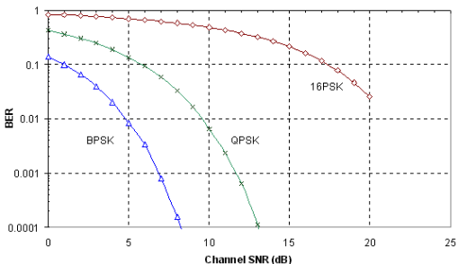
Figure (2) show BER Verses Channel signal to Noise Ratio on BPSK,QPSK,16PSK [8]
.

OTHERS MODULATION TECHNIQUES

Pros and Cons in Using Simulation
Simulation was associated to be the best method of studying the impacts of phenomena over regions. It was also regarded as a low cost and low risk environment during experimentation when compared to other methods like test-bed. It also helped in different situations when uncertainty is high [3]. The applications of simulation were recognised useful to the scientists and researchers. Simulation technology has no standardized approach therefore does not produce good theories that were needed. The whole process of simulation had a challenge in validation process. It had a high scepticism and public implications in socialisations.

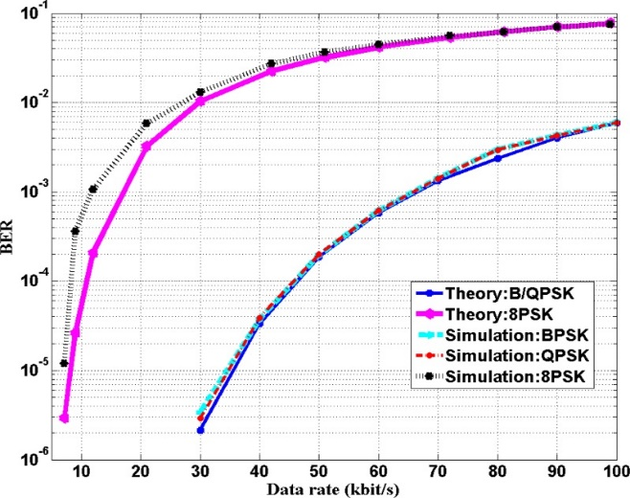
Figure( 1) Image showing how simulation [9]

BPSK performance evaluation

Selecting a good modulation scheme depend on factors. The BER is the most important factor, which is directly involved with SNR. This section will focus in conducting experimental study of BPSK modulation technique and evaluating its performances in different levels of channel noise and evaluate performance whilst gradually increasing the level of noise affecting the channel. Bit error rate (BER) against signal-to-noise ratio (SNR) will be used as performance parameters.
The design was modelled using Matlab/Simulink. After simulation the results that we will obtain will be analysed and should show a good system design and specifications.

AWGN channel will be used between transmitter and receiver. Transmission of modulated signals through AWGN channel and received by the receiver, the receiver should get the original signals correctly. We will modify the values of SNR parameter in the AWGN channel and should notice the changes in modulated signals and also will notice the increase, decrease or no bit error rate (BER).

Referring to the Simulink model design for BPSK on figure (3). I modified the values of SNR parameter (0, -5, -15, -30) on the AWGN channel and noticed the following:

- When used the value of ( 0 ) of SNR parameter figure (4), I noticed no changed on the modulated signals and the receiver receive the exact signals as the original, so BER is zero.
- When increasing value of SNR parameter to ( -5) figure (5), I noticed a changes on the modulated signals and the receiver, received not the exact modulated signals as the original, so BER is increased, but still at low level

- When increasing value of SNR parameter to ( -15 ) figure (6), I noticed a changes on the modulated signals and the receiver, received not the exact modulated signals as the original, so BER is increased, but still at acceptable level.

- . When increasing value of SNR parameter to ( -30 )
figure (7), I noticed a changes on the modulated signals and the receiver, did not received the exact modulated signals from the original source original, so BER is increased very high to not acceptable level.

After conducting the experimental study of BPSK modulation technique and evaluating its performances in different levels of channel noise and evaluate performance whilst gradually increasing the level of noise affecting the channel. Bit error rate (BER) against signal-to-noise ratio (SNR) been used as performance parameters.

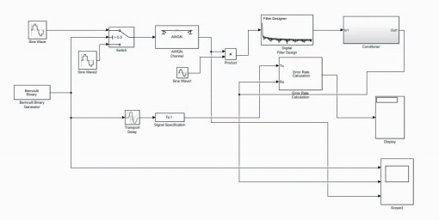
Figure (3) Simulink model for BPSK

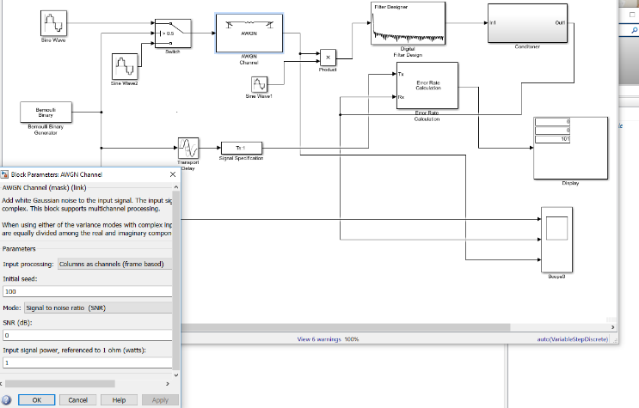

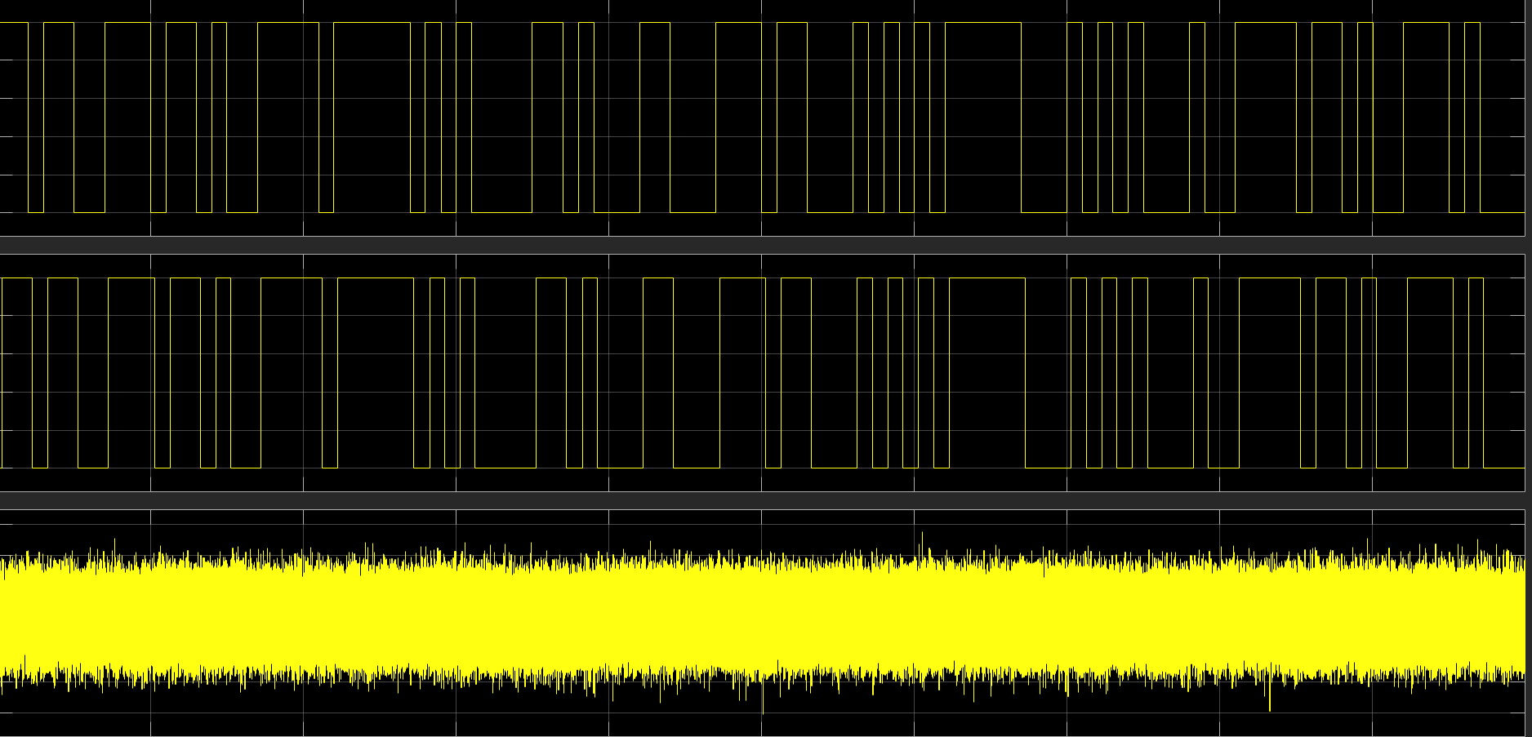
Figure (4) BER vs SNR of BPSK 0 dB

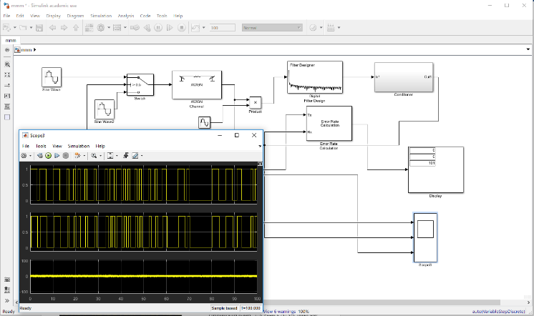
Figure (5) BER vs SNR of BPSK -5 dB

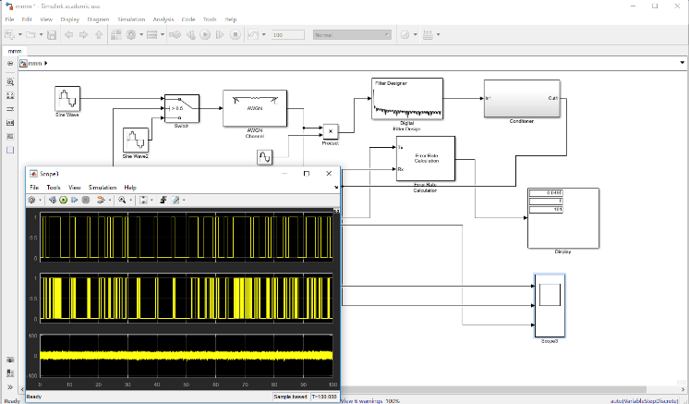

Figure (6) BER vs SNR of BPSK -15 dB

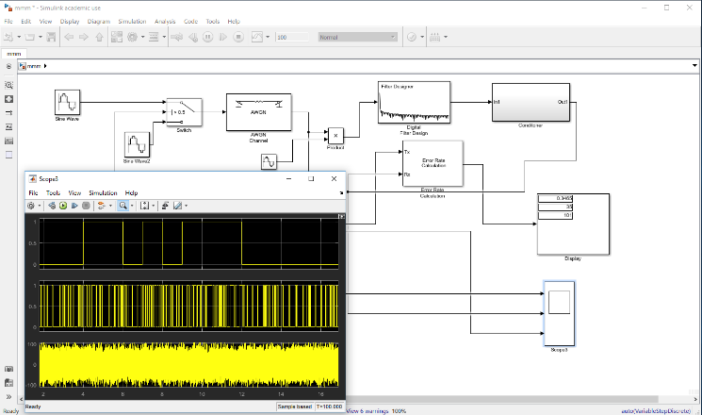
Figure (7) BER vs SNR of BPSK 30 dB

Smart factory design and Toplogy

In this section we designed WSN for smart factory to control the occupancy, secure entry, fire safety, light and motion detection. The network will link to a display on the warehouse manager’s PC, reception PC and also to health and safety officer’s laptop.
Then factory layout will be divided into three main sections, reception, office, store warehouse and production line section.

The design was implemented using NetSim simulation software. We used different sensors linked to a LoWpan that is positioned in the centre of the smart factory for communication efficiency purposes. The data will be stored on server and will link to a display on the warehouse manager PC, reception PC and health and safety officer laptop. We also linked WSN to router as a backbone that will allow for remote monitoring by security contractor.

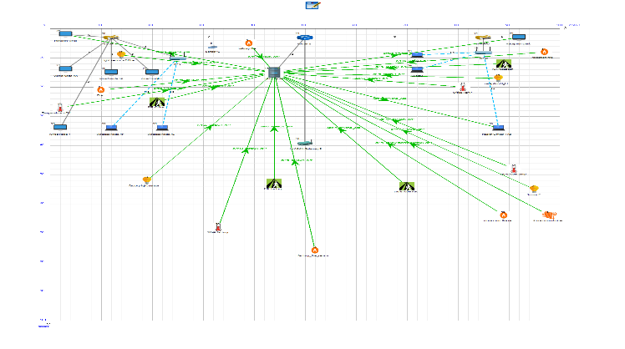
Figure (8) smart factory WSN topology

- Analysis

Due to software limitation on NetSim, I run the simulation on QPSK modulation technique, even though my choosing modulation in which I have discussed previously on this paper was the BPSK modulation technique.

We assume that the noise level across all section will vary due to different interference that will affect the signals in each section.
I assume that the reception will have the lowest level of noise due to the fact that the occupancies of the office will always be low
So the Wi-Fi would be in less use at that space and I also assume that there would be no reflection e.g. objects or windows.

I also assume that the sore room and the office sections will have slightly higher noises compared to reception section due to the fact that the office will be occupied with more people who would have smart devices connecting to the Wi-Fi and there would be a window and maybe a microwave and cordless phone and others object e.g. mirrors glass etc.
The store room will have a low level off noise but maybe slightly higher than office, due to the fact that there would be machinery working there, walls and other reflecting objects that would affect the level of noise.

The factory section will have the highest level of noise because of the nature of the factory environment, as there would be very heavy machinery, heat, objects and vibrations level.

I did run a total number of 7 simulation tests which includes:
- No path loss
- Path loss office only
- Path loss only factory
- Path loss shading factory only
- Path loss fading and shading factory 5,8 and 12 dB

After running the simulation using QPSK modulation techniques I got the following results that need to be disused:
- Between all the simulation the packets transmitted figure (8) almost the same, so no issues.
- The packet collided comparisons figure (9) between all simulations almost looks the same, so no issues. With slight difference when we allay 8 an 12 db with path loss fading and shading

- Packet error comparison between all simulation show the impact of the noise level and the level of inference as we increase the NSR it gets to a point where system start to fail completely as the amount of packets errors are very high level.
- Packet overhead comparison Figure (10) between all simulation show the packet overhead is high due to the fact of protocol exchanges, on the through graph the overhead start very high during the period of protocol exchange and the settle down when starting transmitting the data.

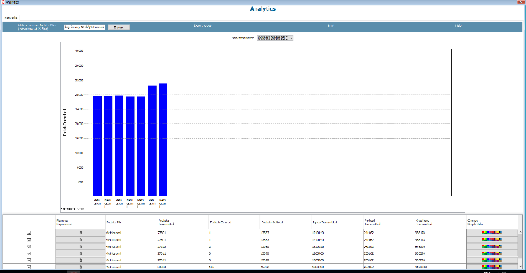

Figure (8) Packet transmitted comparison between all simulation

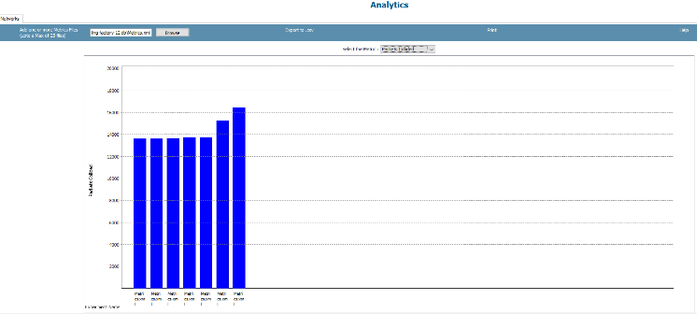
Figure (9) Packet collided comparison between all simulation

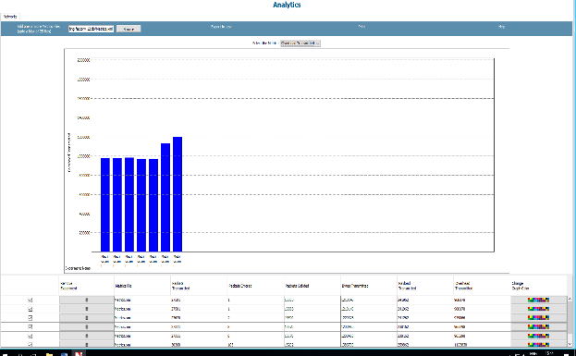
Figure (10) Packet overhead comparison between all simulation

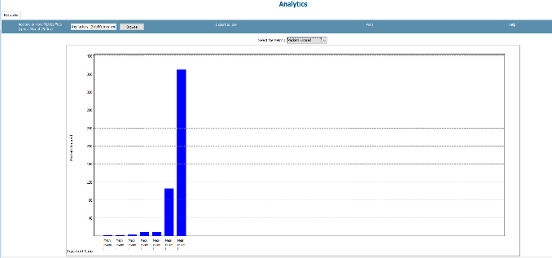
Figure (11) Packet error comparison between all simulation

- Suitable modulation scheme for the Smart factory WSN

Even though I did the simulation on QPSK due to NetSim limitation, I still believe that the BPSK is the most suitable modulation technique that should be used.
Due to I spectral, power rand bandwidth efficiency, and also BPSK is robust to noise and for its simplicity.

Conclusion

BPSK technique should be used due to its recommendable; efficiency over other methods. Simulation technique should be applied during studies in various fields to enhance several impacts on costs and risks to the environment. Modulation has helped the communication industry through improving the communication systems.
BPSK technique should be used due to its recommendable; efficiency over other methods. Simulation technique should be applied during studies in various fields to enhance several impacts on costs and risks to the environment. Modulation has helped the communication industry through improving the communication systems.

References

[1]. Basar, E. Index modulation techniques for 5G wireless networks. IEEE Communications Magazine, 54(7), (2016).168-175.
[2]. Fan, R. & Guan, Y. L.. Generalization of orthogonal frequency division multiplexing with index modulation. IEEE transactions on wireless communications, (2015) 5350-5359.
[3]. Ozluturk, et al. "Code division multiple access (CDMA) communication system." U.S. Patent 8,737,363, issued May 27, 2014.
[4]. Reynders, B., & Pollin, S.. Chirp spread spectrum as a modulation technique for long range communication. In Communications and Vehicular Technologies (SCVT), 2016 Symposium on (2016, November).pp. 1-5). IEEE.
[5]. Wang, Y.& Chi, N.. 4.5-Gb/s RGB-LED based WDM visible light communication system employing CAP modulation and RLS based adaptive equalization. Optics express, 23(10) (2015), 13626-13633.
[6] Vimlesh Department of Electronics and communication Engineering, K.I.E.T, UPTU, Lucknow , India,
[7] D.Jagadees. Department of Electronics and Communication Engineering National Institute of Technology Rourkela 2005 - 2007
Master of Technology In VLSI Design and Embedded System

[8]Ashiqur Rahaman Postgraduate student Department of Applied Physics and Electronic Engineering University of Rajshahi Rajshahi-6205, Bangladesh

[9]https://www.gaussianwaves.com/

[10] Hosamsoleman, Ali Payandeh, Nasser Mozayyani, SaeedSedighianKashi/ International Journal of Engineering Research and Applications (IJERA)

