Documents for Mock Interview

Table of Contents
CV (Care Assistant Application) 3
Cover Letter 4
The Job Advertisement 5
Reference 8

CV (Care Assistant Application)
Contact Information
Address: 112 Oldfiled road
Phone: 07538 911 482
Personal Profile
I am an empathetic and trustworthy person with excellent interpersonal and communication capabilities, whose integrity is to offer excellent individual care and emotional support to clients. I have worked with people and collaborated, and am really interested in assisting people and making their lives better. I am interested in working at the Paragon Home Healthcare to make a difference in the mission of providing person-centred, professional and ethical care services to the London community.
Key Skills
- Good communication and understanding of clients.
- Awareness of standards of hygiene, safety, and confidentiality.
- Capacity to help in performing activities of daily living and mobility aid.
- Dependable, time-conscious and flexible to day shifts or night shifts.
- Educated on how to maintain dignity for the clients and foster independence.
- Team player and independent worker.
- Fundamental knowledge of health and safety within care settings.
Work Experience
Crew Member — McDonald’s, London (2019 – 2020)
- Provided quality services to the customers at a fast-paced environment.
- Hygiene and cleanliness standards are kept in order to comply with company policies.
- Learned how to work in a team, manage time, and communicate.
- Colleagues supported and efficient day-to-day operations.
Work Experience -Solanki Dentist Practice (1990)
- Noticed the treatment of patients and acquired clinical hygiene skills.
- Helped with the administration and reception staff, supported.
- Obtained initial experience in healthcare and patient interaction practice.
Education and Training
- General Certificate of Secondary Education (including English)
- Professional care knowledge is being acquired through professional training and personal research.
Achievements and Interests
- Recognised as an outstanding team player and being reliable, by being named the Employee of the Month.
- Like volunteering and looking after family members.
- Cares about health, well-being, and community service.

Cover Letter
Dear Hiring Manager,
I am addressing you to tell you that I am interested in the Care Assistant role at the Paragon Home Healthcare. Being a very compassionate individual with the desire to help others, I can state that my skills and attitude would fit into the values of your organisation, which consists of offering professional and high-quality home care.
My time at McDonald's has equipped me with good communication, teamwork and time management skills, which are important in dealing with clients and colleagues in a busy setting and combining them into a work environment. My former time with Solanki Dentist Practice provided me with initial exposure to healthcare facilities, and there I realised the value of confidentiality, hygiene, and patient care.
The reason why I am attracted to Paragon Home Healthcare is due to its reputation for being compassionate, growth, and commitment to the development of the staff. I am also willing to join your paid training and engage in enhancing the quality of life of clients by providing personalised and respectful care.
I am also passionate, trustworthy, and willing to become a valuable addition to your award-winning care staff. I would be glad to have a chance to explain how I can assist the needs of your clients and maintain the excellent standards offered by Paragon.
Yours sincerely,
The Candidate

The Job Advertisement
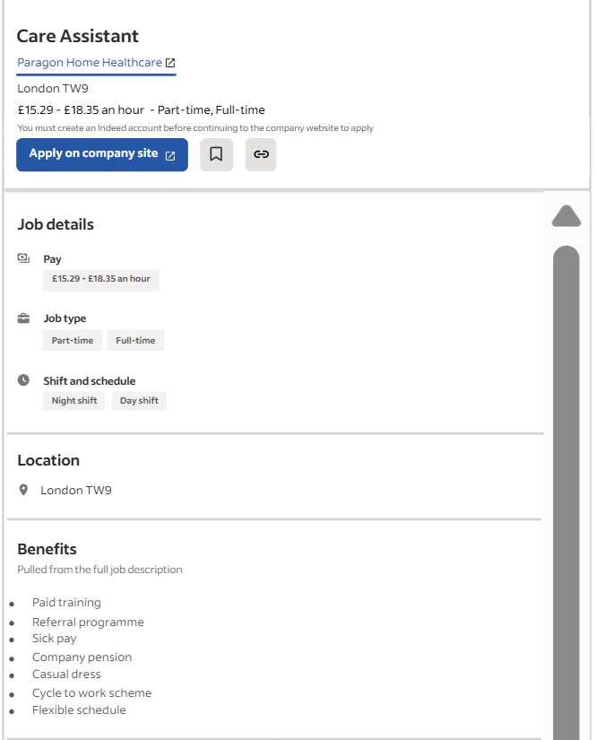

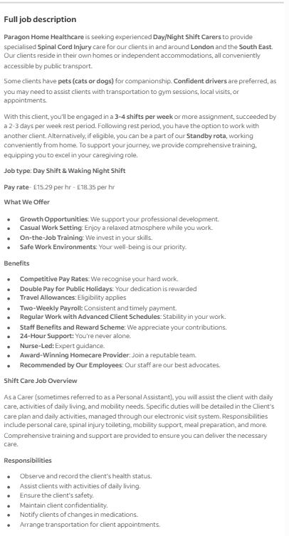
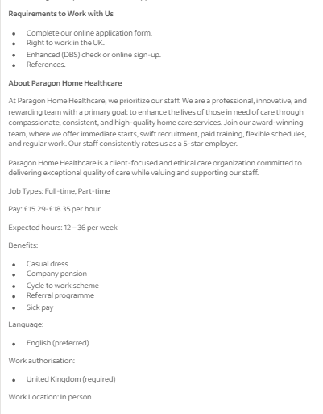
Figures: Job Advertisement of Care Assistant
(Source: Indeed, 2025)

Reference
Indeed, (2025). Care Assistant. Available at: https://uk.indeed.com/jobs?q=care+worker&l=London%2C+Greater+London&from=searchOnDesktopSerp%2Cwhereautocomplete&cf-turnstile-response=0.1bGcCiFFN_-3vS3Klug1KpvBO_cX4Ysjewe5b60fRlBhmbTlwvFaYqsRRwqbiTZSPXhNZUAizp80b3PsJyk93LpOq6GpMg4y-casFwga7YGRllWnavuFHoix7hi_D4lmz0KkBq-Tcbv-UKZ5NcM1UugIn7TWf-hbG6iiI7lGcKiN1JTfg1znJ2v7IUzkXubQ87KjKJa0qnIWfB9dsQkUsQlIvosETvuKINgaJbeUXUVEbgs8R_GPwy4IK5Y8oT-HKY6ajWLkDvDEq3ksMtvX_V_xauy4v9qF19lDlzBiGvgl_-XaQFEOzidCsDX5yz5g4u2dNauuBuGtDZpF-0jP4jm_KYjv4iPm82JOTTP-afCILawhsVW-zFq6rzh54Cn3oBftqJr7SqEoXyPek9bbGfne2qu4FwM6U8s6L_YF4OtbGlRaSARpqvw6kBCSQSoWr-coVA-E1Fh4HrzmhkdwL2QgjUeV-Jn_Z6ux0qJYq9TEOFmnftVV8gA9cqMczofC368ngK_kIeW9RwCHPpPfJaU88OvUYgaB25wdi5PckHhzCGz64TlESbEhFILFPSnqoMmaW6NiTa7Bdp_WVsprNIwunwvmovJ2g16CmLY4GbOOHg0rVcR6yPfHgSeb3EVkpzkLd8b3RH1Vi0XO_YIkij0bxL0EayyRZ3MfyLecQfPxCKGx5XHxwCP4uiGbhPMOYYsEs1cFhn6oLKYBlIhJ4eSwtwIr2_qKifaQl669ZW7mhqY-blSMMn6zv1rXiIbd0nM6yXjr9FRQnQdmcSD31BJHvr39qFmg98lz0T7NfoNn8DKIemlubVE5iVXgltwGP8gK2qGZHZZqbEv_Y2b5r_YWwgQugcgoUl-dU92keuMq5BnpJjUmWaQPWysgLJzRnur6oxjVe08hcjukmSfTVxfWCpO2LE2_W1-mUEr2uSw.EfFYFMM0RJyE_Ra9WKwTYQ.917b25bba60e0b4adc48960169226eae59077da3c816f9a55394033d5468a4f6&vjk=ecc38ab7f52f7ab0 (Accessed: 25 October 2025)

