Accounting assignment

Student Name: LOREDANA MOROSAN
Student Number: 2414597
Module: Finance for Business
Module Code: BMBM4003D
Lecturer: Manjit Biant

Sales day book
Date 2026 | Details | Invoice number | Total  £ | VAT  £ | Net  £ | Sales type 1 £ | Sales type 2 £
30 Jul | Silver Gifts | 1250 | 900 | 150 | 750 | 400 | 350
30 Jul | Special Crafts | 1251 | 1464 | 244 | 1220 | 0 | 1,220
30 Jul | Pan Trading | 1252 | 3168 | 528 | 2,640 | 2,640 | 0
30 Jul | Harlam Lights | 1253 | 2,304 | 384 | 1920 | 820 | 1,100
 | Totals |  | 7836 | 1306 | 6530 | 3860 | 2670

Sales returns day book
Date 20-4 | Details | Credit note number | Total  £ | VAT  £ | Net  £ | Sales type 1 £ | Sales type 2 £
30 Jun | Metal Supplies | 251 | 78 | 13 | 65 | 0 | 65
30 Jun | Pearls | 252 | 162 | 27 | 135 | 135 | 0
 | Totals |  | 240 | 40 | 200 | 135 | 65

Task 1 (B)

Has the correct purchase price of the paper been charged? Yes or No? | YES
Has the correct discount been applied? Yes or No? | YES
What would be the VAT amount charged if the invoice was correct? | 160
What would be the total amount charged if the invoice was correct? | 960

Task 2
Profit and loss account for the year to 31st July 2026 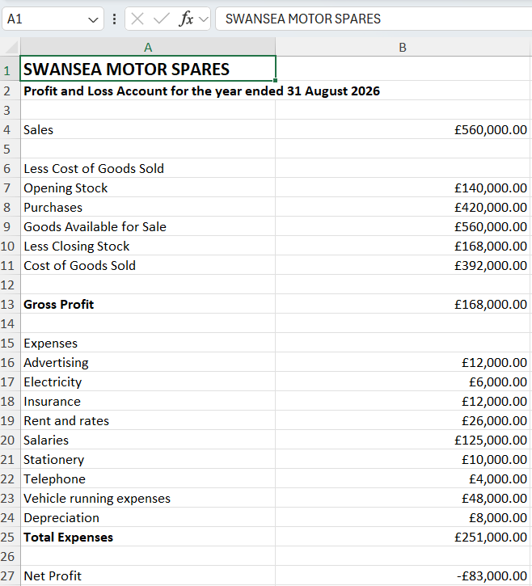

Balance sheet as at 31st August
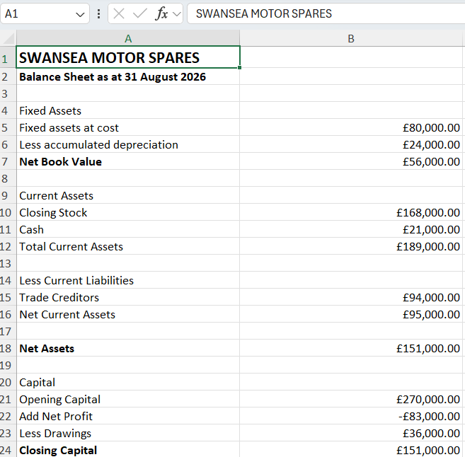

- The business is currently registered for VAT. A new member of staff has been employed to supervise the accounts department and has asked the following questions to which the owner has asked you for some advice:

  - Whether it is possible to, when to, and how to deregister for VAT

A business can apply to cancel its VAT registration if it no longer meets the requirements to remain registered, such as when its taxable turnover is expected to stay below HMRC's deregistration threshold or if it permanently ceases trading. The application can be made through the business's online HMRC VAT account or by completing the appropriate deregistration process. Once deregistered, the business must stop charging VAT on its sales and will generally no longer be able to recover VAT on most business purchases. While this may reduce administrative responsibilities and could enable more competitive pricing for customers who are not VAT registered, the loss of input VAT recovery should be carefully considered before making the decision.

  - The rate of VAT that needs to be charged on each of the products that the business sells

The majority of goods sold by Swansea Motor Spares, including motor vehicle spare parts, tyres, batteries, lubricants and accessories, are subject to the standard UK VAT rate of 20%. It is the responsibility of the business to apply the correct VAT rate to each sale and ensure that all invoices and accounting records accurately reflect the VAT charged. Where a product qualifies for a reduced rate, zero rating or exemption under HMRC rules, the appropriate VAT treatment should be applied.

  - Are there any alternatives to the system of quarterly VAT returns that the business currently uses

HMRC offers several alternatives to the standard quarterly VAT return system. Businesses can choose to submit monthly VAT returns, which may be beneficial if they regularly reclaim more VAT than they pay, improving cash flow through faster repayments. Eligible businesses may also use the Annual Accounting Scheme, which requires only one VAT return each year while making advance payments throughout the year, reducing administrative work. Another option is the Cash Accounting Scheme, which allows VAT to be accounted for only when customers have paid their invoices, rather than when invoices are issued. This can improve cash flow by preventing the business from paying VAT before receiving payment from customers.

- Explain to the owner how the annual depreciation amount would be calculated using 15 years life and what difference this change would make to the profit of the business over the past three years.

The business currently calculates depreciation using the straight-line method over a useful life of 10 years. Under this method, the cost of the asset is spread evenly over its expected useful life.
The annual depreciation is calculated as:
Annual Depreciation = Cost of Asset ÷ Useful Life
Using a 10-year useful life:
£80,000 ÷ 10 = £8,000 per year
If the useful life were increased to 15 years, the annual depreciation charge would be:
£80,000 ÷ 15 = £5,333.33 per year
This would reduce the annual depreciation expense by approximately £2,666.67 (£8,000 − £5,333.33). As depreciation is recorded as a business expense, reducing this expense would increase the annual profit by the same amount. Over the previous three years, the total reported profit would therefore have been approximately £8,000 higher (3 × £2,666.67)
Using a longer useful life also results in a higher net book value for the fixed assets on the balance sheet because they are written down more slowly. However, the depreciation policy should always reflect the assets' expected economic useful life to ensure that the financial statements present a true and fair view of the business's financial position and performance.

- In order to be able to hold more stock, the owner of the business has decided to refit his warehouse at a cost of £200,000. The owner of the business plans to raise the selling price of all of the spare parts by 10% in order to improve profitability. Explain the economic arguments for and against this strategy, paying particular attention to the possible effects of the decision on the level of sales that would be achieved.

Refitting the warehouse at a cost of £200,000 would increase the business's storage capacity, enabling Swansea Motor Spares to hold a wider range and greater quantity of stock. This could reduce the risk of stock shortages, improve customer satisfaction by ensuring products are readily available, and allow the business to purchase inventory in larger quantities, potentially benefiting from bulk purchase discounts. In the long term, these factors could contribute to higher sales and improved profitability. However, the warehouse refit represents a significant capital investment and may reduce cash reserves or require external finance, resulting in additional interest costs and financial risk.
Increasing the selling price of all spare parts by 10% would increase the revenue earned from each sale and could improve profit margins if sales volumes remain unchanged. However, the success of this strategy depends on how customers respond to the higher prices. If demand for the products is price inelastic, customers are likely to continue purchasing similar quantities, leading to higher revenue and profits. Conversely, if demand is price elastic, some customers may reduce their purchases or switch to competitors offering lower prices, causing sales volumes, revenue and profitability to decline. Before implementing the price increase, the business should therefore consider customer demand, competitor pricing and overall market conditions.

- Clearly explain how the pricing strategy in (5) would affect the profitability of the business, assuming that the level of sales and the current business policies remained unchanged.
The business currently generates annual sales revenue of £560,000. If the selling price of all products increases by 10% and the level of sales remains unchanged, forecast sales revenue would increase to:
£560,000 × 1.10 = £616,000
This represents an increase in revenue of:
£616,000 − £560,000 = £56,000
Assuming that the volume of sales, cost of sales and all operating expenses remain unchanged, this additional £56,000 would increase the gross profit and, ultimately, the net profit by the same amount. As a result, the business would become more profitable, with improved profit margins and a higher return on sales. However, this forecast depends on customers continuing to purchase the same quantity of products after the price increase. If higher prices cause demand to fall, the actual increase in profitability may be lower than forecast.
- Illustrate your answer to (6) by producing a forecast profit and loss account in the correct format for the year to 31st August 2028.



