University of Wales Trinity Saint David
London Campus

Entrepreneurship:

Assessment 2: Business Plan

Lector: John Paul Okeke

Galina Gancheva 2022711

Date: 02/09/2022 word count:

Contents:

Introduction …………………………………………………………… page 3
Business Plan…………………………………………………………. page 3
Business Description…………………………………………………. page 3
Industry Analysis………………………………………………………. page 4
Operations and Management Team Plan…………………. ………. page 5
Marketing Plan………………………………………………............... page 6
Financial Plan…………………………………………………. ……… page 7
Market Research………………………………………………………. page 9
Conclusions……………………………………………………………... page 10
Reference List…………………………………………………………. page 11
Appendices……………………………………………………. ………. page 13

Introduction
In this assessment, I will use what I know about entrepreneurship to come up with new products and services that use some kind of technology. It makes a strong business model that includes important parts like a management plan, an operational plan, and a marketing plan. It will use macroeconomic and microeconomic tools like Porter's Five Forces to figure out how attractive an industry is. It will take a critical look at the different ways entrepreneurs can get money.
Based on what I've learned in the entrepreneurship module, I'm ready to take on the challenge of starting my own business. My thought is about style, history, and culture. Some new information about my country. In Bulgaria, traditional clothing is a costume that people wear to festivals, special events, and folk-dance clubs. It is beautiful, different, and has a direct link to traditions. I will talk about what I learned from my first market research and why it led me to choose this solution. I'll explain how the business skills and knowledge I've gained will make sure that my idea will help people solve their problems and meet their needs.
Entrepreneurship is appealing because it gives you the chance to make things that make other people's lives better. To figure out if a business idea is good, it's important to start with the entrepreneurial process, which includes finding opportunities, doing a feasibility analysis, and coming up with a good business model. (Barringer,B., 2019)

BUSINESS PLAN

BUSINESS DESCRIPTION / MARKET OPPORTUNITY

Bulgaria has many different and interesting traditions and customs. My idea includes my interest in fashion, in the different and the way to show how many interesting embroideries there are on traditional costumes in Bulgarian folk folklore. My idea is not related only to making similar type of costumes, but to use beautiful elements from them. These items can be made with the help of a sewing machine on any type of clothing. This can be done in a small workshop that will start with a few sewing machines. In the future, if there is interest, it can be developed. Customers can buy ready-made products from us, entirely our own production, or order them to be made on their own clothing.

According to ethnographers, its origin is mainly Balkans, and traces of the clothing of the peoples with whom the Bulgarians were in contact - Turks, Greeks, Albanians and Vlachs - can also be found. By its nature, the costume is the everyday workwear, which, through artistic decoration, acquires a festive look. It is distinguished by its exceptional practicality for work, traditional rites and celebrations.

In general, there are few competitors who usually use T-shirts that have such elements sewn or appliquéd on them. My idea is to be on blouses, t-shirts, jeans or pants. Why not on pyjamas or underwear. The challenges I will face are the competition and the fact that, in general, only we Bulgarians are familiar with the traditions that date back to the past centuries. In the beginning, it will be something new and unfamiliar for different nationalities. If this idea is implemented successfully, we can develop it as art. Painting on glass, cups, bottles or dishes.

Overall, I think this idea would be successful and attractive to most of us. It will be implemented successfully because it is different and non-standard, and in most cases the different is sought. Everyone wants to show their individuality through something unusual.
What I see as a potential obstacle or delay is the COVID pandemic and a possible lockdown that will affect revenue and expenses overall.

INDUSTRY ANALYSIS

They will be produced using sewing machines. These motifs will also be sewn but will look like a print. In the beginning, we will work with a small number of sewing machines, in a small room. Maximum 5. The finished product will be sold in a small shop where there will be models as a sample, but they will also be able to order by catalogue.

The idea I have generally exists, but not on such a large scale. In general, there are few competing companies that print or embroider on t-shirts purchased from them. What I offer is different. We offer self-made clothes that have embroidery on them. We also accept orders from customers who can bring their own patterns and select their print from a catalogue.

There is potential for growth with an increase in demand, as new sewing machines are purchased and the premises, we envisage for a shop will also be of greater capacity. In the future, with a high growth rate and sales, we will expand our business. We will offer painting motifs from Bulgarian folklore on cups, bottles and dishes.

In the beginning, it will be new, different and unfamiliar to customers. Bargaining power of customers - the initial interest is not expected to be that great. Gradually, when customers become convinced of the quality of the production, we expect an increase in sales.

Then more and more customers will learn about us and prefer our product to that of competitors. We are expecting sales for customers from various dance groups that are related to Bulgarian folk dances. Potential customers are also customers who go to various dance events, as well as those related to Bulgarian folklore.

Porter said that understanding the five forces that drive competition in an industry is part of figuring out what strategy to use. C. Barrow (2021) These are Porter's 5 forces:
1.Competition in the industry
2.Potential of new entrants into the industry
3.Power of suppliers
4.Power of customers
5.Threat of substitute products

- Potential competitors are other small companies that buy t-shirts, make a print or embroidery and sell finished products.
- There is always an opportunity for new entrants to enter the industry. However, our advantage is that we will have established ourselves in the market.
- Mostly companies that deal with online sales use the services of suppliers. It is convenient, the goods reach the customer directly. At the moment, there are no such plans, because a large part of the products offered in the catalog will not be available to the customer. Services such as embroidering their own clothes cannot be done online.
- Potential customers are both people from Bulgaria familiar with our traditions, and people who simply like the different and non-standard. They can be people from dance groups, as well as people who like Bulgarian folk motifs. At first, customers will be skeptical. This is something new and different for them. Subsequently, they will like the look and quality of our products and will recommend them to their friends. There is an expected growth in potential customers.
- There is a potential threat of substitute products, but it is minimal. The focus is mainly on t-shirts, which in most cases are just a print, without embroidery. In most cases, they are cheaper, but of lower quality.
This industry is attractive because it is different and interesting in itself. Something beautiful is being created. Especially for customers who are looking for something different and interesting.
In line with Rickman,C.(2011) Small businesses should have plans for how to stay open during the COVID-19 shock. The survey data includes information about the type of business, how well it is doing financially, how it is dealing with the crisis right now, and what the owners think will happen to their business in the future.

Competitive Rivalry: who are your main competitors and how can you differentiate yourself from them

Name of competitor | Differentiation
Competitor 1  Meli - M | t-shirts are only with print, have no embroidery, price, quality
Competitor 2  Moda Bulgaria | t-shirts are only with print, have no embroidery, price, quality
Competitor 3  Trifon Print EOOD | t-shirts are only with print, have no embroidery, price, quality.

OPERATIONS AND MANAGEMENT TEAM
OPERATIONS

The first steps of the business I am developing are to obtain a permit, hire an accountant and prepare all accompanying documents. To find and rent suitable premises for the production and sale of goods. The next step is to purchase the necessary equipment. Then hire and train suitable staff. All incidental expenses for bills, equipment, opening, bookkeeping and staff salaries must be paid.

The company started with a relatively low budget, and with costs associated with fewer staff. The rented premises have a relatively small area. Our business is expected to grow at a relatively low growth rate each year. The scale of production and sales areas and equipment will gradually increase.
Initially there will be only one manager, but later when the business grows a team leader will be hired. They will be able to replace many of their team members. Five tailors will be hired for the five sewing machines, 1 model maker, one mechanic and two shop assistants.
Regarding personnel, applications from people with experience for the positions we are hiring for will be considered first. We consider the selection to focus on quality and qualified labour. Accordingly, in return we offer good pay and a bonus scheme for good results.

With the increase in sales and the need for additional equipment, and the need to search for larger premises, the number of working personnel will also increase. Regarding the production, there will be a wide range of goods, according to the demand. For starters, pants, long-sleeved tops, t-shirts, and pyjamas (nightgowns). With good production results, we will increase the product range with something different. Painting on glass and dishes of folk motifs. They can also be offered by us, or with customer materials. The difference is that we will rebuy the dishes and glassware and colour them with patterns related to folk costumes.

MANAGEMENT TEAM

Name | Skills | What do they bring to the firm
Manager | creative, time management, hardworking, computer skills, work with documents | Management and organisation to whole working process.
Accountant | Accuracy, honesty, time management, computers skills, work with documents | manages the company's accounting.
Shop assistant | working with money, cash and cards, working with a cash register and computer | Consult, sell
Modeler and Tailors | ability to sew, accuracy, honesty, time management | Create and make different models with sewing machine.
You may add more names if you wish

MARKETING:

Our product will be sold through direct sales in our store. We are betting on a physical store located on a shopping street where many people pass by every day. Advertising is also a key element in selling goods. An important element is the good layout of the store, as the most attractive models are the first we see, placed in an attractive and eye-catching way. Dressing mannequins is a good way to present the merchandise.

Good advertising can also be key to attracting customers. Advertising that we can do is through photos and descriptions on social networks and websites. Making flyers is also a good advertising trick. This way it reaches as many users as possible. What better advertisement than satisfied customers. On a site where the product range will be displayed, there will be a place for comments about our products. Periodically there will be a promotion of various of our products, product, price, place and promotion.

Product: The product we offer is generally unique. Different, attractive, designed for people who are looking for something different from the everyday offers of standard goods.
Price: The price varies according to the quality and complexity of the model. When customers bring their own designs, the price also varies according to the complexity of the design they wish to be embroidered.
Place:
The store must be located in a place where people pass by every day. On a shopping street, maybe in a shopping centre. The warehouse should also be close to the store.
Promotion:
The promotions we can offer are tied to sales. One option is when buying a product above a certain amount, and the other is for a product that is not so popular and therefore needs promotion.

FINANCIALS

The start-up costs of the company are related to renting two types of premises: A small warehouse where our products will be produced and a small shop where they will be sold. Hiring an accountant. Costs of initial establishment of the company and its promotion through advertising.
The company's expenses will be covered partly by own funds and partly by a bank loan. This money will be used to cover the initial and ongoing costs until we start having sales proceeds which will then cover the ongoing costs as well as the loan payments.
Month | Price (£)
January | 27 600
February | 28 000
Marth | 30 000
April | 30 500
May | 35 500
June | 40 000
Total | 191 600

The way I will achieve this is by promoting the products. The most effective way is through advertising on the Internet and social networks. Handing out flyers. Promotions of different types of products and the service we offer. Our catalog will be visible and accessible to all our customers. Our consultants will help in choosing the most suitable clothes and embroidery for each of our customer.

Sources of funds
Income:
expected sales per week:
week | Price (£)
Monday | 800
Tuesday | 950
Wednesday | 900
Thursday | 650
Friday | 750
Saturday | 2 000
Sunday | 850
Sum | 6 900

expected sales per month for 1 year:
Month | Price (£)
January | 27 600
February | 28 000
Marth | 30 000
April | 30 500
May | 35 500
June | 40 000
July | 55 000
August | 54 000
September | 45 000
October | 40 500
November | 35 000
December | 50 000
Sum | 471 100

expected sales per year:
Year | Price (£)
2023 | 471 100
2024 | 475 000
2025 | 550 000
2026 | 600 000
2027 | 700 000
Sum | 2 796 100

Expences:
Shop for rent: £ 3 000
small warehouse for rent: £90 000
Sewing machine £10 000
sewing accessories and equipment: £10 000
Shopfitting supplies £ 10 000
Other £10 000 include electricity, water bill and other utility bills
Salary for personnel: £5 000 per week

Market Research
After doing some preliminary research on the market, we found that our idea is already being used in part, but not on such a large scale. This means finding the information you need to prove the need for what you're proposing and choose the best way to start up or grow. There are companies that buy used t-shirts and put folk motifs on them with embroidery or prints. At the moment, you can buy these kinds of T-shirts online and in markets or small booths at events. At the moment, none of them have gone through the whole process of making, selling, and letting people choose from a catalogue. This is something new and different that we can also do on clothes that our customers bring to us. We've never had this kind of service before. The customer picks the best offer for him from the list.
It's new and different, and I think a lot of people who want something new and different will find it useful and interesting. We make clothes that can be worn to parties, events, or just for everyday life. They are also a good choice for many dance groups that travel the world to show off Bulgarian folk dances.

According to Barrow, C. (2021) Business planning is the first step in starting a new business, growing an existing one, getting funding for a project, getting a grant, or even entering a competition. It is at the heart of organisational and business strategy. A common misconception is that starting and running a business is very risky. However, this is not true. Even though the chance of failure isn't very high, the results can be very bad. You really can lose your shirt! The best way to deal with this risk is to plan, which is the best business habit. The military, which did very well during the recent pandemic, has made it a core rule to never do anything without first making a plan.

According to Cooper, Cary L(2021) From a psychological point of view, what COVID-19 did to many people was make them feel uncertain and like they didn't have any control over the situation. Because of this uncertainty, a business may or may not do well. Many companies focus on what they already know and are sure about because they don't know if the pandemic will affect them or not. They are afraid to try something different and new.

According to Williams, Sara (2019) We can help you make progress in your work and life if you want to improve yourself or move up in your career, become a better leader or better communicator, find new opportunities, or just find more inspiration. Here, Sara talks about how important communication is to getting things done well. When we hire people or try to make a deal or get customers, it's very important to be able to talk to them well. This helps even when things are going badly.

Conclusions:
Every new business has its own problems and problems to solve. Most of us don't know how to start a new business and find it hard to do. It's hard to show what we can do, and it's hard to beat the competition. It's hard to show that we're the kind of people who can do well. When a product is new or different, it takes more time and patience to bring it to market and get people to like it. Differences are what make the whole idea, way of thinking, and search different. Change is hard to deal with, but it helps us get better. There are many challenges and problems, such as the COVID 19 pandemic, dealing with competition, and possible roadblocks.
The new and different is not always perceived with the result we desire. Sometimes it takes time to enter the market and be a preferred product over that of competitors. We rise to the challenge of showing that the new and different can actually create something beautiful. Challenges like the pandemic can make us more flexible to change, but they give us motivation to succeed. I think that we will slowly achieve it and even surpass ourselves.

Reference list:
Barringer, B., Ireland, D., (2019) Entrepreneurship: Successfully Launching New Ventures. Sixth edition; Global edition. Harlow, England: Pearson.
Bplans (2020) Sample Business Plans. Assessed on 21st November 2020. Available at: https://www.bplans.com/downloads/business-plan-template/
Barrow, C., Barrow, P., Brown, R., (2021) The Business Plan Workbook A step-by-step guide to creating and developing a successful business, Tenth edition. Kogan page

Cooper, Gary L., (2021) Psychological Insights for Understanding COVID-19 and Work. Oxon, Routledge https: //www.routledge.com/Psychological-Insights-for-Understanding-COVID-19/book-series/COVID
Williams, Sara (2019/2020) The financial times Guide to Business Start Up Thirty first edition, Harlow, United Kingdom Pearson Education Limited
Granqvist Nina, Grodal Stine, Lounsbury Michael, Cornelissen Joep (2021) Culture, Innovation and Entrepreneurship; First Published; New York ; Taylor & Francis
Lee – Ross, Darren, Lashley, Conrad (2010) Entrepreneurship and Small Business Management in the Hospitality Industry; first edition
David C. Kimball and Robert N. Lussier (2020) Entrepreneurship Skills for New Ventures; Fourth edition; New York and London
Articles:
- Maria I., Marshall a, Corine B., Valdivia B (2021) Bend of break Katare: International Journal of Disaster Risk Reduction, Department of Agricultural Economics, Purdue University, West Lafayette, IN, USA Department of Agricultural Economics, University of Missouri, Columbia, MO, USA International Journal of Disaster Risk Reduction 61

- Luca A. Pazone a, Shaun Larcom b, Po-Wen She b,c ( 2021) Estimating the impact of the first COVID-19 lockdown Pazone, a School of Natural and Environmental Science, Newcastle University, UK www.elsevier.com/locate/gfs Department of Land Economy, University of Cambridge, UK, Department of Finance, National Sun Yat-Sen University, Taiwan

- Franziska Leutner a, Gorkan Ahmetoglu b, Reece Akhtar a, Tomas Chamorro-Premuzic (2014) Contents lists available at ScienceDirect, Personality and Individual Differences, Department of Psychology, UCL, 26 Bedford Way, London WC1H 0AP, UK, Institute of Management Studies, Goldsmiths, University of London, UK New Cross, London, SE14 6NW, UKwww.elsevier.com/locate/paid

- journal homepage: www.elsevier.com/locate/jbusres Gina Santosa, Carla Susana Marquesb, João J.M. Ferreirac (2020) Persevarance and Passion; Passion and perseverance as two new dimensions of an Individual Entrepreneurial Orientation scale; a CETRAD Research Center, University of Trás-os-Montes e Alto Douro, Quinta de Prados, 5000-801 Vila Real, Portugal

- journal homepage: http://www.elsevier.com/locate/ssmp Marcus R. Keogh-Brown a, Henning Tarp Jensen a,b, W. John Edmunds c, Richard D. Smith d (2020) The impact of Covid-19, associated behaviours and policies on the UK, Economy: A computable general equilibrium model; Contents lists available at ScienceDirect
SSM - Population Health
a Faculty of Public Health and Policy, London School of Hygiene and Tropical Medicine, 15-17 Tavistock Place, London, WC1H 9SH, UK
b Department of Food and Resource Economics, Faculty of Science, University of Copenhagen, Rolighedsvej 25, DK-1958, Frederiksberg C, Denmark
c Faculty of Epidemiology and Population Health, London School of Hygiene and Tropical Medicine, Keppel Street, London, WC1E 7HT, UK
d College of Medicine and Health, University of Exeter, Medical School Building, St Luke’s Campus, Magdalen Road, Exeter, EX1 2LU, UK
SSM - Population Health 12 (2020) 100651
Marcus R. Keogh-Brown a, Henning Tarp Jensen a,b, W. John Edmunds c, Richard D. Smith

Appendices:
A map of Bulgarian folk costumes from 1942, composed by Hristo Vakarelski and painted by G. Petkov. On it, distributed on the territory of the country by regions, are shown the Bulgarian costumes in their huge variety.🇧🇬
Fig.1
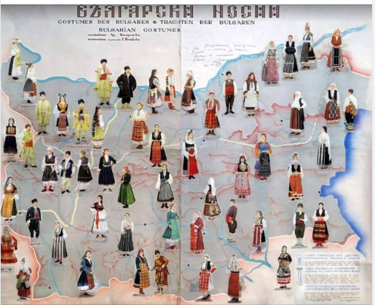
Fig.2
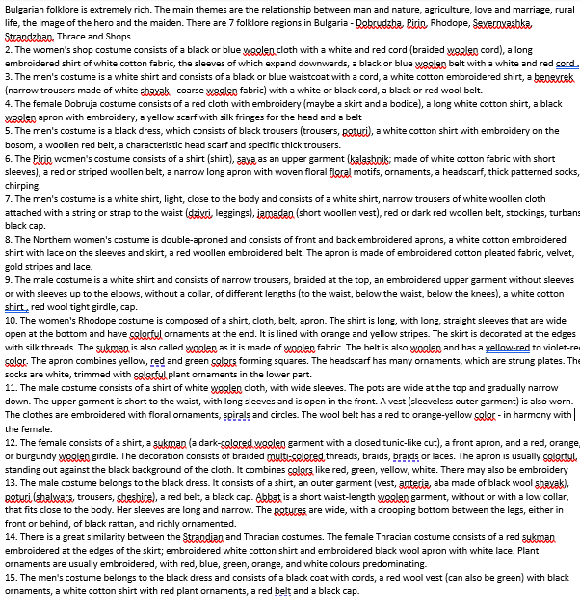
Page11: fig.2.2
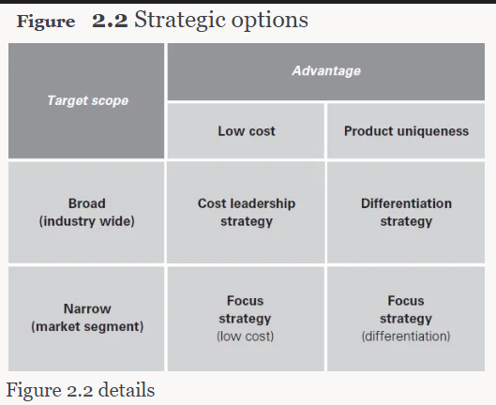
Page
figure 3.1

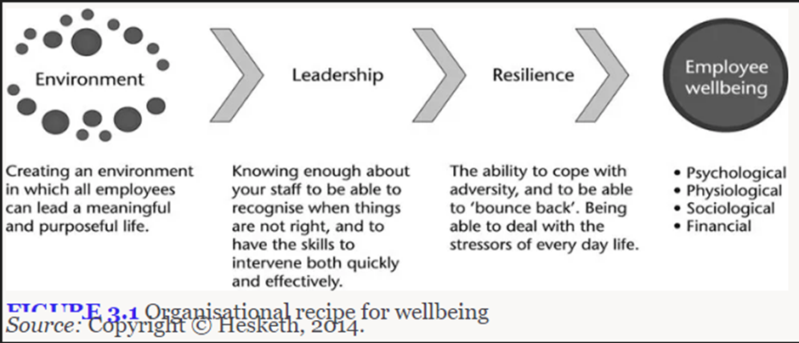

Page 10 fig.3.3
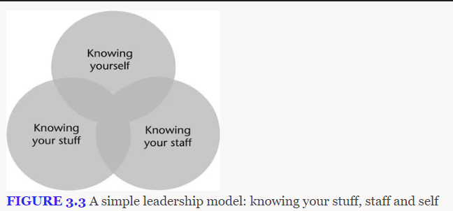

Page 10


