02/03/2020

Group Project
Assignment B
M5X00400
Reflective Writing



Lloyd Davies
BEng Mechanical and Manufacturing Engineering
1909561

Table of Contents
Introduction 2
Purpose 3
Scope Statement 3
Project Priority Matrix 4
Work break down structure 4
Allocation of roles 5
My role 5
Teamwork 6
Fishbone 6
Communication 6
Conflict 7
Motivation 7
Milestones 7
Gantt Chart 8
Project life cycle (PLC) 8
Definition/initiation 8
Planning 8
Execution 9
Closure 9
Conclusion 10
References 11
Appendices 12
Appendix 1 12
Appendix 2 12
Appendix 3 13
Appendix 4 13
Appendix 5 14
Appendix 6 0

Introduction
Crown Food Holdings Inc. is one of the world leaders in metal packaging technology. At the Neath factory, the main area of manufacturing is the 'End' of the metal can. This product is then delivered to customers around the world to be connected to the can body. With foods sealed internally, this produces the single most effective packaging solution that has ever been invented 'The Metal Can'.
Example of products
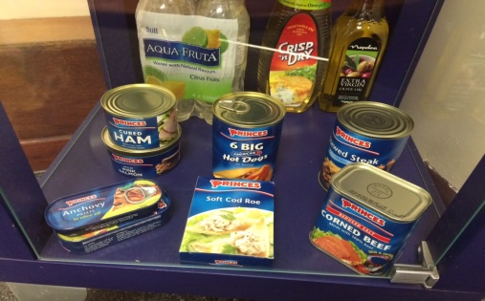
The business we are in there will always be a certain amount of daily spoilage (spoilage is waste of the metal material, what is thrown out because of defects or damage). The budget for this as a plant is 4%. As a section (department), we are currently running at 5.2%, which is out of control. The issue of running out of control has gradually increased since 2018, and it is affecting profits for the company, engineer workload, contractor workload and morale of the whole department.
This project will review, how we formed a project team, the planning process and what tools used to gain the solution.

Purpose
To reduce and eliminate defects to bring spoilage levels back within the target, to be completed within one month, to include direct and indirect employees, and to report back findings weekly by producing an article or newsletter. Setting SMART goals means you can clarify your ideas, focus your efforts, use your time and resources productively, and increase your chances of achieving. (Mindtools, 2020)
To resolve the current spoilage situation, we formed a mini manufacturing improvement team from across all shifts. The team varied from Senior Management to Production Operator, and it even included non-skilled individuals.

Scope Statement
(Khan, 2006)
Project Objectives | To reduce spoilage within the end manufacturing department to below 4% within 6weeks.
Deliverables | - Reduce spoilage to 4% or below.  - Cost-saving of 100k for each 1% we are aiming for 120k of saving by delivering 4%  - Less downtime caused by defects which increases spoilage.  - Job satisfaction, spoilage being reduced will result in less downtime and pressure on the production worker.
Milestones | Items | Date
Milestones | - MIT team formed  - Brainstorming exercise  - Data gathering  - Review of results  - Plan for work to be implemented  - Update the factory of the findings and the plan  - Speak to stakeholders  - Implement the improvement work to reduce spoilage  - Review and discuss | 8-05-2019  10-05-2019  16-05-2019  24-05-2019  31-05-2019  20-05-2019  3-06-2019  04-06-2019  05-06-2019
Technical requirements | All work should be carried out safely; PUWER regulations should be followed when entering the production floor, risk assessments and permits need to be filled in before rectification work starts.  Any rectification work to machinery needs to follow the service book and setting procedure.  Any improvement work which requires new operating procedures needs to be updated and cascaded to all stakeholders.
Limit & Exclusions | Engineers may be resilient to change and new procedures.  Working hours, this project is run over a 24/7 period which could result in inadequate or no information being handed over.  Reducing cost is our primary objective, so the project is limited to how much it can spend to get results.  Conflict with stakeholders, especially management, the project may affect KPIs for the said manager at the beginning.  All staff must be on board, or any improvements will fail.
Customer review | Crown Packaging UK

Project Priority Matrix
The purpose of developing a Project Priority Matrix is based on numerous aspects like strategic direction, values, organisational goals, available resources, etc. Once the project is prioritised, these priorities can be reviewed, and results can be evaluated to determine funding and resource allocation.
This project's purpose is to reduce costs in this case spoilage is the cost and every 1% costs 100k, making machinery more efficient will enhance the performance of the department and reduce costs, time is a constraint to 6 weeks. (Pinto, 1988) (Ebsedu, 2020)

 | Time | Performance | Cost
Constraint
Enhance
Accept

Work break down structure
Activities and responsibilities should be planned and arranged to ensure completion of the project on time. The project tasks get divided into manageable components, and they are Initiation, Planning, Execution and Closeout, the Project Lead is overseeing this. (D'arrigo, 1998) (Khan, 2006)
Project
A.
Initiation
B.
Planning
C.
Execution and control
D.
closeout
B1.
Develop WBS
B2.
Plan schedule
B3.
Plan resource
A.1
Assign project manager
A.2
Develop A3 project tracker
C1.
Manage rectification team
C2.
Manage resource
C3.
Complete H&S documentation required
D1.
Update SOP
D2.
Transfer project
B4.
Plan budget
Set budget for project
B5.
Plan MOC
C4.
Manage changes
C5.
Track and manage tasks
D3.
Document closeout

Allocation of roles
Activities and responsibilities were defined within our work break down structure (WBS), the team is made of 4 members, we must signify each person and their role, this will be depending on experience, ability, willingness, and capabilities. There may be some cross over in these roles as the team is so small, it's crucial to weigh the scope, project priority matrix, and WBS into the allocation of Roles. According to (Turner, 2009) if a project has a less specific or vague objectives, this could affect the measurability and timeframe of the project.
The table below shows the roles and responsibilities assigned to each member.

Team | Roles
Production Manager  Colleague A | Chair, Project manager, timing Plan, problem-solving techniques, assign tasks, A3 tracker, set the budget
Fork Lift truck driver  Colleague B | First-person experience with defects and spoilage, assist with data gathering
Production Engineer  Colleague C | Hands-on, solutions, data gathering, assist with weekly newsletter, manage resource, manage change
Tooling Engineer  Me | Maintenance document, asses' capabilities, solution techniques, timing plan, computer literate, newsletter, SOP writing, transfer project

My role
My primary role was to asses capability of the process, ensure that the current procedures were up to date, and Employees were following the standard operating procedure, incorrect setting of machinery may contribute to spoilage. Another responsibility of mine was solution techniques, fishbone diagrams, brainstorming exercises, weighted chart tools which I have had experience with in the past, and lastly timing plan and newsletter. I employ excellent timekeeping standards, but on review my newsletter capabilities are ordinary, the reason for me inheriting this task was due to the age of the team and other colleagues not being confident using Microsoft Office.

Belbin describes a team role as "a tendency to behave, contribute and interrelate with others in a particular way." There are three action-oriented roles - Shaper, Implementer and Completer Finisher; 3 people-oriented roles - Co-ordinator, Team worker and Resource Investigator and three cerebral roles - Plant, Monitor Evaluator, and Specialist. The nine-team roles are summarised in the table below. (Moultrie, 2020)

By using (Belbin, 2010) theory, it would seem this project would require colleagues with the following natural tendencies, team worker, implementer, plant, co-ordinator, Appendix 1. By comparing these with my self-assessment below, it would seem I possess good Teamworking, plant, specialist, resource investigating skills, but My co-ordinator results are low.
Belbin suggests, I could be apprehensive, poor at chairing meetings and unable to set goals. Being apprehensive or unconfident is linked to a strong team worker's, weakness which is to be indecisive. I also scored poorly in Completer Finisher and agreed delegation is not my strong point and regularly take on more responsibilities to avoid it.

 | Tooling Engineer  Me | Void | Surplus
Team worker | 2
Implementer | 5
Plant | 1
Shaper | 6
Co-ordinator | 8
resource investigator | 3
Monitor evaluator | 7
Specialist | 4
Completer finisher | 9
Weight 1 -9, 1 = Posses capability.

Teamwork
Tuckman's model describes the stages that a team or group goes through to become more productive, shown in Appendix-2, the second stage Storming according to (Chapman, 2020) People now begin to view themselves as part of a team. However, at this stage, they may challenge each other and the leader, this stage is prone to conflict, this can result in lower productivity as there may be a lack of focus on the task. Which was the case at brainstorming for our team they challenged each other for solutions which in my opinion is healthy? But it also led to arguments about previously failed projects and resulted in workers from different departments accusing each other of being responsible for its failure, thus resulted in reduce productivity, to focus the group we all decided during the brainstorming sessions to put all our information together and map it out on a fishbone diagram.

Fishbone
Fishbone diagrams' Ishikawa diagrams' are used across various industries to analyse cause and effect. It provides a systematic approach to analyse a problem when there are many possible causes. (Nishadha, 2020). We used a fishbone diagram along with a data-gathering board seen in Appendix-3 and Appendix-4. As shown in the fishbone diagram, the team identified some root causes that require further investigation.

Communication
Communication consisted of face to face meetings, emails, and newsletters, using Skype or Microsoft teams might have been beneficial, some members of the team were working throughout shifts which resulted on delays between meetings and ideas. Group chats through Teams would have benefited the sharing of documentation and using trending tools to show step changes in production spoilage targets. (Turner, 2009)states that to be successful progress needs to be monitored, with progress meetings set with "controlled attendance, fixed criteria for reporting, and at fixed intervals".

Conflict
A conflict between team members could threaten project goals. During this project team members who work in different departments had a dispute, it was over a clash of ideas and a culture of excepting poor performance machinery, which had to change for us to reach our project scope goal. During this conflict the project lead reiterated the plan and that this project has been prioritised by Senior Management, he also used a collaborative technique incorporating multiple viewpoints and insights from differing perspectives, it resulted in the group being strengthened after the dispute was resolved. Considering the negativity by one individual and inability to change he still reserved time to listen to his concerns (Hacks, 2020)

Motivation
Herzberg's Motivation Theory model argues that there are two factors that an organisation can adjust to influence motivation in the workplace (Herzberg, 1971) which are motivators and hygiene factors. Hygiene wouldn't be addressed during this project, a typical way of improving hygiene would be to improve people's factors for satisfaction, and reducing the number of factors for dissatisfaction but improving dissatisfaction will not result in a satisfied workforce. For example, improving the spoilage efficiency, will not make the production worker satisfied it should make him less dissatisfied at his working conditions. To improve his satisfaction at the job would be to give him more purpose/meaning or recognition. Another example of reducing dissatisfaction would be your environment, 5s and lean is a reduction of waste to make your environment cleaner, uncluttered and safe. Our motivators were Engineers morale. Daily production targets with stress from Senior Management results in short cuts being made, and the tendency of putting up with faulty or malfunctioning equipment. The goal of the project is to save cost while considering my WBS should enhance the performance and downtime of the machine. (Ganta, 2014)

Milestones
Milestone are critical project management tools, when used effectively, can help a Project Manager control and monitor if the project is on schedule. Adjustments can be made if critical goals are not being hit (Bruce, 2000). Milestones are used to control the essential aspects of your project, our key dates within the project scope came from primary stakeholder, which was the company when addressing whether milestones should be included a Project Manager should consider these points.
- Is it deliverable?
- Will it impact the delivery date?
- Is it essential to the project?
- Does it need reviewing by stakeholders?
- Will this event impact the project?

Gantt Chart
A Gantt chart is commonly used in project management, and it is one of the most popular and useful ways of showing activities displayed against time (Gnatt.com, 2020). Based on the tasks set out in Appendix-5, we developed a Gantt chart seen in Appendix-6 the scheduling, control, and monitoring of the project could be better visualised, the assignee was included to prioritise which team member was leading. The Gantt chart in Appendix-6 could have been more accurate, as it only specifies days and not hours this caused some of our team members to leave vital work to organise individuals which had finished early. For this reason, I strongly feel a CPA would have been helpful at the planning stage. By using CPA work which was critical to the project would have been clear, and resources could help in other areas when free. (Smith, 2002) States that team members should have clear roles defined from the start to prevent confusion. PERT could have identified where parallel activities could have been carried out when tasks must be carried out, or the shortest time for the task, this is a more sceptical look on project planning but would have been helpful.

Project life cycle (PLC)
PLC is a sequence of phases of a project. The number of cycles is determined at the start by the stakeholders. The phases have a start and end, controlled and constrained by time or cost, my PLC for the reduction of waste and cost-saving followed a linear process. (Pinto, 1988) (Barron, 2020)
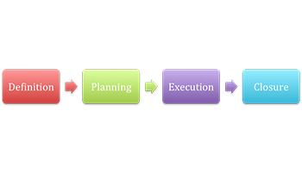

Definition/initiation
The initiation phase is there to set aims and define the project, management agrees to the desired outcome, the scope is then set and issued to our project team, at this stage these decisions were outlined and prioritised.

- The project purpose was to save cost by reducing spoilage.
- We measured the success of this project by the potential cost savings and set desired milestones dates to track that the project was on schedule.
- Our risk was production delays and cost. The current condition was the spoilage data which was a good starting point, and we used existing data to set out a rectification plan at brainstorming.
- We had numerous stakeholders, including Senior Management, Customers, and Production workers.

Planning
The planning phase lays down the strategy, and it should include ideas and concepts of the tasks to be carried out. Allocation of roles should be arranged after the activities are identified, tasks and timeframes will be defined within a detailed plan tracker with all responsibilities included. Costs should be identified for both cost-saving targets and expenditure, equipment needed to rectify the problems may need to be purchased or hired. It's necessary to have a detailed plan which includes targets and control measures, and stakeholders should pass this.

Execution
The project plan should be followed, the problem and the solution were included within the execution phase, the decisions and activities defined during the planning phase implementing, monitoring and controlling of each phase will be necessary. Some activities require team members to manage their tasks carefully to prevent bad information or activities being completed incorrectly.

Closure
Closure is used to complete all tasks it usually follows these processes.
- Hand over the solution and new procedures to production, including any new equipment needed and what guidelines should be followed to keep spoilage reduced.
- Notify stakeholders of completion, set up reflect and review stage.
- Project team to be disbanded and returned to regular duties
- Final newsletter to be produced and issue results to the factory
- Team to re-assemble, reflect and to monitor the outcome to establish if it's sustainable and if production workers have bought into it. This can also be used to examine each member performance and evaluate.

Conclusion
The project team was successful in reducing spoilage and reached its target of saving the company 120k by maintaining a 4% spoilage target per month but missed its delivery target of 6 weeks. On reflection, I was impressed with how clear the scope was, and how it specified precisely what was required from the team. Organising stages, including WBS, precedence table, Gantt chart, these are all project management techniques which were all interesting, and I feel they are transferable when organising my current projects. My role/fishbone/project life cycle takes a more personal look at the project, what my role was how the team worked and how a typical project moves through a linear system to completion. I witnessed a heated debate concerning alternative perspectives on how to lower the spoilage, and a challenging situation where a production worker questioned the maintenance of certain machinery, and the production worker was then challenged with his resilience to change, this was dealt with convincingly by the project lead. By watching these debates, it taught me how to approach resilient employees and how to deal with these situations in the future. I enjoyed how the project leader built a bond between the team by using interesting videos from YouTube of team working. He also empowered everyone with defined tasks and showed the areas of benefit. Everybody has different motivations but in my opinion environment and job satisfaction is key to success. Gnatt chart organising was not specific enough CPA and PERT could have been used effectively, this is something I will work at when organising my current projects. I can appreciate that not everything goes to plan and the way to mitigate the problem is to plan parallel tasks which are critical, and this will help when organising manpower and delivering a project on time.

References
Barron, M. B. a. A., 2020. bc campus. [Online]
Available at: https://opentextbc.ca/projectmanagement/chapter/chapter-3-the-project-life-cycle-phases-project-management/
Belbin, R., 2010. Team Roles at Work 2nd Edition. In: Oxford: s.n.
Bruce, A. &. L. K., 2000. Team roles at work, 2nd Edition. Oxford: Butterworth-Heinemann.
Chapman, A., 2020. Tuckman forming storming norming performing model (2013). [Online]
Available at: www.businessballs.com
D'arrigo, C. S. a. D. E. S., 1998. Method and system for producing a work breakdown structure for a project. s.l.:s.n.
Ebsedu, 2020. [Online]
Available at: https://ebsedu.org/blog/iphone-x-project-priority-matrix/
Ganta, V. C., 2014. Motivation in the workplace to improve the employee performance. International Journal of Engineering Technology, Management and Applied Sciences 2.6, pp. 221-230.
Gnatt.com, 2020. s.l.:s.n.
Hacks, P. M., 2020. [Online]
Available at: http://projectmanagementhacks.com/conflict-management-techniques-pmbok/
Herzberg, F., 1971. The motivation-hygiene theory. s.l.:s.n.
J.Smith, N., 2002. Engineering Project Management second edition. In: s.l.:s.n.
Khan, A., 2006. Project scope management." Cost engineering. s.l.:s.n.
Mindtools, 2020. Smart tools. [Online]
Available at: https://www.mindtools.com/pages/article/smart-goals.htm
Moultrie, J., 2020. IFM management technology policy. [Online]
Available at: https://www.ifm.eng.cam.ac.uk/research/dmg/tools-and-techniques/belbins-team-roles/
Nishadha, 2020. Creately. [Online]
Available at: https://creately.com/blog/diagrams/fishbone-diagrams-tutorial/
Pinto, J. K. a. J. E. P., 1988. Variations in critical success factors over the stages in the project life cycle. In: Journal of management 14.1. s.l.:s.n.
Smith, N. J., 2002. Engineering Project Management 2nd edition. Leeds: Blackwell Science.
Turner, J., 2009. The Handbook of Project-Based Management: Leading Strategic Change in Organisations, 3rd Edition. London: McGraw-Hill.

Appendices

Appendix 1
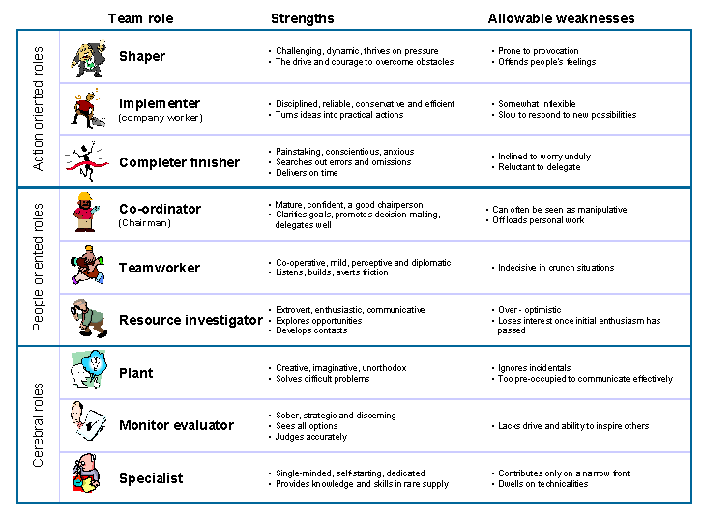
Appendix 1 – Source = (J.Smith, 2002)

Appendix 2
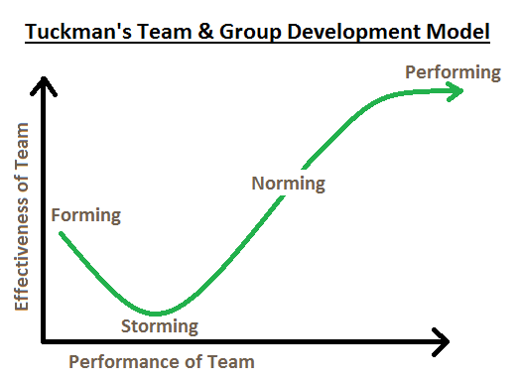
Appendix 2 - Source: https://jamesegerton.wordpress.com/2018/02/24/from-forming-to-performing-group-dynamics/

Appendix 3
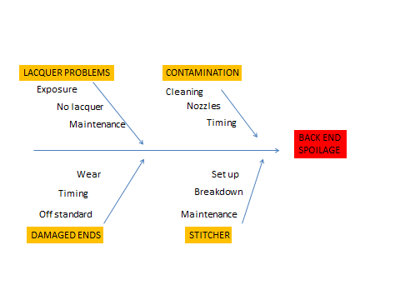

Appendix 3

Appendix 4
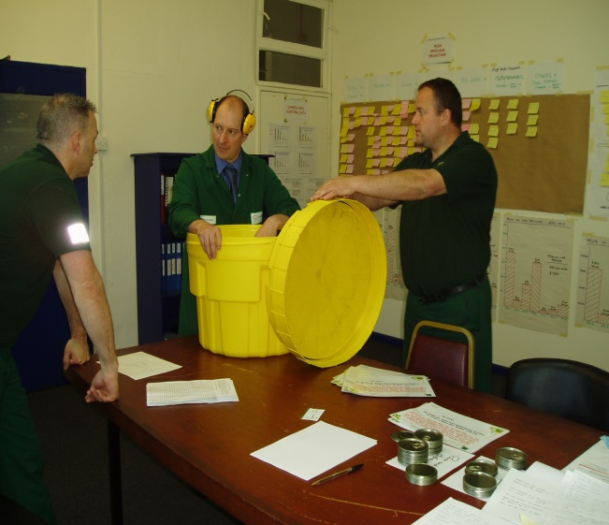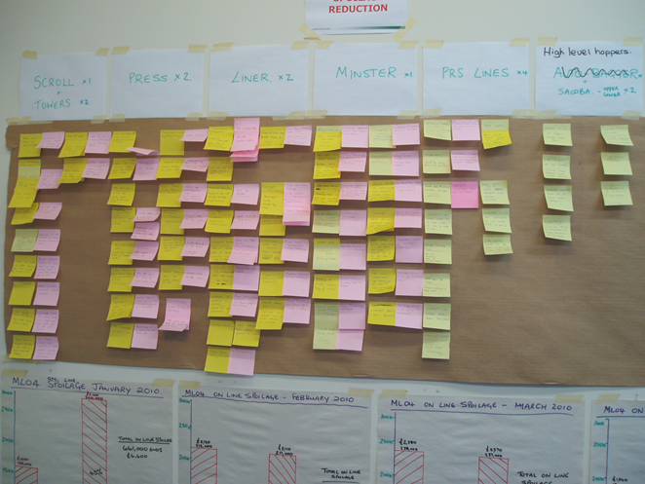
Appendix 4

Appendix 5
Reduction of Spoilage reduce costs MIT Project
Responsible  WBS (ref) | Activity | Duration | Start Date | Finish Date
 | Project start | n/a | 8-5-2019 | 19-6-2019
A | Decide Roles | ½ day | 9-5-2019 | 9-5-2019
A | Decide Project Lead | ½ day | 9-5-2019 | 9-5-2019
All team | Brainstorming | 3 days | 10-5-2019 | 14-5-2019
Project team/everyone | Specify tasks | 1 day | 15-5-2019 | 16-5-2019
B/C/D | Data gathering | 5days | 16-5-2019 | 23-5-2019
B | Compile results into chart | 1 day | 24-5-2019 | 25-5-2019
C/D | Compile/Issue newsletter to factory | 5 days | 20-5-2019 | 25-5-2019
B/C/D | Weigh results consider scope | 1 day | 27-5-2019 | 28-5-2019
A | Address stakeholders | 1 day | 29-5-2019 | 30-5-2019
All team | Decide on solution using data | 2 days | 28-5-2019 | 30-5-2019
B/C | Plan for rectification work | 2 day | 31-5-2019 | 3-6-2019
A/B/C | Discuss with stakeholders 2 | 1 day | 3-6-2019 | 4-6-2016
C/D | Implement improvements | 6 days | 5-5-2019 | 13-6-2019
D | review | n/a | 13-5-2019 | 19-5-2019
B/C/D | Newsletter to factory 2 | 3days | 17-6-2019 | 19-5-2019
All team | Handover | n/a | 19-6-2019 | 19-6-2019
All team | Reflect | n/a | 26-6-2019 | 26-6-2019
Appendix 5

Appendix 6

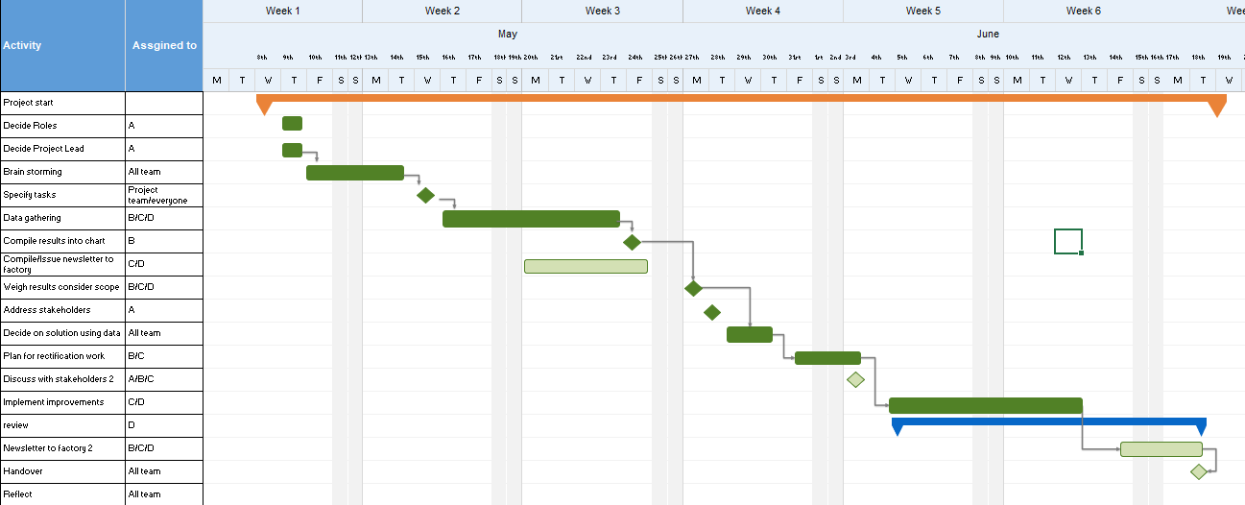
Appendix 6

