Name: Angura Begum
Student ID: 1712139
Module Code: BM SK5006
Lecturer: Dr Md Nazmul Hasan

UNDERSTANDING DATA
Knowledge and Information Management Skills for the Workplace

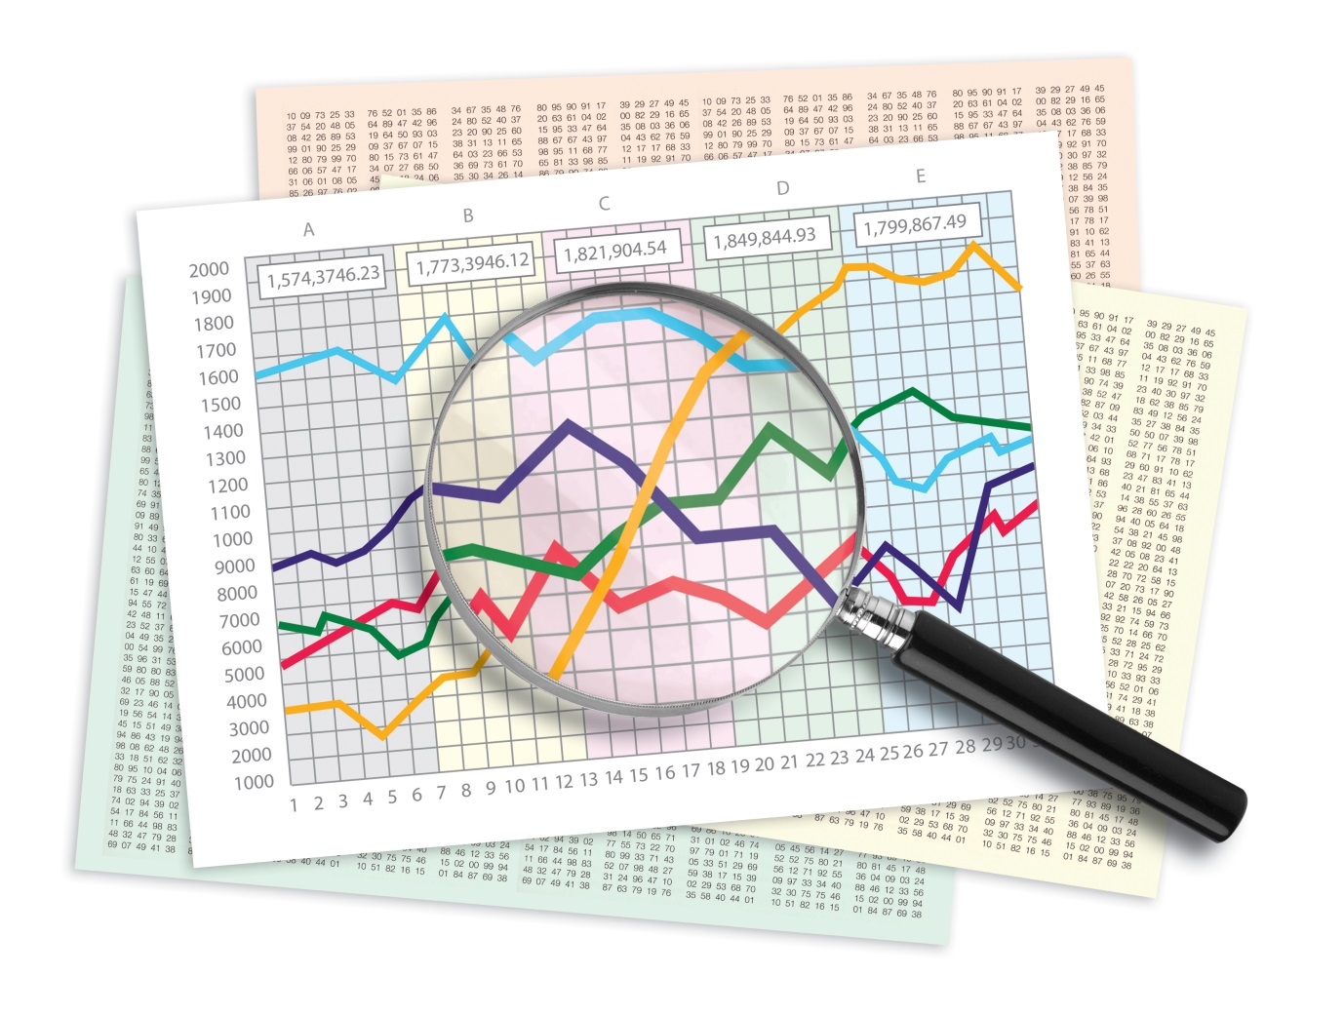

1. Explain why the same set of data can be considered as useful information by some and useless data by others. Further, could this information be termed as “knowledge”? Why

Data is considered to be very important for the functioning of the companies which mainly deals with the management functions. Data can be classified into two categories - hard or quantitative data and soft or qualitative data. The quantitative data can be considered to be the data which can be obtained by an individual in order to measure and quantify the objects or situations in which an individual find themselves (Grawitch et al. 2019). In the similar manner, soft or the qualitative data is the other type of data found by the individuals. In the case of qualitative data, it can be said that the individuals collect data which is said to be found from the secondary sources like that of the interviews, surveys and the works by the previous authors (Back et al., 2016).
In this case, it is said that the data is considered to be useful by some while for others, that same set of data might be considered to be useless. This is because of the fact that a particular piece of information can be used by an organisation or a company for their own uses. Once the company or the organisation has used that same amount of data for their businesses, the management of the companies can use the knowledge they gained for conducting their daily business operations. This can be best explained by the example of an IT company and a restaurant (. In the case of the IT Company, it is seen that people mainly deal with all kinds of data for their day to day activities. Hence, data can be considered to be important for them as it would allow them to continue their operations in an effortless manner. In the similar way, a restaurant company is mainly concerned with the customers and providing the best possible qualities of food for them. This means that for a restaurant, the data is of no use as they do not need it in any way. Hence, it is said that the same set of data is considered to be useful for some people while for the others, it would be considered to be useless (Grissom et al., 2015).
The information which is considered to be useful can also considered to be knowledge due to the fact that knowledge needs to be analysed in the same manner as information. This means that the companies who use the data for preparing their business strategies needs to analyse the information in order to determine in what ways they can use the information to their advantage. In the same way, it can also be said that knowledge also needs to be analysed to find out how to use that knowledge for the purpose of learning (Back et al., 2017). Once the information in the knowledge have been analysed, it can be said that the individuals can determine for themselves how it is going to be helpful for their careers and objectives. This is the reason why it has been rightly said that the information is considered to be knowledge (Travis, 2017).

2. Describe the ways in which “knowledge” differs from “data” and “information”. Justify your answers with a relevant diagram.

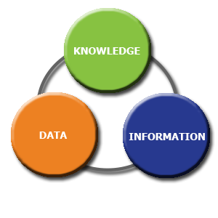
(Source: Escartin, 2017).
The concepts of the knowledge, Information and Data, although are related to each other, are considered not to be the same. There exist major differences between the concepts of the knowledge, information as well as data (Escartin, 2017). The first difference is the fact that the knowledge is considered to be the awareness of a particular subject or the experience which the individuals gather from the learning of a particular subject, while the concept of the data is used to express the basic forms of education which the individuals can find themselves for conducting the study. The second difference between the two concepts would include the definition of data to be the raw components out of which the information is created. In a similar manner, it can also be said that the information is the final product which an individual will get once he or she will analyse the data to its use (Flin et al. 2015). On the other hand, the concept of knowledge can be defined to be the important and appropriate information which can be used by the individuals from the data and the information obtained by them (Jang, 2016).
The third difference between the concepts of the knowledge, information and data is the fact that when the data can be compiled easily, it can be used to get the relevant information. In a similar manner, it can also be said that the correct information leads to the right knowledge, which utilised properly by humans, can result in the right knowledge for the humans (Jackson, 2016). The fourth difference between the three concepts argues the point that all data and information which can be obtained by humans should not be considered to be knowledge. On the other hand however, it is also said that all forms of knowledge can be considered to be the information of some sort. The fifth difference between the three concepts of the knowledge, information and data is the fact that it is possible for humans to represent the information with the help of low cost. Since the information is made up of data, it can be said that the data can also be produced at a very low cost. On the other hand, it can also be said that knowledge cannot be produced at a low cost because it differs o the perspectives and the experiences of the other individuals. Hence, it is from all these differences, that it can be said that the concept of the knowledge, information and data is said to be different from each other (Jang, 2016).
The differences between the concepts of the knowledge, information as well as the data can be best explained in the form of the organisational structure of a particular company. In a particular company, it can be said that the market analysis which the company makes can be considered to be the data of the company (Graywitch et al.2019). In the same way, the strategies which the company formulates using the data from the market analysis can be considered to be the information (Jackson, 2016). Finally, the result which the company gains from the market, using the information and the data can be considered to be the knowledge which the company uses in the market in its daily operations. Hence, it can be said that the differences between the data, knowledge and information is an important one (Back et al., 2015).

3. Does a player in a card game use tacit or explicit knowledge? Explain why. Define and explain the difference between the two.

Card Playing is quite a common form of spending leisure time among the humans his is because of the fact that it enables humans to use the brain for overcoming the difficulties of their opponents. In this case, it can be seen that there are two concepts of knowledge which are commonly used by humans (Mattson et al.2016).These two types of knowledge includes the concept of tacit knowledge as well as explicit knowledge. Both of these types of knowledge are although, similar to each other, has certain differences between them (Escartin, 2015).
Tacit Knowledge is said to be the process by which can be hard to pass from one individual to the other individual since such types of knowledge can be difficult to be written down or transferring it verbally. Hence, it can be said in this regard that this type of knowledge is more difficult than explicit knowledge (Flin et al. 2016). On the other hand, the concept of the explicit knowledge is said to be easier than that of tacit knowledge as it involves stating the purpose of the conversation in a clear and concise manner.
In the case of a cared player, it would be said that he would be using a combination of both tacit and explicit knowledge. This is because the tacit knowledge can be used to confuse the opponents and the explicit knowledge can be used to overcome the difficulties of the strategies of the opponents that he comes up with (Grawitch et al., 2015).

4. Consider five decisions you have made today (they could be simple such as taking a turn while driving or even choosing a soda at a convenience store). In each case, determine the data, information or knowledge that was involved in the decision.

The five cases:
- Choosing a particular brand of soda at a convenience store
- Choosing a particular type of product (in this case soap or body wash)
- Choosing laptop over desktop
- Choosing a particular type of cuisine (in this case Italian over French)
- Choosing LED over fluorescent lightning

Case 1
In this case people can choose Coca-Cola or Pepsi when buying soda at a convenience store to support their choice. Surveys say Coke still remains the primary preference of consumers. To some extent this preference pattern of the people is related to psychology. This includes factors like the memories people tend to associate with, emotions it evokes, experience, the satisfaction it offers. The trademark red colour of coca cola evokes the brain with happiness and celebration at a subconscious level. It is the psychology not the secret formula that has made Coke a success.
Case 2
Consumer psychology is shifting towards the use of body wash over soap. Body wash comes with essential ingredients like oils, fragrances and vitamins and moisturises the body. It offers more hygiene factor and cosmetic purposes as compared to soap. In case of skin diseases soap can be harmful for people, whereas body wash are prescribed by skin specialists as it avoids contamination factor.
Case 3
One prime factor of using a laptop is portability issues. If one needs to regularly take their computer out of the house then owning a laptop certainly makes sense. Besides this laptops use less power than desktop. The low cost of a laptop also persuades consumers to incline towards laptop.
Case 4
Italian and French cuisines are world famous, but people have their different opinions as per their taste buds. The ingredients used in Italian foods are always fresh compared to French foods which make too much usage of sauces. Italians stick to only four to eight ingredients to make their food taste great, while the French offer a variety of added ingredients to make their food taste exotic (Grawitch et al., 2015). Good Italian food is made by traditional means with the use of fresh vegetables and fish and includes less fat compared to French cuisine.
Case 5
Fluorescent lamps are harmful because of their UV emissions.LEDs are much more preferable and safe in this aspect. LED lights usually run on low voltage power supply compared to fluorescent. The lifespan of fluorescent bulbs are way too less compared to LEDs.

5. Now consider how those decisions would have been influenced by the lack of pre-existing data, information or knowledge.

It is said that the lack of information, knowledge and data is said to cause a lot of problems for people in their daily lives. In this case, it can be said that without the use of the information, knowledge and data, I would have faced a lot of problems.

Choosing a particular brand of soda at a convenience store

In the case of choosing a brand of soda at a convenience store, if I did not have the right kind of information, knowledge and data available to me. Without the right kind of data, information and knowledge, I would have purchased Pepsi over Coca Cola. If I would have purchased Pepsi, then I would not have known about the more popularity of the Coca Cola brand over that of Pepsi (Grawitch et al., 2015).

Choosing a particular type of product (in this case soap or body wash)

According to the latest information, it has been confirmed that in the present time, the body washes are known to have a variety of fragrances and important vitamins and minerals, which are not found in the soaps. Moreover, the body washes are easily portable than the soaps. I would have made the mistake of purchasing the soap over the body wash if I did not have the correct data, information and knowledge on the products.

Choosing laptop over desktop

Laptop is much smaller in size as compared to a desktop. In addition to this, the laptop is the result of the newer technologies, which makes it much faster than that of the desktop. Moreover, it can be said that the laptops are also more easily portable than the desktop. Hence, this could be easily carried around. In this case, I can say that I would have gone for the old technological desktop, if I did not have the accurate information, knowledge and data to myself (Tetrickj et al., 2015).

Choosing a particular type of cuisine

In the case of a particular type of cuisine, it can be said that Italian cuisines are considered to be the best cuisines in the world mainly due to the presence of the ingredients and the efforts that the people put into the preparation of the food. If this knowledge, information and data were unavailable to me, I would have gone for any other cuisines over the Italian cuisine (Dereli, 2015).

6. You have recently invented a new product. Collect demographic data from a sample population, determine how you would use this data, and convert it into information and possibly knowledge for promoting the product.

Q1. Gender
Gender | Total No of respondents | No of respondents | % of respondent
Male | 35 | 25 | 71%
Female | 35 | 10 | 29%
Total | 35 | 35 | 100%
Table 1: Question 1 of demographic segmentation
(Source: Created by Researcher)
The above table describes that out 35 respondents, 25 persons (71%) were male whereas out of 35 respondents, 10 were female. This can be concluded that male persons were more proactive to take part in the interview process.
Q2. Age
Age | Total No of respondents | No of respondents | % of respondent
15-20 years | 35 | 5 | 14%
21-25 years | 35 | 10 | 29%
26-30 years | 35 | 7 | 20 %
31-35 years | 35 | 13 | 37 %
Total | 35 | 35 | 100%
Table 2: Question 2 of demographic segmentation
(Source: Created by Researcher)

From the above analysis, it has been identified that out of 35 respondents, 5 (14%) individuals were coming under the age group of 15 to 20 years whereas 10 respondents (29%) were between the age group of 21 to 25 years. The researcher has interviewed 7 (20 %|) respondents who were at the age group of 26 to 30 years. Likewise, 13 (37%) individuals were at the age group of 31 to 35 years. This has found out from the above analysis that among the 35 respondents, most of the individuals were at the age group of 31 to 35 years.

Q3. Do you think new Rosemary health drink has more nutritious value than the normal health drink available in the market?

Option | Total No of respondents | No of respondents | % of respondent
Yes | 35 | 31 | 89%
No | 35 | 4 | 11%
Total | 35 | 35 | 100%
Table 3: Question 3 of product information
(Source: Created by Researcher)
The above narrative analysis shows that, out of 35 respondents 31 individuals (89%) have shared their opinion that Rosemary health drink has more nutritious value than the normal health drink.
Q4. Is it affordable for you to pay extra for the flavoured health drink?
Option | Total No of respondents | No of respondents | % of respondent
Yes | 35 | 28 | 80%
No | 35 | 7 | 20%
Total | 35 | 35 | 100%
Table 4: Question 4 of Product Cost
(Source: Created by Researcher)
The above table shows that among the total 35 respondents 28 (80%) persons said they are ready to pay extra money for this new flavoured health drink whereas 7 respondents out of 35 interviews replied that they are not interested to pay extra for this new product.

Q5. What kinds of promotional activity do you familiar with?
A. Offline promotion B. Online promotion
Option | Total No of respondents | No of respondents | % of respondent
Offline | 35 | 4 | 11%
Online | 35 | 31 | 89%
Total | 35 | 35 | 100%
Table 5: Question 5 of Promotional Activity
(Source: Created by Researcher)
From the above mentioned data, this has been found out that out of total 35 respondents, 4 (11%) respondents are familiar with offline promotional activities. On the other hand, out of 35 individuals, 31 personnel (89%) are familiar with online promotions.

References
- Back, A.L., Steinhauser, K.E., Kamal, A.H. and Jackson, V.A., 2016. Building resilience for palliative care clinicians: an approach to burnout prevention based on individual skills and workplace factors. Journal of pain and symptom management.
- Carvalho, A., 2016. The impact of PBL on transferable skills development in management education. Innovations in Education and Teaching International.
- Dereli, D.D., 2015. Innovation management in global competition and competitive advantage. Procedia-Social and behavioral sciences.
- Escartín, J., 2016. Insights into workplace bullying: psychosocial drivers and effective interventions. Psychology research and behavior management.
- Flin, R. and Maran, N., 2015. Basic concepts for crew resource management and non-technical skills. Best Practice & Research Clinical Anaesthesiology.
- Grawitch, M.J., Ballard, D.W. and Erb, K.R., 2015. To be or not to be (stressed): The critical role of a psychologically healthy workplace in effective stress management. Stress and Health.
- Grissom, J.A., Loeb, S. and Mitani, H., 2015. Principal time management skills: Explaining patterns in principals’ time use, job stress, and perceived effectiveness. Journal of Educational Administration.
- Jackson, D., 2016. Modelling graduate skill transfer from university to the workplace. Journal of Education and Work.
- Jang, H., 2016. Identifying 21st century STEM competencies using workplace data. Journal of Science Education and Technology.
- Matteson, M.L., Anderson, L. and Boyden, C., 2016. " Soft Skills": A Phrase in Search of Meaning. portal: Libraries and the Academy.
- McConnell, C.R., 2016. Umiker's management skills for the new health care supervisor. Jones & Bartlett Learning.
- Ngang, T.K. and Chan, T.C., 2015. The importance of ethics, moral and professional skills of novice teachers. Procedia-Social and Behavioral Sciences.
- Noe, R.A., Hollenbeck, J.R., Gerhart, B. and Wright, P.M., 2017. Human resource management: Gaining a competitive advantage. New York, NY: McGraw-Hill Education.
- Tetrick, L.E. and Winslow, C.J., 2015. Workplace stress management interventions and health promotion. Annu. Rev. Organ. Psychol. Organ. Behav.
- Travis, T.A., 2017. From the classroom to the boardroom: The impact of information literacy instruction on workplace research skills. Education Libraries.

Airline Strategies
Knowledge and information and management skills for the workplace
Name: Angura Begum
Student ID: 1712139
Module code: BSMK5006
Lecturer: Dr M d Nazmul hasan

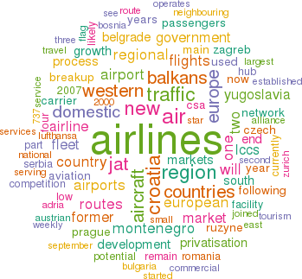

PART 1

1. Describe how the overall approach adopted by American Airlines incorporated the basic competitive strategies of cost leadership and product differentiation.

Cost Leadership Strategy:

This is a type of strategy that helps the company to reduce the production cost with the quality standard of goods in order to meet the business objectives in monetary terms (An and Lifen, 2016). Almost all the companies are concerned with the activities of this strategy. In cost leadership strategy, a company is generally tends to target a huge market from where it can get large demands by offering lowest comparative prices (Sedlmeyer and Dwyer, 2018). American Airlines operates their business keeping in mind the above strategy for the purpose of achieving higher profitability margin. This company provides with low cost that makes travelling more convenient.

Product Differentiation:

According to Davcik and Sharma (2015), product differentiation is a marketing strategy that helps the company to differentiate their products from other companies in order to attract more customers towards their goods and services in a competitive market. It can be defined as offering and producing few unique products that provides comparatively amassed benefits to the target population (Hoberg and Philips, 2016). American Airlines has adopted product differentiation process to differentiate themselves from others and provide more quality of goods and services. They basically provide services of flight attendants, board bars and quality foods.

2. In what ways did SABRE provide American Airlines with a competitive advantage? Your analysis should refer to concepts related to the strategic use of information systems, for example, entry barriers.

Semi-Automatic Business Research Environment is a system that is adopted by American Airlines with the concept of introducing a web-based online technology in reservation system. This concept helped them in cost reduction of various business activities such as reservation. It is a well known fact that in 2000s the online systems were not as effective as the number of internet users were less that is; no one was easily accessible to the online process. Thus, the company has made a marketing strategy of online booking system to increase their business growth for the purpose of achieving organisational profits. It has given various benefits to the company in the year 2000s in which there was less competitive company with the online technologies.

Porter’s Five Forces
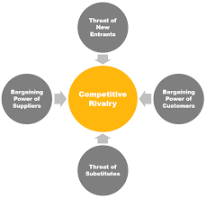
Figure 1: Porter’s Five Forces
(Source: Created by the Rothaermel, 2017)
Competitive Rivalry – Competition level is medium in this market. Computer-based information cannot be handled and operated by everyone. Some experts are required for this. Hence, the competition is not so high.
Threat of substitute – Threats of substitute is high over here. It is because that many other information tools are there who can easily replace the above mentioned computer-based information system. It is essential for the organisation to develop few inbuilt features with latest innovation so information can remain safe effectively.
Threat of new entrance – Threats of new entrance is high over here. It is because of low competition which enables more new companies to invest in their business and expand it in this market. The company should increase its customer base so new firms would not be able to capture these customers.
Bargaining power of suppliers – Power of suppliers are medium for this industry. It implies that number of suppliers is less of this system which makes the organisation completely depended on them same as suppliers also depended upon them as they get more advantage from these products.
Bargaining power of buyers – Power of buyers are low. People over here desire to maintain their living standards and desire to have best quality of goods and services. This organisation basically provides best services with advanced technology to keep all the information or data safe and secure which force the customers to pay high amount.
More Advantages was provided by SABRE

Availability of reservation process in the business is high - It means that the customer can be able to book their tickets for travelling purposes, could be easily accessible anywhere through smart phones or laptops devices.
Reduction in cost - Through the implementation of this process, cost of different business activities is getting reduced. The company is capable of achieving higher profits as the business expenditures are decreased. It implies that online system is one time investment by the company instead of paying monthly salaries to perform the equal job activities within an organisation (Abadi et al., 2018).
Faster payments - Major advantage that the organisation achieves from online booking is faster payment. Generally at the time of online ticket booking, passengers are tends to pay some amount of money in advance and the remaining after the ticket has been booked which helps the company to receive payments earlier.
Valuable insight - Online system helps the organisation to get a proper review after a well service to the passengers which helps to improve the company’s reputation in the market. Thus, improves the business work performances.
Customers Growth - This system helps the company to grow the customer attraction towards their business as people sitting at their home can be easily switch check out the overall benefits of a product or services.
Sustainable Revenue - As the company is engaged with this system, it provides sustainable revenue due to high applicability of services.

3. Although SABRE was undoubtedly successful, American Airlines was not able to maintain its competitive advantage beyond the late 1980s. What factors played a part in the erosion of the company’s lead over its competitors and how did the company react?

High Expenditure –

It is one of the major disadvantages that are being faced by this company. Online system has various benefits to the company because of its high advanced technology due to which the organisation have to incur huge expenditure (Ramya et al., 2017). It is a well-known fact that higher technologies require high investments for its implementation as different machines and innovative technologies are required to start up a new informative system.

Lack of internet users –

Company made a strategy of introducing an effective information system which failed due to the reason of less internet users in the market. As in the year 1980s most people were not engaged with the online activities instead they mainly believe in manual interaction due to which the company failed to show the benefits that the customer could get through this system. American Airlines has negatively affected through implementation of this informative system.

Socio-culture factor –

Major disadvantage that the company faced was of socio-culture factor. It has been seen that about 95% out of total population feels insecure through processing online transactions or activities. According to Srivastava (2017), people were afraid of using online process as they believe that the data or information can be leaked as many hackers in the globe does exist as well as highly involvement in cyber-crime has made the public feel uncomfortable in online transaction. As a result the company was negatively affected through this system.

Lack of internet knowledge –

Knowledge of people towards the internet was extremely low. According to Srivastava (2019), people were not aware of using internet properly due to the lack of net banking system which thereby has made the business effort low in web-based system hence; result in failure of the business performances.

PART -2

1. Define an information system;

(IS) is a process in which all the organisational information is being collected, designed, stored and distributed within an organisation. According to Laudon and Laudon (2016), informative system is a method which is used by the company in order to identify and analyse a particular data which is thereby further used as useful information in decision-making process. It can be said that, it is a key role that helps to support organisational activities in respect to increase the work performances of the company. (IS) is a process in which all the organisational information is being collected, designed and stored. Through this system, a business can be able to run their overall business activities smoothly and efficiently hence, enables to stand profitable in the competitive market along with the achievement of business goals (Takahashi et al., 2019). The various dimensions of information system are given below in details:

Organisational Dimension: This dimension helps the company to gather overall knowledge about the operating procedure and culture performed within the company.

Management Dimension: It helps the managers in allocating, coordinating and monitoring for the purpose of improving their work through wide range strategic decision.

Technology Dimension: Various technologies are being used by the supervisors in order to carry out their business function such as computer hardware and software and many others advanced technology.
The above three dimensions have been implemented in the information system of American Airlines for the betterment of the company in every business aspect.

2. Describe the categories of computer-based information systems, providing relevant business examples for each category identified;

There are different types of computer based information system that helps a company to collect authentic information in reference to run their financial activities efficiently.

Transaction Processing System:

It is a process that provides various information about online transaction to a company through maintaining, storing and updating the data transactions of a business (Aragone et al., 2017). The aim of this system is to develop the scheduled business performances in which all departments of a company is completely depend. However transaction may vary in different types of organisation such as billing customers or deposits cheques or drafts etc. It has influenced the accounting activity of American Airlines through processing authentic information regarding overall transaction occurring in the company.

Management Information System:

Computer based systems are essential to be adopted as they process correctly and helps the company to record huge amount data easily (Huang et al., 2017). Besides this, it helps the management team to easily access the data and application due to which financial position of a company can be identified by the managers that provide them the opportunities in decision making process. This system can be defined as a method that gives overall information to the management team which are significant to operate business activities fluently. Managers of American Airlines can easily run their business as they are concerned with this system that helps them to gather all the necessary information to achieve positive results.

Office Automation System:

This system is being implemented with the purpose of increasing the effectiveness and productivity of an entire business system such as staffs, managers, administrative assistants and many others (Ghildyal and Chang, 2017). In other words, it is a process that helps to increase the overall work performance in electronic mode. It has improved overall business performances and develops advanced technological system. For example, It has introduced an electronic process of communicating among different level of employees through computer terminals. American Airlines has adopted office automation system in reference to improve their organisational activities smoothly as well as to perform multi-function task appropriately.

3. Explain how computer-based information systems can support managers at each level of an organisation.
Providing information to the organization decision maker
The financial or any operation issues of marketing, the Managers should have quick access to collect the information so that the company's performance can develop for taking the good decisions. Managing information system is a place where all information is preserved vastly. Further, the managers of different segments will be able to access the information so that they as quick as possible can take the decisions related to the company’s problem. For example, the middle level management would collect all the relevant information of their respective departments and shared them with the decision maker department that is, HR management. Then the HR manager would take corrective decision in order to meet the organisational goals and objectives effectively.
Management information system aids to collect data
Operational data of every day are collected together from various external data sources. This authorizes an effective and healthy relationship among the distributors, retailers and the other members of the supply chain. This also keeps the good flow of the performance and the numbers of sales are monitored and stored. Therefore, it can be accessible by all staffs. This aids to detect problems early and make decisions in the quickest method. For example, accounting software namely Tally. ERP 9 would be responsible for collecting all the authentic data of stocks purchase and sale so that the accountant professional could be able to measure the actual quantity of stocks that whether they are in surplus or shortage in stocks.
To develop coordination in workplace
Many departments or segments of the organization can give inputs before making the decision. The process of making decisions takes a long time if there is no well-organized communicational channel. Sometimes different stakeholders cannot access to all information having a good communication channel, it would create obstacles before finishing the process. Management information system assures all the staffs of the group who are initially able to take the decision may have the control to required information for making the decision. For example, the communication level between the managers and their team members of “Captify Company” is high. It implies that the internal work environment of this company is positive. When the managers decide to implement marketing strategy to get positive results, they organise a meeting where the managers and all the other employees basically discuss about the various opinions to implement the strategy in a best way. It helps to develop their coordinating power in the business organisation.
Improve company’s reporting
Management information systems are highly recommended because of its efficient report features. Simple and easy information in reports helps in taking decisions quickly. These effective reports are accessible without any difficulty to different people in various organizations. As a result, it is an effective tool for communication across the world. Moreover, the findings are shared straightforwardly among colleagues with necessary supplementary data.
Contribute promising scenario in different business scenario –
Notable precautions are taken into consideration while making decision that affects whole business. Hence, there are many checks and verifications during decision-making. For it, an executive of the organization runs important metrics that can affect business through management information systems. All these metrics are presented in reports with data and graphs that are easy to understand and interpret. For example, the financial reporting structure of JD Sports Company is comparatively high as the accountant professional of this organisation follows the various steps to maintain the company’s reporting structure. At first, they collect and analyse the overall data then the necessary information have been organised. The managers work from a single source of data and try to collaborate across the business entity. The above steps enable the company to maintain their financial reporting structure wisely.
Aids in tracking the implemented decision
The executives of companies use management information systems for making expected projections for a particular decision. It helps in keeping tracks of changes while taking decisions. These decisions are monitored for achieving desired results. The reports of management information systems are recommended for evaluating goals. Additionally, it aids in correcting measures at an early stage to get back on track. For example, Finzi Trust Company tracks their accounting information through analysing and classifying various data. The accountant professional of this organisation generally prepares general ledger and trial balance to have an authentic track of their accounting information.
References

- Abadi, S., Huda, M., Hehsan, A., Mohamad, A.M., Basiron, B., Ihwani, S.S., Jasmi, K.A., Safar, J., Mohamed, A.K., Embong, W.H.W. and Noor, S.S.M. (2018). Design of online transaction model on traditional industry in order to increase turnover and benefits. International Journal of Engineering and Technology (UAE), 7(2.27), pp.231-237.
- An, G. and Lifen, C. (2016). June. Explore the Integration of Cost Leadership Strategy and Differentiation Strategy. In 7th International Conference on Education, Management, Information and Computer Science (ICEMC 2017). Atlantis Press.
- Aragone, M., Argano, M., Van De Kerckhove, G., Geoffroy, E. and Lamy, M., Amadeus SAS. (2017). Online transaction processing system for multi-product transactions. U.S. Patent Application 15/080,188.
- Davcik, N.S. and Sharma, P. (2015). Impact of product differentiation, marketing investments and brand equity on pricing strategies: A brand level investigation. European Journal of Marketing, 49(5/6), pp.760-781.
- Donate, M.J. and de Pablo, J.D.S. (2015). The role of knowledge-oriented leadership in knowledge management practices and innovation. Journal of Business Research, 68(2), pp.360-370.
- Ghildyal, A. and Chang, E. (2017). IT Governance, IT/Business Alignment and Organization Performance for Public Sectors. Journal of Economics, Business and Management, 5(6), pp.255-260.
- Hoberg, G. and Phillips, G. (2016). Text-based network industries and endogenous product differentiation. Journal of Political Economy, 124(5), pp.1423-1465.
- Huang, T.T., Liu, G.J., Liu, N.Q., Mi, A.L. and Zhou, B.C., International Business Machines Corp, (2017). Identifying performance bottleneck of transaction in transaction processing system. U.S. Patent 9,632,818.
- Laudon, K.C. and Laudon, J.P. (2016). Management information system. Pearson Education India.
- Ramya, N., Sivasakthi, D. and Nandhini, M. (2017). Cashless transaction: Modes, advantages and disadvantages. International Journal of Applied Research, 3(1), pp.122-125.
- Sedlmeyer, L.R. and Dwyer, R.J. (2018). Fire officer leadership strategies for cost management. Disaster Prevention and Management: An International Journal, 27(5), pp.495-507.
- Srivastava, P. (2019). Advantages & Disadvantages of E-Education & E-Learning. Journal of Retail Marketing & Distribution Management, 2(3), pp.22-27.
- Takahashi, K., Hase, J., Matsuhara, K., ANEZAKI, K. and Kubota, H., Konica Minolta Inc. (2019). Information system and multi-functional information device. U.S. Patent Application 10/298,660.

