Module: Managing Food & Beverage Operations (Placement) Portfolio
Module code: BMIH6011
Name: Marius Daniel Cirpaci
Student number: 2317399
Lecturer: Daniel Payne

AI acknowledgement: I confirm that I only used AI to check grammar, spelling in this assignment using ( Grammarly.com) with the prompt “ check the spelling and grammar of this text” in line with University of Wales Trinity Saint David guidelines. I can confirm that all content is my own

Part 1
This reflection is my experience shadowing a shift supervisor in the food and beverage department of Novotel City Centre for the during my placement. The food and beverage department included the provision of bar services, the operation of restaurant, supporting events, and the preparation of conferences in nine meeting rooms. Initially, I performed operational duties as part of my job including serving drinks, taking orders and preparing for events. As time progressed, I began to observe and assist with supervisory responsibilities such as delegating tasks, predicting demand, and coordinating teams. I selected to write about shadowing the shift supervisor as it was a way for me to see the difference in perspective between performing operational roles versus managing them. It challenged some of my perceptions regarding the requirements of good supervision, and indicated to me that effective F&B management involves both technical skills, and emotional regulation, anticipation strategy, and interdepartmental communication. Utilising Gibbs (1988) reflective cycle, this assessment will look at how theory within service operations, leadership, and quality management and professional development.

Description
I am going to analyse an experience of mine that took place at one of my first jobs at a large hospitality venue with 120 people attending a conference in the hotels biggest meeting space. My immediate supervisor was responsible for managing both the bar area and event operations. In this instance, he gave me the responsibility of monitoring the amount of food available at the buffet and toping up the during the conference break . At the same time he would oversee how the rest of the staff performed in regards to overall customer service delivery. The event started at 10AM and continued through 6PM. During that time there was a buffet lunch provided for each of the 120 guests attending the conference. Furthermore, there was several significant physical limitations of this space including the fact that the size of the buffet table and hot plate did not meet the demand of the volume, therefore creating a queue where guests had to wait longer. For most of this event I witnessed my Manager remained visible calm and delegated responsibilities to other staff members according to their skill level; newer staff members were given clearance duties whereas experienced bar servers were able to work independently managing drink orders. Before sending me into the kitchen to request additional food supplies my supervisor told me to "just keep an eye on it and let me know when there is almost no food left" rather than allowing me to simply let him know when we ran out of food. Afterward, during an Easter period and happy hour, which was the busiest times of the day at the bar, I saw him adapt to different situations. if there was a line forming, he would jump right in and take charge; however, during quieter moments or event set-up, he would delegate these responsibilities to trusted team members. He also maintained proper hand-off protocol and made sure all tab payments and guest requests were clearly relayed to the next group of employees working. This shadowing experience lasted six weeks, during which time I went from being passively observing what was happening to becoming actively involved as a supporting role.

Feelings
At the beginning of this experience, I had a lot of anxiety as I watched the manager seemingly easily handle pressure in front of large number of guests. Prior to this event, I was extremely anxious about making errors. I was particularly concerned that if I made errors, it would impact the guests experience. Also, my lack of experience may result in me letting the team down. When I was asked to monitor the buffet, I felt both proud of being given a position of trust and very nervous. On one hand, I was grateful to be included in what was going to be a high-pressure situation. But at the same time, I knew that I wasn't confident enough. Seeing the manager remain composed during the chaos of the Easter rush and the live music events impressed me, but also intimidated me. I questioned whether I could ever find myself to be able to remain calm like that. As well, there were many occasions where I became frustrated because I didn't know the answers to questions regarding the bar menu or where tables were located. I found myself depending upon my colleagues for some of these basics. Although, as the weeks went by and I started doing things on my own during staff meetings while running the bar, I did feel a sense of pride growing inside of me. And I remember feeling relieved when the team leader said he was glad that I was present during busy clear downs. At the end of my placement I felt a sense of accomplishment for developing my skills and experience. I grew to be much more confident in my ability to interact appropriately with my guest’s and also with staff. This transformation is evidence of how developing an understanding of your own emotions will help you develop the skills necessary to better manage challenging situations and enhance both your professional and personal development. (Reindel, 2024)

Evaluation
Several factors contributed to a successful shadowing experience. First, the Manager took a systematic and organised way to delegate responsibilities and handled stressful moments calmly and professionally. He also helped prevent service failures by instructing us to plan ahead for the buffet replenishment instead of reacting to what is happening at the moment. Additionally, he modelled positive leadership behaviour by staying calm during peak hours and by demonstrating how to remain composed in high-pressure situations. In addition, he trusted me enough to allow me to perform duties independently and eventually allowed me to be responsible for covering the bar without him present. Also, he had clearly defined transition processes so that there would be no gaps in communication or operations from one shift to another. Unfortunately, there were some things that didn't work as smoothly. The physical design of the buffet area presented challenges. Although it was an established limitation (the small table and hot plate), I believe we should have developed solutions prior to the event, i.e., planned different ways to serve food if needed.

Analysis
My placement experience can be analysed using frameworks which provide insight into Food and Beverage supervision. The Managers’ behaviour demonstrates Situational Leadership Theory (Hersey & Blanchard, 1969). Adapting the leadership style to the situational pressures. When working at an event with 120 people he directed new staff members to clear and set up by providing them with detailed directions as well as delegated tasks to experienced Bar Staff who were able to carry out the duties. Additionally, his ability to remain composed during the Easter period demonstrated Emotional Intelligence (Goleman, 1998). Specifically his ability to adapt himself emotionally provided a sense of stability to the operation. The Buffet Re-fill Task also represents key concepts within Operations Management (Slack et al., 2016). The Small Buffet Table showed a Capacity issue where Demand (120 Guest) exceeded the Capability (Table Size & Hot Plate Capacity). By instructing me to calculate when we would need to re-fill our Buffet, demonstrated an example of Demand Forecasting & Inventory Management practices to ensure that Supply met Consumption Patterns prior to a Crisis occurring. However, failing to identify and resolve the issue indicates lack of skill in Preventive Operations and planning Planning. A good approach might have been of adding Additional Service Points and Modifying Menu Items that required Less Space on the Hot Plates. SERVQUAL Model (Parasuraman et al., 1988) allows us to understand the relationship between Supervisory Decisions and Guest Perceptions. Delegation allowed the Supervisor to Ensure Reliability (Accurate Orders, Timely Service) and Responsiveness (Proactive ) as well as creating Assurance (Composed Presence). I was responsible for Maintaining Standards related to Tangibles and Polishing Glassware and Double-Checking Allergy Notes.

Conclusion
This experience has shown me that an effective Manager can operate at three different levels; first level being operational execution (what to do), second level being team coordination (how to work together) and third level is strategic anticipation (anticipating what you need to be ready for). The Manager was very good at all three areas. He had a calm approach when delegating tasks, he had strong analytical skills and was able to predict customer demand. As such his actions have provided me with a model to follow. Additionally this experience highlighted weaknesses in proactive planning, communication of information and empowerment of staff, impacts the ability to operate resiliently. My personal development through this process started with operational anxiety and ended in independent confidence. But I recognise that having confidence does not necessarily mean I am capable of moving into a management position. I now believe that effective supervisory performance involves a balance between satisfying the needs of your current customers while developing your future employees. I also understand that emotional intelligence is equally important as the technical operational abilities required of Manager.

Action Plan
My action plan is to develop my ability to supervise by completing the following. I will complete courses in Revenue Management so I can learn about how to think financially in addition to how to run an operation. Also, I will ensure that there are cross-training programs available in all teams that I am involved with. In this way, I can avoid creating issues. Furthermore, I will study service recovery models extensively so that I have the capability to deal with customer complaints routinely in a non-escalating manner. Lastly, I will keep a journal at work during my next position, and use Gibbs Cycle to speed up my learning through reflection.

Part 2: Hotel Mentor Feedback
Knowledge of menu and service standards: Did the student demonstrate an understanding of menu items, allergies, and service
etiquette? *
Yes, satisfactory level. Marius was quick to learn the menu and certain standards. He needs help to understand customer special needs and allergen requirement.

Speed and efficiency in service: Was the student able to deliver food and drinks promptly and correctly? *
Good fast learner and does the job asked of him, with responsibility

Ability to upsell and engage with guests: Did the student actively promote menu items and create a positive guest experience?
* He has been able to take orders independently. He still has long way to learn on how to approach guests and upsell.

Food and Beverage Feedback: Please provide specific feedback on the student’s performance in the Food and Beverage department. Please include comments on General and Supervisory experience
* We are satisfied with Marius's efforts and attempt to integrate with the team and learn. He has shown willingness to learn and adapt, which is the single most important thing in F&B service

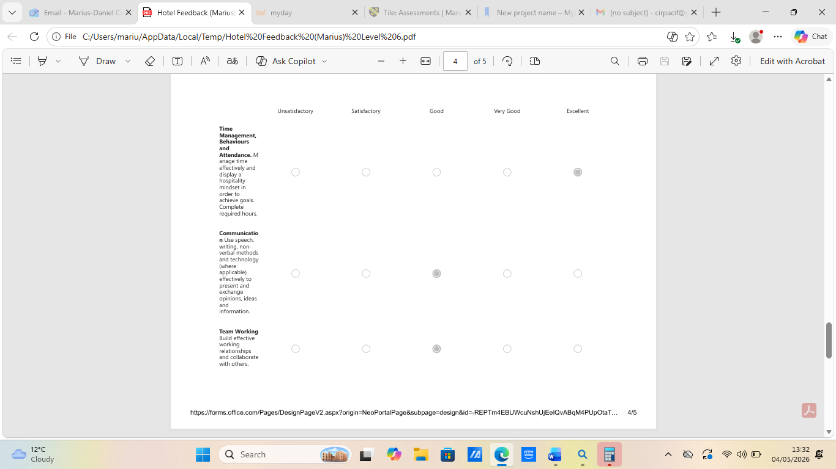
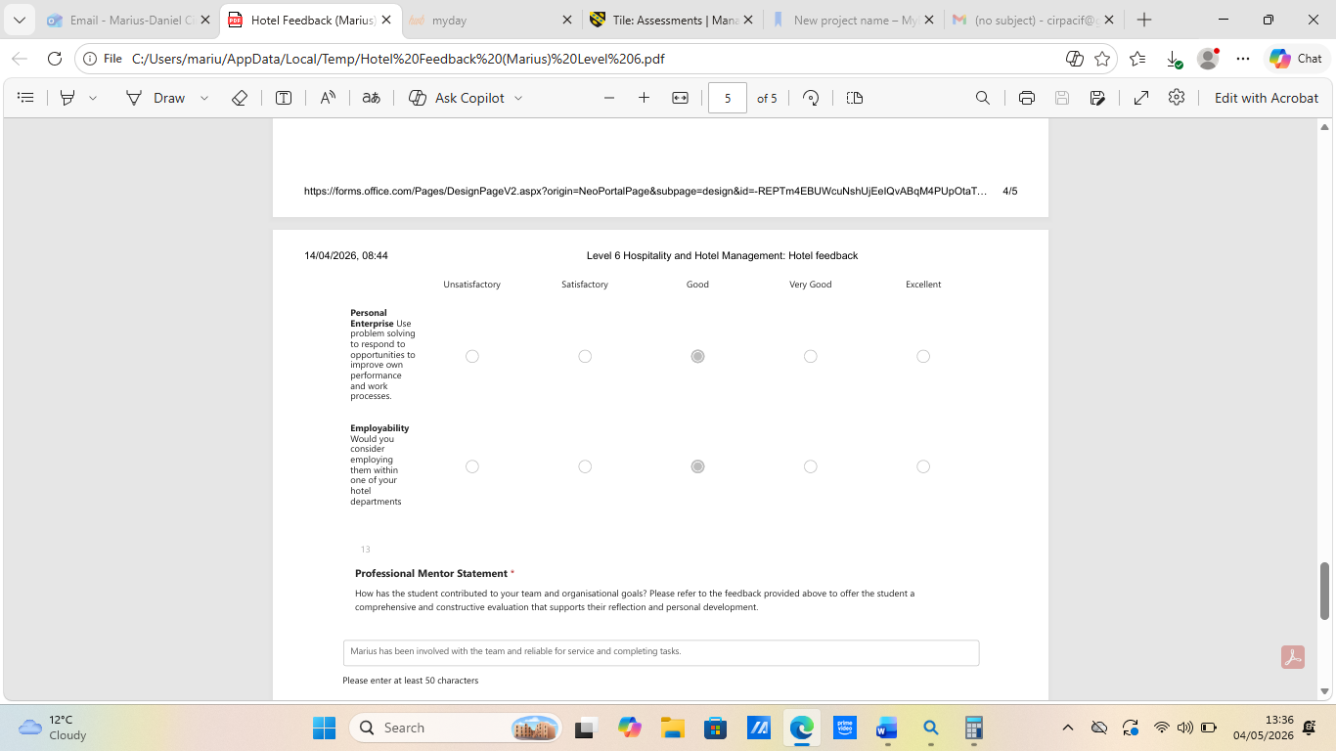
How has the student contributed to your team and organisational goals? Please refer to the feedback provided above to offer the student a comprehensive and constructive evaluation that supports their reflection and personal development.

Marius has been involved with the team and reliable for service and completing tasks.

Part 3: Academic Tutor feedback
Time Management
Marius experienced a delayed start to his placement due to the hotel placement being postponed by two weeks. Despite this, he has since made progress in working towards completing the required hours and has currently achieved approximately half of the total placement requirement.
At present, Marius has completed around 80 hours, with a further 80 hours remaining. In order to successfully meet the placement requirements, he will need to take on additional shifts and maintain a consistent schedule moving forward.
Marius has demonstrated flexibility in his working pattern, taking on a range of shifts across different days. This approach is particularly positive, as it allows him to experience a broader view of the hospitality industry and its varying demands.
While he has been actively attending placement since his start date, Marius has missed a small number of shifts during the placement. Increasing his hours will be essential to ensure timely completion of the placement. Improving reliability and ensuring attendance at all scheduled shifts will be important as he works towards completing his remaining hours.

From a tutor’s perspective, Marius has attended all scheduled meetings and remained engaged throughout. Moving forward, careful planning of his remaining time and commitment to additional shifts will be key to successfully completing the placement.

Communication
Marius has communicated in a highly effective and professional manner throughout the placement. He has attended all meetings, engaged fully in discussions, and consistently demonstrated a strong level of preparation.
A particularly positive aspect of Marius’ communication is his approach to academic engagement. He has come to meetings with detailed and specific questions regarding his assignment, showing a clear commitment to producing high-quality work. This level of preparation and depth of questioning reflects a serious and proactive attitude towards his studies.
Within the workplace, Marius has continued to build on his previous experience, particularly in Food & Beverage. His prior knowledge from Level 5, including familiarity with systems such as tablets, has supported his confidence and ability to communicate effectively within the team.
Looking ahead, maintaining this high level of engagement and communication will continue to support both his academic success and professional development.

Behaviour
Marius has demonstrated a positive and adaptable attitude throughout his placement. Despite the delayed start, he appears to have integrated well into the working environment and has shown a willingness to learn and develop his skills further.
He has embraced a varied working schedule, which highlights a strong level of flexibility and commitment to gaining a wide range of experience. This approach has allowed him to better understand the pace and demands of the Level 6 placement, which he has recognised as being significantly busier than his previous placement.

Marius’ ability to reflect on the differences between Level 5 and Level 6 demonstrates growing awareness of industry expectations.
Moving forward, maintaining this positive attitude while improving reliability in attending scheduled shifts will further strengthen his professional behaviour.

Problem-Solving
Marius has demonstrated good problem-solving abilities during his placement, particularly by applying knowledge and skills developed during Level 5.
This ability to transfer skills across placements is a strong indicator of his development.
In discussions, Marius has shown initiative by asking detailed and relevant questions, which has helped him clarify expectations and improve his academic work. This proactive approach reflects a willingness to take responsibility for his own learning.
Looking ahead, continuing to build confidence in unfamiliar situations and seeking opportunities to gain experience in additional departments will further enhance his problem-solving skills.
Marius should now focus on completing his remaining placement hours by taking on additional shifts in other areas. By maintaining his current level of engagement and building on his existing strengths, he will be well positioned to successfully complete the placement and continue developing within the hospitality industry.

Part 4: Reflection on Hotel and Placement Tutor Feedback
The above reflection examines feedback provided by both my mentor and placement tutor as it relates to my performance within the F&B department of the Novotel City Centre. According to ( Boud and Molloy 2013), feedback has an important role in helping professionals identify areas where they may be unaware of themselves (blind spots), validating their strengths, and developing specific action plans to improve their skills. Therefore, this analysis will examine my identified capabilities relative to those identified through my mentors as well as provide me with a more detailed view of my supervisory potential and operational abilities. The Hotel mentor discussed my strengths. I have demonstrated a “good” level of menu knowledge, and I am able to learn the standards quickly. The mentor stated I was “a good fast learner,” and complete assignments with accountability and take orders on my own. The mentor said I demonstrate the will to work together as part of the team and the will to adjust when necessary. This is “the one most important things about food and beverage service.” I was also seen by the mentor as reliable to serve customers and complete assignments. However, the mentor felt I have clearly defined areas of opportunity. I need to develop deeper understanding of customer’s special needs or allergies. Although I can currently take orders independent of others, I “have a ways to go in learning how to interact with our guests and upsell.” The Placement Tutor emphasised somewhat similar yet distinct elements. Elements of strength include excellent communications skills both internally and externally, a strong academic commitment to completing all aspects of detailed assignment questions, and very positive, flexible behaviour. The tutor noted that I was able to easily switch from one shift schedule to another, and that I could identify the difference between what is expected of a Level 5 student versus what is expected of a Level 6 student at this point in time. The tutor further expressed their appreciation of my problem solving abilities, specifically noting my ability to apply prior knowledge/experience to new problems and my pro-active approach to asking questions. The Placement Tutor indicated areas where I may grow into being a more competent student. Specifically, the Placement Tutor believes that I need to manage my time better. During the term, I experienced a late arrival to work and had approximately 80 hours of work completed during the term. At the end of the term, there were 80 hours left for me to complete. Additionally, I missed a few shifts and needed to become consistent with respect to attending shifts. The Placement Tutor suggested that I would benefit by working some additional shifts in other departments so that I might gain broader exposure to experiences. While both mentors agree that I am willing to learn and adapt, they emphasise different areas of weakness. In particular, the Hotel Mentor focuses on my weaknesses relative to operational skills and interacting directly with guests (i.e., allergens, upselling) while the Placement Tutor emphasises the structure of reliability and behavioural (i.e., class/shift attendance and hours completed). The Hotel Mentor sees me as a potential member of an operational team; the Placement Tutor views me as an academically committed student struggling with managing his time. This feedback has significantly influenced how I perceive my role as a supervisor. The mentor from the Hotel commented that I have “a long way to go” in regards to upselling and guest contact. While I had assumed that once I mastered the menu and worked efficiently, it would automatically translate to leadership, this feedback showed me that I was focusing on completing tasks rather than connecting with guests and generating revenue. This relates to my previous experience when I managed the buffet for the 120 person conference. At that time, I concentrated on re-filling the buffet accurately, however, I did not interact with the attendees nor identify opportunities to sell premium beverages to enhance our revenue. Feedback from the placement tutor regarding reliability resonated with me more I could have imagined. The Hotel Mentor recognised my willingness to learn as well as the Tutors recognition of my capacity for self-reflection. Neither of them felt that they saw evidence of sustained behavioural changes resulting from my reflections. I am very good at making observations and questioning things; however, I have difficulty translating those questions into sustained behaviour modification prior to the next shift.
Collectively, this feedback has also enhanced my knowledge base of what supervision looks like in F&B. Prior to receiving this feedback, I thought F&B supervision meant watching and ensuring everything was done right operationally. Now, I know that F&B supervision includes revenue responsibility (upselling), safety accountability (food allergies), modelling for your team (punctuality), and coordinating with other departments. The Hotel Mentors comments about food allergies and the Tutor’s recommendations to try other departments support this realization: F&B Supervisors function within a larger hotel wide environment not just within the confines of F&B.
Based on this mentor feedback, my action plan is To first address my gaps in upselling and engaging guests, I will use intentional practice. I will ask for some "shadow" time with our hotels best server or bartender to watch how they do things. Additionally, I want to look at the premium items on the menu, along with the wine pairing options, so I can make confident recommendations. The research has shown that successful upselling is directly related to the amount of product knowledge you have and the perception of your authentic identity as a server (Kimes, 2016). Also, I will next get myself certified in Allergen Training. This can be done by completing the hotel’s existing program or getting an external Food Safety Certification. In doing this, I will convert what was identified as a weakness, into a demonstrated ability to perform in this area. Food Safety technical competency is a baseline requirement for F&B Managers (Walker, 2021). Furthermore, I will establish systematic time management strategies to guarantee attendance and hours completed. This will include using digital scheduling calendars to block out every single one of my work shifts. Reflecting upon the feedback I received from my Hotel Mentor and Placement Tutor, I realised that while I have the strengths of willingness to learn, operational speed, and academic enthusiasm, they are insufficient and necessary to achieve supervisory status. To move forward, I need to build my guest-facing confidence, attendance, and knowledge of other departments within our hotel operation. I believe that the process of receiving feedback was absolutely necessary because it provides a great indication of skill level.
Part 5
Part 6
References
Bitner, M.J., Booms, B.H. and Tetreault, M.S. (1990). The Service Encounter: Diagnosing Favorable and Unfavorable Incidents. Journal of Marketing, 54(1), p.71. doi:https://doi.org/10.2307/1252174.

Boud, D. and Molloy, E. (2013). Rethinking Models of Feedback for learning: the Challenge of Design. Assessment & Evaluation in Higher Education, [online] 38(6), pp.698–712. doi:https://doi.org/10.1080/02602938.2012.691462.

Bowen, D.E. and Lawler, E.E. (1992). The Empowerment of Service Workers: What, Why, How, and When. [online] MIT Sloan Management Review. Available at: https://sloanreview.mit.edu/article/the-empowerment-of-service-workers-what-why-how-and-when/.

Goleman, D. (1998). What Makes a Leader? [online] Available at: https://dme.childrenshospital.org/wp-content/uploads/2019/06/What-makes-a-Leader-HBR.pdf.

Kimes, S.E. (2008). The Role of Technology in Restaurant Revenue Management. Cornell Hospitality Quarterly, [online] 49(3), pp.297–309. doi:https://doi.org/10.1177/1938965508322768.

Parasuraman, A.P., Zeithaml, V.A. and Berry, L.L. (1988). SERVQUAL: A multiple- item scale for measuring consumer perceptions of service quality. [online] ResearchGate. Available at: https://www.researchgate.net/publication/225083802_SERVQUAL_A_multiple-_Item_Scale_for_measuring_consumer_perceptions_of_service_quality.

Reindel, L. (2024). Exploring Emotional Development and its Impact on Personal Growth and Relationships. International Journal of School and Cognitive Psychology, [online] 11(9), pp.1–2. doi:https://doi.org/10.35841/2469-9837.24.11.411.

Scribd. (2025). Hersey, P., & Blanchard, K. H. (1969). Life cycle theory of leadership. [online] Available at: https://www.scribd.com/document/846614123/Hersey-P-Blanchard-K-H-1969-Life-cycle-theory-of-leadership.

The University of Edinburgh (2024). Gibbs’ Reflective Cycle. [online] The University of Edinburgh. Available at: https://reflection.ed.ac.uk/reflectors-toolkit/reflecting-on-experience/gibbs-reflective-cycle.

Walker, J. (2021) Introduction to Hospitality Management. 5th edn. New York: Pearson.

