Supervisor: Jonathon Williams
BA (Hon) Illustrations
Word count 5080
List of Illustrations
Soo-Leng Yeap (P146603)

Is digital technology killing art? Does this
Mean the end of painting?
M6X01791

Figure 1. Pank, G. Vogue Cover 1918
Figure 2. Seichen, E. Photograph Vogue Cover July 1932
Figure 3. Nudmik, N. Emoji Nation Digital
Figure 4. Bolognese, M. untitled. Watercolour
Figure 5. Unknown. Untitled
Figure 6. Jodic, S. Untitled
Figure 7. Cave Painting in Chauvet-Pont-
Figure 8. Fearless, J. Blue Butterfly. 2016
Figure 9. Qi, B. Insect and plant
Table of Content

List of illustration 1

Introduction 3

Chapter 0ne The Evolution
1.1 What is art? 5
1.2 The functions of art 7
1.3 Summary 10

Chapter two Machine Took Over
2.1 Digital – A new Medium and A New Tool 11
2.2 Art in postmodern Digital Era 13
2.3 Summary 17
Chapter three Man Versus Machine
3.1 Traditional versus Mechanical 18
3.2 East versus West 20
3.3 Summary 22
Conclusion 23

Reference List 25

Further reading list 26

List of Illustrations 27

Introduction

How can traditional art and craft survive the digital revolution with their values intact in a digital age when almost everything can be created via a computer, including the making of art? This dissertation will discuss how an art student who is ‘techno-phobic’ can adapt to this new world. The main objective is to analyse the technological inventions centred on their use in art making with a focus on illustration. As well as being anxious about this new climate, curiosity is the drive behind this research. The fear and the feeling of uncertainty draw on parallels to that when photography was introduced in 1839. Although there has been debates on whether photography is and art form or not, but it is without doubt that it has changed the perspective of painting and image making. Also, when Marcel Duchamp in 1917 introduced the concept of ‘readymade’, it challenged the traditional hand skill and that ideas alone can be art (Lovejoy, 2008).

The main objective of my study is to discuss the impact of technology on traditional skills, the handmade craft element rather than the nature of visual representation. As an illustrator passionate about traditional skills, often I feel as I have to employ new digital techniques in order to find work. A recent survey by the Department of Culture, Media and Sports (Courthold, 2017) shows that the number of people visiting museums and galleries has reduced over the last decade. Although the report suggests that this is due to terror attacks, but could also be due to images availability of being viewed online and with no need to visit a museum or gallery?

Chapter 1 will examine cave painting, how it started and why there is a need for a creation of image. To determine how technology can have an impact on art, it will be essential to study the functions of art thus to reveal the evolution particularly in the nineteenth century when photography was introduced. The discussion will be focus on the development on technical skill rather than the shift of visual representation since the introduction of photography.

In chapter 2, I will examine Martin Heidegger’s theory on technological invention and his essay Question Concerning Technology. By looking at the impact of technology and aim to understand the influence of scientific and technological invention and whether the hand rendered element will be threatened. Can traditional art and craft lose the value in the digital era?

What is the unique quality of traditional painting that is not found in digital art? In chapter 3, I will be looking at the uniqueness of traditional Chinese painting and Clive Bell’s theory of the significant form. In Walter Benjamin’s essay ‘The work of Art in The Age of Mechanical Reproduction’, he raised questions about uniqueness and originality of a work of art when it can be reproduced. The authenticity of a work of art is an important aspect but is it still relevant today particularly in the virtual world?
My aim for this research is that it will allow me to focus on the methods that I have practiced and to gain confidence as an emerging illustrator.

Chapter one The Evolution

What is art?

“From this day on, painting is dead” - Paul Delaroche, 1839
The turning point for art was 1839 with the introduction of the photographic daguerreotype; painting was nearly dead as described by art critic Clive Bell (1881-1964), “scientific accuracy is judged the proper end of painting” (1967: 186). The skill and ability to depict an object accurately became useless, painting needed to find a new meaning, or a different use. Painting began to lose its usefulness to record that special moment through capturing the likeness of an object and questions of why use painting when there is an alternative and the purpose is accomplished or replaced through photographic means. The discussion is not about how photography had influenced painting or how modern technology changed one’s perception; the research is to look at the motif behind technological inventions and the origin of art, thus to get a better understanding as to how a technological invention like photography can threaten a traditional skill that has existed for thousands of years.

The crisis that happened to painters in the mid nineteenth century was deepened with the introduction of the portable camera in 1888 when a photograph could be taken without having to visit a photography studio. It seemed like technology would replace traditional skill or posed a threat on an artist’s position. Another critical moment for the history of art was when Marcel Duchamp (1887-1968) exhibited his ‘readymade’; artwork made up of found objects such as a signed urinal, entitled Fountain (1917) and alphabet inscribed on a photographic reproduction of the Mona Lisa. Duchamp challenged the notion of art, “he was widening the question posed originally by photography about the reproducibility verses the uniqueness of a work and the necessity of hand skills” (Lovejoy, 2008: 47), that the idea is paramount and that anything can become art.

To examine what is art, it is essential to look at the very basic function of art or its system within a society. Therefore, the understanding of the origin of art or its existence would be important before researching the developments, evolution of visual art and the impact of technological advancement. The earliest drawing could be traced back to prehistoric times when there were cave paintings. Although the motif remains unclear it is believed that the cave was the place for gathering and the drawings were meant for rituals or religious ceremonies rather than decorative. This finding established that images were used as a way for recording and communicating. (Male, 2014)

The most recent study shows that these prehistoric men were not depicting the world around them, but the illusion triggered during a spiritual ceremony, “in an altered state of consciousness” (Spivey, 2005: 41). Evidence highlights that art is not necessarily about creating images of objects from reality or elements, which can be described by words. One can argue that image was used because language was not established at that time.

One of the earliest books, The Book of Death, produced in ancient Egypt depicts written words and illustrations. This means that image can convey messages, giving more advanced information than word itself and allow imagination to take place, as Kant’s remarked, art can “stimulate thinking in a way that exceed verbal or conceptual comprehension” (cited in Luhmann, 2000: 41). When painters started to create images as realistic as possible, artwork turns it’s back or contradicts the origin of art, that of the function of expression. (Luhmann, 2000)

The function of art

Does art have a function? Luhmann suggests that from the sociological point of view, the function of art is simply a way of meaningful communication. He defined “a function is nothing other than a focus for comparison. It marks a problem in such a way that multiple solutions can be compared and that the problem remains open for further selections and substitution” (2000: 138)). He came up with an analysis on the function of art as to whether art as an independent system or as a system which operates within another social system such as economy, politics or science. The formal, like fine artists who have the freedom to express anything and the latter, are illustrators and designer working for clients. Luhmann drew his focus on the system/system analysis and raised questions as to what happens if the other system becomes dominant. Will art become a servant? (2000)

His theory can explain what happened in the late nineteenth century, the golden era of illustration. The increased demands for illustration for books and advertisement in the 1850’s gave rise to new professions such as illustrator and graphic designer. Artists found new way to earn a living as their works became useful as visual representation for books, magazines or advertisements. Beautiful hand drawn illustrations were featured on the front cover of fashion magazines such as Vogue. These aesthetically pleasing works of the great masters of illustration were particularly popular for a few decades, however were replaced by photographic images. When there are multiple solutions available to solve the problem, a comparison can be made to which is a better one; In this case, it will be determined by the consumer as the artwork is used for the purpose to draw consumer’s attention to boast sale. Photography offered another solution and may be considered as a better alternative for this purpose. (Derrick, 2009)

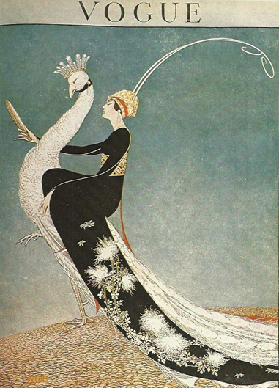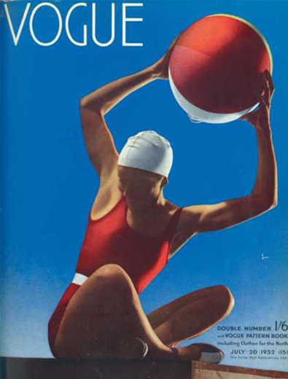
Fig. 3 Vogue Cover April 1918 by George Wofe Pank Fig. 4. Vogue Cover July 1932 by Edward Seichen
Illustration was often used for books, but the purpose to use as magazine front cover is now accomplished or replaced. Luhmann explained that a purpose is different from function, “a purpose is a program that seeks to diminish, if not to conceal, the difference between a desired condition and the actual state of the world” (Luhmann, 2000: 138). When art is used for a different purpose and not necessarily carry the very function of art, this can be fulfilled. What will happen when art is used in another system, which is more dominant? It indicates that art is useful as a communication system, but its existence will be determined by society, as society can have an influence in the way an artist may work.

There was evolution with the change of consumer behaviour and at the same time the mode of production. When the printing process became mechanical this reflected in the rate of production, old printing methods such as etching, engraving or lithograph were not efficient in terms of their speed regardless of their superb quality. Engravers and printers’ jobs were replaced when they no longer cope with the demands thus giving way to new developments of printing. Technological invention is an ongoing process, old methods became outdated and reinvention is needed. Traditional printmaking was the creation of the desire of printing images on the page along with text but became inadequate when compared to new invention but survive as a way for artist to create natural art prints.
Mankind’s dream of gaining a maximum of inorganic power from the world around him and of rendering human work to a minimum does not stop at the threshold of the domain of representation art. All these efforts concur with the desire to increase pictorial exactness and verisimilitude and create an image as close to the model in nature as possible (Schwarz, 1987: 96).

The invention of the printing press in the fifteenth century provided a new way of learning and acquiring knowledge besides religion and there had been great development in science, mathematics and technology. The invention of photography was the long culmination of science and was the beginning of the invasion of technology in art. (Schwarz, 1987)

Summary

It seems that art provided the world what is not found in reality, a way of communication that is more powerful than words. Since the introduction of photography, the skill of creating accurate images became insufficient, secondary to artist’s ability and sensibility to perceive and express. The concept is fundamental whereas the way to represent can be achieved by any practical methods or any object where technical skill is not always essential. Another problem with traditional methods is the time constraint when compared with modern technology and able to produce larger quantities in a shorter space of time and poses the question to choose quantity over quality.

Chapter two Machine takeover

Digital - a new medium and a new tool

As discussed in chapter one, technological invention will continue, one major discovery in the twentieth century is the computer.

Since the Industrial Revolution, Western cultural attitudes have continued to put “man” in opposition to “machine”. Translated into cultural value … By now, we have developed mechanical or electronic extensions of almost everything we used to do with our bodies alone. A welding tool – hand, a camera – eyes, sound system – ear; and the computer as an extension of the brain ((Lovejoy, 2008: 3-5).

There has been massive development since the introduction of photography, reproduction of an image became quicker; the process has been significantly reduced from taking days, to a day, then an hour. One problem remained, while a painter has the freedom to draw attention to a focal point and leave out a certain area the camera remains truthful. Due to the switch over from analogue to digital there has been a huge impact on contemporary creative industries, computer software such as Adobe Photoshop allows editing and manipulating of a photograph, which requires a knowledge and skill of a different kind. One of the issues surrounding technology is, while solving one problem, another problem occurred. When a photograph can be edited or manipulated, the notion of the photograph as accurate is now challenged.

One of the reasons that artists turn to the computer is the convenience to make amendment and adjustment therefore saving time especially when there is a deadline to meet. Resolving inconvenience became the motif for one to turn to, using technology to seek improved methods of working. According to German philosopher and thinker Martin Heidegger (1889 - 19760, whose essay Question Concerning Technology discusses the truth or the essence of technology as “a way of revealing” (Quoted in Braver, 2014: 196); technology offers a solution by revealing the problem. An artist opts for a computer as a better option, motivated by the problem or issues that interfere when creating artwork; the solution which is offered by technology highlights this and it became an obstacle or inconvenience that needed improvement. There is now a possible comparison with an alternative in addition to what is already available; the choice between the time-consuming hand-rendering when any mistake can cause damage or to turn to a computer which allow editing and manipulating. At the time before software was available for art making, there was no other way accept working on the technical skill to create the perfect outcome to meet designated deadlines. Issues about time constraints, dealing with difficult clients were challenges that need to be overcome. (Braver, 2014)

Whichever medium an artist decides to use, there will always be limitation; with traditional mediums each have their own characteristics, although time constraints provide their own limitations. The skill needed to create artwork via computer is very different; it required the understanding of the software involved, where as a hand drawn image can be edited but not essential. The computer offers a selection of built in tools with a variety of effects mimicking traditional medium therefore lacking its own character, and image can appear ‘flat’ or without texture when printed on paper. While an illustrator or designer may often work with a commercial client, with their works featured on a printed page, the uniqueness of the original hand drawn piece will not be an important aspect to consider when there are other issues to deal with such as time frame. Moreover, the image may need to be scanned and sent electronically therefore working via computer would be a suitable choice. “New methods and materials are only justified if their use enhances the idea of image being conveyed … If, however, the choice of method and material seems to follow the latest fashion or sensation it will be seen superficial in intent” (Simmons, 2005: 32-33).

Art in The Postmodern Digital Era

Digital technology along with the Internet had created a virtual world, a space where there is no physical existence of any kind except when viewing on the screen. Such creation allows communication through text and picture with the convenience of one being connected to the Internet or Wi-Fi system with a hand-held device. The device - ‘smartphone’ not only permits image capturing, sharing, as well as simple image editing with ‘application’ that can be download, which was previously only accessible through computer software. With access to the Internet, one can view images and at the same time copying and editing which can have an impact on a work of art. Figure 3, an image found online, created by editing and adding an icon of social media to an Edward Hooper’s oil painting this reflects what is Post Modern. The original painting depicts a quiet morning where a man sits in front of the empty shop; it is descriptive but not conclusive as what the man is doing. When the symbol is added into the painting, that changed the context of the painting, such act is difficult to judge as to whether it is a great idea or lack of personal style since idea itself can be art.
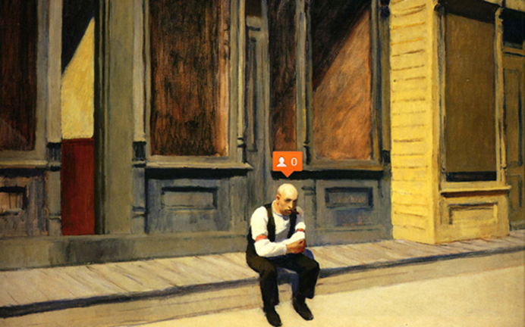
Figure 3. Nastva Nudmik Emoji Nation Digital

Arguments about the lack of personal style as a new icon of the post-modern time were due to the easy access to the computer. Are artists guilty of not being innovative? Is the computer or technology to be blame? Figure 6, 7 and 8 are watercolour paintings featured online when searching on the Internet. There are online tutorials showing ways to create watercolour painting and similar styles can be found on the Internet when one searches through the online gallery. This cyberspace provides a platform for artists to showcase works to reach the wider audience around the world. The issue is this space is with such huge quantities of available works, one needs to have a distinctive style to be able to get attention. This mode of communication means art operates independently as mentioned in chapter one; the system/environment analysis. Luhmann described that when art operates in the environment, which means art operates “in its unmarked space” (2000: 135) thus it can be anything. Furthermore, there is another space, the virtual world, which provides a new platform with the freedom to express but may be lacking the spiritual force. It is with creativity along with artistic skill that will differentiate the work of a great artist and an ordinary mind.
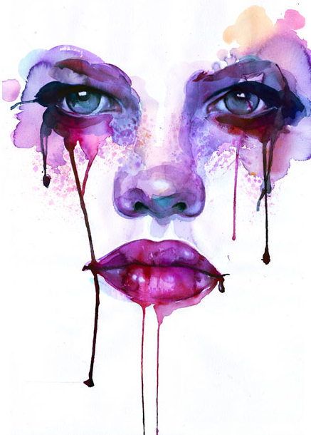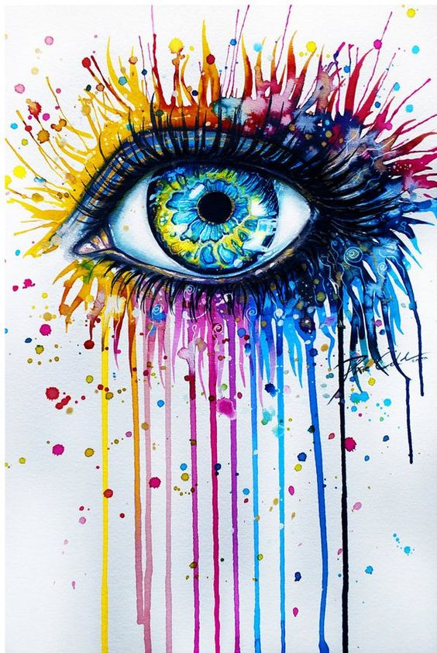
Fig. 4 Marion Bolognesi Watercolour Online Fig. 5 Artist Unknown Watercolour

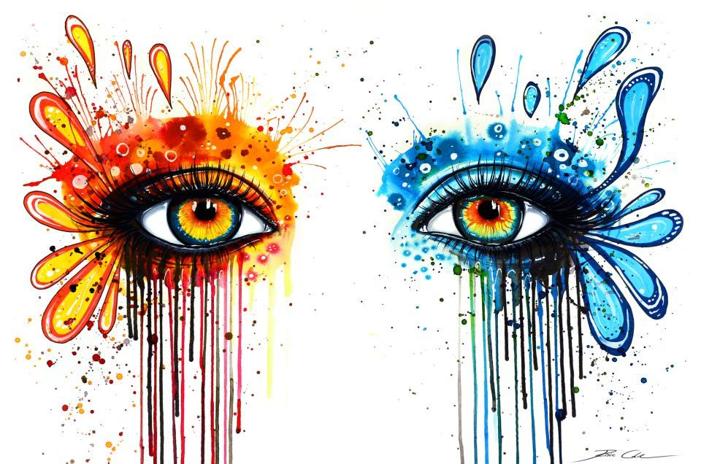
Fig. 6 Svenja Jodic Watercolour
What happened to art in the digital age? Computer software allows an image or photograph to be enhanced beyond the realm of the traditional representation. The comparison was made from Renaissance period to present days when the aesthetic theory was first established, “that a work of art is the direct and faithful representation of a natural object” (Panofsky cited in Schwarz, 1987: 98). It was this theory that painting suffered the fatal moment when the invention of photography was announced in 1839. However, by looking at cave painting, it was never about reality or likeliness, it is about painting an illusion occurred during an event of significant that one needed to express and record.

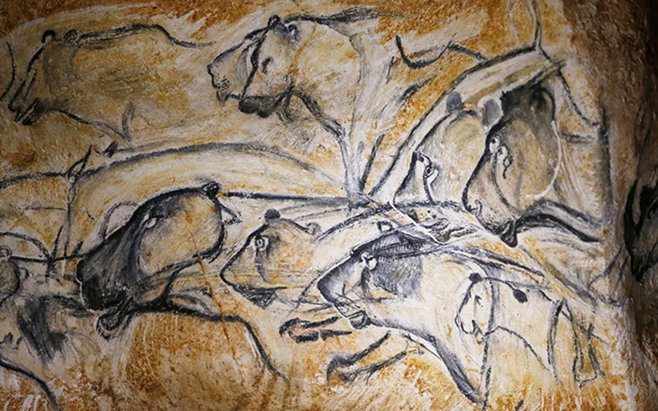
Fig. 7 Cave painting in Chauvet-Pont-d’Arc

According to Luhmann’s, “art split the world into a real and an imaginary world … it is not just a matter of enriching a given world with further objects. How does reality appear when there is art” (2000: 41)? Evidently, art is a manifestation of one’s imagination and what has changed is the surface and the tools available. From the cave to animal skin or tree’s bark until paper was invented. Digital technology and computer provides access and a new tool which allows new experimentation and increase the variety of possibilities that an artist can express.

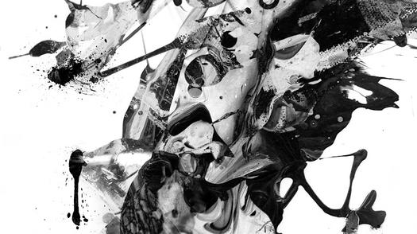
Fig. 8J.H. Fearless Butterfly Dream Digital 2016

Summary
While it seems as the invention of photography threaten the livelihood of painters and designers, digital media provides a new tool and the platform for artists to raise their profile and showcase their works. In comparison to the invention of photography, changes that occurred with new electronic media were a more gradual one and artists and designer had learnt to adapt to new environment.
Chapter three Man versus Machine

Traditional Verses Mechanical

The success of social media indicates society’s obsession with capturing images to record the time and place thus to share it in the virtual world. It is a journey that started off with the invention of photography and finally reached its maturity; by solving the problems of processing, storing and showing when there is now a platform to showcase and share that important moment. One concern might be that all images can only be seen on the screen, what is the uniqueness of an artwork that is stored in the computer terminal without physical existence and separated from the world? In his essay The Work of Art in the Age of Mechanical Reproduction, Walter Benjamin (1892-1940) addressed the issues about ‘aura’, the authenticity and the remoteness of a work of art. He suggested that photographic “reproduction shrinks the ‘aura’ - unique existence in the place where it is at this moment” (2008:5), the quality which does not possess in the reproduction. If the uniqueness of a work of art is its existence being the singular object, will a computer-generated artwork that can be printed indefinitely have the same quality? Does ‘Aura’ or uniqueness of a work of art matter in this cyber space where nothing seems to materialize and vanishes when it is not connected to Internet or without power?

A handmade artwork can be passed down from one owner to another, carry with it the unique traces left behind thus become an object which is unique and being the single one. In contrast, with digital artwork the image is stored as information in the data bank, without contact with the artist and the physical world, the image does not carry any trace or mark and remains fresh when it is printed. There is no original copy as all the copies printed will be identical regardless as to whether it is the first or last. (Love in Smith, 2015)

Heidegger’s revealing of technology is that the usefulness of the tool is concealed whereas with traditional methods the usefulness of the tool is made noticable. The artist is aware of the tool during the process and the effect that this has on the creation of the surface, the marks, or brushstroke, pigments and even the texture of the paper became noticeable by the act of the artist. Digitally created images do not have the same effect when viewing on the computer screen; while creating an artwork digitally, the image is concealed visible only through the screen but separated from the artist and reality. While a painter’s activity is creating; which is to start from a blank surface, digitally produced work is not always the case, and it can be constructed by reducing or editing of an existing image where the artist has full control of the whole process. This contradicts Heidegger’s theory on the origin of art, that “the great artists do not control but submit, letting the marble guide their hammer to free what ‘wants’ to be let out” (Braver, 2014; 192).

East Versus West

It seems that art is needed “as an autonomous force in the society”, but will painting survive the digital revolution? Abstraction and non- objective painting, the responses towards photography as ways to challenge the limitation of photography, all of this can be achieved through computer software. Turning away from technical skill and paying attention to the concept as it is the process where the artist can take ownership thus cannot be replaced by technological means. When the concept becomes such an important part of art, its presentation can be in any form or any medium; found objects, installation, absolutely anything. The process of creating art thus split into two stages; first, the idea and then how to present it; “all planning and decision are made beforehand and the execution is a perfecting affair” (Lovejoy, 2008: 28). Is turning away from technical skill such as painting and drawing how painting can survive? There must be a quality in painting that cannot be achieved through technology or concept alone.

In 1914, Bell published his book entitled Art, in which he discussed his hypothesis relating to visual art and the ‘significant form’, which defines a quality found in a work of art that provokes an emotion in the spectator. Bell defined art as
an expression of and a means to a state of mind as holy as any that man can experience; and it is towards art that modern minds turns, not only for the most perfect expression of transcendent emotion, but for an inspiration by which to live (1949:227).

In other words, an artist’s response in the moment of inspiration by an object or imagination can manifest itself through mark making or the arrangement of lines and colours. Significant form, is not commonly found in photographs or most illustrations. For Clive Bell, “photographs provide information but nothing else and most illustrations are descriptive paintings in which form is used to convey emotions, not as an object of emotion” (1949: 16-17). His theory was based on his own response to visual art particularly Modern painting in the early twentieth century. Although there is no clear definition about significant form, his theory coincides with the practice of Chinese Painting.
What defines painting is its spiritual quality, its idealism, and its life and movement... Otherwise, it would be just like photography, repetitive and uniform, and indistinguishable from it. … What defines art is the artist’s ability to affect his viewer, and to elicit a sympathetic response with his own spirit. Only when an artist experiences a response himself can he move his viewer to respond to what he feels (Chen Hengke quoted in Fong, 2001:14-15).

The essence of Chinese painting is based on the principal of calligraphy brush strokes, capturing the spirit or life force of each subject. It is not about “representation or non-representation but on the essential harmony between the two” (Fong, 2001: 8). The focus of Chinese painting is about learning, a journey of self-cultivation and not emphasized on personal style or concept. The mind extended through the hand and the brush, with varying strength, direction, with each brush stroke different, reflecting the personalities of each painter. This quality cannot be achieved by technological means or replaced. The focus of Traditional Chinese painting is the inner self which reflects on the artwork whereas in the West, practical method and concept became the driving force. (Fong, 2001).
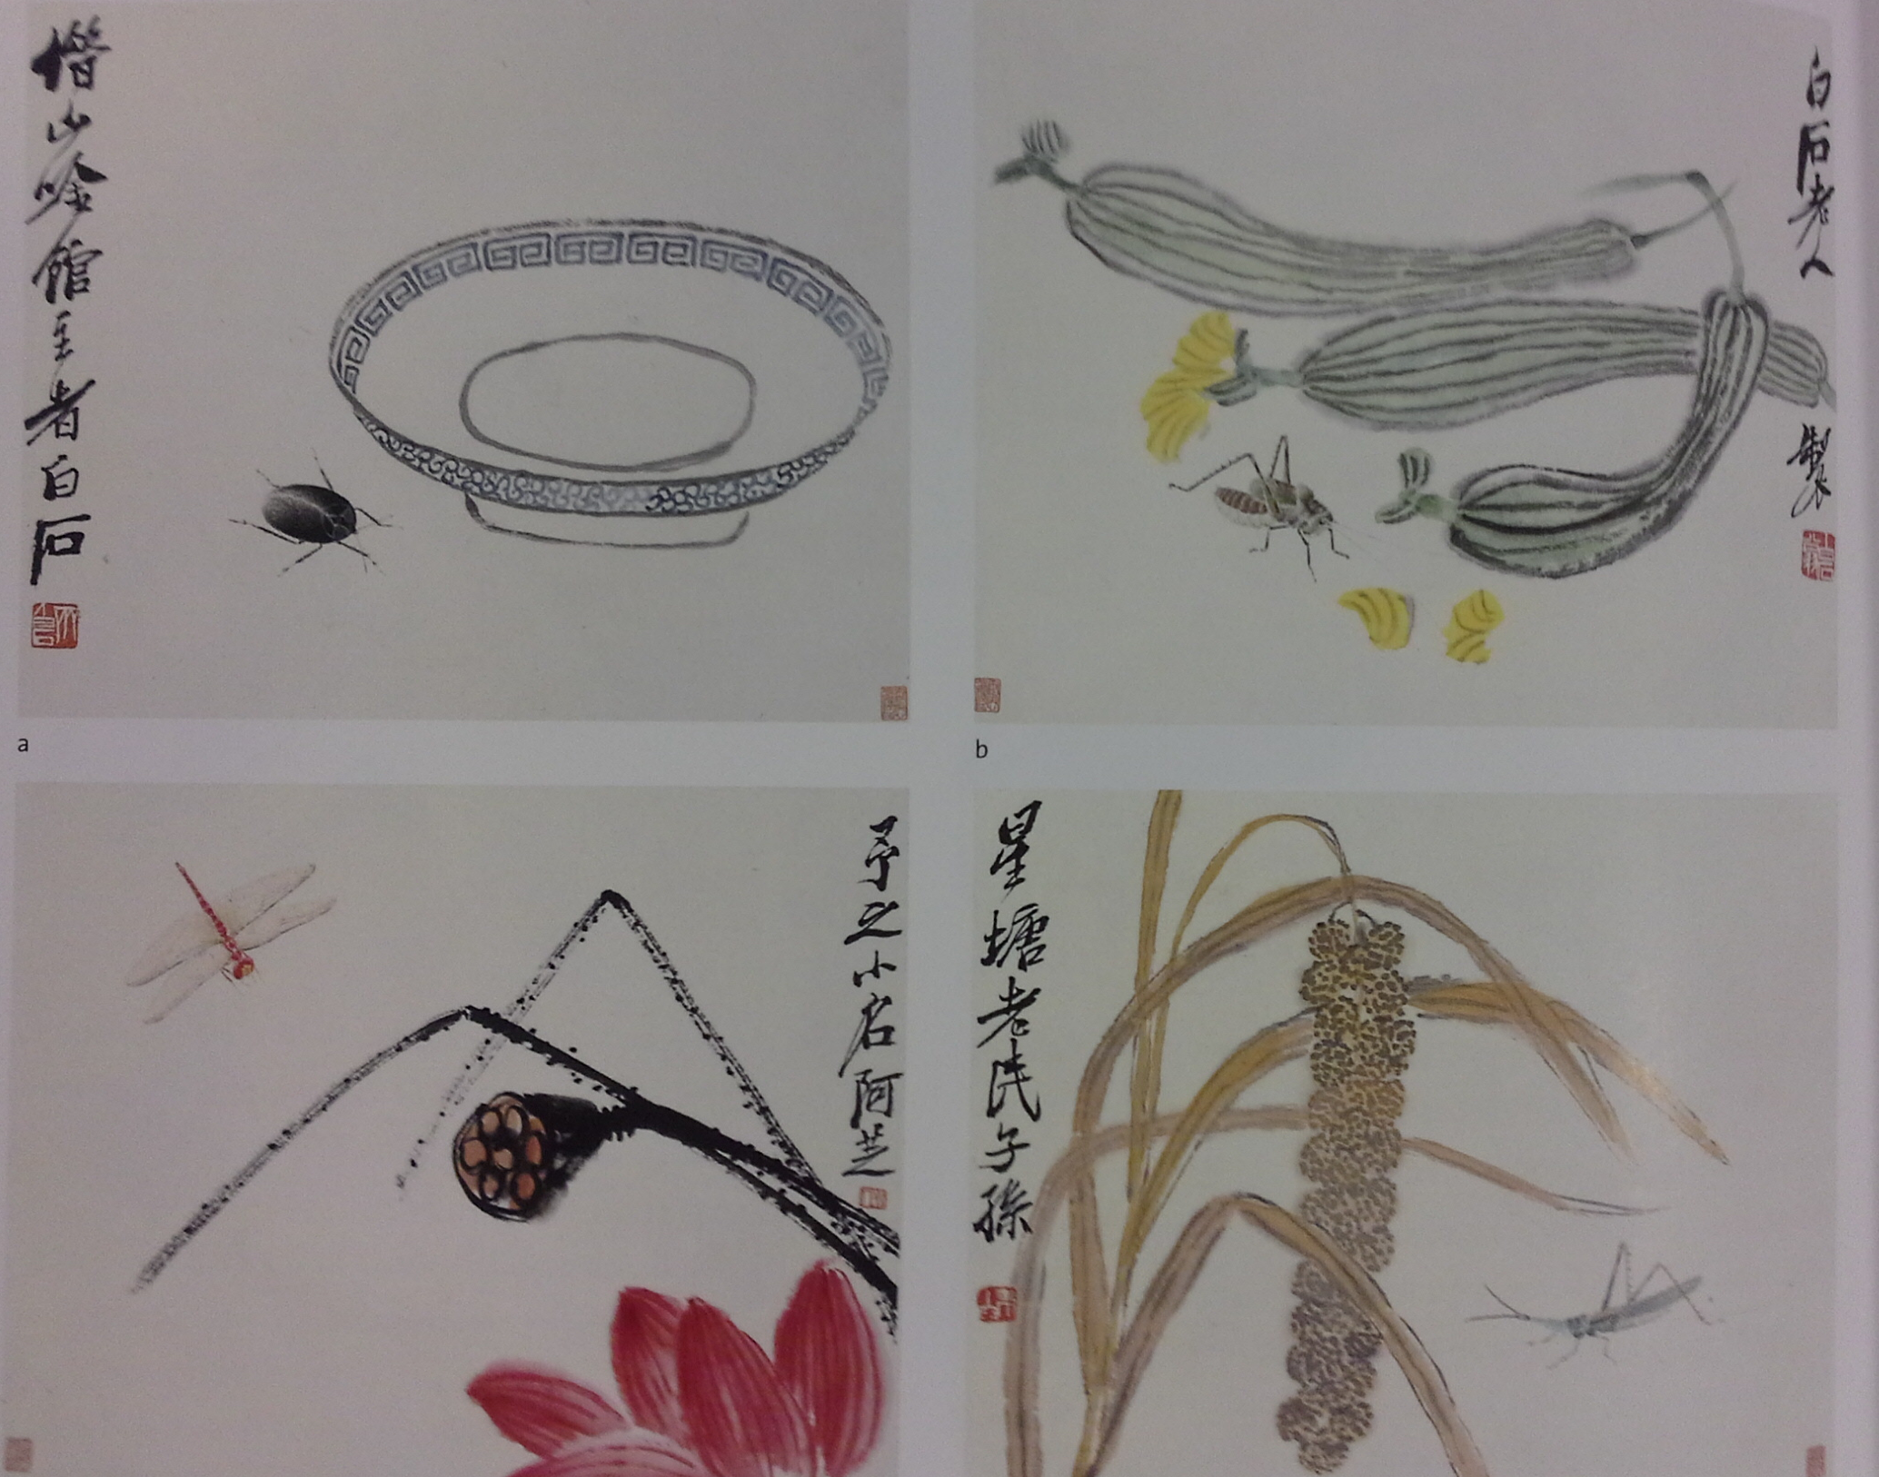
Figure 9. Qi Bashi insect and Plant Ink
It is difficult to distinguish painting from illustration as often there will be annotation or poem written along to express the feeling or thought associated with the painting. Modern technology rarely has any impact or influence on Traditional Chinese Painting and the practice remains the same in modern days. Chinese Painting as the act of painting is an autonomous response, spontaneous rather than constructing. As Heidegger’s theory on the origin of an artwork, “the great artists do not control but submit, letting the marble guide their hammer to free what ‘wants’ to be let out just like Michelangelo” (Braver, 2014: 192). The difference between the two cultures is that the Eastern approach to painting is more spiritual, the mind and the body is regarded as one.

Summary

Digital technology provided an additional tool that enables an artist to create, edit, store, print and communicate which seems to be an ideal solution in the computerised society. However, an artist will only consider a computer as a better option when there is a problem with the existing working method. If an artist prefers the time consuming traditional working method or sees a mistake as a way of learning or need improvement, then seeking technological help is not needed. In the West the concept is “the most important aspect of the work … The idea becomes the machine that make art” (Sol Levitt cited in Lovejoy, 2008: 73).

Conclusion

The shift from representation towards conception emphasises the importance of the idea and the ability to express while the skill to draw or paint become less of a focus. Fine art students are encouraged to be creative in terms of idea or concept rather than working on drawing or painting skills. Even though the idea is an essential part of the creative process what is the issue with developing fundamental core skills with concept? What is the future for an art student that adores traditional handcraft methods in the world that evolved so rapidly? If traditional art and craft must gain its value, where is the place to start?

Art itself is a complex system within itself, contextual art has been the focus within the practice of art since the beginning of the twentieth century, and the definition of art became so complicated that it is difficult to classify what art is or what is not.

Has traditional painting lost its value in the modern world that filled with high-tech devices when the younger generation have already started creating images and filming using the IPad? With the national curriculum now including digital competency as part of the requirement along with literacy and numeracy that indicates that the digital skill is essentially an important part of everyday life in the 21st century. The definition for digital competency is “the capabilities which fit someone for living, learning and working in a digital society” (Learning Wales, 2016). What about art, will there be less focus on student’s creativity and artistic skill?
At the time when I was researching, AlphaGo, the artificial intelligence invented by Google DeepMind had won the second game of the Go world championship, beating the world’s number one player, Ke Jie. This sparked the debate as to whether positions that require analytical and mathematical skill can be better performed with the help of A.I. (BBC, 2017). The advancement in technology is so rapid that it is difficult to predict what will happen to artist and designer in the near future and the impact on daily life cannot be foreseen.

I have written my dissertation on the subject that I am most concerned with, not just as an artist but as an individual. My perception of digital technology as a tool and new art form has changed because of my research. I thought that as an emerging artist, I must adapt to the industry and how it evolves in order to find work. My research now shows that although digital skill is essential for communication, and to showcase work the use or the choice of medium is up to the artist to decide, as to which is the most suitable one to work with. What has changed at the turn of the twenty first century was the mode of communication; electronic media, became part of everyday life, convenience and as a preferred method for the majority.
The development in digital technology has transformed the way artists work. It broadens and increases the possibility of the way an artist can explore, although there is a concern whether artworks stored in the computer have the same quality as a hand painted artwork in each embedding the meanings through time thus to become unique.

Reference List

Books and journal

Benjamin, W. (2008) The Work of Art in the Age of Mechanical Reproduction. Translates from German to English by Underwood, J. London. Penguin
Bell, C. (1949) Art. Oxford University Oxford. Press
Braver, L. (2014) Key Contemporary Thinkers: Heidegger. Cambridge. Polity Press
Derrick, R. Muir, R. ed (2009) Vogue Covers: on Fashion’s Front Cover. London. Little Brown
Fong, W. (2001) Between Two Cultures. New York. Yale University Press
Lovejoy, M. (2008) Digital Currents: Art in The Electronic Age. Oxon. Routledge
Luhmann, N. (2000) Art as A Social System. Translated from German to English by Knodt, E. Stanford.
Stanford University Press
Male, A. (2014) Illustration Meeting the Brief. London. Bloomsbury visual Art
Schwarz, H. (1987) On Photography in Parker, W. (ed) Art and Photography: Forerunners and Influences. Chicago. The University of Chicago Press
Simmons, R. (2005) Collecting original Prints: A Complete Guide. London. A & C Black Publisher Ltd.
Love, J. (2015) ‘Somewhere between Printmaking, Photography and Drawing: Viewing Contradiction within The Printed Page’ Journal of Visual Art Practice. 14 (3) London. Routledge
Spivey, N (2005) How Art Made the World. London. BBC Books

Online
Jisc (2015) Developing students’ digital literacy available on https://www.jisc.ac.uk/guides/developing-students-digital-literacy, accessed on 05/07/17
Andrews, A. (2012) An Apple for the teacher: are iPads the future in class? https://www.theguardian.com/teacher-network/2012/aug/13/schools-secondary-schools, acceded on 05/07/17
Learning Wales (2016) Digital Competence Framework. Available on http://learning.gov.wales/resources/browse-all/digital-competence-framework/?lang=en, accessed on 05/07/17
BBC (2017) Google AI defeats human Go champion. Available at: bbc.co.uk Accessed on 25/05/17

Further Reading List

Books and Journal
Gabury, J (2015) ‘Hidden Surface Problems: on The Digital image as material Object’ Journal of Visual Art Practice. London. Routledge
Greenberg, C. (1993) Affirmations and Refusal Volume 3: The collected essays and Criticism. Chicago. The University of Chicago.
Heller, S. and Chwast, S (2008) Illustration: A Visual History. New York. Abrams.
Horne, A. (1995) The Dictionary of 20th Century British Book Illustrators. Suffolk. Antique Collectors’ Club Ltd.
Houfe, S. (1996) The Dictionary of 19th Century British Book Illustrator. Suffolk. Antique Collectors’ Club Ltd.
Lovejoy, M. (2008) Digital Currents: Art in The Electronic Age. Oxon. Routledge

Online
British Museum ( ) Ancient Egyptian Book of the Dead. Available on, https://www.britishmuseum.org/pdf/3665_BOTD_schools_Teachers.pdf, accessed on 13/11/17
Cole, B. (2007) Jean Delville’s La Mission de I’Art: Hegelian Echoes in fin-de-siecle Idealism available http://web.a.ebscohost.com/ehost/pdfviewer/pdfviewer?vid=10&sid=531e8b75-523a-4b5f-8519-74736ef06ef5%40sessionmgr4010, accessed on 02/10/17
Farago, J. (2015) Is Painting Dead? Available on, http://www.bbc.co.uk/culture/story/20150217-is-painting-dead, accessed on 26/06/17
Ghosh, P. (2014) Cave Painting Change Ideas about the Origin of Art, available on, http://www.bbc.co.uk/news/science-environment-29415716, accessed on 12/11/17
Levitt, M. (1954) Question Concerning Technology. Available on, http://ssbothwell.com/documents/ebooksclub.org_The_Question_Concerning_Technology_and_Other_Essays.pdf, accessed on 12/11/17
British Museum ( ) Ancient Egyptian Book of the Dead. Available on, https://www.britishmuseum.org/pdf/3665_BOTD_schools_Teachers.pdf, accessed on 13/11/17
Stanford Encyclopaedia of Philosophy (2015) Walter Benjamin, available on, https://plato.stanford.edu/entries/benjamin/, accessed on 04/07/17

List of Illustrations

Figure 1. Pank, G. Vogue Cover 1918 [online] Available at: http://www.vogue.co.uk/magazine/september-1916. Accessed on 30/10/17
Figure 2. Seichen, E. Photograph Vogue Cover July 1932 [online] Available at: http://www.condenast.de/en/ueber-uns/heritage Accessed on 30/10/17
Figure 3. Nudmik, N. Emoji Nation Digital [Online] Available at:

Figure 4. Bolognese, M. untitled. Watercolour. [Online] Available at: http://www.partfaliaz.com/illustrators/illustrative-watercolors-paintings-by-marion-bolognesi/ Accessed on 07/12/17
Figure 5. Unknown. Untitled, [Online] Available at: https://homesthetics.net/19-incredibly-beautiful-watercolor-painting-ideas/ Accessed on 07/12/17
Figure 6. Jodic, S. Untitled. [Online] Available at: http://myartmagazine.com/colorful-watercolor-paintings - Accessed on 07/12/17
Figure 7. Cave Painting in Chauvet-Pont-d’Arc. [Online] Available at: http://www.telegraph.co.uk/news/worldnews/europe/france/11522306/Chauvet-Pont-dArc-cave-paintings- Accessed on 07/12/17
Figure 8. Fearless, J. Blue Butterfly. 2016. [Online] Available at: https://creators.vice.com/en_us/article/mgpzxp/disquieting-digital-abstractions-challenge-the-nature-of-reality Accessed on 07/12/17
Figure 9. Qi, B. Insect and plant Photograph taken from Fong (2001) Between two Culture New York. Yale University Press

