There is no place where we can’t be!

2019
Cristina Sulugiuc
GAC Transport
12/1/2019
Business Plan

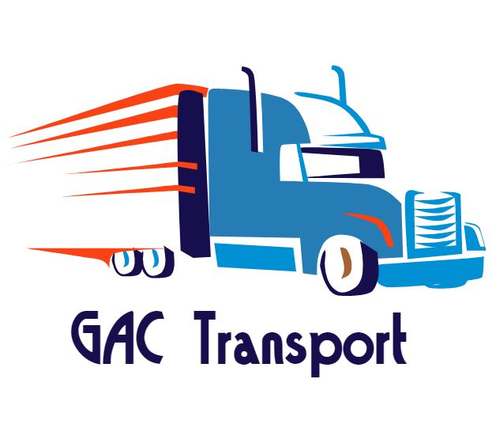
Marketing Strategy – GAC TRANSPORT
Business logo
The logo of the business represents the first impression, the vibe and energy that the service or product transmits. Some might say that it is the front door of the business. (Paish, 2017)
How can you tell that a logo design is successful? “Successful logos are immediately recognizable, reflect a brand’s message and stand out from the crowd. They build trust and look timeless and professional.” (Paish, 2017)
Inspired by 100 famous logos (Coca Cola, Mercedes Benz, Toyota, Nike, Etc) (inkbotdesign, 2017) GAC Transport decided to create its own logo in order to promote its Traction Trailers business. The truck is the main symbol that informs the market what our service is. Regarding the colors, it have not been set randomly, but in chromatic scheme in order to “satisfy” the eye and to be easy to remember. According to a study on the interactive effects of logo color, that measures how consumers judge the appropriateness of colour, based on product function, blue is a functional colour that is appropritate for products that can solve problems. As our service is to solve other’s goods transportation problem, this color reflects best our functionality. Blue and orange are complementary colours that are high in vibrance and contrast, creating visual balance with opposites. (freelogoservices.com, 2018)
Similar logos with complementary colours are used by the following known brands: Tide (blue, orange and yellow), Heineken (green and red), Firefox (blue, orange and yellow) Carrefour (orange and blue) (inkbotdesign, 2017)
The logo will be printed on business cards and drivers’ t-shirts, not on the tractor units also, because they are rented. After the business will buy its own tractor units, we will be able to personalize the tractor units and the curtain side of the truck, in order to make our brand more visible.

T-shirt design
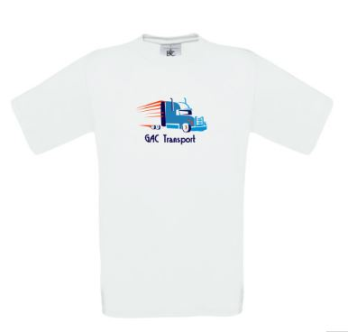

Business card design
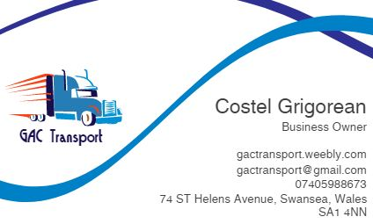

- Defining the target market
When looking at the current state of the economy, it is important to have a defined target market for our company. Being a small business, we cannot afford to target everyone, but can find a niche market in order to be able to compete with the large competitors, as DHL, Owens, etc. Also, targeting a specific market it does not mean that we give up on possible customers, but it becomes more efficient to create the message and use the right media to transmit it. (Porta, 2019)
Our target market are basically organizations and companies who own trailers and need to move them from one location to another location.
In other words, our target market is in Wales, but in the future, we intend to expand the area into whole United Kingdom and Europe according with our medium-term objectives.
Below there is a list of the people and organizations that we have plans to do business with:
- Merchants (importers, exporters, traders, suppliers, wholesalers, and dealers)
- Manufacturers
- Warehouses like Amazon
- Supermarkets like LDL, Tesco, ASDA etc
- Small business owners
- Hazards sector
- Strategic Marketing Alliance with Our Competitors in the Trucking Industry
In order to increase our sales, our company will form strategic marketing alliance with other competitors in the industry, due to the fact that some trucking companies may lack the capacity to handle certain freight contracts. Our company intends to form alliances with the following and not only competitors: DHL, Owens, John Pearce Transport, XPO, etc.
Main collaborators
Due to the fact that GAC Transport will ensure the transportation of hazardous goods as well, we will collaborate with Freithroute and Hazchem.

- Marketing Mix – 7 Ps
Product: GAC Transport is a Transport Company that offers traction only services to customers that own trailers. Having a fleet of 3 Volvo 6x2 capacity 44 tonnes trucks, GAC Transport will distribute a variety of goods to any location in United Kingdom. For this service to be in accordance with the legal laws, a contract between our company and the client will be concluded.
Price: GAC Transport sells its service to a price of 350 pounds/shift comparing to other similar companies that have a higher price. The price will increase depending on the profit that the business will make over time.
Place: Customers that are interested in our services are expected to our home-based office on 74 Saint Helens Avenue, SA14NN, Swansea Wales. For more information and details customers are directed to our website - https://gactransport.weebly.com/ In the first 2 years, the company will distribute goods only on the territory of United Kingdom. After the Brexit will be clarified and United Kingdom will continue to be or not to be a part of Europe, GAC Transport will consider extending our services to the territory of other countries in Europe.
Promotion: To attract the customers and keep them longer, at the beginning, GAC Transport will offer 15% discounts for every 3 loads. The marketing strategy we have chosen to promote our company combines both traditional and modern tools. Through social media (Facebook and LinkedIn) we will connect with our possible customers, keep them up to date regarding our business, prices, events. We will also run a direct mail and e-mail campaign in order to let as many customers as possible know what our business is all about and why we are the perfect choice for their transportation problem.
People: This company is run by one owner and 4 partners. In order to best meet the needs of our customers and assure that the goods arrive safely to the desired destination, the company hired qualified drivers. Due to the fact that they are the image of our company, we offer our drivers a motivating salary and excellent working conditions to take care of our customers. Because our drivers focus on professionalism, punctuality and traffic safety, customer’s trailers are transported with the utmost care and trust.
Physical evidence: All contracts signed between the company and customers are kept in our home-based office and anyone that it is interested in doing business with us can visit us to 74 Saint Helens Avenue, SA1 4NN, Swansea. Our 3 Volvo traction units can be seen in the parking lot rented by our company. After we start running our services, the general public will have access to customers reviews on our Facebook page and ‘Google my business’.
Process: Although GAC Transport offers a practical solution to a complex problem which concerns the whole economy, the process is simple and transparent. Our tractor units will take the customer’s trailers and will transport them safely to the needed location. During the transportation, our drivers will be monitored, and we will know exactly their location and the time at which our customer’s trailers have been delivered. (Toolshero, 2019)
- Marketing activities
Jared Fischgrund (Director for OMG Tow Marketing), advised that is important to have an online presence on the well-known platforms like: Google, Yahoo, Bing and social media, Facebook, Instagram, etc (Insurancehub, 2019).

- Google my business
Google my business is a free tool that helps businesses like ours to manage the online presence in Google Search and Google Maps. The information displayed on the knowledge card for our GMB page includes plenty of data that informs people about our business and it is easy for them to determine whether want to engage with our service or not. (Philips, 2019)
GAC Transport will take advantage of “Google my business” in order to increase visibility in research and to direct easier the traffic to our website and our front door.
Our knowledge card from GMB (Google My Business) would look like this:
Business Name
GAC Transport
Business Type
Transportation/Distribution
Address (Office)
74 St Helens Avenue, SA1 4NN, Swansea, Wales
Hours of operation
24h/7
Phone Number
07405988673
Link to website
https://gactransport.weebly.com/
Images
Link to Google Maps
Reviews
Overall Star Rating
Popular times to visit
8am – 12pm
Related Searches
In order to optimise this tool, we will follow the next steps, as Kevin Philips (2019) advised:
- Complete the business information and add description
- Upload more and better images
- Respond to Google My Business reviews
- Use posts to promote events, offers, and content
- Create and upload videos

- Domain and website
An important step in developing a strong online presence is to have a professional-looking website. Jared Fischgrund (2019) explained that “A guy with two trucks can make himself look like a million-dollar business if he has great pictures and it looks professional.” Based on the fact that people make decisions more on what they see than what they read, GAC Transport created a professional looking website (https://gactransport.weebly.com/ ) in order to be easier to access the service, to provide a clear and precise information about our traction only services and our prices.
Domain: gactransport.co.uk
- Social Media (Facebook and LinkedIn)
Because having a great website for the business is not the end of the marketing strategy that can bring customers, there is an important factor that can help the business grow, which is social media. Moreover, by engaging the future customers with the social media, we will be able to connect with them more easily, constantly keep them up to date regarding our prices and possible events and collaborations with other competitors from trucking industry.
It is also imperative to mention that social media marketing is cost effective and will help the business to keep the expenses low. Specialists advise that social media might help improve the searching engine rankings as well. (Smith, 2019)
By creating a Facebook page, we intend to establish networks with potential commercial customers, join professional trade groups and local business groups. Besides this, we can improve and develop our service, by having direct feedback from customers through reviews posted on Facebook page.
After reaching a certain profit, after 2 or 3 years, GAC Transport will have the possibility to run advertising campaigns on LinkedIn platform in order to build awareness about our brand and raise the number of our customers.
Campaign Manager is a platform on LinkedIn where you can advertise your business. It is easy to set up the budget for the campaign whether daily or monthly. When testing a new platform, for the first 2-4 weeks, it is recommended to spend around 4000 pounds a month, or 80 pound per day. Although it is a considerable sum, building a strong foundation for the long-term marketing strategy, it is an important step for the growth of the business. Investing much money on the campaigns, means that it will reach a high number of people and we will be able to verify the ad performance, based on the objective that we have set for it. (LinkedIn, 2019)

- Direct mail and e-mail marketing campaign – Niche growth
In order to establish the business in a niche market, GAC Transport will run a direct both e-mail and mail marketing campaign. Possible customers like Amazon, Tesco, Lidl, Etc, will receive creative and on point mails regarding our new business and attractive packages for our service. Even though mails are the oldest form of marketing, it has been proven that direct mail campaigns have a higher return on investment (ROI) than any other online ads. However, social media remains among the top marketing tools that has the highest ROI. (mailchimp,2019)
Selling our service much cheaper than the other big competitors, only 350 pounds/shift, we believe it will boost our sales and gain more customers.

References
Ferraioli, T. (2019) Marketing Ideas for Trucking Companies. Chron [Online] Available at: https://smallbusiness.chron.com/marketing-ideas-trucking-companies-3562.html (Accessed: 29th November 2019)
Fischgrund, J. (2019) in Betts, K. (2019) Marketing a tow truck business. insurancehub.com. [Online] Available at: https://insurancehub.com/marketing-a-tow-truck-business/ (Accessed: 5th November 2019)
Freelogoservices (2018) Logo colour psychology: A complete guide to choosing brand colours. Freelogoservices.com [Online] Available at: https://www.freelogoservices.com/blog/2018/02/08/logo-color-psychology-choosing-brand-colors/ (Accessed: 5th November 2019);
Inkboot Design (2017) The 100 Most Famous Logos of All-Time. Inkbootdesign.com [Online] Available at: https://inkbotdesign.com/100-famous-logos/ (Accessed: 2nd November, 2019);
LinkedIn (2019) Make the most of your budget. Linkedin.com [Online] Available at: https://business.linkedin.com/marketing-solutions/success/best-practices/maximize-your-budget (Accessed: 27th November 2019)
Paish, C., (2017) Top 10 of the world’s most famous logos and what you can learn from them. 99designs.co.uk. [Online] Available at: https://99designs.co.uk/blog/logo-branding/famous-logos/ (Accessed: 5th November 2019)
Philips, K., (2019) How to Completely Optimize Your Google My Business Listing for 2019. Impactbnd.com [Online] Available at: https://www.impactbnd.com/blog/google-my-business-tips (Accessed: 5th November 2019);
Smith, K. (2019) 15 Reasons Why Marketing Through Social Media is a Must for Every Small Business. Lyfemarketing. [Online] Available at: https://www.lyfemarketing.com/blog/marketing-through-social-media/ (Accessed: 20th November 2019)
Toolshero (2019) Service Marketing Mix (7 P’s). toolshero.com [Online] Available at: https://www.toolshero.com/marketing/service-marketing-mix-7ps/ (Accessed: 1st December 2019)

