Programme: BA in Business Management
Module: Project Management
Module Code: LCBB5005
Lecturer: Dr Molly Jack
Student Name and ID – Valentina Georgieva Pencheva – 2023164
Assessment 2

Table of Contents
Introduction 3
Main body 3
Evaluating project success 3
Project elements 5
Time 5
Cost 6
Quality 7
Other considerations 7
Operational efficiency 7
Sustainability 8
Social and cultural business case 8
Economic effect 9
Impact on local areas and businesses 10
Conclusion 11
References 13

Introduction
Elizabeth Line is among the largest European infrastructural projects and of significant importance for the transportation system in London. It is a source of numerous different benefits for travellers, citizens and other stakeholder groups. However, the project is also associated with significant cost overruns, delays and other issues. As investigated and analysed in assignment 1, some of the project elements, such as time and cost, have failed to deliver initially planned results and performance. Still, in terms of quality and other benefits, the project may be considered as effective and properly completed. Analysing the various perspectives of the project is essential, so that both its positive sides and areas for future improvement are identified and this is used as a guideline in regard to alternative risks which may be faced by similar initiatives.
The current essay aims to explore the various arguments serving as a foundation for considering Elisabeth Line as both success and a failure, so that an overall conclusion can be drawn. For this purpose, different areas of the project are evaluated and presented in depth.

Main body

Evaluating project success
The success of projects is assessed on the basis of diverse criteria which depend on the nature of the project, its scope, significance and impact on various stakeholder groups. Evaluating the degree of project success is essential for analysing good practices and areas for improvement, so that they are considered in other future projects of similar nature. Project success evaluation is a topic which is widely discussed and debated by academic scholars.
The basic criterion for project success is compliance with the Iron Triangle (a.k.a. Triple Constraint) – cost, time and quality. These three elements are perceived as the foundation of assessing project performance and defining it as a success or failure. Evaluating project results and outcome in terms of time, cost and quality is considered to be relatively easy to implement and interpret, as well as comprehendible. The priority of each element, however, would depend on the specific project, as well as its nature and context (Prostejovska and Tomankova, 2017). Despite the fact that these elements are measurable, many projects fail to comply with them which show the importance of investigating such gaps and the potential reasons for their occurrence.
Figure 1 – Iron Triangle
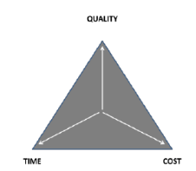
Source: Prostejovska and Tomankova (2017)
Apart from the Iron Triangle, some academics suggest that there are other criteria of performance which can be used to assess whether the initiative has been a success or a failure. According to Prostejovska and Tomankova (2017), these criteria include the information system, the benefits arising for different stakeholders and the social/cultural impact of the project. The outcome in these areas, though, depends on the context and management of the specific project under consideration. Thus, a combined framework for assessing project success can be developed and used in the case of evaluating Elisabeth Line, as shown below.
Figure 2 – Success criteria framework
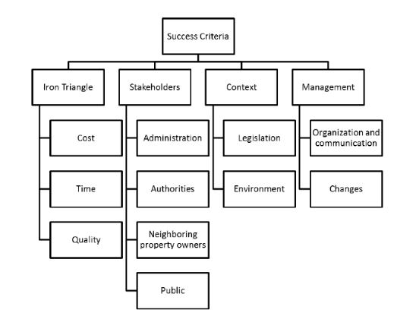
Source: Prostejovska and Tomankova (2017)
In addition to all this, Zwikael and Meredith (2019) suggest another set of project success criteria, mainly focused on using a multi-dimensional approach of evaluation, including areas like implementation operational process, perceived quality, impact on stakeholders, social and cultural significance, information and system quality, user satisfaction and net benefits. This further leads to the assumption that various project areas should be examined in order to justify a final decision on whether a certain project can be classified as a success or a failure.
Based on this review of academic views and literature, a combined approach of assessing project performance has been designed and applied in the case of Elisabeth Line. The project has been officially assessed by auditors emphasising on six main functions, including commercial, health and safety, quality, environment, community relations and social responsibility (Learning Legacy, 2022). The current essay uses a similar approach and analyses some of these areas with the aim of evaluating overall project performance.

Project elements

Time
As analysed in assignment 1, the construction of Elisabeth Line was initiated in 2009 and planned to be completed in 2018 (Sandle, 2022). However, this year marked the partial opening of the line which is expected to be completely finalised in 2023. The significant delay of more than four years is caused by various issues which arose, such as problems with safety testing and signalling systems and the complications caused by the recent COVID-19 pandemic (Sandle, 2022). As indicated in assignment 1, the main part of the delay could have been planned and addressed earlier, as the adjusted schedule from 2012 has indicated a 12-month slip followed by urged need for training employees, trial operation and other operational activities which accompany the opening of the project (Weaver, 2022).

Figure 3 – 2012 schedule
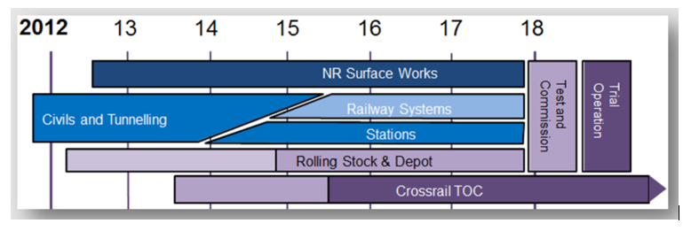
Source: Weaver (2012)
The full project is planned to be completed in May 2023 when all stations should operate and function normally. Currently, the newly opened system is operating as three separate railways, while works on Bond Street Station in central London are significantly delayed due to testing and integration issues (Weaver, 2022).
Figure 4 – Elisabeth Line
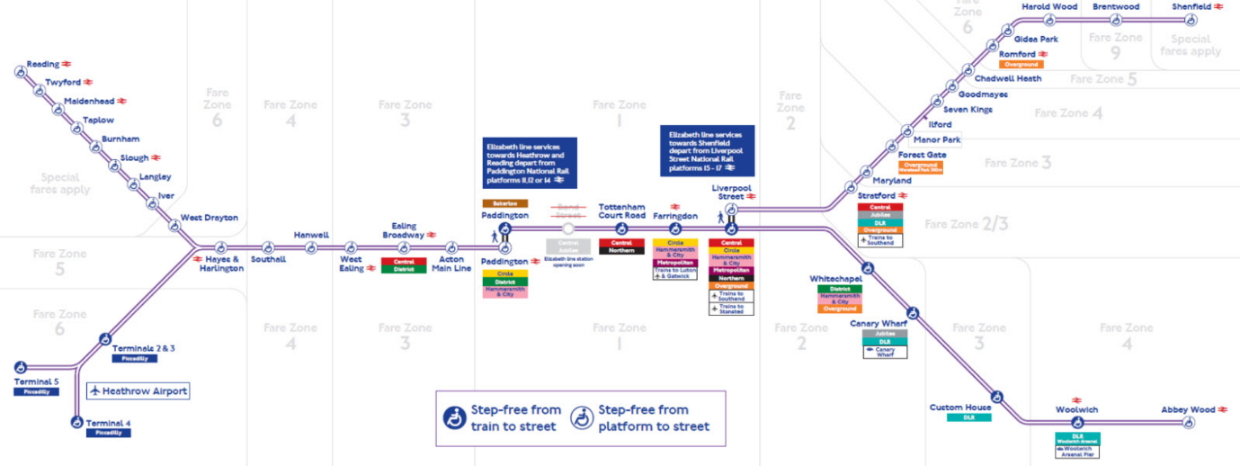
Source: Weaver (2022)

Cost
The cost objective of the project has not been complied with. The budget of the project was £14.8 billion in 2010 but has gradually climbed over the years by reaching £18.9 billion in 2022 and expected to go over £19 billion until final opening of the line in 2023 (Mulligan, 2022). Moreover, it should be noted that the significant delays in opening the line have further contributed to increasing costs. The estimated revenue lost from fares, if Elisabeth Line was opened as expected are approximately, equal to £1.5 billion (London Gov, 2020). Considering the projected cost overruns and revenue losses together, the total budget impact of the delay is estimated to be approximately equal to £5.3 billion (London Gov, 2020). This is a very large deviation from the initial budget of the project and is considered to be one of the main areas of failure of Elisabeth Line (Marshall, 2020).

Quality
Quality objective of the project is considered to be complied with. Currently, services from Reading, Heathrow and Shenfield are on track with 22 trains per hour in peak times and 16 trains per hour in off-peak times (Crossrail, 2022). The plan is to reach up to 24 trains per hour at peak periods between Paddington and Whitechapel, as well as 20 trains per hour in off-peak periods, and this is currently forecasted to be completed by May 2023 (Crossrail, 2022). The design of the stations also contributes to higher perceived quality of the overall project. It is based on addressing three main elements, including the station itself, above-station property development and improved public spaces, all aiming at creating safe and attractive environment with improved accessibility and enjoyable surroundings (Global, 2022).

Other considerations

Operational efficiency
Despite the indicators for a significant delay, which could have been determined and addressed back in 2012, the project was generally on time and on cost up until 2018 or at least this was the image developed by the ones responsible for it. Information about system integration issues has been mentioned to the public, but the general message has been that it would be relatively easy to be resolved. The technical debt built up by hiding and discounting these issues has been enormous (Weaver, 2022). Integrating signalling systems issues have been first identified in 2015 which means that the constructors have had enough time to consider, address and resolve them (Weaver, 2022). Railway professionals’ opinions were taken into account only after the original management team was fired and new people were brought in the project (Weaver, 2022). The project management approach implemented by the new team has been focused on ensuring that every stage of opening 100% of planned services to be provided will run as timetabled and planned. This means that the initially planned simple testing has been substituted with testing a complex system of different scenarios to ensure that all possible issues and risks are identified and mitigated in impact (Weaver, 2022). This also included testing railways using volunteer crowds to ensure traveller safety and operational reliability of the railway (Weaver, 2022).
Considering all this, as well as the smooth operation of the opened lines up until now, it can be stated that the project has achieved the objective of operational efficiency. This is also supported by the Public Performance Measure (PPM) indicator used to assess operational performance of the line. It has been forecasted that, post-opening this indicator would be relatively stable at an approximate rate of 95% (Crossrail, 2022). However, it has over-performed this target and achieved a 96.8% on average for the three sections which are currently operating (Crossrail, 2022).

Sustainability
The impact of the project on sustainability is also significant and, considering current climate issue challenges faced worldwide, it should be assessed and recognised. The project is developed in a way, so that it contributes to greater sustainability, energy efficiency and biodiversity. For example, 98% of the 6 million tons of evacuation material used in construction and developing Elisabeth Line is re-used (Global, 2022). In addition to that, Elisabeth Line trains are lighter which contributes sufficiently to higher energy efficiency and lower carbon emissions. Furthermore, the project uses LED lighting across the whole line which is 62% more efficient than standard railway lighting (Global, 2022). Moreover, stations and infrastructure buildings are constructed with bio diverse green and brown rooftops which support birds, mammals, bees and butterflies (Global, 2022). The use and development of green and brown rooftops also contribute to better air quality; lower air pollution levels, improved water absorption and drainage, conservation and biodiversity, as well as decreasing noise pollution (Global, 2022).

Social and cultural business case
The social and cultural benefits of the project are significant, as well. As discussed by a recent report, the new trains of Elisabeth Line will carry more than 200 million passengers per year (London Gov, 2020). Due to the innovative and high-tech nature of the project, this would also reduce journey times sufficiently (London Gov, 2020). The project includes ten new stations with step-free access and 31 improved and renovated stations, which will increase rail capacity of the city with 10%, as well as accessibility to transport, leading to improved standard of living of local community (London Gov, 2020). On some of the rooftops developed, cleansing sedum plants have been also included, so that they also contribute to decreasing pollution levels (Global, 2022). Sustainable solutions are also used and integrated in underground stations. One of the examples is the integration of screen doors and under-platform heat extraction leading to maintaining stations naturally cool or warm; thereby, further increasing energy efficiency and sustainability in operation (Global, 2022).
For the purposes of critical analysis, it should be noted that the impact of the project on local areas is also associated with some drawbacks, including construction external costs, such as noise, pollution, lower accessibility during construction phases and others. Moreover, the project also caused several accidents, leading to the death of four people which should be considered as a major human loss (Sandle, 2022).

Economic effect
Elisabeth Line is not assessed only as a standard transportation system, but also as a source of wider economic benefits and discussions. One of the main arguments in favour of the project is based on the assumption that current transport capacity of London is one of the main constraints for central London employment growth (Buchanan, 2018). It has been reported additional transport capacity is required in order to boost employment in central London and Elisabeth Line provides a partial solution for that (Buchanan, 2018). This is expected to further encourage the demand from employers to locate in the area, as well as developers to build new commercial spaces (Buchanan, 2018). In the beginning of the project, it has been claimed that the wider economic benefits would be approximately equal to £15 billion but this figure is forecasted to increase in the near future (Buchanan, 2018).
The positive economic impact of the project is significant. The total development projections of the project on different areas are shown below. As evident, the overall contribution score is significantly high.

Table 1 – Development contribution of Elisabeth Line
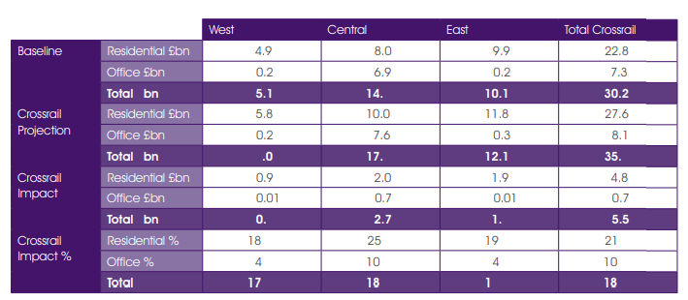
Source: GVE (2022)

Impact on local areas and businesses
The impact of the project on local areas and businesses is also debatable. One of the main stakeholders of the project is local business community. It is argued that Elisabeth Line would improve access for existing staff and an additional 1.5 million people brought within 45-minute commute of central London (Wright et al., 2017). Improved access to central London area is expected to contribute to maximised clustering agglomeration effects which could be the main driver of economic growth, development and increase in productivity (Wright et al., 2017).
Apart from the wider economic benefits, which have already been discussed above, retail companies would also benefit from improved access and transportation links. This contribution to local businesses is expected to be at least £2-£3 billion and gradually increase over the years (Wright et al., 2017). It should also be pointed out that transport links would not only be extended, but also better coordinated and integrated. For example, another main stakeholder of the project is claimed to be Heathrow Airport which is expected to achieve higher growth after completing the project. Developing a branch which connects the western leg of the railway with Heathrow Airport central terminals directly is an essential infrastructural improvement and a main driver of future growth of airport’s operations (Wright et al., 2017). This would also increase the capacity of airport services and operations and would further contribute to developing the area. These benefits are also recognised by the management and owners of the airport who decided to contribute £70 million to the project. The specific areas which are impacted by the construction of Elisabeth Line are shown below.
Figure 5 – Areas impacted by the project
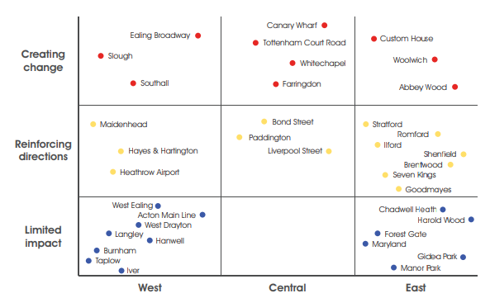
Source: GVA (2022)

Conclusion
To sum up, the Elisabeth Line failed in meeting its time and cost objectives, resulting in severe delays and cost overruns caused by different problems and challenges faced. However, it can be claimed that Elisabeth Line complies with its quality objective. Furthermore, its operational efficiency and contribution to sustainability are considered to be high. The economic, social and cultural impacts of the project are also perceived as a significant success in the long-run. The impact on local businesses is rather negative in the short-run (during construction phases) but is expected to be significantly favourable in the long-run, as confirmed by presented analysis. Overall, it can be stated that Elisabeth Line is a success in terms of its significance and contribution to economic development, sustainability and growth.
Nevertheless, in terms of project management, there are many areas which have to be investigated in greater detail and used as lessons learnt for future projects. Assessing causes and alternative ways to address issues in terms of delays and cost overruns are recommended to be main priorities for this assessment. Moreover, decision makers should pay more attention to various tail risks in the future. Rare events, such as the pandemic, tend to be a real threat to complex and especially time requiring projects. Thus, time buffers and other precautionary practices could be of help. The occurrence of fatal accidents is another relevant area worth being improved as a part of future risk management practices, as well. Decision makers are also advised to more actively cooperate with all relevant stakeholder groups in order to boost the prospects for a successful project management process.

References
Buchanan, P. (2018) The Appraisal and Business Case for Crossrail, [online] Available: https://learninglegacy.crossrail.co.uk/documents/appraisal-business-case-crossrail/ [Accessed: 1 September 2022]
Buck, M. (2017) Crossrail Project: Finance, Funding and Value Capture for London’s Elizabeth Line, [online] Available: https://learninglegacy.crossrail.co.uk/wp-content/uploads/2017/09/1C-002-Finance-Funding-and-Value-Capture.pdf [Accessed: 2 September 2022]
Crossrail (2022) Crossrail Project Update, [online] Available: https://www.crossrail.co.uk/news/articles/crossrail-project-update [Accessed: 5 September 2022]
Global (2022) Sustainability on the Elizabeth Line, [online] Available: https://global.com/outdoor/rail/tfl-rail-estate-advertising/elizabeth-line-advertising/sustainability/#:~:text=Reducing%20carbon%20emissions%20and%20promoting,efficient%20than%20standard%20light%20fittings [Accessed: 5 September 2022]
GVA (2022) Crossrail Property Impact Study, [online] Available: https://learninglegacy.crossrail.co.uk/wp-content/uploads/2016/02/4C-005-crossrail_property_impact_study_main-_small.pdf [Accessed: 5 September 2022]
Learning Legacy (2022) Audit and Assurance, [online] Available: https://learninglegacy.crossrail.co.uk/learning-legacy-themes/project-and-programme-management/audit-and-assurance/ [Accessed: 7 September 2022]
London Gov (2020) Crossrail: The Project at a Glance, [online] Available: https://www.london.gov.uk/sites/default/files/crossrail_-_project_at_a_glance.pdf [Accessed: 7 September 2022]
Marshall, J. (2020) Crossrail Costs to Top £19 bn as Bosses Confirm 2022 Opening, [online] Available: https://www.building.co.uk/news/crossrail-costs-to-top-19bn-as-bosses-confirm-2022-opening/5107598.article [Accessed: 7 September 2022]
Mulligan, E. (2022) How Much Did the Elizabeth Line Cost? When the Crossrail Project Started and Delays in Its Opening Explained, [online] Available: https://inews.co.uk/news/how-much-did-elizabeth-line-cost-when-crossrail-project-started-delays-explained-1649736 [Accessed: 7 September 2022]
Prostejovska, Z. and Tomankova, J. (2017) Project Management: How to Assess a Project’s Success, Journal Business & IT, DOI: 10.14311/bit.2017.01.01
Sandle, P. (2022) London’s $24 Billion Crossrail Finally Opens, [online] Available: https://www.reuters.com/world/uk/londons-24-billion-crossrail-finally-opens-2022-05-23/ [Accessed: 3 September 2022]
Vernet, A. (2016) Crossrail Innovation Programme – Innovation Evaluation Report, [online] Available: https://learninglegacy.crossrail.co.uk/wp-content/uploads/2016/05/11A-003_Crossrail-Innovation-Programme-Evaluation-Report-Final.pdf [Accessed: 5 September 2022]
Weaver, P. (2022) London’s Elizabeth Line Now Open (Sort-of), [online] Available: https://mosaicprojects.wordpress.com/2022/05/27/londons-elizabeth-line-now-open-sort-of/ [Accessed: 5 September 2022]
Wright, S., Palczynski, R. and Have, P. (2017) Crossrail Programme Organisation and Management for Delivering London’s Elizabeth Line, [online] Available: https://www.icevirtuallibrary.com/doi/epdf/10.1680/jcien.17.00016 [Accessed: 5 September 2022]
Zwikael, O. and Meredith, J. (2019) Evaluating the Success of a Project and the Performance of Its Leaders, IEEE Transactions on Engineering Management, Vol. 99(1), pp. 1-13.

