Name: Alin Florin Carare

Student number: 2246440

Module code and name: LCBB4005
Global Business Management

Module coordinator: Dr. Umar Saddat
Assignment Title: Identify and evaluate how actions of business behavior can influence the broader external business environment in which they operate.

Table of Contents
Introduction 3
Findings 3
Conclusion 9
References 10

Introduction
Here in this project, it has been focused on the issues around the various perspectives that have been faced by the administration team while managing the external environment. Aspects related to the corporate governance, ethics corporate social responsibility, altruism, pay structure and adoption of technologies have been portrayed through this project. Theories and the strategies that can be implemented by the administration team while reducing the complications have also been portrayed through this project. It is important for the administration team to maintain better opportunities within the external environment. It allows the management team to improve the profitability of the organisation in a limited time frame.

Findings
Identify the issues around wages/pay structures, ethics and corporate social responsibilities, corporate governance, adoption of new technology and altruism by businesses to analysesnhow they influence the external environment.

Pay structure
Income inequality can be marked as the most important complication which influences the external environment. Income inequality may be influenced by both wage and pay system disparities (Bapuji et al. 2020). This might lead to social unrest and economic difficulties, which would have an impact on consumer spending habits and the sustainability of the planet. In terms of handling the employees, the administration team of the company might face uses in managing the long-term labour contracts. While managing the higher wage and allowance of the employees the administration team needs to maintain numerous policies. As an example, it can be said that, having the issues with higher allowance the administration team might maintain the same gross salary. Through, this approach might influence other companies to adopt the new pay structure. It can be said that it allows the administration team to influence the political aspects of the company. Trade union bargaining power can be influenced by the pay structure of the company which is directly related to the political aspects. The other major complication within the pay structure is well being of the worker. The well-being of the employee can be harmed by not serving the right amount of money to them. Discrimination within the payment process became the reason for decreasing the productivity. By harming the image of the company, lowering its capacity to recruit and retain talent has created a negative impact on the external environment of the company.

Ethics and corporate social responsibility
Consumers continuously value the business who are maintaining ethical aspects in the long run. In terms of enhancing the customer satisfaction and also getting better profitability, the administration team of the company can easily able to adopt strategies for managing corporate social responsibilities (Cheema, Afsar and Javed, 2020). While managing the health and workplace culture allows the administration team to influence other employees and companies to manage the environmental aspects. Not maintaining the corporate social responsibility has become the reason for damage to the organisational reputation. This can directly influence the external environment of the company which includes the market share, consumer behaviour as well as long-term viability.
The other aspect that can be marked as an issue that needs to be managed is the relations of stakeholder. An unethical relationship or the connection with the stakeholder has become an issue for the company. As a consequence of adverse consequences, stakeholders may have issues with regulations and rules, constrained availability of assets, and diminished communication. Communication with the stakeholders can become difficult while not managing the ethical aspects of the stakeholders.

Corporate governance
Not having appropriate transparency and accountability within the organisation has become a major ethical concern for the organisational team. Weak governance structure within the organisation has become an issue that can lead to legal and reputational risks of the company (Almagtome, Khaghaany and Önce, 2020). It directly creates issues for the external environment and also creates an impact or effect on the financial markets and regulatory interventions. Inappropriate relations with investors within the company can be marked as other major issues for the corporate governance. Strong corporate governance only helps the administration team to attract new investors. Poor governance has become a major issue for the investors. Limit access to the capital has become a reason for reducing the economic growth. The external environment has been affected by not having a proper relationship with the investors or not maintaining proper corporate governance. Economic development has been disrupted.

Adaptation of new technology
Adopting new technologies within the organisation has become the reason for job displacement and unemployment. Through implementing the artificial intelligence as well as automation, a more significant number of employees are not able to complete their work. This can become the reason for social and economic implications. Having the issues within the external environment has changed the rate of employment and the financial distribution within the society. “3,900 job cuts were in the year 2023 because of AI and the reasons behind other job cuts could be economic conditions, cost cutting, restructuring at the company, or mergers and acquisitions.” By this, it can be said that the adoption of the technology within the organisation has created an effect on the social sculpture and the employment aspects.
The other aspects that have been hampered by the external environment were skill gaps and the training sessions. While adopting the technology the administration team needs to require new skills and train their employees. Not being able to train the employees decrease the productivity in the long run. Not guiding the employees has become an issue for the organisational team to adopt new technologies in the long run. Limitations within economic growth can be identified through not having appropriate training. The external environment may be affected by changes to staff efficiency, creativity, and economic expansion. It can be portrayed that without giving better training, employees are not able to complete their tasks in a limited time frame. By guiding them to complete their work will be beneficial to gain better productivity accordingly.

Altruism by business
Altruistic behaviour within the organisation indicates not only the sustainable environment but also indicates social initiatives. It is important for the administration team to manage the sustainability to manage the organisational operations. Maintaining the environmental aspects allows the organisation to manage its brand image as well as its reputation (Said and Junaid, 2020). The positive influence of organisational profitability can be identified through enhancing or managing the brand image. It can be said that through maintaining the altruism behaviour the administration team is able to attract the customers and also influence the consumer preferences.
The other aspect that should be managed by the administration team is industry and community impact. Businesses' charitable endeavours can benefit a wide range of sectors and communities. Establishing the credibility within the organisation can be possible by maintaining a better brand image. It is important for the company to gain better respect from the consumers. This allows the management team to gain competitive advantages. For instance, encouraging sustainable behaviour or supporting neighbourhood projects may contribute to the protection of the environment and the development of the neighbourhood. By promoting feasible procedures, creating improvements in society, and generally raising people's standards of life, these efforts may have an impact on the environment. It is important for the administration team to maintain a better community impact. This allows the administration team to attract the customers as well as the stakeholders.

Analysis of the principles, theories and motivations behind the actions of businesses in these areas
Various principles, theories and motivations can be managed by the administration team while managing profitability. Profit maximisation can be marked as one of the most important aspects that should be considered by the administration team. Setting the wages and the pay structure helps the administration team to maximise the profit (Buccella, Fanti and Gori, 2022). A fair pay structure is also beneficial for the administration team to attract and retain employees. The administration team of the company needs to attract and retain talented employees by providing better training and guidance to adopt new technologies. Adaptation of new technologies helps the administration group to complete all the operations and reduce excess costs. As a result, the company is able to enhance its profit abilities in the long run.
The other one of the most important theories that can be adopted by the administration team is stakeholder theory. According to this theory, the management team needs to maintain a positive relationship with the stakeholders (Freeman, Dmytriyev and Phillips, 2021). These stakeholders include employees, customers, suppliers, communities as well as shareholders. Managing ethical aspects and practising corporate social responsibility within the organisation is beneficial for the administration team to improve profitability. Trust and loyalty can be gained by the management team long term through maintaining better relationships and connections with the stakeholders. Maximising the profits and returns for their shareholders within the organisation can be possible by the management team through implementing stakeholder theory. Business ethics, morals and values should be maintained by the management team through managing the stakeholder theory.
Reputation management can be marked as an important factor for the organisational team to gain competitive advantages (Christensen and Lægreid, 2020). Maintaining a better reputation for the company plays a vital role to attract the customers. Ethical standards, transparent governance structures and sustainable initiatives can be maintained by the administration team while managing the reputation. Sustainable approaches can be adopted by the management team of the company to build a positive brand image in the business market. The trust of the customers and the investors can be gained by the management team through managing a better brand image. Influencing the perceptions of the stakeholders and boosting the opportunities for the business is important to gain better productivity. The culture of the brand directly influences the performance of the brand. Reputation management allows the management team to develop appropriate strategies that help the administrational team to monitor, and influence the public opinion about the business.
Legal and regulatory compliance should be managed by the administration team to enhance organisational profitability. Compliance with maintaining proper laws and regulations is important to manage business behaviour. In this recent era, actions should be taken by the administration team to develop or implement better legal requirements. Legal and regulatory compliance should be managed by the higher authority of the company to manage better ethical aspects in the long run. Organisational teams can easily able to implement better pay structures and corporate governance to reduce the legal complications accordingly. Proper laws should be managed by the administration team to get better profitability.
Long-term sustainability should be maintained by the higher authority of the company to improve profitability accordingly (Butler and O’Brien, 2019). Resources should be managed by the administration team to maximise satisfaction in the long run. By focusing on the ecological dependency of the social system the administration team is able to create better activities. Long-term viability can be managed by the administration team to gain long-term sustainability. Managing the long-term environmental issues, the administration team is able to achieve sustainability. Social sustainability, economic sustainability and environmental sustainability should be managed by the higher authority to gain better opportunities.
Consumer or citizen expectations should be managed by the higher authority of the company to improve the brand image (Blühdorn and Butzlaff, 2020). Business decisions are significantly influenced by both social norms and customer needs. In order to maintain current consumers, draw in new ones, and represent the beliefs of the public as a whole, businesses may comply by requirements for appropriate wage rates, moral behaviour, and environmentally conscious activities. A positive brand image, increased market share, and better customer retention can result from meeting these expectations. The administration team of the company have to take the initiative to manage better ethical practices and handle the customer loyalty. Market share growth and the positive brand image help the organisation gain competitive advantages and enhance the productivity in the long run.
Motivation theory should be developed by the administration team to guide the employees. There is numerous motivational theory that helps the administration team to guide the employees to improve the productivity and the performance.
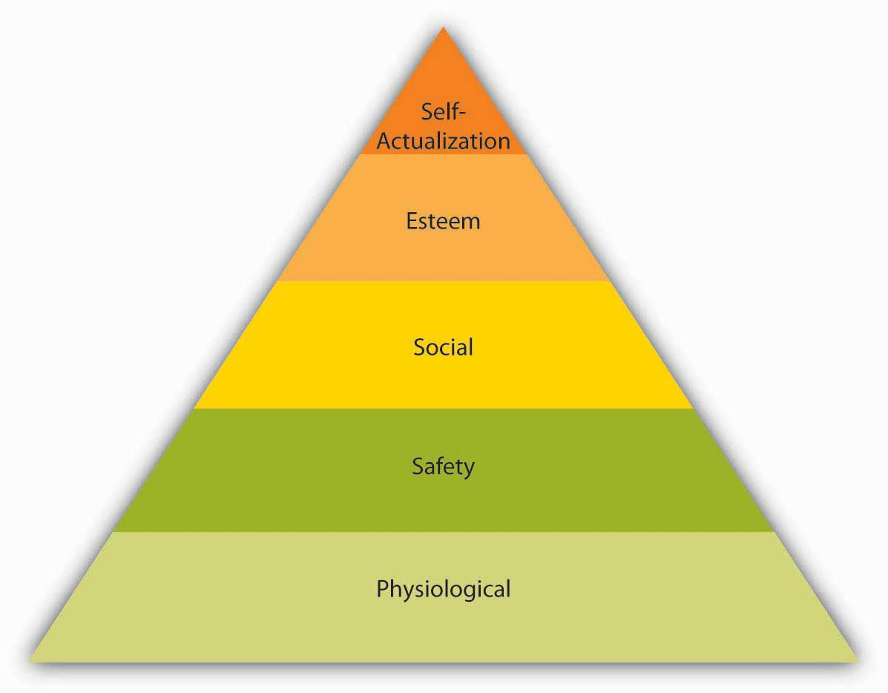
Figure 1: Maslow’s hierarchy of Needs
(Source: Hopper, 2020)
Implementation of the Maslow’s hierarchy of needs helps the higher authority of the company to motivate the employees in a systematic way. The administration team of the company needs to maintain physiological, safety, social, esteem and self actualisation (Hopper, 2020). Managing the satisfaction of the employees allows the administration team to gain better opportunities. Safety and social needs should be maintained by the higher authority of the company to enhance the productivity of the company and also to maintain a better brand image accordingly.
It is imperative to keep in mind that various industries, firms, and individuals may have various motives for engaging in specific commercial activities. Even though increasing profits frequently serves as the primary goal, companies can additionally take a number of other factors into consideration to meet their goals.

Conclusion
From the above discussion, it has been concluded that the administrative staff should create a motivation theory to direct the workers. There are many theories of motivation that the management team can use to help the workers increase their output and performance. The company's management team must uphold physical health, social safety, self-actualization, and self-esteem. Managing employee satisfaction enables the administrative team to take advantage of greater prospects.
For the company to be more productive and to have a stronger brand image, the higher ups in the organisation should ensure safety and social needs. The leadership staff can win the confidence of stakeholders and loyalty over time by upholding stronger bonds and ties with them. The top leadership team may maximise earnings and profits for the shareholders within the organisation by putting stakeholder theory into practice. The management team ought to oversee the stakeholder theory to uphold business ethics, morality, and values. Analysing the pay structure and the technology helps the administration team to identify the external aspects accordingly.

References
Almagtome, A., Khaghaany, M. and Önce, S., 2020. Corporate governance quality, stakeholders' pressure, and sustainable development: An integrated approach. INTERNATIONAL JOURNAL OF MATHEMATICAL ENGINEERING AND MANAGEMENT SCIENCES, 5(6).
Bapuji, H., Patel, C., Ertug, G. and Allen, D.G., 2020. Corona crisis and inequality: Why management research needs a societal turn. Journal of Management, 46(7), pp.1205-1222.
Blühdorn, I. and Butzlaff, F., 2020. Democratization beyond the post-democratic turn: towards a research agenda on new conceptions of citizen participation. Democratization, 27(3), pp.369-388.
Buccella, D., Fanti, L. and Gori, L., 2022. ‘Green’managerial delegation theory. Environment and Development Economics, 27(3), pp.223-249.
Butler, T. and O’Brien, L., 2019. Understanding RegTech for digital regulatory compliance. Disrupting finance: FinTech and strategy in the 21st century, pp.85-102.
Cheema, S., Afsar, B. and Javed, F., 2020. Employees' corporate social responsibility perceptions and organizational citizenship behaviours for the environment: The mediating roles of organizational identification and environmental orientation fit. Corporate Social Responsibility and Environmental Management, 27(1), pp.9-21.
Christensen, T. and Lægreid, P., 2020. The coronavirus crisis—crisis communication, meaning-making, and reputation management. International Public Management Journal, 23(5), pp.713-729.
Freeman, R.E., Dmytriyev, S.D. and Phillips, R.A., 2021. Stakeholder theory and the resource-based view of the firm. Journal of Management, 47(7), pp.1757-1770.
Hopper, E., 2020. Maslow’s hierarchy of needs explained. ThoughtCo, ThoughtCo, 24, pp.1-3.
India Today, 2023. Lost jobs in technology. Available at: https://www.indiatoday.in/technology/news/story/nearly-4000-people-working-in-tech-lost-their-jobs-because-of-ai-in-may-2388575-2023-06-04#:~:text=4%2C000%20people%20lost%20jobs%20because%20of%20AI&text=From%20these%2C%203%2C900%20job%20cuts,cuts%20in%202023%20till%20now.
Said, D. and Junaid, A., 2020. Altruistic Value Reflection Company Policy and Strategy: Finding Local Wisdom and the Meaning of CSR. ATESTASI: Jurnal Ilmiah Akuntansi, 3(2), pp.98-105.

