

Changemakers: Creativity and Value Creation
Module Code - BMHP5014

Assignment – Online Portfolio of Set Exercises

Student Name - Shumon Ahmed
Student Number - 2310119

Lecturer – Elena Leonova

Date – 17/11/2025

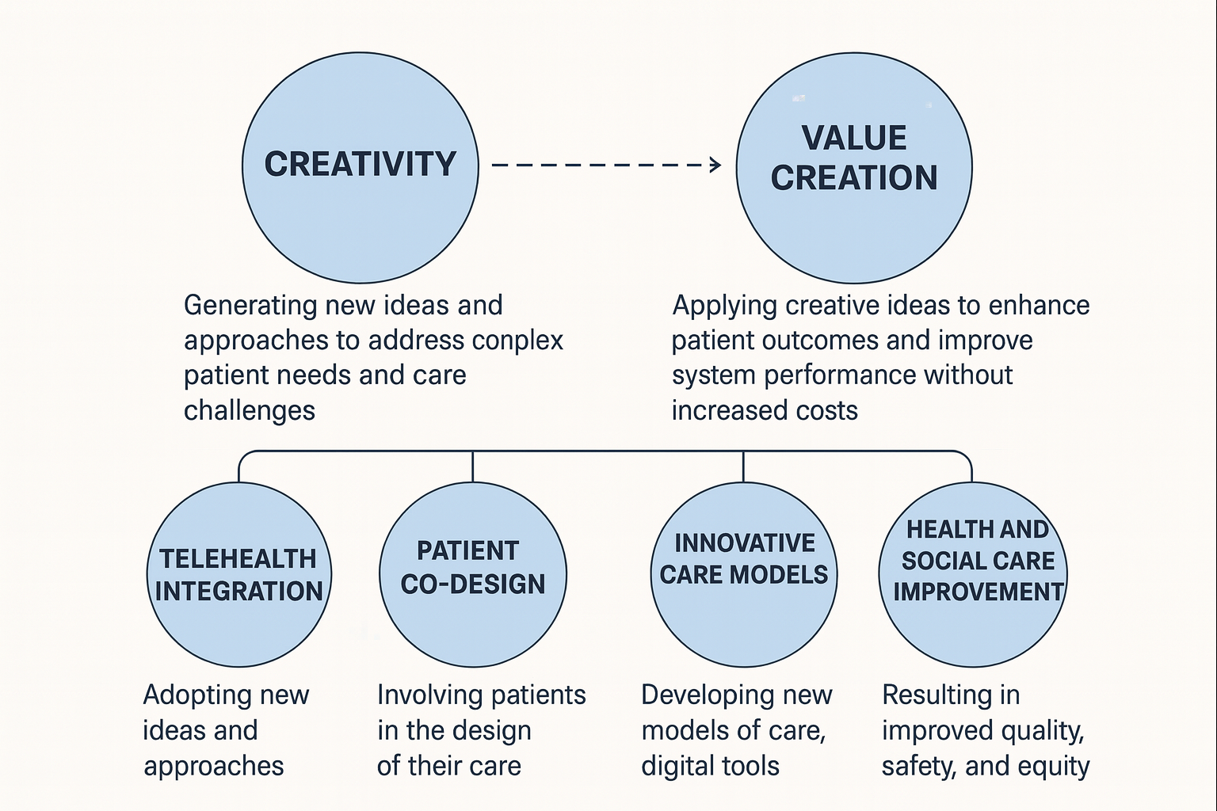
This portfolio presents a collection of activities and reflections developed throughout the module on creativity, leadership, value creation, and contemporary technology in health and social care. It demonstrates my engagement with weekly learning materials and my ability to apply theoretical concepts to real-world challenges. The work reflects my growing understanding of how innovative thinking and effective leadership can drive improvement and value within complex care environments.
1. Creativity
In health and social care, creativity involves developing innovative ways to address complex problems such as staff shortages, patient engagement, or service efficiency. It is not limited to artistic expression but includes the ability to think differently, combine ideas, and adapt existing practices to meet new challenges.
Through the module, I learned that creativity can be nurtured by adopting an open mindset and questioning established procedures. For example, when considering the issue of hospital discharge delays, I proposed a creative solution involving a “virtual discharge coordinator” — an online platform that connects patients, families, and social care providers. This exercise helped me realize that creativity in health care often depends on collaboration and willingness to test new ideas within professional and ethical boundaries.
2. Leadership
Effective leadership in health and social care goes beyond managing people; it involves inspiring and empowering teams to deliver safe, compassionate, and innovative care. Leadership theories such as transformational and servant leadership emphasize emotional intelligence, communication, and shared vision.
I reflected on my own leadership style after learning about transformational leadership. I noticed that in group tasks, I naturally tried to encourage others by recognizing their contributions and helping them connect their tasks to the overall goal. This self-awareness reinforced the importance of relational leadership in creating trust and motivation within multidisciplinary teams, particularly in high-pressure environments such as hospitals or community care settings.
3. Value Creation
Value creation in health and social care refers to generating benefits for patients, staff, and the wider system — improving outcomes while ensuring sustainability and efficiency. It often requires balancing clinical effectiveness, patient satisfaction, and cost management.
One lecture challenged me to think about how innovation can create value without additional cost. I reflected on a real example: introducing telehealth consultations for chronic disease management. This approach can reduce unnecessary hospital visits and increase accessibility for patients with mobility issues. I recognized that value is not only financial — it also lies in improving patient experience and staff workflow.
4. Contemporary Technology
Contemporary technology plays a crucial role in transforming health and social care delivery. Digital health tools, artificial intelligence, and data analytics are enhancing decision-making, communication, and patient monitoring. However, these innovations also raise ethical concerns, such as data privacy and digital exclusion.
I explored how wearable devices could support early intervention for patients with heart disease. This made me appreciate how technology can empower both patients and practitioners. However, I also reflected on challenges — for instance, ensuring that older adults or low-income groups are not excluded from these digital advancements. This highlighted the importance of aligning technology with inclusive and ethical practice.

Overall Reflection
Bringing these four themes together, I’ve realized that creativity, leadership, value creation, and technology are interconnected. Creative leadership drives innovation: technology enables value creation; and reflective practice ensures these developments remain person-centred and ethical. This understanding has shifted my perspective from focusing solely on service delivery to seeing myself as an active contributor to positive change in health and social care.

Case Study: The NHS Remote Monitoring Service – A UK Innovation in Health and Social Care
Innovation is central to improving quality, efficiency, and patient outcomes within the UK’s health and social care system. One significant recent example is the NHS Remote Monitoring Service, which uses wearable devices and digital platforms to monitor patients’ health conditions at home. This innovation, accelerated during the COVID-19 pandemic, reflects the creative application of technology and leadership to deliver value-driven, patient-centred care across the UK.
The remote monitoring service was initially developed to support patients with chronic conditions such as diabetes, heart disease, and respiratory illnesses. Through wearable sensors and mobile apps, patients can record vital signs including heart rate, oxygen saturation, and blood pressure, which are transmitted directly to healthcare teams. Clinicians can then track data trends, identify early signs of deterioration, and intervene promptly reducing the need for unnecessary hospital visits. This model of care demonstrates creativity in rethinking traditional healthcare delivery, shifting focus from reactive treatment to proactive, preventative care.
The leadership behind this innovation came from collaborative efforts between NHS England, local Integrated Care Systems (ICS), and digital health companies such as Docobo and Huma. Effective leadership was required to manage organisational change, coordinate multidisciplinary teams, and maintain trust among staff and patients. Transformational leadership principles were evident as leaders inspired teams to embrace digital solutions and adapt workflows to integrate remote data. This aligns with Bass’s (1985) transformational leadership theory, which emphasises vision, motivation, and empowerment as key drivers of innovation.
From a value creation perspective, remote monitoring generates significant benefits for patients, professionals, and the wider healthcare system. For patients, it provides convenience, greater independence, and reassurance that their health is being monitored in real time. For healthcare providers, it reduces pressure on hospital capacity and allows resources to be focused on those most in need. Economically, it offers long-term cost savings through the prevention of avoidable hospital admissions. Porter’s (2010) concept of Value-Based Healthcare is evident here—value is measured by patient outcomes achieved relative to costs incurred. The success of remote monitoring services demonstrates how technology can deliver value that is both clinical and economic.
The role of contemporary technology is fundamental to this innovation. Wearable devices, artificial intelligence, and cloud-based analytics enable continuous monitoring and data-driven decision-making. However, technology alone is not sufficient; successful implementation also depends on digital literacy, data security, and equitable access. Ethical considerations—such as privacy, consent, and digital exclusion—must be managed carefully to ensure the service remains inclusive and person-centred. The NHS Digital Health Framework recognises these challenges and promotes ethical data use as a cornerstone of future innovation.
In summary, the NHS Remote Monitoring Service exemplifies how creativity, leadership, value creation, and technology can combine to transform healthcare delivery in the UK. By leveraging wearable technology and digital infrastructure, the NHS has redefined how care is delivered, empowering patients, supporting clinicians, and strengthening system sustainability. This case study highlights the importance of innovation that is not only technologically advanced but also compassionate, inclusive, and aligned with the values of health and social care. As the sector continues to evolve, the lessons learned from this initiative will inform future approaches to digital transformation and person-centred innovation across the UK.

Research
Access to health and social care for homeless people remains a significant area of concern, with research consistently showing that this population experiences substantial barriers to essential services. Homeless individuals often face complex health needs, including higher rates of mental illness, substance misuse, chronic conditions and trauma. Despite this, they frequently struggle to access timely and appropriate care. Barriers include a lack of permanent address, difficulties registering with GPs, limited awareness of available services and experiences of stigma or discrimination from professionals. Practical obstacles such as transportation, unstable routines and competing priorities—like securing food or shelter—also prevent consistent engagement with care.
Research indicates that services designed with flexibility and outreach in mind can significantly improve access. Mobile health clinics, drop-in centres, multidisciplinary outreach teams and peer support workers have been shown to reduce inequalities by offering low-threshold, person-centred support. Trauma-informed and non-judgemental approaches also help build trust and encourage long-term engagement. Integrated care pathways that link healthcare with housing, mental health support and social services are particularly effective in addressing the interconnected challenges homeless people face. Overall, evidence suggests that reducing barriers and adopting inclusive, compassionate practices can lead to better health outcomes and greater stability for individuals experiencing homelessness.
Research on mental health highlights its crucial role in overall wellbeing and the significant impact mental disorders can have on individuals, families and communities. Studies show that common conditions such as anxiety, depression and stress-related disorders are increasing globally, influenced by social pressures, economic instability, trauma and lifestyle factors. Research also emphasises that mental health is shaped by a combination of biological, psychological and social determinants, meaning effective support must address more than symptoms alone.
Access to early intervention is consistently identified as a key factor in improving outcomes. Evidence shows that timely support—through counselling, cognitive behavioural therapy, medication or community services—can reduce the severity of symptoms and prevent long-term complications. However, many people face barriers such as stigma, limited service availability, long waiting times and a lack of culturally appropriate care. Research also highlights inequalities, with disadvantaged groups often experiencing higher rates of mental ill-health and fewer opportunities for treatment.
Recent studies underline the importance of holistic, person-centred approaches that incorporate social support, physical health, housing stability and meaningful activity. Preventative strategies, including education, resilience-building and workplace wellbeing initiatives, are shown to reduce risk and support long-term mental wellness. Overall, research demonstrates that investing in accessible, compassionate and integrated mental health support leads to healthier individuals and stronger communities.
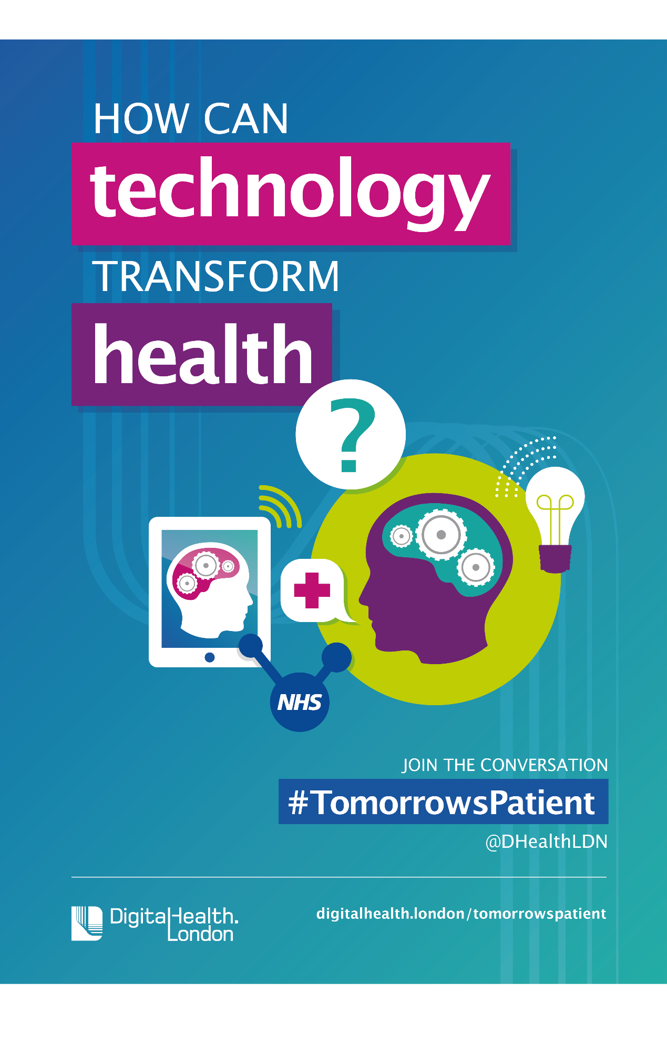
Podcast

NHS Leadership Framework – Analysis
The NHS Leadership Framework outlines the behaviours, skills and values expected of health and social care leaders. It supports consistent, high-quality leadership across clinical and non-clinical roles. The framework is organised into seven domains, each contributing to effective leadership.
1. Demonstrating Personal Qualities
Leaders must show self-awareness, emotional intelligence, integrity and resilience. This domain recognises that leadership begins with understanding one’s own strengths, limitations and behaviours. In practice, this means reflective practice, openness to feedback and maintaining professionalism under pressure.
2. Working With Others
Collaboration is essential in multidisciplinary environments. Leaders should build trust, encourage contribution, resolve conflicts and maintain positive professional relationships. The domain supports team cohesion, shared goals and respect across roles.
3. Managing Services
This focuses on operational competence: planning, managing resources, monitoring performance and ensuring safe, effective service delivery. Good leaders balance quality, safety and efficiency, using data to inform decisions.
4. Improving Services
Leaders are expected to drive continuous improvement. This includes identifying gaps, using evidence-based methods, supporting innovation and embedding changes sustainably. It encourages proactive attitudes rather than reactive problem-solving.
5. Setting Direction
Strategic thinking is central to long-term success. Leaders interpret policy, analyse trends, and guide teams towards a clear vision. This domain links national priorities—such as patient safety, integration and digital transformation—to local action.
6. Creating Vision
Effective leaders inspire others by shaping and communicating a meaningful, shared vision. This domain emphasises motivation, inclusive involvement and clarity of purpose, ensuring teams understand why change matters.
7. Delivering the Strategy
Turning vision into actionable plans requires project management, monitoring progress, managing risk and evaluating outcomes. This domain ensures strategies are implemented effectively and deliver real improvements in patient care.

Overall Evaluation
The framework promotes holistic, person-centred leadership. Its strength lies in balancing personal qualities, collaborative practice, and strategic capability. It fits well with the NHS values and encourages leaders at all levels—not just senior managers—to take responsibility for improvement.
However, critics note that the framework can be broad and idealistic, requiring strong organisational support, time and resources to implement. Nonetheless, it remains a widely respected model for building leadership capability across the NHS.

Self-Reflection
My self-reflection journey on creativity and value creation in health and social care has helped me appreciate how innovation can make a genuine difference to people’s wellbeing. At the start, I viewed creativity as something abstract or artistic, but I have come to understand it as a practical skill that enables me to see challenges from new angles and design solutions that are truly person-centred. Through daily interactions with individuals and colleagues, I noticed how even small creative adjustments such as adapting communication methods, reorganising tasks, or using digital tools more intuitively can increase efficiency, dignity and engagement.
Reflecting on specific experiences has allowed me to identify moments where creative thinking added real value. For example, finding alternative ways to support someone with anxiety or tailoring activities to match an individual’s interests showed me how personalised approaches can improve outcomes. These reflections also highlighted the importance of collaboration, as creativity often emerges from listening to others, sharing ideas and embracing diverse perspectives within a multidisciplinary team.
I have also recognised the barriers that can restrict creativity, such as limited time, rigid routines or fear of making mistakes. Reflecting on these challenges encouraged me to become more confident and proactive in suggesting improvements, knowing that value creation is not just about major innovations but about contributing to a culture that prioritises safety, compassion and continuous improvement.
Overall, this journey has strengthened my understanding that creativity in health and social care is closely tied to empathy and problem-solving. It involves being curious, adaptable and committed to enhancing the experiences of those we support. By valuing creativity and reflecting on my practice, I feel better equipped to contribute meaningfully to positive change and deliver care that truly centres on people’s needs.

References

Brewster, A. L., Lee, Y. S. H., Linnander, E. L. & Curry, L. A. (2021) ‘Creativity in problem solving to improve complex health outcomes: Insights from hospitals seeking to improve cardiovascular care’, Learning Health Systems, 6, e10283. doi: 10.1002/lrh2.10283.
Carmichael, C., Schiffler, T., Smith, L., Moudatsou, M., Tabaki, I., Doñate-Martínez, A., Alhambra-Borrás, T., Kouvari, M., Karnaki, P., Gil-Salmeron, A. & Grabovac, I. (2023) ‘Barriers and facilitators to health care access for people experiencing homelessness in four European countries: an exploratory qualitative study’, International Journal for Equity in Health, 22(1), p. 206. doi: 10.1186/s12939-023-02011-4.
McNeill, S., O’Donovan, D. & Hart, N. (2022) ‘Access to healthcare for people experiencing homelessness in the UK and Ireland: a scoping review’, BMC Health Services Research, 22, Article 910. doi:10.1186/s12913-022-08265-y.
NHS Digital (2023) Statistics on obesity, physical activity and diet, England 2023. Available at: https://digital.nhs.uk/data-and-information/publications/statistical/statistics-on-obesity-physical-activity-and-diet
NHS Leadership Academy (2011) Leadership Framework: A Summary. Coventry: NHS Institute for Innovation and Improvement. Available at: https://www.leadershipacademy.nhs.uk/wp-content/uploads/2012/11/NHSLeadership-Framework-LeadershipFramework-Summary.pdfAccessed: (Accessed 7 November 2025).
NHS Leadership Academy (2014) The Healthcare Leadership Model: enhancing leadership across the system. Available at: https://www.leadershipacademy.nhs.uk/wp-content/uploads/2014/11/Leadership-Framework.pdf
Teisberg, E., Wallace, S. & O’Hara, S. (2020) ‘Defining and implementing value-based health care: A strategic framework’, Academic Medicine, 95(5), pp. 682–685. doi: 10.1097/ACM.0000000000003122.
The King’s Fund (2014) ‘Developing collective leadership for health care’. Available at: https://www.kingsfund.org.uk/insight-and-analysis/reports/developing-collective-leadership-for-health-care
World Health Organization (2025) Mental health: strengthening our response. Available at https://www.who.int/news-room/fact-sheets/detail/mental-health-strengthening-our-response (Accessed: 8 November 2025)

