  - Research Methods & Data Analysis Assignment
  - M7X01702
Jamie Ellis | 29th November 2018
Table of Contents
Introduction 3
What is data? 3
What is Statistics? 3
The data - background 3
Hypothesis 4
The data – analysed 5
Frequency distribution – Mature students 6
6
Frequency distribution – Young students 7
7
The T test 8
Outliers 10
Factors to talk about 13
Conclusion 14
References 15

Table of figures

Figure 1 datasets 3
Figure 2 Table of the range , max and min values 5
Figure 3 - graph of mean and medium 5
Figure 4 tally chart mature students Figure 5 frequency distribution graph mature 6
Figure 6- tally chart young students Figure 7 - frequency distribution young students 7
Figure 8 T-test p 0.10 8
Figure 9 T-test p 0.02 8
Figure 10 T- test p 0.01 9
Figure 11 Grubbs test mature 10
Figure 12 Grubbs test mature graph 11
Figure 13 Grubbs test younger students 11
Figure 14 Grubbs test younger graph 12

Introduction
Before we start looking at the statistics from the trial study, let’s take a look at what data and statistics are and how important they are in today’s world. We will then take a look at the data from the study.

What is data?
In today’s world, you can find data almost everywhere you go. From the phone in your pocket to the shelfs in the supermarkets you shop at. Technology today does not exist without the need for the collection of data. [1]. Data can come in the form of a list, table. It’s just an ordered form of information – could contain information about yourself or even just the foods sold to you. [2].

What is Statistics?
Statistics play a huge part in today’s world with the rise of technology and increase in companies using data analysis tools. John. H. Kranzler describes statistics as a “Broad range of techniques and procedures for gathering, organizing, analyzing and displaying quantitative data”. Quantitative data is the term given when data is showed in numbers e.g. a list of customers and the payments they have made to a company. [3]. Companies can use statistical tools to analyze data which is why it’s so important to companies to obtain data to use statistics to find patterns and trends to work smarter.

The data – background

“A research study was conducted to examine the differences between Younger and Mature Students on perceived university experience satisfaction. A trial study was conducted to examine this hypothesis. Ten mature students (aged between 45- 62) and ten younger adults (between 17 and 20) were give a university Experience satisfaction test (known to have high reliability). Scores on the measure range from 0 to 60 with high scores indicative of high university experience satisfaction; low scores indicative of low university experience satisfaction.” – from the assignment brief.
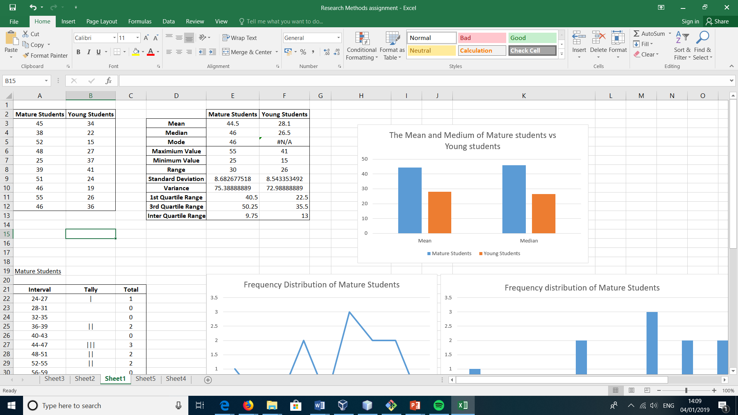
Figure 1 datasets

Hypothesis
A hypothesis is a way of testing the means of datasets to see if there is a difference or not. We call our first hypothesis the null hypothesis and this is what we are looking to prove that the means are the same. [4]
The Null Hypothesis – Younger Students and Mature Students have an equal satisfaction level in general. (age is not a factor)
We now need to have a hypothesis in case there is a difference between the means. We call this one the alternative hypothesis.
The Alternative Hypothesis – Mature Students have a higher satisfaction level than Younger Students in general. (age is a factor)

The data – analysed
To first analyze the data, I will need to organize it from its unordered state. We do this by working out the range of the data sets and using it to work out the frequency distributions. The intervals were set on a scale of 3 starting at the lowest satisfaction level to the highest.
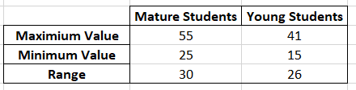
Figure 2 Table of the range , max and min values
As you can see from the data above, the Young students have a lower satisfaction score by 10 than the mature students while the mature students have a bigger satisfaction score with 55 compared to young students who scored a highest of 41. This could suggest that the mature students have had a better experience in university than the younger students but we will need to do more analyzing to be able to say confidently if that is true. They do however have a similar range score.
More tests are needed to get a clearer understanding of what the data is showing. The mean is needed to work out the average of the sets of data so we can see if the suggestion that Mature students are getting a better experience than young students is possible. The medium will be used to find out the middle score. We test both Mean and Medium as a way of showing the average of both data sets without any distortions. [5]

Figure 3 - graph of mean and medium
The mean and the shows a significantly higher average score between the mature students and the young students. The medium also shows a higher average middle score for mature students than young students. These tests also back up the idea that mature students have a better experience at university due to their high satisfaction levels.
With all this information I can now look at the frequency distribution. The frequency distribution will group the data sets by using the intervals to sort them into categories. [6] The categories will help show more clearly the patterns in the data and in this case will show if any satisfaction levels are edging towards higher or lower for the mature and young students.

Frequency distribution – Mature students
Interval | Tally | Total
24-27 | | | 1
28-31 |  | 0
32-35 |  | 0
36-39 |  | 0
40-43 |  | 0
44-47 | ||| | 3
48-51 | || | 2
52-55 | || | 2
56-59 |  | 0

Figure 4 tally chart mature students Figure 5 frequency distribution graph mature
The frequency distribution of mature students is showing a negatively skewed distribution which also suggests that the mature students have an evidentially high satisfaction level and very little low satisfaction.

Frequency distribution – Young students
Interval | Tally | Total
14-17 | | | 1
18-21 | | | 1
22-25 | || | 2
26-29 | || | 2
30-33 |  | 0
34-37 | ||| | 3
38-41 | | | 1
42-45 |  | 0

Figure 6- tally chart young students Figure 7 - frequency distribution young students
The younger students do not have a clear negative or positive skewed distribution so it would not be fair to say they have a higher or lower satisfaction level. It would be more clear to say that the young students experience in the university is mixed. The frequency distribution for younger students shows more of a bimodal distribution as it peaks twice.

The T test
The T-Test will help us determine if the means of the Mature Students and Younger Students are significantly different from each other. This will give us the clarity we need to be able to confidently accept or reject the Null and Alternative Hypothesis. [7] There are different kind of T-tests and the one we will be using is an Independent Sample T-Test as the satisfaction levels of Mature and Younger Students are independent to each other. [8]
We will be using a one tailed t-test for the Null and Alternative Hypothesis as we want to prove one hypothesis while disregarding the other one using confidence levels of 90%(p0.1), 98%(p0.02) and 99%(p0.01).
P = 0.1
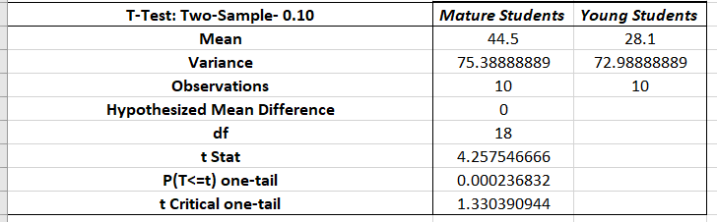
Figure 8 T-test p 0.10
P = 0.02
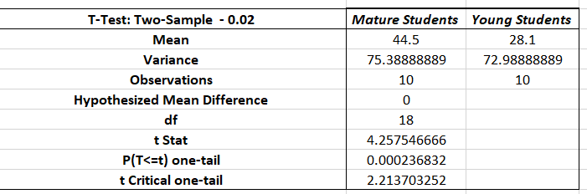
Figure 9 T-test p 0.02

P = 0.01
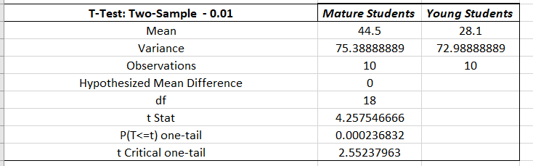
Figure 10 T- test p 0.01

Outliers
An outlier is a piece of data in a group that is visibly different from the rest of the dataset. We need to take a look at any outliers in the datasets to check for any abnormal data in the sets that may be affecting the results of the investigation. Just looking at the data we can see there is at least one potential outlier in the mature and young student’s data set but we would need to run a test to check if they are actual outliers or not. [9]
The Grubbs Test
The purpose of the Grubbs test is to locate all the outliers in a dataset until it can no longer find anymore. It finds out the critical value from the datasets mean to help it locate any values that are over the critical value. [10] They get removed until all is left is the dataset that is within the critical value from the mean. We will use a confidence level of 99% to look for outliers.
Mature Students
Grubbs Critical value for 99% - 2.41 [10]
Mature Students | Grubbs Value
45 | 0.057585923
38 | 0.748617
52 | 0.863788847
48 | 0.403101462
25 | 2.245851001
39 | 0.633445154
51 | 0.748617
46 | 0.172757769
55 | 1.209304385
46 | 0.172757769
Figure 11 Grubbs test mature

Results

Figure 12 Grubbs test mature graph
No outliers but score of 25 was very close but not significant enough to be considered an outlier.
Young Students
Grubbs Critical value for 99% - 2.41[11]
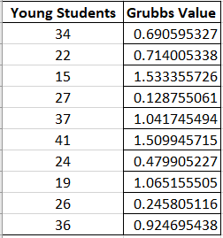
Figure 13 Grubbs test younger students

Results
No significant outliers in the dataset.

Figure 14 Grubbs test younger graph

Factors to talk about
There are a few factors that we can talk about that should have been considered before setting up the experiment.
- Larger datasets – to be able to say that satisfaction levels are higher or lower than another age group confidently I would expect a university to have a larger population that would need to be included into the research for them to be able to have a good idea that the data being analyzed is good data to use for testing. This can be achieved by creating of questionnaires etc to gather information.
- Age categories- The investigation would bring back more detailed and accurate results if the students were not split into Mature and Younger but into categories of age e.g. 18-24, 25-31. With the current design ages 21-44 are not getting tested and that could be a pretty high percentage of students. A good way to control this would be by handing out questionnaires to students which asks them to choose their age category.
- Circumstances out of control- Some factors that cannot be controlled need to be considered too. It’s possible that satisfaction levels of a student of any age can differ with circumstances going on in their personal lives and the moods of the students on the day they fill out the forms could be different.

Conclusion

The results of the T-Tests show that we have a T Stat value that is significantly over the T critical value for all the significant levels we tested it with. This shows that there is a statistically significant difference between the two sets and with a 0.00023682 chance of it being there by chance that we can reject the Null Hypothesis that the Mature Students and Younger Students are equal to each other in satisfaction levels.
We can therefore accept the Alternative Hypothesis that Mature Students have a greater satisfaction level than Younger Students as proven by the mean being greater and evidence of the data being analyzed earlier.

References
[1] M. Loukides, What Is data science?, 1st ed. Sebastopol, Calif.: O'Reilly Media, 2012.
[2] C. Clifton, What Every Engineer Should Know About Data Communications. New York and Basel: Marcel Dekker, 1987.
[3] Kranzler, Statistics for the terrified, 6th ed. chapter 4.
[4] M. Hammon, Hypothesis Testing in Excel - The Excel Statistical Master. Mark Harmon, 2011, 2011.
[5] "Calculating the median", Bbc.co.uk, 2019. [Online]. Available: http://www.bbc.co.uk/skillswise/factsheet/ma38aver-l1-f-other-averages-the-median. [Accessed: 04- Jan- 2019].
[6] N. Bajpai, Business statistics. Delhi: Pearson, 2010.
[7] T. Urdan, Statistics in plain English, 2nd ed. Psychology Press, 2005, p. 89.
[8] Kranzler, Statistics for the terrified, 4th ed. chapter 11
[9] C. AGGARWAL, OUTLIER ANALYSIS, 2nd ed. [Place of publication not identified]: SPRINGER, 2016.
[10] N. Mahalik, Sensor Networks and Configuration. Berlin, Heidelberg: Springer-Verlag Berlin Heidelberg, 2007.
[11] Sediment.uni-goettingen.de, 2019. [Online]. Available: http://www.sediment.uni-goettingen.de/staff/dunkl/software/pep-grubbs.pdf. [Accessed: 04- Jan- 2019].

