ACCA4027 - Contemporary Challenges: Making a difference
Iain Martin (2311038)
Group Presentation
2024
Contents
URLs 6
Presentation Screenshots 7
Bibliography. 12

URLs

Personal Section Video Presentation - https://youtu.be/k1vlsL4DRgE
Full Presentation Video – https://www.youtube.com/watch?v=vGQzlKn14jA
Power Point Presentation File – https://uowtsd-my.sharepoint.com/:p:/g/personal/2311038_student_uwtsd_ac_uk/EeqWl6QvAM9EqbgrwiLm_RcB4BSQUZf-GrVjdPHCRZvk_A?email=richard.morgan1%40uwtsd.ac.uk&e=nv1GGc

Presentation Screenshots



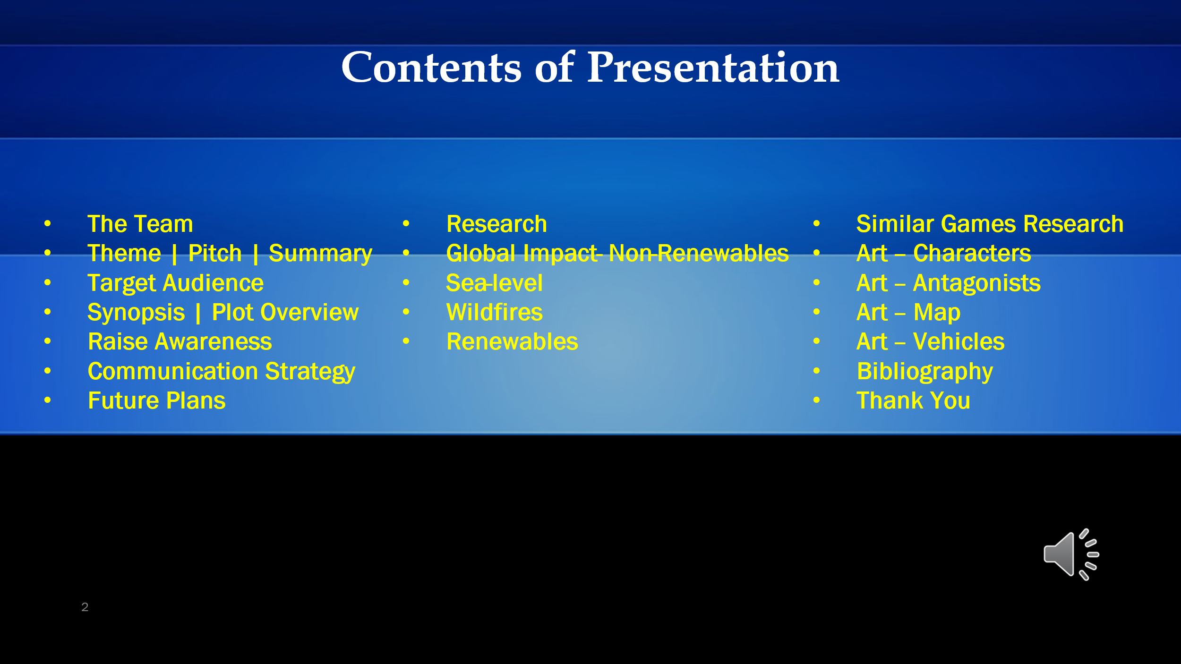



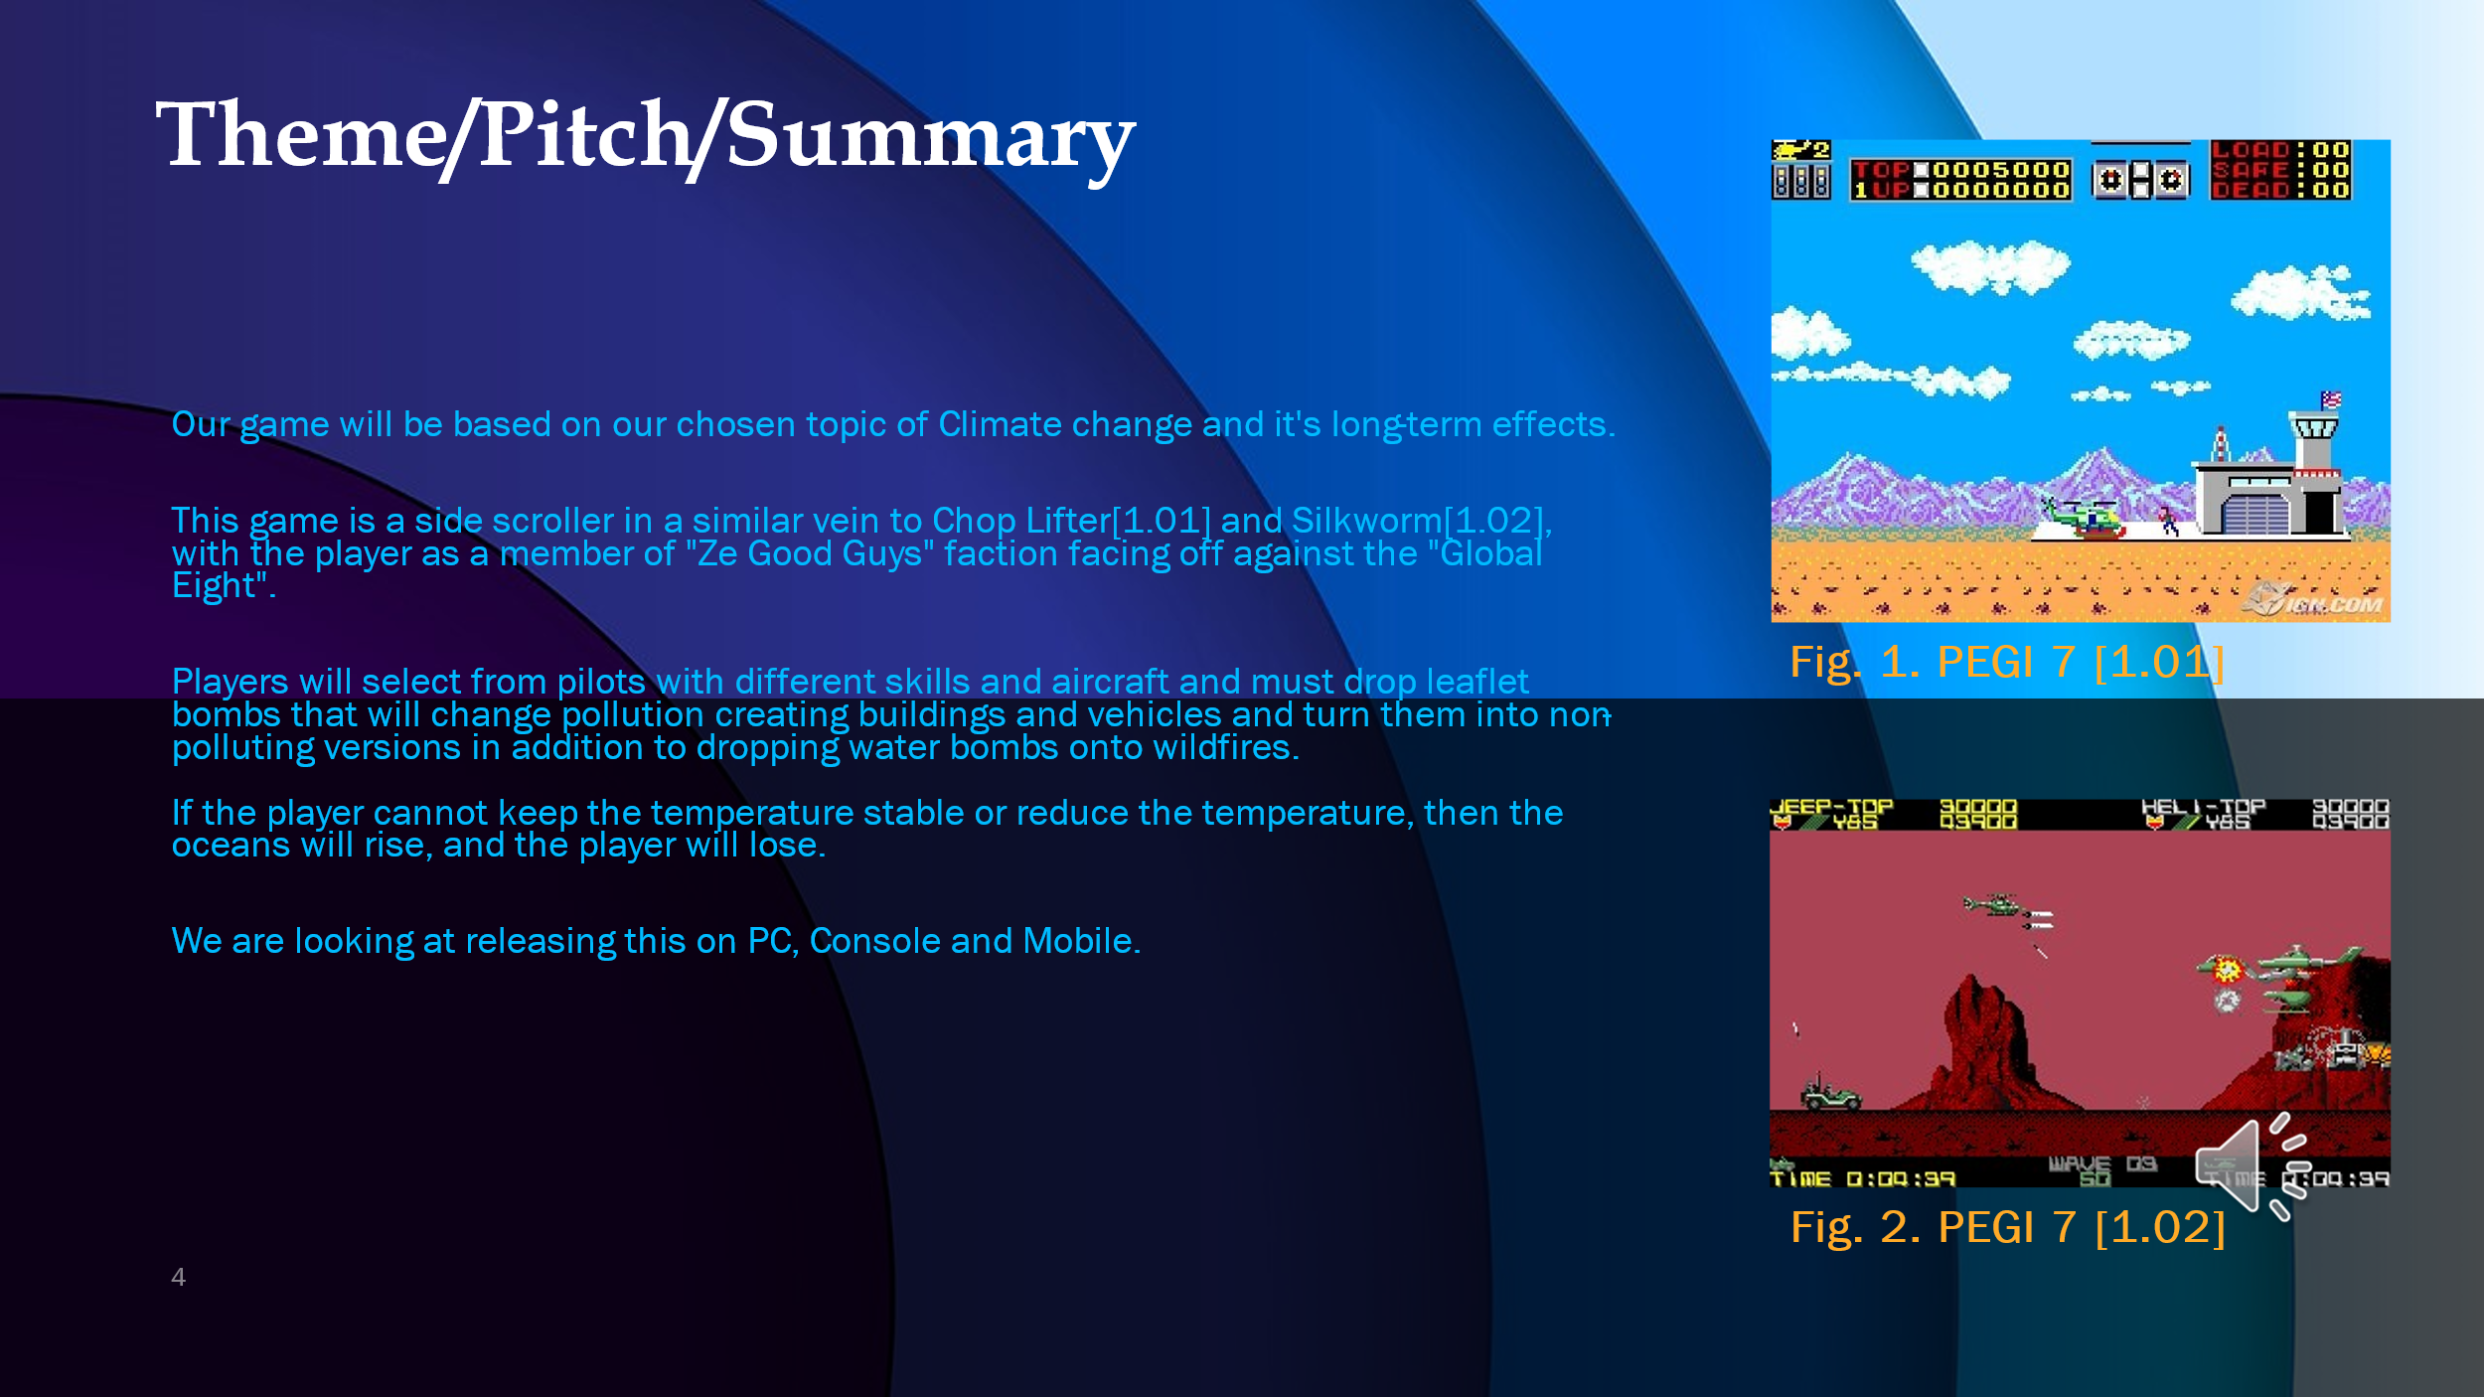

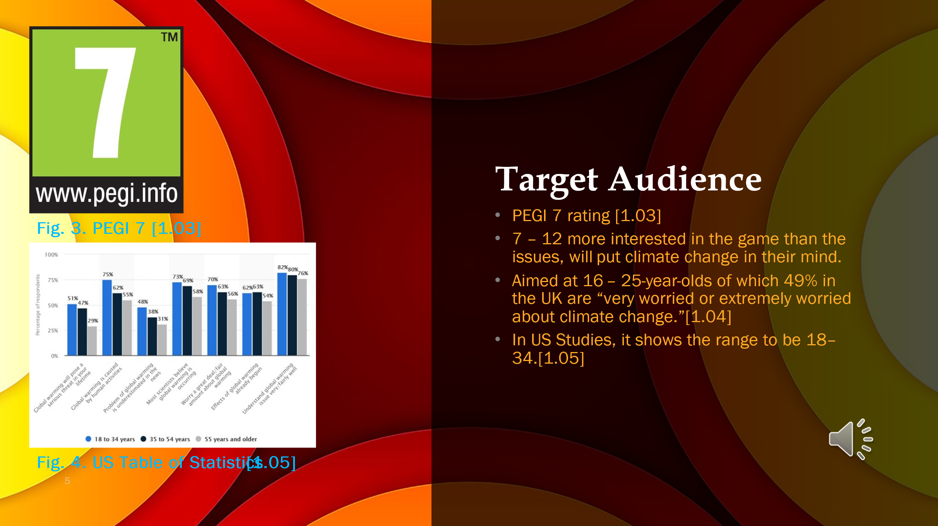



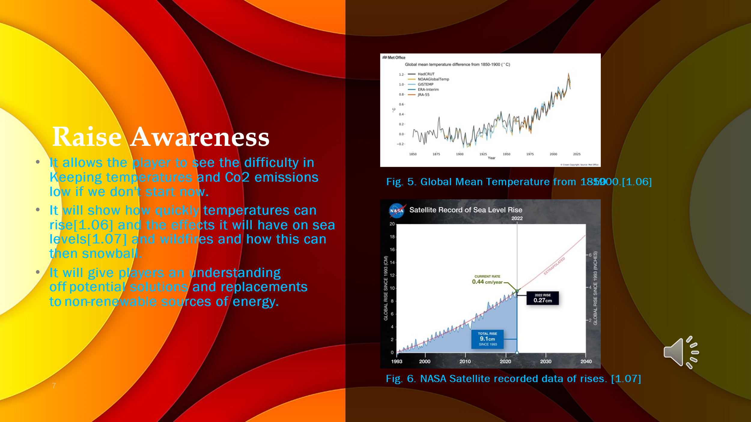



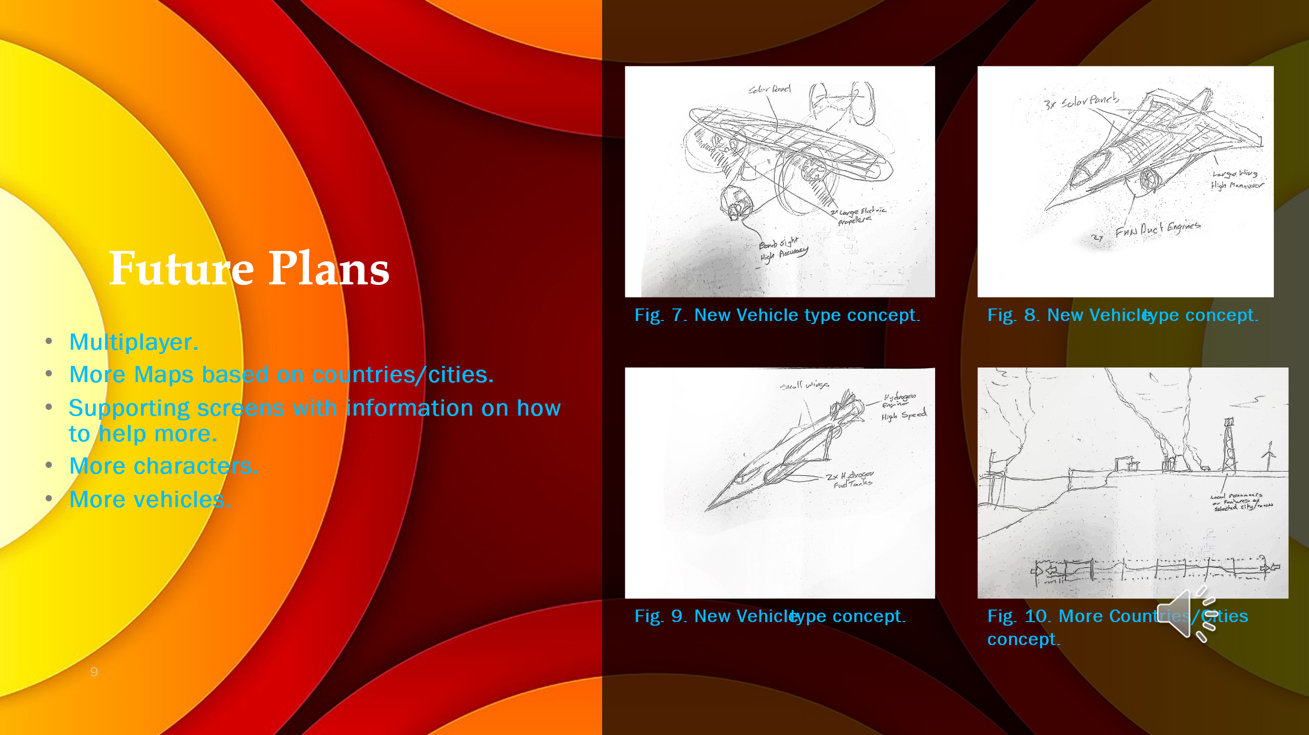

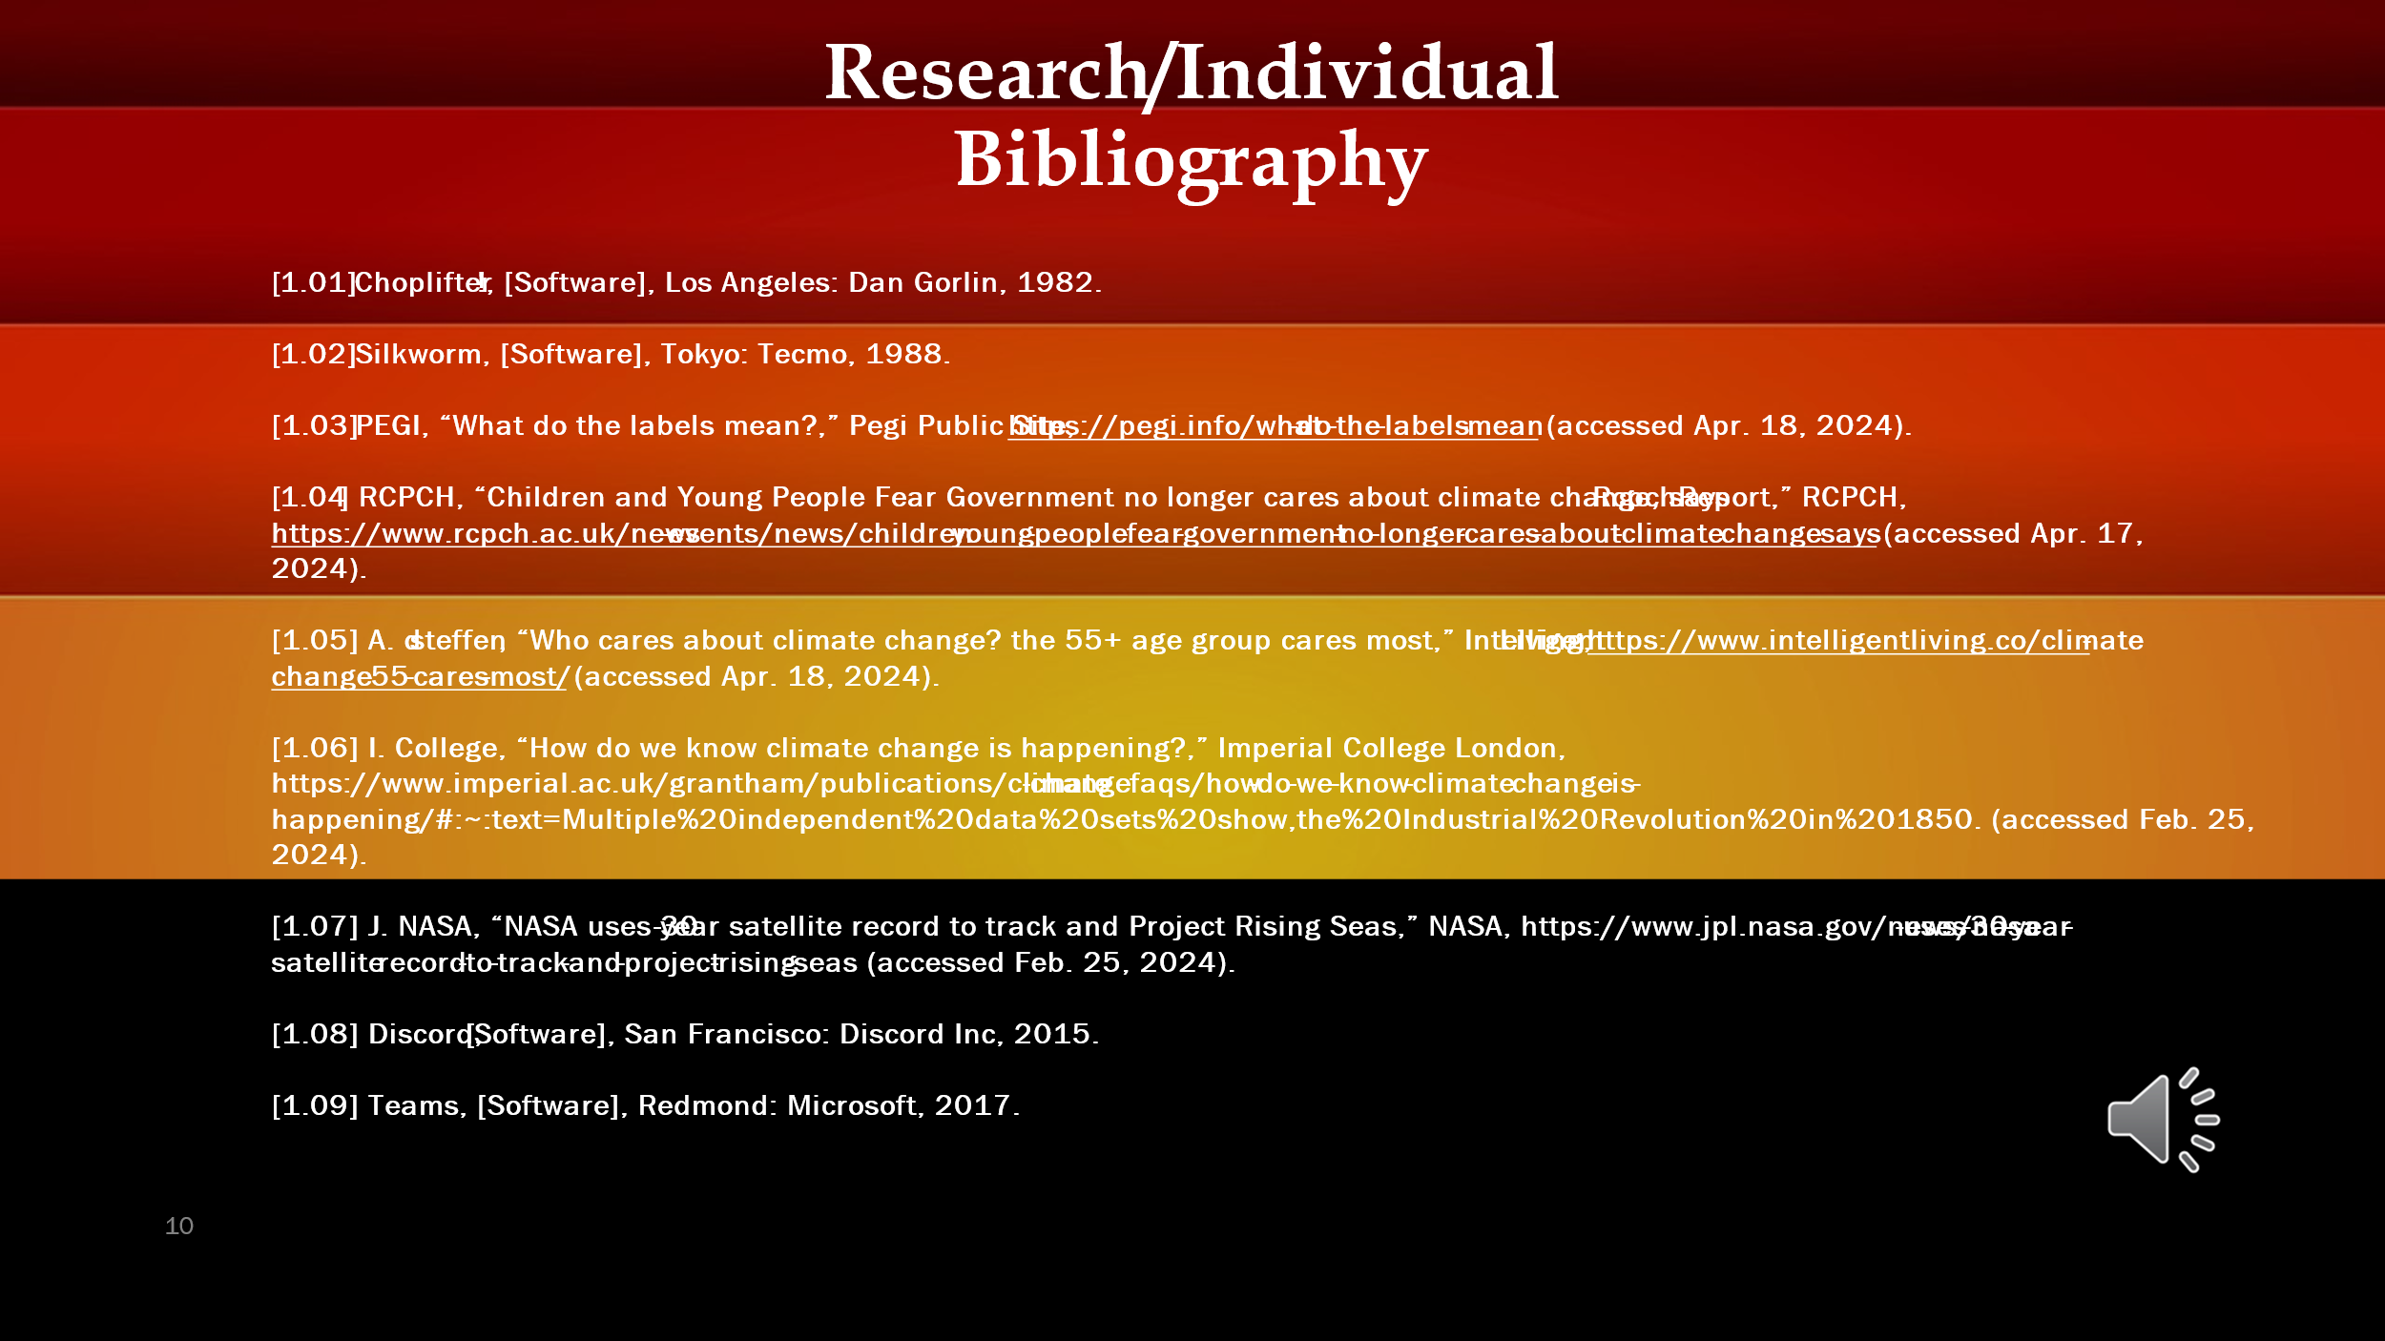

Bibliography.

[1.01] Choplifter!, [Software], Los Angeles: Dan Gorlin, 1982.
[1.02] Silkworm, [Software], Tokyo: Tecmo, 1988.
[1.03] PEGI, “What do the labels mean?,” Pegi Public Site, https://pegi.info/what-do-the-labels-mean (accessed Apr. 18, 2024).
[1.04] RCPCH, “Children and Young People Fear Government no longer cares about climate change, says Rcpch Report,” RCPCH, https://www.rcpch.ac.uk/news-events/news/children-young-people-fear-government-no-longer-cares-about-climate-change-says (accessed Apr. 17, 2024).
[1.05] A. d steffen, “Who cares about climate change? the 55+ age group cares most,” Intelligent Living, https://www.intelligentliving.co/climate-change-55-cares-most/ (accessed Apr. 18, 2024).
[1.06] I. College, “How do we know climate change is happening?,” Imperial College London, https://www.imperial.ac.uk/grantham/publications/climate-change-faqs/how-do-we-know-climate-change-is-happening/#:~:text=Multiple%20independent%20data%20sets%20show,the%20Industrial%20Revolution%20in%201850. (accessed Feb. 25, 2024).
[1.07] J. NASA, “NASA uses 30-year satellite record to track and Project Rising Seas,” NASA, https://www.jpl.nasa.gov/news/nasa-uses-30-year-satellite-record-to-track-and-project-rising-seas (accessed Feb. 25, 2024).
[1.08] Discord, [Software], San Francisco: Discord Inc, 2015.
[1.09] Teams, [Software], Redmond: Microsoft, 2017.

