Llyn Cerrig Bach – A ritual site, or ancient refuse pit?

Introduction:
The Llyn Cerrig Bach archaeological site is located on the west coast of the island of Anglesey. This is an interesting site as whilst there are some mentions of Druids by ancient authors, Publius Cornelius Tacitus (56-120CE) wrote specifically of his father-in-law’s (Gnaeus Julius Agricola), visit to the Isle of Mona (today known as Anglesey). During Rome’s occupation of Britain in 60CE, Gaius Suetonius Paulinus (40-69CE) invaded the sanctuary of Mona ‘on the grounds that it was feeding native resistance.’ He describes Druids on the beach as the Romans advanced ‘Close by stood Druids, raising their hands to heaven and screaming dreadful curses’. He further describes groves ‘devoted to Mona’s barbarous superstitions’ which were later destroyed by the Romans. This small insight gives us glimpse into what use the island may have had, prior to its destruction by Rome.
This essay will look at some of the objects found and discuss their significance to the people who lived on the island and what use the lake, turned marshland, once had.

Archaeological finds:
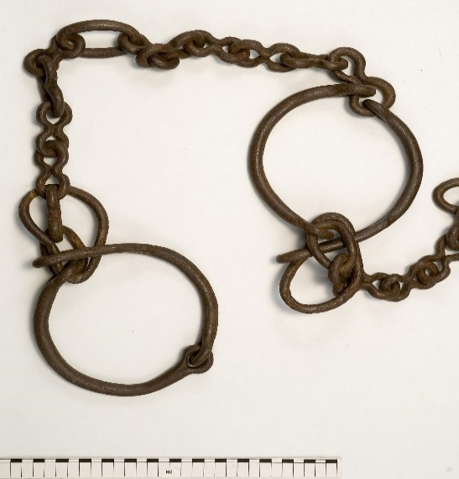
In 1942, during World War II, an airfield was constructed within the Tywyn Trewan sand dunes, this became RAF Valley. It was on the northern side of this excavation, in the Cors yr Ynys bog during peat extraction that the artifacts were found, along with some animal bones. Some 170 Iron Age artifacts and animal bones were discovered, along with some modern and one medieval piece and were then examined and a report eventually published by Sir Cyril Fox (1882-1967CE), of the National Museum of Wales in 1947. The site is now named Llyn Cerrig Bach (Lake of Small Stones), likely after the nearby farm ‘Cerig Bach’. The first object found at the site was the iron ‘gang-chain’ (figure 1) dated to around 100BCE-50CE. This was initially used by workers at the site (who didn’t know it’s origin) to pull lorries stuck in the mud when their tow ropes broke. This is a remarkable testament to the craftmanship that went into making this chain and the preservation that it had within the peat. The chain was designed to imprison five people, is 3 metres in length and held it’s prisoners roughly 60cm apart from each other. The presence of this chain (and possibly others that were apparently not retained) is significant in showing that captives may have been kept on the island, the significance of which will be shown later.
Figure 1
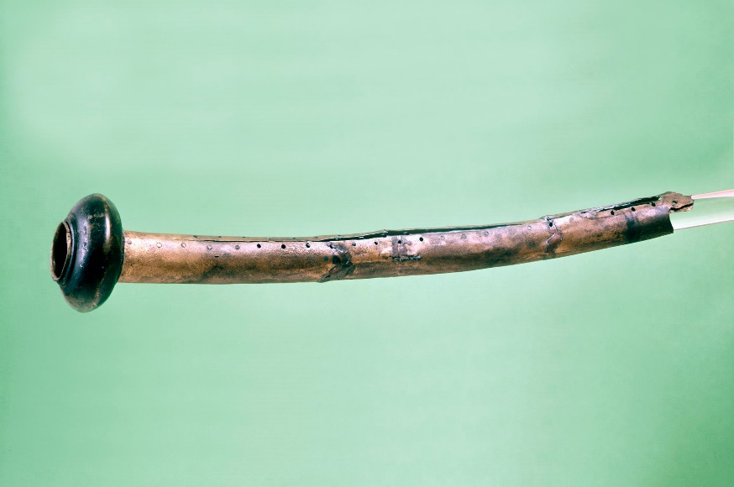
Also found was a fragment of what has been described as a ‘curved-horn, or trumpet’ dated to around 150BCE-50CE. Phillip MacDonald, in his book ‘Llyn Cerrig Bach’ describes this fragment as ‘crumpled and in two pieces when recovered’ but was later restored and reshaped into its original form. It is made of a copper alloy sheet which was rolled over to form a long tube and curved concavely slightly, and then riveted in place (figure 2).
MacDonald states that the trumpet is likely of the ‘curved-horn’ variety as opposed to the ‘Carnyx’ type found elsewhere. These C-shaped instruments were constructed with copper alloy sheet, riveted along its length and ended in a bell-shaped mouth from which the sound emerged. An example of a complete curved-horn (figure 3) was found at another lake site, Loughnashade, in Co. Armagh, Ireland along with other horns and an array of human skulls and bones.
Figure 2
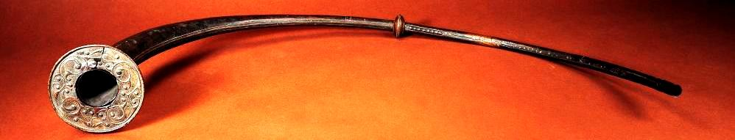
Figure 3
Other examples of this type of horn have also been found at other bogs according to MacDonald, mostly in Ireland but also in Sweden and Germany and also depicted on the statue of the ‘Dying Gaul’.
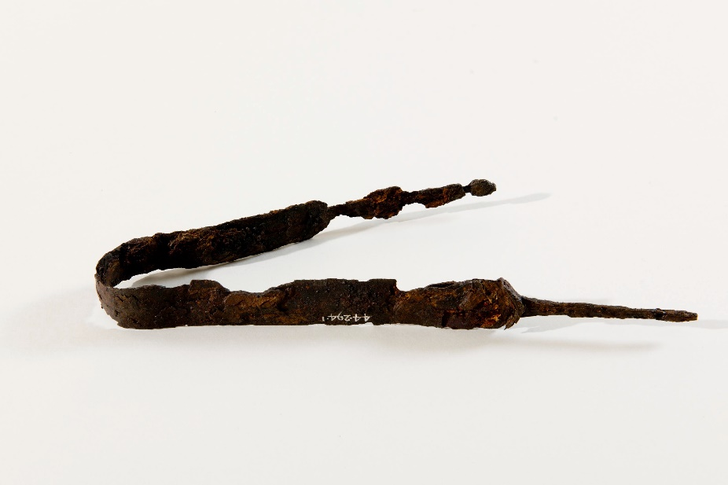
Weapons also form a good portion of artifacts found in the site. A number of swords and spear heads were found in the bog, most bent beyond use. The swords found have been identified as the La Téne III sword type which was used between the 1st century BCE and 1st century CE. Copper alloy fragments of scabbards were also found, some still attached to the swords where they have decayed (figure 4). This example has been bent so further use would be impossible. Miranda Green in her book ‘Celtic Myths’, describes this as a votive offering:
Figure 4
‘Two aspects of votive offerings of inanimate objects are of special interest: one is deposition in watery places; the other is ritual breakage. Both rituals were practised in Europe long before the main Celtic period. Both appear to have in involved the separation of votive gifts from the mundane world by ritual ‘killing’, rendering them inaccessible or useless to humankind and thus appropriate gifts to the supernatural powers.’
This certainly seems to be the case with some of the offerings at Llyn Cerrig Bach, particularly with regard to weapons.
A shield boss mount was also found and dated to around 100BCE-50CE, also made of a copper alloy it formed the front of a shield, the ‘boss’ or rounded mound that comes off the front of the shield, conceals the users hand underneath so that the shield handle (fitted across an opening in the flat of the shield itself), can be held comfortably. The shield boss has etchings on it in the form of ‘asymmetrical triskele designs’, which has been applied with ‘incised lines and infilled with overlapped tremolo hatching’. This pattern is decorated in what MacDonald refers to as Stead’s Style V, meaning Dr I.M. Stead who wrote a book called ‘Celtic Art in Britain before the Roman Conquest’ within which he refers to different art styles. Style V refers to the La Téne inspired art style of the 1st century BCE. Figure 5 shows this shield boss and it’s remarkable etching.
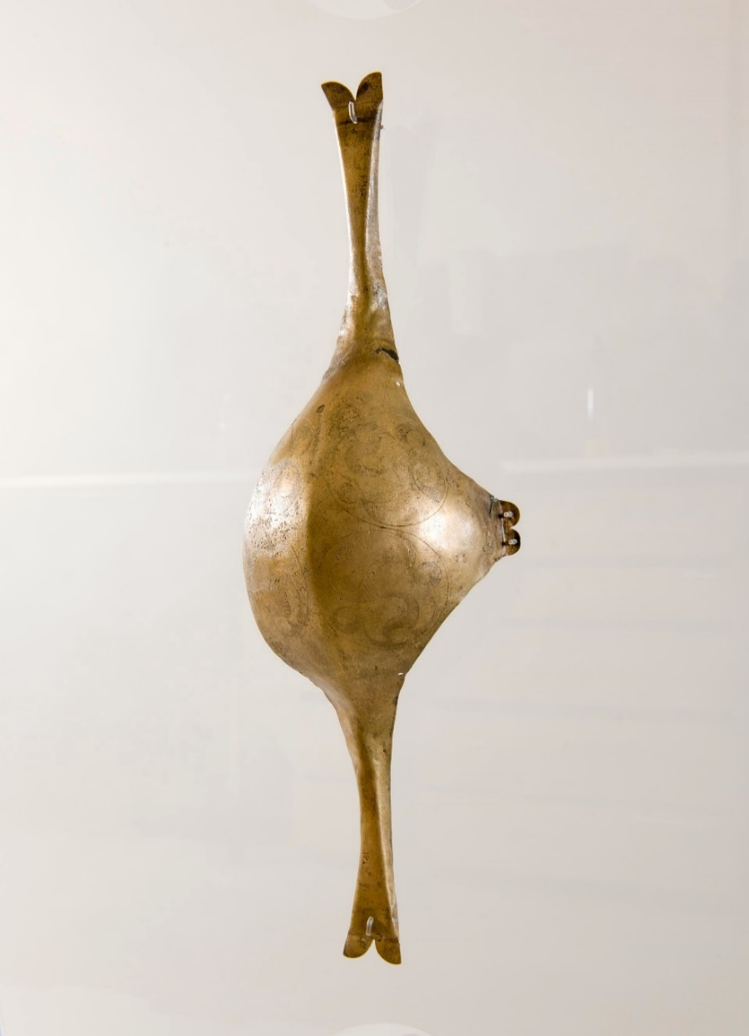
This shield boss was likely fitted to a wooden or hide shield and MacDonald discusses in detail the likely origin of the shield as being a part of the north Wales shield group, although it cannot be confirmed as there are style differences and similarities. Whatever its origin, it is an ornate design and with its lack of battle scarring, unlikely to have been used in combat.

Figure 5
These are just a few of the types of items that were deposited into the lake. Other items include horse bridles, blacksmithing tools, chariot parts and farming tools. Several copper alloy plaques were also found including a decorative plaque generally referred to as the crescentic decorative mount.
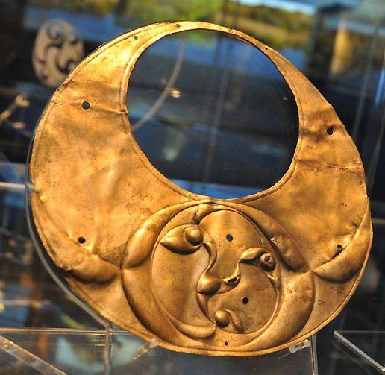
This mount, dated to around 200BCE-50CE, was likely at one time, mounted on something as it has several holes in it for such a purpose, but archaeologists have not been able to determine what it was mounted on. The plaque itself is decorated with ‘an elaborate repoussé triskele design’. MacDonald says that it has great importance to the study of La Téne art in Britian and is a ‘defining example of Stead’s Style V, referred to above’. The triskele pattern (figure 6), has been hammered up on one side in the repoussé style creating a raised pattern. The triskele pattern represents a much-used pattern from throughout the Classical world and may have been used in an apotropaic meaning, which would ward off evil spirits.

Figure 6

Water Offerings:
The finding of weapons, trinkets and other items (including human remains) in bogs or lakes is widespread throughout the Celtic world. The La Téne site in Switzerland produced over 1500 artifacts, Loughnashade in Ireland, which produced the Loughnashade Horn and the ‘Bog Bodies’ from Oldcroghan and Clonycavan are all examples of Iron Age water offerings. According to Miranda Green ‘Water was perceived as both a creator and destroyer of life’ so the use of water by Iron Age people in the gods that they worshipped (Nantosuelta, Grannus, Llyr and Manannán mac Lir to name a few) and in the places that they chose to make offerings, is understandable. The practice of votive offering was discussed above, but it is the sacrifice of an item of value that truly gives the ‘gift’ its power; ‘The more valuable the offering, the more powerful the act of propitiation’.
The place of sacrifice was also important to the Celtic ritual. Groves of wood are mentioned in classical writings, Oak being a sacred tree to the Celtic people. Peter Beresford Ellis talks of the ‘Crann Bethadh’ (Tree of Life), a large oak tree, being present in the centre most Celtic villages. As mentioned above, Tacitus mentions groves on the island of Mona, and together with the presence of the Druids the idea of Mona being used as a ritual and religious site becomes clear. Of the groves Tacitus also says ‘For it was their religion to drench their altars in the blood of prisoners and consult their gods by means of human entrails’. This shows that these sites were also likely used for ritual sacrifice of human beings, which also alludes as to why animal bones were also found at the Llyn Cerrig Bach site, animals being an important sacrifice for the Iron Age people.
In his concluding remarks of his book ‘Llyn Cerrig Bach’, Phillip MacDonald discusses the nature of disposal of the artifacts found. Many of the items found appear to have been deposited into the lake in a way consistent with a votive offering. The animal bones recovered also show no signs of butchery, indicating that they ‘represent sacrifices rather than the remains of feasting.’ MacDonald does mention human bones being found at the site, but there seems to be some confusion over the validity of this. MacDonald states that Sir Cyril Fox describes an RAF engineer describing animal bones being found with the metal objects, however examination of the letter from the engineer held by the National Museum of Wales shows that the engineer ‘actually states that the metal-work had been found with human, not animal, bones.’ Discussion on this subject of human remains seems to be sparse so it will remain a ‘possibility’ for the purposes of this essay.

Conclusion:
As can be seen by the artifacts presented, all appear to be of a military nature and given the nature of a votive offering, of value to the previous owner. The significance of the island of Anglesey as a religious site seems to be proven, the presence of Druids during the Roman attack, the finding of sacred groves (clearly still in use from Tacitus’ description), following their defeat, show a clear use of a religious nature. The site of Llyn Cerrig Bach itself shows that sacrifices and offerings (including animal and possibly human, bearing in mind the gang-chain also found) were made in the waters of the lake and it was significant enough to be a place for those who lived their to ritually break weapons at a time when they would have been of use in war.
Llyn Cerrig Bach was clearly not just a dumping ground for discarded goods, but a very important site for the residents of the Isle of Mona. It was also significant enough for people to seek it as a sanctuary and use it to strike out at the Romans, to such a degree that it caused the Romans to attack it and destroy its religious groves.

Bibliography:
Ellis, Peter Beresford, ‘The Druids’ (London: Robinson, 2017).
Encyclopaedia Britannica, ‘Repoussé’ https://www.britannica.com/art/repousse [Accessed: 4th January 2024].
Green, Miranda Jane, ‘Celtic Myths’ (London: British Museum Press, 1993).
History And Archaeology Online, ‘Llyn Cerrig Bach – A Celtic Ritual Site’ https://historyandarchaeologyonline.com/llyn-cerrig-bach-a-celtic-ritual-site/ [Accessed: 4th January 2024].
Irish Archaeology, ‘Five Ancient Musical Instruments From Ireland’ http://irisharchaeology.ie/2014/03/five-ancient-musical-instruments-from-ireland/ [Accessed: 4th January 2024].
MacDonald, Phillip, ‘Llyn Cerrig Bach’ (Cardiff: University of Wales Press, 2007).
Megaw J.V.S. and Megaw M. Ruth, Book Review of ‘Celtic Art In Britain Before The Roman Conquest, by I.M. Stead’ https://www.journals.uchicago.edu/doi/abs/10.2307/505467?journalCode=aja [Accessed: 4th January 2024].
Mingren, Wu, ‘The Carnyx: Ancient Trumpet Leading Celtic Warriors To Battle’ https://www.ancient-origins.net/artifacts-other-artifacts/carnyx-ancient-trumpet-leading-celtic-warriors-battle-006019 [Accessed: 4th January 2024].
Museum Wales, ‘Iron Age – Copper Alloy Trumpet’ https://museum.wales/collections/online/object/8b9be422-c1c7-3133-88b2-4e99a55e0a37/Iron-Age-copper-alloy-trumpet/?field0=string&value0=Llyn%20Cerrig%20Bach&field1=with_images&value1=1&field2=string&value2=trumpet&index=0 [Accessed: 4th January 2024].
Museum Wales, ‘Iron Age – Copper Alloy Shield Boss’ https://museum.wales/collections/online/object/c90483e6-615b-31b9-9dd0-eeaa00f744b7/Iron-Age-copper-alloy-shield-boss/?field0=string&value0=Llyn%20Cerrig%20Bach&field1=with_images&value1=1&page=2&index=16 [Accessed: 4th January 2024].
Museum Wales, ‘Iron Age – Iron Gang Chain’ https://museum.wales/collections/online/object/3430858b-6057-3d62-9e60-6f0e0c58a48a/Iron-Age-iron-gang-chain/?field0=string&value0=Llyn%20Cerrig%20Bach&field1=with_images&value1=1&page=2&index=17 [Accessed: 4th January 2024].
Museum Wales, ‘Iron Age – Iron Sword’ https://museum.wales/collections/online/object/33f0f656-2e42-3021-9f8d-d6184d6f5c93/Iron-Age-iron-sword/?field0=string&value0=Llyn%20Cerrig%20Bach&field1=with_images&value1=1&page=2&index=22 [Accessed: 4th January 2024].
National Museum of Ireland, ‘Bog Bodies Research Project’ https://www.museum.ie/en-IE/Collections-Research/Irish-Antiquities-Division-Collections/Collections-List-(1)/Iron-Age/Bog-Bodies-Research-Project [Accessed: 8th January 2024].
Tacitus, ‘Agricola And Germania’ (London: Penguin Group, 2009).
Tacitus, ‘The Annals Of Imperial Rome’ (London: Penguin Books, 1996).
The Celtic Journey, ‘Triskele’ https://thecelticjourney.wordpress.com/tag/triskelion/ [Accessed: 4th January 2024].
The-Past.com, ‘The Riddle Of The Lake: Llyn Cerrig Bach And Iron Age Anglesey’ https://the-past.com/feature/the-riddle-of-the-lake-llyn-cerrig-bach-and-iron-age-anglesey/ [Accessed: 4th January 2024].

Tacitus, ‘Agricola And Germania’ (London: Penguin Group, 2009), p. 11.
Tacitus, ‘The Annals Of Imperial Rome’ (London: Penguin Books, 1996), p. 327.
Ibid., p. 327.
Phillip MacDonald, ‘Llyn Cerrig Bach’ (Cardiff: University of Wales Press, 2007), p. 2.
Museum Wales, ‘Iron Age – Iron Gang Chain’ https://museum.wales/collections/online/object/3430858b-6057-3d62-9e60-6f0e0c58a48a/Iron-Age-iron-gang-chain/?field0=string&value0=Llyn%20Cerrig%20Bach&field1=with_images&value1=1&page=2&index=17 [Accessed: 4th January 2024].
MacDonald, ‘Llyn Cerrig Bach’, p. 4.
Ibid., p. 103.
Ibid., p. 103.
Museum Wales, ‘Iron Age – Copper Alloy Trumpet’ https://museum.wales/collections/online/object/8b9be422-c1c7-3133-88b2-4e99a55e0a37/Iron-Age-copper-alloy-trumpet/?field0=string&value0=Llyn%20Cerrig%20Bach&field1=with_images&value1=1&field2=string&value2=trumpet&index=0 [Accessed: 4th January 2024].
The ‘Carnyx’ was a type of horn or trumpet used by the armies of the Iron Age, in particular those who we call Celtic. It was an upright instrument and usually had an animal head fixed where the sound emerged.
Irish Archaeology, ‘Five Ancient Musical Instruments From Ireland’ http://irisharchaeology.ie/2014/03/five-ancient-musical-instruments-from-ireland/ [Accessed: 4th January 2024].
MacDonald, ‘Llyn Cerrig Bach’, p. 98.
Museum Wales, ‘Iron Age – Iron Sword’ https://museum.wales/collections/online/object/33f0f656-2e42-3021-9f8d-d6184d6f5c93/Iron-Age-iron-sword/?field0=string&value0=Llyn%20Cerrig%20Bach&field1=with_images&value1=1&page=2&index=22 [Accessed: 4th January 2024].
Miranda Jane Green, ‘Celtic Myths’ (London: British Museum Press, 1993), p. 70-71.
The ‘Triskele’ is an ancient symbol consisting of three interlocking spirals.
MacDonald, ‘Llyn Cerrig Bach’, p. 127.
Ibid., p. 127.
J.V.S. Megaw and M. Ruth Megaw, Book Review of ‘Celtic Art In Britain Before The Roman Conquest, by I.M. Stead’ https://www.journals.uchicago.edu/doi/abs/10.2307/505467?journalCode=aja [Accessed: 4th January 2024].
Museum Wales, ‘Iron Age – Copper Alloy Shield Boss’ https://museum.wales/collections/online/object/c90483e6-615b-31b9-9dd0-eeaa00f744b7/Iron-Age-copper-alloy-shield-boss/?field0=string&value0=Llyn%20Cerrig%20Bach&field1=with_images&value1=1&page=2&index=16 [Accessed: 4th January 2024].
‘Repoussé’ is a method of decorating metals by raising a pattern from the back or inside of an object by using a hammer or punch.
MacDonald, ‘Llyn Cerrig Bach’, p. 119.
Ibid., p. 123.
History And Archaeology Online, ‘Llyn Cerrig Bach – A Celtic Ritual Site’ https://historyandarchaeologyonline.com/llyn-cerrig-bach-a-celtic-ritual-site/ [Accessed: 4th January 2024].
Green, ‘Celtic Myths’, p. 51.
Ibid., p. 67.
Peter Beresford Ellis, ‘The Druids’ (London: Robinson, 2017), p. 40.
Tacitus, ‘The Annals Of Imperial Rome’, p. 327-328.
Green, ‘Celtic Myths’, p. 69.
MacDonald, ‘Llyn Cerrig Bach’, p. 173.
Ibid., p173.

