A Critical anlaysis of policing in South Wales during the COVID 19 pandemic.
Kirsty Lauren Jones-Higginson - 1901468

Contents
Abstract 3
Declarations 4
Acknowledgements 5
Chater 1.1 Introduction 6
Chapter 2.0 Literature Review 10
2.1 Policing South Wales during Covid 19 Pandemic 10
2.2 Police approaches in Wales compared to other countries 15
Chapter 3.0 Research Methods 18
3.1 Research Onion 18
3.2 Philosophy 19
3.3 Approach 19
3.4 Research Strategy 20
3.5 Choices 21
3.6 Time 21
3.7 Technique 21
3.8 Ethics 22
3.8 Limitations and Potential Hurdles 22
Chater 4.0 Findings 24
4.1 Research data analysis 24
4.2 Questionnaire Feedback 24
Chapter 5.0 Conclusion 35
5.1 Summary of findings 35
5.2 Objective one 35
5.3 Objective Two 36
5.4 Objective three 36
5.5 Recommendations and lessons learned. 37
References 38
Appendix 1 50
Questionnaire 50

Abstract

This dissertation aims to critically assess the policing approach during the Covid 19 pandemic. The aim of this research will be met through three objectives in order to gather full analysis. The study will include both primary and secondary to analyse. To achieve a deep analysis and evaluation a mixed methods approach will analyse both quantitative and qualitative methods.

Declarations
This work has not previously been accepted in substance for any degree and is not being concurrently submitted in candidature for any degree.
STATEMENT 1
This dissertation is being submitted in partial fulfilment of the requirements for the degree of BA/BSc.
STATEMENT 2
This dissertation is the result of my own independent work/investigation, except where otherwise stated.
Other sources are acknowledged in the Reference Section.
STATEMENT 3
I hereby give consent for my dissertation, if accepted, to be available for photocopying and for interlibrary loan, and for the title and summary to be made available to outside organisations.
STATEMENT 4
I hereby give consent for my dissertation, if accepted, to be available on the university’s IT system to those who have consent to use the system.

Student’s Name: Kirsty Lauren Jones-Higginson

Signed:

Date: Wednesday 1st May 2024

Acknowledgements
I would like to thank all lectures at UWTSD for the help I have received throughout studying my undergraduate. I would also like to say a special thank you to Laura who has been the best dissertation supervisor, and I honestly would not have got through my dissertation without your support. I would also like to thank Sadie for her support throughout my studies. I am thoroughly grateful to have the most amazing family, friends and partner who have also been by my side every step of the way. Thank you all!

Chater 1.1 Introduction

During the four-week period following the announcement of the coronavirus pandemic and subsequent lockdown up until May 24th, the National Police Chiefs' Council (NPCC) reported a total of 134,188 incidents directly related to the Covid-19 pandemic and policing. All reports had relations to officers communicating the new restrictions, breaches, and other criminal behaviours (Currenti and Flatley, 2020). The NPCC South Wales Police published an article in 2020 to give a key understanding of the legislation during the lockdown. They prioritised clear communication with the public to ensure understanding of rules and public safety, including awareness of potential fines for rule violations. South Wales Police swiftly adapted to enforce new laws and changes (South Wales Police, 2020).
The overall aim for this dissertation is to critically assess the policing approach in South Wales during the Covid 19 pandemic. In order to make this aim achievable objectives are needed to meet the criteria. The following objectives are:
- Assess how policing changed during the Covid-19 pandemic.
- Compare and contrast the police approach in Wales compared to other countries.
- Evaluate public perceptions on policing in South Wales during the pandemic.
Initially, the announcement of the first lockdown due to Covid 19 significantly impacted policing, the introduction of safety measures such as mandatory mask-wearing, full personal protective equipment (PPE) and gloves was implemented. These guidelines were being reviewed every three weeks to see if the spread of Covid 19 was being impacted upon (Drakeford, 2022). In relation to policing when the pandemic first came about the police suffered from having no PPE to start with, as well as not knowing how to enforce the new laws which the government had set (De Camargo, 2021). This put a large strain on the forces to ensure that communities were following guidelines as well as having to ensure people were familiar and adapting to the changes quickly.
The implementation of new guidelines and laws has posed challenges for the efficiency of police forces in both England and Wales. With the introduction of the two-meter rule, many businesses closed or must ensure they had adapted to social distancing (UK Parliament, 2021). This resulted in criminal justice system having to close the courts, ensure single patrols were carried out as well as enforcing social distancing across all forces with many remotely from home (HMICFRS, 2021). This prevented police forces in Wales from referring offenses to the criminal justice system, resulting in a backlog and longer waiting times for victims. However, when in the process of getting the courts back up and running Wales’s forces came up with different ways in which they could support victims in the interim. A good example that South Wales police did was provide extra support to victims of domestic violence and abuse and those who were very vulnerable (South Wales Police and Crime Commissioner, 2021).
Police forces across the UK had seen a recent increase in domestic abuse and violence since the government announced a lockdown where everyone had to stay at home. According to Elkin (2022) from the crime survey in England and Wales states that the number of reports that were domestic abuse related increased by 7.7% compared to the year prior to Covid 19. However, the statistics also show that that 4 years prior to the pandemic the cases reported had not increased. Therefore, this shows that because the lockdown rules were forcing everyone to stay at home, this could actually have caused individuals to be more at risk with no escaping mechanism (Walklate, Godfrey and Richardson, 2021). This in effect impacted on the police as the restrictions made it harder for the police to engage with victims. According to Johnson and Hohl (2021) additional policies were added to ensure co-ordination between each domestic abuse victim and police forces was at a high standard, new awareness campaigns, stronger safeguarding measures, such as ongoing communication with repeat victims and repeat perpetrators to ensure wellbeing and safety.
According to (Tehrani, 2022) front-line police officers have persistently safeguarded the public, addressed civil unrest, and conducted criminal investigations. Despite these duties, they grappled with workforce challenges and heightened stress due to increased workload demands. The pandemic introduced additional daily tasks for police forces across England and Wales, necessitating the completion of all other work alongside these new responsibilities. This left officers with double the workload causing a shortage of staff to manage it. Therefore, this led to an overall poor performance of the criminal justice system due to the delays throughout. However, this was an added pressure that could have a negative impact on the confidence that the public had in the police forces and within criminal justice (College of Policing, 2021).
Public perceptions to policing during Covid 19 findings will be gathered from the primary research of a questionnaire. This is where there will be a wide range of questions to gain an insight in how people feel about Covid 19 and how the way the police have dealt with the problems they faced during the lockdown.
Throughout this study, both primary and secondary research methodologies will be employed. Primary research will involve the creation of a questionnaire to collect data directly from participants, while secondary research will be conducted through a comprehensive literature review. The questionnaire will be available to access through online platforms to gain an insight into public perceptions of policing during the Covid 19 pandemic. The questionnaire will feature a variety of open and closed questions in order to gain quantitative and qualitative research (Jones, Baxter and Khanduja, 2013). The questionnaire will have a large focus on the third objective but will have a link to the first objective. However, the questionnaire will not be asking any questions that will cause an ethical concern or anything personal. From the findings of the questionnaire the results will be done through thematic analysis in order to identify key themes and patters that appear in the questionnaire on a number of occasions (Caulfield, 2022).
As an overview of the estimate timescale for this dissertation the research commenced on October 2, 2023, and will continue until early January 2024. Throughout October and November 2023, the focus will be on completing the full submission and draft of the ethics, proposal, and introduction sections. By around November 20th, 2023, resources for the main body will be identified, and key themes and points will be analysed for the literature review. Upon returning from the Christmas break in January 2024, primary research will be completed and sent out for data collection. The methodology will be finalised to proceed with the conclusion and recommendations by March 2024. Proofreading and editing will be completed by the end of March 2024, allowing a month for any necessary revisions before the final deadline on May 7, 2024.
The Coronavirus pandemic became a global issue in a very short period. The research will be carried out to identify if there are any gaps within the research from the pandemic as well as identifying new literature. This study could potentially be a benefit to South Wales police forces for any future global pandemics or crises. This study will be beneficial as it will allow individuals to understand the impact Covid had on policing as well as educating the important of communities, trust and engagement, as well as an increase in police supply and demand (Laufs and Waseem, 2020).

Chapter 2.0 Literature Review

Stripe (2020) suggests that there was a 32% reduction in all crimes during the first two months of the lockdown however this did not include fraud or computer misuse. Firstly, within this literature review it will be identifying the different crimes committed and looking at the statistics of each crime during the pandemic. It will allow an overview of the changes that implementing policing during the pandemic. Following on from assessing how different crime rates fluctuated it will also look at comparing police approaches in Wales compared to other countries looking at any similarities or differences.

2.1 Policing South Wales during Covid 19 Pandemic

According to Langton, Dixon, and Farrell (2021), the Covid 19 pandemic significantly impacted societies, in particular criminal behaviour. Ashby (2020b) suggests the effect of the UK lockdown and the government requirement for people to stay at home have evidenced changes in social interactions which created greater opportunities for crime. It can be identified that theft and robbery showed a decrease with being sixty percent below expected crime rate. This can be show from the changes and laws that were put in place to stop individuals from mixing and implementing the “stay at home” guidelines. Due to the closure of many companies during the first lockdown in 2020 this impacted the decrease in this type of crime. However, crimes that were more likely to happen in a community like burglary were known to be more than a third lower than expected. This could potentially have been due to many people remotely working from home and the lowered numbers of individuals leaving their homes.
An overall decrease has been shown in criminal damage and arson offences as well as public order decreasing by twenty percent below the average rate. Criminal damage and arson offenses fell by 31% by April 2020 which meant 13,902 less offenses committed at the start of the Covid 19 restrictions being implemented (Stripe, 2020). According to Stripe (2020) public order offences fell during the period between March to April 2020 but later in the months April to May had risen by 23% this shows an overall change increasing the demand for policing during Covid 19 within this area of crime. However, with public order a gradual increase was identified as the lockdown period went on with an increase in alcohol related incidents. During the first six months of the pandemic according to the Crown Prosecution Service (2021) “public order offenses were primarily coronavirus related” this could have been as there was an increase in assaults against emergency service workers and key workers. Therefore, putting an overall strain on policing as well as more pressure to ensure key workers were not becoming victims of crime. On the other hand, it was also often seen that anti-social behaviour reports were down to people breaking the lockdown rules or Covid 19 restrictions attending house parties, social events, or abuse towards staff members (Clements and Skidmore, 2020).
Cybercrime and fraud have been identified more since people were made to work from home. Fraud and computer misuse offences had seen an increase of 54% due to Covid 19 pandemic (Elkin, 2022). The government have seen more scams related to covid 19 and during covid than any other areas (National Cyber Security Centre, 2020). In 2020 from the month of March to May, Kemp et al., (2021) suggests that there was a “sharp spike” in the rates of cybercrime and fraud, this shows a greater amount than the months in the previous 3 years. The UK went into a national lockdown in March 2020 forcing people to stay at home and move to remote working at their households, therefore this shows the increase of these types of crimes online and the decrease of crimes happening offline. However, with the increase in fraud due to more people being actively working online, more individuals were shopping online making it easier for online fraud to happen (Kemp et al., 2021).
During the period February 2020 to March 18th, 2020, there were 105 reports from victims of coronavirus related frauds, which led to a total loss of £970,000. Following these 200 reports from individuals receiving phishing emails regarding attachments and financial personal information (South East Regional Organised Crime Unit, 2020). According to the NCSC (2020) between the start of May 2020 and the end of May 2020 there were 160 reports on ‘suspected emails. In response to these figures the National Crime Security Centre closed 471 fake online shops down with Her Majesty’s Revenue and Customs removing 292 fake websites (Lallie et al., 2021)
Police recorded crime data shows that there was an increase in domestic abuse related crime. The crime survey for Wales and England highlighted between March 2019 and March 2020, there was a 7% increase in police-recorded domestic abuse cases, with 1.6 million women and 757,000 men having experienced such incidents. Additionally, a 12% increase in the number of cases being referred to victim support from domestic abuse crimes (Havard, 2021). However, these types of offences are being recorded more accurately over the years which has also shown the increase, so it is hard to tell if the increase is due to more accurate data. However, London Metropolitan police have identified that there was an increase in calls for incidents involving this crime which has a potential of being because more people were having to be at home. Therefore, more partner agencies and helplines were becoming more use to individuals and first point of contact from domestic abuse (Office for National Statistics, 2020).
According to Chandan et al., (2020) to prevent a higher increase in domestic violence cases during the pandemic the WHO public health organisation created an approach which included four steps. However, the approach was in question for adaption to contribute to tackling domestic violence throughout the pandemic. The police forces then used this approach during Covid 19 to adapt for policing. ‘The four steps were adapted to surveillance, identifying risk and protective factors, implementation and developing and evaluating interventions’ (Clements and Skidmore, 2020). However, they also suggested that it would not be possible to tackle domestic violence during the Covid 19 pandemic without surveillance. By having surveillance, it allows support to interventions to link police forces with health records and other professional to identify individuals affected. The interventions will allow the victims to be able to access the services that are needed to prevent any further risk (Chandan et al., 2020).
Police officers were under pressure with the new regulations and law that came into force from the beginning of COVID 19 as they were new to them as well as everyone else in the community. The new regulations allowed officers to have strengthened powers in order to help tackle Covid 19, therefore some of the new regulations included police forces ensuring people stayed at home and were not carrying out unessential travelling, breaking up gatherings or giving instructions to go home if rules were breached, as well as issuing fines for breaches within these rules (Home Office, 2020).
Aitkenhead et al., (2022) suggests that two thirds of the public which was 65% were not clear of the rules and new enforcements that were being set out which had a negative impact on police forces trying to enforce the new laws with no clarity and many individuals not following guidelines. 67% of the public stated that the police were “under-resourced” as the pandemic added pressures and certain crime types to increase causing more work for the forces as they still had day to day tasks to do within their job role as well as having other jobs with the Covid 19 pandemic. Police officers were often unsure of the guidelines and new laws themselves as the new law enforcement introduced were so fresh, so it was hard for the information to be relayed accurately. According to Clements and Skidmore (2020) it was seen that the country was taken out of the lockdown restrictions quickly, with guidelines which were not laws which therefore made it harder for police to get the public to follow the rules from all the different changes being made too quickly.
From the spread of the coronavirus illness this caused many disruptions within forces of the police when it came to staffing issues. Due to the spread of illness individuals had to self-isolate and if family members caught covid often led to households having to isolate together increasing the number of staff taking sick leave or working from home. According to Fleming and Brown (2021) the workloads for individuals increased by 23% due to a strain on the forces to cover staff sickness. This caused police officers who were able to work to take on workloads of others making it more difficult. Police and front-line workers were often being treated with disrespect just by doing their job, according to Royce (2020) police officers were being coughed at and spat out whilst on daily patrols by individuals who were drunk and disorderly whilst trying to enforce Covid restrictions. This was putting officers at risk being on the front line throughout this horrible time as well as added stress and pressures to the force as officers the feared doing their jobs from being treated in this way. However, impacting the mental health of officers as well as not having enough officers patrolling. Therefore, the’ Coronavirus Action Plan’ was implemented in order for police staff to focus on main priority crimes (Winchester, 2020). According to the (NPCC, 2021) despite having faced these barriers with restrictions easing they will continue to ensure regular patrols are completed and engaging in communities to ensure restrictions are being adhered to.
Syed et al., (2020) undertook a systematic review in mental health problems within police forces. The findings suggest that the trauma that police officers experienced was linked to the increase in mental health issues. However, showing 14.6% within depression, 14.2% PTSD, 25% showing individuals within a higher risk of alcohol assumption above recommended intake as well as 9.6% of individuals experiencing anxiety. Covid 19 pandemic added more daily tasks to police officers’ jobs as they continued to complete criminal investigations and tasks prior to Covid 19. Despite the issues police forces were facing with their own employees suffering with mental health issues, forces ensured at there was support services available for staff like the ‘National Police Wellbeing Service and Oscar Kilo (Newiss et al., 2021). As well as having to deal with police forces being the first point of contact for any mental health calls, added extra pressure to the forces (Baker, 2020).
During the Covid 19 pandemic there were many changes seen within attitudes and behaviours towards the police. It was often seen that many people had confidence in the police at a very worrying time, however, did feel let down by the police when individuals were reporting breaches of the restriction rules with nothing being done about it in certain areas (Boulton et al., 2024).This then led to some of the public believing that the police were not enforcing the regulations and guidelines properly which then led to a potential negative public perception (Clements and Skidmore, 2020). Charman et al., (2022) suggests that individuals believe that the police forces were not being strict enough with the Covid 19 rules which led to people getting away with breaching Covid 19 rules. However, Crest (2020) suggests that there are people in support of the police approach and the police must ensure that tougher action is taken next time to maintain the support with the public and work with communities effectively following the principles in policing by consent.
According to Myhill and Beak (2008) the significance of engagements with police forces becomes apparent within the corners of public trust. Those who seek aid from the police also found satisfaction in the response displayed higher levels of confidence compared to those who had not found help. This observation suggests that, unlike certain previous research, there exists potential for high-quality service to positively impact overall trust in the police force.
By police forces already having a relationship with the public that is not that strong by having the police forces enforce the new regulations and guidelines it could also be an added strain especially if police do not enforce professionally. However, it was often seen in Covid 19 that individuals retaliated and chose not to follow police instructions (Chenane et al., 2023). Communities seen unfairness with not enough being done within breaches of Covid 19 which then led to a negative public perception as many individuals obeyed to all restrictions including not seeing family, yet others were out having gatherings with no fines being issued (Boulton et al., 2024).

2.2 Police approaches in Wales compared to other countries

At the start of the pandemic the National Police Chief Council (NPCC) and the College of Policing enforced the 4 Es approach for both Wales, England, and Scotland and Northern Ireland This included engage, explain, encourage, and enforce. This was introduced to allow forces to be able to collaborate with communities to ensure that people are following the guidelines to preserve lives but to also put public health priority and be able to tackle crimes with individuals who are “obstinate non-compliers.” It was set to ensure that the public are aware that the police are not aiming for people to be criminalised but ensuring priorities of health within the Covid 19 pandemic, and only using enforcement when guidelines were not followed and if necessary (Charman et al., 2022). Metropolitan police advised English forces to operate and obey accordingly to the 4 Es (Metropolitan Police, 2020).
In April 2020 Welsh and English police were known to have given 2 fines out per 10,000 people. Whereas the Scottish police had issued 4 fines out per 10,000 people (The Police Foundation, 2020). Both Welsh and English authorities implemented restrictions and new laws similarly, but English police issued fines with a higher amount than Wales. In Wales, fixed penalty fines were capped at £120, whereas in England, they could escalate to £960 depending on the offense (Senedd, 2020). By February 2022, authorities in Wales and England had issued a total of 118,978 fines for breaches within both countries, showing that both countries were ensuring that the police were ensuring rules and regulations were stuck to (NPCC, 2020).
Spain had issues 133 fines per 10,000 people. At the end of the lockdown there was over one million fines issued by Spanish authorities whereas in Wales and England just being 22,621. According to Jiménez-Franco, Aguerri and Forero-Cuéllar (2023) 52% of individuals who did not follow the lockdown rules were issued fines. In Northern Ireland more than 8000 fines had been issued since the start of the Covid 19 pandemic up until March 2021 (BBC News, 2021).
South Wales police ensured restrictions remained in place whilst tackling repeated breaches that were causing threat to public health including large gatherings and house parties (South Wales Police, 2021). Throughout daily tasks as a force, they ensured that all members of the public stayed 2 meters apart and adhering to social distancing, however ensuring that they continued to police by consent encouraging individuals to follow rules safely addressing the 4 Es in practice. As a force they took full advantage to engage and educate individuals across social media platforms and in person where they could (South Wales Police, 2020).
Following on to Dyfed Powys police as a force operated following the 4 Es approach throughout the pandemic firstly to ensure then engaged with the public, provided explanation of the guidelines and new laws to follow to encourage communities to put the safety of others first and preventing the spread of the virus. However, enforcement was only used when breaches were made if necessary (Dyfed Powys Police, 2020). As a force they ensured to keep communities safe as well as the vulnerable. They maintained the approach of protecting communities in the area as well as being engaging, as a force they ensured the correct PPE was worn with the Crime Commissioner collaborating with all employees to sure all other partner agencies were working together effectively (Police and Crime Commissioner Dyfed Powys Police, 2020).
The Scottish police response to Covid included a “strong foundation, rapid and continual re-shaping, public communications and engagement, internal communications and engagements and the role of independent scrutiny, advocacy and accountability.” By having this response in place, it allowed for Scottish police to understand what they were doing right and where they were going wrong (Fereday and Smith, pp.1-6 2021). Spain had a large focus on ensuring people were not leaving their home and local areas without good reasoning. However, they also used drones to ensure that people who were outside their addresses were not breaching the Covid 19 rules and were fined if they did (Scottish Government, 2020).
Northern Ireland followed the 4 E’s approach like the rest of the UK by ensuring that they give full explanation of their understanding of the new regulations and enforcing laws in communities. However, they identified criticisms within the public noticing that there was a lack of knowledge on the new laws and regulations that were put in place at the start of the pandemic, as well as struggling without inadequate PPE (Northern Ireland Police Board, 2020).
As part of the send objective in comparison between different countries within the UK. It can be identified that they have all followed the 4 E’s approach that has been set out by The College of Policing for the UK to ensure they are operating the forces effectively and efficiently. Wales was a little further behind in the government announcing a lockdown which therefore had a strain on Welsh forces as the virus was continuing to spread. In comparison to Scotland, from the statistics show it can be identified that they were giving out more fines than other areas of the UK under enforcements. Northern Ireland also used enforced the guidelines by giving out more fines compared to both Wales and England.

Chapter 3.0 Research Methods
The previous chapter outlined an overview is of how policing changed during the COVID 19 pandemic, analysing the different levels of crimes and the trends between crimes were identified. However, it also shows a comparison of the police approaches within different forces across Wales compared to other forces in the UK. Objectives one and two have been achieved through secondary research within the literature review. This chapter aims to outline the methodological approach used to meet the third objective of this research by evaluating public perception of policing in South Wales during the Covid-19 pandemic.

3.1 Research Onion
The research onion is an approach that is used for guidance throughout a methodology. This approach is identified as ‘a research onion’ as it is known by the different layers like an onion has. It allows individuals to be able to give a clear structure to describing the different choice that were made throughout the research conducted. In order to use this model, it is vital to ensure that it is used from the outside layer inwards. The research onion is good to use not just for the structure but to allow individuals to think deeper with gathering research (Phair and Warren, 2021).
This is an image of the research onion (figure 3.1.1) displaying the different layers of the structure (Saunders et al., 2019).

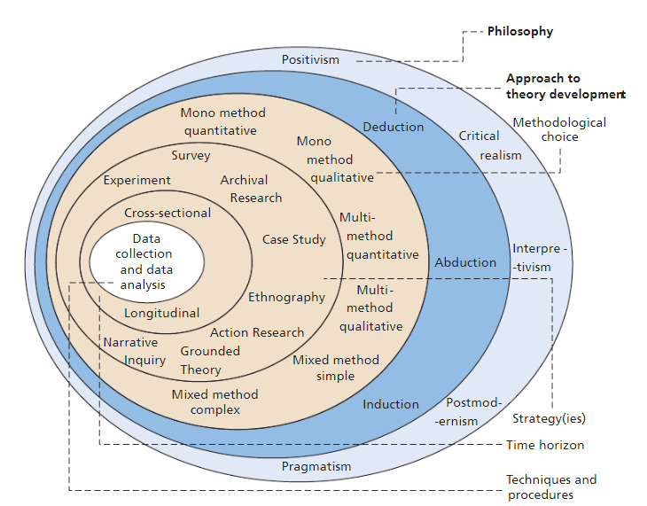
3.2 Philosophy
Philosophy is the idea within a thought process within research or in order to gather information. It allows individuals to identify the ideals of “assumptions, meanings, beliefs and theories” behind research (Pecorino, 2020). The research philosophy in any written study is the framework to ensure all research is carried out effectively (Gialdino, 2009). The image above of the research onion showing the identification of each layer shows within the philosophy layer lies positivism, critical realism, interpretivism and postmodernism. Within this dissertation the chosen philosophy type that will be best is interpretivism. However, it is often shown that interpretivism has a larger focus on qualitative methods within the layer of data collection on the research onion. Therefore, within this dissertation this type of philosophy will be used as this allows more qualitative methods of data to be analysed.

3.3 Approach
In the approach section of the research onion, it is vital that the correct approach is chosen to ensure the different ways of reasoning within the research conducted. The chosen approach for this dissertation is inductive research. According to Streefkerk, (2022) inductive research allows the researchers to “develop theories” through observations. In order to justify using this method of approach, it does not require a hypothesis in the first place therefore will allow for a wide range of research to be carried out which allows for more meanings, and it makes it easier for the researcher to identify different patterns and find a conclusion (Bernard, 2011, pp.5–8). According to the University of Nottingham (2023) the inductive approach can be identified through observation potentially between people and objects. This method has a large focus on people which therefore, this will then allow the researcher to be able to look closely at what is being investigated to gain a wider knowledge and understanding. According to Dudovskiy (2021) inductive research will allow the study to progress with existing research and knowledge being used to build a theory on answering the overall aim of analysing how policing changed during the COVID 19 pandemic. The research conducted will be through a mixed methods approach which will use both qualitative and quantitative analysis methods (Wasti et al., 2022). Quantitative research focusses on numerical data this includes percentages averages and mathematical methods, whereas qualitative research is based on data that does not involve numerical information which looks for more descriptive research (Lakshman et al., 2000). This type of data can be carried out through analysing different feelings and opinions of how policing during the pandemic affected the different communities (Greetham, 2019, pp.167–173).

3.4 Research Strategy
Within this dissertation the secondary research will be carried out in the literature review meeting both objective one and objective two. The primary research will be carried out through a questionnaire answering the third objective. A questionnaire is a common research strategy to obtain research from certain participants. Within this research strategy it allows for individuals to answer open or closed questions in an organised structured way. Each participant will answer the same questions surrounding the area of policing during the COVID 19 pandemic (Matthews and Ross, 2010, pp.200–215). A survey allows for a large target audience to be reached through the access of google forms. The chosen strategy is a survey over an interview as it is a quick and easy process to follow to gather data easily (Jain,2021). According to Jones, Baxter and Khanduja, (2013) a survey will allow the gathering of information from a ‘large cohort’ of people. A survey is beneficial as it can allow quick responses whilst only using a small amount of the participants time, it is a cost-effective method, however it is not always guaranteed that every individual will participate or answer the questions correctly. The research gathered on the chosen area of policing during the Covid 19 pandemic will be described through descriptive research in order to analysis new research gathered against current research that has already been found (Aggarwal and Ranganathan, 2019).

3.5 Choices
The methodological choice of the research onion allows the research to determine which method is best for the research being carried out, Mixed method research is a term used when both qualitative and quantitative research methods are used within a research document in order to obtain a wider range of data from both research types ( Bryman, 2016, pp.634–660). Mixed method research will be used as both qualitative and quantitative data will be gathered from the survey. By combining these methods, it can allow for a stronger understanding of the research question with more answers from the variety of different questions in the survey. However, it can be a lengthy process as it requires both methods therefore more information to gather and analyse from the results (Office for Health Improvement and Disparities, 2020).

3.6 Time
On the other hand, the chosen time horizon for this dissertation will be a cross sectional time horizon. Cross-sectional time horizon is a study that aims to analyse data from a certain time period (Wang and Cheng, 2020). This time horizon aims to identify the overall outcome of the primary research, it is often completed through a survey as they look at different variables and outcomes within findings (Jesson, 2001). The time horizon for this study with be completed between October 2023 with the completion of the study in May 2024.

3.7 Technique
The technique section of the research onion identifies the data collection and data analysis. The data collection method is a survey, which will gather the responses from a series of questions that will be put onto google forms in order to distribute the survey across social media platforms and online (Story and Tait, 2019). Sampling is a process where researchers gather information from a wide target audience to collect information (Ball, 2019). Systematic sampling will be used to ensure participation is voluntary for individuals over the age of 18. The chosen sample will be reached through snowball sampling. This is where participants who have already received the questionnaire will recommend others from within the area of South Wales to answer the questionnaire through social media platforms (Parker, Scott, and Geddes, 2019). The survey will be produced on google forms which will allow for the survey to be posted online for participants within the south Wales area to answer. To ensure that it is only individuals from this area it will be specified within the brief of the survey as well as being shared with individuals from this area. The data can then be collected from social media platforms through sharing the survey. Furthermore, it will be analysed through collating the findings from google forms creating pie charts ready to provide description, analysis, and synthesis. It will comply with the fundamental research ethics as it will not include children therefore will not require parental consent.

3.8 Ethics
Ethical issues are imperative within research to ensure that there is no “ethical misconduct.” In order for the research to be ethical it must be clarified that the university has ensured that the subject means the ethical standards of UWTSD, therefore minimising any risks to participants as all guidelines are followed. However, within this study all ethical concerns have been looked at, approved, and adhered to. (University of Wales Trinity Saint David, 2024). It is vital to follow the guidelines to ensure the rights of individuals are protected as well as ensuring the researchers attain the right “quality and integrity of research”. If the participant is under the age of 18 there is a function on the form that will automatically close down the questionnaire to prevent the participant from continuing.

3.8 Limitations and Potential Hurdles
In order to gain public perception of policing during Covid 19 pandemic the questionnaire will be asking participants questions on what happened from four years ago. Therefore, information from previous years must be recalled therefore this could be a threat to the accuracy of the information (Griffin, 2015). As a recommendation for future research, a question based on ethnic minority should be included in the questionnaire to ensure all views of the ethnic minorities are considered subsequently impacting on the overall results.

Chater 4.0 Findings
Following on from the methodology the primary research conducted was completed in order to achieve the third objective of this research project to evaluate public perceptions on policing in South Wales during the pandemic. However, there is a link between some questions and the first objective which assesses how policing changed during the Covid-19 pandemic.

4.1 Research data analysis
This methodology will outline the method of the research and show justification of the approaches used (Niada, 2022). Raw data will be coded per research objectives one and three. Therefore, identifying different patterns and themes to break the questions down to analyse. Coding allows for key trends to be spotted as well as allowing for comparison on interpretated data (Saldaña, 2014). Following on from the analysis from each question the data will be analysed through thematic analysis according to relevant data from the literature review identifying any similarities and differences. In order to gather responses for the questionnaire it was created on google forms then published on social media platforms targeting an audience of individuals within South Wales police forces and Dyfed Powys who must be over the age of 18.

4.2 Questionnaire Feedback
Firstly, considering Q1 and Q2 of the questionnaire focused on gender and age. The findings indicate that 72.2% of participants identified as female, and all participants were over the age of 18. One participant indicated they were under 18, prompting the questionnaire to be closed to prevent them from proceeding further due to ethical considerations.
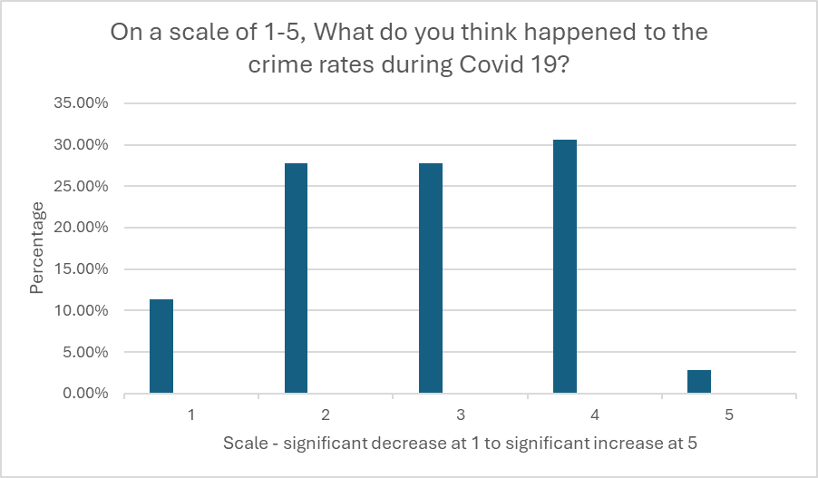

The third question on the questionnaire aimed to gauge public perception on whether crime rates increased or decreased during Covid 19. From the results gathered on the scale starting at 1 there was 11.1%, 27.8% for 2-3 along the scale, followed by 30.6% at 4, 2.8% at 5. Therefore, showing a large portion of individuals believed that crimes had increased. However, according to Stripe (2020) there was a reduction of 32% in all crimes during the first couple of months at the start of Covid 19.
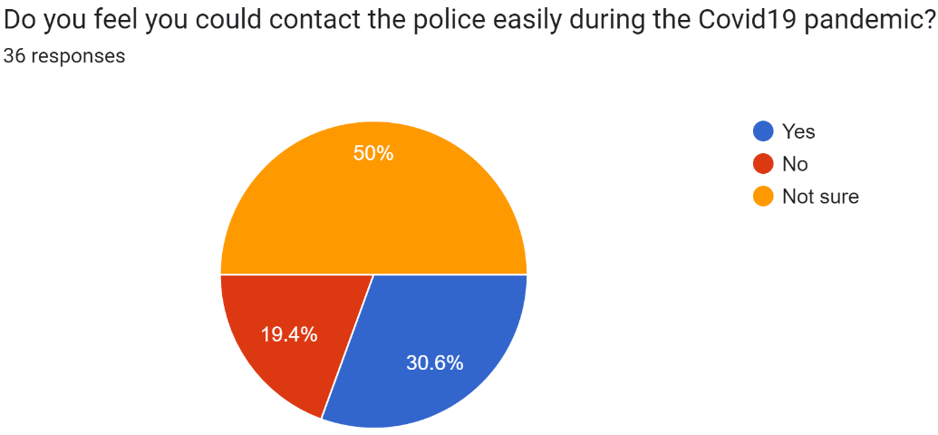
Q4- Q5

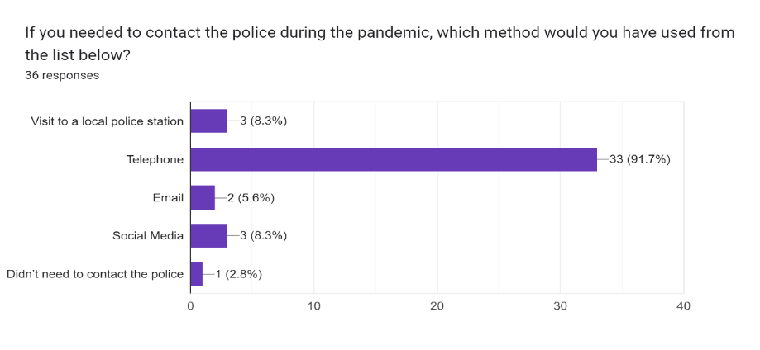

Regarding contacting the police during the pandemic, uncertainty was common. Results showed that 50% of participants were unsure, while 19.4% felt they could not contact the police, and 30.6% felt they could. In response to Q5, 97.1% preferred contacting the police via telephone, with social media and in-person visits each at 8.3%. However, 2.8% felt they did not need to contact the police. According to Boulton et al. (2024) some individuals felt let down by the police as many people were reporting breaches of the rules with nothing being done about it in some areas. This therefore could have had an impact on uncertainty and demand for requiring the police in public need.
.
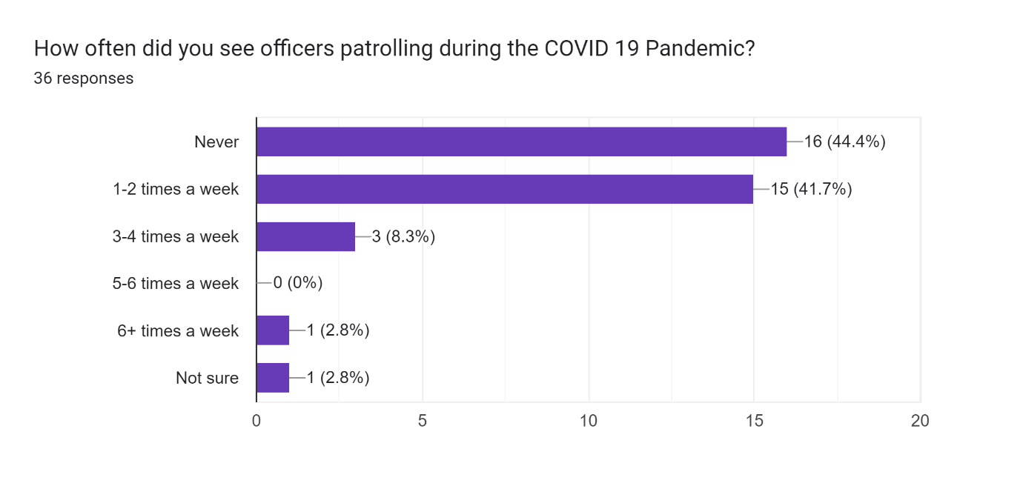
Q6
In relation to police presence 44.4% of participants stated that they did not see any police officers patrolling throughout the pandemic, with 41.7% stating they seen police presence at least 1-2 times a week. However, 8.3% showing 3-4 times a week with only 2.8% either saying 6+ times a week or not sure. The highest percentage shown is for individuals not seeing any police presence during the pandemic. Despite encountering obstacles to patrolling the pandemic from staffing issues, PPE shortages, the National Police Chiefs' Council (NPCC, 2021) ensured commitment to maintaining regular patrols across each force as well as engaging with communities to ensure adherence to restrictions, even as restrictions ease.
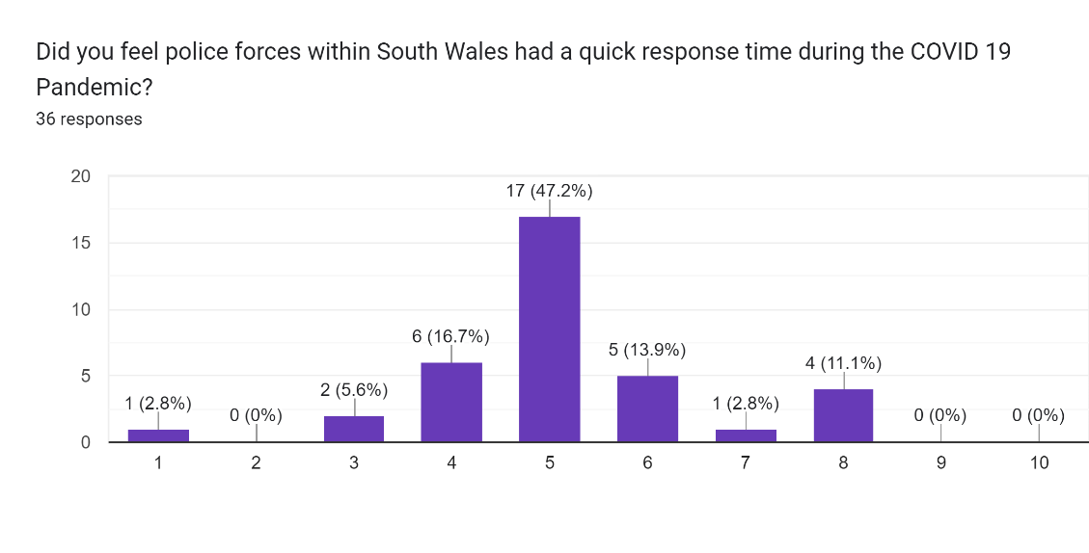
Q7

From the findings of Q7 the majority of participant stated a 5 which is directly central between low and high priority. However, also identifying that no participants believe the response time was a high priority with a larger amount of people stating below 5. According to Myhill and Beak (2020) satisfaction is important with certain encounters in police in relation to public confidence. Suggesting that individuals who had approached the police for help had a satisfactory response demonstrating a high confident response than those who did not contact the police. This demonstrates that good quality of service provided will impact the overall response from police and confidence.
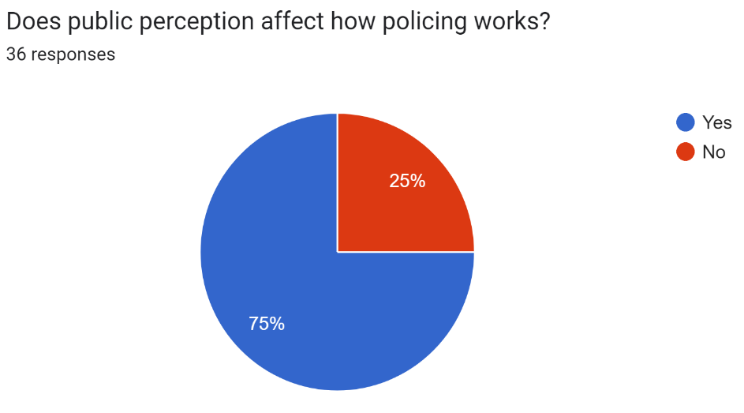
Q9

Public perception has been displayed as 75% of individuals stating that it does affects how policing works, with 25% stating no.
Many individuals believe that the police lack resources to be out in communities to show their presence in order to build their public perception, but also often experience barriers in doing so through police corruption and the media which influence a negative perception of the police. According to Aitkenhead et al., (2022) 67% of the public had expressed that police were ‘under-resourced’ especially with added pressures with the pandemic as well as completely all daily workloads from prior to Covid 19. Therefore, putting a strain on police building perceptions as they do not have to support there in place to provides to local communities.
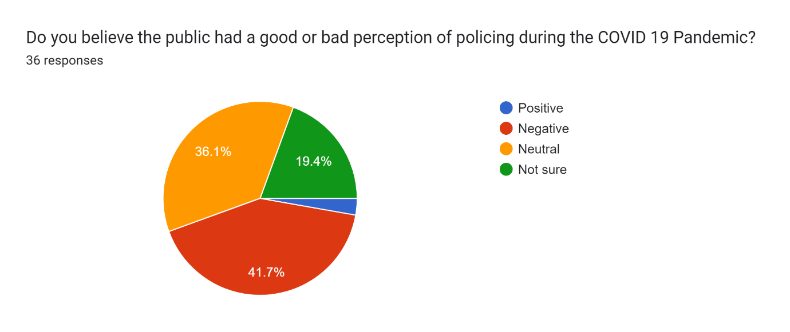
Q10

The findings suggest that the majority (41.7%) of participants thought that the public perception of the police during the Covid 19 pandemic was negative. However, 36.1% have shown a neutral response and 19.4% stating not sure. From this data it shows that participants are unsure on how they feel the police have been throughout the pandemic. During this time of concern, many individuals-maintained confidence in the police. However, there were instances where people felt disappointed by law enforcement when reporting breaches of restriction rules in certain areas, with no apparent action taken (Boulton et al., 2024).
Q11 – What did South Wales do that was beneficial during Covid?
From the findings of this question, it calls for debate whether there were many benefits carried out by South Wales forces. Firstly, the majority of participants suggested that they were ‘unsure’ with the benefits whereas one participants response suggests that “Regular patrols, not only to keep people inside but to aid from the use of hot spot policing to tackle criminal offences such as theft and anti-social behaviour which were on the rise due to opportunities outside homes.”. This suggests that it was beneficial in reducing criminal activity, whilst this gives public reassurance and a continuous services provided even though it does not require seeing eye to eye with members of the public. This was evident in Dyfed Powys Police (2020), as they try to enforce compliance with rules and regulations concerning COVID-19 isolation for those who violated them.
Q12 - What did South Wales forces do that had a negative impact during the Covid?
From the findings some participants stated they were ‘not sure’ whilst others stated the police did not monitor traffic during the highest peaks of Covid 19 or carry out patrols. South Wales Police forces behaviour was not necessarily negative, but rather influenced by the complexities of the lockdown situation. The introduction of new laws left little time for the police to familiarise themselves and adjust their policing approach accordingly. Whereas according to Clements and Skidmore (2020) it was observed that the country swiftly lifted lockdown restrictions, introducing guidelines rather than enforceable laws. This posed a challenge for the police in persuading the public to adhere to the rapidly changing rules. In April 2020 Welsh and English police were known to have given 2 fines out per 10,000 people, this was on average much lower to other countries (The Police Foundation, 2020). However, forces wanted to prioritise engaging and encouraging before handing out fines. On the other hand, many individuals were retaliating to guidelines and not following instructions which led to police issuing more fines (Chenane et al., 2023).
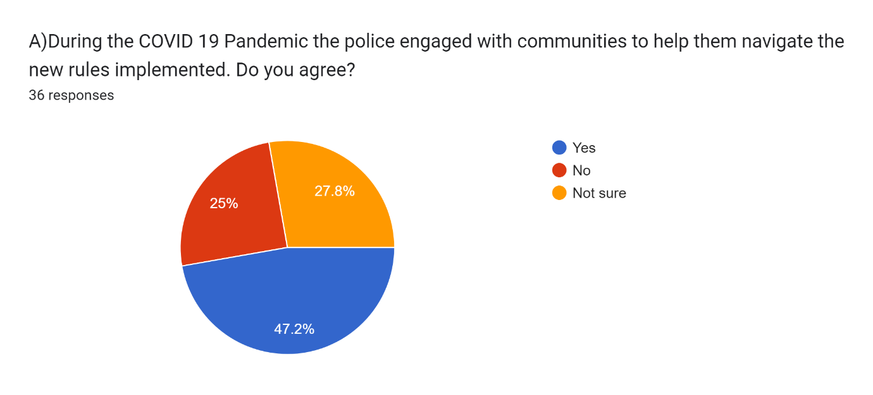
Q13 South Wales forces implemented many strategies throughout the COVID 19 Pandemic. Considering the aims be low, do you think these were achieved and why?

From the pie chart above it can be identified that 47.2% of individuals agreed that the police were engaging with communities to help implement the new rules, whilst 25% did not feel that the police were engaging with communities leaving 27.8% with unsure on if they displayed this. From the justified responses to this question, it can be identified that many people did not follow the guidelines and continued to social and mix outside of their households. However, others demonstrate the public's understanding of the intricacies of the new regulations left them uncertain about what was permissible and what wasn't. While the rules were broadcasted nationwide on live television, police discretion played a significant role in issuing warnings to individuals who were unaware of the new regulations, rather than immediately resorting to penalties or prosecution. Social gatherings were halted, and fines were issued to those found participating in such gatherings However, according to Charman et al. (2022), individuals perceive that police forces were not strictly sufficient in enforcing Covid-19 rules, resulting in people getting away with violating them.

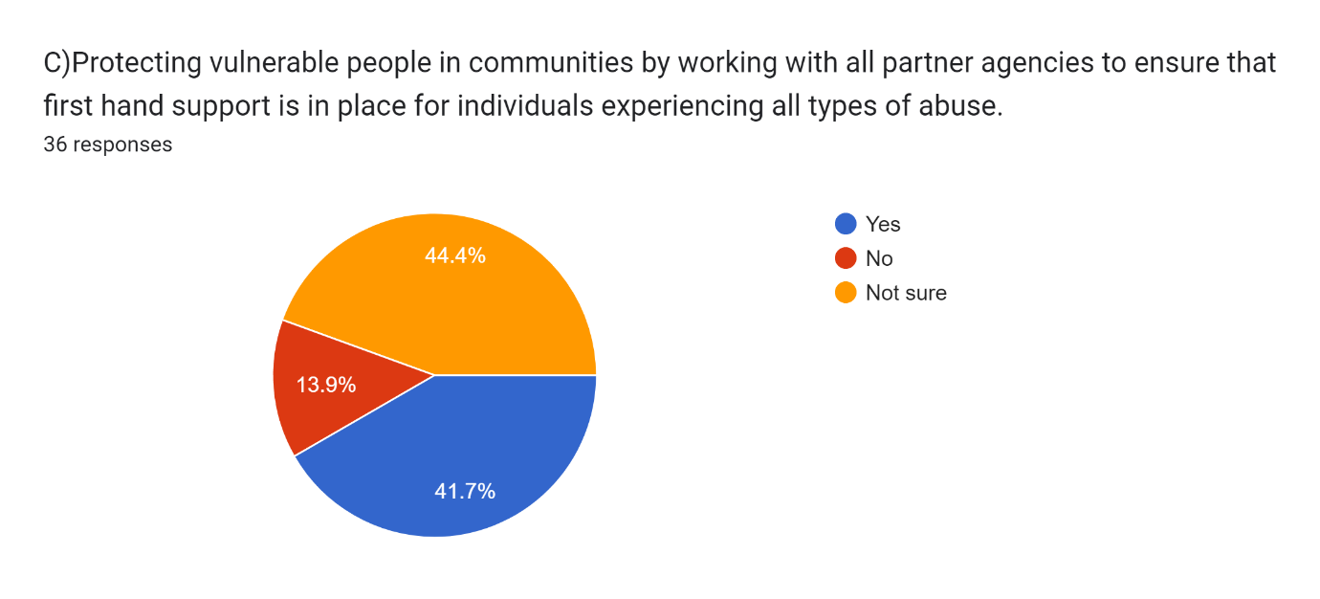
This data has shown that 50% of individuals are not sure on whether they agree with this strategy being effective due to many individuals being kept in the dark who do not use technology or have no access. However, 41.7% of the participants stated that they do agree with this strategy being used as technology has been used effectively during the difficult period in enforcing new regulations and guidelines. South Wales forces ensured they engaged with communities across social media platforms to keep up to date with regulations but also tried to educate in person where it was possible to do so (South Wales Police, 2020).

From the justified responses to this question participants have identified effective communication goes beyond virtual interactions alone. Essentially, individuals across various age groups, including the elderly, adults, and young people, may face barriers in understanding, accessing, or affording the necessary technology to stay connected with their loved ones. As a result, all forms of communication, whether visual or otherwise, came to a halt during the pandemic, leading to distressing situations for some members of the public. This led to a decrease in some communications. Adherence to the national decision model and code of ethics has been affected as digital policing necessitates a different approach. In order to protect individuals who were victims of domestic abuse, the who public health organisation created a four-step approach to which the police adapted to and used (CDC, 2021). The four steps were altered to surveillance, identifying risk and protective factors, implementation and developing and evaluating interventions’ (Clements and Skidmore, 2020). By implementing this within police it allowed for more focus on safeguarding, as well as ensuring surveillance was present and ensuring all vulnerable were being kept safe.
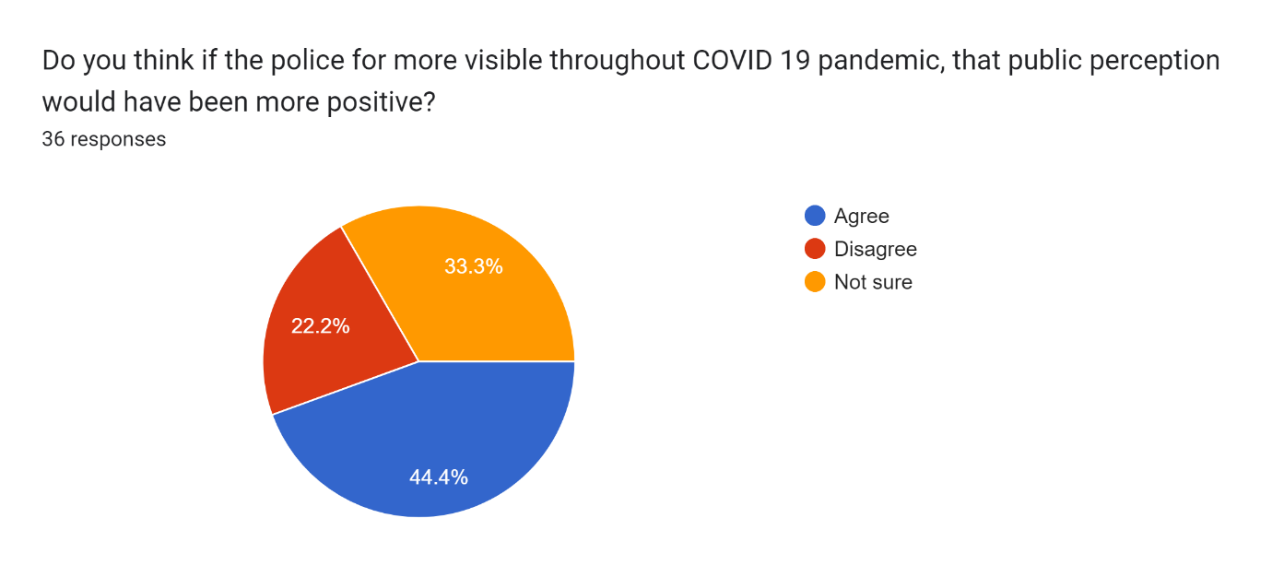
Q14

The findings from this question suggest that 44.4% agree that more police visibly would have a more positive outlook on public perception. Whereas 33.3% stated unsure and 22.2% disagreeing. From the justified responses it can be identified that many could see police visibility was reduced due to staffing issues as well as preventing officers from contracting the virus. Boulton et al (2024) having established the negative public perception of breaking restriction rules aided the need for the increase in police presence for the public to adhere to not rule breaking. This may have allowed members of the public to feel safer by having the reassurance of public servants present in their communities. It could be argued according to Royce (2020) that actions of those ‘coughing and spitting’ at officers impacted the police response in correlation to Aitkenhead et al., (2022) suggesting the police were “under-resourced”, which could suggest an uncertainty for how they approached the public in the pandemic.

Q15
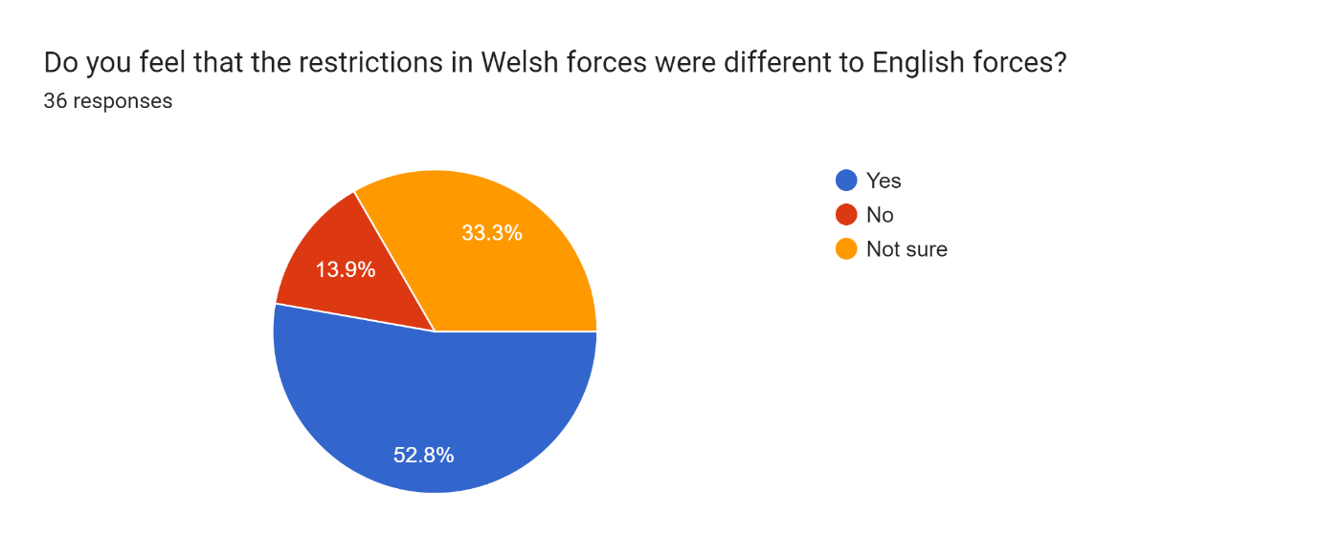

Participants were asked “do you feel that the restrictions in Welsh forces were different to English forces,” According to the statistics, 52.8% said Yes, 33.3% said not sure and 13.9% said no. Given the results, it suggests that a stricter policing strategy may have been used to address the issue, given the Prosecution Service's (2021), which noted that "public order offences were largely linked to the coronavirus," specifically pointing out the rise in assaults against emergency service workers. This suggests that, in response to community behaviour, particular areas were subjected to stricter controls.

Q16
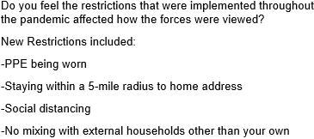
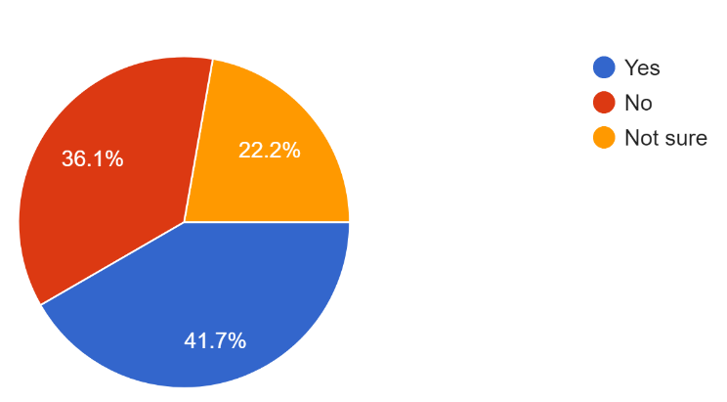

Regarding whether the pandemic restrictions affected people's opinions of the police, statistics show that 41.7% of respondents agreed, 36.1% disagreed, and 22.2% were unsure. Based on community compliance to isolation restrictions, the data suggests that there is a link between uncertainty and previous question 15 title and the Prosecution Service (2021). This connection could result from uncertainty and the implementation of tougher policing methods. While most respondents agreed, the CDC's (2021) claims that "the efficacy of strategies in addressing domestic violence during the pandemic" is being examined raises concerns and suggests a review of how the police handles these kinds of cases. This calls into question the thoroughness these tactics' implementation was.

Chapter 5.0 Conclusion

The overall aim of this research was to critically assess the policing approach during the Covid 19 pandemic. The first objectives chosen to achieve this aim was to assess how policing changed during Covid 19 pandemic. The second objective was to compare and contrast the police approach in Wales compared to other countries. The third objective which was to evaluate public perception on policing in South Wales during the pandemic.

5.1 Summary of findings

5.2 Objective one
From the research conducted in the literature review it can be identified that the Covid-19 pandemic brought significant changes to UK policing and crime rates. Public order offenses as well as violence against key workers were identified as mainly Covid-related (Crown Prosecution Service, 2021). Initially, crime rates dropped by 32% below average (Stripe, 2020), but there was a surge in coronavirus fraud cases, totalling a loss of £970,000 from 105 reports (South East Regional Organised Crime Unit, 2020). Domestic abuse cases also rose by 12%, prompting collaboration between police and the WHO to develop a four-step approach focusing on risk assessment and intervention (Clements and Skidmore, 2020). The police adapted the approach to include identifying the different risks and protective factors that are needed, implementation, as well as developing and evaluating interventions (Clements and Skidmore, 2020).
According to Fleming and Brown (2021) the workloads for police staff increased by 23% due to a strain on the forces to cover staff sickness. This caused police officers who were able to work to take on workloads of others making it more difficult. Individuals could work from home whereas others could not do that depending on their job type. However, it was also identified that many officers having struggled with many levels of stress from 14.6% within depression, 14.2% PTSD, 25% showing individuals within a higher risk of alcohol consumption above recommended intake as well as 9.6% of individuals experiencing anxiety. These types of stresses did not help officers as well as the contributing factor of public attitudes and behaviours towards the police.
From the findings of the primary research a large proportion of the participants believed that there had been an increase in crime rates during the Covid 19 pandemic. Many stated that the police operated effectively ensuring they carried out regular patrols whilst trying to enforce the new regulations. However, forces had to change daily operations to work effectively by using social media platforms to work with communities rather than face to face operations.

5.3 Objective Two
Objective two allows for comparison between the policing approaches in Wales and other countries.52.8% of participants believed that the restrictions in Wales were different to England, according to the Senedd (2020) Wales and England operated similarly and according to the 4 Es with more similarities than differences overall (Charman et al., 2022). However, in comparison to Scotland and Northern Ireland, they both operated according to the 4 Es. Scotland however also focussed on communication and engagement with public, building a strong, rapid foundation in order to identify what they are doing correctly and incorrectly (Fereday and Smith, pp.1-6 2021). However, in comparison to Spain, they focussed on ensuring individuals were not outside their home addresses or carrying out any breaches by the implementation of drones. This however allowed Spain to stop the virus from spreading (Scottish Government, 2020).

5.4 Objective three
Objective three gathers the findings of public perception of policing during COVID 19 pandemic. Most of the participants reported an increase in crime rates. National Police Chiefs' Council (NPCC) reported a total of 134,188 incident which were primarily Covid 19 related (Currenti and Flatley, 2020). 75% of participants stated that public perception affects how policing works, however, many identified that police forces were perceived negatively throughout the media prior to Covid 19. Furthermore, participants believed public perception was negative of police during the pandemic as many believed that police forces set the lockdown rules although they were set by the government. 47.2% of participants agreed that police forces in South Wales were engaging with communities to provide new regulations and navigation of new laws. Furthermore, 41.7% showed that police forces engaged effectively across social media platforms.
To conclude, crimes rates increased during the pandemic. South Wales police forces engagement with communities and adapted approaches effectively. All countries within the UK followed the 4 Es effectively, however other countries used different approaches. From the primary research conducted public perception was positive with good community engagement. “The successes of policing in Covid-19 are given towards absence of arrests, use of force and hard enforcement, or any militarised authoritarian lockdown” (Aitkenhead et al., 2022).

5.5 Recommendations and lessons learned.
A recommendation for the next global pandemic could be to ensure all police forces have clear understanding of the pandemic regulations and laws, therefore ensuring adequate training is provided as well as ensuring that there are enough officers to carry out regular patrols. A recommendation could be that the government and police forces communicate effectively to ensure a plan is in place for the future in case something like this was to happen, for example ensure forces are providing training to deal with a crisis alongside health and safety training or first aid.

References
Aggarwal, R. and Ranganathan, P. (2019) ‘Study designs: Part 2 – Descriptive Studies’, Perspectives in Clinical Research, 10(1), pp. 34–36. Available at: https://doi.org/10.4103/picr.PICR_154_18.
Aitkenhead, E. et al. (2022) Policing the pandemic, The Police Foundation. London: Crest, p. 18. Available at: https://www.police-foundation.org.uk/wp-content/uploads/2010/10/policing_the_pandemic_final.pdf (Accessed: 20 December 2023).
Ashby, M.P.J. (2020) ‘Changes in Police Calls for Service During the Early Months of the 2020 Coronavirus Pandemic’, Policing: A Journal of Policy and Practice, 14(4), pp. 1054–1072. Available at: https://doi.org/10.1093/police/paaa037.
Baker, S. (2020) Dealing with mental health during the coronavirus pandemic, College of Policing. College of Policing. Available at: https://www.college.police.uk/article/dealing-mental-health-during-coronavirus-pandemic (Accessed: 14 December 2023).
Ball, H.L. (2019) ‘Conducting Online Surveys’, Journal of Human Lactation, 35(3), pp. 413–417. Available at: https://doi.org/10.1177/0890334419848734.
BBC News (2021) ‘Coronavirus: More than 8,000 Covid fines issued since pandemic began’, BBC News - Northern Ireland, 22 March. Available at: https://www.bbc.co.uk/news/uk-northern-ireland-56488450 (Accessed: 22 April 2024).
Bernard, H.R. (2011) Research Methods in Anthropology: Qualitative and Quantitative Approaches. 1st edition, Google Books. 1st edition. Plymouth: Rowman Altamira, pp. 5–8. Available at: https://books.google.co.uk/books?id=Ngg-MNMH1YoC&printsec=frontcover&source=gbs_ge_summary_r&cad=0#v=onepage&q&f=false (Accessed: 12 February 2024).
Boulton, L. et al. (2024) ‘Policing the pandemic: Exploring Public Perceptions of the Enforcement of COVID-19 Restrictions in the United Kingdom’, The Police Journal, 0.0(0032-258X), pp. 1–17. Available at: https://doi.org/10.1177/0032258x241228048.
Bryman, A. (2016) Social Research Methods. 5th edition. Oxford: Oxford University Press, pp. 634–660.
Caulfield, J. (2022) How to Do Thematic Analysis | Guide & Examples, Scribbr. Available at: https://www.scribbr.co.uk/research-methods/thematic-analysis-explained/ (Accessed: 30 October 2023).
CDC (2021) The Public Health Approach to Violence Prevention |Violence Prevention|Injury Center|CDC, www.cdc.gov. WHO. Available at: https://www.cdc.gov/violenceprevention/about/publichealthapproach.html (Accessed: 2 November 2023).
Chandan, J.S. et al. (2020) ‘COVID-19: a public health approach to manage domestic violence is needed’, The Lancet Public Health, 5(6), pp. 1–5. Available at: https://doi.org/10.1016/s2468-2667(20)30112-2.
Charman, S. et al. (2022) ‘“Giving the right service to different people”: revisiting police legitimacy in the Covid-19 era’, Policing and Society, 33(3), pp. 1–18. Available at: https://doi.org/10.1080/10439463.2022.2113785.
Chenane, J.L. et al. (2023) ‘Public Perceptions of the Police during COVID-19: a Cross-National Analysis’, Criminal Justice Review, (0734-0168), pp. 1–26. Available at: https://doi.org/10.1177/07340168231198127.
Clements, J. and Skidmore, M. (2020) LONG READ: Policing the pandemic: public attitudes to police visibility, enforcement and fairness, The Police Foundation. Crest Advisory - the Police Foundation. Available at: https://www.police-foundation.org.uk/2020/10/long-read-policing-the-pandemic-public-attitudes-to-police-visibility-enforcement-and-fairness/ (Accessed: 20 December 2023).
College of Policing (2021) COVID-19: An appraisal of the police response to the pandemic, College of Policing. Available at: https://www.college.police.uk/article/covid-19-appraisal-police-response-pandemic (Accessed: 4 October 2023).
Crest (2020) Policing the COVID-19 lockdown - what the public thinks | Crest Advisory, Crest Site Official. Available at: https://www.crestadvisory.com/post/policing-the-covid-19-lockdown-what-the-public-thinks (Accessed: 13 December 2023).
Crown Prosecution Service (2021) 6,500 coronavirus-related Prosecutions in First Six Months of Pandemic | the Crown Prosecution Service, www.cps.gov.uk. Available at: https://www.cps.gov.uk/cps/news/6500-coronavirus-related-prosecutions-first-six-months-pandemic (Accessed: 4 November 2023).
Currenti, R. and Flatley, J. (2020) POLICING THE PANDEMIC: Detailed analysis on police enforcement of the Public Health Regulations and an assessment on disproportionality across ethnic groups in police enforcement of ons and an assessment on disproportionality across ethnic groups, National Police Chief’s Council, pp. 7–10. Available at: https://www.northyorkshire-pfcc.gov.uk/wp-content/uploads/2020/07/Policing-the-Pandemic-NPCC.pdf (Accessed: 30 September 2023).
De Camargo, C. (2021) ‘The Postcode Lottery of safety: COVID-19 Guidance and Shortages of Personal Protective Equipment (PPE) for UK Police Officers’, The Police Journal: Theory, Practice and Principles, 95(3), p. 0032258X2110187. Available at: https://doi.org/10.1177/0032258x211018768.
Drakeford, M. (2022) Written Statement: Review of the Health Protection (Coronavirus Restrictions) (No.5) (Wales) Regulations 2020 (25 March 2022) | GOV.WALES, www.gov.wales. Welsh Government. Available at: https://www.gov.wales/written-statement-review-health-protection-coronavirus-restrictions-no5-wales-regulations-2020-5 (Accessed: 20 October 2023).
Dudovskiy, J. (2021) Inductive Approach (Inductive Reasoning), Business Research Methodology. Blackwell Publishing. Available at: https://research-methodology.net/research-methodology/research-approach/inductive-approach-2/ (Accessed: 6 January 2024).
Dyfed Powys Police (2020) Covid-19 Restrictions Remain in Place in Wales: Police Response to First Minister’s Announcement, Dyfed Powys Police. Available at: https://www.dyfed-powys.police.uk/news/dyfed-powys/news/2020/may-2020/covid-19-restrictions-remain-in-place-in-wales-police-response-to-first-ministers-announcement/ (Accessed: 2 January 2024).
Elkin, M. (2022a) Crime in England and Wales - Office for National Statistics, www.ons.gov.uk. Office of National Statistics. Available at: https://www.ons.gov.uk/peoplepopulationandcommunity/crimeandjustice/methodologies/userguidetocrimestatisticsforenglandandwalesmeasuringcrimeduringthecoronaviruscovid19pandemic#offence-types (Accessed: 1 December 2023).
Elkin, M. (2022b) Domestic abuse in England and Wales overview - Office for National Statistics, www.ons.gov.uk. Office of National Statistics. Available at: https://www.ons.gov.uk/peoplepopulationandcommunity/crimeandjustice/bulletins/domesticabuseinenglandandwalesoverview/november2022#:~:text=There%20was%20no%20significant%20change (Accessed: 4 November 2023).
Fereday, D. and Smith, M. (2021) Policing and the Pandemic -The Scottish Experience a Research and Evidence Forum Event Professor Susan McVie (Speaker and Panel Member) -Professor of Quantitative, Scottish Police Authority. Glasgow: The Scottish Police Authority, pp. 1–6. Available at: https://www.spa.police.uk/spa-media/hutd0rii/policing-and-the-pandemic-roundtable-newsletter.pdf (Accessed: 17 November 2023).
Fleming, J. and Brown, J. (2021) ‘Staffing the force: police staff in England and Wales’s experiences of working through a COVID-19 lockdown’, Police Practice and Research, 23(2), pp. 1–18. Available at: https://doi.org/10.1080/15614263.2021.1938048.
Gialdino, I.V. de (2009) ‘Ontological and Epistemological Foundations of Qualitative Research’, Forum Qualitative Sozialforschung / Forum: Qualitative Social Research, 10(2), pp. 1–100. Available at: https://doi.org/10.17169/fqs-10.2.1299. (Accessed: 11 November 2023).
Godfrey, B., Richardson, J.C. and Walklate, S. (2021) ‘The Crisis in the Courts: before and beyond Covid’, British Journal of Criminology, 62(4), pp. 1–18. Available at: https://doi.org/10.1093/bjc/azab110. (Accessed: 20 November 2023).
Greetham, B. (2019) How to Write Your Undergraduate Dissertation. 3rd edition London: Bloomsbury Publishing Plc - Red Globe Press, pp. 167–173.
Griffin, Elizabeth.R. (2015) ‘When Are Old Data New Data?’, GeoResJ, 6(1), pp. 92–97. Available at: https://doi.org/10.1016/j.grj.2015.02.004. (Accessed: 14 November 2023).
Havard, T. (2021) Domestic abuse and Covid-19: A year into the pandemic, UK Parliament. UK Parliament: House of Commons Library. Available at: https://commonslibrary.parliament.uk/domestic-abuse-and-covid-19-a-year-into-the-pandemic/ (Accessed: 5 November 2023).
HMICFRS (2021) Policing in the pandemic, Criminal Justice Inspectorates - HMICRFS. Birmingham: Her Majesty’s Inspectorate of Constabulary and Fire and Rescue Services, pp. 54–78. Available at: https://assets-hmicfrs.justiceinspectorates.gov.uk/uploads/policing-in-the-pandemic-police-response-to-coronavirus-pandemic-during-2020.pdf. (Accessed: 21 January 2024).
Home Office (2020) Police given new powers and support to respond to coronavirus, GOV.UK. Home Office - the Rt Hon Priti Patel MP. Available at: https://www.gov.uk/government/news/police-given-new-powers-and-support-to-respond-to-coronavirus#:~:text=To%20ensure%20people%20stay%20at (Accessed: 21 January 2024).
Jain, N. (2021) ‘Survey Versus Interviews: Comparing Data Collection Tools for Exploratory Research’, The Qualitative Report, 26(2), pp. 541–554, 1–16. Available at: https://doi.org/10.46743/2160-3715/2021.4492. (Accessed: 21 February 2024).
Jesson, J. (2001) ‘Cross-sectional studies in prescribing research’, Journal of Clinical Pharmacy and Therapeutics, 26(6), pp. 397–403. Available at: https://doi.org/10.1046/j.1365-2710.2001.00373.x. (Accessed: 26 January 2024).
Jiménez-Franco, D., Aguerri, J.C. and Forero-Cuéllar, A. (2023) ‘Off-the-Cuff Law-Making: Policing Pandemic Dispossession in Spain’, Critical Criminology, 31(2), pp. 363–378. Available at: https://doi.org/10.1007/s10612-023-09702-y. (Accessed: 1 January 2024).
Johnson, K. and Hohl, K. (2021) The Impact of Covid-19 on Domestic Abuse Reported to the Police, and Policing Responses, UK Parliament. Available at: https://committees.parliament.uk/writtenevidence/22280/html/ (Accessed: 2 October 2023).
Jones, T., Baxter, M. and Khanduja, V. (2013a) ‘A Quick Guide to Survey Research’, The Annals of The Royal College of Surgeons of England, 95(1), pp. 5–7. Available at: https://doi.org/10.1308/003588413X13511609956372. (Accessed: 21 October 2024).
Jones, T., Baxter, M. and Khanduja, V. (2013b) ‘A Quick Guide to Survey Research’, The Annals of the Royal College of Surgeons of England, 95(1), pp. 1–7. Available at: https://doi.org/10.1308/003588413X13511609956372. (Accessed: 15 January 2024).
Kemp, S. et al. (2021) ‘Empty Streets, Busy Internet: A Time-Series Analysis of Cybercrime and Fraud Trends During COVID-19’, Journal of Contemporary Criminal Justice, 37(4), p. 104398622110279. Available at: https://doi.org/10.1177/10439862211027986. (Accessed: 21 February 2024).
Lakshman, M. et al. (2000) ‘Quantitative Vs Qualitative Research Methods’, The Indian Journal of Pediatrics, 67(5), pp. 369–377. Available at: https://doi.org/10.1007/BF02820690. (Accessed: 21 March 2024).
Lallie, H.S. et al. (2021) ‘Cyber Security in the Age of COVID-19: a Timeline and Analysis of Cyber-Crime and Cyber-Attacks during the Pandemic’, Computers & Security, 105(1), pp. 1–20. Available at: https://doi.org/10.1016/j.cose.2021.102248. (Accessed: 21 April 2024).
Langton, S., Dixon, A. and Farrell, G. (2021) ‘Six months in: pandemic crime trends in England and Wales’, Crime Science, 10(1), pp. 9–16. Available at: https://doi.org/10.1186/s40163-021-00142-z. (Accessed: 25 March 2024).
Laufs, J. and Waseem, Z. (2020) ‘Policing in pandemics: a Systematic Review and Best Practices for Police Response to COVID-19’, International Journal of Disaster Risk Reduction, 51(1), p. 101812. Available at: https://doi.org/10.1016/j.ijdrr.2020.101812. (Accessed: 23 March 2024).
Matthews, B. and Ross, L. (2010) RESEARCH METHODS: a practical guide for the social sciences. 1st edn. S.L.: Pearson Education Limited, pp. 200–215. (Accessed: 21 April 2024).
Metropolitan Police (2020) Police on Duty in Downing Street on 13 & 27 November 2020 and 18 December 2020, Metropolitan Police. Available at: https://www.met.police.uk/foi-ai/metropolitan-police/d/february-2022/police-on-duty-in-downing-street-on-13-27november2020-18december2020/ (Accessed: 22 October 2023).
Myhill, A. and Beak, K. (2008) Public Confidence in the Police, National Policing Improvement Agency, pp. 16–18. Available at: https://library.college.police.uk/docs/npia/public-confidence-in-the-police.pdf (Accessed: 1 November 2023).
NCSC (2020) Public Urged to Flag Coronavirus Related Email Scams, National Cyber Security Centre. Available at: https://www.google.com/url?sa=i&url=https%3A%2F%2Fwww.ncsc.gov.uk%2Fnews%2Fpublic-urged-to-flag-covid-19-threats-new-campaign%2F&psig=AOvVaw21vrC5bMi0qbxIFP8mpWy8&ust=1715066816465000&source=images&cd=vfe&opi=89978449&ved=0CAcQrpoMahcKEwjo2Lv0v_iFAxUAAAAAHQAAAAAQBA (Accessed: 5 January 2024).
Newiss, G. et al. (2021) ‘Taking the strain? Police well-being in the COVID-19 era’, The Police Journal: Theory, Practice and Principles, 95(1), p. 0032258X2110447. Available at: https://doi.org/10.1177/0032258x211044702. (Accessed: 12 January 2024).
Niada, L. (2022) LibGuides: Dissertations 4: Methodology: Start, libguides.westminster.ac.uk. University of Westminster. Available at: https://libguides.westminster.ac.uk/methodology-for-dissertations (Accessed: 30 January 2024).
Northern Ireland Police Board (2020) THEMATIC REVIEW OF THE POLICING RESPONSE TO REPORT ON THE, Report on the Thematic Review of the Policing Response to Covid 19. Belfast: Northern Ireland Policing Board, pp. 1–123. Available at: https://www.nipolicingboard.org.uk/files/nipolicingboard/publications/report-on-the-thematic-review-of-the-policing-responser-to-covid-19.PDF (Accessed: 22 January 2024).
NPCC (2021) Update on Coronavirus FPNs Issued by Police – June 2021, National Police Chiefs’ Council (NPCC). Available at: https://news.npcc.police.uk/releases/update-on-coronavirus-fpns-issued-by-police-june-2021 (Accessed: 1 January 2024).
NPCC (2022) Update on Coronavirus FPNs Issued by Forces in England and Wales, and the Payment of FPNs, National Police Chiefs’ Council (NPCC). Available at: https://news.npcc.police.uk/releases/update-on-coronavirus-fpns-issued-by-forces-in-england-and-wales-and-the-payment-of-fpns (Accessed: 1 April 2024).
Office for Health Improvement and Disparities (2020) Mixed Methods Study, GOV.UK. Office for Health Improvement and Disparities. Available at: https://www.gov.uk/guidance/mixed-methods-study (Accessed: 30 January 2024).
Office for National Statistics (2020a) Domestic Abuse during the Coronavirus (COVID-19) pandemic, England, and Wales - Office for National Statistics, www.ons.gov.uk. Office of National Statistics. Available at: https://www.ons.gov.uk/peoplepopulationandcommunity/crimeandjustice/articles/domesticabuseduringthecoronaviruscovid19pandemicenglandandwales/november2020 (Accessed: 2 November 2023).
Office for National Statistics (2020b) Domestic abuse during the coronavirus (COVID-19) pandemic, England and Wales - Office for National Statistics, www.ons.gov.uk. Available at: https://www.ons.gov.uk/peoplepopulationandcommunity/crimeandjustice/articles/domesticabuseduringthecoronaviruscovid19pandemicenglandandwales/november2020 (Accessed: 17 November 2023).
Parker, C., Scott, S. and Geddes, A. (2019) ‘Snowball Sampling’, SAGE Research Methods Foundations, 1(1), pp. 1–100. Available at: https://doi.org/10.4135/9781526421036831710. (Accessed: 17 November 2023).
Pecorino, P.A. (2020) What is Philosophy? Cuny.edu. Queensborough Community College. Available at: https://www.qcc.cuny.edu/SocialSciences/ppecorino/INTRO_TEXT/Chapter%2012Conclusion/What_is_Philosophy.htm (Accessed: 1 February 2024).
Phair, D. and Warren, K. (2021) Saunders’ Research Onion: Explained Simply, Grad Coach. Grad Coach. Available at: https://gradcoach.com/saunders-research-onion/ (Accessed: 27 January 2024).
Police and Crime Commissioner Dyfed Powys Police (2020) May 2020 Report from the Police and Crime Commissioner for Dyfed-Powys to the Dyfed-Powys Police and Crime Panel Response to the Coronavirus (COVID-19) Pandemic, Dyfed Powys Police Crime Panel Wales. Dyfed Powys Police - Carmarthen: Dyfed Powys Police and Crime Commissioner, pp. 1–31. Available at: https://www.dppoliceandcrimepanel.wales/media/6004/report-from-the-police-and-crime-commissioner-for-dyfed-powys-response-to-the-coronavirus-covid-19-pandemic-june-2020.pdf (Accessed: 17 April 2024).
Royce, L. (2020) Two Men Jailed after Spitting and Coughing at Police Officers, Wales Online. Available at: https://www.walesonline.co.uk/news/wales-news/coronavirus-cough-spit-police-officer-18421155 (Accessed: 4 December 2023).
Saunders, M. et al. (2019) ‘Research Methods for Business students’ Chapter 4: Understanding Research Philosophy and Approaches to Theory Development, ResearchGate. www.researchgate.net. Available at: https://www.researchgate.net/publication/330760964_Research_Methods_for_Business_Students_Chapter_4_Understanding_research_philosophy_and_approaches_to_theory_development (Accessed: 25 January 2024).
Scottish Government (2020) Coronavirus (COVID-19): strategic approach, Scottish Government. First Minister - Scottish Government. Available at: https://www.gov.scot/collections/coronavirus-covid-19-strategic-approach/#:~:text=Scotland (Accessed: 28 December 2023).
Scottish Government (2020) Spain, www.gov.scot. Scottish Government. Available at: https://www.gov.scot/publications/part-1-international-policing-responses-covid-19-during-lockdown/pages/17/ (Accessed: 22 January 2024).
Senedd (2020) Coronavirus: Policing, research, Senedd, Wales. Welsh Government. Available at: https://research.senedd.wales/research-articles/coronavirus-policing/ (Accessed: 4 September 2023).
South East Regional Organised Crime Unit (2020) Fraud & Cybercrime – Covid-19 – South East Regional Organised Crime Unit, Covid 19 - Fraud & Cybercrime. Available at: https://serocu.police.uk/covid19/ (Accessed: 16 November 2023).
South Wales Police (2020a) Annual Report South Wales Police and Crime Commissioner, South Wales Police Crime Commissioner. Wales: South Wales Police, pp. 1–52. Available at: https://commissioner.south-wales.police.uk/media/2186/2021-09-14-swpcc-annual-report-final.pdf (Accessed: 23 November 2023).
South Wales Police (2020b) South Wales Police response to the Coronavirus pandemic, South Wales Police and Crime Commissioner. South Wales Police and Crime Commissioner. Available at: https://www.cwmtafmorgannwgsafeguardingboard.co.uk/En/KeepingourCommunitiesSafeDuringCOVID19/Public/RelatedDocuments/SouthWalesPoliceResponsetoCovid19.pdf (Accessed: 2 January 2023).
South Wales Police (2021) SWP Response to Welsh Government Coronavirus Announcement, South Wales Police. South Wales Police. Available at: https://www.south-wales.police.uk/news/south-wales/news/2021/march/swp-response-to-welsh-government-coronavirus-announcement/#:~:text=A%20number%20of%20restrictions%20will,house%20parties%20and%20large%20gatherings. (Accessed: 29 December 2023).
South Wales Police and Crime Commissioner (2021) Annual Report South Wales Police and Crime Commissioner, South Wales Police and Crime Commissioner. South Wales: South Wales Police, pp. 1–4. Available at: https://commissioner.south-wales.police.uk/media/2186/2021-09-14-swpcc-annual-report-final.pdf (Accessed: 9 October 2023).
Story, D.A. and Tait, A.R. (2019) ‘Survey Research’, Anaesthesiology, 130(2), pp. 192–202. Available at: https://doi.org/10.1097/ALN.0000000000002436.
Streefkerk, R. (2022) Inductive vs Deductive Research Approach (with Examples), Scribbr. Available at: https://www.scribbr.co.uk/research-methods/inductive-vs-deductive-reasoning/ (Accessed: 2 February 2024).
Stripe, N. (2020) Coronavirus and crime in England and Wales - Office for National Statistics, Office of National Statistics. Office of National Statistics. Available at: https://cy.ons.gov.uk/peoplepopulationandcommunity/crimeandjustice/bulletins/coronavirusandcrimeinenglandandwales/august2020 (Accessed: 1 December 2023).
Syed, S. et al. (2020) ‘Global prevalence and risk factors for mental health problems in police personnel: a systematic review and meta-analysis’, Occupational and Environmental Medicine, 77(11), pp. 737–747. Available at: https://doi.org/10.1136/oemed-2020-106498. (Accessed: 17 November 2023).
Tehrani, N. (2022) ‘The psychological impact of COVID-19 on police officers’, The Police Journal: Theory, Practice and Principles, 95(1), p. 0032258X2110399. Available at: https://doi.org/10.1177/0032258x211039975. (Accessed: 11 November 2023).
The Police Foundation (2020) Policing the long crisis: an appraisal of the police response to Covid-19, The Police Foundation. Available at: https://www.police-foundation.org.uk/2020/12/long-read-policing-the-long-crisis-an-appraisal-of-the-police-response-to-covid-19/ (Accessed: 20 November 2023).
The Police Foundation (2022) Police must build on their approach to the pandemic to bolster public trust and adapt to online crime, says major new report, The Police Foundation. The Police Foundation. Available at: https://www.police-foundation.org.uk/news/police-must-build-on-their-approach-to-the-pandemic-to-bolster-public-trust-and-adapt-to-online-crime-says-major-new-report/ (Accessed: 28 December 2023).
UK Parliament (2021) Report Published on the Impact of COVID-19 on Courts and Tribunals in England and Wales - Committees - UK Parliament, committees.parliament.uk. Available at: https://committees.parliament.uk/committee/172/constitution-committee/news/153596/report-published-on-the-impact-of-covid19-on-courts-and-tribunals-in-england-and-wales/ (Accessed: 5 October 2023).
University of Nottingham (2023) Understanding Pragmatic Research, University of Nottingham. Nottingham University. Available at: https://www.nottingham.ac.uk/helmopen/rlos/research-evidence-based-practice/designing-research/types-of-study/understanding-pragmatic-research/section02.html#:~:text=Interpretivism%20is%20based%20on%20the (Accessed: 11 January 2024).
University of Wales Trinity Saint David (2024) Research Integrity and Ethics, The University of Wales Trinity Saint David. Available at: https://www.uwtsd.ac.uk/research/research-integrity-and-ethics#:~:text=The%20University%20of%20Wales%20Trinity%20Saint%20David%20is%20committed%20to (Accessed: 1 February 2024).
Walklate, S., Godfrey, B. and Richardson, J. (2021) ‘Changes and continuities in police responses to domestic abuse in England and Wales during the Covid-19 “lockdown”’, Policing and Society, 32(2), pp. 1–13. Available at: https://doi.org/10.1080/10439463.2021.1896514. (Accessed: 1 February 2024).
Wang, X. and Cheng, Z. (2020) ‘Cross-sectional studies: Strengths, weaknesses, and Recommendations’, Chest, 158(1), pp. 65–71. Available at: https://doi.org/10.1016/j.chest.2020.03.012. (Accessed: 1 May 2024).
Waseem, Z. and Laufs, J. (2020) Policing a Pandemic: Impact of the COVID-19 Pandemic on Law Enforcement Agencies, Taylor and Francis Online. Taylor and Francis Journals, pp. 1–13. Available at: https://www.ucl.ac.uk/jill-dando-institute/sites/jill-dando-institute/files/impact_on_law_enforcement_final_no_11_.pdf (Accessed: 1 November 2023).
Wasti, S.P. et al. (2022) ‘The Growing Importance of mixed-methods Research in Health’, Nepal Journal of Epidemiology, 12(1), pp. 1175–1178. Available at: https://doi.org/10.3126/nje.v12i1.43633. (Accessed: 1 May 2024).
Winchester, N. (2020) Covid-19 and the police: New Powers but more pressure? UK Parliament. House of Lords Library. Available at: https://lordslibrary.parliament.uk/covid-19-and-the-police-new-powers-but-more-pressure/ (Accessed: 20 November 2023).

Appendix 1

Questionnaire

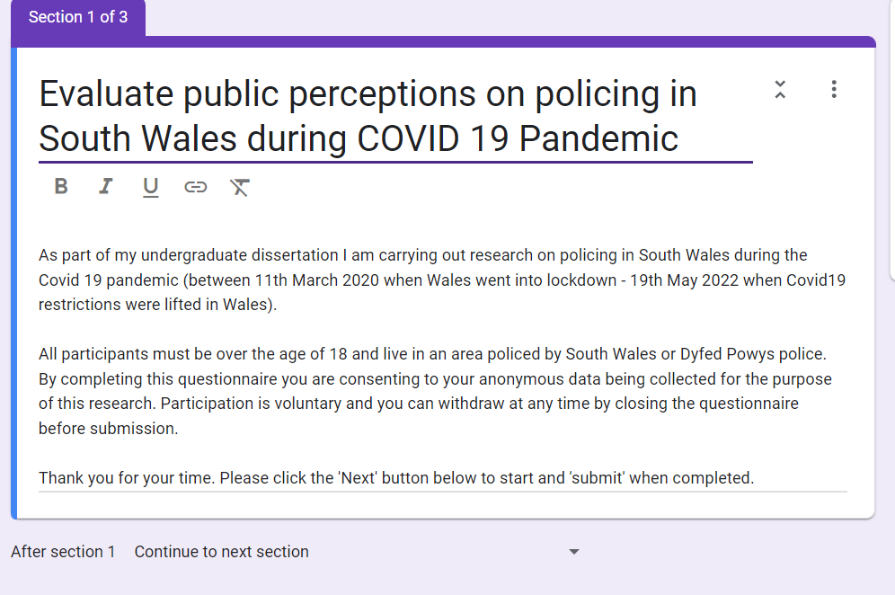

https://docs.google.com/forms/d/e/1FAIpQLSfLO6ITdnmw57G6bf46k4a6aJtBAMKebS5hy618LVmMWan4Ww/viewform?usp=sf_link



