28/10/19 Quality management
Definition of quality management systems (QMS)
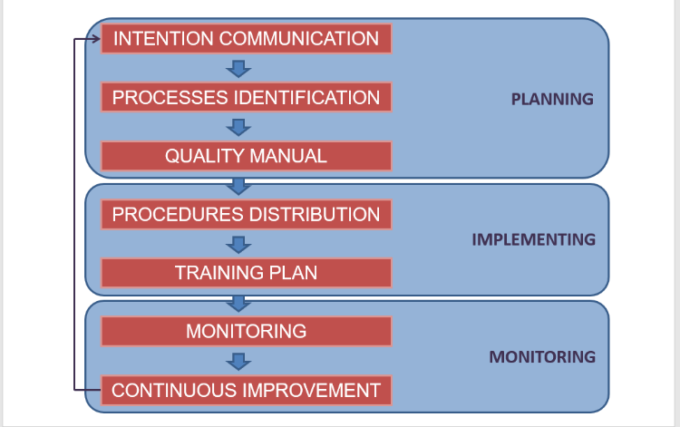

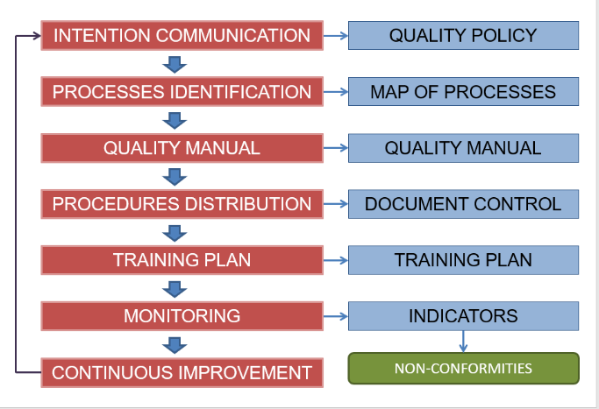

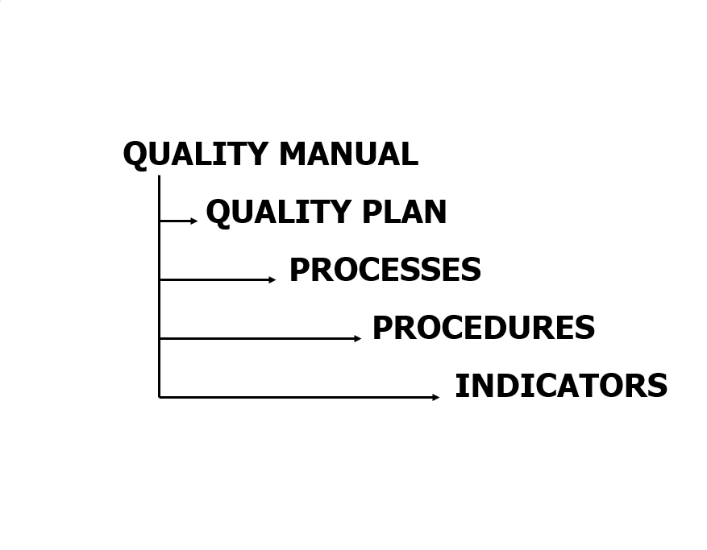
Quality policy
- Established the version and mission of the organisation oriented to the expectative of its customers and the achievement of its quality objectives.
Factors:
-Requirements of ISO 9001
-Clients Developed and approved by the direction
-Market
-Organisation
-Direction
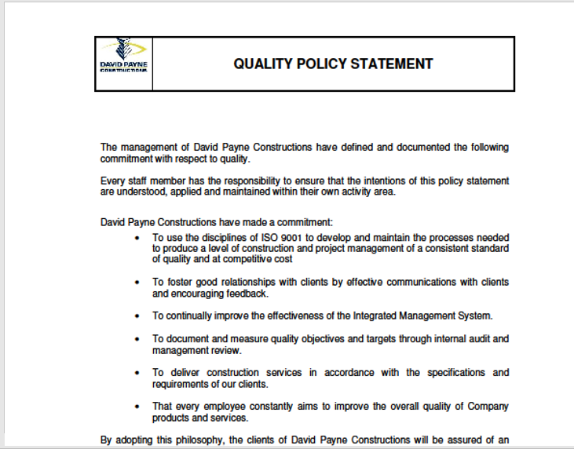

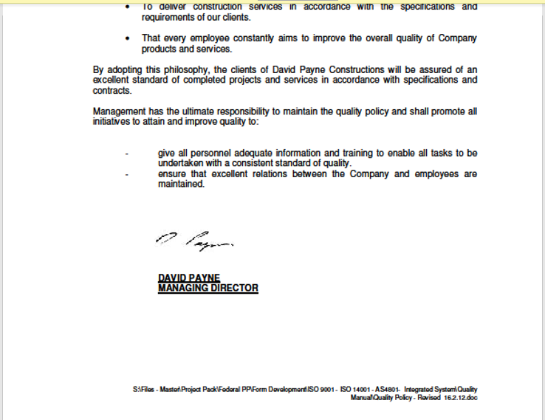

Processes

Process:
- System of activities that are linked or interact between them and transform input elements in results.
Product:
Result of a process. It can be tangible (processed materials) or intangible (services)

Quality manual
Document where it is clearly mentioned what the organization makes to implement a quality management system.
Compromises:
- The scope of the QMS
- The procedures
- Process map

Monitoring and Assessment
- Measurement
- Client satisfaction
- The processes performance
- The resulting product
- Indicators
- Data analysis
- Improvement
- Corrective action
- Preventive action
Indicators
- Measurement tools, based on facts and data, that allow assessment of the quality of processes, product and services to ensure the client satisfaction.
- Each indicator is associated to the monitoring and assessment of one or various procedures.
Components of the quality indicator:
- Indicator: what can be measured
- Units
- Reference values: minimum and maximum
- Data source: where the information came from
- Responsible for data collection
- Frequency: diary, weekly, monthly etc.
- Tendency or desire evolution
- Data obtained
Examples
- Achievement of deadlines
- Investment compared to expected
- Average waiting time (personalized attention)
- Average production time
- Number of visits
- Number of complaints

