

Student name: Joice Rumila Dos Reis Gomes Pina
Student ID: 2312503

Module name: Independent Project
Module code: BMHP6020
Supervisor’s name: Bianca Sanfilippo

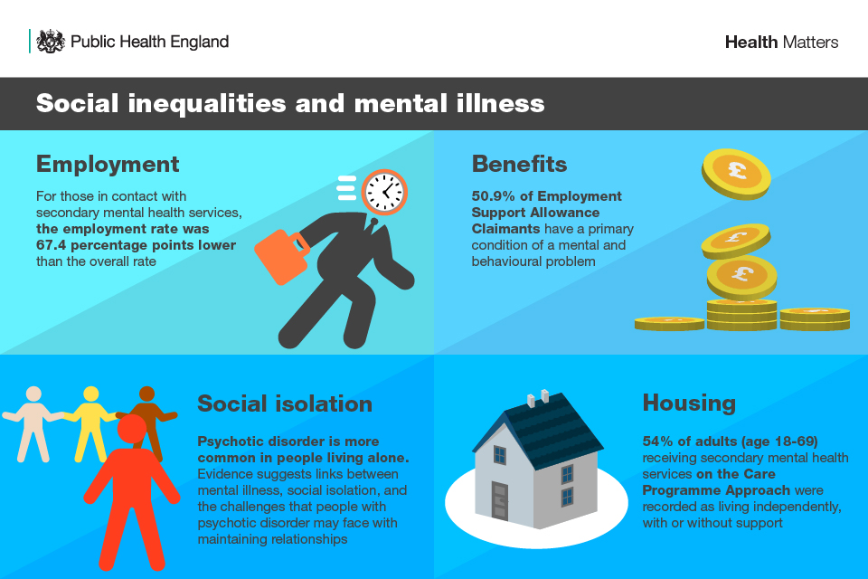 |  | Introduction  My project title: The Impact of Socioeconomic Factors on Health Inequalities in the UK.  Aim: To explore how socioeconomic factors such as income, education, employment, and housing contribute to health inequalities in the UK.  Objectives:  • To examine how key socioeconomic factors—such as income, education, employment, and housing—contribute to patterns of health inequalities across different UK populations.  • To analyze the relationship between socioeconomic deprivation and access to healthcare services, including barriers faced by disadvantaged groups and health inequalities.  • To identify evidence‑based strategies and interventions that could reduce health inequalities linked to socioeconomic disadvantage in the UK.  Inclusion criteria:  • Peer-reviewed  • Primary research is first review person did the reviewed article such as questionnaires.  • Studies based in the UK.  • Studies related to the topic/ title.  • Studies published after 2016 to 2026  Exclusion criteria:  • Non-Peer-reviewed studies and sources (reports, websites, blogs)  • Secondary research studies (e.g., literature reviews, meta-analyses)  • Studies based outside the UK.  • Studies not related to the topic/ title (socioeconomic factors or health inequalities)  • Studies published prior to 2016.  Data analysis: thematic analysis. 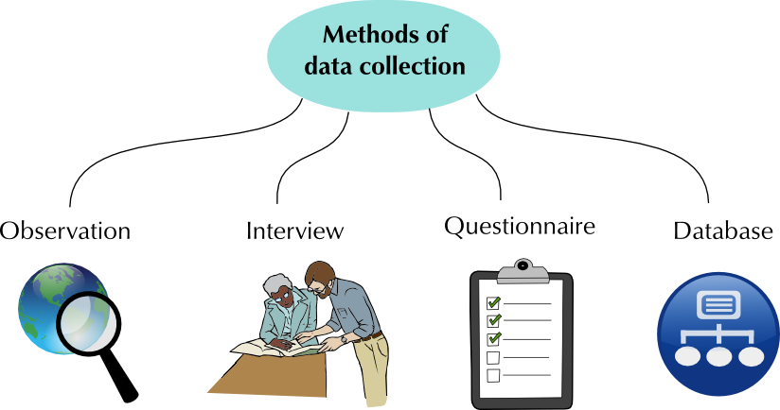 |  | 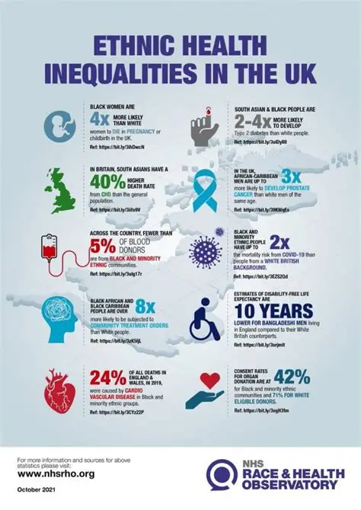
Methodology  The methodology is secondary research using a systematic literature review. Ten peer-reviewed journal articles will be included. This research will use secondary research methodology through a systematic literature review. The review will synthesise existing evidence on how socioeconomic factors influence health inequalities in the UK. A total of ten peer‑reviewed journal articles will be selected for in‑depth analysis.  Databases:  • ProQuest  • PubMed  • Google Schoolar  Keywords  Search terms will include combinations of:  “Health inequalities UK”  “Socioeconomic factors”  “Social determinants of health”  “Deprivation and health outcomes”  “Public health UK”  Boolean operators (AND, OR) will be used to refine searches. |  |  |  | Data Analysis method  Thematic analysis is used to identify common patterns and ideas among the studies.  Ethical considerations  Ethical considerations for secondary research project include honest reporting of data, avoiding bias and providing citations for all sources used.  

References
- Bambra, C., Smith, K.E. and Pearce, J., 2019. Scaling up: The politics of health and place. Social Science & Medicine, 232, pp.36–42.
- Marmot, M., Allen, J., Boyce, T., Goldblatt, P. and Morrison, J., 2020. Health Equity in England: The Marmot Review 10 Years On. Institute of Health Equity.
- Public Health England, 2018. Health Profile for England: Chapter 5 – Inequalities in Health. PHE Publications.
- Asaria, M., Doran, T. and Cookson, R., 2016. The costs of inequality: whole-population modelling study of lifetime inpatient hospital costs in the English NHS by level of neighbourhood deprivation. Journal of Epidemiology & Community Health, 70(10), pp.990–996.
- Darlington-Pollock, F. and Norman, P., 2020. Ethnic inequalities in health: The role of socioeconomic position. Population, Space and Place, 26(5), e2313.
- Green, M.A., Strong, M. and Bailey, J., 2017. Investigating the relationship between deprivation and emergency hospital admissions in England. BMJ Open, 7(7), e014461.
- Nazroo, J.Y. and Becares, L., 2020. Ethnic inequalities in health: Addressing the hidden causes. The Lancet Public Health, 5(3), pp. e123–e124.
- Wickham, S., Anwar, E., Barr, B., Law, C. and Taylor-Robinson, D., 2016. Poverty and child health in the UK: Using evidence for action. Archives of Disease in Childhood, 101(8), pp.759–766.
- Cookson, R., Asaria, M. and Ali, S., 2018. Health equity monitoring for healthcare quality assurance. Social Science & Medicine, 198, pp.148–156.
- McGowan, V.J., 2021. The impact of housing quality on health inequalities in the UK: A systematic review. Housing Studies, 36(7), pp.1103–1125.

