
University of Wales Trinity Saint David
Master of Business Administration

Student Name: Md Abdur Roshid
Student ID: 2436449

Research Title: Corporate Turnaround Strategies in UK Airlines Post-COVID-19: The Case of British Airways and EasyJet

Supervisor: Mark Piekarz

Declaration
I, Md Abdur Roshid, declare that this dissertation has been composed by myself, that the work contained herein is entirely my own except where explicitly stated otherwise in the text, and that this work has not been submitted for any other degree or qualification, in whole or in part, except as specified.

Signature:.......... Roshid............................................
Date: …………27/08/2026………………............................

Acknowledgement
I would also like to say a few words of thanks to my supervisor, Mark Piekarz, whose support, patience, and valuable feedback influenced this dissertation on all levels. The academic staff of the university also deserve credit for their support of the programme. Lastly, I would like to express my greatest thanks to my family and friends, whose belief and constant encouragement enabled me to complete this work.

Abstract
This research looks into the recovery of the two airlines in the UK, British Airways and easyJet, who have contrasting business models amid the COVID-19 shock between 2018 and 2025. The pandemic led to the collapse of air travel, and there is little research that compares individual UK carriers on a long-term basis or interprets their recovery in terms of turnaround theory and resource-based view. To bridge this divide, a pragmatic, abductive, mixed-methods comparative case design is employed in the study. Thematic analysis of corporate documents and industry documents determines the strategies of every airline, a ratio analysis of eight years of audited accounts determines the outcomes, and each of the mentioned strategies is evaluated against the evidence of measurement. The paper concludes that both airlines utilised the same crisis instruments to serve different purposes: easyJet employed its financing to reduce debt, whilst British Airways employed similar financing to maintain liquidity. Almost every metric was top-ranked by easyJet at the peak of the crisis in 2021, yet by 2025 British Airways will be in better profitability, and easyJet will have better liquidity, solvency and asset productivity. This reversal demonstrates that recovery is not one-dimensional and cannot be measured at a single point in time. The research suggests that airlines should maintain low gearing prior to a crisis and select financing based on its intended use and not on duplication, and the evaluation should be on recovery over multiple years rather than at a single point.

Table of Contents
Declaration 2
Acknowledgement 3
Abstract 4
Chapter 1 Introduction 8
1.1 Background and Problem Statement 8
1.2 Research Aim 9
1.3 Research Objectives 9
1.4 Research Questions 9
1.5 Significance and Relevance of the Study 9
1.6 Brief Research Methodology 10
1.7 Structure of the Dissertation 10
1.8 Chapter Summary 11
Chapter 2 Literature Review 12
2.1 Introduction 12
2.2 History and Evolution of the Airline Industry 12
2.3 The Airline Industry's Structural Vulnerability and General Challenges 13
2.4 The Impact of COVID-19 on the Airline Industry 15
2.5 Airline Business Models: Low-Cost Carrier versus Full-Service Carrier 17
2.6 Corporate Turnaround Strategies 19
2.7 Theoretical Framework 20
2.8 Conceptual Framework 23
2.9 Literature Gap 24
2.10 Chapter Summary 25
Chapter 3 Research Methodology 26
3.1 Introduction 26
3.2 Research Philosophy 26
3.3 Research Approach 27
3.4 Methodological Choice 28
3.5 Research Strategy 28
3.6 Time Horizon 29
3.7 Data Collection 30
3.8 Data Analysis 33
3.9 Ethical Considerations 34
3.10 Chapter Summary 34
Chapter 4 Findings and Analysis 35
4.1 Introduction 35
4.2 Summary and Presentation of Findings 35
4.2.1 Findings for Objective One: Financial Recovery Strategies 36
4.2.2 Findings for Objective Two: Operational Restructuring Approaches 37
4.2.3 Findings for Objective Three: Comparative Financial Performance 39
4.3 Analysis of Results 44
4.3.1 Identical Instruments, Different Financing Logics 44
4.3.2 Restructuring Depth against Restructuring Speed 44
4.3.3 Reading the Liquidity Evidence against Stated Strategy 45
4.3.4 Two Routes to Deleveraging and Their Implications 46
4.3.5 Efficiency, Investment Timing and the Cost of Transformation 47
4.3.6 Which Recovery Proved More Effective 47
4.4 Discussion of Results 49
4.4.1 Structural Fragility Confirmed but Unevenly Distributed 49
4.4.2 The Contested Business Model Debate Revisited 49
4.4.3 State Support and the Attribution Problem 50
4.4.4 Applying Turnaround Theory and the Resource-Based View 50
4.4.5 Stabilisation or Genuine Renewal 51
4.4.6 Contribution to Existing Knowledge 52
4.5 Chapter Summary 52
Chapter 5 Conclusions and Recommendations 54
5.1 Summary of Main Findings 54
5.2 Conclusion Based on the Research Questions 54
5.3 Recommendations 56
5.3.1 Practical Recommendations 56
5.3.2 Theoretical Recommendations 57
5.4 Limitations of Research 57
5.5 Recommendations for Future Work 58
References 59
Appendices 68

Chapter 1 Introduction

1.1 Background and Problem Statement
Commercial aviation has been one of the most revolutionary industries of modern times, and the United Kingdom was the first country to develop it, introducing the world's first scheduled daily international airline between London and Paris in 1919 (Dobruszkes and Graham, 2016). British Airways was established in 1974 through a merger, privatised in 1987, and later merged with Iberia in 2011 to form the International Airlines Group (British Airways, 2024). In 1995, Sir Stelios Haji-Ioannou founded EasyJet and pioneered low-cost point-to-point travel in the UK (Simple Flying, 2024). Together, these two airlines represent the opposing business models that have defined the modern UK aviation landscape.
The history of the industry is one of being prone to vulnerability. According to Aviation Business News (2025), the terrorist attacks of September 2001, the 2008 world financial crisis and the 2010 Icelandic volcanic ash cloud all had a great but short-term impact. None, however, were as big as COVID-19. The International Airport Review (2021) states that in 2020 the total number of passengers at UK airports decreased by 75.2, down to 1985 levels, and April to December 2020 saw an 89.1 per cent fall compared to the same months in 2019. This was not only a demand shock but a structural crisis of being in the sector.
The economic impact was drastic. According to Airlines UK (2023), in 2020 and 2021, British Airways incurred losses before exceptional items of £2.3 billion and £1.9 billion, respectively, whereas EasyJet incurred losses of £858 million in the year to September 2021 (Airlines UK, 2023). As validated by Budd, Ison and Adrienne (2020), European airlines had to implement cost-saving initiatives on a large scale, and Amankwah-Amoah (2020) indicates that the severity of the impact was conditioned by both externally imposed limitations and cost structures of carriers. Although this disruption is of such magnitude, there is limited comparative analysis of UK-specific turnaround strategies. As British Airways and EasyJet are opposite extremes of companies that reacted to the pandemic unevenly, a comparative analysis of their post-pandemic strategies is an unexplored, yet analytically rich, source of information.

1.2 Research Aim
The aim of this research is to conduct a comparative study examining the corporate turnaround strategies adopted by British Airways and EasyJet following the COVID-19 pandemic.

1.3 Research Objectives
- To analyse the financial recovery strategies implemented by British Airways and EasyJet post-COVID-19.
- To evaluate the operational restructuring approaches adopted by both airlines during the recovery period.
- To compare the effectiveness of turnaround strategies between British Airways and EasyJet post-pandemic.

1.4 Research Questions
- What financial recovery strategies were implemented by British Airways and EasyJet following COVID-19?
- What operational restructuring approaches did both airlines adopt during the post-COVID recovery period?
- How do the turnaround strategies of British Airways and EasyJet compare in terms of post-pandemic effectiveness?

1.5 Significance and Relevance of the Study
This work is significant to both the academic and practical audiences. In academic terms, many existing studies have concentrated on the acute period of the crisis in 2020 and consider the global aviation industry as a system, as opposed to individual UK carriers in the entire period of recovery. The article by Warnock-Smith et al. (2021) measures the extent of the dramatic fall in revenue throughout the pandemic but does not focus on the discussion of how individual airlines managed to rebound in the future. This study will fill that gap by providing a longitudinal, UK-specific comparison of two airlines having differing business models, which contributes to the sparse comparative turnaround literature.
In practice, the results will be applicable to the airline managers, investors and policymakers. The study can inform decision-makers to develop resilience to future shocks by determining the types of financial and operational strategies that have contributed to greater recovery. An insight into why two UK airlines rose to their feet in different ways can thus assist the greater industry to be better prepared, and the research also addresses the current argument on whether turnaround measures actually heal structural defects or are simply a way of holding the airlines until the next crisis. This issue is supported by Ma (2024), who discovers that low-cost carriers recovered faster and achieved better financial performances compared to full-service carriers even when the latter received more government bailouts, which indicates that strategy and cost structure are critical factors in outcome recovery.

1.6 Brief Research Methodology
The philosophy used in this research is pragmatist, as the research questions involve both quantitative and qualitative analysis and not the adherence to one paradigm. It takes an abductive strategy, alternating between empirical findings and theory, which is appropriate to a topic where there has been limited previous research on these two particular airlines. The research is a mixed-methods study (comparative case study) that compares British Airways and easyJet in 2018-2025. All the information is based on secondary sources. The quantitative strand is based on published annual reports to derive financial ratios like liquidity, profitability and leverage, whereas the qualitative strand is based on the review of strategic statements, restatements of restructuring and publications by IATA and the Civil Aviation Authority. The quantitative data are subjected to the financial ratio analysis and the qualitative data to the thematic analysis. No ethical issues of consent or privacy arise since solely publicly available data is utilised.

1.7 Structure of the Dissertation
This project is organised into five chapters. Chapter 1 presents the research by providing the background, problem statement, aim, objectives, questions and significance of the study. Chapter 2 summarises the current literature, including the history of the airline industry, the effects of COVID-19, general industry issues, business model variations and the theoretical framework, and outlines the research gap. Chapter 3 discusses the research methodology, including the philosophy, approach, design, data collection methods, data analysis techniques and ethical considerations, and rationalises each one. Chapter 4 outlines the findings, interprets the financial and qualitative findings, and discusses them with the literature. Chapter 5 is the final part of the study, as it summarises the key findings, provides answers to the research questions, gives practical and theoretical recommendations, identifies limitations, and gives the future research directions.

1.8 Chapter Summary
The chapter has presented the research by summarising the history and vulnerability of the airline industry in the UK and the dire effects of COVID-19 on British Airways and easyJet. It defined the issue that, although this disruption is on a large scale, there is little relative study of UK-specific turnaround strategies. The chapter identified the aim, objectives and research questions and discussed the scholarly and practical implications of the research. It then gave a short explanation of the methodology and how the rest of the chapters were going to be organised and gave a clear roadmap of the rest of the project which guides the reader on the work that follows.

Chapter 2 Literature Review

2.1 Introduction
This chapter critically examines the existing body of knowledge pertinent to corporate turnaround strategies in the airline industry, with special focus on the post-COVID-19 recovery of British Airways and EasyJet. The aim is not to list what has been written but to compare, contrast and synthesise competing findings so as to find out where understanding is incomplete. The review proceeds through the historical development of the industry, its structural vulnerability, and the shock of COVID-19 to discuss the controversial difference between low-cost and full-service business models and then applies the conceptual lenses of the study to turnaround theory and the resource-based view. The discussion questions the quality and limitations of the evidence, instead of taking it at face value. The chapter concludes by tying together the threads into the conceptual framework and pinpoints the specific gap that the present comparative, UK-based, longitudinal research aims to fill.

2.2 History and Evolution of the Airline Industry
Origins and Early Development
The history of commercial aviation emerged not as a result of a single invention but as a continuum of more than a century of gradual experimentation, from the Montgolfier balloons of 1783 and the early principles of heavier-than-air flight that Cayley proposed to the Wright brothers' first flight of 1903 (Britannica, 2024). The United Kingdom was at the leading edge initially since Aircraft Transport and Travel Ltd opened the first daily international scheduled passenger route between London and Paris on 25 August 1919, the service to which British Airways has its roots (Royal Aeronautical Society, 2019). British Airways, in turn, developed out of Imperial Airways, the wartime creation of BOAC, the merger in 1974 that resulted in the creation of the airline, and privatisation in 1987 (British Airways, 2024). What is remarkable, and analytically significant, is that weak economics existed at the very outset, with early passenger services failing over and over again due to high operational expenses and only surviving due to government mail contracts and subsidies (Smithsonian, 2021).
Deregulation, Liberalisation and Structural Growth
This fragile economic continuity is important in that it is an indication that thin profitability is not new but structural. The deregulatory turn solidified the trend: Goetz and Vowles (2009) report that deregulation in the US airline industry in 1978 brought lower fares and increased volume but also created large swings of profits and losses throughout the cycle, where the losses exceed the gains. The same conclusion is drawn by Sitaraman (2023), who considers the liberalisation issue through a different perspective and suggests that it created consolidation and repeated bailouts instead of long-term gains. Against this turbulence, the long-term increase in the number of passengers from a few million passengers in the 1950s to billions nowadays (IATA, 2024) cannot be viewed as constant growth but rather as growth with crisis interruptions between it. Dobruszkes and Graham (2016) warn that liberalisation did not have a consistent impact on markets and types of carriers, and this fact makes the examination of the divergent nature of legacy and low-cost UK carriers historically grounded, as opposed to accidental.

2.3 The Airline Industry's Structural Vulnerability and General Challenges
The Structural Roots of Low Profitability
The structural weakness of the airline industry is a common theme in the literature, but the authors differ in their reasons. Based on data envelopment analysis of 66 international airlines, Merkert and Morrell (2012) reveal that the long-run average EBIT margin of the sector is near zero, making low profitability an inherent property and not a transient stage. Maung, Douglas and Tan (2022) empirically generalise this using GMM analysis of international carriers between 2005 and 2019 and find four persistent sources of fragility: high fixed costs, overleveraged balance sheets, low entry barriers and fuel price sensitivity. The two studies complement each other, although Maung, Douglas and Tan (2022) make a crucial qualification that Merkert and Morrell (2012) do not, which is that full-service carriers are subject to a growth-profitability trade-off that low-cost carriers can structurally evade. This means that fragility is not evenly distributed among business models, a fact which will be centre stage in this review.
Diagnostic Crisis or Origin of Weakness
Where these quantitative accounts find a vulnerability in cost structures, Gössling (2020) makes a more critical interpretation, suggesting that COVID-19 was a diagnostic crisis that revealed chronic over-reliance on volume growth and insufficient liquidity buffers. His argument is useful in that it focuses less on external shocks and more on the logic of revenue-maximisation in the industry in general, although as a conceptual exercise it cannot attach weight to the extent to which the liquidity weakness, as opposed to cost structure, actually dictated results. Suau-Sanchez, Voltes-Dorta and Cuguero-Escofet (2020) assist in overcoming this by evaluating the impact of the pandemic in comparison to earlier shocks, stating that the pandemic did not introduce new structural weaknesses but devastatingly widened the existing ones. Together, Gössling (2020) and Suau-Sanchez, Voltes-Dorta and Cuguéró-Escofet (2020) come to a common assertion: the crisis did not cause the fragility; it just demonstrated it.
This convergence matters when judging the recovery. If the weakness is structural, then post-pandemic recovery may be stabilisation within a weakened model, not a cure, which this paper continues to explore. Any simple narrative is also not facilitated by the empirical picture. Jaroenjitrkam, Kotcharin and Maneenop (2023) determine that firm size and network breadth, rather than the business model, can be used to moderate the negative impact of increasing COVID-19 cases on stock returns, which can be interpreted as a 'too big to fail' interpretation of resilience. Their approach is effective, but due to the one-year window, they only capture the acute phase, not the long-term recovery.
Beyond Finance: Operational and Multidimensional Pressures
Other evidence extends the finance prism. Kijkasiwat, Siriphot and Lee (2023) observe that the drivers of financial performance were operational fundamentals such as passenger load factor and available seat kilometres, which implies that the vulnerability to demand volatility, rather than the balance-sheet weakness, was the underlying driver of vulnerability. Tanrıverdi et al. (2023) confirm this multidimensionality on a multi-criteria model of 56 airlines, and it is obvious that financial pressures, operational pressures and environmental pressures do not work in isolation but interact with other pressures. Cook, Mayer and Doy (2023) provide the most acute contribution, as their systematic review indicates a lack of scholarly agreement regarding the way in which airlines should respond to crisis situations and that the responses are often improvised instead of evidence-based. This absence of consensus in itself is a consequence: it is a depiction of a gap in theory which makes a systematic comparison of actual carrier strategies not only descriptive but also analytical.

2.4 The Impact of COVID-19 on the Airline Industry
The Scale of the Financial and Operational Shock
The literature is unanimous that COVID-19 was the greatest shock in the history of the aviation industry, but more interesting controversies revolve around what the headline numbers hide. Using ICAO, IATA and EUROCONTROL data, Dube, Nhamo and Chikodzi (2021) report on widespread bankruptcies and a fall in passenger numbers, but this depends on aggregate statistics, which do not tell why particular airlines managed to take the shock more effectively. Warnock-Smith et al. (2021) are more specific, estimating a fall in the global passenger revenues amounting to US 371 billion in 2020, with international traffic declining 74% as domestic markets were stronger. A useful analytical separation of international and domestic implies that there was no network dependence, but if they focused on the Chinese market, greenfield-type applications to other carriers' route plans in the UK would be limited.
While noting that May 2020 was the worst month in the history of aviation, as pointed out in the article by Sun, Wandelt, Zheng and Zhang (2021), recovery too is in part a matter of policy and hence a competitive one too, making it a winner-takes-all scenario rather than a question of airline strategy. This is in significant contrast to the financial studies above and sets up a tension which runs through the remainder of this review: to give credit to a company's management for recovery when they have been operating in a market ripped by the force of an external event. As a whole, these studies highlight and demonstrate scale but not causation, and that is why there must be a controlled study conducted by two carriers in one nation-state.
Government Intervention and Uneven Recovery
The problem where the state's position is concerned is the point at issue most strongly contested by different opinions in the literature. In her conceptual argument, Amankwah-Amoah (2020) argues that the impact's intensity depended on two factors, namely impact-specific cost structure and externally applied government restriction, which suggests that the impact could not be attributed solely to a single cause. This is empirically examined by Kotcharin, Maneenop and Jaroenjitrkam (2023); the performance of airline stocks was highly sensitive to government policy responses, and they varied according to airline ownership and type. The overlap is significant: position recovery is a product of strategy and policy and is a fundamental critique of the studies which only see recovery through management. They sharpen the point further by proving the scale and design of support packages, which also differed hugely from jurisdiction to jurisdiction, creating unequal competition (Abate, Christidis and Purwonto, 2020). There is a methodological implication here in the present study, because British Airways and EasyJet were in the same support regime in the UK, so the study should compare the strategy to the policy variable which can be controlled to some extent.
The recovery was not even. Sun, Wandelt and Zhang (2023) analyse more than 100,000 markets and find a 'non-uniformity' with some airlines outperforming pre-pandemic levels as summer 2022 approached, while others lagged. This is a clear counter to expectations of a sector-wide recovery and is the case that strategic and structural differences led to and explained the variation in outcomes and not the extent of the initial shock. Albers and Rundshagen (2020) depict the first phase in which European carriers are concerned with conserving liquidity and reducing costs; with their cut-off set in May 2020, they’re stuck in reactive survival mode. The literature, therefore, only disposes of the first stages, and the subsequent imbalance of the recovery has not been explored in sufficient depth, with regard being limited to the UK.
The UK Context and Business Renewal
There is comparatively little evidence in relation to issues specific to the UK, which are often just part of the wider European study. Budd, Ison and Adrienne (2020) examine 40 airlines in Europe, including British airlines, and conclude that none of them had sufficient contingency plans, and the reduction of the workforce was the most frequent, at about 30%. They are useful in capturing real-world responses like fleet rationalisation and deferred deliveries, but its early-2020 horizon is unable to capture longer-term recovery trends. This is the exact time constraint that the current study up to the year 2025 aims to address.
Su et al. (2023) enriched the qualitative landscape by using grounded-theory interviews in pre-, during-, and post-pandemic periods, discovering that the profitability penalty was universal but differed with the domestic market size and business-model flexibility and that carriers that ran more flights were more likely to recover with scale and network effects. This depth is a strength, yet the convenience sample based on non-European-based employees critically weakens any claims made regarding the European market and generalisation to the UK. Amankwah-Amoah, Khan and Wood (2021) repackage these reactions as strategic renewal instead of survival and state that airlines sought to restructure their costs, digitalise and reconfigure their operations with unequal effectiveness. This renewal framing is significant in the sense that it suggests that turnaround is to be measured in terms of long-term repositioning, not short-term balance-sheet stabilisation, a criterion against which British Airways and EasyJet have not yet been methodically pitted against each other.

2.5 Airline Business Models: Low-Cost Carrier versus Full-Service Carrier
The Convergence Debate
This research is based on the difference between low-cost carriers and full-service carriers, but the literature is starting to doubt the extent to which the difference is clean. Empirically, Klophaus, Conrady and Fichert (2012) reveal that many European low-cost carriers had already embraced hybrid features, which proves that the model is not monolithic. Daft and Albers (2015) extrapolate this into a convergence thesis, which determined that the low-cost and full-service carriers were converging before the pandemic, with the former incorporating connecting services and fare bundling. Provided this convergence is accurate, it has a sharp implication: any divergence in performance in response to COVID-19 cannot be attributed solely to model labels and must be attributed to certain strategic decisions.
Its strength of convergence is, however, disputed. It is qualified by Azadian and Vasigh (2019) based on a financial-ratio analysis, which results in a cost convergence between legacy carriers and Southwest Airlines but which is carrier-specific and not universal. This is important as it maintains the potential that there are still cost advantages that are genuine for some carriers, which is decisive in the explanation of differential resilience. Albers, Daft, Stabenow and Rundshagen (2020) take the argument a step further by applying k-modes clustering of 49 European airlines, which yields not two categories but four, with two types of hybrids. The cumulative evidence, such as that presented by Magdalina and Bouzaima (2021), who also discover prevalent hybridisation among European airlines, points to the fact that a binary classification is not analytically sufficient. This directly underpins the concept of considering British Airways and easyJet as part of a continuum, as opposed to polar opposites, and crystallises the framing that is inherent in the proposal.
Convergence in Form, Divergence in Performance
Although there was convergence in form, there was divergence in performance during crisis, and it is in that paradox that the literature is most helpful in explaining the divergence. Maung, Douglas and Tan (2022) assert that legacy carriers retain a structural growth-profitability trade-off that low-cost carriers avoid, and Soyk, Ringbeck and Spinler (2021) show that long-haul low-cost entry put downward pressure on fares, undermining the shielded margins that legacy carriers were accustomed to. Kuljanin et al. (2021) offer UK-specific evidence that is rare, indicating that British Airways has modified the transatlantic pricing to respond to the low-cost competition of Norwegian, but the narrow route focus restricts the generalising of the strategic posture. Collectively these studies imply that the pressure on full-service carriers to compete was already increasing long before COVID-19, making them more vulnerable to the shock when it came.
Contested Evidence on Crisis Resilience
The evidence of the pandemic era that one model has performed better is truly mixed, and this research has been keen to take into consideration this disagreement instead of deciding it at an early stage. Ma (2024) concludes that low-cost carriers have made a quicker and more successful recovery even with less federal support, attributing this to their leaner cost base and operational flexibility. But being a study based on a sample of students in the US, its findings must be reinforced before being applied to the UK. Most importantly, Jaroenjitrkam, Kotcharin and Maneenop (2023) obtain a somewhat contrary conclusion since, at the beginning of the pandemic, low-cost carriers suffered more, in part due to narrow bodies and insufficient access to subsidies. The paradox is instructive rather than fatal: timing matters, with early vulnerability for low-cost carriers and a later recovery advantage for them coexisting within the same crisis. Kaffash and Khezrimotlagh (2023) allow resolving the positions by revealing that performance was contingent on how strict government policies and shocks in passenger demand are, which proves that the performance of the models cannot be examined in isolation from the regulatory and behavioural environment. The synthesis of this literature is that business model is not a sufficient predictor of resilience and that strategy, fleet, network and policy context are all determinants of outcomes, which precisely is what a close UK comparison can help shed light on.

2.6 Corporate Turnaround Strategies
From Sequential Typology to Integrated Duality
The turnaround theory is still the basis for analysing the response of British Airways and easyJet; the key categories are still applicable. Hambrick and Schecter (1983) distinguish between efficiency-orientated turnaround strategies, such as asset surgery or cost surgery, and entrepreneurial repositioning, of which the latter is more likely to be significantly associated with turnaround in a full-fledged industry. The typology has a seminal character and is justified also for its age, but doubts have arisen in the later literature concerning its sequential, either-or character. 'Retrieve' and 'recover' are contradictory but complementary, and using them together leads to better performance, according to Schmitt and Raisch (2013). The message would prove to be a big development, as it contradicts the idea that stabilisation has to come first and that turnarounds can be done at the same time with cost discipline and repositioning. These categories are extended by Wenzel, Stanske and Lieberman (2021), who categorise responses on a spectrum from retrenching through persevering and innovating to exit, redefining carrier behaviour as strategic positioning instead of uniform defensive cost reduction.
Turnaround in the Airline Context
Applying the turnaround theory to the airline setting reveals its applicability and its limitations. Amankwah-Amoah, Khan and Wood (2021) conceptualise the responses to the pandemic as business renewal; they observe cost restructuring, digitalisation and operational reconfiguration, but they find uneven outcomes of renewal, which begs the question of why such approaches yielded different outcomes. It is here that the turnaround theory is not enough but should be counterpointed with the evidence of resilience. Jaroenjitrkam, Kotcharin and Maneenop (2023) demonstrate that firm size and market diversification played a crucial role in resilience, which suggests that the turnaround capacity is pre-conditioned by the scale and network endowment, and not merely a strategic choice. The implication is noteworthy: two airlines can implement similar retrenchment strategies and recover in different ways due to the differences in the resources they have. Trahms, Ndofor and Sirmon (2013) provide a significant warning that there is no universal model of turnaround and that the right response depends on a cause of decline, meaning that assessing these two carriers cannot be done without considering the drivers of their decline.
Stabilisation versus Genuine Renewal
The time aspect also makes assessment more difficult. Albers and Rundshagen (2020) depict the liquidity conservation-capacity reduction-focused initial stage of the airline turnarounds, yet the cut-off point of their May 2020 study is too early and fails to demonstrate the transition to the repositioning stage, which the duality model considers a necessary step. This leaves the recovery side of the retrenchment-recovery relationship empirically vacant, which this study bridges by following strategies throughout the entire recovery process. Schmitt, Raisch and Volberda (2018) provide a convenient evaluation criterion, claiming that in order to achieve effective strategic renewal, it is necessary to balance exploitation of current resources with exploration of new opportunities. Viewed through this standard of ambidexterity, carriers that only retrench could stabilise but not renew, whilst those that trade off efficiency with repositioning will be in a better position to turn recovery into sustained benefit. The only thing that is lacking is a study that would use these developed insights on two opposite UK carriers over the whole post-pandemic period and evaluate whether their reaction resulted in an actual renewal or only stabilisation.

2.7 Theoretical Framework
This paper is supported by two complementary theories, the turnaround theory and the resource-based view, brought together to comprise one analysis framework. The turnaround theory provides the language used to classify what strategic actions were undertaken by each of the airlines, and the resource-based view allows one to understand why the same actions yielded different results considering the endowments that each carrier had. The two are intentionally combined since neither is adequate on its own: turnaround theory is firm-action-based but lacks specification of the internal constraints, whereas the resource-based view describes the variation in capabilities but not the actual decisions made in the face of crisis. The framework is constructed, then, by overlaying strategic responses (turnaround theory) onto resource endowments (resource-based view) such that every action observed can be interpreted against the resources that facilitated or constrained it.
Turnaround Theory
Originally developed by Hambrick and Schecter (1983) and focusing on the two main categories of recovery responses, efficiency-orientated retrenchment and entrepreneurial repositioning, turnaround theory is directly applicable here since it offers the terms to define what kind of measures British Airways and EasyJet took and whether they were effective in accordance with established recovery principles. Its main advantage is the clarity of analysis: by isolating cost and asset surgery and strategic change, it enables the classification and comparison of responses by different carriers in the same system, and Wenzel, Stanske and Lieberman (2021) show that it can be generalised to form a more complete crisis-response spectrum. Its primary weakness is that the initial framework addresses retrenchment and recovery in a chronological manner as well as being firm-orientated with minimal emphasis on the external conditions that determine results. Schmitt and Raisch (2013) reveal this flaw by revealing that the two are more accurately conceptualised as an integrated duality, whereas Trahms, Ndofor and Sirmon (2013) warn that there is no one turnaround model that fits everywhere, so the theory needs to be used with sensitivity to the cause of decline. Operationally, this analysis will be based on the turnaround theory whereby every action recorded by a carrier will be coded into two categories: retrenchment (such as fleet cuts, workforce cuts, route suspensions and liquidity conservation) and recovery or repositioning (such as digitalisation, network reconfiguration and changes in revenue model). This coding is the qualitative foundation of the thematic analysis and gives the categories on which the two airlines are directly compared.
Resource-Based View
The resource-based view is a theory that was formulated by Barney (1991), and as such, the concept of sustained competitive advantage is based on both resource value, which is considered valuable, rare, imperfectly imitable and non-substitutable, and applicability here, since the British Airways Heathrow slots and alliance membership are not on the same plane as easyJet's lean fleet and low-cost culture. Its strength is in its ability to focus on internal endowments that are not easily replicable by competitors, and D'Oria et al. (2021) strengthen its explanatory power by demonstrating that meta-analytically strategic resources are a consistent predictor of performance differences between firms. Its weakness is that resources themselves do not ensure the benefit; D'Oria et al. (2021) emphasise that they can benefit only with managerial intervention, and critics point out the challenge of determining what resources should be considered as desirable in the first place. It is due to this that the resource-based view is accompanied herein with the turnaround theory, which provides the missing aspect of strategic choice. The resource-based view will be utilised in this study by defining the strategic resources that were important to each airline in relation to the VRIN criteria (British Airways' Heathrow slot portfolio, oneworld alliance membership and its long-haul full-service network; easyJet's single-fleet cost base, low-cost operating culture and point-to-point network) and then applying these in interpreting why the same or similar turnaround actions yielded different recovery paths. The resource mapping is directly implemented at the interpretation phase of the analysis, where the movement of financial ratios is not interpreted in isolation but in the context of the resource base on which each carrier strategy is built.

2.8 Conceptual Framework

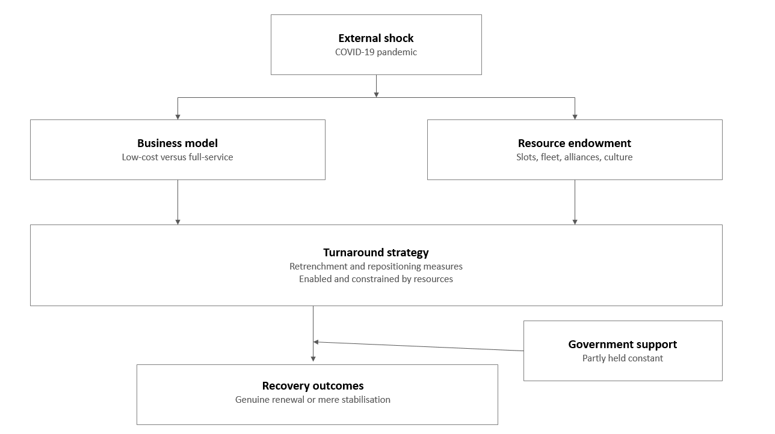
Figure 1: Conceptual Framework, Source: (Self-Constructed using MS PowerPoint- Appendix 4).
The Figure 1 framework was created by taking the four key concepts covered in this chapter and positioning them in the sequence they lead to each other. The pandemic is the external shock that will be the starting point. This meets two carriers that already differ in their business models and in the resources they hold. These circumstances inform the available turnaround choices that each airline can actually pursue, based on the turnaround theory, and the resource-based view subsequently clarifies why the identical choice can succeed in one airline but fail in the other. The last box is the recovery outcome, which is measured in this study. Each box thus represents a body of literature already discussed above, not an abstract concept, and the arrows show how that literature suggests the flow of influence. The themes of this review are connected to each other in one explanatory chain in the conceptual framework. COVID-19 is an external shock that is inflicted on two carriers, which have different business models and endowments of resources. These underlying conditions, the vulnerability of structures and resource placements that have been analysed in the previous section of this chapter, influence the spectrum of turnaround strategies that can realistically occur for each airline. The carrier then each chooses retrenchment and repositioning options, explained by turnaround theory, which are both facilitated and limited by its valuable, rare and inimitable resources, explained by the resource-based view. This process is conditioned by government assistance, which is partly kept unchanged in the two UK carriers. The interaction of strategy and resources generates recovery outcomes, which can be evaluated not only as financial stabilisation but also as genuine strategic renewal. This paradigm will inform the empirical analysis, as it focuses on the connection between what each airline did and what its underlying resources enabled it to do. The same framework is carried into the findings chapter. The themes of the financial and the operational are interpreted as the strategy stage of the chain, the results of the ratio are interpreted as the outcome stage, and the analysis returns to the resource boxes to justify the reason why two airlines with the same tools ended up in different positions.

2.9 Literature Gap
In the synthesis of the literature, a definite gap is revealed. The available literature persuasively confirms that the airline industry is structurally weak, that the COVID-19 crisis did not cause but heightened this weakness, and that the recovery was not even and was influenced by the strategy and government support. It further indicates that the categories of low-cost and full-service have merged in structure but separated in terms of crisis performance. Nevertheless, evidence is still scattered on these themes and is predominantly early-pandemic and cross-sectional studies, mostly not from the UK. The substantial portion of the literature, including the one by Budd, Ison and Adrienne (2020), concerns the acute phase of 2020 and leaves a long way before the recovery is full. Consequently, it cannot demonstrate whether an early recovery position is or is reversed over time, and very little comparative literature is available to determine whether two contrasting carriers within the same national support regime recover on the same measures or on different ones. More importantly, none of the studies utilised both turnaround theory and the resource-based view to compare British Airways and easyJet longitudinally in the years 2020-2025 to differentiate the strategic decisions and resource-based limitations. This is important since even the use of similar strategies can yield varying results. Additionally, this distinction can frequently be based on the resources possessed by each carrier, which would not be reflected by single-lens or single-point research. Ma (2024) shows that there are model-based performance differences, but they have to be corroborated by the UK. This paper fills this gap by presenting a business-model-comparative, theoretically based and longitudinal study that is lacking in the literature.

2.10 Chapter Summary
This chapter has critically assessed the literature applicable to airline turnaround strategies, moving from the industry and its long-standing fragility, to the uneven impact of COVID-19, and to the ever-blurred line between low-cost and full-service models and the theories that can be used to explain recovery.The synthesis represents a field in which the scale of the crisis is agreed upon but the cause is not; it records the beginning and ultimate unevenness of recovery, underexamines the linking strategic choices, and is becoming more aware of business model as an inadequate predictor of resilience. The turnaround theory and the resource-based view were developed as complementary lenses that can be used to separate strategic choice and structural constraint. The gap that the review has found is the following: there is no longitudinal, UK-specific, theoretically based comparison of British Airways and EasyJet. The next chapter outlines the research methodology, which aims at filling this gap and answering research questions of the study.

Chapter 3 Research Methodology

3.1 Introduction
The chapter describes and supports the methodological choices made to address the research question, which is to compare the corporate turnaround strategies of British Airways and EasyJet following COVID-19. The layers of the research onion are used to structure the chapter, starting with the philosophical assumptions and proceeding to approach, methodological choice, strategy and time horizon, and finally the techniques employed to gather and analyse data (Saunders, Lewis and Thornhill, 2019). Each of the layers is accompanied by the chapter stating what had been selected, why the possible main alternatives were rejected, and what the chosen option will bring to the study and what it will cost it. This is a deliberate construction, as a methodology only makes sense when the reader is able to trace how an abstract philosophical stance becomes a concrete decision concerning which data are collected and how they are processed. The chapter then outlines the ethical stance of the study and then summarises the overall design.

3.2 Research Philosophy
The research follows pragmatism, which believes that a research question must guide the selection of methods and not a priori adherence to a single paradigm (Saunders, Lewis and Thornhill, 2019). This stance is appropriate to the research, as its objectives are not of one kind. The initial two goals relate to strategic plans and reorganisation decisions, which are documented definitions and thus need to be interpreted, and the third relates to financial performance, which is independent of the researcher and must be calculated. The philosophy which could support one of these only would compel the study to renounce part of its own purpose.
Positivism was taken into account and put aside. Even though it would help the ratio work effectively by objectifying and making financial data measurable, it would decrease the strategic announcement to countable variables or disregard it altogether, losing the rationale behind the decisions of each airline (Saunders, Lewis and Thornhill, 2019). Interpretivism was discarded on the contrary ground that it would consider audited financial statements to be but a single account among a number of accounts, which is hard to defend when such figures are externally valid, prepared by common standards and can be directly compared across the two carriers. The nearest substitute was critical realism, which was rejected not based on principle but on pragmatic reasons since the determination of the underlying causal mechanisms it focuses on would require evidence of internal processes that cannot be given publicly through external sources (Bell, Bryman and Harley, 2019).
The most evident strength of pragmatism is that the combination of numerical and textual evidence can be done without initially solving profound ontological conflicts, staying focused on the problem itself (Tashakkori, Johnson and Teddlie, 2021). This flexibility is not free, though, as the findings made on the basis of various epistemological traditions do not necessarily fit and have to be brought together through a conscious effort and not by presupposition (Creswell and Creswell, 2018). That risk is later considered by a specified point of integration in the analysis.

3.3 Research Approach
An abductive approach is used, which moves between empirical evidence and theory rather than running in one direction (Saunders, Lewis and Thornhill, 2019). The research starts with a proven theory of turnaround as an interpretive perspective, but it is not considered rigid. Abduction in this work implies that the turnaround framework is applied to explain the evidence, but where the evidence points otherwise, the framework is modified to align with it. This is important, as the two carriers were expected to move in the same direction in the important ratios, and in the instances when they are not, the analysis shifts back to the theory and interprets the difference in the resources each airline possesses. This is merely to outline this logic; the evidence that establishes it will be found in the findings chapter.
The purely deductive approach was ruled out since hypothesis testing cannot be done without a stable mass of previous research, and the studies of the post-pandemic turnaround in UK aviation are still thin and recent. An all-induction method was also denied in that the ground-up development of theory would eliminate the large body of turnaround literature that already exists and would render the findings more difficult to place in an academic context. Abduction has the advantage of being based on existing frameworks but being literally open to outcomes that improve them (Saunders, Lewis and Thornhill, 2019). The threat of researcher bias represents a weakness because it allows for repetition between theory and data, which can lead the researcher to favour evidence that aligns with a predetermined framework (Bell, Bryman and Harley, 2019). Here, the scope is restricted by pieces of evidence that both fit and do not fit into the framework.

3.4 Methodological Choice
It follows a mixed-methods design, namely, a convergent design where both strands are gathered simultaneously and unified during the interpretation phase (Creswell and Plano Clark, 2018). The quantitative strand and the qualitative strand, respectively, achieve the third and the first two objectives by the ratio analysis and the thematic analysis of strategic documents. The qualitative strand in this research involves reading documents (the rights-issue announcements, the export-finance-backed loan filings and the base-close and fleet decisions) and classifying them into the retrenchment and repositioning categories identified in the theoretical framework. The quantitative strand turns the eight years of audited figures into the ten ratios used in the findings. The two strands converge at a single, clear point: each theme is checked against the corresponding ratio result; thus, a statement in a company document is not acknowledged until the figures back it up. The strands represent the same amount of weight, as ratios indicate what has occurred but not why, but corporate documents indicate intent in terms which are often favourable and thus require verification by an independent party.
A mono-method quantitative design was eliminated because it was unable to answer the first two objectives, and a mono-method qualitative design was eliminated because the effectiveness required by the third objective could not rely solely on corporate self-description. The mixed methods are useful in this case since both of the strands balance out the known limitations of the other and provide superior corroborated conclusions to what each could have achieved alone (Molina-Azorin, 2016). Oppositely, these designs are challenging in time and analytical ability, and with poor integration may lead to two studies being run in parallel, not a single one (Fetters, 2020). To protect against that eventuality, every qualitative theme will be subsequently analysed against the associated movement in the ratio data.

3.5 Research Strategy
The selected approach is a comparative case study of two organisations. Case study research can be used in studies with 'how' and 'why' questions because it focuses on a phenomenon in a real-life context rather than in isolation from that context (Yin, 2018). Two instances are utilised due to the fact that both British Airways and easyJet encountered the same shock, the same regulatory structure and the same domestic market but with totally divergent business models, one being a full-service network carrier and the other being a low-cost point-to-point operator. The differences in recovery can thus be more credibly ascribed to strategic and structural decisions, as so many external conditions are effectively kept constant.
The single case study was disregarded since it would eliminate the comparative aspect around which the objective hinges. A comprehensive survey of UK carriers was also rejected, as there are too few similar airlines in the market to statistically generalise, and the breadth would compromise the depth required to trace decisions about restructuring in finer detail. The advantage of this strategy lies in analytically detailed description of process and outcome instead of description per se (Bell, Bryman and Harley, 2019). It does not provide statistical generalisation, and any broader assertions should be analytically drawn to theory and not a population (Yin, 2018).

3.6 Time Horizon
A longitudinal horizon with eight financial years (2018-2025) is employed; three different phases can be singled out in the same dataset. 2018 and 2019 are used as a pre-pandemic baseline; 2020 and 2021 represent the collapse in demand; and 2022 to 2025 follow the recovery until the latest published stories. The analytical significance of extending the window to 2025 is that a shorter window, with an endpoint of 2022 or 2023, would show the return to profit but not the persistence of this improvement, and turnaround literature cautions against the quick recovery. Similarly, the absence of the 2018 and 2019 baseline would not allow to assess whether either of the airlines has managed to recover in earnest or has just ceased to lose money, which is the main focus of the third objective. The use of a cross-sectional horizon was thus eliminated since a snapshot does not qualify to display trajectory. The longitudinal design is valuable in that it demonstrates how the patterns change through the entire cycle of crisis and not the status quo (Saunders, Lewis and Thornhill, 2019). One of the challenges is that inter-year comparability may be influenced by changes in accounting treatment, which is important in this case.

3.7 Data Collection
This study uses all secondary data. The quantitative strand retrieves line items of the published annual reports of both companies in each of the years 2018 to 2025 regarding revenue, operating profit, profit after tax, finance costs, total assets, current assets, inventories, current liabilities, borrowings, total equity and operating cash flow. Annual reports were chosen over commercial financial databases since they are audited and publicly verifiable, and since the notes to each figure can be viewed, showing how items such as lease liabilities and borrowings have been aggregated, as opposed to relying on how a third party has treated them. Practically, the easyJet figures were taken from the easyJet investor reports, and the British Airways figures were taken from the annual reports that are submitted to the Companies House on GOV.UK, and both were cross-checked with the regulatory news service reports.
The qualitative strand uses two layers of sources. The former is a review of peer-reviewed journal articles on airline crisis response and turnaround strategy, accessed in Google Scholar and Scopus. The second are those of corporate announcements, regulatory news service filings and stipulated industry reporting, which are required since operational details like base closures, fleet grounding decisions and workforce consultations are seldom reported in academic journals within the studied timeframe. The primary sources of this strand were FlightGlobal, the Centre for Aviation, BBC News, CNBC, Aviation Week, Travel Weekly and Aviation24, and the IATA and Civil Aviation Authority data. These constitute the same sources that resurface in the financial and operational themes in Chapter 4, thus enabling the reader to trace back every assertion to its origin.
Secondary data provide access to audited and longitudinal data that an individual researcher would not have been able to produce in the first place (Bell, Bryman and Harley, 2019). The trade-off is that these data were generated to meet other ends, and the researcher could not decide what was measured and revealed (Saunders, Lewis and Thornhill, 2019). Corporate reports are also more or less promotional documents, and as such, every source is evaluated on the basis of authenticity, credibility, representativeness and meaning and not taken at face value. To make sure that this assessment was implemented in a systemic and not informal manner, the search process and the limits of the dataset were predetermined, and the following two tables listed the search terms utilised and the criteria applied to the decision whether a source was included in the study or not.
Search Terms:
Focus area | Search terms used | Example sources / websites found
Airline journals (turnaround, COVID-19, recovery) | ("airline" OR "airlines") AND ("COVID-19" OR "pandemic" OR "post-COVID") AND ("UK") AND ("strategic response" OR "retrenchment" OR "business renewal" OR "recovery") OR "flights" — searched on Google Scholar | (Albers & Rundshagen, 2020; Budd, Ison & Adrienne, 2020; Adrienne, Budd & Ison, 2020; Amankwah-Amoah, Khan & Wood, 2021)
Aviation news, job & workforce cuts | "British Airways job cuts COVID", "easyJet workforce cuts coronavirus", "easyJet closing bases staff cuts" | BBC News; CNBC; PressReader
Aviation news, capacity, funding & transformation | "easyJet capacity cuts seasonal bases COVID", "easyJet raises billion loan finance COVID", "IAG British Airways rights issue COVID", "British Airways transformation plan investment post-COVID" | Aviation Week; FlightGlobal; Reuters; Aviation24
Aviation analysis / consultancy sites | ("British Airways" OR "easyJet" OR "BA") AND ("COVID-19" OR "pandemic") AND ("state aid" OR "sale and leaseback" OR "Aircraft Sale and Leaseback During COVID-19" OR "UK Export Finance" OR "bailout" OR "BA COVID recovery" OR "post-pandemic comeback") | Centre for Aviation (CAPA); ACC Aviation; Travel Weekly; Fast Company
Financial / investor & market sites | ("easyJet" OR "British Airways" OR "IAG" OR "BA") AND ("COVID-19" OR "pandemic" OR "recovery") AND ("easyJet reports" OR "trading update" OR "underwritten rights issue" OR "annual report" OR "share buyback" OR "British Airways Owner IAG Profits" OR "BA Media Centre COVID") | easyJet investor reports; Investegate; Fortune; LexisNexis; British Airways Media Centre

Table 1: Literature search terms, Source: (Self-Constructed).
Inclusion and Exclusion Criteria:
Criterion | Included | Excluded | How it applied in this study
Publication date | 2015 onwards | Published before 2015 | Kept the 2018 and 2019 baseline used to judge recovery in Chapter 4
Language | English | Non-English sources | UK-focused study, so all annual reports and filings were English
Source type | Peer-reviewed journals, audited annual reports, regulatory filings, established industry outlets | Blogs, opinion columns, unverifiable sources | Kept audited reports and RNS filings behind the themes and ratios; dropped unverifiable posts
Geographic focus | UK and European aviation, with global work where directly relevant | Studies with no aviation relevance | Kept UK and European carrier evidence used in the comparison
Subject focus | Airline strategy, turnaround, COVID-19 impact, low-cost and full-service models | Unrelated transport or tourism studies | Kept turnaround, business-model and COVID-19 airline studies cited in Chapter 4
Table 2: Inclusion and exclusion criteria, Source: (Self-Constructed).
As indicated in Table 1, the search was organised into five focus areas instead of a broad-based query, and this was critical in ensuring that the strategic and the financial aspects of the research purpose were represented instead of one taking over the dataset. All search evidence of the above search terms are in Appendix 3. The results are then filtered in Table 2, where the cut-off year 2015 is selected to ensure that the industry conditions prior to the pandemic can be seen and the outdated material that is of little importance is discarded. Collectively, the two tables render the limits of the dataset clear and reproducible, which enhances the credibility of the qualitative strand.
The searches had yielded the sources that have been used in the findings chapter. The literature area, which is searched on Google Scholar, yielded the literature that puts the analysis into context, including Albers and Rundshagen (2020) and Amankwah-Amoah, Khan and Wood (2021). The aviation news focus categories revealed the job cut, funding and capacity news releases by the BBC News, CNBC, FlightGlobal and Reuters news agencies. The aviation analysis focus area yielded the sources behind the state-aid, sale-and- leaseback and recovery themes, including Centre for Aviation, ACC Aviation and Travel Weekly. The financial and investor focus domain yielded the corporate documents that lay out the financial themes, which are the easyJet and British Airways company reports. The rules of inclusion and exclusion at the time made the difference: the 2015 cut-off left the pre-pandemic base of recovery measurement, and the rule of source type left the audited reports and regulatory filing on which the ratio work and the theme coding are dependent. This is why the same sources reoccur when the themes are constructed and tested later in the analysis.

3.8 Data Analysis
Financial ratio analysis is used to analyse quantitative data, and ten ratios of profitability, liquidity, solvency and efficiency are calculated for both airlines over the eight-year period and compared year-on-year and between the carriers at the same point. Thematic analysis of qualitative data utilises a six-step process of Braun and Clarke (2021), passing through familiarisation, coding, creating initial themes, reviewing them, defining and naming them, and writing up. The content analysis was dismissed since the frequency of the terms will be counted, which will reflect the emphasis in communication as opposed to the strategic content. Reliability is facilitated since calculations of the ratios are formula-driven and can be traced completely to published statements; therefore, another researcher would come up with the same, whereas validity is enhanced by triangulating corporate claims with audited results. The process of integration takes place at the stage of interpretation when every theme is subjected to the ratio evidence (Timans, Wouters and Heilbron, 2019).

3.9 Ethical Considerations
Because the study utilises publicly available secondary data only, there are no concerns regarding participant consent, confidentiality or harm, and no ethical approval of human participants was required. Ethical responsibility is thus based on integrity of use as opposed to protection of subjects. The sources are cited correctly and consistently, figures are copied verbatim as they appeared in print and have not been changed to fit the argument, and no source is quoted to give a different meaning. Where evidence is against the argument that is emerging, this is reported and not silently omitted. A secondary design eliminates the ethical risks associated with primary fieldwork (Saunders, Lewis and Thornhill, 2019). In return, the entire ethical burden lies on transparent and non-selective reporting, in that the researcher alone decides what to include and what not to include.

3.10 Chapter Summary
This chapter has warranted a pragmatic, abductive, mixed-methods comparative case study of British Airways and EasyJet in the financial years 2018 to 2025. Pragmatism was chosen since the goals seek both interpretation and measurement; abduction, since the current turnaround theory is valuable but incomplete to this scenario; and the comparative case study, since two carriers with different business models in the face of a common shock enable the isolation of strategic differences. All the data is based on audited yearly reports, peer-reviewed literature and validated sources in the industry, and it is controlled in accordance with the inclusion and exclusion criteria, as stated above. Analysis is a mixture of ratio analysis and thematic analysis, which are combined at the interpretation level, whereby the stated strategy is tested against the measured outcome. These judgements give the methodological foundation to the findings that are given in the next chapter.

Chapter 4 Findings and Analysis

4.1 Introduction
This chapter introduces, reviews and analyses the evidence collected to respond to the three research objectives identified in the introductory chapter. Since the research is based on the mixed-methods approach, the results are presented in two shapes. The two initial goals, dealing with financial recovery strategies and operational restructuring approaches, are introduced in a thematic manner based on academic, corporate and industry sources. The third objective, related to the comparative effectiveness, is provided numerically with the help of the ratio analysis of both carriers in 2018-2025. The presentation of findings is made at the beginning of the chapter to allow the observation of patterns before interpretation is made. It continues next to the analysis where the qualitative and quantitative strands are not restated but instead amalgamated and subjected to interrogation and then discussion where results are compared with the existing literature and read through the prism of turnabout theory and the resource-based view. The chapter ends with a brief summary and is connected with the following conclusions. The chapter is designed to address the gap in the literature review that is the absence of a long-run, UK-based comparison of British Airways and easyJet read through a turnaround theory and the resource-based view. It does this by following the conceptual framework outlined above, switching between the strategies each airline selected, the resources supporting those strategies, and the resulting recovery, and it employs the integration step outlined in the methodology, in which each theme is not just put side by side but is tested against the corresponding ratio.

4.2 Summary and Presentation of Findings
The results are categorised by objective. Each of the two qualitative objectives was then developed into four themes, which were formed around patterns which are common across independent sources. The full set of codes and their grouping into these themes is provided in the thematic coding table in Appendix 1. To achieve the quantitative goal, it was possible to perform ten ratios of both airlines over eight financial years and provide them in a comparison table, with the support of figures that show the most important shifts.

4.2.1 Findings for Objective One: Financial Recovery Strategies
Theme 1: Layered Emergency Liquidity Raising
Both of the carriers acted in reaction to the revenue crunch by piling up a number of sources of funds instead of relying on a single instrument. The initial phase of raising over £2.4 billion was done by easyJet through a combination of a drawdown of a revolving credit facility of 400 million pounds, 600 million pounds of Covid Corporate Financing Facility, 400 million pounds of term loans, 608 million pounds of sale-and-leaseback proceeds and 419 million pounds of equity (Aviator.aero, 2020). Similar reasoning was applied by British Airways, which overlaid a £300 million Bank of England facility with furlough support and had over £8 billion in cash and undrawn facilities in its parent (Travel Weekly, 2021). The sale-and-leaseback was especially beneficial since it tapped capital that was locked up in owned aircraft without the need to add conventional borrowings (ACC Aviation, 2020), which implies that speed of access was a more important factor at this point than cost of capital.
Theme 2: State-Backed Loans and Export Finance Guarantees
The second theme is the application of partially guaranteed lending, which enabled both airlines to borrow on scale when purely commercial appetite constrained them. In December 2020, British Airways took a £2 billion five-year syndicated term loan partly guaranteed by UK Export Finance in what was a continuation of the role UK Export Finance has played in supporting large domestic exporters (Centre for Aviation, 2021). EasyJet obtained a similar tool a few months later, a five-year, $1.87 billion UK Export Finance-supported facility that extended its debt maturity structure and released aircraft from security (FlightGlobal, 2021). The intent was different, even though its mechanism was the same. The facility was primarily used by British Airways to add liquidity and by easyJet to refinance shorter-dated obligations, which is indicative of a more future-orientated approach to maturity risk.
Theme 3: Equity Issuance and Balance Sheet Repair
Debt was not sufficient to fix either balance sheet, and therefore both parties resorted to shareholders, albeit at different points in time. In September 2020, IAG underwent a fully underwritten rights issue that raised €2.741 billion through 2.97 billion new shares at a 36 per cent discount to the theoretical ex-rights price, with Qatar Airways taking its full entitlement (Reuters, 2020). A year later easyJet issued a £1.2 billion fully underwritten rights issue, saying that the funds would enhance the balance sheet, net debt would be reduced and it would have the flexibility to exploit opportunities as European flying resumed (Investegate, 2021). This time lag is analytically significant, in the sense that it suggests that EasyJet was able to postpone dilution while British Airways moved earlier under heavier balance sheet pressure.
Theme 4: Transition from Survival Funding to Profitable Growth
The fourth theme is the way the purpose of financing shifted back to its position when demand came back. At the FY2021 year-end, easyJet had raised approximately £7 billion of liquidity; held unrestricted access to £4.4 billion against £2.3 billion a year prior; owned 59 per cent of its fleet, 44 per cent of which was not encumbered; and reduced weekly cash burn to £36 million against £40 million guidance (easyJet plc, 2021). FY2023 saw recovery with a profit before tax of £455 million, revenue increased 42 per cent to £8.17 billion and a reinstated dividend (easyJet plc, 2023) with debt reduction and the growth of the higher-margin holidays business (Fast Company, 2024). The parent of British Airways was at a similar level, as it came back to profitability and reported a share buyback (Fortune, 2025; AFP, 2025).

4.2.2 Findings for Objective Two: Operational Restructuring Approaches
Theme 1: Large-Scale Workforce Reduction Programmes
These functional themes are the retrenchment end of the turnaround axis in the conceptual framework, which indicates what each airline rolled back prior to repositioning. The initial and biggest structural lever of both carriers was labour, though the depth and framing were dissimilar. British Airways suggested up to 12,000 out of its 42,000 employees in a restructuring and redundancy programme following furloughing over 30,000 workers and also aimed to change the contractual conditions of the rest of its employees, which sparked union opposition and political questioning (BBC News, 2020). EasyJet declared that it was cutting its workforce by up to 30 per cent, approximately 4,500 jobs, and clearly stated it was related to a reduced fleet, streamlined bases and eliminating non-essential spending on airport contracts and advertising (CNBC, 2020). This contrast is important since easyJet framed cuts as a fit with a permanently smaller operation, as compared to British Airways, which undertook a wider renegotiation of employment terms at a higher reputational cost.

Theme 2: Network and Base Rationalisation
Both airlines also redefined their place of operation, not the amount they flew. EasyJet put in consultation closing its bases at Stansted, Southend and Newcastle and withdrawing based aircraft and crew but retaining these airports in its route network at a time when it had 11 UK bases, 163 aircraft and 546 routes (PressReader, 2020; BBC, 2020). It also viewed continental bases like Venice and Naples as seasonal and was an indication that it would reserve appealing slots at opportune times (Aviation Week Network, 2020). British Airways went further structurally, combining workforce cuts with a joint venture on Australian routes and a permanent exit from its London Gatwick base, making it an unusual European case of simultaneous retrenchment, partnering and exit (Albers and Rundshagen, 2020).
Theme 3: Partial Fleet Grounding for Operational Readiness
Neither carrier put all its fleet into deep storage, which turns out to be a planned readiness measure, not an operational mishap. British Airways retained about a third of its fleet in serviceable condition to ensure that it could quickly resume services, followed by the gradual reintroduction of capacity to domestic and high-demand flights at lower frequencies (Budd, Ison and Adrienne, 2020). EasyJet followed suit with approximately 30 per cent of the aircraft being on the go, with the rest scattered out across its various European bases rather than being centralised at one store (Adrienne, Budd and Ison, 2020). The far-flung model was more appropriate to a multi-base low-cost network, and it arguably reduced reactivation time, but it also maintained parking and maintenance expenses at a time when revenue was at a minimum.
Theme 4: Transformation Programmes versus Granular Cost Reduction
The two airlines took distinctly different paths towards a cheaper bottom line. British Airways has developed its restructuring based on a £7 billion transformation programme with over 600 initiatives focused on customer experience, digital capability and operational efficiency, including a new website and application, new short-haul seats and network expansion to Bangkok and Kuala Lumpur (Aviation24, 2024). Instead, easyJet operated what it said was the biggest cost-out programme in its history, focusing on crew efficiency, reduced airport and ground handling costs and engineering savings (LexisNexis, 2021), which it subsequently dubbed 'self-help measures' that saved it over a first half in the face of Omicron and fuel inflation (easyJet plc, 2022). Due to the fact that such gains should be reversed unless implemented permanently (Amankwah-Amoah, Khan and Wood, 2021), British Airways resolved this issue by using a continuous improvement strategy boasting of over 1,000 projects so far completed (British Airways, 2024).

4.2.3 Findings for Objective Three: Comparative Financial Performance
The following table provides ten ratio values of both carriers on the eight financial years between the years 2018 and 2025, which are classified into profitability, liquidity, solvency and efficiency ratios. The numbers in brackets are negative. The reports are due 31 December at British Airways and 30 September at EasyJet, which is why the two airlines are recording their worst results at different times. MS Excel is used to analyse the data and create table, graph, and charts. The full financial statements (for each company), including the computed financial ratios with the formulas and figures applied are provided in Appendix 2.
Ratio | Company | 2018 | 2019 | 2020 | 2021 | 2022 | 2023 | 2024 | 2025
Profitability
Operating margin (%) | British Airways | 18.09 | 10.07 | (97.55) | (47.90) | 2.95 | 9.99 | 14.14 | 15.19
 | EasyJet | 7.85 | 7.30 | (29.88) | (62.41) | (0.47) | 5.54 | 6.33 | 6.89
Net profit margin (%) | British Airways | 16.13 | 8.34 | (87.48) | (44.62) | 0.55 | 8.11 | 16.40 | 12.96
 | EasyJet | 6.07 | 5.47 | (35.86) | (58.85) | (2.93) | 3.97 | 4.86 | 4.89
ROCE (%) | British Airways | 21.64 | 10.71 | (37.81) | (15.49) | 2.58 | 13.55 | 15.22 | 16.48
 | EasyJet | 9.39 | 8.48 | (19.35) | (12.82) | (0.40) | 7.95 | 8.97 | 9.46
ROE (%) | British Airways | 36.90 | 19.10 | (190.84) | (91.96) | 2.46 | 44.65 | 49.60 | 29.87
 | EasyJet | 11.07 | 11.69 | (56.82) | (32.51) | (6.67) | 11.63 | 15.20 | 14.12
Liquidity
Current ratio (x) | British Airways | 0.73 | 0.74 | 0.36 | 0.45 | 0.54 | 0.35 | 0.52 | 0.44
 | EasyJet | 0.97 | 0.79 | 0.67 | 1.56 | 1.34 | 1.00 | 1.02 | 1.11
Quick ratio (x) | British Airways | 0.70 | 0.71 | 0.35 | 0.44 | 0.53 | 0.34 | 0.50 | 0.42
 | EasyJet | 0.97 | 0.79 | 0.67 | 1.56 | 1.34 | 1.00 | 1.02 | 1.11
Operating cash flow ratio (x) | British Airways | 0.29 | 0.29 | (0.43) | 0.02 | 0.25 | 0.24 | 0.33 | 0.30
 | EasyJet | 0.47 | 0.29 | (0.20) | (0.39) | 0.21 | 0.37 | 0.33 | 0.39
Solvency
Gearing, debt to equity (%) | British Airways | 78.10 | 108.66 | 479.12 | 544.08 | 420.34 | 321.62 | 176.08 | 114.29
 | EasyJet | 30.22 | 63.72 | 181.20 | 168.47 | 170.15 | 103.48 | 110.33 | 83.65
Interest cover (x) | British Airways | 20.22 | 6.11 | (14.51) | (4.12) | 0.66 | 2.37 | 4.65 | 5.76
 | EasyJet | 15.43 | 7.77 | (1.83) | (4.35) | (0.19) | 2.52 | 4.46 | 4.46
Efficiency
Asset turnover (x) | British Airways | 0.78 | 0.70 | 0.25 | 0.21 | 0.53 | 0.74 | 0.67 | 0.65
 | EasyJet | 0.84 | 0.78 | 0.36 | 0.15 | 0.55 | 0.83 | 0.84 | 0.88
Table 1: Comparative Ratio Summary of British Airways and EasyJet, 2018 to 2025, Source: (Appendix 2).
Depth and Timing of the Collapse
This crisis did not occur to the two carriers during the same year. In the year 2020, British Airways achieved the lowest operating margin of negative 97.55 per cent and net margin of negative 87.48 per cent, which is why it made a loss of nearly a pound on the revenue it earned. The worst year that easyJet has had was in 2021, with an operating margin of negative 62.41 per cent since its September year-end represented a more complete period of restricted travel. The scale was also quite dissimilar, as the trough of British Airways was about 1.6 times deeper than that of EasyJet. This time difference implies that any comparison made at a particular date would be a fallacy, and that is the reason why the longitudinal design was embraced in this study.
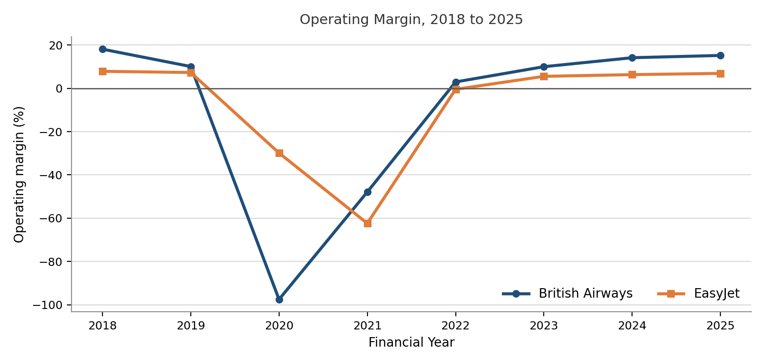
Figure 1: Operating Margin of British Airways and EasyJet, Source: (Appendix 2).
Profitability Restored vs Profitability Exceeded
In 2025 the two carriers found themselves in distinctly different places compared to their respective baselines. The operating margin of British Airways stands at 15.19 per cent, ROCE at 16.48 per cent, and ROE at 29.87 per cent, which is significantly higher than the figures of 10.71 per cent and 19.10 per cent in 2019. EasyJet records 6.89 per cent, 9.46 per cent and 14.12 per cent, respectively, just lower than its operating margin of 7.30 per cent in 2019 but slightly above its ROCE of 8.48 per cent in 2019. Briefly, British Airways has surpassed the level of profitability it had prior to the pandemic, whereas EasyJet has generally recovered it, albeit with some of the percentage point difference being structurally due to the higher base of a full-service airline.
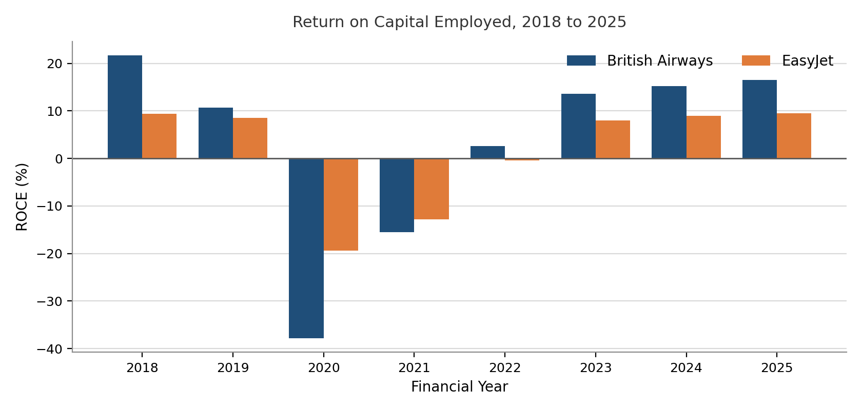
Figure 2: Return on Capital Employed of British Airways and EasyJet, Source: (Appendix 2).
Cash Holding Against Cash Generation
The order is reversed by liquidity. The current ratio of easyJet increased to 1.56 in 2021 compared to 0.79 in 2019 and has stayed above 1.00 until the last year and ended with 0.44, but British Airways never surpassed 0.74 over the entire period. However, this is complicated by the operating cash flow ratio, as, in 2021, British Airways got back to positive operation cash generation at 0.02, whereas EasyJet was negative at 0.39 in the same year. The two measures are hence heading in different directions, with easyJet having more cash but still spending it, whereas British Airways has less but is starting to produce it again.
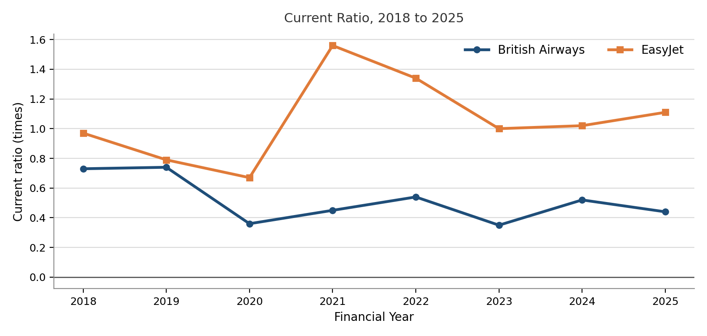
Figure 3: Current Ratio of British Airways and EasyJet, Source: (Appendix 2).
Leverage Peaks and Two Routes to Deleveraging
The most drastic deviation in the data is solvency. In 2021, British Airways was at a high of 544.08 per cent gearing compared to easyJet's 181.20 per cent in 2020, which is about three times higher. The two then also decreased leverage, albeit through different ways. British Airways reduced gearing to 114.29 per cent by 2025, mostly by rebuilding equity, which rose from £2,600 million in 2023 to £6,367 million in 2025, whereas EasyJet reduced total debt in absolute terms from £4,446 million in 2021 to £2,926 million in 2025. Both had increased interest cover, with British Airways and EasyJet having interests that were 5.76 times and 4.46 times, respectively.
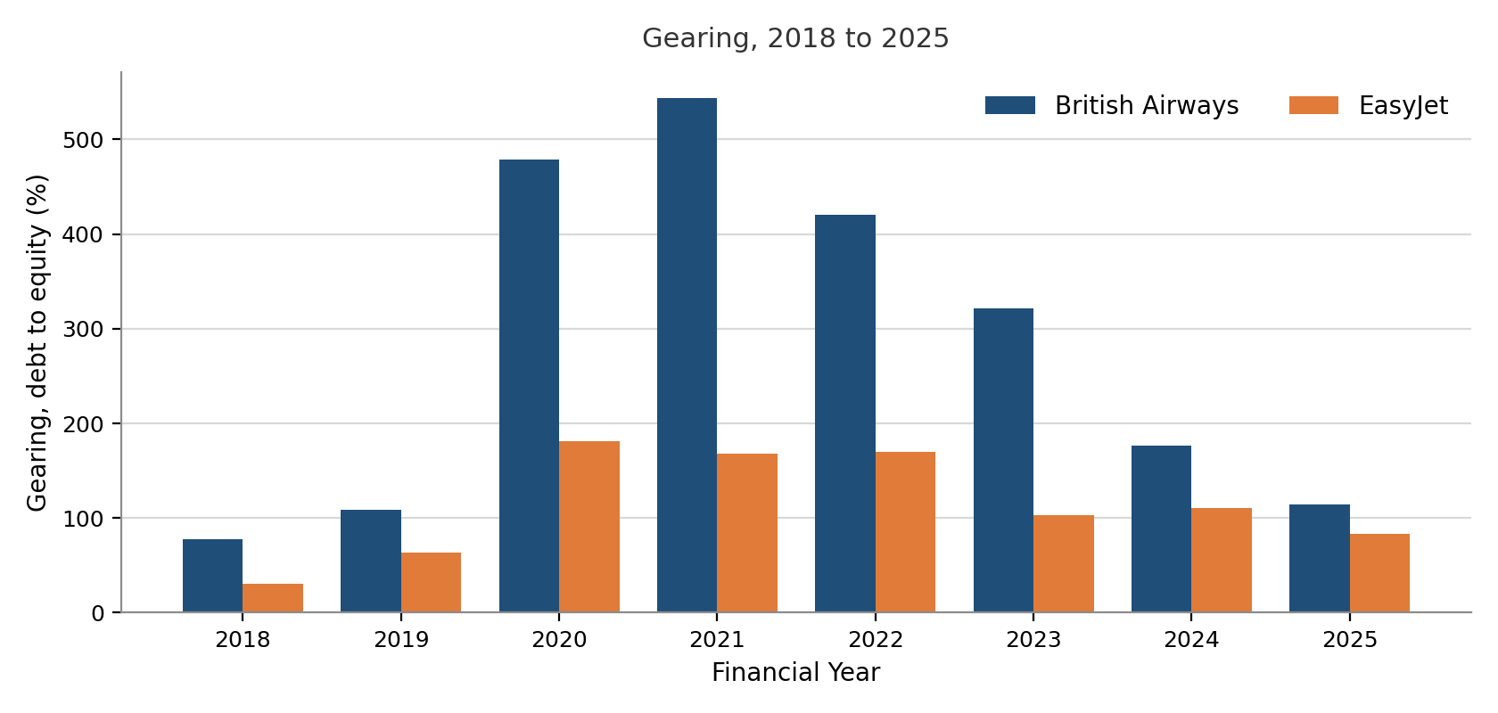
Figure 4: Gearing of British Airways and EasyJet, Source: (Appendix 2).

Asset Productivity and the Cost of Transformation
The best piece of evidence in favour of easyJet is efficiency. Its asset turnover has revived to 0.88 in 2025, higher than the 0.84 in 2018 and compared to British Airways at 0.65 and the 2019 benchmark of 0.70. British Airways grew total assets from £19,253 million in 2023 to £22,416 million in 2025 while revenue rose only from £14,322 million to £14,679 million. EasyJet, by contrast, grew revenue from £8,171 million to £10,106 million on an asset base that expanded far more modestly. The following section discusses these opposing trends.
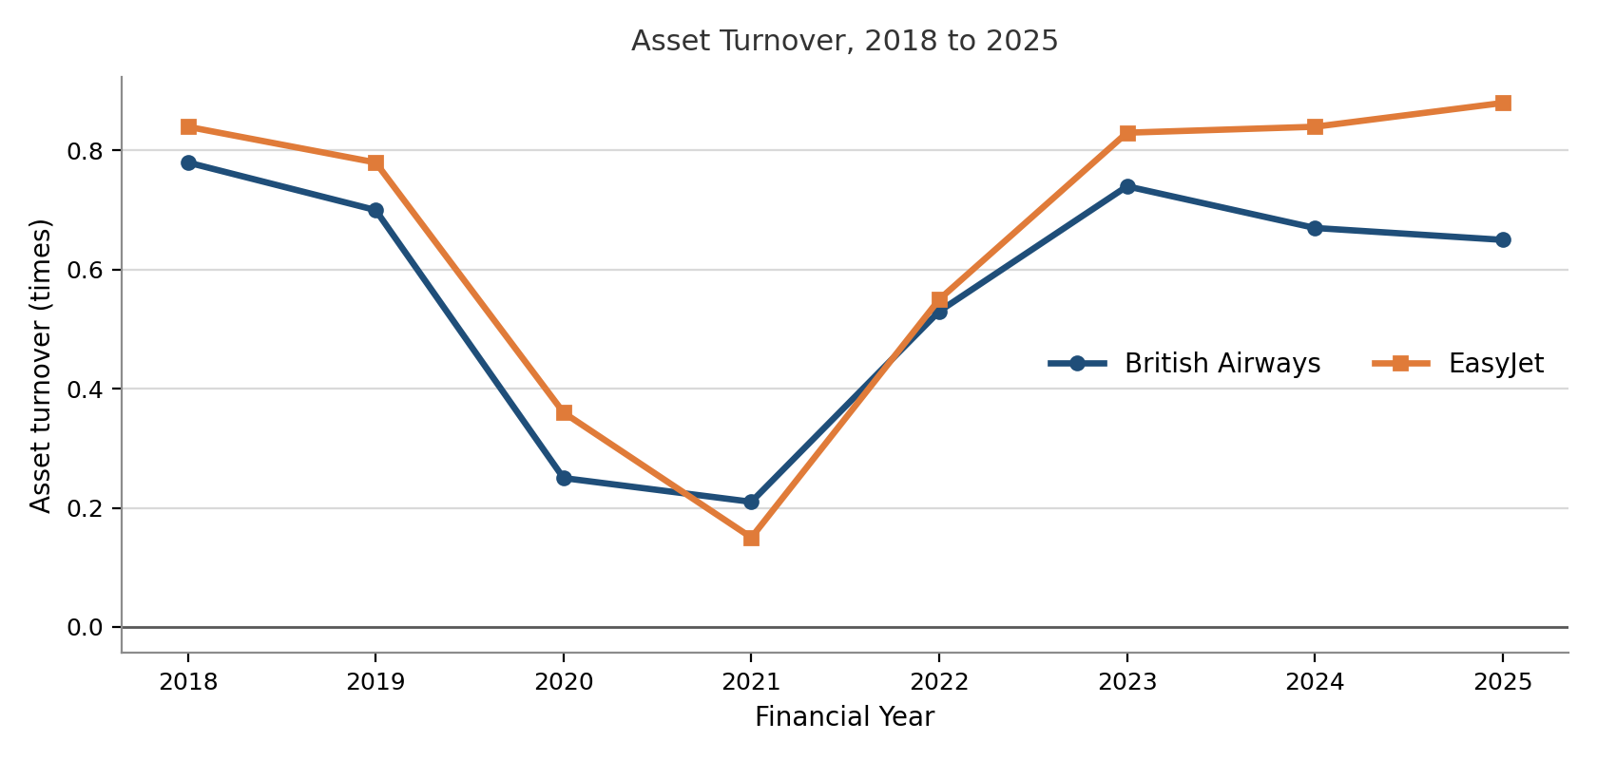
Figure 5: Asset Turnover of British Airways and EasyJet, Source: (Appendix 2).

4.3 Analysis of Results

4.3.1 Identical Instruments, Different Financing Logics
This initial theme occupies the strategy-to-outcome position of the conceptual framework: the airlines used the same set of turnaround tools, but their varying resources transformed the tools into varying outcomes. Even though the two carriers applied a very similar set of instruments of rights issues, export-credit-backed loans and asset monetisation, the analysis demonstrates that the same instruments were applied to different purposes. According to Dube, Nhamo and Chikodzi (2021), the recovery of financial stability relied heavily on the strength of pre-crisis balance sheets and the accessibility of capital in a short period, and the data noted here supports the former section of this assertion more than the latter. The two airlines tapped capital quickly, but the manner in which they utilised it was different. EasyJet channelled its guaranteed loan towards refinancing shorter-term obligations, and the ratio evidence confirms this purpose, as the total debt dropped in absolute terms between 2021 and 2025 from £4,446 million to £2,926 million. British Airways relied on similar tools to develop liquidity, and its debt fell far more slowly, from £9,750 million to £7,277 million over the same period.
This difference matters since it narrows down the argument of Maung, Douglas and Tan (2022) that the overly leveraged balance sheets are a long-running cause of airline vulnerability. The leverage had not only restricted the amount that each carrier was allowed to borrow but also what it could do with what it borrowed. One airline was operating the size of its debt, and the other was operating the amount of its cash, and neither of the two strands of evidence would have shown up by itself, which proves the value of the mixed-methods design as an analytical tool.

4.3.2 Restructuring Depth against Restructuring Speed
This is connected to the resource aspect of the framework: the same depth of cutting released the cash at extremely different rates due to the resources which each carrier possessed. The results of its operations contribute to the understanding of the reasons for such an unequal collapse. British Airways was able to reduce its workforce by approximately 29 per cent and leave one of its bases but still had an operating margin of negative 97.55 per cent in 2020, compared to EasyJet, which managed to reduce its workforce by 30 per cent and only negative 29.88 per cent in the same year. The difference cannot be explained by depth of retrenchment, however, because the proportions were very similar, and both sit near to the sector average of about 30 per cent discovered by Budd, Ison and Adrienne (2020). A more persuasive argument is the rate at which both cost bases might be actually decreased.
Both Merkert and Morrell (2012) and Maung, Douglas and Tan (2022) recognise that high fixed costs are an inherent characteristic of airline economics, but the current results indicate that fixity is not evenly distributed by business model. A long-haul network carrier has slot obligations, ownership of wide-bodies and alliance commitments which are not responsive to a redundancy programme on a single financial year, but a point-to-point carrier can withdraw based aircraft and crew from a station almost instantaneously. It substantiates the argument of Amankwah-Amoah (2020) that the results were conditioned by the interplay between internal cost structures and externally imposed constraints rather than by managerial action alone. Equal depth retrenchment had an unequal effect on financial relief, and this is a warning against using redundancy statistics as a measure of restructuring performance.

4.3.3 Reading the Liquidity Evidence against Stated Strategy
This is one more exercise of the theme against the ratio test that is stipulated in the methodology, where a given strategy can only be embraced after the numbers prove it. The most analytically interesting pattern in the dataset is that the airline with the stronger liquidity ratios was, for a period, the weaker cash generator. The current ratio of easyJet is 1.56 in 2021 with an operating cash flow ratio of negative 0.39, which indicates that easyJet had a huge amount of cash yet still used it at the same rate. This is also very much in line with its declared strategy of maximisation of liquidity and minimisation of cash burn and proves that such a strategy was indeed implemented and not announced only. It also reveals the weakness of that strategy, as piled-up cash does not automatically rejuvenate the trading performance. The same year, British Airways has the reverse of this, with a current ratio of 0.45 and slightly positive operating cash flow of 0.02.
Gössling (2020) blames airline vulnerability on a lack of liquidity buffers, and the evidence of EasyJet seems to support the idea that a large buffer helps to survive. But the British Airways evidence puts its argument in context, as its current ratio stood at 0.35 in 2023, which is a profitable year. This is business model distortion and not distress, as a full-service carrier gathers fares long before travel, such that the deferred revenue is included within current liabilities but is not an obligation to pay cash. Kijkasiwat, Siriphot and Lee (2023) discover that financial performance was propelled by operational fundamentals, like load factor, more than balance sheet position, and the trend here is in line with that perspective. Such a balance sheet should not be applied to a conventional benchmark of 1.0 because doing so would give a false conclusion, and therefore the ratio is considered directionally useful but not necessarily meaningful.

4.3.4 Two Routes to Deleveraging and Their Implications
Both carriers decreased gearing significantly over their peaks and in 2025, but the mechanisms have varied implications for resilience. British Airways' fall in gearing from 544.08 per cent to 114.29 per cent was driven predominantly by equity accumulation from retained profit rather than debt reduction, as equity more than tripled from £1,792 million in 2021 to £6,367 million in 2025 while debt fell comparatively little. This path is based on long-term profitability, and thus a fresh demand shock would stop the deleveraging in its tracks. The route that EasyJet took was that of real repayment, which reduces the fixed finance liability irrespective of subsequent trading. Read against Dube, Nhamo and Chikodzi (2021), who emphasise pre-crisis balance sheet strength, the difference reflects starting position rather than differing ambition, since British Airways entered 2020 with gearing already above 100 per cent and thus had less capacity to repay.
Lee (2021) demonstrates that governments preferred internationally exposed flag carriers to receive aid, and the results here partially prove this statement and make it complicated. British Airways did get an increased guaranteed facility, but the ratio evidence is that the state-supported borrowing has increased gearing to a level that is far higher than that of easyJet, and thus the aid did not eliminate the solvency issue, as it postponed it. Caution is to be observed with the figures of the return on equity. British Airways' negative 190.84 per cent in 2020 is inflated by a denominator effect because equity contracted from £5,807 million to £1,834 million within twelve months, and the same effect works in reverse in 2024, when an ROE of 49.60 per cent sits alongside a far more moderate ROCE of 15.22 per cent. The headline ROE thus overemphasises the fall and the recovery, which justifies the multidimensional method of airline performance measurement proposed by Tanrıverdi et al. (2023).

4.3.5 Efficiency, Investment Timing and the Cost of Transformation
Asset turnover is the least uncertain one to compare, as it is not influenced by the capital structure or the equity consideration and connects directly to the operational results. The recovery of EasyJet to 0.88 in 2025 can be explained by the base closures, seasonal basing and network optimisation that have been previously identified because all of these measures eliminate the fixed operational capacity and still maintain revenue-generating routes. The 0.65 number of British Airways, lower than its own 2019 baseline, is the anticipated trademark of a £7bn transformation programme in the investment stage, where assets are added before the associated revenue or efficiency gains appear.
This result is in fruitful conflict with Wu et al. (2024), who, in an efficiency analysis of 26 airlines, note that low-cost carriers demonstrated poorer financial efficiency than full-service counterparts on certain indicators even when the industry had yet to recover fully in 2022. The current findings are indicative of the compatibility between the two positions, provided that efficiency is disaggregated, since easyJet is decisive on asset productivity, whereas British Airways is decisive on margin-based efficiency. It also creates a timing issue for any effectiveness judgement, in that investment depresses the asset turnover prior to it increasing the margins, so a comparison made in 2025 will place British Airways in the cost phase of its programme and will underestimate its ultimate location. Or the efficiency gain of EasyJet can be the depletion of the remaining savings available at low cost instead of a recurring benefit, as the productivity of the crew and renegotiation with suppliers have natural constraints. Neither side can thus be said to be settled.

4.3.6 Which Recovery Proved More Effective
By uniting the three purposes, the strategic and financial evidence are aligned more closely than they are divergent but do not give a single winner. Carriers excel in exactly the aspect which their strategy focused on. The liquidity-first financing and granular cost programme of EasyJet aligns with better liquidity, solvency and asset productivity, and the transformation-led strategy of British Airways aligns with better profitability, with an operating margin that is more than two times that of EasyJet by 2025. The ratios bring to the corporate self-description what it lacks, namely, that both carriers described their programmes as a total renewal, but neither of them is leading along all four ratio groups. It is that test that is promised in the methodology at work. The company assertion of full renewal is not taken literally but is countered by the measured ratios, and it is the difference between the two that yields the finding.
Trahms, Ndofor and Sirmon (2013) caution that there is no universal turnaround model, and the response to take is determined by the cause of decline. Since the cause in this case was the same to both carriers, it must be in structure and resources, not in diagnosis, which makes the suggestion that the turnaround theory should be integrated with a resource-based reading stronger. Cook, Mayer and Doy (2023) also warn that the response to the airline crisis has been largely improvised and not evidence-based and that this puts any assertion that either approach could be a model to follow in a cold perspective. The main point of analysis, then, is that the recovery was not two wholesome recoveries but two specialised recoveries, and that effectiveness cannot be proclaimed until one has specified in what dimension of recovery the value is being placed.

4.4 Discussion of Results

4.4.1 Structural Fragility Confirmed but Unevenly Distributed
These findings are consistent with Gössling (2020), who argues that COVID-19 acted as a diagnostic crisis, exposing chronic weakness rather than creating it. The current ratio of British Airways at 0.74 in 2019 was already below the traditional standards, and the gearing of the company was already at 108.66 per cent without any impact of the pandemic, so the decline in 2020 was only a further worsening of a situation. It is aligned with Maung, Douglas and Tan (2022), who note that overleveraged balance sheets are a long-standing cause of airline vulnerability, and with Suau-Sanchez, Voltes-Dorta and Cuguéró-Escofet (2020), who find that the pandemic did not produce unknown vulnerabilities but exacerbated previous ones.
Nevertheless, the current results qualify that literature in a single aspect. Previous literature would consider fragility as a property at the sector level, but the data in this case indicates that it was disproportionately distributed even within the set of two carriers active on the same national market with the same restrictions. EasyJet started 2020 with gearing of 63.72 per cent, about half that of British Airways, which provided it with a much greater ability to absorb debt-financed survival funding. Fragility is then more appropriately thought of as positioning as carriers in an industry that is structurally fragile, something that the previous aggregate studies failed to capture.

4.4.2 The Contested Business Model Debate Revisited
The results directly relate to the open debate of whether low-cost or full-service carriers have fared better. Ma (2024) finds that low-cost carriers rebounded sooner and better financially when they received less state assistance, but Jaroenjitrkam, Kotcharin and Maneenop (2023) conclude that low-cost carriers fared worse during the initial phase due to narrow-body fleets and reduced access to subsidies. The current findings indicate that both are partially right and that the seemingly contradicting fact is mostly a timing thing. The first position is justified by the shallower trough and higher rate of recovery of asset productivity in easyJet and the greater profitability of British Airways in 2025; the argument that scale and network breadth ultimately count is justified.
This supports Sun, Wandelt and Zhang (2023), who demonstrate that recovery has been disproportionate across markets and cannot be forecasted solely based on business models. It also concurs with the convergence literature. If, as Daft and Albers (2015) demonstrate, low-cost and full-service models had already begun to blur before the pandemic, then divergence in outcome cannot be explained by model labels. The evidence here supports that view, since easyJet's expansion of a higher-margin holidays business and British Airways' investment in digital efficiency are precisely the cross-model moves that convergence would predict. This study is contributory in that it demonstrates that the two models differed in the aspect of recovery they attained, rather than whether they attained recovery.

4.4.3 State Support and the Attribution Problem
The UK Export Finance guarantees that both carriers received are of fairly similar design, making it possible to maintain the policy variable at a constant. This is a benefit of the research design, as Abate, Christidis and Purwanto (2020) demonstrate that support packages differed massively across jurisdictions and distorted competition among carriers with different regimes. In situations where the support is similar, strategy and resources can be more reliably cited as the causes of the difference in outcome.
Nonetheless, the results cannot entirely avoid the attribution issue posed by previous researchers, as Sun, Wandelt, Zheng and Zhang (2021) warn that government actions formed winners and losers based on their competitiveness without managerial intervention, and Lee (2021) shows that flag carriers were systematically favoured. British Airways also had parent-level support via IAG that easyJet did not, such as access to capital markets and a rights issue, both done at the parent level. The distinguishing variable in the case of the UK was thus corporate structure and not national policy, which adds a refinement to the existing literature that ownership arrangements can reproduce the same distortion that national policy differences yield in other countries.

4.4.4 Applying Turnaround Theory and the Resource-Based View
This part unites the two theories mentioned in the conceptual framework, firstly naming the strategy adopted by each airline and then explaining the various results based on the resources each of them possessed. Read through turnaround theory; both carriers transcended the sequential logic of Hambrick and Schecter (1983), where efficiency-seeking retrenchment comes first, then entrepreneurial repositioning. British Airways cut 12,000 jobs while simultaneously entering an Australian joint venture and exiting Gatwick, and easyJet closed bases while opportunistically acquiring slots. These are concurrent rather than staged actions, which supports Schmitt and Raisch (2013), who argue that retrenchment and recovery operate as a duality and that combining them improves performance. This is supported by the financial evidence, as both carriers were back to positive operating margins by 2023 even as they continued to cut and invest.
The resource-based view is then used to explain why similar actions had varied outcomes. The Heathrow slot portfolio, alliance membership and long-haul network of British Airways qualify as value, rarity and imperfect imitability, in the terminology of Barney (1991), and these assets form the basis of an operating margin of 15.19 per cent in 2025 which easyJet cannot structurally match. The single-fleet cost base and low-cost operating culture adopted by easyJet are also hard to replicate by a legacy carrier, and they justify why it is doing well in terms of an asset turnover of 0.88. The qualification that D'Oria et al. (2021) highlight is crucial, i.e., resources provide an advantage only when they are activated by the management. EasyJet's unencumbered aircraft generated £608 million only because management chose to monetise them, and British Airways' slot portfolio produced returns only after transformation investment began improving yields. This supports the fact that both endowment and action are required, and both theories alone would not have accounted for the divergence witnessed.

4.4.5 Stabilisation or Genuine Renewal
The biggest puzzle is whether or not any of the carriers realised renewal instead of stabilisation. Compared to Schmitt, Raisch and Volberda (2018), for whom genuine renewal requires balancing exploitation of existing resources with exploration of new opportunities, the two carriers are at different ends of the spectrum. British Airways demonstrates greater exploration in terms of its transformation programme and network to Asia, yet the asset turnover shows that exploration has not yet translated into productivity. EasyJet indicates a greater degree of exploitation by cost discipline and cost efficiency, with exploration being limited to the holidays' business.
Amankwah-Amoah, Khan and Wood (2021) caution that turnarounds backtrack when changes are not institutionalised and companies go to familiar and cosy pre-crisis practices. This dataset has some partial evidence of that risk. The increase in asset base by British Airways between 2023 and 2025 was over 3 billion pounds, and the revenue was nearly stationary; this is similar to capital-intensive growth instead of embedded efficiency. The further decrease in debt and even higher-than-average productivity of its assets indicate that easyJet has more lasting structural change, yet its operating margin is slightly lower than in 2019. The result is thus inconclusive, and it aligns with Wu et al. (2024), who also discover the partial recovery of efficiency in the global industry by 2022. Nor can either of the carriers be said to be entirely renewed, on the evidence that are presented.

4.4.6 Contribution to Existing Knowledge
Past research found a gap in literature where there was no longitudinal, UK-specific and theoretically based comparison of the two carriers. This paper fills in that gap by projecting the observation horizon out to 2025, long after the cut-off of the main European studies in early 2020, and by showing that inferences made at the acute phase would have been inverted by 2025. In 2021, a verdict would have found that EasyJet would have performed better on nearly all measures, but by 2025 British Airways will be ahead on all four profitability ratios. The broader implication is that the effectiveness of airline turnaround is not an individual measure and cannot be measured at a single point in time, which clarifies but does not eliminate the debate initiated by previous comparative studies.

4.5 Chapter Summary
The findings have been presented, analysed and discussed in this chapter in relation to the three research objectives. Qualitative evidence revealed that both airlines engaged in layered liquidity raising, state-sponsored borrowing, issuance of equity and subsequent repositioning, but that British Airways engaged in transformation-led restructuring and EasyJet in granular cost reduction and network rationalisation. The quantitative evidence revealed a greater collapse and a better profitability recovery at British Airways, with a backdrop of greater liquidity, solvency and asset productivity at EasyJet. The two strands were combined in the analysis to determine that the same financing instruments can be used for various purposes and that various headline ratios are subject to business model and denominator effects. These findings were compared with the existing literature and analysed using both the turnaround theory and the resource-based view, finding that neither of the two carriers had fully recovered but had experienced a specialised recovery. The next chapter draws conclusions and offers recommendations.

Chapter 5 Conclusions and Recommendations

5.1 Summary of Main Findings
This paper aimed at comparing the recovery of British Airways and easyJet during the COVID-19 shock of 2018-2025, interpreting their financial and operational strategies through turnaround theory and the resource-based view. Three findings stand out. First, both carriers tapped into a virtually similar crisis toolkit, i.e., layered liquidity raising, loans through UK Export Finance, equity issuance and asset monetisation, but they applied them for separate purposes. easyJet has been refinancing and decreasing its debt with its guaranteed facility, whereas British Airways was predominantly using such instruments to create liquidity, and its debt decreased much more slowly. This proves that the choice of instruments alone is not a big factor to explain, but the purpose and resources behind it have much to explain.
Additionally, the ratio evidence indicates that there are two specialised recoveries instead of one superior model. British Airways finishes ahead on profitability, whereas easyJet is on top on liquidity, solvency and asset productivity. Notably, in virtually every measure the 2021 position leaned toward easyJet, but by 2025 this has turned the other way on profitability. This indicates that success in turnaround cannot be measured at a point in time.
Moreover, even the collapse was not uniformly distributed among the two carriers that were being exposed to the same shock, the same regulator, and the same home market. EasyJet had far less gearing than British Airways when entering the crisis, and this initial state, instead of prowess during the crisis, determined how deep each of the falls was. Based on this fact, the concept of fragility can be better explained as a factor of standing in a structurally weak industry, rather than an industry-wide characteristic.

5.2 Conclusion Based on the Research Questions
On the initial question on strategies of financial recovery, the study concludes that the two carriers came to the same place in terms of instruments but left in terms of logic. The mixed-methods design was necessary in this case, as the evidence (thematic) indicated that there were identical announcements and the ratio evidence indicated different balance-sheet trajectories. Keeping the two together was to show that easyJet's financing paid off debt and shortened its maturities; thus, its debt decreased in absolute terms, but British Airways' financing kept its liquidity, so its cash position was safeguarded with its debt remaining high. In a nutshell, easyJet was in control of its debt size, and British Airways was in control of its cash size.
Going to the second question about the restructuring of operations, the answer is that the same amount of retrenchment depth had unequal financial relief. Both airlines reduced their employees by approximately 30 per cent, but British Airways experienced a much greater operating loss in the worst year. This is not because of the magnitude of reduction but rather cost organisation, as a long-haul network carrier cannot divest slots, wide-body commitments and alliance ties in a single financial year, but a point-to-point operator can divest based aircraft and crews nearly instantly. Redundancy numbers are thus a poor indicator of restructuring effectiveness.
In answering question three on comparative performance, the research finds that there is no evident winner to say. British Airways performed most successfully in the area of profitability, and easyJet in the areas of liquidity and asset productivity, and none of the companies led in all the ratio groups. This means that it is impossible to say 'effectiveness' without specifying which dimension of recovery is being valued and at what period of time. The key analytical conclusion of this study, which states that airline turnaround performance is not a measurable outcome but a multidimensional and time-dependent concept, is the point of departure.
Combined, these answers substantiate the theoretical stance of the study that the turnaround theory and the resource-based view should be read together. The same actions produced different outcomes since the carriers possessed different resources, namely, the Heathrow slot portfolio and long-haul network of British Airways against the single-fleet, low-cost base of easyJet, and because these resources were only realised when the management used them, such as when easyJet monetised its unencumbered aircraft to raise cash. The divergence can not be explained by either of the theories.

5.3 Recommendations

5.3.1 Practical Recommendations
Build Resilience before Crises
The fact that easyJet has lower opening gearing than British Airways means that there is ample space to absorb survival funding when it is needed far more than when it is in good years, and boards should see gearing discipline as the primary source of resilience. Simply put, easyJet was safeguarded by pre-crisis positioning rather than in-crisis decisions, and therefore, resilience is created at the beginning and not invented at the end.
Read Ratios in Context
Because the denominator effects distort headline ratios like return on equity, and the current ratio of a full-service carrier is reduced by deferred revenue but not distress, analysts must interpret ratios directionally and in a business-model context. Otherwise, generic benchmarks give false inferences regarding which carrier is actually stronger.
Match Financing to Purpose
Since the same instruments were used for different purposes – easyJet trimming the debt and British Airways retaining liquidity – the managers of both airlines ought to select crisis financing based on the task it is required to perform and not on imitation. Thus, the worth of a facility is determined by its usage and not by how quickly it is achieved.
Judge Recovery over Time
Since the 2021 reversal was reversed by 2025, managers and investors are not to proclaim recovery at just one stage. Effectiveness, on the other hand, ought to be followed over multiple years, as the initial stance was in favour of easyJet prior to the profitability edge of British Airways becoming apparent.
Assess Restructuring beyond Headcount
Despite equal proportions of personnel cut by both carriers, the financial relief varied drastically. Managers should therefore assess restructuring by the speed at which the cost base can actually be reduced rather than by the number of redundancies, as fixed commitments constrain the rate at which a network carrier can transform cuts into savings.

5.3.2 Theoretical Recommendations
Theoretically, the research suggests that Turnaround Theory should cease to treat retrenchment and repositioning as independent processes since they were both undertaken simultaneously by these two carriers, a fact that advocates the retrenchment-recovery duality instead of a sequential turnaround model. Furthermore, it suggests the use of the resource-based view with the qualifier that resources produce an advantage only when mobilised by the management and stretches it to a resource-plus-action reading. Moreover, the facts indicate that Turnaround Theory and the Resource-Based View are to be combined, as the first one explains the strategies adopted, whereas the second one explains why the same strategies yielded different results. They are improvements and not replacements.

5.4 Limitations of Research
These conclusions are limited in a number of ways. The most significant is the two-case design, as comparisons of carriers in the same market with similar state support isolate the strategic and resource differences quite well but cannot reveal the extent to which those findings can be generalised to other markets, ownership structures or support regimes. The conclusions are thus analytically and not statistically generalisable. Moreover, the research is based solely on secondary, audited data that is both reliable and traceable but omits the internal rationale of the decisions, so conclusions on intent are based on reported actions, as opposed to observed ones. Moreover, the two worst years will not be in the same period due to the different financial year-ends, and though the longitudinal design will alleviate this issue, the point-in-time comparison will not be flawless. In addition to this, access to parent-level IAG support, which does not exist in easyJet, is structurally asymmetric to the design and thus not wholly eliminated, and therefore, some divergence is due to corporate structure and not just to strategy. Lastly, the window closes in 2025 when the British Airways transformation programme is still in the investment phase; thus, its asset-productivity values might be lower than its ultimate position.

5.5 Recommendations for Future Work
These limitations could be overcome through future research in three ways. Firstly, an expansion of the comparison to a larger range of paired carriers in other countries and support regimes would be one way of testing whether the specialised-recovery pattern and the positioning-based perspective of fragility are relevant to other settings. Furthermore, including primary evidence of, e.g., interviews with managers or board members would enable the purpose behind financing and restructuring decisions to be investigated and not deduced, which would enhance the resource-activation argument that this study could only support indirectly. Lastly, as the analysis implies reversal effects on outcomes over time, a longer study that extends long beyond 2025 would be worthwhile, especially to determine whether the transformation investment made by British Airways does ultimately translate into its current asset productivity and whether the efficiency gains achieved by easyJet are long-lasting or merely exhaust the low-cost savings it can enjoy. The kind of work would help to clarify the debate that this study has narrowed but is unlikely to close.

References
Abate, M., Christidis, P. and Purwanto, A.J. (2020) 'Government support to airlines in the aftermath of the COVID-19 pandemic', Journal of Air Transport Management, 89, 101931.
ACC Aviation (2020) Aircraft Sale and Leaseback During COVID-19. Available at: https://accaviation.com/news-insights/aircraft-sale-and-leaseback-during-covid-19/ (Accessed: 23 July 2026).
Adrienne, N., Budd, L. and Ison, S. (2020) 'Grounded aircraft: an airfield operations perspective of the challenges of resuming flights post COVID', Journal of Air Transport Management, 89, 101921.
Airlines UK (2023) Value of UK-based Airlines Report. Available at: https://airlinesuk.org/wp-content/uploads/2023/07/Value-UK-based-airlines-report-July-23.pdf (Accessed: 29 June 2026).
Albers, S. and Rundshagen, V. (2020) 'European airlines' strategic responses to the COVID-19 pandemic (January–May 2020)', Journal of Air Transport Management, 87, 101863.
Albers, S., Daft, J., Stabenow, S. and Rundshagen, V. (2020) 'The long-haul low-cost airline business model: a disruptive innovation perspective', Journal of Air Transport Management, 89, 101878.
Amankwah-Amoah, J. (2020) 'Note: Mayday, Mayday, Mayday! Responding to environmental shocks: insights on global airlines' responses to COVID-19', Transportation Research Part E: Logistics and Transportation Review, 143, 102098.
Amankwah-Amoah, J., Khan, Z. and Wood, G. (2021) 'COVID-19 and business renewal: lessons and insights from the global airline industry', International Business Review, 30(3), 101802.
Aviation Business News (2025) Comment: Industry resilience under pressure. Available at: https://aviationbusinessnews.com/in-depth/articles_comments/comment-industry-resilience-under-pressure (Accessed: 29 June 2026).
Aviation Week Network (2020) EasyJet Cuts Capacity to 25%, Plans Two Seasonal Bases. Available at: https://aviationweek.com/air-transport/airports-networks/easyjet-cuts-capacity-25-plans-two-seasonal-bases (Accessed: 25 July 2026).
Aviation24 (2024) British Airways Unveils £7 Billion Transformation Plan: Resumption of Asian Routes, New Seats and Digital Innovations. Available at: https://www.aviation24.be/airlines/international-airlines-group-iag/british-airways/british-airways-unveils-7-billion-transformation-plan-resumption-of-asian-routes-new-seats-and-digital-innovations/ (Accessed: 24 July 2026).
Aviator.aero (2020) easyJet Statement: Aircraft Sale and Leaseback. Available at: https://aviator.aero/press/easyjet-statement-aircraft-sale-and-leaseback/ (Accessed: 23 July 2026).
Azadian, F. and Vasigh, B. (2019) 'The blurring lines between full-service network carriers and low-cost carriers: a financial perspective on business model convergence', Transport Policy, 75, pp. 19–26.
Barney, J.B. (1991) 'Firm resources and sustained competitive advantage', Journal of Management, 17(1), pp. 99–120.
BBC News (2020) British Airways to Cut Up to 12,000 Jobs as Air Travel Collapses. Available at: https://feeds.bbci.co.uk/news/business-52462660 (Accessed: 24 July 2026).
Bell, E., Bryman, A. and Harley, B. (2019) Business Research Methods. 5th edn. Oxford: Oxford University Press.
Braun, V. and Clarke, V. (2021) Thematic Analysis: A Practical Guide. London: SAGE Publications.
Britannica (2024) History of flight. Available at: https://www.britannica.com/technology/history-of-flight (Accessed: 29 June 2026).
British Airways (2024) A Message From Our Chairman and CEO, Sean Doyle. BA Media Centre. Available at: https://mediacentre.britishairways.com/factsheet/details/717 (Accessed: 26 July 2026).
British Airways (2024) Explore Our Past. Available at: https://www.britishairways.com/content/information/about-ba/history-and-heritage/explore-our-past (Accessed: 29 June 2026).
Budd, L., Ison, S. and Adrienne, N. (2020) 'European airline response to the COVID-19 pandemic – contraction, consolidation and future considerations for airline business and management', Research in Transportation Business and Management, 37, 100578.
Centre for Aviation (2021) British Airways & easyJet: UK Export Finance's New Form of State Aid. Available at: https://centreforaviation.com/analysis/reports/british-airways--easyjet-uk-export-finances-new-form-of-state-aid-548577 (Accessed: 25 July 2026).
CNBC (2020) EasyJet to Cut Workforce by 30% as Coronavirus Pandemic Weighs. Available at: https://www.cnbc.com/2020/05/28/easyjet-to-cut-workforce-by-30percent-as-coronavirus-pandemic-weighs.html (Accessed: 23 July 2026).
Cook, D., Mayer, R. and Doy, G. (2023) 'Crises and the resilience of the aviation industry: a literature review of crises and airline responses', Transportation Research Procedia, 75, pp. 33–42.
Creswell, J.W. and Creswell, J.D. (2018) Research Design: Qualitative, Quantitative, and Mixed Methods Approaches. 5th edn. London: SAGE Publications.
Creswell, J.W. and Plano Clark, V.L. (2018) Designing and Conducting Mixed Methods Research. 3rd edn. Thousand Oaks, CA: SAGE Publications.
Daft, J. and Albers, S. (2015) 'An empirical analysis of airline business model convergence', Journal of Air Transport Management, 46, pp. 3–11.
Dobruszkes, F. and Graham, A. (2016) 'Air transport liberalisation and airline network dynamics: investigating the complex relationships', Journal of Transport Geography, 50, pp. 1–3.
D'Oria, L., Crook, T.R., Ketchen, D.J., Sirmon, D.G. and Wright, M. (2021) 'The evolution of resource-based inquiry: a review and meta-analytic integration of the strategic resources–actions–performance pathway', Journal of Management, 47(6), pp. 1383–1429.
Dube, K., Nhamo, G. and Chikodzi, D. (2021) 'COVID-19 pandemic and prospects for recovery of the global aviation industry', Journal of Air Transport Management, 92, 102022.
easyJet plc (2021) Annual Report and Accounts 2021. Luton: easyJet Airline Company Limited. Available at: https://s203.q4cdn.com/522538739/files/emtn_docs/eacl-annual-report-and-accounts-2021.pdf (Accessed: 24 July 2026).
easyJet plc (2022) H1 2022 Trading Update. RNS, 12 April. Available at: https://s203.q4cdn.com/522538739/files/doc_financials/2022/q2/h1-22-trading-update.pdf (Accessed: 24 July 2026).
easyJet plc (2023) Results for the Twelve Months Ending 30 September 2023. RNS, 28 November. Available at: https://s203.q4cdn.com/522538739/files/doc_financials/2023/q4/FY23-RNS-FINAL.pdf (Accessed: 26 July 2026).
Fast Company (2024) How easyJet Is Making a Post-Pandemic Comeback. Available at: https://www.fastcompany.com/91126478/easyjet-post-pandemic-comeback (Accessed: 25 July 2026).
Fetters, M.D. (2020) The Mixed Methods Research Workbook: Activities for Designing, Implementing, and Publishing Projects. Thousand Oaks, CA: SAGE Publications.
FlightGlobal (2021) EasyJet Raises $1.9 Billion Partially Guaranteed Loan. 11 January. Available at: https://www.flightglobal.com/strategy/2021/01/easyjet-raises-1-9-billion-partially-guaranteed-loan/ (Accessed: 23 July 2026).
Fortune/AFP (2025) British Airways Owner IAG Profits, Share Buyback. Fortune Europe, 28 February. Available at: https://dc.fortune.com/europe/2025/02/28/british-airways-owner-iag-profits-share-buyback (Accessed: 26 July 2026).
Goetz, A.R. and Vowles, T.M. (2009) 'The good, the bad, and the ugly: 30 years of US airline deregulation', Journal of Transport Geography, 17(4), pp. 251–263.
Gössling, S. (2020) 'Risks, resilience, and pathways to sustainable aviation: a COVID-19 perspective', Journal of Air Transport Management, 89, 101933.
Hambrick, D.C. and Schecter, S.M. (1983) 'Turnaround strategies for mature industrial-product business units', Academy of Management Journal, 26(2), pp. 231–248.
IATA (2024) World Air Transport Statistics. Available at: https://www.iata.org/en/services/data/market-data/world-air-transport-statistics/ (Accessed: 29 June 2026).
International Airport Review (2021) New data shows the severity of COVID-19's impact on UK airports. Available at: https://www.internationalairportreview.com/news/154938/data-impact-covid-19-uk-airports/ (Accessed: 29 June 2026).
Investegate (2021) easyJet plc: Fully Underwritten Rights Issue. RNS announcement, 9 September. Available at: https://www.investegate.co.uk/index.php/announcement/rns/easyjet--ezj/fully-underwritten-rights-issue/6773164 (Accessed: 24 July 2026).
Jaroenjitrkam, A., Kotcharin, S. and Maneenop, S. (2023) 'Corporate resilience to the COVID-19 pandemic: evidence from the airline industry', The Asian Journal of Shipping and Logistics, 39(4), pp. 26–36.
Kaffash, S. and Khezrimotlagh, D. (2023) 'U.S. network and low-cost carriers' performance in response to COVID-19: strictness of government policies and passengers' panic', Research in Transportation Business & Management, 46, 100835.
Kijkasiwat, P., Siriphot, N. and Lee, J. (2023) 'Impact of COVID-19 on airlines' financial performance and innovation strategy', Hong Kong Journal of Social Sciences, 62, pp. 1–14.
Klophaus, R., Conrady, R. and Fichert, F. (2012) 'Low cost carriers going hybrid: evidence from Europe', Journal of Air Transport Management, 23, pp. 54–58.
Kotcharin, S., Maneenop, S. and Jaroenjitrkam, A. (2023) 'The impact of government policy responses on airline stock return during the COVID-19 crisis', Research in Transportation Economics, 99, 101298.
Kuljanin, J., Kalić, M., Begović, B., Mijović, N. and Renold, M. (2021) 'The effect of LCC market entry on dominant FSC's price into long haul sector: a case of Norwegian competition on British Airways' prices on selected transatlantic routes', Journal of Air Transport Management, 91, 101997.
Lee, J.W. (2021) 'Government bailouts of airlines in the COVID-19 crisis: improving transparency in international air transport', Journal of International Economic Law, 24(4), pp. 703–723.
LexisNexis (2021) EasyJet Announces £1.2bn Rights Issue as the Airline Industry Emerges From the Pandemic. Available at: https://www.lexisnexis.co.uk/blog/research-legal-analysis/easyjet-announces-1-2bn-rights-issue-as-the-airline-industry-emerges-from-the-pandemic (Accessed: 25 July 2026).
Ma, V. (2024) 'The effect of the COVID-19 pandemic on financial performance of full-service versus low-cost airlines', Journal of Student Research, 13(2).
Magdalina, A. and Bouzaima, M. (2021) 'An empirical investigation of European airline business models: classification and hybridisation', Journal of Air Transport Management, 93, 102059.
Maung, Y.S.Y., Douglas, I. and Tan, D. (2022) 'Identifying the drivers of profitable airline growth', Transport Policy, 115, pp. 275–285.
Merkert, R. and Morrell, P.S. (2012) 'Mergers and acquisitions in aviation – management and economic perspectives on the size of airlines', Transportation Research Part E: Logistics and Transportation Review, 48(4), pp. 853–862.
Molina-Azorín, J.F. (2016) 'Mixed methods research: an opportunity to improve our studies and our research skills', European Journal of Management and Business Economics, 25(2), pp. 37–38.
PressReader/BBC (2020) EasyJet Plans to Close Bases and Cut Staff. The Malta Business Weekly, 2 July. Available at: https://www.pressreader.com/malta/the-malta-business-weekly/20200702/281651077384155 (Accessed: 23 July 2026).
Reuters (2020) British Airways Owner IAG in 2.7-Billion-Euro Rights Issue. 10 September. Available at: https://investing.com/news/stock-market-news/british-airways-owner-iag-in-27billioneuro-rights-issue-2291126 (Accessed: 26 July 2026).
Royal Aeronautical Society (2019) One hundred years of international passenger flights. Available at: https://www.aerosociety.com/news/one-hundred-years-of-international-passenger-flights/ (Accessed: 29 June 2026).
Saunders, M., Lewis, P. and Thornhill, A. (2019) Research Methods for Business Students. 8th edn. Harlow: Pearson Education Limited.
Schmitt, A. and Raisch, S. (2013) 'Corporate turnarounds: the duality of retrenchment and recovery', Journal of Management Studies, 50(7), pp. 1216–1244.
Schmitt, A., Raisch, S. and Volberda, H.W. (2018) 'Strategic renewal: past research and future challenges', International Journal of Management Reviews, 20(1), pp. 81–98.
Simple Flying (2024) History: The Merger That Formed Today's British Airways. Available at: https://simpleflying.com/british-airways-merger-history/ (Accessed: 29 June 2026).
Sitaraman, G. (2023) Why Flying Is Miserable and How to Fix It. New York: Columbia Global Reports.
Smithsonian (2021) The Evolution of the Commercial Airliner. Available at: https://airandspace.si.edu/explore/stories/evolution-commercial-airliner (Accessed: 29 June 2026).
Soyk, C., Ringbeck, J. and Spinler, S. (2021) 'Effect of long-haul low-cost carriers on North Atlantic air fares', Transportation Research Part E: Logistics and Transportation Review, 152, 102415.
Su, J., Wu, H., Tsui, K.H., Fu, X. and Lei, Z. (2023) 'Aviation resilience during the COVID-19 pandemic: a case study of the European aviation market', Transportation Research Part A: Policy and Practice, 175, 103772.
Suau-Sanchez, P., Voltes-Dorta, A. and Cugueró-Escofet, N. (2020) 'An early assessment of the impact of COVID-19 on air transport: just another crisis or the end of aviation as we know it?', Journal of Transport Geography, 86, 102749.
Sun, X., Wandelt, S. and Zhang, A. (2023) 'A data-driven analysis of the aviation recovery from the COVID-19 pandemic', Journal of Air Transport Management, 109, 102401.
Sun, X., Wandelt, S., Zheng, C. and Zhang, A. (2021) 'COVID-19 pandemic and air transportation: successfully navigating the paper hurricane', Journal of Air Transport Management, 94, 102062.
Tanrıverdi, G., Merkert, R., Karamaşa, Ç. and Asker, V. (2023) 'Using multi-criteria performance measurement models to evaluate the financial, operational and environmental sustainability of airlines', Journal of Air Transport Management, 111, 102456.
Tashakkori, A., Johnson, R.B. and Teddlie, C. (2021) Foundations of Mixed Methods Research: Integrating Quantitative and Qualitative Approaches in the Social and Behavioral Sciences. 2nd edn. Thousand Oaks, CA: SAGE Publications.
Timans, R., Wouters, P. and Heilbron, J. (2019) 'Mixed methods research: what it is and what it could be', Theory and Society, 48(2), pp. 193–216.
Trahms, C.A., Ndofor, H.A. and Sirmon, D.G. (2013) 'Organizational decline and turnaround: a review and agenda for future research', Journal of Management, 39(5), pp. 1277–1307.
Travel Weekly (2021) BA Covid Recovery Bid Boosted by £2bn Bailout. Available at: https://travelweekly.co.uk/news/ba-covid-recovery-bid-boosted-by-2bn-bailout (Accessed: 25 July 2026).
Warnock-Smith, D., Graham, A., O'Connell, J.F. and Efthymiou, M. (2021) 'Impact of COVID-19 on air transport passenger markets: examining evidence from the Chinese market', Journal of Air Transport Management, 94, 102085.
Wenzel, M., Stanske, S. and Lieberman, M.B. (2021) 'Strategic responses to crisis', Strategic Management Journal, 42(2), pp. O16–O27.
Wu, S., Kremantzis, M.D., Tanveer, U., Ishaq, S., O'Dea, X. and Jin, H. (2024) 'Performance evaluation of the global airline industry under the impact of the COVID-19 pandemic: a dynamic network data envelopment analysis approach', Journal of Air Transport Management, 118, 102597.
Yin, R.K. (2018) Case Study Research and Applications: Design and Methods. 6th edn. Thousand Oaks, CA: SAGE Publications.

Appendices
Appendix 1: Thematic Coding Table
Objective | Codes | Sub-Themes | Themes | Supporting Sources
Objective 1 | Revolving credit facility drawdown; Covid Corporate Financing Facility; term loans; sale-and-leaseback proceeds; early equity issuance; Bank of England facility; furlough support; parent-level cash and undrawn facilities; unlocking trapped aircraft capital | Multi-source funding stacking; conversion of owned assets into cash; speed of access prioritised over cost of capital | Theme 1: Layered Emergency Liquidity Raising | Aviator.aero (2020); Travel Weekly (2021); ACC Aviation (2020)
Objective 1 | £2 billion syndicated term loan; UK Export Finance partial guarantee; widening role of export credit agency; $1.87 billion five-year facility; extension of debt maturity profile; release of aircraft from security | State-supported borrowing at scale; identical instrument used for different purposes; liquidity building versus maturity management | Theme 2: State-Backed Loans and Export Finance Guarantees | Centre for Aviation (2021); FlightGlobal (2021)
Objective 1 | IAG rights issue of €2.741 billion; 2.97 billion new shares; 36 per cent discount to theoretical ex-rights price; Qatar Airways full entitlement; £1.2 billion fully underwritten rights issue; net debt reduction; flexibility for future opportunities | Recourse to shareholders; differing timing of dilution; equity as a repair mechanism rather than a survival mechanism | Theme 3: Equity Issuance and Balance Sheet Repair | Reuters (2020); Investegate (2021)
Objective 1 | £7 billion liquidity raised; £4.4 billion unrestricted liquidity; 59 per cent fleet ownership with 44 per cent unencumbered; weekly cash burn of £36 million; FY2023 profit before tax of £455 million; 42 per cent revenue growth; dividend reinstatement; return to profit and share buyback | Stabilised financial footing; balance sheet repair completed; revenue diversification into higher-margin activity; shift from defensive financing to capital return | Theme 4: Transition From Survival Funding to Profitable Growth | easyJet plc (2021); easyJet plc (2023); Fast Company (2024); Fortune/AFP (2025)
Objective 2 | Proposed cut of up to 12,000 of 42,000 staff; furlough of more than 30,000 employees; renegotiation of contractual terms; union resistance and parliamentary scrutiny; up to 30 per cent workforce reduction; around 4,500 roles; removal of non-critical airport and marketing expenditure | Labour as the primary structural lever; contested versus consensual framing of cuts; alignment of headcount with a permanently smaller operation | Theme 1: Large-Scale Workforce Reduction Programmes | BBC News (2020); CNBC (2020)
Objective 2 | Closure of Stansted, Southend and Newcastle bases; retention of airports within the route network; 11 UK bases, 163 aircraft and 546 routes; seasonal treatment of Venice and Naples; opportunistic slot acquisition; Australian joint venture; permanent exit from London Gatwick | Conversion of fixed base costs into variable capacity; demand-responsive network structure; simultaneous retrenchment, partnering and exit | Theme 2: Network and Base Rationalisation | PressReader/BBC (2020); Aviation Week Network (2020); Albers and Rundshagen (2020)
Objective 2 | Retention of around one third of fleet in flying condition; phased capacity return on domestic and high-demand routes; reduced frequencies; approximately 30 per cent of aircraft kept active; dispersal of grounded aircraft across European bases | Deliberate readiness rather than full shutdown; agility and rapid reactivation; trade-off between cash preservation and standing costs | Theme 3: Partial Fleet Grounding for Operational Readiness | Budd, Ison and Adrienne (2020); Adrienne, Budd and Ison (2020)
Objective 2 | £7 billion transformation programme; over 600 modernisation initiatives; new website and application; new short-haul seats; network expansion into Bangkok and Kuala Lumpur; largest cost-out programme in company history; crew efficiency; lower airport and ground handling fees; engineering savings; self-help measures; over 1,000 completed improvement projects | Technology and customer-experience-led modernisation; supplier and productivity-focused cost reduction; embedding change to prevent regression | Theme 4: Transformation Programmes Versus Granular Cost Reduction | Aviation24 (2024); LexisNexis (2021); easyJet plc (2022); Amankwah-Amoah, Khan and Wood (2021); British Airways (2024)

Appendix 2: Ratio Calculation
Information Collected from Financial Statements:
Table 1: British Airways (Group, £m) — 2018–2025
Line item | 2018 | 2019 | 2020 | 2021 | 2022 | 2023 | 2024 | 2025
Total revenue | 12,965 | 13,290 | 4,001 | 3,693 | 11,030 | 14,322 | 14,568 | 14,679
Operating profit/(loss) | 2,346 | 1,338 | (3,903) | (1,769) | 325 | 1,431 | 2,060 | 2,230
Finance costs | 116 | 219 | 269 | 429 | 494 | 605 | 443 | 387
Profit/(loss) after tax | 2,091 | 1,109 | (3,500) | (1,648) | 61 | 1,161 | 2,389 | 1,902
Total assets | 16,681 | 18,882 | 16,124 | 17,764 | 20,809 | 19,253 | 21,670 | 22,416
Total current assets | 4,287 | 4,720 | 2,093 | 2,847 | 4,438 | 3,031 | 4,228 | 3,890
Inventories | 175 | 156 | 73 | 74 | 70 | 98 | 122 | 180
Total current liabilities | 5,838 | 6,390 | 5,801 | 6,342 | 8,208 | 8,696 | 8,131 | 8,884
Borrowings – non-current | 3,953 | 5,378 | 7,477 | 8,918 | 9,226 | 7,112 | 7,598 | 5,542
Borrowings – current | 473 | 932 | 1,310 | 832 | 1,211 | 1,250 | 884 | 1,735
Total equity | 5,667 | 5,807 | 1,834 | 1,792 | 2,483 | 2,600 | 4,817 | 6,367
Net cash from operating activities | 1,715 | 1,856 | (2,513) | 131 | 2,038 | 2,053 | 2,644 | 2,708
Total debt | 4,426 | 6,310 | 8,787 | 9,750 | 10,437 | 8,362 | 8,482 | 7,277

Table 2: EasyJet (Group, £m) — 2018–2025
Line item | 2018 | 2019 | 2020 | 2021 | 2022 | 2023 | 2024 | 2025
Total revenue | 5,898 | 6,385 | 3,009 | 1,458 | 5,769 | 8,171 | 9,309 | 10,106
Operating profit/(loss) | 463 | 466 | (899) | (910) | (27) | 453 | 589 | 696
Finance costs | 30 | 60 | 491 | 209 | 143 | 180 | 132 | 156
Profit/(loss) after tax | 358 | 349 | (1,079) | (858) | (169) | 324 | 452 | 494
Total assets | 6,993 | 8,163 | 8,473 | 9,773 | 10,454 | 9,841 | 11,035 | 11,507
Total current assets | 1,999 | 2,119 | 2,563 | 4,165 | 4,929 | 4,130 | 4,545 | 4,625
Total current liabilities | 2,060 | 2,668 | 3,826 | 2,677 | 3,678 | 4,144 | 4,471 | 4,152
Debt – non-current | 968 | 1,683 | 2,230 | 3,957 | 3,626 | 2,234 | 2,637 | 2,669
Debt – current | 9 | 219 | 1,211 | 489 | 684 | 650 | 643 | 257
Total equity | 3,233 | 2,985 | 1,899 | 2,639 | 2,533 | 2,787 | 2,973 | 3,498
Net cash from operating activities | 961 | 761 | (762) | (1,035) | 776 | 1,551 | 1,465 | 1,625
Total debt (derived) | 977 | 1,902 | 3,441 | 4,446 | 4,310 | 2,884 | 3,280 | 2,926

Table 3: British Airways ratio calculations, 2018 to 2025
Ratio Group | Ratio Name | Formula | 2018 | 2019 | 2020 | 2021 | 2022 | 2023 | 2024 | 2025
Profitability | Operating margin (%) | Operating profit ÷ Revenue × 100 | 2,346 ÷ 12,965 = 18.09 | 1,338 ÷ 13,290 = 10.07 | (3,903) ÷ 4,001 = (97.55) | (1,769) ÷ 3,693 = (47.90) | 325 ÷ 11,030 = 2.95 | 1,431 ÷ 14,322 = 9.99 | 2,060 ÷ 14,568 = 14.14 | 2,230 ÷ 14,679 = 15.19
Profitability | Net profit margin (%) | Profit after tax ÷ Revenue × 100 | 2,091 ÷ 12,965 = 16.13 | 1,109 ÷ 13,290 = 8.34 | (3,500) ÷ 4,001 = (87.48) | (1,648) ÷ 3,693 = (44.62) | 61 ÷ 11,030 = 0.55 | 1,161 ÷ 14,322 = 8.11 | 2,389 ÷ 14,568 = 16.40 | 1,902 ÷ 14,679 = 12.96
Profitability | ROCE (%) | Operating profit ÷ (Total assets − Current liabilities) × 100 | 2,346 ÷ 10,843 = 21.64 | 1,338 ÷ 12,492 = 10.71 | (3,903) ÷ 10,323 = (37.81) | (1,769) ÷ 11,422 = (15.49) | 325 ÷ 12,601 = 2.58 | 1,431 ÷ 10,557 = 13.55 | 2,060 ÷ 13,539 = 15.22 | 2,230 ÷ 13,532 = 16.48
Profitability | ROE (%) | Profit after tax ÷ Total equity × 100 | 2,091 ÷ 5,667 = 36.90 | 1,109 ÷ 5,807 = 19.10 | (3,500) ÷ 1,834 = (190.84) | (1,648) ÷ 1,792 = (91.96) | 61 ÷ 2,483 = 2.46 | 1,161 ÷ 2,600 = 44.65 | 2,389 ÷ 4,817 = 49.60 | 1,902 ÷ 6,367 = 29.87
Liquidity | Current ratio (x) | Current assets ÷ Current liabilities | 4,287 ÷ 5,838 = 0.73 | 4,720 ÷ 6,390 = 0.74 | 2,093 ÷ 5,801 = 0.36 | 2,847 ÷ 6,342 = 0.45 | 4,438 ÷ 8,208 = 0.54 | 3,031 ÷ 8,696 = 0.35 | 4,228 ÷ 8,131 = 0.52 | 3,890 ÷ 8,884 = 0.44
Liquidity | Quick ratio (x) | (Current assets − Inventories) ÷ Current liabilities | 4,112 ÷ 5,838 = 0.70 | 4,564 ÷ 6,390 = 0.71 | 2,020 ÷ 5,801 = 0.35 | 2,773 ÷ 6,342 = 0.44 | 4,368 ÷ 8,208 = 0.53 | 2,933 ÷ 8,696 = 0.34 | 4,106 ÷ 8,131 = 0.50 | 3,710 ÷ 8,884 = 0.42
Liquidity | Operating cash flow ratio (x) | Operating cash flow ÷ Current liabilities | 1,715 ÷ 5,838 = 0.29 | 1,856 ÷ 6,390 = 0.29 | (2,513) ÷ 5,801 = (0.43) | 131 ÷ 6,342 = 0.02 | 2,038 ÷ 8,208 = 0.25 | 2,053 ÷ 8,696 = 0.24 | 2,644 ÷ 8,131 = 0.33 | 2,708 ÷ 8,884 = 0.30
Solvency | Gearing, debt to equity (%) | Total debt ÷ Total equity × 100 | 4,426 ÷ 5,667 = 78.10 | 6,310 ÷ 5,807 = 108.66 | 8,787 ÷ 1,834 = 479.12 | 9,750 ÷ 1,792 = 544.08 | 10,437 ÷ 2,483 = 420.34 | 8,362 ÷ 2,600 = 321.62 | 8,482 ÷ 4,817 = 176.08 | 7,277 ÷ 6,367 = 114.29
Solvency | Interest cover (x) | Operating profit ÷ Finance costs | 2,346 ÷ 116 = 20.22 | 1,338 ÷ 219 = 6.11 | (3,903) ÷ 269 = (14.51) | (1,769) ÷ 429 = (4.12) | 325 ÷ 494 = 0.66 | 1,431 ÷ 605 = 2.37 | 2,060 ÷ 443 = 4.65 | 2,230 ÷ 387 = 5.76
Efficiency | Asset turnover (x) | Revenue ÷ Total assets | 12,965 ÷ 16,681 = 0.78 | 13,290 ÷ 18,882 = 0.70 | 4,001 ÷ 16,124 = 0.25 | 3,693 ÷ 17,764 = 0.21 | 11,030 ÷ 20,809 = 0.53 | 14,322 ÷ 19,253 = 0.74 | 14,568 ÷ 21,670 = 0.67 | 14,679 ÷ 22,416 = 0.65

Table 4: EasyJet ratio calculations, 2018 to 2025
Ratio Group | Ratio Name | Formula | 2018 | 2019 | 2020 | 2021 | 2022 | 2023 | 2024 | 2025
Profitability | Operating margin (%) | Operating profit ÷ Revenue × 100 | 463 ÷ 5,898 = 7.85 | 466 ÷ 6,385 = 7.30 | (899) ÷ 3,009 = (29.88) | (910) ÷ 1,458 = (62.41) | (27) ÷ 5,769 = (0.47) | 453 ÷ 8,171 = 5.54 | 589 ÷ 9,309 = 6.33 | 696 ÷ 10,106 = 6.89
Profitability | Net profit margin (%) | Profit after tax ÷ Revenue × 100 | 358 ÷ 5,898 = 6.07 | 349 ÷ 6,385 = 5.47 | (1,079) ÷ 3,009 = (35.86) | (858) ÷ 1,458 = (58.85) | (169) ÷ 5,769 = (2.93) | 324 ÷ 8,171 = 3.97 | 452 ÷ 9,309 = 4.86 | 494 ÷ 10,106 = 4.89
Profitability | ROCE (%) | Operating profit ÷ (Total assets − Current liabilities) × 100 | 463 ÷ 4,933 = 9.39 | 466 ÷ 5,495 = 8.48 | (899) ÷ 4,647 = (19.35) | (910) ÷ 7,096 = (12.82) | (27) ÷ 6,776 = (0.40) | 453 ÷ 5,697 = 7.95 | 589 ÷ 6,564 = 8.97 | 696 ÷ 7,355 = 9.46
Profitability | ROE (%) | Profit after tax ÷ Total equity × 100 | 358 ÷ 3,233 = 11.07 | 349 ÷ 2,985 = 11.69 | (1,079) ÷ 1,899 = (56.82) | (858) ÷ 2,639 = (32.51) | (169) ÷ 2,533 = (6.67) | 324 ÷ 2,787 = 11.63 | 452 ÷ 2,973 = 15.20 | 494 ÷ 3,498 = 14.12
Liquidity | Current ratio (x) | Current assets ÷ Current liabilities | 1,999 ÷ 2,060 = 0.97 | 2,119 ÷ 2,668 = 0.79 | 2,563 ÷ 3,826 = 0.67 | 4,165 ÷ 2,677 = 1.56 | 4,929 ÷ 3,678 = 1.34 | 4,130 ÷ 4,144 = 1.00 | 4,545 ÷ 4,471 = 1.02 | 4,625 ÷ 4,152 = 1.11
Liquidity | Quick ratio (x) | (Current assets − Inventories) ÷ Current liabilities | 1,999 ÷ 2,060 = 0.97 | 2,119 ÷ 2,668 = 0.79 | 2,563 ÷ 3,826 = 0.67 | 4,165 ÷ 2,677 = 1.56 | 4,929 ÷ 3,678 = 1.34 | 4,130 ÷ 4,144 = 1.00 | 4,545 ÷ 4,471 = 1.02 | 4,625 ÷ 4,152 = 1.11
Liquidity | Operating cash flow ratio (x) | Operating cash flow ÷ Current liabilities | 961 ÷ 2,060 = 0.47 | 761 ÷ 2,668 = 0.29 | (762) ÷ 3,826 = (0.20) | (1,035) ÷ 2,677 = (0.39) | 776 ÷ 3,678 = 0.21 | 1,551 ÷ 4,144 = 0.37 | 1,465 ÷ 4,471 = 0.33 | 1,625 ÷ 4,152 = 0.39
Solvency | Gearing, debt to equity (%) | Total debt ÷ Total equity × 100 | 977 ÷ 3,233 = 30.22 | 1,902 ÷ 2,985 = 63.72 | 3,441 ÷ 1,899 = 181.20 | 4,446 ÷ 2,639 = 168.47 | 4,310 ÷ 2,533 = 170.15 | 2,884 ÷ 2,787 = 103.48 | 3,280 ÷ 2,973 = 110.33 | 2,926 ÷ 3,498 = 83.65
Solvency | Interest cover (x) | Operating profit ÷ Finance costs | 463 ÷ 30 = 15.43 | 466 ÷ 60 = 7.77 | (899) ÷ 491 = (1.83) | (910) ÷ 209 = (4.35) | (27) ÷ 143 = (0.19) | 453 ÷ 180 = 2.52 | 589 ÷ 132 = 4.46 | 696 ÷ 156 = 4.46
Efficiency | Asset turnover (x) | Revenue ÷ Total assets | 5,898 ÷ 6,993 = 0.84 | 6,385 ÷ 8,163 = 0.78 | 3,009 ÷ 8,473 = 0.36 | 1,458 ÷ 9,773 = 0.15 | 5,769 ÷ 10,454 = 0.55 | 8,171 ÷ 9,841 = 0.83 | 9,309 ÷ 11,035 = 0.84 | 10,106 ÷ 11,507 = 0.88

Source: Financial Statements
British Airways
EasyJet

Note: 8 Years information is found on these annual Reports as each annual report represents two years of information.

Appendix 3: Search Terms Results and Evidence
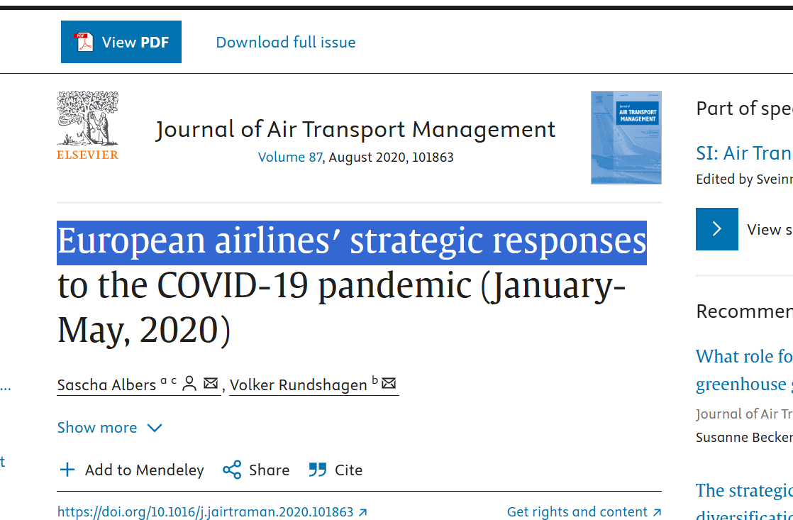
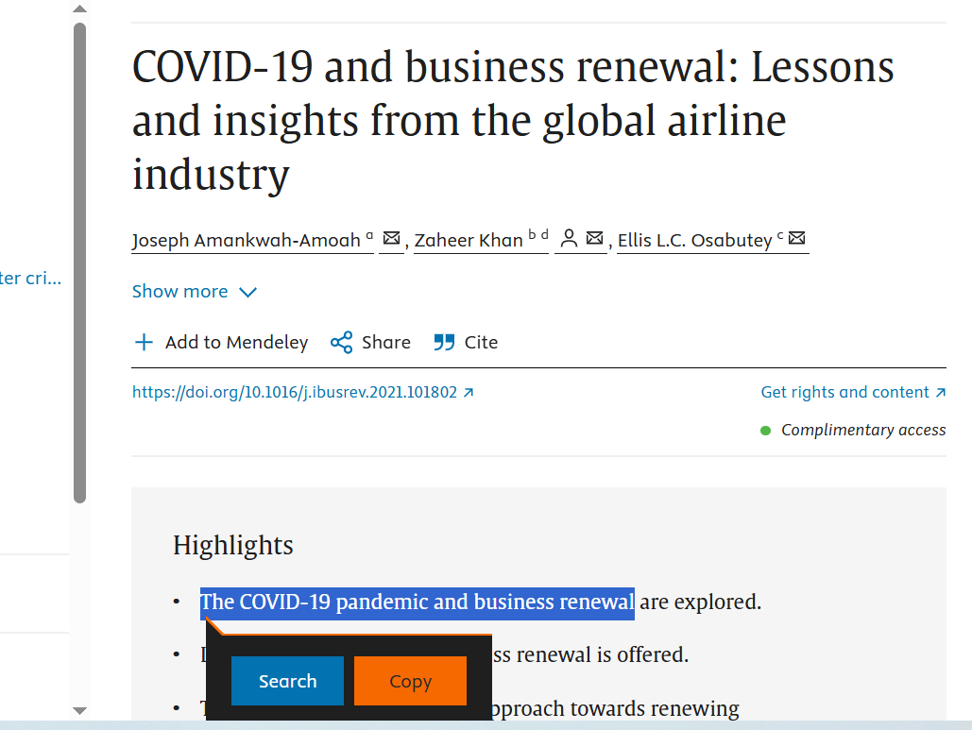
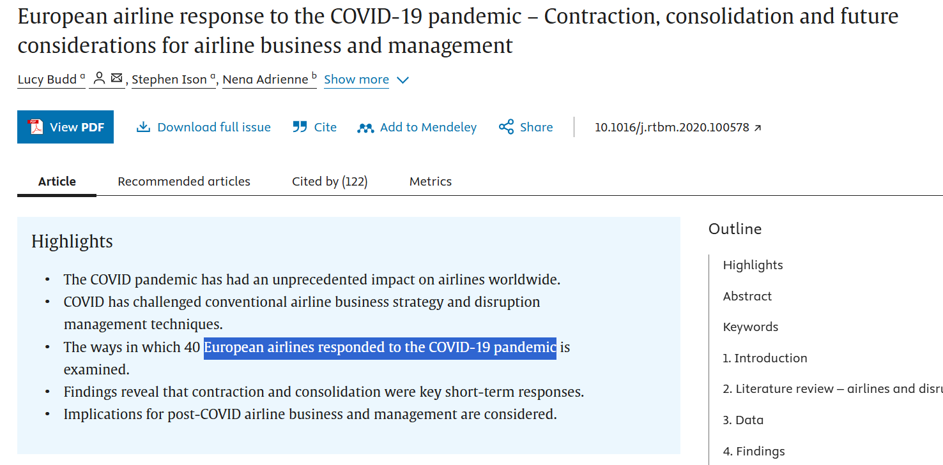
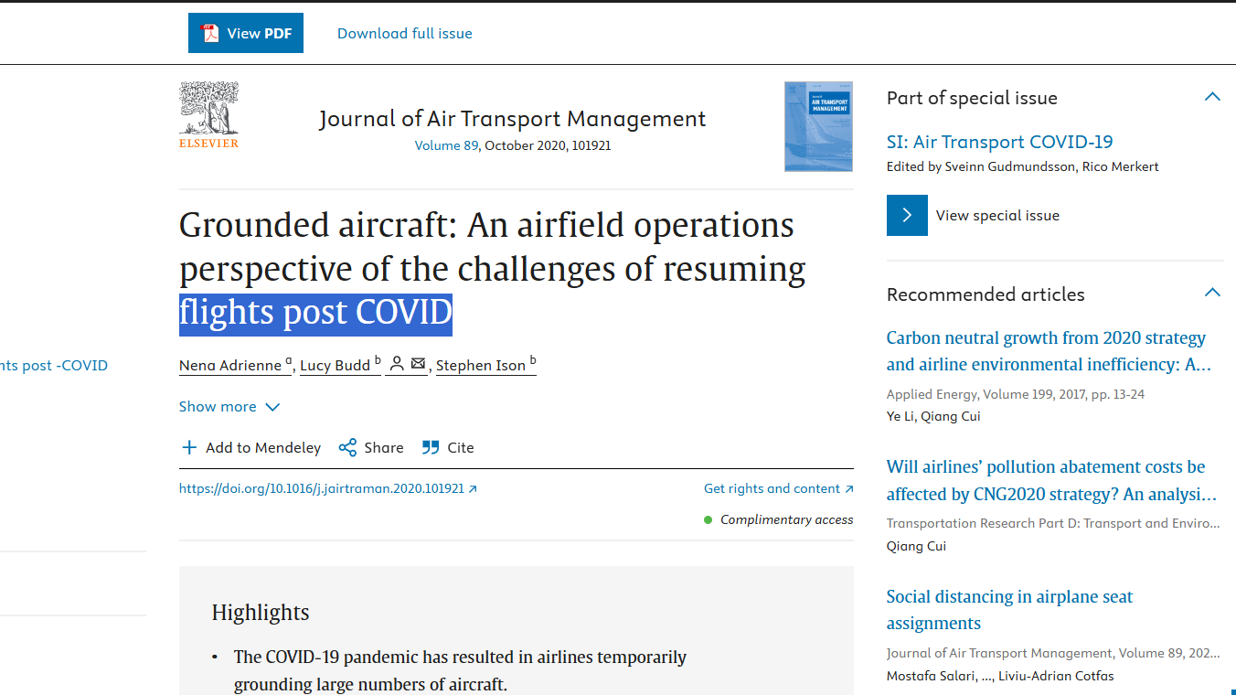

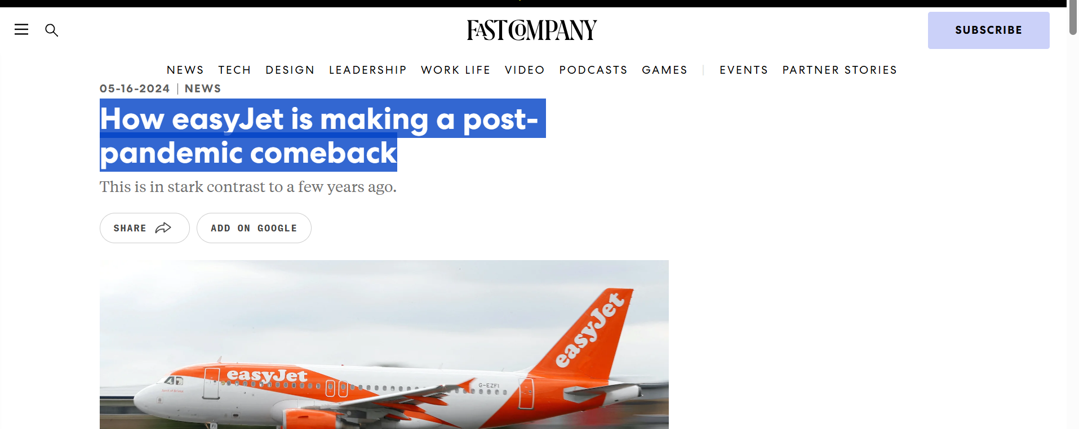

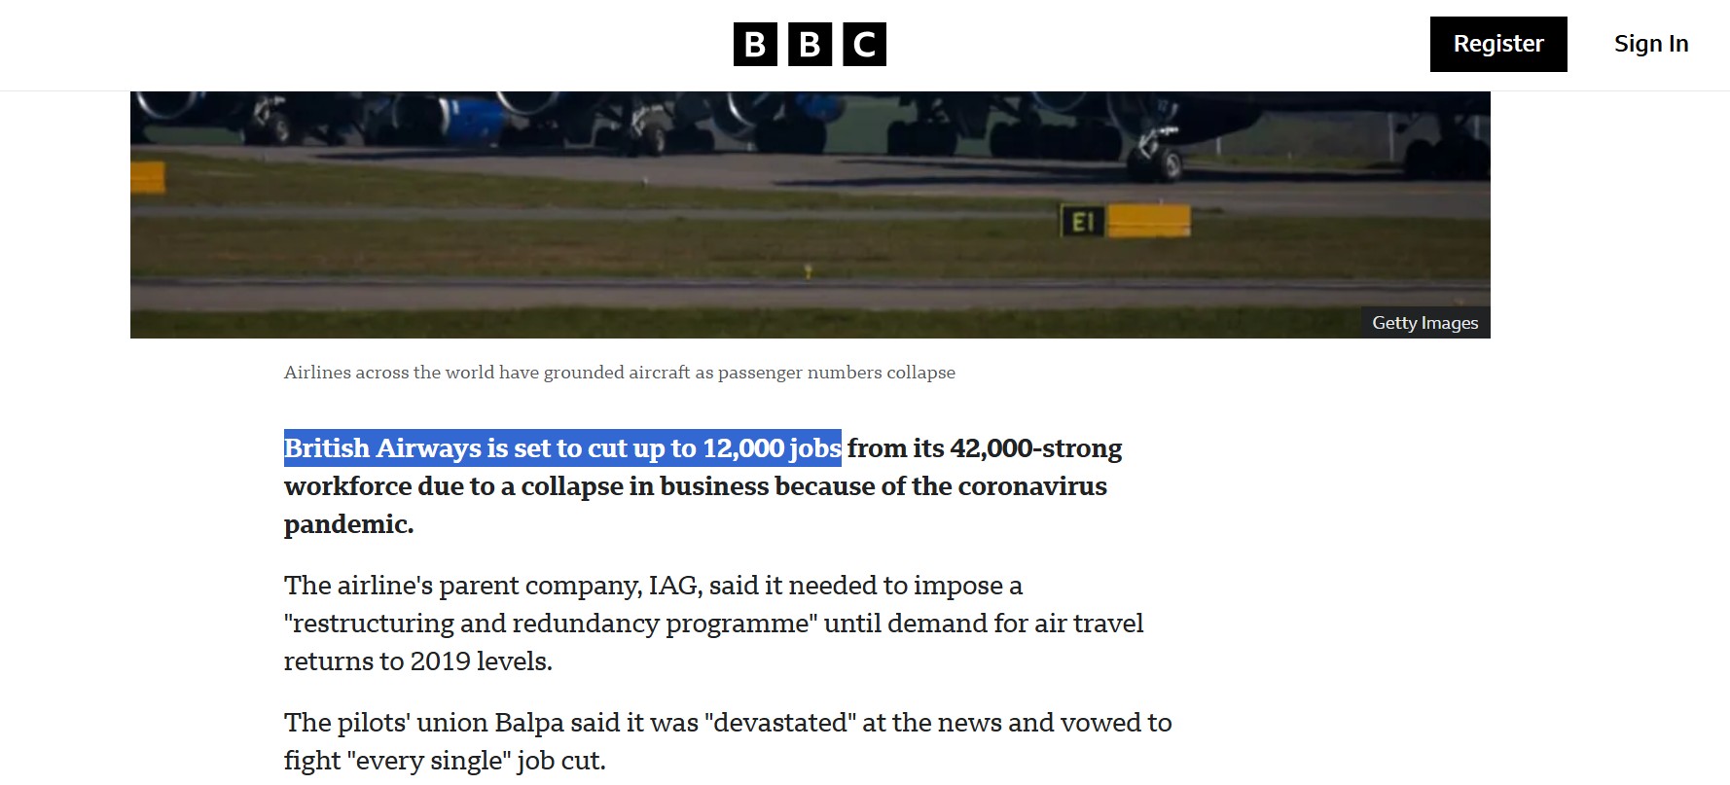
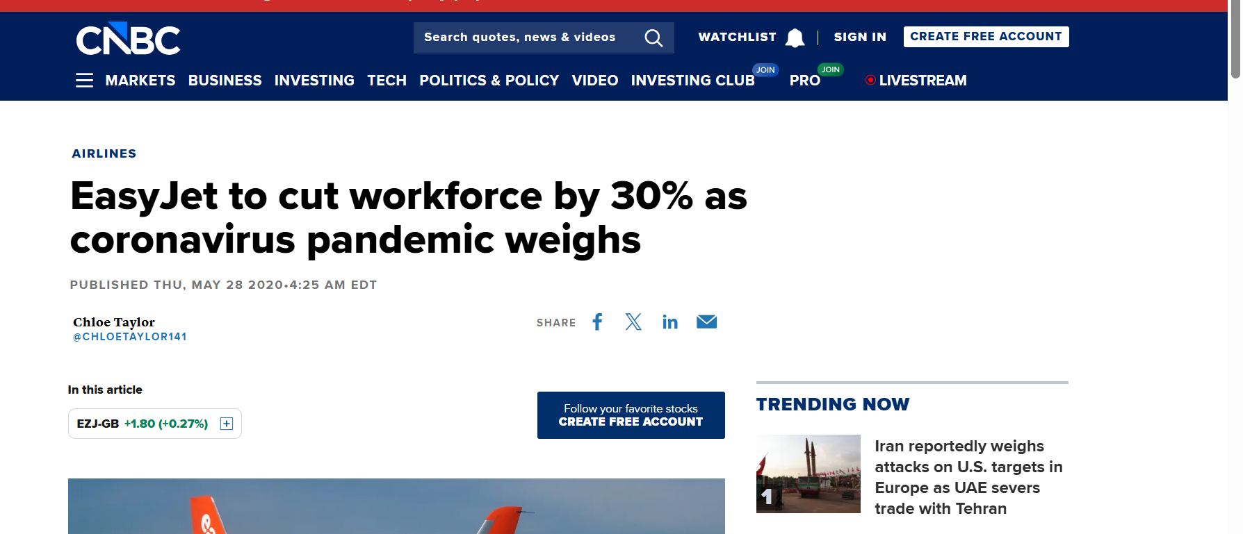
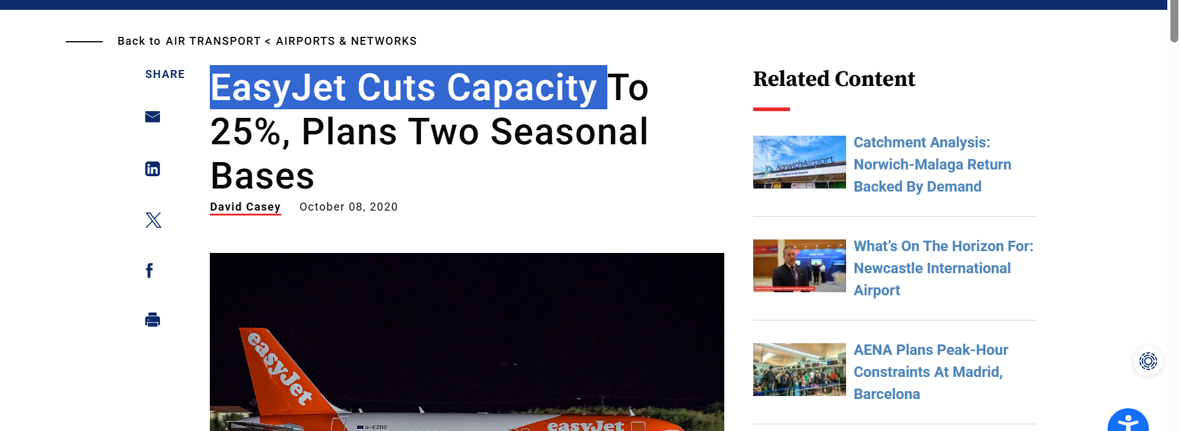

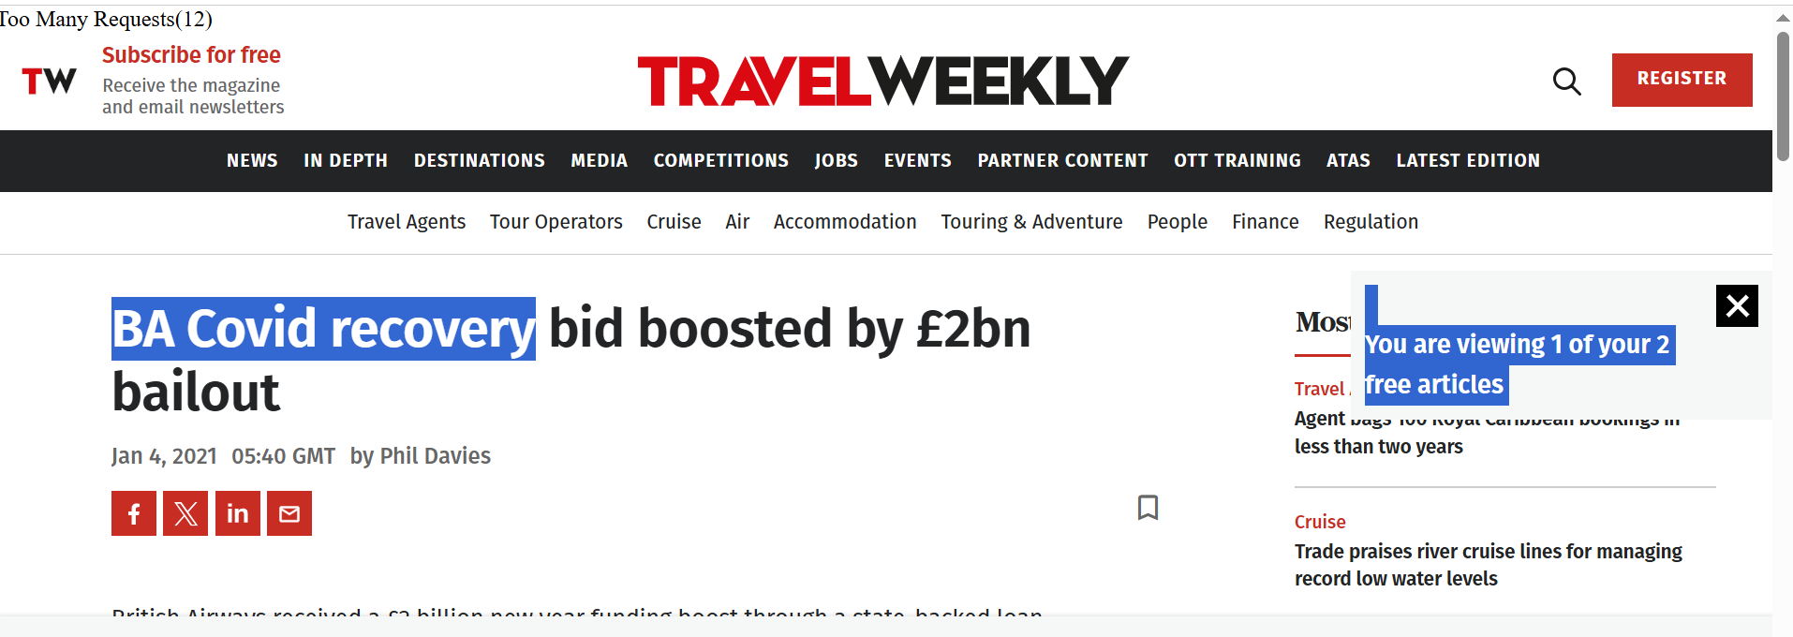
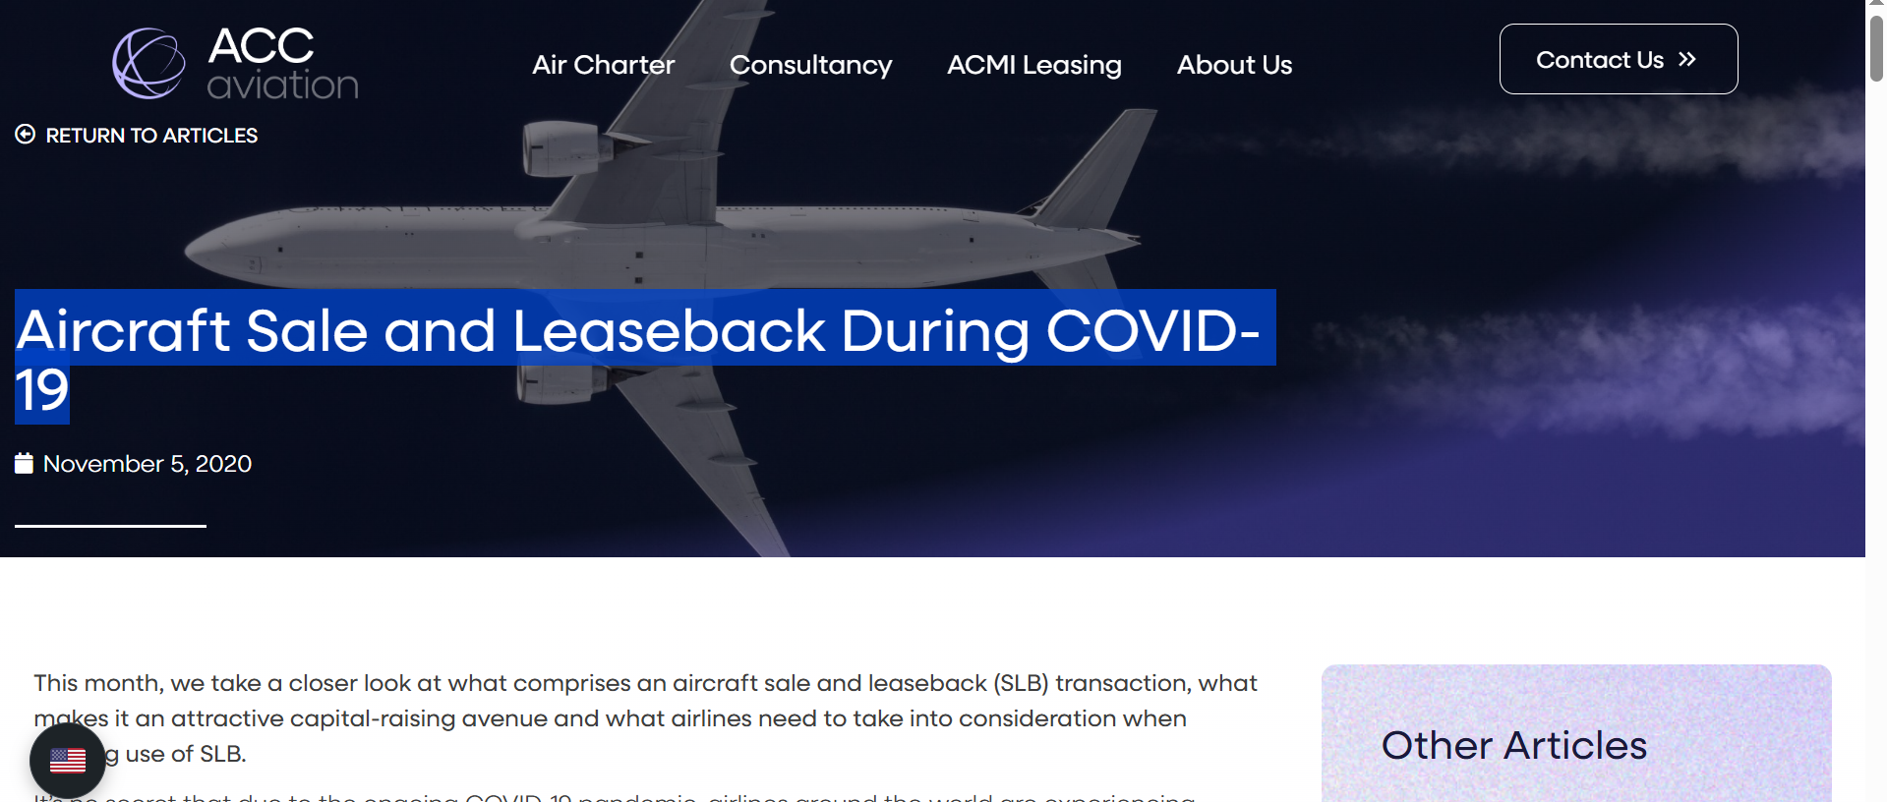

Appendix 4: Conceptual Framework Making Using MS PowerPoint
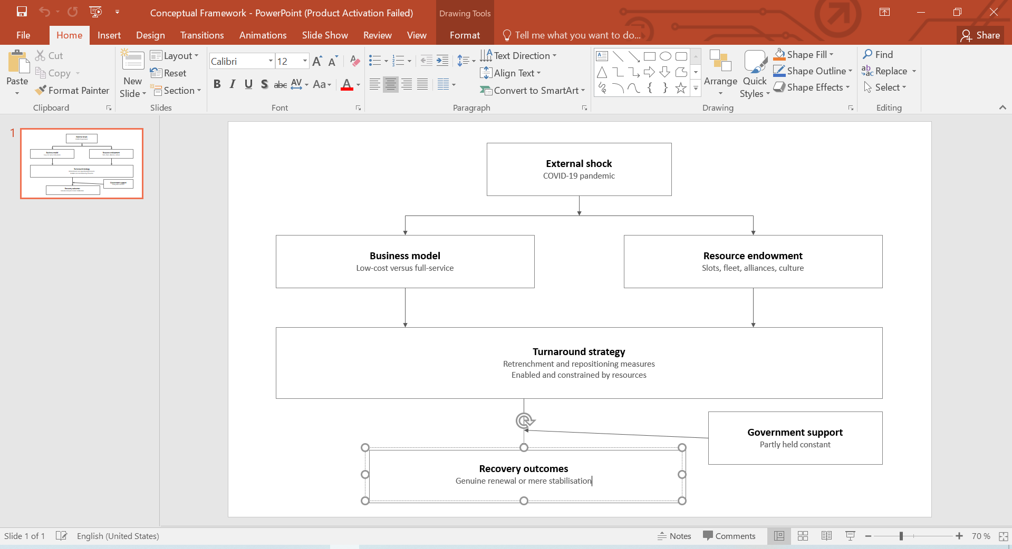

Appendix 5: Ethics Form


