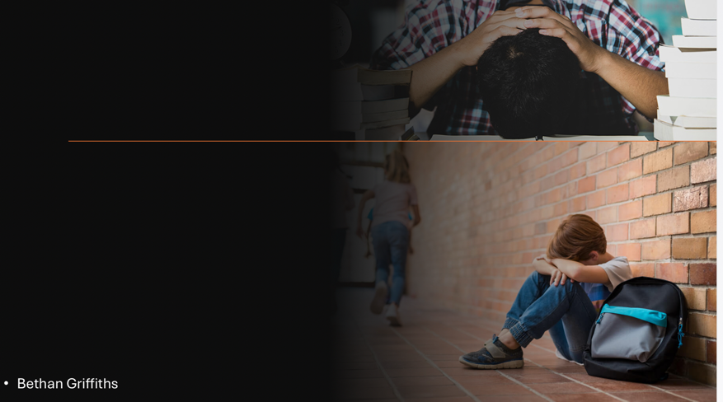
Slide 1 - Temporary accommodation can have a highly negative impact of children’s education. Children living in temporary accommodation, particularly those experiencing homelessness often have to move school's multiple times which will interfere with the child’s stability. By having negative educational disruptions caused by temporary accommodation, it could lead to reduced educational attainment and limited future opportunities.

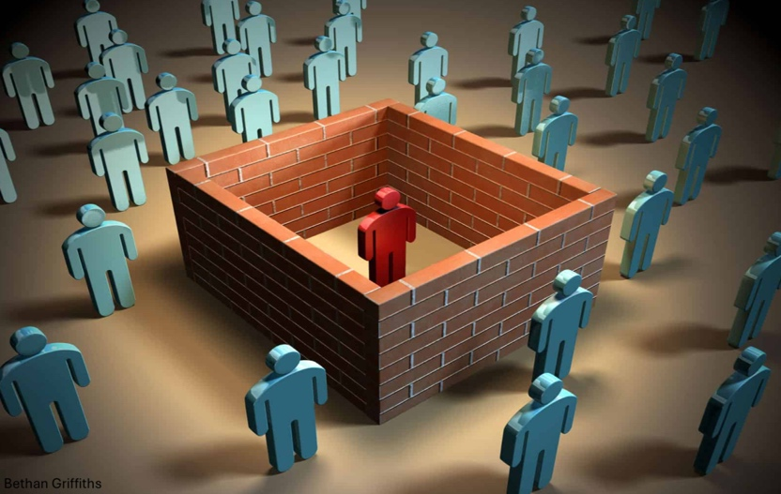

Slide 2 - Temporary accommodation can make children/young adults feel isolated. Lack of social interaction can also lead to feelings of insecurity. They can feel anxiety and embarrassment that they don’t have a stable home or family. Children in temporary accommodation may feel isolated from their peers and struggle to form social connections, which can negatively impact their emotional well-being and development.
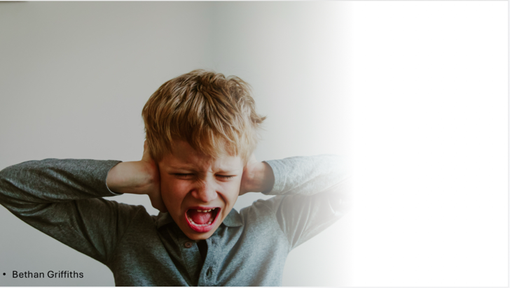

Slide 3 - Lack of stability, isolation, mental health and lack of nutrition can lead to negative behaviours in and out of the classroom. Negative behaviours can then follow to a negative impact on the child’s education, following to them potentially having an involvement with the criminal justice system.


Slide 4 - Nutrition is a big impact on everyday life. Many temporary accommodations, like hotels or B&Bs, lack kitchens or adequate cooking facilities, making it difficult for families to prepare nutritious meals.
Families in temporary accommodation may struggle to afford a healthy and balanced diet, leading to reliance on cheaper, less nutritious foods. The stress of homelessness and living in temporary accommodation can negatively impact eating habits and nutrient intake. In some cases, other needs like safeguarding issues can take precedence over nutrition, leading to it being overlooked
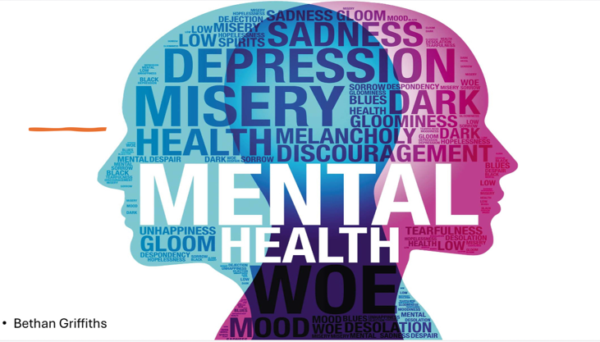

Slide 5 - Temporary accommodation placements may be located far from the children's original schools, resulting in long and difficult commutes that further disrupt their education and increase stress.
The instability and stress of living in temporary accommodation can contribute to mental health issues, such as anxiety and depression, which can further hinder a child's ability to learn and thrive.



