Managing enterprise in the 21st century- part one

BMSK4006

Laura cooper 2125162

4th July 2022 -17.00 pm

logo

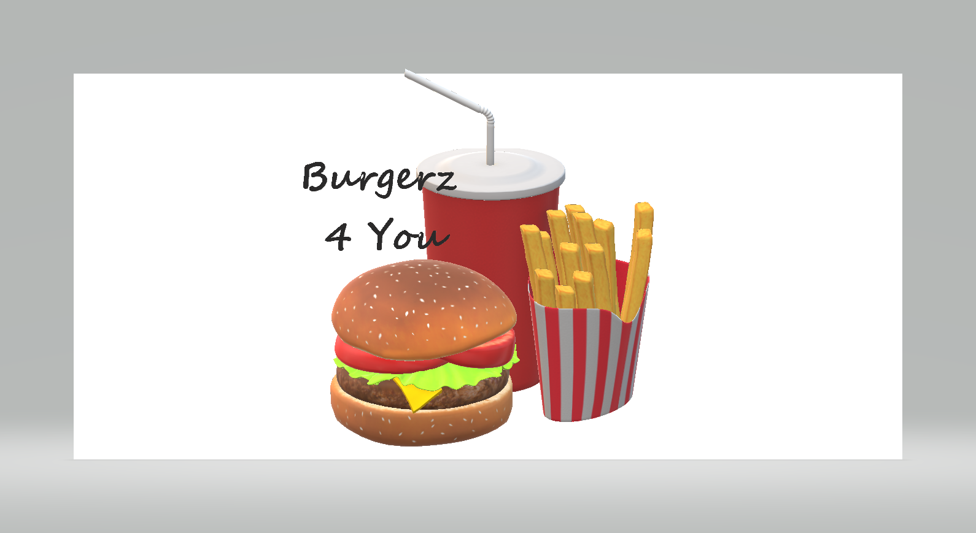
*Your food you’re way*

Business name
Burger’z 4 You
*Your food your way *

Owner details
Laura Cooper & James’s Bidder

Business location
Pitched along the beach Swansea, with a change in location situated over the sa1 for the winter months, with a licence to attend event days.

table of contents

Contents
Cover page 1
Front page 2
table of contents 3
executive summary 4
introduction 5
operations 6-11
marketing 11-12
revenue and pricing 12-15
RISK AND BENEFITS……………………………………………………………………….15-16
finance 16
references 17
appendices 18

Executive summary

My name Laura cooper, I am 27 years old with 2 young kids, I have had 11 years’ experience within the food industry, my business idea is a food truck which is situated alongside the beach by Bryn mill lane in Swansea during summer moths with a change of location to the sa1 during the winter months.
The food trainer will offer several different products with a number one theme behind it all, your food your way.
The concept is that you order a portion of child and build your own loaded fries how you would like, or you build you burger to your taste with several different addon’s available, or simply order the standard of options available on the menu already.
I believe that this type of unique food would be a great benefit to Swansea, with several different consumers the food trailer would please.

Introduction
My name is Laura Cooper, and I am proposing my business plan to you today, my business plan idea is to have a food truck where you build your own burger to your own style and taste Burger’z for you will be pitched alongside the beach, a perfect location for a bite to eat after having a nice walk along the coast.
By having a food truck this gives the business flexibility to maximise profits with the opportunity for the use of being hired for events, may this be weddings events or parties of concerts. Additionally, by using a food truck, Rental, maintenance and overhead costs will be at a minimum.
Legal status
The legal status of the company will be shared partnership between two people, myself and my co-dependent where we will split the workload by 50 percent with the loss of earnings and profit shared between one and another.
Details of business owners-
Laura cooper | James’s bidder
28/04/1995 | 26/02/1991
3 grey street swansea | 3 grey street Swansea
co-owner | CO-OWNER

I have known my co-dependent for the last 12 years, with both have an extensive background in hospitality and catering with all the relevant qualifications. Understanding how a hospitality business runs, front of house and back, it is now time to venture out and run our own business working together.
The team load would be shared between myself and my partner with the potential to grow the business within time with the potential for more food trailers in future.
Services
The services that we would provide would include freshly prepared food with the option of building your own meals to your own taste while being out and about, or delivery service straight to your door using an app like just eat or Deliveroo. That way everybody gets to taste our menu.

Operations
Location
Burger’z 4 you will be located along the beach during the summer months with a change of location during the winter months to the SA1 area due to a large footfall because to the presence of multiple large office buildings, high-capacity rental flats and multiple university sites, with the change of locations during seasons this helps keep up with the demand of customers being weather permitted.
With the potential of attending special events that will go ahead within the Swansea area during all seasons.
Services
The premises in which services and goods will be sold and prepared out of is a food truck, the storage preparation and selling of the services will come from the food truck.
The service provided will be a takeaway or delivery service of burgers and loaded fries made to your own taste, with a few different options available.
Equipment
Equipment needed will be included in the purchase of the food truck with an additional purchase’s required will be from a supplier Nesbit’s. the type of equipment needed for purchasing will include,
Storage containers | Metal bowls
Knives | Fire extinguishers
Colour coded chopping bored | First aid kits
Utensils | Sign boards
Takeaway containers | Menu bored
Chefs’ uniforms (aprons) | Bins
Cleaning equipment | Fly zapper
Blue roll

The bill for the start up cost for all equipment needed would come to £1,000 equipment will need replaying with wear and tear over the years.

Production and distribution
The production of all goods will come from the food truck, which will use quality ingredients and produce good quality stock, the stock will be stored correctly with the correct procedures in place, ready to be freshly made to order for the customer.
The distribution for stock that is needed for the food truck will be delivered from my suppliers, with all the correct procedures in place, the food will then be inspected to check for any flaws, and then stored away correctly.
The sale of food will then be prepared freshly ready for collection either by delivery service that will be stored in a heat protection bag with the correct packaging for delivery and delivered straight to their door, or the customer can order from the food truck where food will be served open for then to eat right away.
Staff
The staff would include myself and my co-partner, with the food truck being a small space proximity there would be no need for anymore staff to be included, but if the business was to bloom there would be a possibly to branch out further with a potential of hiring staff to join into the business.
We would hire to have an accountant to keep all the finances and books up to date with the responsibility to make payments to suppliers and licencing when needed.
Suppliers
There are several suppliers that are needed for my business, which included fresh and frozen food, fresh vegetables, oil collection when needed, and equipment needed for burger’z 4 you.

Castle Howell | Frozen and fresh food | 01269 846060
Olleco oil | Oil and removal services | 01236 433567
Rynolds catering | Fresh vegetables | 01324 473210
Nesbitt’s | Equipment | 02921971240

Castle Howell will be delivered 2 times a week to keep up with the freshness of ingredients.
Olleco oil services will be provided every three days for fresh use of oil with the safe removal of oil included at the same time.
Rynolds catering service will be provided every 3 days for the upmost use of fresh ingredients
Nesbitt’s services will be provided with one big order to start up the business and then when and where needed.
Income stream
The income stream that will be generated from burgers for you daily will all depend on how busy the area generally is, we hope to sell at least 90 -120 serviced goods a day on average, which will become a regular occurrence.
Average sales | Total takings
92 a day | £630.50
2750 a month | £20.412.50

The figures above show the forecast for the first month production, with 4 items of production off the menu, the numbers would have growth once all items are included altogether.
Systems and processing
There are several systems that will need to be in place to adjure with the law with running a food business.
All the procedures in place must be implemented to the best of ability daily
Fire safety | Have the correct training and understanding of correct procedures and use of fire extinguishers.
Health and safety training | Training in health and safety with food services.
Food safety management procedures | The procedure in which all systems and controlled and in place and implemented
Personal Hygiene | Keep up with the correct person hygiene EG; hair nets, hand washing
Food cooling and heating log | Records of the cooling systems in place with temperatures included with timings of how long to cool, or temperatures of heating products up.
Comply with food safety | Adorning to food safety practises
Training in food safety | Have a level 2 or 3 food safety.
Food labelling | Keep records of all food production dates and best before dates
Specification of all additives and allergies | Records of all allergies and additives to comply with another’s specific needs.
Traceability of all produce | Food has come from reputable source with the evidence provided in case any problems
HACCP food safety | Risk assessments of all stages of food production
Food grade packaging | All products are stored and packages correctly
Daily records of temperatures of fridges and freezers | To check the average temperature of fridges and freezer to check for problems
Records of all invoices for produce | For traceability back to suppliers
Probe temperature calibration | Check the probes are in correct working order
Records of cleaning check list | Ensure that correct cleaning duties are being completed
Vent cleaning | Risk of fire and bacteria
Monthly audits on practices | To check all procedures are being followed and if any more training is needed.
COSHH records | Having a list of all chemicals on use in premises
COSHH procedures | Using the correct dosage of chemicals in the correct area.
COSHH risk assessments | A document that show’s all risks including while using the chemicals and to do in an event ion wrong usage EG, if the chemical gets in the eyes
Pat test on all electric equipment | Regular testing on all electric equipment.
Environmental and equipment risk assessments | Document’s which shows the risks involved in working in a specific environment or equipment
Pest control | The regular service and inspection of pest control methods from an outside source.

Health and safety legal compliance
In order to be successful in my business I will adjourn to the health and safety laws that is required of me, including following health and safety practises, record keeping of HASSP food safety, keeping records of COSHH documents, have fire safety training with having the correct fire equipment. Have EHO standards with the correct upkeep of standards in the premises, if I fail to comply with the legal requirements, I understand that I may be prosecuted.
Licences required
There are several different licences required for my business, I will need to inform the council that I am starting my own business up and have the food business registered, with a street trading licence. A licence for my business to be able to have some chairs and tables included for the use of customers, with a business licence included to.
I’ve estimated a cost of upfront cost of £300 pound then a rolling £115 street licence trading licence

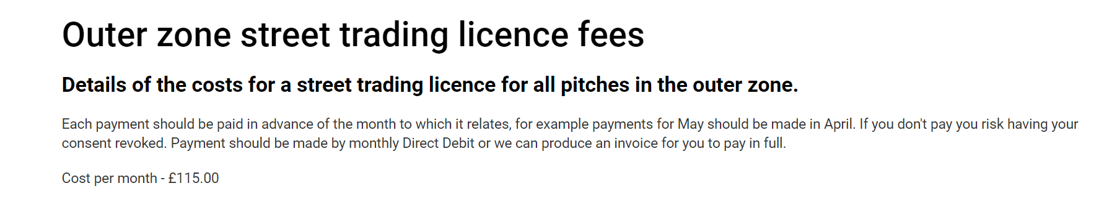

Insurance
There are different types of insurance I would need for my business, one would be a vehicle insurance to be able to move the truck about, business insurance and public liability insurance to cover any potential risks
The monthly cost for the insurance provided above comes to £515.00 pound per month.
Marketing
A way in how I will choose to market will use a few different platforms in order to reach a different clientele, there are a lot of competitors in the food business which offer similar food, but I think my business plan is different from others as my food is delivered to your own liking, by this I mean you can choose how to have your own burgers or fries , may that be simple or extravagant.
The strategies in how I will market my product is to use a cost leader strategy in where I keep my cost down lower than other competitors in a way to get more clientele.
With also using a differential business strategy in which I offer a unique type of service which isn’t available in Swansea where is where my business will be situated.
So how I will choose to market to my clientele I would use social media platforms to promote by business to the younger generation.
I would also go to the local universities to offer vouchers to attract the youngster to come to the food truck which is situated locally in hopes that this will build a regular occurrence.
For the older clientele I would market the business by placing ads on the radio and handing some flyers out with offering an old age pensioner discount on certain days.

Marketing promotion

In order to have a stability of customers I would have a selection of promotions available with different offers through the week in order to

Monday | OAP 25%
Tuesday | Student discount 25%
Wednesday | Burger and drink £7.50
Thursday | Loaded fries and drink £7.50
Friday | Burger with 3 toppings £6.50
Saturday | Loaded nachos £5.00
Sunday | Loaded fries and loaded burger £10.00

Revenue and pricing
Pricing -
A strategy I choose to set my prices would be a neutral setting, where I would set my prices for a competitive price, which will use range of similar priced product, I find this will be the best pricing strategy within the food business.
I would also keep in mind of a market based priced where I would control all prices on where I will estimate my pricing based of what a consumer would likely pay. With this I can keep in factor of all environmental and economic factor, seasonal demand.

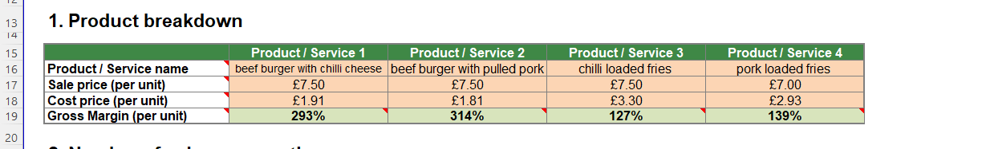
The photograph above shows my item menu cost price per item, the gross margin of the item and the sale price for per item.

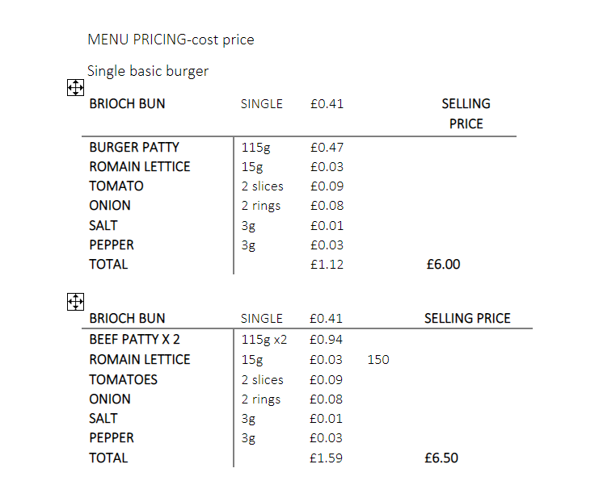

The photograph above shows how I have costed up the menu items, so in retrospect I had a list of all ingredients that I will receive from the suppliers, which then I worked how the portion sizes for each individual ingredient and then worked out how much that one portion cost to buy.
I then added all the ingredient pricing together to come to the cost price of per dish that would be included, I then added on a percentage of 60 percent to make sure that would break even, but then used a neutral in a way I can set my prices to be able to complete with competitors that will be offering the same service but also affordable for a range of different clientele.
The good thing about having the cost prices correct with my type of business, is the burgers are set to a certain price, the clients will then pay for extras to be added on to fit the consumers own taste and price range.
see below for reference-
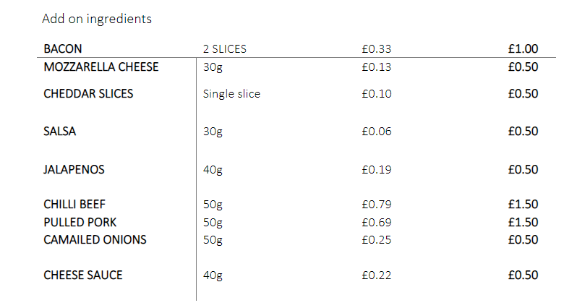

Revenue-
I am asking for a start up loan of £100,000 pound to help get burgers for you off to a kick start, with the costs that will be upfront e.g.:
- Food truck cost £54,000
- All licencing requirements £300.00
- All stock needed to kick start business £1500.00
- Insurance £ 300.00
- Equipment cost for a start-up £1500.00
- Utilities £ 250.00
- Accounting £250.00
- Mobile phones £65.00
- Marketing £100.00
- Vehicle running cost £500.00
- Training fees £350.00
- Electric pat testing
At an estimate all the start-up cost will be- £62,075
With such a high start up cost, I’m asking for £100,000 to help kick start my business up, I’ve gone through all the costings and have worked out what my running costs will be per month, with a steady income of profits my business will stay steady over the year, with a change of having a more demand with more sales throughout the day to build up on the average sales per day.

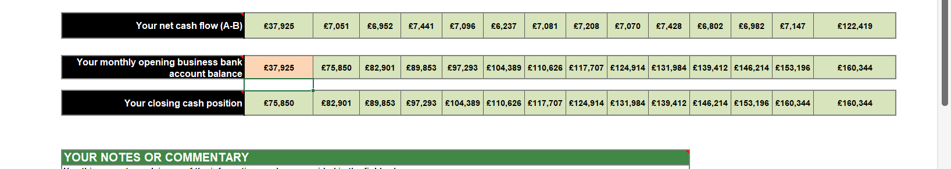
The screen shot above shows that with a hefty cost of £62,075 to start up the business, my opening bank balance is £37,925, after all start-up costs are paid for, the chart also shows what my net cash flow is and how much expenses are due to come out over a 12-month period. The 4 menu items that I have provided costing for with an average amounts of sales per day will earn my business a steady profit of £6,500-£7500 a month, all other menu items are NOT included within these figures.
Risks and benefits
All business will accrue a sense of risk taking when opening a new business with so many competitors about, but there a several factor to consider when thinking about risks.
- Environmental risk factors
Which will apply for burgers 4 you as a location factor as in a sense of weather permitted or traffic setting or even a level of foot fall or the gradient of the surface being permitted to work on.
- All finances are entirely the owner’s responsibility
All finances are down to the owners, we need to offer a unique and desired product in order to achieve sales, keep all costs down to an affordable rate, all bookkeeping must be kept up to date.
- Competitors
To set myself apart from my competitors and make my business idea different from another would be that I have a little advantage being in a location with an offering of a twist, people on lunch breaks from location locations will be offered a faster rate of service from other competitors, with my running costs down to a minimum this has given me a little advantage of being able to keep cost prices competitive.
Marketing
Marketing your business can have the utmost benefit if done correctly, you need to understand what type of consumer you are after and a way in how to reach the consumer, so my customers would be people going for walks along the beach, and students and employees on their lunch breaks, locations come into factor with all consumers for myself. With the correct marketing of offering promotions and discounts on certain groups I can reach my full potential with the correct marketing strategy
Failure
Every business has a risk of failing, there are several factors in how I could potentially fail, may this be by financial issues, by not offering the correct product which is not a popular demand, or the wrong usage of marketing.

Benefits
I myself have two young children who depend on me, with me being able to run my own business I can fit my hours alongside my children, I can be my own boss with a flexible timeline, where I can take control of the finances, with a steady income burger 4 you have potential in expanding my business.

Financing
Financial information will be provided separate on a excel spreadsheet with all relevant information.

. \Downloads\Gavin\Cash-Flow-Forecast-Start-Up-Loans (version 1).xlsx

Refences

Register a food business | Food Standards Agency
Annette, B. H. (2013). Writing a Successful Business Plan: An Overview. AAOHN Journal, 61(1), 19. 10.3928/21650799-20121221-53
Blackwell, E. (2017). How to prepare a business plan: your guide to creating an excellent strategy, forecasting your finances and producing a persuasive plan (6th ed.). Kogan Page.
Blythe, J. (2006). Marketing. SAGE.
Davies, T., Davies, T., & Crawford, I. (. P. (2011). Business accounting and finance (1st ed.). Pearson.
Fill, C. (2011). Essentials of marketing communications [electronic resource] (1st ed.). Financial Times Prentice Hall.
Journal of current issues in finance, business, and economics. (2007). Journal of Current Issues in Finance, Business, and Economics.,
Marketing (2018). Intech Open.
Maund, A., Shriek, M., & Tinkler, P. K. (2017). Certificate in higher education: skills for the workplace student yearbook. Sage.
Finance in Business I: Finance for Starting a Business. Mustafa, M. H. (Director). (2005). [Video/DVD] England: TV Choice.
Young, P. Business Plan. Global Media Publications.

Appendices

menu pricing costing final.docx (sharepoint.com)

ingredient pricing .docx (sharepoint.com)

gam 1\menu finalised .docx

..\Downloads\Gavin\LCCV2.docx



