DS 1 Template

My Screenshots/Photos

Screenshot/Photo 1
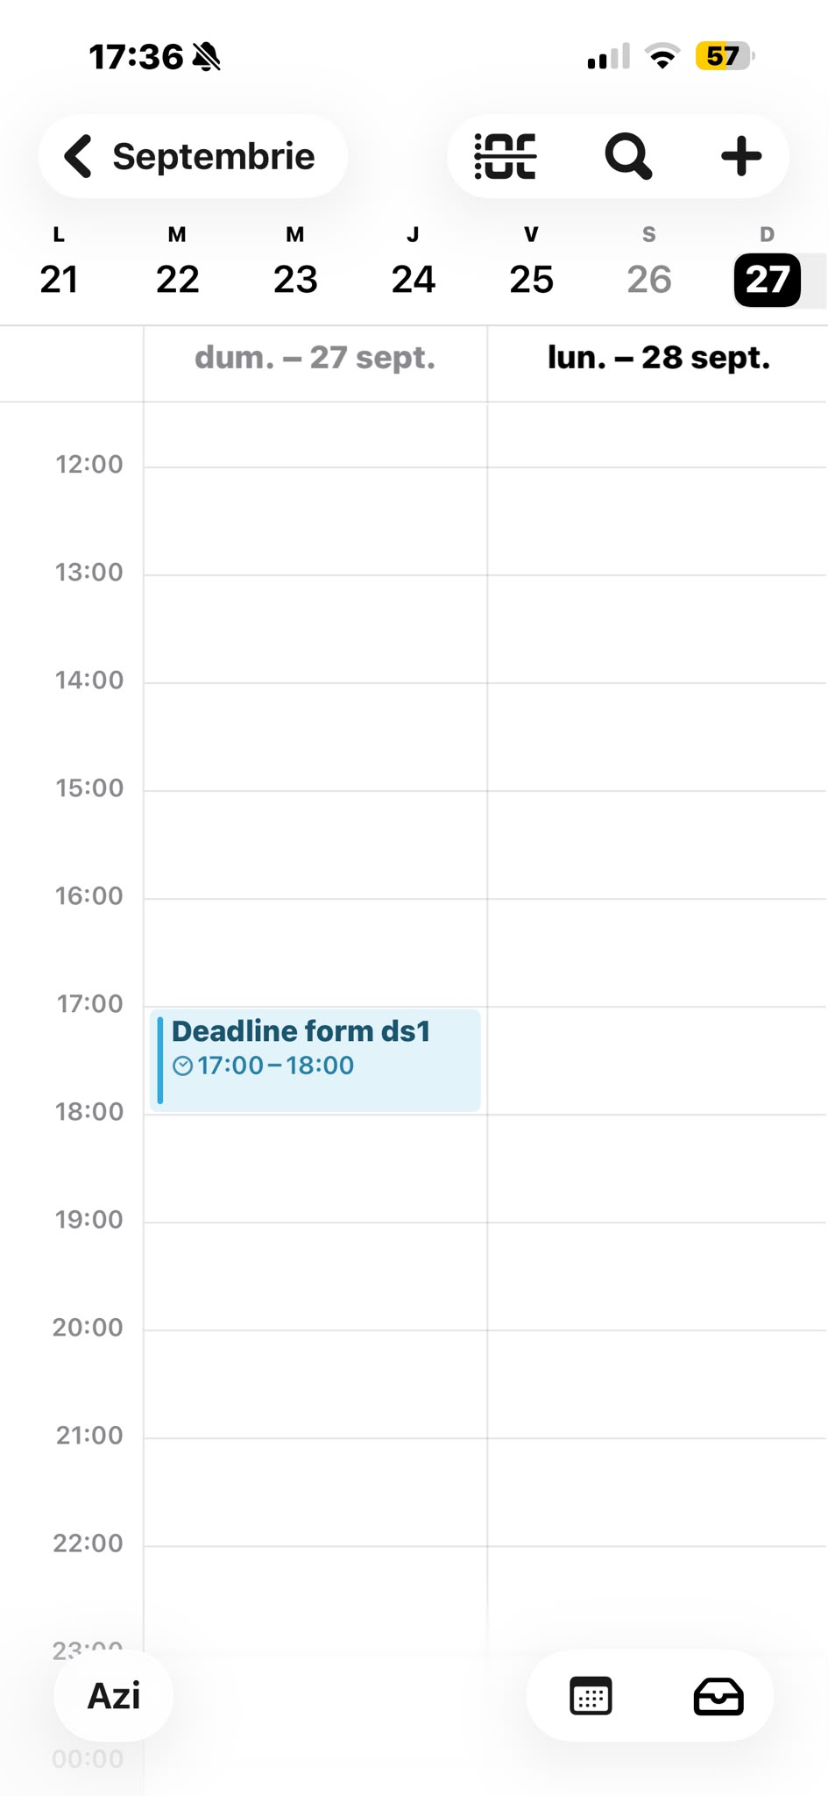
I use the calendar to remember important dates, appointments, exams and things I need to do.

Screenshot/Photo 2
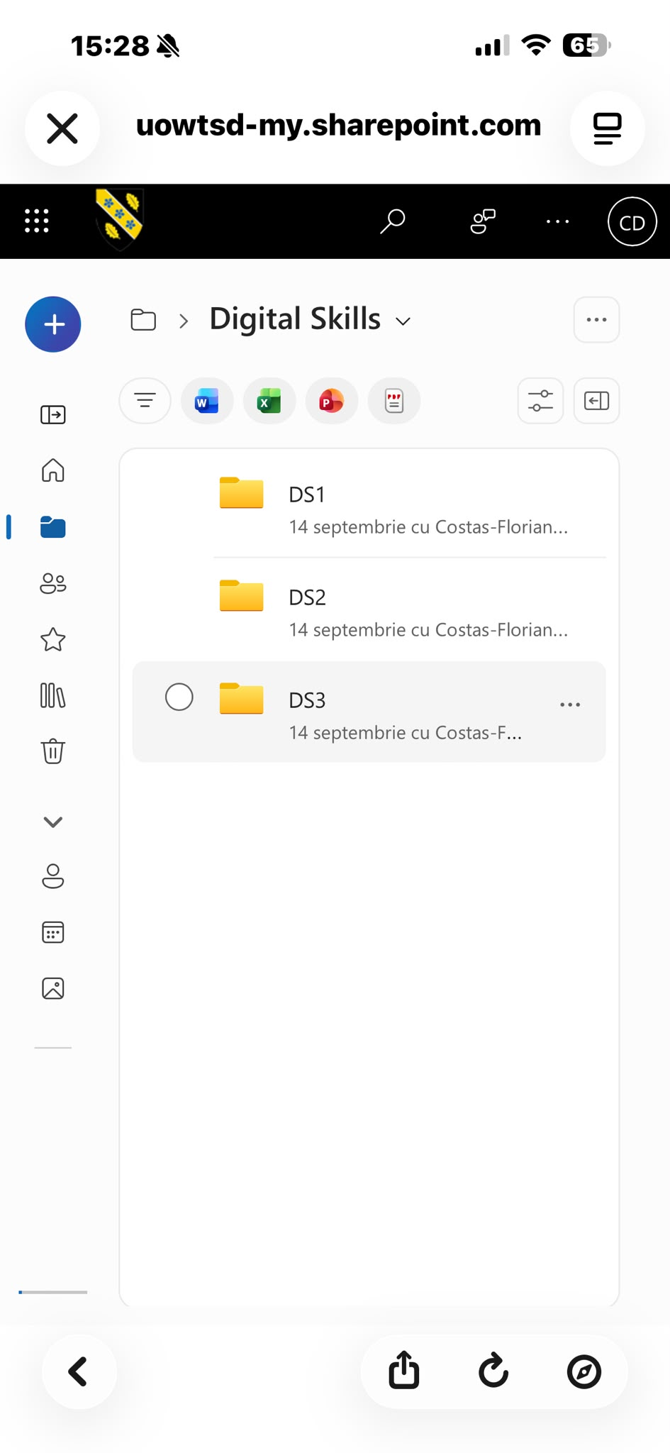
I use One Drive to store my important files and documents and access them from different devices.

Screenshot/Photo 3

I use Youtube to watch videos, learn new things, listen music, fallow my favourites creators, and find information and entertainment

Screenshot/Photo 4

I use nationwide to manage my money ,make payments, transfer money, check my balance, and save money.

Screenshot/Photo 5

I use Instagram to share photos and video, stay in touch with friends and family, fallow people , and discover new content and ideas.

Screenshot/Photo 6
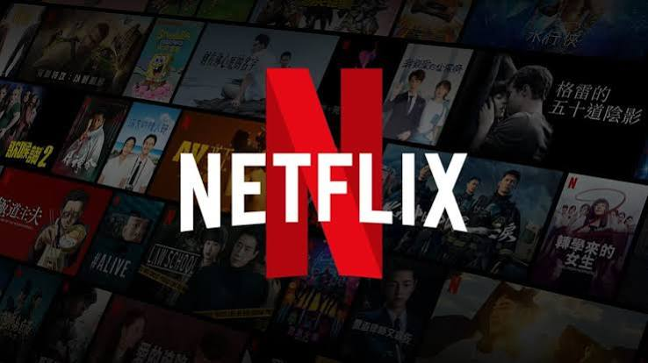
I use Netflix to watch movies, tv shows, documentaries, and other entertainment.

My Short Reflection
Digital technology is an important part of my everyday life. I use it for studying, communication, entertainment, managing my money and keeping important information organised. It helps me save time, stay connected with other people and access information whenever I need it. I think my digital life makes many everyday tasks easier and more convenient.

