

‘An Analysis into Domestic Violence Through the Ages’

Due Date: 10th October 2022
An analysis by: Daniel Richards

Contents
Introductions

Chapter 1 – Rationale
1.1 - Introduction
1.1.2 - Research Rationale
1.2 - Aims and Objectives
1.2.1 - Objective
1.3 - Research Structure
1.4 - Reliability
1.5 - Resource and Time Management

Chapter 2 – Literature Review
2.1 - Introduction
2.2 - Psychology of DV
2.3 - Domestic Abuse – A brief history
2.4 - The impact of domestic abuse
2.5 - Conclusion
Chapter 3 – Research Methodology
3.0 - Introduction
3.1 – Research methods
3.2 – Data Collection
3.2.1– Primary data research
3.2.2 – Secondary data research
3.3 - Research Onion
3.3.1 - Deductive and inductive
3.3.2 - Research Approach
3.3.3 - Research strategy
3.3.4 – Time horizon
3.3.5 - Data Analysis
3.4 – Limitations
3.5 – Conclusion

Chapter 4 – Research analysis
4.1 - Data analysis
4.2 - Public confidence – A YouGov study
4.3 - Barriers that can influence results
4.4 - Police powers – Are they being commonly used?
4.5 - Conclusion

Chapter 5 – Conclusions and Recommendations
5.1 - Chapter Two Findings
5.2 - Chapter Four Findings
5.3 - Conclusion
5.4 – Recommendations
5.5 - Future Research

Bibliography

Introduction
The aim of this dissertation was to identify if public perceptions of the police has changed through the progression of domestic violence. It is a belief that although changes have been made for the very benefit of the victims of domestic violence, the added laws and powers have created an imbalance of consistency between neighbouring forces.
Since becoming a police officer in January 2020, I have developed my understanding on laws and powers and policies that an officer holds. During the three years I have also developed my knowledge through university participation at University of Wales Trinity St David.
The reason for the forthcoming investigation is based on some personal experiences during my time as a police officer. Domestic violence has in recent times become a more recognised and talked about topic both in politics and public life and as a result police involvement has become more common and expected.
I would make an educated assumption that a police officer on an everyday tour of duty will be attending domestic incidents on every shift. Some can incur injuries, and some can be domestic non crime incidents. During attendance to any call, officers shall always look to provide the best support to the victim that they can.
The research will begin by looking at the progression of laws and policies of domestic violence and lead on to research data of the public to establish if there is a trend to suggest that confidence has changed in any way.
Analysis will be completed following research to attempt to make recommendations for improvements to be made to ensure that the victims are able to feel supported throughout their journey with police involvement and post-police involvement. At present there is evidence to support suggestions trust has been lost in police actions. It is the aim of the research to identify the truth and accuracy of this and to establish the reasons behind this from relevant sources.

Acknowledgements
As well as the many thanks I can give to my peers, tutors and colleagues that have helped me so far on my journey, I would like to place my utmost thanks to my family. My mother, my father, my sister and my Nan for their unconditional support and motivation to succeed not only during my time of learning through this university course but for the motivation they have given me to become a successful police officer.

Chapter 1 - Rationale
1.1 - Introduction
Within this chapter a rationale will be presented for the reasons for this project. A brief background will be given on the topic and present how the objective will be accomplished.
Over recent years, domestic abuse through various media channels has become a more commonly discussed topic, which in turn has created an upward trend of domestic abuse cases being reported.
Throughout the research, data will primarily focus on UK-based domestic violence. It is evident that on a global scale domestic abuse is a common problem for many countries with a report by the World Health Organisation reporting that 37% of women in less developed countries between the ages of 15-49 years old will have experienced some sort of intimate partner-related violence in their lifetime. (Devastatingly pervasive: 1 in 3 women globally experience violence 2022)
Of these countries less than 10% of victims seek support from the police; the majority turn to family and friends instead for support.
Research will be based and conducted within the England and Wales with statistics from the police forces to ensure accuracy of statistics and data compiled, along with qualitative research conducted within these forces to attempt to answer the research question.
Within England and Wales there is a visible trend whereby the reported number of domestic related crimes have almost doubled within a four-year period. Between 2015 – 2019, the below table shows that the reported crimes have risen from 421,185 to 746,219.
Table 9: Number of domestic abuse-related crimes recorded by the police and percentage of offences that were domestic abuse-related, by police force area, English regions and Wales, year ending March 2016 to year ending March 2019^{1,2}
England and Wales |  |  |  |  |  |  |  |  |  | Police recorded crime
Area code | Police force area | Total number of domestic abuse-related crimes | Percentage of all crimes that were domestic abuse-related |  | Total number of domestic abuse-related crimes | Percentage of all crimes that were domestic abuse-related | Total number of domestic abuse-related crimes | Percentage of all crimes that were domestic abuse-related | Total number of domestic abuse-related crimes | Percentage of all crimes that were domestic abuse-related
Area code | Police force area | Apr '15 to Mar '16 |  |  | Apr '16 to Mar '17 |  | Apr '17 to Mar '18 |  | Apr '18 to Mar '19
K04000001 | ENGLAND AND WALES | 421,185 | 11 |  | 488,049 | 11 | 599,549 | 12 | 746,219 | 14

(Figure 1)
(Domestic abuse prevalence and trends, England and Wales - Office for National Statistics, 2022)
In the year ending March 2021, the trend has continued to rise whereby the number of incidents reported sat at 1,459,663. However only 58% of these were recorded as crimes. (Domestic abuse prevalence and trends, England and Wales - Office for National Statistics, 2022)
Whilst the numbers recorded by police can be recognised as a positive and used as an evidential measure that victims are beginning to trust the police processes. The charging rate from the crime prosecution service (CPS) charging rate however, has decreased for the third successive year of domestic-abuse related crimes to 70% from 76% for the year ending March 2021 can be an argument for police inconsistencies or police officer incompetence remains to be seen. (Domestic abuse and the criminal justice system, England and Wales - Office for National Statistics, 2022)
From experiencing first-hand in a role as a police officer the difference in decision making of identical crimes, research will be conducted as to whether there are recommendations should be made on a base point to ensure there is a more accurate or reliable threshold across the board.
1.1.2 - Research Rationale
With the UK Government adapting laws and creating further laws to assist with the support and protection of domestic violence victims, it is concerning that there remains a differentiation between incidents reported to the police and incidents disclosed through third party research studies, such as questionnaires or polls. The table below shows a survey conducted whereby the pattern of domestic abuse has remained consistent over a ten-year period, whilst official figures show a trend in the number of domestic related crimes reported.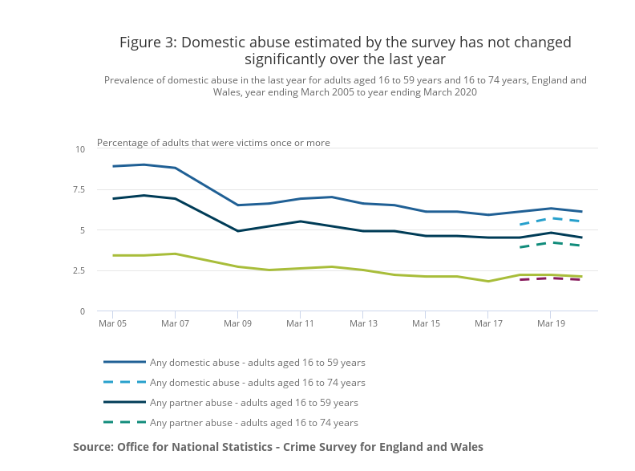
(Figure 2)
(Domestic abuse prevalence and trends, England and Wales - Office for National Statistics, 2022)
  - - Aims and Objectives
The aim of the dissertation is to analyse the progression of domestic violence over time and to make recommendations that could assist with increasing public confidence in the police force specifically when dealing with domestic violence incidents.
    - Objective
Chapter 2 will look to meet objective one:
“The progression and development of Domestic Violence laws through the ages”
Chapter 3 will look to meet objective two:
“To identify the most proportionate research route to achieve objective three”
Chapter 4 will look to meet objective three:
“Investigate if public trust in the police force is rising or falling as a result of introductions of further laws”
Chapter 5 will look to meet objective four:
If there are any recommendations identified, I will look to analyse these to better protect and serve victims of domestic abuse
  - - Research Structure
The dissertation will be structured into five chapters.
    - – Chapter one has identified the rationale of the chosen research field along with a background of the field
    - – Chapter two will provide a literature review of the progression of domestic violence and the psychology behind domestic violence, during this chapter objective one will be met.
    - – Chapter three will look at the research methodology which will be used to assist with meeting objective three.
    - – Chapter four will look at the research conducted and analyse results in which it will either prove or disprove that public confidence of the police is either rising or falling. During this chapter objective three will be met.
    - – Chapter five will look at concluding the dissertation, whilst also providing any identified recommendations that can be used in the future.
1.4 - Reliability
Throughout the research, both qualitative methods and quantitative methods will be used. This will be used to ensure that biased personal opinions are kept to a minimum.
Through either channel of both quantitative and qualitative research there may be opinions that lead towards one side of the argument. Therefore, it is with a great aim to gather research from both methods to help to provide a reliability to the gathered data. By achieving this it is maximising the results that will be gained and give a better understanding of the recommendations made at the conclusion of the research.
Through Quantitative research the ability is there to gather information that can help to prove or disprove the proposal question. This will be the aim whilst gathering information and research will be completed through many platforms to ensure accuracy and reliability.
Through the completion of qualitative research, due to the ethical considerations of the emotive topic it will not be possible to provide questionnaires to victims of domestic violence and research through this channel will be conducted through already published polls and surveys. By following this route, I will be remaining within the ethics previously submitted but also obtaining the views of victims close to the topic whilst keeping identities unknown.
1.5 - Resource and Time Management
Due to full-time work commitments, time management has been considered in the approach to meet an achievable timeframe for research and completion. Due to the employment within the police force, some research can be achieved on-the-job through evaluation of knowledge on processes. Other positives can be utilising officers’ thoughts through anonymous research data.
The university has constant availability to use the online learning to assist with writing materials and functions. Using an online calculator of everyday time restraints, the below highlights the disposable time available each week to complete research.
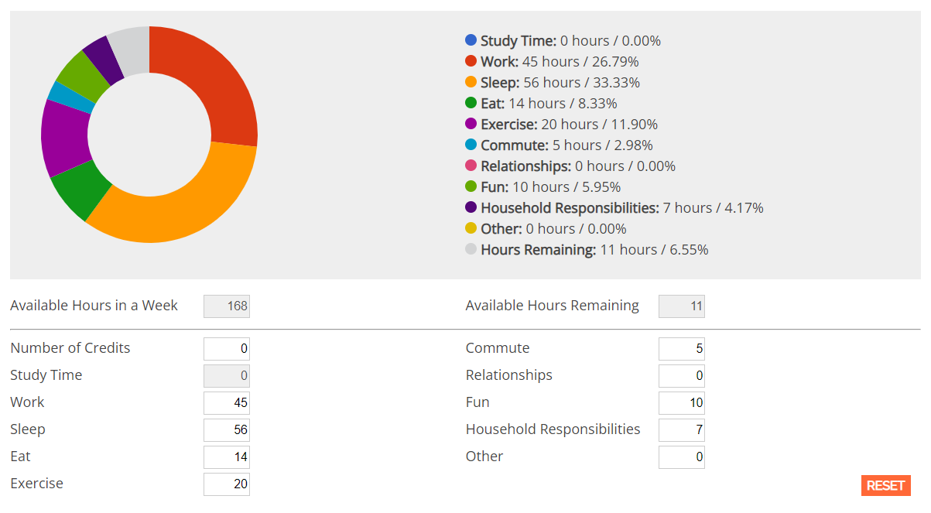
(Figure 3)
With support from employers, dedicated days have been built into a work rota to allow for comprehensive research and study time. This will allow for adequate analysis of any research completed in relevance to the study.

Chapter two – Literature Review
2.1 - Introduction
This chapter will be looking meet objective one
“The progression and development of Domestic Violence laws through the ages”
From the progression of women’s rights, a factor for introducing and adapting acts for domestic violence the objective will be achieved by research conducted through published literature and reports. This review will not include independent accounts by those that have not been published.
The review will also include published statistical data that will evidence the recording of domestic violence cases in the United Kingdom over time. This will help to prove or disprove the hypothesis that domestic violence reporting figures are rising throughout police forces, however police performances whether that be misconduct or process is restricting the supporting offered to victims.
2.2 - Psychology of DV
Although many definitions have been generated by different sources, there is not a ‘one fits all’ across the board. Simply the knowledge that domestic violence consists of being physical, sexual, psychological or emotional abuse, and can include violence or threatening behaviour.
Historic assumptions that domestic abuse existed simply between partners has been proved inaccurate, in addition to the misguided belief that only women are victims of domestic abuse.
‘We define domestic abuse as an incident or pattern of incidents of controlling, coercive, threatening, degrading and violent behaviour, including sexual violence, in the majority of cases by a partner or ex-partner’ (womens aid, 2022)
Domestic abuse covers both intimate partner abuse (man on woman, woman on man and same sex) and abuse within families (parents against adult children, children against parents, sibling against sibling). It covers both a one-off incident of violence such as throwing furniture across the room and long-term coercive control involving no physical violence. The government uses the term domestic abuse rather than domestic violence to encompass abuse which is not physical.
Younger women (16-24) are significantly more likely to be victims of domestic abuse than women over 45, as are women with a long-term illness or disability. Women who live in poorer households are also more liable to become victims - those living in households with an income of less than £10,000 were more than four times as likely (14.3%) to have experienced partner abuse in the last 12 months than women living in households with an income of £50,000 or more (3.3%).
Whilst there is no link a study looking at those suffering severe and multiple disadvantage suggested that of those who were homeless, involved in offending and had substance misuse problems, 48% were perpetrators of domestic violence.
(Penelope Gibbs, 2018)
2.3 - Domestic Abuse – A brief history
As recent as January 2022 the government revised the domestic abuse act 2020 stating ‘It is vital that in tackling domestic abuse, everyone from statutory bodies to members of the public, has a proper understanding of it and how to support and protect victims. A statutory definition of domestic abuse will help to do this, emphasising that domestic abuse is not just physical or sexual violence but can also be emotional, coercive or controlling, and economic abuse. (Statutory definition of domestic abuse factsheet, Gov.uk 2020)
As a result, the definition of domestic abuse according to legislation.gov.uk ‘Behaviour of a person towards another person is “domestic abuse” if A and B are each aged 16 or over and are personally connected to each other, and the behaviour is abusive. Behaviour is “abusive” if it consists of any of the following; physical or sexual abuse; violent or threatening behaviour; controlling or coercive behaviour; economic abuse, psychological, emotional or other abuse; and it does not matter whether the behaviour consists of a single incident or a course of conduct’ (legislation.gov.uk, 2021)
This move has allowed a clearer and more consistent approach when dealing with domestic violence both from a victims perspective and prosecution.
Domestic abuse has been a mainstay throughout history and for many years historically was accepted and expected between a male and female. Pre 1919 women were presumed to be the property of men, where women during time would have no legal access to money and would have not be able to object to sex with their partners.
Whilst women’s rights have progressed within the last 100 years, with many acts introduced to legislation allowing women more equality, it was not until 1991 that rape within marriage became illegal. Before this time, men up to that point allowing their contractual agreement through marriage had the right to enforce conjugal rights on their spouse.
‘For the act of marital rape to be prosecuted, the prosecution must prove that: Penetration of the anus, mouth or vagina occurred, The act of penetration was intentional, The complainant did not consent to the act of penetration, The defendant did not believe – within reason – that the complaint had consented to the act.’ (Lawtons Law, Marital Rape)
It was not until the introduction of the sexual offences act 2003 for consent to be given a definition.
2.4 - The impact of domestic abuse
The progression of domestic abuse actions by the police has progressed since 1986, whereby Chris Smith (a member of Islington, South and Finsbury in the house of commons) made reference to the alarming amount of cases of violence documented in a report by the metropolitan police. The report estimated that approximately 28,000 calls a year were made in London alone. However, it was believed that this was only a quarter of the predicted actual number.
Mr. Smith stated ‘Looking at the statistics in the report, we can only conclude that there must be something like 100,000 incidents of domestic violence in London each year. That is a staggering problem and the House and the Metropolitan police should be worried about it’(Domestic Violence (Hansard, 3 November 1986),1986)
The house responded that from the introduction of the police and criminal evidence act, improvements had already been made that gave police more powers to arrest for such violence. The House had also stated that to record accurately, effectively and to establish the true concern of domestic violence.
‘We have recommended that substantial changes should be made in the practice of recording no crime. Incidents should be recorded as no crime only if there is positive evidence of fabrication or withdrawal. Insufficient evidence itself is not a reason for showing no crime.’ (Parliament.uk)
Since 2005, the government has remained intent and committed to tackling domestic violence and prosecuting those responsible for the offences.
The domestic violence crime and victims act 2004 was the biggest overhaul of the law on domestic violence in the last 30 years. (The Domestic Violence, Crime and Victims Act 2004., 2004)
The Act made several changes to the family law act 1996, notably breaches of non-molestation orders now carrying sentences of up to five years. Other changes to the act that represented the step forward in prosecuting offenders were common assault was now an arrestable offence and also an offence was created for "causing or allowing the death of a child or vulnerable adult" ((A-Z of legislation: Domestic Violence, Crime and Victims Act)
In todays society, there has been an upheaval in support services available to victims. With agencies like Women’s Aid and text services such as Ask for ANI.
The government has remained committed to delivering better support for victims of domestic violence even if the offender has not been criminally prosecuted. The Domestic Violence Protection Notice (DVPN)/ Domestic Violence Protection Order (DVPO) were introduced in 2014 and were ‘rolled out across all 43 police forces in England Wales from 8 March 2014. DVPOs are a civil order that fills a “gap” in providing protection to victims by enabling the police and magistrates’ courts to put in place protective measures in the immediate aftermath of a domestic violence incident where there is insufficient evidence to charge a perpetrator and provide protection to a victim via bail conditions.’ (Domestic Violence Protection Notices (DVPNs) and Domestic Violence Protection Orders (DVPOs) guidance)
The DVPN/DVPO allows police extra powers to protect a victim following the offenders release from custody. The DVPN/DVPO can be issued even against the victims wishes, however must be signed off by a superintendent if there is reasonable belief that the victim may be at risk if there is further contact with the offender.
In 2014, Clares law was rolled out within England and Wales and has since rolled out in countries worldwide. Clare’s Law was introduced following the death of Clare Wood in 2009 at the hands of her ex-partner George Appleton. Unbeknown to Wood at the time Appleton had a history prior to them both meeting.
Clare’s Law allows a partner access to their partners criminal history, they have the right to ask and the right to know (What is Clare's Law? - Clare's Law)
Any requests and disclosures have to be considered ‘lawful, proportionate and necessary’ (Clares-law.com)
Following the introduction of The Domestic Abuse Act 2021, Clare’s law has been made into law under the act, which now allows victims a legal right to check their partners criminal history, which means this is no longer at police discretion.
The Domestic Abuse Act 2021 was introduced as a result of the domestic abuse bill.
‘In December 2019 the Government was elected with a manifesto commitment to “support all victims of domestic abuse and pass the Domestic Abuse Bill” originally introduced in the last Parliament. The act aims to ensure that victims have the confidence to come forward and report their experiences, safe in the knowledge that the state will do everything it can, both to support them and their children and pursue the abuser’ (Domestic Abuse Act 2021: overarching factsheet, 2022)
The Domestic Abuse Act 2021 was introduced as a result of the domestic abuse bill.
‘In December 2019 the Government was elected with a manifesto commitment to “support all victims of domestic abuse and pass the Domestic Abuse Bill” originally introduced in the last Parliament. The act aims to ensure that victims have the confidence to come forward and report their experiences, safe in the knowledge that the state will do everything it can, both to support them and their children and pursue the abuser’
In March 2022, Priti Patel, Home secretary stated ‘The government will be investing a minimum of £47.1 million over three years into support services. We will make the police, family courts, and criminal justice system easier for victims and survivors to navigate.’ ((Tackling Domestic Abuse Plan - Command paper 639 (accessible), 2022)
In July 2022, the government has continued with its promise to deliver into support services. The government announced that there will be slight alterations to the existing DVPN and DVPO’s currently in place which will operate exactly like the current DVPN’s and DVPO’s. The Domestic Abuse Protection Notice (DAPN) and the Domestic Abuse Protection Order (DAPO) will still require the aggressor to leave the home of the victim for a period of 48 hours which if granted in court can be extended. The DAPO currently only has the facility where the police can apply to the courts for however further alterations are expected to me made to allow the victim or the victims family to make the application directly to a court.
The survivors Refuge work with consistently report that existing injunctions are limited in their effectiveness… Refuge, therefore, welcomes the provisions establishing the new consolidated Domestic Abuse Protection Order (DAPO) and that breach of a DAPO will be a criminal offence. Further, Refuge is pleased that the new DAPO can be applied for, and recognised, in both criminal and civil courts. ((Domestic Abuse Protection Notices / Orders factsheet, 2022)
The government have evidently made it clear that they are as committed as ever to reducing and stopping domestic abuse with laws changing and new acts introduced to combat any loopholes in previous laws. This has resulted in police reporting figures increasing for domestic violence.
Between March 2015 – March 2019 reporting figures as can be seen in figure 1 in chapter one; in England and Wales had risen from 421,185 to 746,219. By March 2021, this number had risen again to 1,459,663. However only 58% were recorded as crimes.
This figure still represents 18% of all crimes reported by police in England and Wales is domestic-related.
In England and Wales, 2.3 million people are known to have experienced it in one year, 1.6 million of them women.
Although the reporting figures to police for domestic offences have risen in recent times, whether that be for the increase of offenders committing offences or because victims have more confidence to speak up and report remains to be seen.
The ever-growing figures and the fact that victims now feel more empowered to speak up, with recent global figures such as Ruth Dodsworth speaking up. As well as the highly publicised Johnny Depp and Amber Herd case meaning there is greater responsibility and expectation on police and the criminal prosecution service to act.
For the year ending March 2021, the cps charging rate for domestic related crimes had dropped for the third successive year from 76% to 70%.
Confidence in police currently appeared damaged, with a recent poll conducted following the Sarah Everard case showing that respondents to the poll rising from 31% to 34% of not having much confidence in the force in the space of a month
This along with the report that 80% officers that have been accused of domestic related offences have kept their jobs represents the inconsistencies that may exist between the police and the public. (The Guardian)
2.5- Conclusion
This chapter has now concluded and objective one has successfully been met.
The review has highlighted that whilst the statistics are there to support domestic abuse figures increasing, there are also many more cases of domestic violence that are not identified. For this reason, the actual picture of domestic violence cannot be understated.
The impact of domestic abuse can increase the longer this continues, to a point where around five percent of victims are at high risk of being seriously injured or at risk of death from their perpetrator.
Governmental input has increased following their own review into domestic abuse, with the introduction of the domestic abuse bill 2019-2020, at a cost of £300 million to improve legal support and provide more adequate safety measures to support victims. Due to more recent global issues such as the Coronavirus pandemic, victims or their families have still found support hard to access and as a result lives have been lost.
Following a review by HMICFRS in September 2021, that although improvements had been made by police forces in their response to violence against women and girls, there were still inconsistencies identified, such as:
• at an individual case level: victims reported very different responses, depending on which officer they spoke with, or the call-handler who took their call; they told us that some officers showed exceptional care and sensitivity, while others made them feel like they weren’t believed;
• at force level: there are unexplained variations in how frequently different forces are using the protective powers and orders at their disposal to protect women and girls;
• at local partnership level: roles and responsibilities for partners working together in multi-agency safeguarding arrangements vary considerably; and
• at national level: actions to improve the police response are split over multiple Government strategies.
(Police response to violence against women and girls - Final inspection report - HMICFRS, 2021)
It is the belief that whilst reviews of processes in recent times have enhanced the protection of victims of domestic violence, there is still a difference in approach between neighbouring forces in action taken by police in respect to domestic violence incidents. The literature review has identified that further research is required to identify if public perception of the police has increased or decreased as a result of the introductions of further laws and policies. Further research will be conducted to establish if police forces are consistent with uses civil routes such as a DVPN to support victims of domestic violence.

Chapter 3 – Research Methodology
3.0 - Introduction
Following the previous chapters successful completion of objective one.
“The progression and development of Domestic Violence through the ages”
Reflecting on the previous chapter of research undertaken, there is a wide range of statistical data available through legislation and case studies already produced that provides effective evidence to support the objective.
The objective of the research is to identify the progression of domestic violence throughout time and make recommendation on future policies that may help with victim confidence of the police force. Explanations will be giving for the research methods conducted and why other methods have been discarded.
This chapter will be looking at identifying the best research methods to meet objective three
“Investigate if public trust in the police force is rising or falling as a result of introductions of further laws”
3.1 – Research methods
Research is finding out about thing that no one else knew. It is about advancing the frontiers of knowledge (Walliman, 2010 P7) Walliman further goes on to say If you use the right sort of methods for your particular research, then you should be able to convince other people that your conclusions have validity (Walliman, 2010 P7)
There are many types of research methods that can be considered to generate all available information, whether that be statistical data or previous published data. Thus can be achieved through primary or secondary research. There are also methods that can mix research to ensure thorough research has been conducted.
The previous chapter has successfully answered the first objective in identifying ‘The progression and development of Domestic Violence through the Ages’ however further research will need be conducted in order to meet the overall objective of this dissertation. The research route will be identified within this chapter.
3.2 – Data Collection
3.2.1– Primary data research
Whilst policing colleagues were considered, considerations were made as to how or if they would impact or influence the proposal in anyway. Taking the three objectives into consideration it was concluded that they would not in fact provide any factual or statistical evidence or input that would be relevant to meet any of the objectives. This would be purely opinionated rather than factual. In contrast to enable research data to still be conducted, pre-published from other sources could be used to help complete objective two without compromising any ethical considerations.
3.2.2 – Secondary data research
Secondary data research is data that has been constructed by somebody else, or is somebody else’s original work. As outlined above whilst my research will be conducted through a secondary source as Kothari stated, analyses conducted on statistical surveys can constitute secondary data (Kothari, 2004). Some sources can class as both primary and secondary research such as newspapers and therefore a ‘Mixed method’ may be the choice of research
3.3 - The research onion
To ensure the correct research approach was undertaken, there are many methods that can be followed. The most popular being ‘The Research Onion’ developed by Saunders et al in 2007.
The research onion provides an effective progression through which a research methodology can be designed. Its usefulness lies in its adaptability for almost any type of research methodology and can be used in a variety of contexts (Bryman, 2012).
The figure below shows ‘the research onion’ in action. There are many skins to the onion that need to be peeled to ensure a positive outcome on a methodology.
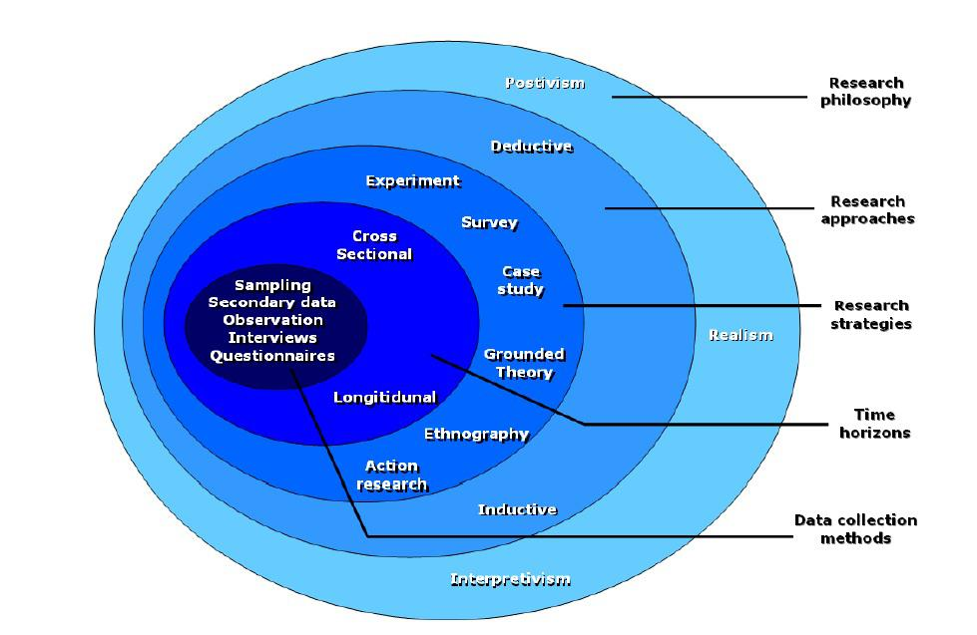

3.3.1 - Research Philosophy
The first part is the research philosophy. Research philosophies can differ on the goals of research and on the best way that might be used to achieve these goals (Goddard & Melville, 2004). Research philosophy is split into 3 parts, Positivism, Realism and interpretivism. Positivism assumes that reality exists independently of the thing being studied. In practice this means that the meaning of phenomena is consistent between subjects (Newman, 1998). Whilst Interpretivism is a type of research philosophy. Interpretivist research focuses on understanding a process or phenomenon (Alamgeer, 2022, Innovedia, 2022).
Positivism adheres to the view that only “factual” knowledge gained through observation (the senses), including measurement, is trustworthy. In positivism studies the role of the researcher is limited to data collection and interpretation in an objective way. ((Positivism - Research Methodology, 2022)
3.3.2 - Research Approach
The next stage will be the research approach. This will be split into two sections deductive or inductive

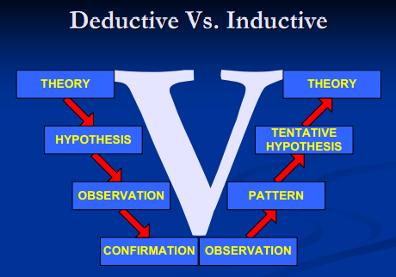

As highlighted in the figure above there are two types of research approaches. Deductive and Inductive. The deductive approach develops the hypothesis or hypotheses upon a pre-existing theory and then formulates the research approach to test it (Silverman, 2013) Whilst inductive starts from the observation and works into a theory following research. This research will contain the deductive approach, based on the personal theory that laws and police powers in domestic incidents are influencing confidence levels of the police force
3.3.3 - Research strategy
Quantative method is defined as ‘a systematic investigation of phenomena by gathering quantifiable data and performing statistical, mathematical, or computational techniques.’ (Quantitative Research: What it is, Tips & Examples | QuestionPro)
Qualitative method is defined as ‘a method of research that produces descriptive (non-numerical) data, such as observations of behaviour or personal accounts of experiences.’ (City University of Seattle Library: Research Methods and Design: Qualitative Research Methods)
Research in the dissertation will be conducted through two both methods.
Qualitative research will be the primary used source of information gathering throughout the research, through various different methods. This will be current and published news articles, honest and trustworthy websites or domains and published books. The online library at UWTSD will also be a method of choice should the need arise.
There are many articles and documents that are available to access especially on recent events that have unfolded that question the trust in police behaviours and actions.
Quantative research was to be conducted to prove or disprove the research question proposed. This was considered to be through surveys distributed to both serving officers for completion and members of the public.
Although Quantitative method research was considered originally to gather the data to assist with meeting objective three. However due to the emotive topic and ethical considerations, I would have been unable to complete a questionnaires or surveys with victims of domestic violence. Taking this reasoning, I have completed my research using the qualitative method. This has allowed me to gather research already published. This has not restricted results as through research previously published surveys and polls using the quantitative method has been found which will enable me to analyse and make recommendations if identified.
By completing both research method’s, it will enable to analyses a greater depth from various sources which at its conclusion will be to attempt to answer the proposal question and to make any necessary recommendations that are identified throughout the method.
3.3.4 – Time horizon
Due to time constraints, work commitments the research undertaken cannot be a large time scale and will therefore leave room for research in the future
3.3.5 - Data Analysis
As previously alluded to in previous chapters, due to limitations surrounding sensitivity of the topic field and ethical considerations, there were no questionnaires completed with colleagues as there would be no evidential relevance simply opiniated responses from an unreliable source. Questionnaires were considered to generate public opinions on domestic violence however due to the sensitivity aspect that there may lie the potential of victims of domestic violence, this also was discarded.
Pre- existing published reports by governmental organisations such as HMICFRS and Justice Inspectorate provided updated statistics figures on Domestic Violence, as well as their own reports published police related actions on Domestic Violence. This allowed an accurate representation of the problem that domestic violence has within the United Kingdom. Published news articles and polls has then allowed data to be gathered from sources unknown but relevant to the dissertation which in the following chapter may allow to make recommendations going forward.
3.4 – Limitations
As identified in chapter one, a main constraint that was identified was time. Factoring in full time work commitments and everyday commitments meant it is difficult to achieve all available data to conclude an absolute result to the proposal.
Due to the sensitivity and emotive subject of domestic violence being chosen, this has resulted in and identified with the completed ethics form that primary data may be restricted, as victims of domestic violence would not be targeted for data research. This means that any primary research conducted would be through policing colleagues.
3.5 – Conclusion
The chapter has now concluded and has successfully identified the research method that will be used to conduct, and present in the following chapter. Following the considerations and recognition of limitations such as the emotive topic and sensitivity included the most appropriate form was identified to enable the following chapter to successfully answer objective two.

Chapter Four - Results analysis
The Previous chapter has highlighted the route at which the research will be undertaken to achieve objective 2.
“To identify the most proportionate research route to achieve objective three”
As previously stated, due to ethical considerations of the emotive subject of domestic violence and the accuracy that would be gained from interviewing those who have not experienced domestic violence personally. This chapter consists of data and research previously published with statistics and reports from trusted sources which had ability to help prove or disprove objective three.
“Is public trust in the police force rising or falling as a result of introductions of further laws”
Throughout the chapter reference will be made to previously documented statistics in chapter two along with producing further research which will allow for recommendations to be made in chapter five during the conclusion stage.
4.1 - Data analysis
A definition of research in data analysis: According to LeCompte and Schensul, research data analysis is a process used by researchers for reducing data to a story and interpreting it to derive insights. The data analysis process helps in reducing a large chunk of data into smaller fragments, which makes sense. (Data analysis in research: Why data, types of data, data analysis in qualitative and quantitative research | QuestionPro,)
As previously stated, due to ethical considerations, it was difficult to obtain first hand from victims their views on how their confidence has changed throughout their interaction with the police. I have considered both qualitative data research and quantitative data research and analysed to allow the objective to be met.
Through this chapter an understanding has been on public perceptions of the police in general which has then allowed an evaluation to be made to establish if this has changed from a victim perceptive when police are investigating domestic incident victims.
4.2 - Public confidence – A YouGov study
When analysing the results of the survey conducted on around 1500 people of all genders and ages by YouGov it was found that confidence in the police conducting a good job in general had fallen by around 20% in two years. The below table in figure four shows that in July 2019 70 % of participants in the survey felt police were doing a good job, whereas at the end of February 2022 l this had fallen considerably to around 53%.
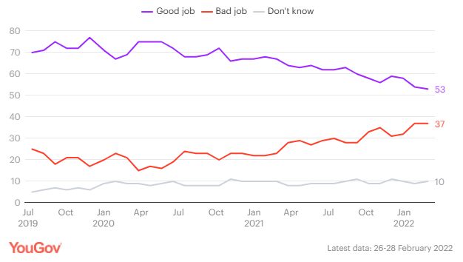
(Figure 4)
Whilst the respondents had appeared to have lost trust in the police force over the two year period, the same respondents appeared to have the belief that crimes were occurring nationally and not in their areas. 61% of participants believe that crime nationally has risen whilst only 11% believe that it has gone up in the local area.
The results can appear concerning from a police view of public perception, however it is also important to point out that the level of participants that have the belief that crime has remained the same in their local area is considerably more than that who believe it has gone up. This highlighting that it is based on interpretation rather than statistical and factual beliefs. As identified in the table below in figure five.
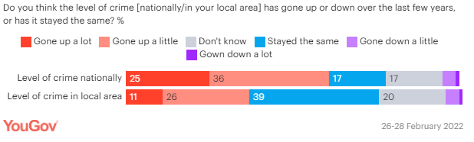
(Figure 5)
The results are a contrast to what have been reported in a report by Her Majesty’s Inspectorate of Constabulary and Fire & Rescue Services (HMICFRS). In the report published 2018 it states from their own study 61% of respondents were satisfied with their local police forces. This rising from 53% the previous year. (HMICFRS 2018 (Public perceptions of policing in England and Wales 2018 - HMICFRS, 2018)
4.3 - Barriers that can influence results
There are barriers that can influence respondents results such as politics, sex and, in this case, public scrutiny. These three factors have been visible in the public eye throughout the duration of the study.
Looking at the respondents results at the end of June 2022, 55% of conservative supporters believed police were doing a good job, this compared to 46% of labour supporters at the same period. Furthermore this comes during a time in which conversative are in power in parliament instead of labour.
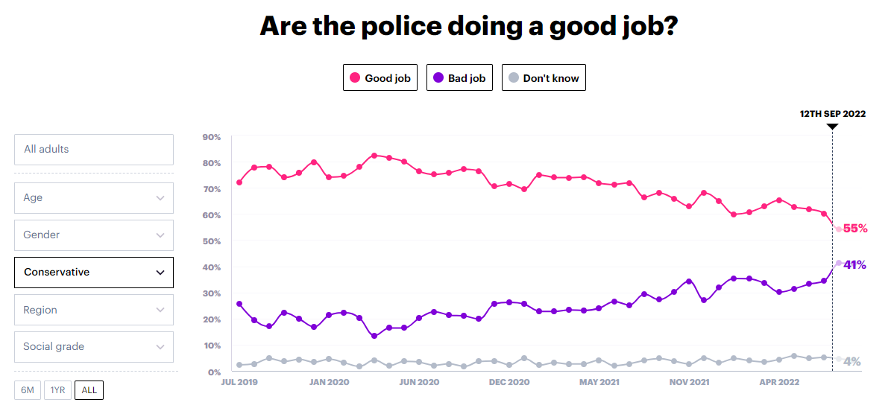
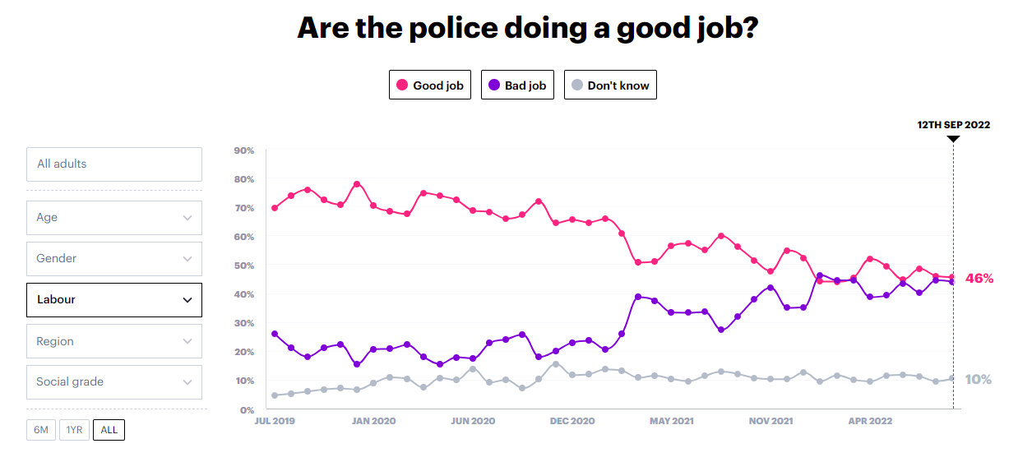
(Figure 6)
General media of the police can also influence results considerably, recent events such as the Sarah Everard case. A case in which Wayne Couzens, a police officer was found to have murdered her. The black lives matter movement has also been heavily documented in the media with many reports identifying police failings when dealing with incidents involving black people. ‘According to the 2020 Crime Survey of England and Wales, public confidence in the police has been on a downward trend over the last two years – from 62% in 2017 to 55% in 2020’ (Rusi.org, Feb 2022) However in contrast the following table in figure 7 shows that whilst this is the case in general there is no real difference between females and males trust in the police. The table below showing that 29% of men have a fair amount of confidence compared to that of 37% for women.
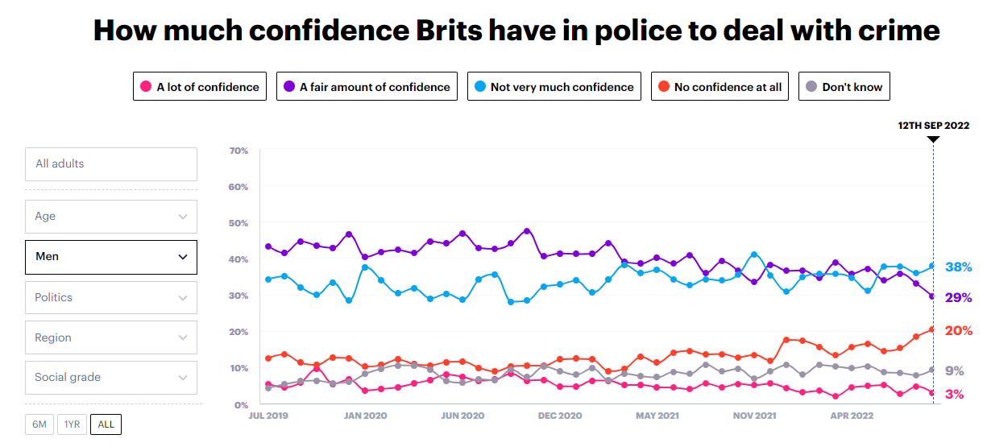
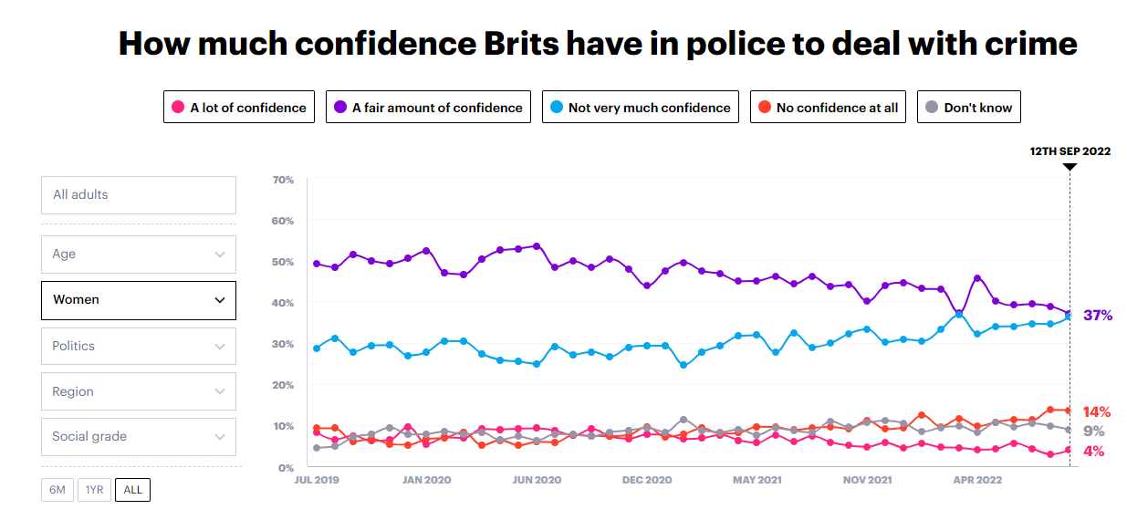
(Figure 7)
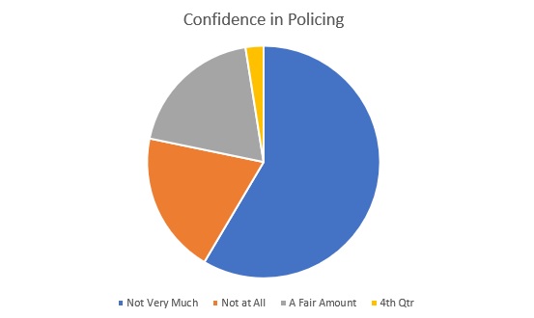
In a further survey conducted by Filia, a feminist charity, it had 290 respondents. The survey was conducted on women’s confidence on policing. Of the 290 respondents from throughout the UK there were a vast number that did not have the confidence in police. The graph below shows that out of the respondents only 2.5 % had a lot of confidence in the police with 58.5% having ‘not very much confidence in the police’

The respondents were also asked to give their view on why they had little confidence in the police, with only 46% victims reporting crimes that they were victim off to the police. With respondents stating that they don’t feel they will be believed because they’re women and have little faith that action would be taken. (Filia)
Other factors can include the perception that the police are failing in their ability to detect and tackle crime with violence particularly a sour topic where convictions are harder to obtain, especially in a domestic setting. The police as a result ‘have often been criticised for a lack of care and sensitivity towards victims’ (Rusi.org, Feb 2022) This along with the results in chapter one that crown prosecution service charging rate had dropped again to 70%. A drop identified for the third year running.
As a result of public scrutiny, the government launched a report on violence against women and girls (VAWG). From this report a survey was conducted called Violence Against Women and Girls (VAWG) Call for Evidence. This study received 180,000 respondents nationally and was conducted between December 2020 and February 2021 and was open to both genders. The report found on average ‘over 27% of women had experienced domestic abuse since the age of 16 (14% of men)’ (quote)
The study also showed that their confidence in the police is low and the barriers around reporting exist. In such case the fear of humiliation prevented crimes being recorded to police. There is also the danger of following the reporting to police they withdraw their complaints due to delays in such investigative powers.
As presented in chapter two, the police recorded a total of 1,459,663 domestic abuse-related incidents and crimes in England and Wales in the year ending March 2021.
Of these, 845,734 were recorded as domestic abuse-related crimes, an increase of 6% from the previous year, representing 18% of all offences recorded by the police in the year ending March 2021.
Estimates from our most recent Crime Survey for England and Wales year ending March 2020 show 5.5% of adults aged 16 to 74 years (2.3 million) experienced domestic abuse in the 12 months prior.
(Domestic abuse prevalence and trends, England and Wales - Office for National Statistics, 2022)
4.4 - Police powers – Are they being commonly used?
As previously mentioned in chapter 2, as well as powers of arrest for domestic incidents officers have the power to consider Domestic violence protection notices (DVPN), which if granted by the courts can be issued to a Domestic violence protection order (DVPO). However are these being utilised to the maximum effect?
No Occurrence with DVPN’s | Year
Month | 2018 | 2019 | 2020 | 2021 | Grand Total
January | N/A | 8 | 4 | 2 | 14
February | N/A | 6 | 2 | 3 | 11
March | N/A | 4 | 3 | 1 | 8
April | 6 | 5 | 2 | 6 | 19
May | 3 | 3 | 3 | 4 | 13
June | 4 | 3 | 3 | 7 | 17
July | 11 | 3 | 1 | 3 | 18
August | 11 | 4 | 3 | 6 | 24
September | 5 | 2 | 2 | 2 | 11
October | 10 | 4 |  | 6 | 20
November | 13 | 1 | 3 | 2 | 19
December | 12 | 2 | 5 | 2 | 21
Grand Total | 75 | 45 | 31 | 44 | 195
(Gwent Police (Gwent Police DVPN Figures, 2022))
The above table highlights the number of DVPN’s that had been granted by Gwent Police since 2018. The worrying statistic being since the governmental push to tackle domestic abuse more effectively the number of DVPN’s granted have almost halved, from 75 to 44.
DVPN’s and DVPO’s were introduced to bridge the gap that exists to allow a victim ‘breathing space’ from the aggressor if there is no realistic chance of prosecution.
4.5 - Conclusion
The research has not fully met the objective three
“Is public trust in the police force rising or falling as a result of introductions of further laws”
There is no real evidence to suggest that public trust of the police is dropping as a result of the introduction of further laws. Looking at the research conducted, confidence in the police is at a low in general and not necessarily because of police performance with domestic violence. Although when analysing the results of the poll conducted by YouPoll, whilst public confidence has decreased in policing, there is no real difference in trend between males and females. Females in fact have slightly more confidence in police. These figures coincide with the figures in a report by Filia that a comparable number of participants in their report have responded in a similar manner. Interestingly, the report by Filia has provided further detail citing their trust in police was affected by high profile policing incidents in the media.
It is also evident that police forces and officers are not utilising the tools available to them. With the figures from Gwent Police showing a decline in DVPN’s being issued over a four-year period and reporting that a new smart water spray has only been culpable for one conviction for domestic abuse, forces should be ensuring that their officers are aware of the added tools available at their disposal. Not only to protect the immediate safety of the victim but further down the line also.

Chapter five – Conclusions and Recommendations
The previous chapters have looked at gathering data from sources to outline the progression of domestic violence within the United Kingdom and also identifying if there is a trend that exists in reducing the trust victims of domestic abuse have of the police force.
This chapter will look to collate findings from both chapter two and chapter four to present and analyse to establish if any recommendations can be made in chapter six to assist with any future legislative policies.
5.1 - Chapter Two Findings
Chapter two met the objective of identifying and analysing the development of Domestic Violence through the ages.
Following the initial review within chapter two, it was evident that the government since 1986 - where the claim made by Chris Smith in the house of commons that domestic violence numbers were not at all accurate which resulted in a wholesale review of domestic violence and criming in particular within the United Kingdom. This has continued through time and along with the women’s rights movements has adapted many laws and introduced many more. For example in 199, where rape within marriage became illegal, albeit appears a decision that was far behind the times.
There is no argument that the government appear publicly committed to provided support for domestic violence victims as well as ensuring change to laws assisting police forces throughout the United Kingdom. Funding to a value of £47.5 million was promised in March 2022 to assist with support services, whilst a further £300 million was used to introduce the domestic abuse act.
These changes and introductions have meant that reporting figures have increased to a more accurate figure and provides each police force and government with a clearer indication of how big a problem domestic violence is within the United Kingdom. What the review has not provided was how the police force are acting or coping with the changes, whilst the adaptions of laws and introduction of further powers to police especially in regard to powers of arrest. The following chapters have outlined what research will be conducted in the following chapters and how this will be obtained.
5.2 - Chapter Four Findings
Chapter four attempted to meet objective are their inconsistencies compromising victim’s trust of the police force.
Following the analysis of the research conducted, it is plausible to agree that overall, there are some inconsistencies that are damaging trust or victim experience of the police force. For example, as presented in chapter four, articles have been published by different sources which suggest that perceptions and trust in the police force is not at the level it should be. There are many reports which has highlighted or suggested that though incidents have been reported to the relevant forces the confidence is not there that offenders will be brought to justice.
Social perceptions as a whole has not helped entirely with the findings. Many negative stories having an influence on the trust in the police force such as the Sarah Everard case and also the Black Lives Matter movement. Whilst these were not necessarily related to domestic violence, it has still damaged a reputation which every field within the police has to combat to build the trust of the public.
Further presented and researched was trying to identify if there was a difference between the process of individual forces. Whilst there was no outstanding evidence to agree with the theory, there were some experiences that found different forces reacted or dealt with incidents better than others.
In keeping with the ethical considerations as previously stated, pre published reports by sources such as the justice inspectorates found that a third of people felt no safer following reporting of domestic incidents to the police. Adding to this is the development that whilst domestic violence has quite obviously become a governmental and organisational policy to improve not all forces have actively prioritised this and are focusing on other activities instead.
There has been research found that identifies both the positives and negative perceptions and adding to the information found within chapter two, will allow for recommendations to be made whilst also acknowledging the positive aspects that appear to be working as a whole.
5.3 - Conclusion
As a result of analysing the findings from both chapter two and chapter four, it was possible to analyse the progression within the domestic violence field and also how important government intervention was at certain periods. For many periods domestic violence went unnoticed or un-reported and was possibly accepted as the norm by victims and others surrounded by domestic violence. As a result of natural progression of women’s rights and equality as a whole had encouraged females to change and speak up as well as laws adapting as a result. What has been recognised and probably not considered until more recently is that males can also be victims of domestic violence. Statistics currently don’t represent the true value of male victims in domestic violence, and it may be the stigma that men could feel ashamed or weak that stops them reporting to police. This is obviously a barrier that needs breaking to encourage and best protect every victim regardless of gender.
The following chapter will identify recommendations that could assist with any legislative powers or policies. The project will then conclude with an overall reflection of the learnings and findings within the project
5.4 - Recommendations
Although I was unable to achieve to the objective three in full, it is evident that public confidence within the police is falling, however this appears to be in general rather than because of the introduction of new laws and policies. Public confidence has been influenced by incidents involving those that work within the force. Wayne Couzens a prime example. This shocking incident was not a police incident however not one you would expect from anyone in life especially for someone who is responsible for protecting and serving.
This research has highlighted some recommendations that could be brought about to help to repair public confidence and victim confidence to encourage those to come forward with the knowledge that officers will care, will act with the utmost integrity and to provide the support or safety that they need and deserve.
Recommendation 1
Government funding and spending has increased in recent times and the introduction of news bills such as the domestic abuse bill will only serve as an added support to victims. In March 2022 further funding of £47million was introduced to better support services, however what else can be provided?
Currently officers can consider DVPN/DVPO’s as part of investigations into domestic incidents where there are slim chances of prosecution or where there is the expected No further Action following the custody procedure. This consideration should become a compulsory for any domestic incident where there is no complaint from the victim at first point of contact. By issuing the DVPN in all cases where bail conditions are not issued, it is giving the victim the breathing space as it was intended to do to seek support. However why should a victim have to seek support?
When the police and other services become aware of such incidents, support should be ready to offer itself and not sought after by someone in need. The 48 hours that a DVPN grants can be the most important for a victim to feel believed, to feel supported and to feel they have somewhere to turn. Support from partner agencies should be on hand to provide this as soon as a DVPN is granted and to provide the next level of support to the victim.
Recommendation 2
Domestic abuse incidents represent 18% of all crimes recorded in England and Wales, however the charging rate for domestic related crimes has dropped to 70%. Further training is required to ensure all victims are treated with the same respect and dignity. Research shows there is a lack of consistency around support and officer actions towards victims.
Further training or teams should be considered to provide the unequivocal support to officers and victims to ensure that each investigation ensures every avenue of enquiry is explored to achieve the absolute maximum potential of prosecution. By having a dedicated team on hand to provide assistance or advice on what considerations need to be explored, there can be no excuses from officers that experience was a factor.
These teams can also provide the follow up support to the victims to ensure that partner agencies are aware, that the victims are not forgotten about and are aware of where they can go should they need to seek support in the future.
5.5 - Future Research
Following this research there is room for further research to expand on the findings from this. It is plausible to make assumptions that public confidence in the police is at a low and that police interactions can be at fault. However due to the research ethical limitations any further studies in the future my wish to expand and delve deeper into the topic to analyse if police domestic violence investigations are directly impacting upon the public perception of the police force.

Bibliography
Alamgeer, Z., 2022. What is Interpretivism? - The Innovidea. [online] The Innovidea. Available at: <https://theinnovidea.com/what-is-interpretivism/>
Access date: 26th October 2022

Api.parliament.uk. 1986. Domestic Violence (Hansard, 3 November 1986). [online] Available at: <https://api.parliament.uk/historic-hansard/commons/1986/nov/03/domestic-violence>
Access date: 26th October 2022

Business Research-Methodology. 2022. Positivism - Research Methodology. [online] Available at: https://research-methodology.net/research-philosophy/positivism/
Access date: 26th October 2022

Bryman, A. (2012). Social research methods (5th ed.). Oxford: Oxford University Press

City University of Seattle Library.cityu.edu. 2022. City University of Seattle Library: Research Methods and Design: Qualitative Research Methods. [online] Available at: <https://library.cityu.edu/researchguides/researchmethods/qualitative>
Access date: 26th October 2022

Clare's Law. 2022. What is Clare's Law? - Clare's Law. [online] Available at: https://clares-law.com/what-is-clares-law/
Access date: 26th October 2022

Crime Justice and law GOV.UK. 2020. Domestic Violence Protection Notices (DVPNs) and Domestic Violence Protection Orders (DVPOs) guidance. [online] Available at: https://www.gov.uk/government/publications/domestic-violence-protection-orders/domestic-violence-protection-notices-dvpns-and-domestic-violence-protection-orders-dvpos-guidance-sections-24-33-crime-and-security-act-2010
Access date: 26th October 2022

Crime Justice and law, policy paper GOV.UK 2021. Tackling violence against women and girls strategy (accessible version). [online] Available at: <https://www.gov.uk/government/publications/tackling-violence-against-women-and-girls-strategy/tackling-violence-against-women-and-girls-strategy>
Access date: 26th October 2022
Crime Justice and law, GOV.UK. 2004. The Domestic Violence, Crime and Victims Act 2004.. [online] Available at: <https://www.gov.uk/government/publications/the-domestic-violence-crime-and-victims-act-2004>
Access date: 26th October 2022

Domestic Violence GOV.UK. 2020. Statutory definition of domestic abuse factsheet. [online] Available at: <https://www.gov.uk/government/publications/domestic-abuse-bill-2020-factsheets/statutory-definition-of-domestic-abuse-factsheet>
Access date: 26th October 2022

Domestic Violence, policy paper GOV.UK. 2022. Tackling Domestic Abuse Plan - Command paper 639 (accessible). [online] Available at: <https://www.gov.uk/government/publications/tackling-domestic-abuse-plan/tackling-domestic-abuse-plan-command-paper-639-accessible-version>
Access date: 26th October 2022

Domestic Violence policy paper GOV.UK. 2022. Domestic Abuse Act 2021: overarching factsheet. [online] Available at: <https://www.gov.uk/government/publications/domestic-abuse-bill-2020-factsheets/domestic-abuse-bill-2020-overarching-factsheet>
Access date: 26th October 2022

Goddard, W. & Melville, S. (2004). Research Methodology: An Introduction, (2nd ed.) Oxford: Blackwell Publishing.
Guardian. 2022. 80% of UK police accused of domestic abuse kept jobs, figures show. [online] Available at: https://www.theguardian.com/uk-news/2022/mar/17/80-percent-of-uk-police-accused-of-domestic-abuse-kept-jobs-figures-show
Access date: 26th October 2022

Guardian. 2009. A-Z of legislation: Domestic Violence, Crime and Victims Act 2004. [online] Available at: <https://www.theguardian.com/commentisfree/libertycentral/2009/jan/13/domestic-violence-act>
Access date: 26th October 2022

Gwent Police. 2022. Gwent Police DVPN Figures. [online] Available at: <https://www.gwent.police.uk/foi-ai/gwent-police/disclosure2/2022/january/202124721---dvpn-dvpo-dapn-and-dapo/>
Access date: 26th October 2022

HMICFRS. 2022. Police response to violence against women and girls - Final inspection report - HMICFRS. [online] Available at: <https://www.justiceinspectorates.gov.uk/hmicfrs/publications/police-response-to-violence-against-women-and-girls/>
Access date: 26th October 2022

HMICFRS. 2022. Public perceptions of policing in England and Wales 2018 - HMICFRS. [online] Available at: <https://www.justiceinspectorates.gov.uk/hmicfrs/publications/public-perceptions-of-policing-in-england-and-wales-2018/>
Access date: 26th October 2022

Katerina Duran Mynenko and Keith Ditcham 2022 n.d. Public confidence in the police - a new low. [online] Available at: https://www.rusi.org/explore-our-research/publications/commentary/public-confidence-police-new-low-service
Access date: 26th October 2022

Kothari, C. R. (2004). Research methodology: methods and techniques. New Delhi: New Age International

Lawtons Law. 2022. Marital Rape. [online] Available at: <https://www.lawtonslaw.co.uk/resources/what-are-the-legal-penalties-for-marital-rape/>
Access date: 26th October 2022

Newman, I. (1998). Qualitative-quantitative research methodology: Exploring the interactive continuum. Carbondale: Southern Illinois University Press

Office of national statistics. 2022. Domestic abuse and the criminal justice system, England and Wales - Office for National Statistics. [online] Available at: https://www.ons.gov.uk/peoplepopulationandcommunity/crimeandjustice/articles/domesticabuseandthecriminaljusticesystemenglandandwales/november2021
Access date: 26th October 2022

Office of national statistics. 2022. Domestic abuse prevalence and trends, England and Wales - Office for National Statistics. [online] Available at: <https://www.ons.gov.uk/peoplepopulationandcommunity/crimeandjustice/articles/domesticabuseprevalenceandtrendsenglandandwales/yearendingmarch2020>
Access date: 26th October 2022

Office of national statistics. 2022. Domestic abuse prevalence and trends, England and Wales - Office for National Statistics. [online] Available at: <https://www.ons.gov.uk/peoplepopulationandcommunity/crimeandjustice/articles/domesticabuseprevalenceandtrendsenglandandwales/yearendingmarch2020>
Access date: 26th October 2022

Office of national statistics 2022. Domestic abuse prevalence and trends, England and Wales - Office for National Statistics. [online] Available at: <https://www.ons.gov.uk/peoplepopulationandcommunity/crimeandjustice/articles/domesticabuseprevalenceandtrendsenglandandwales/yearendingmarch2021>
Access date: 26th October 2022

Office of national statistics. 2022. Domestic abuse prevalence and trends, England and Wales - Office for National Statistics. [online] Available at: <https://www.ons.gov.uk/peoplepopulationandcommunity/crimeandjustice/articles/domesticabuseprevalenceandtrendsenglandandwales/yearendingmarch2021>
Access date: 26th October 2022

QuestionPro. 2022. Quantitative Research: What it is, Tips & Examples | QuestionPro. [online] Available at: <https://www.questionpro.com/blog/quantitative-research/>
Access date: 26th October 2022

QuestionPro. 2022. Data analysis in research: Why data, types of data, data analysis in qualitative and quantitative research | QuestionPro. [online] Available at: <https://www.questionpro.com/blog/data-analysis-in-research/>
Access date: 26th October 2022

Silverman, D. (2013). Doing Qualitative Research: A practical handbook. London: Sage

Transformjustice.org.uk. 2018. [online] Available at: <http://www.transformjustice.org.uk/wp-content/uploads/2018/08/Transform-Justice-Love-Fear-and-Control.pdf>
Access date: 26th October 2022

Transformjustice.org.uk. 2018. [online] Available at: <http://www.transformjustice.org.uk/wp-content/uploads/2018/08/Transform-Justice-Love-Fear-and-Control.pdf>
Access date: 26th October 2022

Walliman N (2010) 2009 Your research project, Los Angeles, Sage

Who.int. 2022. Devastatingly pervasive: 1 in 3 women globally experience violence. [online] Available at: <https://www.who.int/news/item/09-03-2021-devastatingly-pervasive-1-in-3-women-globally-experience-violence>.
Access date: 26th October 2022

Women’s Aids 2022. What is domestic abuse? - Women’s Aid. [online] Women’s Aid. Available at: https://www.womensaid.org.uk/information-support/what-is-domestic-abuse/
Access date: 26th October 2022

Yougov.co.uk. 2022. Are the police doing a good job?. [online] Available at: <https://yougov.co.uk/topics/legal/trackers/are-the-police-doing-a-good-job>
Access date: 26th October 2022

Yougov.co.uk. 2022. Are the police doing a good job?. [online] Available at: <https://yougov.co.uk/topics/legal/trackers/are-the-police-doing-a-good-job>
Access date: 26th October 2022

