Assessment 2
Data Handling and Business Intelligence

Student Name: Vanya Dragneva
Student No: 2010312
Module Code: LCBB5000
Programme: Business Management, Level 5
Lecturer's Name: Joy Botu

Vanya Dragneva (2010312)

Part 1

Introduction
Microsoft Excel is an excellent tool for processing and manipulating structured data for users. Data preparation consists of converting raw data into a format easy to understand. Missing data, noisy data, and numerous errors abound in the raw data; therefore, data preparation techniques are highly useful to solve all the problems.
Evaluating re-processing data with Excel
Data must be pre-processed before it can be used. The transformation of raw data into a clean data set is the concept of data pre-processing. The dataset is pre-processed to look for missing values, noisy data, and other anomalies before running the algorithm. It is typically incomplete and lacks a coherent design, not to mention faults and contradictions. Good, pre-processed data is even more important than the most powerful algorithms, to the point where the data may actively obstruct the analysis that is being attempted, resulting in unsatisfactory findings. The accuracy of downstream operations will improve if the data is correctly pre-processed. The importance of data-driven decision making is commonly discussed; nevertheless, if the data being used is poor, the results will be the same.
This also involves data quality assessment, as well as data cleaning, transformation, and reduction. Examine data closely to verify its overall quality, project relevance, and consistency. There are various data abnormalities and inherent issues to be aware of in any data set, as follows:
-Mismatched Data types: When collecting data from a variety of sources, it may arrive in a variety of forms.
- Mixed data values such as employment of different feature descriptors, such as man or male.
-Outliers in the data: Outliers can have an enormous effect on the results of data analysis.
-Missing Data due to human error requires cleaning up the data
Data cleaning is the process of filling in missing data and repairing, updating, or removing inaccurate or unneeded data from a data set. It is the most important stage since it guarantees that data is ready for downstream purposes.
Usual challenges and problems in this process are as follows: missing and wrongly typed data, data variation, manual storing, numerical units, file handling and missing anonymisation.
Few methods exist for dealing with missing data, but the two most regular are:
-Ignoring the tuples: A tuple is a list or sequence of numbers or entities in a prepared manner.
-Manually fill in missing data: This takes time, but it's necessary when working with smaller data sets. Data cleaning also includes the correction of "noisy" data.
Furthermore, binning divides a large data collection into smaller, more comparable groups of data. It is commonly used in demographic research.
Regression is a method of discovering which variables are significant to certain research. Regression analysis is used to smooth substantial amounts of data.
Clustering techniques are used to efficiently group data so that it may be studied alongside similar data.
In most cases, data transformation occurs in one or more of the following scenarios:
-Aggregation: The act of merging all data into a single, standard format is known as data aggregation.
Normalization converts your data into a regularised range, allowing for more precise comparisons.
-Feature selection: Feature selection is the process of determining which variables (features, characteristics, categories, etc.) are most important to the study. Discretisation is the process of breaking down data into smaller time intervals. It's similar to binning, but only after the data has been cleaned. Concept hierarchy generation consists of adding a hierarchy within and between your features that weren't there in the original data is possible with concept hierarchy generation.
Data reduction not only simplifies and improves analysis but also reduces data storage. However, pre-processing is a highly needed process using Excel for obtaining quality results despite the drawbacks and difficulties mentioned above.
Evaluating the use of Excel for analysing data
Data analysis is a crucial ability for any professional to have. Without some type of processing, the existence of data in its raw acquired state is of little utility.
Excel is a famous spreadsheet programme from Microsoft that allows you to calculate and show complex mathematical formulas. Additionally, extensive formatting is available to tailor the appearance of these calculations. It imports data from several sources and enables the user to transform and save the data in spreadsheets.
Excel has extremely useful tools for analysing data such as Pivot table, different formulas and functions for calculating. Furthermore, it allows for the creation of a Pivot chart for presenting the data visualised. This makes it a very useful tool to calculate, organise and display information.
Other tools used in Excel are the functions such as IF, VLOOKUP, SUM and many more, to give the user also the option to not only analyse but even compare the data.
The programme enables the user to save their work in worksheets, with a range of options to colour them to differentiate easily.
However, the use in more in-depth investigations might cause problems because of some limitations such as issues with missing data analysis, and lack of flexibility in data analysis as this necessitates cutting, pasting, sorting, and otherwise rearrangement of the datasheet, which increases the risk of errors. Also, the output is dispersed across several pages, and it may be incomplete, increasing the risk of misidentification.
Requests for some analyses must be repeated several times to perform them for numerous variables or to request multiple alternatives. As the user needs to perform functions, and formulas on his own which leads to the danger of making mistakes. In addition, there is no record of what is performed to arrive at conclusions, making it difficult to document your work or replicate it if necessary.

Evaluating the use of Excel for visualising data
Analysing data is becoming of high importance to displaying data that efficiently. As a result, there has been a surge in data analysis and data mining. Over the last few years, visualisation tools have become increasingly popular. For many people, Microsoft Excel, on the other hand, remains the workhorse. Their requirements for data visualisation when using Excel and when the default setting is no need for limiting the data visualisation to chart kinds. Therefore, expanding the tool's capabilities to produce new chart types is a good idea.
Visualising data in Excel means representing the data in tables, graphs such as bars, pies or histograms and charts using a variety of technics for the user Davis G., and Pecar B., (2013, p.3), suggested. Variables are used as a measured characteristic for categorical such as quantitative and qualitative variables.
The quantitative has three scales such as interval, ratio and ordinal. In addition, the qualitative is measured on a nominal scale.
Also, presenting data in tables is the most comprehensive method and gives the user to read the data intelligible. This could be presented in a variety of formats, but the aim is to summarise and allow the user to read important information.
The first one is displaying the data in a manner that the graphs, should be readable and to gain a better understanding is needed to stick to the that the most important information is the data. The key aspect of the graph should be provided in the most straightforward manner possible. However, this does not imply that all the data must be available. Moreover, displaying too many graphs might be confusing because of too much information.
The second one is to eliminate Clutter and discard unnecessary or distracting graphic features. Clutter appears in a variety of forms such as gridlines that are too dark or heavy, tick marks, labels, or text that are not necessary, also decorative shading and gradients, superfluous icons or graphics as well unneeded dimensions.
Thirdly, is important to make the text and the graph work together. They're more accessible when they're directly on the chart. The idea that the graph maker should follow these three principles is encapsulated in these three principles. It will assist the reader in rapidly and readily obtaining information. However, graphs can communicate more clearly and effectively information but many graphing and analysis programmes provide default graph options. In addition, statistical programmes tend to clutter the screen and separate text from graphics.

Analysing the data Crime rate - Pivot Table

Figure 1: Data showing the calculation of Crime rate using Pivot Table
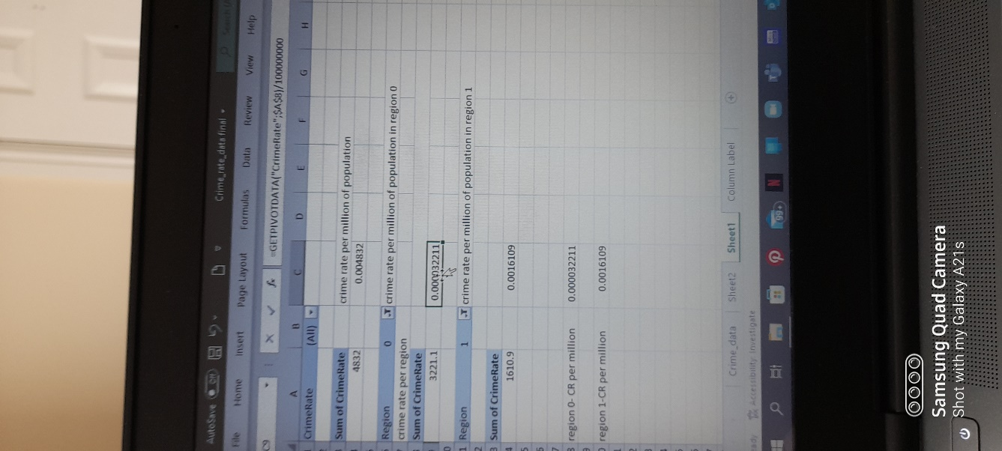
Figure 2: Data showing the calculation of Crime rate per million using Pivot Table
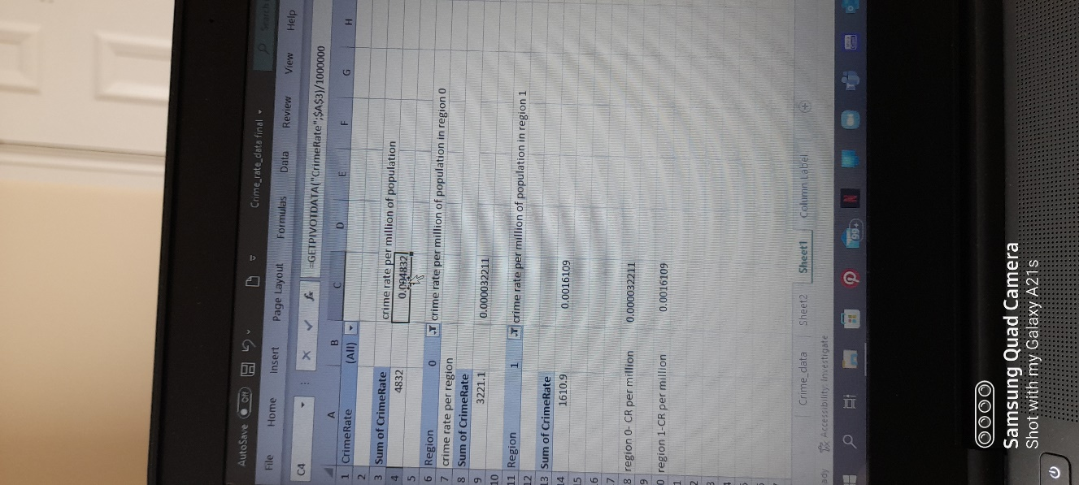
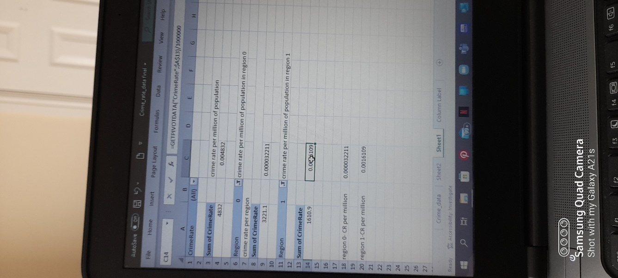
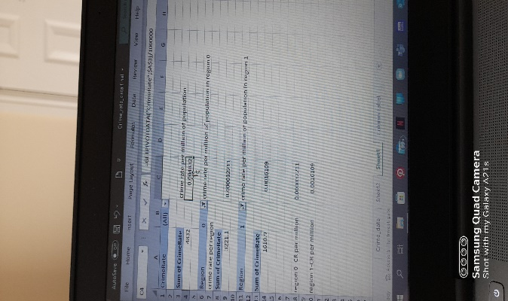 Figure 3: Data showing the calculation of Crime rate per million using Pivot Table in regions 0 and 1

Figure 4: Data showing the calculation of Crime rate per million using Pivot Table in regions 0 and 1
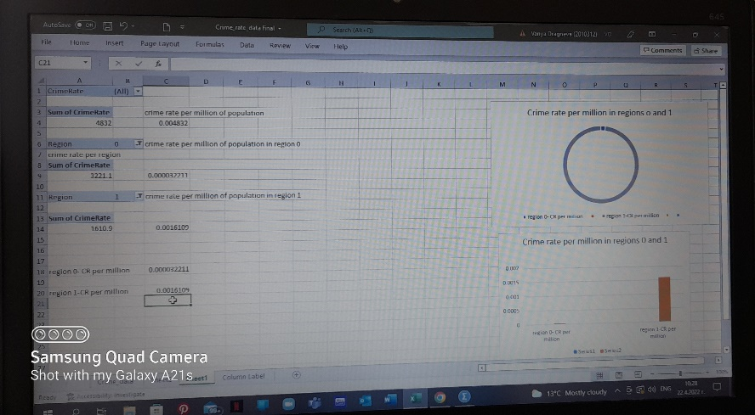

Graphical representation of crime rate in regions 0 and 1 per million of population

Source: The Author

Source: The Author

IF function
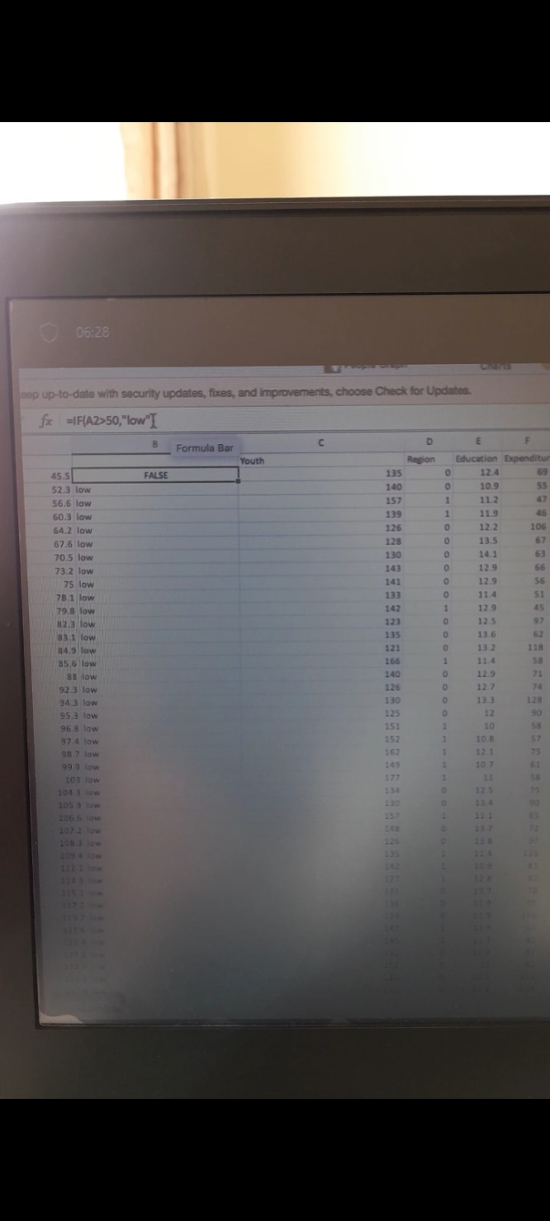
Figure 5: Data showing function IF when A2 is bigger than 50 as ‘low‘
Source: The Author

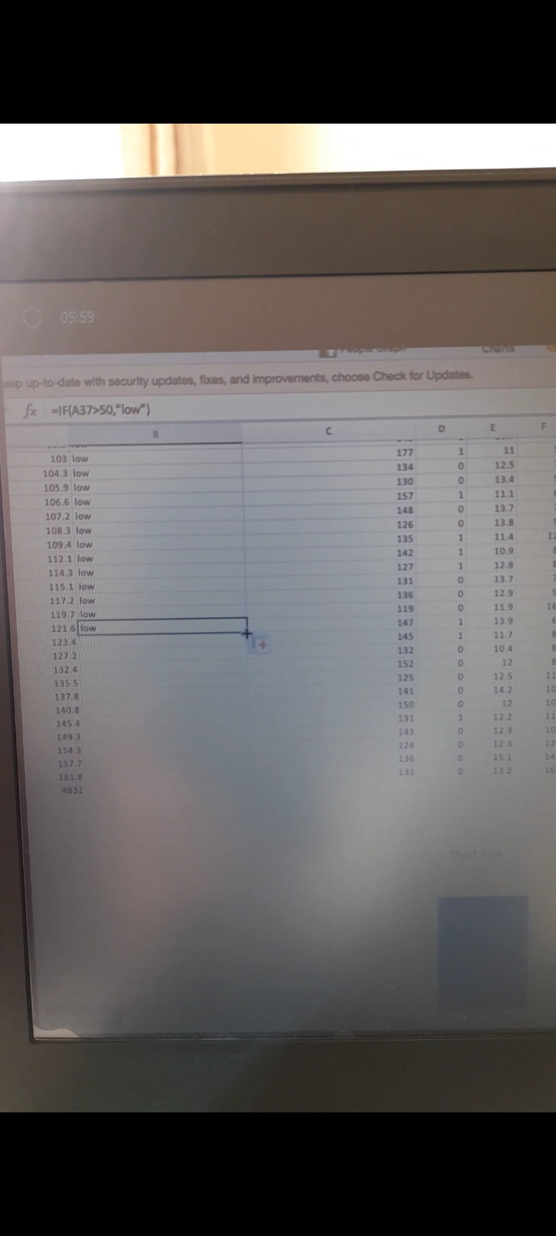
Figure 6: Data showing function IF when A37 is bigger than 50 as ‘low‘
Source: The Author
Here IF function is used setting the value of A2 bigger than 50 as low and applying the formula scrolling down the rows. In the second example, the A37 is used, set the value bigger than 50 as low and applied.

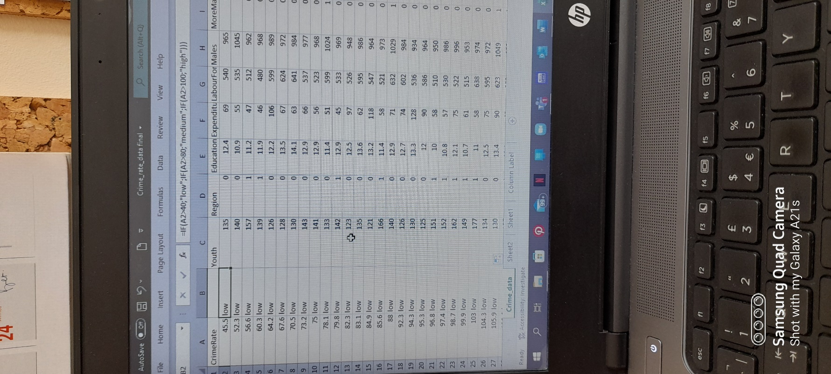
Figure 7: Data showing function IF when A2 is bigger than 40 as ‘low‘, A2 is bigger than 80 than ‘medium‘, and A2 is bigger than 100 than ‘high‘.
Source: The Author

Here, in the formula are applied more conditions with a result as shown.

VLOOKUP function
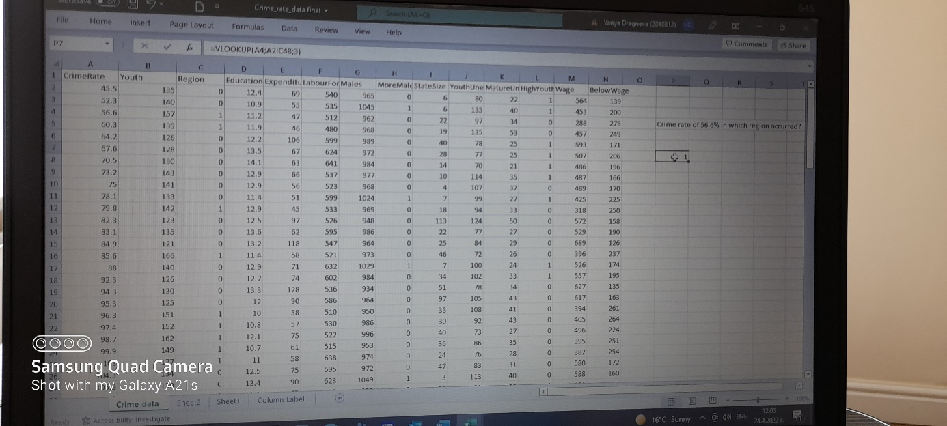
Figure 8: Data showing VLOOKUP function when is set up the following requirement: Which region has crime rate of 56,6%?
Source: The Author

Here, as an example of how to use VLOOKUP is set the question:
Applying the formula as shown in the screenshot has as a result region 1.
Part 2
1) How many students like vanilla flavour?

Figure 9: Data showing how many students prefer vanilla ice cream
Ice_cream favourite flavour
 |  | Frequency | Percent | Valid Percent | Cumulative Percent
Valid | Vanilla | 95 | 47,5 | 47,5 | 47,5
Valid | Chocolate | 47 | 23,5 | 23,5 | 71,0
Valid | Strawberry | 58 | 29,0 | 29,0 | 100,0
Valid | Total | 200 | 100,0 | 100,0

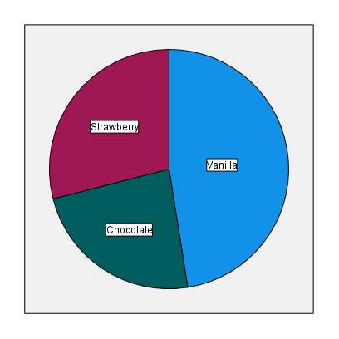
Figure 10: Bar graphic representation of percentage ice cream preferences using SPSS
95 students like vanilla flavour ice cream according to the findings.

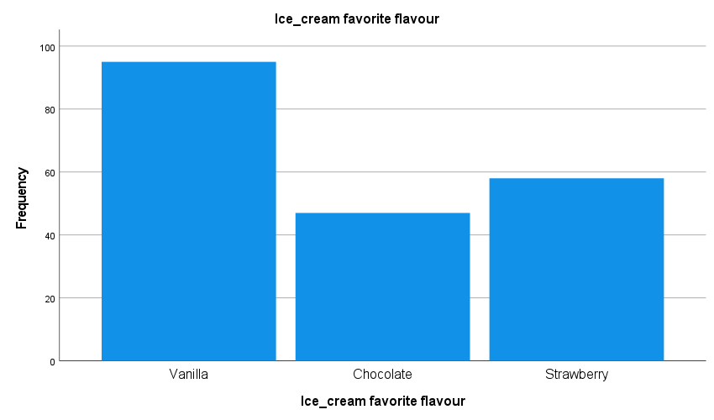
Figure 11: Chart graphic representation of percentage ice cream preferences using SPSS

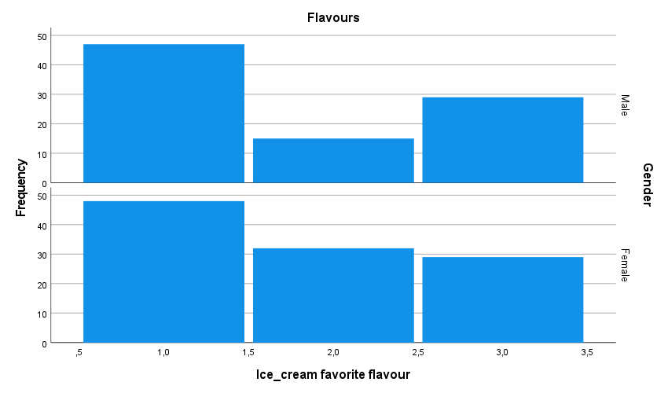
Figure 12: Chart graphic representation of percentage ice cream preferences by gender using SPSS

2)How many students are male and female?
Figure 13: Data showing students by gender
Gender
 |  | Frequency | Percent | Valid Percent | Cumulative Percent
Valid | Male | 91 | 45,5 | 45,5 | 45,5
Valid | Female | 109 | 54,5 | 54,5 | 100,0
Valid | Total | 200 | 100,0 | 100,0
91 students are male and 109 are female according to the results.

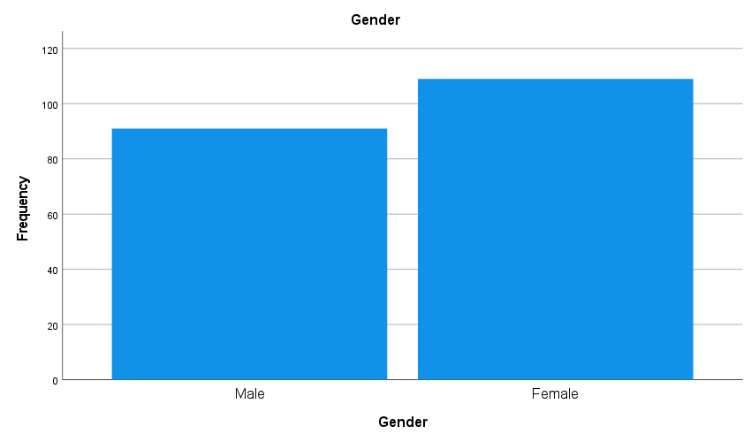
Figure 14: Chart representation of students by gender
3)What are the Mean and Median of participants who likes chocolate and strawberry flavour?

Statistics
Ice_cream favourite flavour
N | Valid | 200
N | Missing | 0
Mean |  | 1,82
Std. Error of Mean |  | ,061
Median |  | 2,00
Std. Deviation |  | ,858
Range |  | 2
Minimum |  | 1
Maximum |  | 3

Figure 15: Table statistics of Mean and Medium for student who like chocolate and strawberry ice cream
The Mean and Median of participants who like chocolate and strawberry flavour are respectively 1,82 and 2,00.

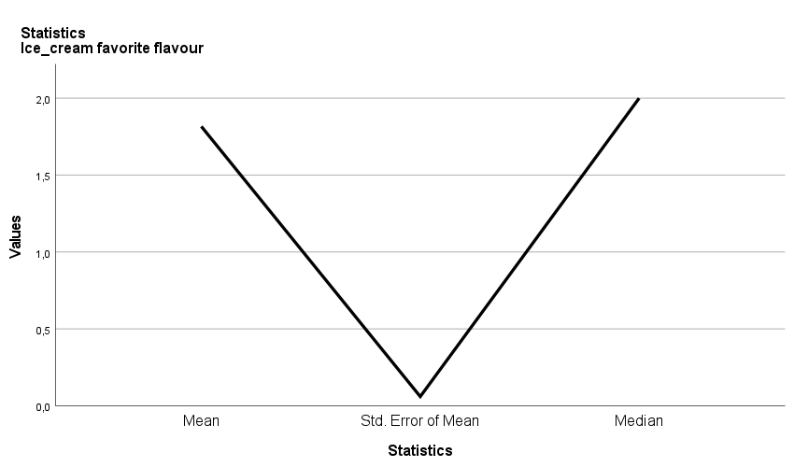
Figure 16: Histogram representation of the Mean and Median of students who like chocolate and strawberry flavors

a) example of clustering
Cluster analysis is the technique of identifying a group of items that are similar but distinct from those in other groups in Data Mining. Clustering is a method for converting a collection of unrelated elements into groups of similar items. Cluster analysis separates a collection of data or objects into multiple distinct subclasses called clusters. Clustering is a pre-processing step for other algorithms that aids in the understanding of a data collection's structure or natural grouping. It can be used as a standalone tool to learn more about data distribution or as a pre-processing step for other algorithms.
The most often used clustering algorithm is K-means. It computes the clusters and their centroids in an iterative manner.

Using the data Ice _cream.csv and imported in SPSS, it is done in three clusters with the following results.

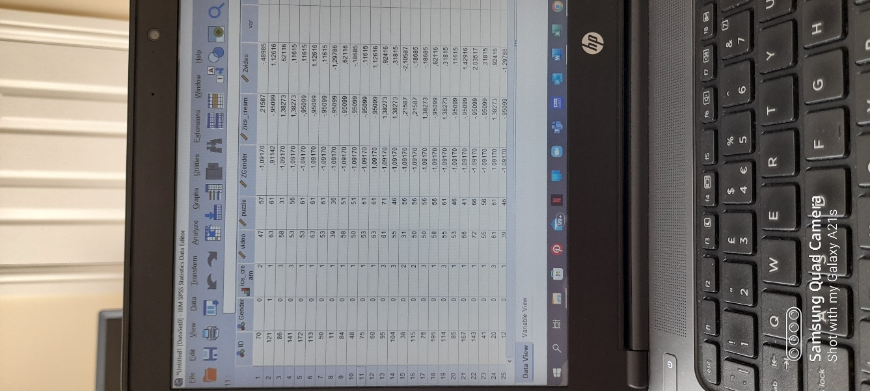
Figure 17: Data showing SPSS equalisation of measurement

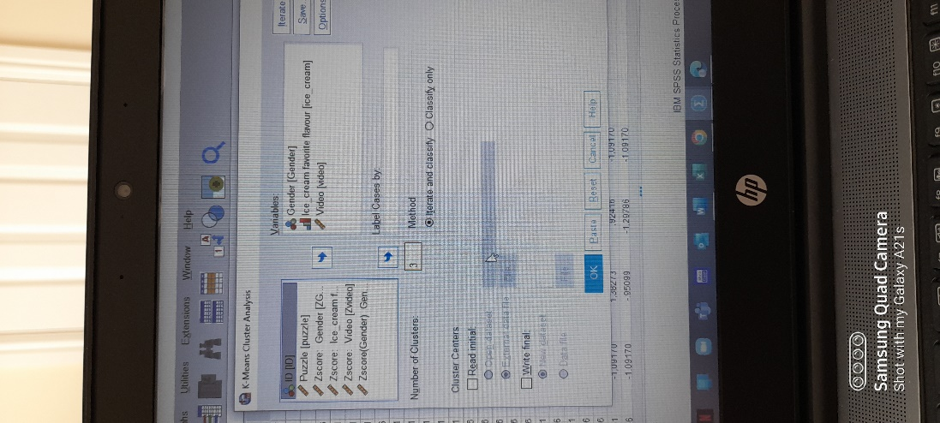
Figure 18: Data showing setting values of gender, ice cream and video in K-clustering method in SPSS

Initial Cluster Centers
 | Cluster
 | 1 | 2 | 3
Gender | 0 | 0 | 1
Ice_cream favorite flavour | 3 | 1 | 2
Video | 26 | 74 | 50

Figure 19: Table representation of initial clusters centers of the three clusters

Final Cluster Centers
 | Cluster
 | 1 | 2 | 3
Gender | 1 | 0 | 1
Ice_cream favorite flavour | 2 | 2 | 2
Video | 39 | 63 | 52

Figure 20: Table representation of final clusters centers of the three clusters

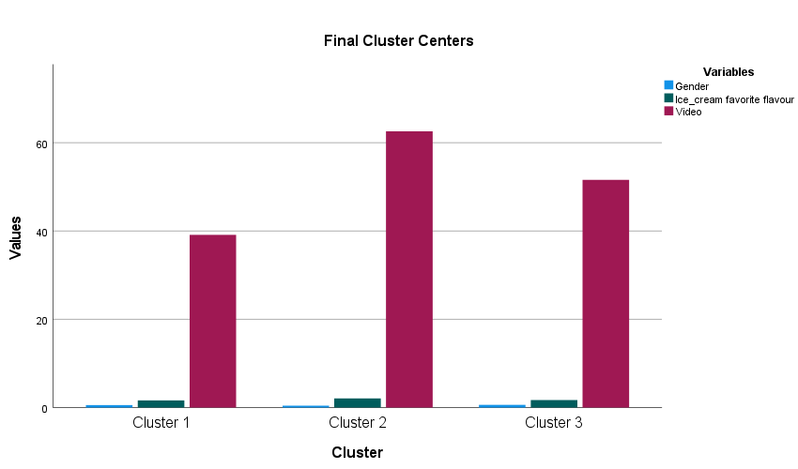
Figure 21: Chart representation of final clusters centers of the three clusters

The interpretation of the results is as follows:
There are three clusters and the first one is outlined by gender 1 which is female, preferring chocolate (number 2) ice cream and with the lowest interest in a video compared to other clusters.
The second one is identified as male, preferring chocolate ice cream and highly interested in video.
The third cluster means that females, with a chocolate preference for ice cream, are medium interested in video. In a conclusion, in this K-means cluster analysis people who like chocolate ice cream men are most interested in video, followed by the second group of women with a medium interest in video and the last group of females is classified with the lowest interest in video, all preferring chocolate ice cream.

The first cluster consists of 55 people, the second one of 67 and the third of 78 participants.

Number of Cases in each Cluster
Cluster | 1 | 55,000
Cluster | 2 | 67,000
Cluster | 3 | 78,000
Valid |  | 200,000
Missing |  | ,000

Figure 22: data showing the number of cases in each cluster

b) data and text mining methods
Data mining is the process of anticipating outcomes in large data sets by looking for anomalies, patterns, and correlations. This data may be used in a variety of ways to improve sales, save expenses, increase customer relationships, reduce risks, and more.
The decisions trees are a simple approach to direct one's (decider's) path to a decision and are a data mining technique that creates a model for categorising data. Because the models are developed in the form of a tree structure, they are classified as supervised learning.
A root node, branches, and leaf nodes make up a decision tree. An attribute test is represented by each internal node, a test result by each branch, and a class label by each leaf node.
The advantages of Decision Trees are as follows:
-there is no need for information training due to the pre-processing
-they do not involve information
-they do not need scaling
-ignored values in the data do not interrupt the process of creating these
- the model is stress-free and equal intuitive.
However, there are some disadvantages such as:
-A slight changes in the data can have in a notable shift in the decision tree's design, causing in unpredictability.
-Calculations for a decision tree might sometimes be significantly more complex than for other methods.
-Training the model with a decision tree takes longer every time.
-The cost of preparing a decision tree is high due to the difficulty and time required.
-For linking decaying and anticipating continuous data, the decision tree technique is insufficient.
Another method in the data mining process is the statistical approach of regression use up to describe the predicted link among numerous separate variables and one dependent variable. The goal of this model, also known as an explanatory model, is to find a functional relationship between the target variable and a selection of the dataset's remaining attributes and its purpose is to emphasise and comprehend the target variable's dependence.
There are various regressions such as Linear and Polynomial. More of this model are logistic, ridge and lasso regression types.
The following are some of the advantages of the regression model, which are based on basic statistical principles such as correlation and least square error and are easy to understand:
-Simple algebraic equations that are easy to learn, and use are provided by regression models.
-The correlation coefficients, as well as other well-understood statistical metrics, are used to assess the regression model's strength.
-Other modelling techniques cannot equal or beat the predictive power of regression models.
-Regression models can include any variables that the user desires to include in the model.
-Software for regression modelling is extensively utilised.. They can be found in both statistical and data mining packages.
However, there are some disadvantages of using this model as follows:
-Poor data quality issues are not covered by regression models.
-Collinearity issues plague regression models
-Although some packages attempt to do so, a regression model will not automatically choose amongst highly collinear variables.
-Nonlinearity is not automatically handled by regression models.
-Only numeric data and not categorical variables are used in regression models.
Text mining is the art and science of extracting knowledge, insights, and patterns from a structured set of textual datasets. It's also known as text analysis, and it's the process of transforming unstructured text into structured data so that it can be more easily analysed. Text mining uses natural language processing (NLP) to allow robots to automatically understand and analyse human language. Text mining assists in the analysis and finding of meaningful information from massive amounts of raw data.
Applications of text mining could be found in the marketing, different business operations can be examined for business development, as well as lawyers and paralegals can more readily examine case histories and legislation for relevant papers, in Governance and politics and so on.
The structural approach revolves around Term-document Matrix (TDM). Text can be converted to numeric data, which can subsequently be mined using standard data mining techniques.
Documents containing the phrases, customer orders, and marketing, for example, maybe packaged together more frequently. As a result, a few well-defined bundles could contain the core of the TDM. Asking the proper question is the most crucial practice.
There is some free text software as miming tools such as RapidMiner, Gate and Spy-EM, however, the commercial ones such as IMB SPSS- Text Miner, SAS Enterprise Miner, Statistical Data Miner- Text Miner and ClearForest are paid.

c) advantages and disadvantages of using SPSS and Excel

SPSS vs Excel
Advantages | Disadvantages
Specific statistic software | Expensive
Data analysis features | It cannot be used for analysing very large data
Faster and easier functionalities | Needed training to explore all features
Easier statistic test | More complicated graph features
Pivot tables are with incorporated functions
Pivot tables have add-in tools for data analysis
Superior graphs and diagrams
Table construction is easier
Easily convert codes to values or phrases
Missing values are never an issue
Preventing data input errors
Infinitive rows
Speed and performance

Excel vs SPSS
Advantages | Disadvantages
Organises data in a simple way | User Bias
Streamlines calculations | Needed skills for Syntax
Multiple user access | Lack of control and insecurity
The table expands automatically | Is not designed for a fast-paced business
All data is consistent when are used formulas. | incapable of assisting in making quick selections.
Using Tab to add more rows | Difficult to combine
Has multiple methods of importing and exporting data | Is not meant to be used in a group setting.
Can create records | Challenging to troubleshoot and test
Flexibility to use external database to do analysis
Reduction of data redundancy
The last version has high tools for graphics

Conclusion
Business intelligence has huge importance in the nowadays business World and highly useful tool for data and text mining, pre-processing, analysing and visualising data. It can have a great impact on the decision-making process in the Business, displaying the best available options.

References:
Azevedo, A., & Santos, M. F., (2015), Integration of Data Mining in Business Intelligence Systems, Available at: https://doi-org.ezproxy.uwtsd.ac.uk/10.4018/978-1-4666-6477-7,Accessed: 16th April 2022
Connoly, T.,(2015), Database systems: a practical approach to design, Available at: https://r4.vlereader.com/Reader?ean=9781292061849,Accessed: 16th April 2022
DataFlair (2021), What is Text Mining in Data Mining – Process & Applications, Available At: https://data-flair.training/blogs/text-mining/,Accessed: 17th April 2022

Goldwater E., (2007), Using Excel for Statistical Data Analysis, Available at: https://people.umass.edu/evagold/excel.html,Accessed: 17th April 2022
Davis G., and Pecar B., (2013), Business Statistics using Excel, Available at: https://books.google.co.uk/books?hl=en&lr=&id=Zh2fu2EphmQC&oi=fnd&pg=PP1&dq=using+excel+for+analysing+data&ots=ApgXUFL36C&sig=OYaVO11LBx4AqBSjyePIbrOlIZg&redir_esc=y#v=onepage&q=using%20excel%20for%20analysing%20data&f=true,Accessed: 17th April 2022
Larose D., (2016), Data mining methods and models, Available at: https://theswissbay.ch/pdf/Gentoomen%20Library/Data%20Mining/Data%20Mining%20Methods%20And%20Models_Larose%20DT%20%282006%29.pdf,Accessed: 17th April 2022
Maheshwari, A. K. (2015). Business Intelligence and Data Mining. Business Expert Press, LLC. New York
Maheshwari, A. K. (2015), Business Intelligence and Data Mining. Business Expert Press, LLC. New York
Sherman, R. (2015). Business Intelligence Guidebook: From Data Integration to Analytics. Morgan Kaufmann. USA
Schwabish J., (2016), A Step-by-Step Guide to Advanced Data Visualization, Available at: https://policyviz.com/wp-content/uploads/woocommerce_uploads/2017/07/A-Guide-to-Advanced-Data-Visualization-in-Excel-2016-Final.pdf, Accessed: 17th April 2022
Pedamkar P., (2022), Differences Between SPSS vs EXCEL, Available at: https://www.educba.com/spss-vs-excel/,Accessed:17th April 2022
Statistics Consultation (2013), SPSS, the advantage over MS-Excel, Available at: https://statisticsconsultation.wordpress.com/2013/07/30/spss-the-advantage-over-ms-excel/,Accessed: 17th April 2022
Tutorialspoint (2021), Data Mining – Cluster Analysis, Available at; https://www.tutorialspoint.com/data_mining/dm_cluster_analysis.htm, Accessed: 17th April 2022

Vercellis C.,(2009), Business Intelligence: Data Mining and Optimization for Decision Making, Available at: https://onlinelibrary.wiley.com/doi/pdf/10.1002/9780470753866,Accessed: 16th April 2022
VFU (2016), Analysing data using Excel, Available at: https://www.vfu.bg/en/e-Learning/MS-Office--excel.pdf,Accessed:17th April 2022
Wikitechy (2021), Clustering in Data Mining, Available at: https://www.wikitechy.com/tutorial/data-mining/clustering-in-data-mining#:~:text=What%20is%20Clustering%20in%20Data%20Mining%20%3F%201,a%20cluster%20can%20be%20considered%20as%20one%20group,Accessed: 17th April 2022

