
1814694 MARIN ZAHARIDOV 03/05/2019

INFORMATION ENGINEERING
  - CLASS TEST – ACCC4004

DIAGRAM 1:
In the Entity Relationship Diagram a make by using STARUML the connection between customer and Catering Business.
Owner of the “SANDWICH R Us”, which is local business located in Swansea. The business is expanded and now have a new store in Neath, Port Talbot, LIanelli and Carmarthen. The owner would like to use a system that will allow to record customer details, information of services and events and automatically print out invoices. To be able to show at some future information about sales, connected with quarterly and yearly profits.

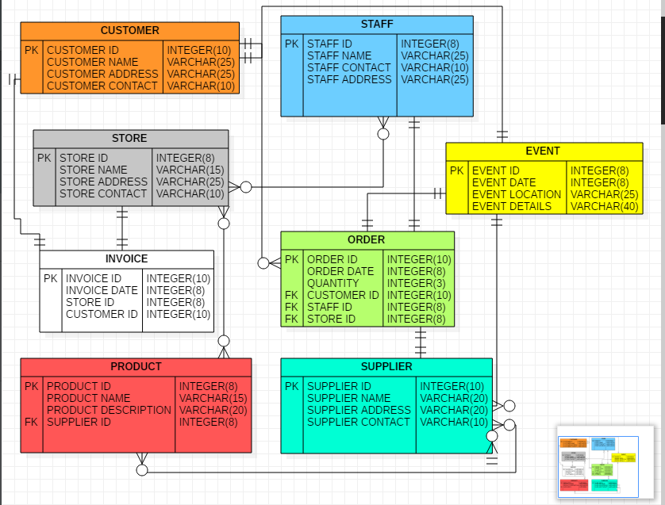

The Customer make order for event or a product from the Store. One customer can order many products, or one or more events but for a certain date. The staff in the store place the order, add the new customer in the system and after the payment is confirm, supplier provide the product to the store and it is ready to be collected or if the customer is purchase a catering event, the staff is preparing everything for the exact date to place and deliver the products for the event.
The customer is receiving invoice for the order that he make when the staff confirm the payment and check all details. If the customer is in the system, the staff need to check if his details are correct to place the order.
Supplier is making contact with store to confirm the quantity and the date for delivery. One supplier can provide many products, or the store can be connected with different suppliers delivering different products.
DIAGRAM 2: USE CASE DIAGRAM

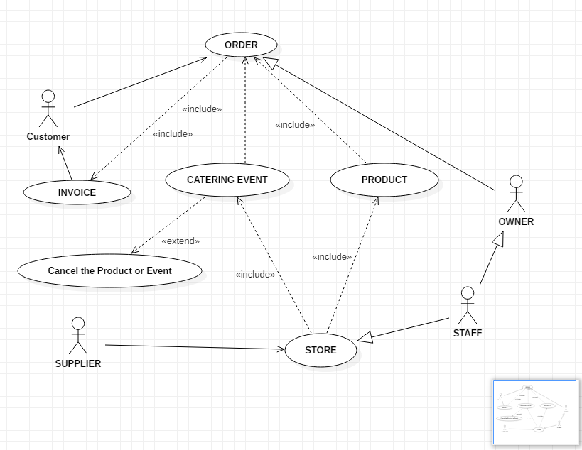

DIAGRAM 3: DATA FLOW DIAGRAM
Interface, process, data store and Data Flow:
To find information about all purchases made from supplier, and record of transactions.

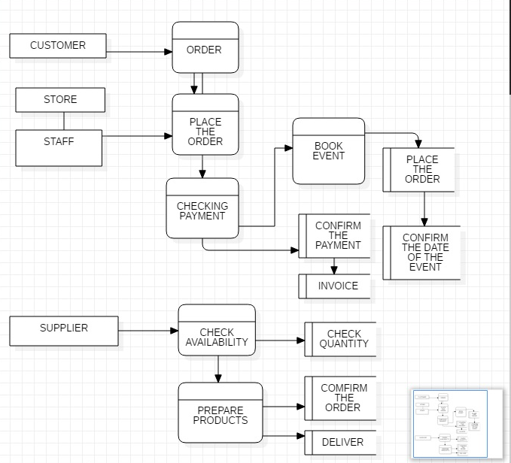

Before confirmation of the event, If the payment it’s not successful staff is making contact with the client to ask him to make payment with other account or to cancel the order.
The customer can decide to cancel the order or event store must refund the payment if the customer is already payed.

