Programme: Master of Business Administration
Module: International Marketing: Principles and Practices
Module Code: LCMB7026
Assignment Title: International Marketing: Principles and Practices
Lecturer’s Name: Tushara Balendran
Student Name:Md Arman Uddin
Student ID:2433803

Table of Contents
1. Introduction 3
2. Brand Overview 4
2.1 Founding of BMW 4
2.2 Vision and Mission of BMW 4
3. The macro environment (PESTLE) of BMW in the UK and Denmark 5
4. STP strategies in the UK and Denmark 11
4.1 STP Strategies of BMW in the UK and Denmark 12
4.2 Perceptual Map of BMW 14
5. Marketing mix (7Ps) strategies in the UK and Denmark 17
6. Evaluation of the performance of marketing strategies 21
7. Ethical issues of the marketing mix 25
8. Strategic Recommendations 27
9. Conclusion 28
References 29

1. Introduction
Companies tend to enter business markets internationally to reach diverse audiences and gain higher competitive advantages. However, using the same international marketing strategies can be challenging for companies in different business locations (Doole, Lowe and Kenyon, 2019). By nature, international marketing represents the application of principles and marketing activities across more than one country (Kotabe and Helsen, 2022). Proper application of international marketing strategies, following the principles and practices, allows organisations to deal with diverse customer groups globally. Large organisations and brands are highly eager to adopt international marketing strategies and practices to enter different business markets and deal with market opportunities and threats. BMW, one of the largest German multinational manufacturers of luxury vehicles and motorcycles, has been operating in more than 140 countries. The company has been using international marketing strategies and promotional approaches while operating in different markets for diverse customer groups. Here, the study will address the international marketing strategies of BMW in the UK and Denmark and their comparison regarding the effectiveness of marketing strategies. BMW is using different marketing strategies globally. The study will also discuss the success or failure of the marketing strategies of the company internationally in two countries.

2. Brand Overview

2.1 Founding of BMW
BMW Group has been managing four brands, such as BMW, MINI, Rolls-Royce and BMW Motorrad (BMW Group, 2025). The company is considered the world’s leading and largest premium manufacturer of automobiles and motorcycles. The company also provides premium financial services and operations in the markets with a global sales network and product delivery in more than 140 countries (BMW Group, 2025). The company started its business from the year 1916 and internationally, the company entered the international market in 1973.

2.2 Vision and Mission of BMW
Vision: The vision of BMW is to maintain a strong commitment towards customer service, digitalization and sustainable premium manufacturing service.
The company focuses on the emotional state of the customers where bringing products to evoke emotion. The BMW iFACTORY is also considered the BMW Group’s vision for the quality, development and transformation of car production, sustainability, digitalization, and efficiency (BMW Group, 2025). Following the position as the effective, successful, and sustainable premium manufacturer in the industry, BMW has ensured to value the culture of innovation, digitalization, efficiency and effective car production.
Mission: The mission of BMW is to manage corporate governance, leadership strategy, collaboration, and transparent reporting.
The core mission and value of BMW to evoke emotion have also helped the company to create and communicate the future of mobility through innovation, customer focus, commitment to digitalization and sustainability. The company emphasizes quality management while creating vehicles and mobility solutions for the customers with the intention towards the development of strong emotional connection with the user. The company also has a mission statement to ensure a thrilling experience in driving vehicles.

3. The macro environment (PESTLE) of BMW in the UK and Denmark
Macro environment or external business environment has always impacts on shaping business strategies and practices of the organisations (Kotler et al., 2023). BMW has faced challenges and opportunities in different markets internationally, where in some cases, it differs based on the market location. PESTEL analysis of the UK and Denmark for BMW is as follows:
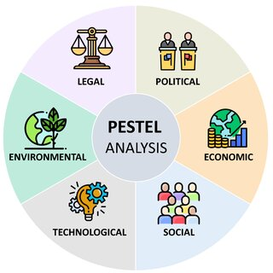
Figure 1 PESTEL Analysis
Source: (Segura et al., 2023)
Political Factors: Political factors represent how the government holds power over resource allocation and management in the markets (Shtal et al., 2018). From the tax policy to the environmental regulation, tariffs, trade restrictions and reform and political stability have impacts on the strategies and practices of the organisations, both locally and internationally. Many countries with political restrictions and challenges can hinder the growth of the process and performance of the organisations.
In the UK, BMW has dealt with the complexities of Brexit and changes to rules for electric vehicles (EVs). This has affected the supply chain and production activities of BMW for the business under tariff-free trade. Hence, BMW has adapted to the localization and investment in EV production to comply with the new trade rules in the country.
On the other hand, Denmark follows the rules and regulations of the EU on vehicle standards, which leads to stable regulations for the business compared to the UK. In such a situation, BMW has been benefiting from the regulations and standards in the business markets while tailoring its sales strategies and promoting the EV lineup for electric vehicles.
Economic Factors: The Economic environment of the markets represents the factors related to interest, inflation, wage rates, economic growth or economic decline, unemployment, and other factors (Kotabe and Helsen, 2022). The number of competitors, tariffs, recession, or economic growth has impacts on the price, cost, growth or business of any organisations. In the UK, GDP has been 3,643,834 M US$ and in Denmark, the GDP has been 429,457 M US$ (Worlddata.info, 2025). The GNP of the UK has been 3,365,233 M US$ and in Denmark, it has been 441,050 M US$.
In the UK, BMW has seen exchange rate fluctuations in the markets regarding post-Brexit, which has the impacts on the income and BMW's profitability. Even the economic downturns and inflation have impacts on the purchasing of customers and the income level of the business. Hence, BMW has worked on a strategy for adjusting for exchange rate fluctuations to maintain the business profit in challenging times.
On the other hand, in Denmark, a high GDP leads to the high purchasing power of the customers. The strong EV market in Denmark has also supported the growth and performance of BMW in the country.
Socio-cultural Factors
Cultural factors:
Cultural norms, customer base, expectations, population growth rates, and other market social factors influence the decision-making and behaviour of the customers (Kotabe and Helsen, 2022). These impact the decision and performance of the organisations as well. BMW has a worldwide reach and is dealing with the cultural attitude and norms in the markets. Culturally, both UK and Denmark have similar cultural elements where cultures of BMW have been improved following core values in businesses. The company has a progressive culture with flexible working environment and equal opportunities following 5 core values (BMW Culture, 2025).
Social factors
In the UK, BMW has established a reputation for business performance. The UK consumers are concerned with sustainability and demanding more effective and greener products and hence, BMW is heavily promoting its electric and hybrid models for the generations.
On the other hand, the vehicle sector could see how Denmark gives strong focus on sustainability and environmental protection in the markets and these belief systems have shaped consumer values, spending patterns and preferences of the customers. Thus, BMW uses promotion and marketing highlighting the EV performance and sustainable technologies to deal with the culture.
Hofstede’s cultural dimension: Hofstede's cultural dimensions provide a structured framework and process for assessing, understanding and comparing cultures in the markets which helps business to understand and work on international business culture, cross-culture management and communication (Hofstede, 2001). 6 cultural dimensions are available such as power distance index, individualism vs collectivism, masculinity vs femininity, uncertainty avoidance index, long-term vs short-term orientation, and indulgence vs restraint (Nickerson, 2025).
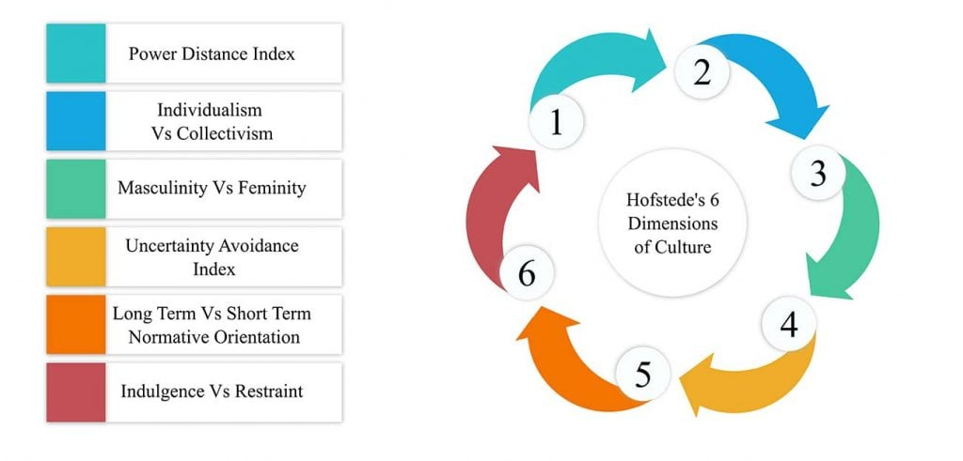
Figure 2 Hofstede’s cultural dimension
Source: (Nickerson, 2025)
 | UK | Denmark
Power distance | 35 | 18
Individualism vs collectivism | 89 | 74
Masculinity vs femininity | 66 | Very low in (F)
Uncertainty avoidance index | 35 | 18
Long-term vs short-term orientation | 25 | 10
Indulgence vs restraint | 69 | 70
According to Hofstede’s cultural dimension, Denmark scores lower on power distance, masculinity and uncertainty avoidance, where the country is higher on individualism for fairness, equality and risk-taking in business. Similar to Denmark, the UK has also scored low in uncertainty avoidance and power distance and high in individualistic culture. But, there is a difference between the score of masculinity between the UK and Denmark as the UK has a moderate score for masculinity compared to Denmark. This has supported the growth and performance of BMW in both countries while targeting the audiences and markets for sale.
Advantages of Hofstede’s cultural dimension
Comprehensive understanding: This model offers structured framework for the international business. This method is applied to address cultures of stakeholders and business to foster culture in workplace.
Practical applications: The model helps with recognizing the changing culture of stakeholders and business and working on the manner and cultural principle in international business. The organisation can apply the model to work on decision and strategy development.
Credible framework: This model is developed based on research with different companies and countries and hence, this model is credible framework for assessing national and international culture.
Disadvantages of Hofstede’s cultural dimension
Overgeneralization: The model can simply the complex culture and situations of the organisations where overgeneralization of the model affects the culture, growth and performance of the organisation.
Outdated data: But, the model can be based on available outdated data without having updated data which can lead to stereotypes in the management.
Limited dimensions: The bias towards one culture can affect the decision for the cultural environment as well. It only uses certain dimensions which can be limited in nature for the companies.
Technological Factors: Technologies have changed the world with IoT, Artificial Intelligence. Machine Learning and Deep Learning and these technological advancements, have created both threats and opportunities for businesses (Kotler et al., 2023). BMW has been very adaptive to the changing business markets with the latest technologies while competing with other car manufacturers and industries.
The UK market is moving towards EVs with technological advancement and UK consumers are expecting advancement in car technology. This has been considered as the strength for the production and operation. Thus, BMW has been investing a lot in R&D for the battery technology, charging solution, software, and driver-assistance systems to retain the customers and competitive advantages (Kukkamalla et al., 2021). However, it can be costly for adaption.
Similarly, Denmark is full of consumers expecting integration of technology and strong EV performance. Thus, BMW has also worked on the strong investment in research and development (R&D) while promoting its high-tech features, and efficient system in the business.
Legal Factors: The legal factors of the country represent the legal obligation, rules and regulation, legislation impacting employment, import and export, taxation and company policies (Shtal et al., 2018). Different markets in the world have legal issues and obligations that might have impacts on the success and performance of BMW.
The UK's new trade relationships, UK regulation for vehicle, supply and manufacturing safety and business growth have pushed BMW to adhere to the regulation and standard for the business. The company has also followed the company law, new trade agreements and safety laws (Kukkamalla et al., 2021).
In Denmark, BMW is following legislation, and strict national laws for the production, supply chain management and growth of the business. The company adheres to legal compliance for the delivery, supply chain management and production of the products. Both Denmark and UK maintain some similar laws and regulation where in Denmark, environmental standards practices are strictly followed compared to the UK.
Environmental Factors: The environmental factors of the market are receiving a lot of attention for the industries where the organisations are expected to follow waste disposal rules, environmental protection legislation and other rules (Kotler et al., 2023). In the UK, BMW has seen how the government is focusing on waste management, emission management and other environmental rules and regulation. BMW prioritizes developing an efficient business model and more sustainable waste management processes, aligning with the standards and laws of the country. In Denmark, BMW has to follow the strict LEZs, EU rules on ELV management, and standards for driving and supply chain management compared to the UK.

4. STP strategies in the UK and Denmark
STP strategy is the marketing strategy of the business organisations that involves Segmentation, Targeting, and Positioning to create more personalized, flexible and effective marketing messages for the business promotion (Albrecht et al., 2023). BMW's STP strategy varies in different markets based on the market, culture, customer group and business environment. The STP strategies of BMW vary in the UK and Denmark. These are discussed below:
VALS Segment Characteristics
Segment | Lifestyle characteristics | Psychological characteristics | Consumer characteristics
Innovators (20% in the UK, 25% in Denmark) | High income and individual taste in things | Value independence and quality of services | High resources individuals and motivated based on fine things
Thinkers (20% in the UK, 20% in Denmark) | Well-educated | Rational decision-making consumers | Motivated based on knowledge
Believers (5% in the UK, 10% in Denmark) | Social in nature | Making own decisions | Less likely to accept innovation
Achievers (25% in the UK, 20% in Denmark) | High resource and income | Making decisions based on success of brands | Motivated by achievements
Strivers (15% in the UK, 10% in Denmark) | Wants to reach achievement with lower resources | Necessary resources or social status can help them making decisions | Motivated by lower cost and achievement
Experiencers | Self-expressions | Young adults | Early adopters and higher spending
Makers (10% in the UK, 10% in Denmark) | Self-expression with limited resources | Building a better family | Better lifestyle for family
Survivors (5% in the UK, 5% in Denmark) | Less adoption of innovation | Do not change their actions | Brand loyalty and more aged consumer segments
Table: VALS Segment Characteristics
Source: Own

4.1 STP Strategies of BMW in the UK and Denmark
Segmentation Strategies of BMW in the UK and Denmark
Segmenting strategies of the organisation represents the first step of marketing, where the company starts to divide its entire potential customer base into small groups to understand their nature and preferences (Doole, Lowe and Kenyon, 2019). In the UK, BMW has evolved its strategy to work on the brand image and include a wider range of electric cars and more affordable options within the premium car image development. In the car industry, often organisations target selected generation and customers based on available or wide range of available products (Hackley and Hackley, 2021). BMW is using a multi-faceted approach as the part of its segmentation strategy to divide the UK market into different groups. In the case of geographic group, BMW targets the community and customers from highly industrialized and affluent regions in the major cities of the UK (Kukkamalla et al., 2021). Based on demographic era, BMW has targeted the core audience of high-earning men and women. Even the brand targets younger drivers with more preference for cars and EVs. In the meantime, the consumers of BMW are segmented by lifestyle and personality. BMW has targeted the aspirers, explorers, and succeeders with a wide range of products. In the Behavioural segmentation, the company has distinguished the customers between the "hard-core loyal" and "soft-core loyal" with the technology, benefits and impacts.
In the Danish market, BMW has been segmenting its target customers into different groups with a mixture of geographic, demographic, psychographic, and behavioural sections. In geographic segmentation, both urban and rural areas are operated by BMW with the sales companies and dealerships. BMW has adapted to the rapid adoption of customers of EV customers in Denmark with strong production and a strong charging infrastructure (Kukkamalla et al., 2021). In demographic segmentation, BMW has targeted the customers of high-income and professionals, including the preferences of the customers for luxury models and sports cars. In psychographic segmentation, BMW has been targeting customers who prefer experience, premium service, high-performance driving and passion for driving. The brand segments different drivers and customers based on their preferences and benefits, brand loyalty and core services from the brand in Denmark.
Targeting strategies of BMW in the UK and Denmark
Targeting strategy allows organisations to communicate with customers with a message and ability in various segmentations (Albrecht et al., 2023). In targeting, the organisation identifies, assesses and selects the most promising customer groups and segments to work on the marketing efforts and strategies (Hackley and Hackley, 2021). By utilizing a differentiated marketing strategy, BMW has been designing separate campaigns and products, service and promotional approaches in the markets. The wide range of products for the core audiences, BMW has been targeting audiences with a high-income base, young generations, eco-conscious consumers and the most affluent customers in the markets.
In the case of targeting the audience and customer in the market in Denmark, BMW has been applying a differentiated and multi-segment targeting strategy. The wide portfolio of models has helped the company to address the distinct needs and preferences of each segmented group. Thus, BMW has worked on the product development and offerings to the customers of Premium and Sport Segments, Family and SUV Segments, Electric Vehicle (EV) Segment and Entry-Level Premium Segment.
Positioning strategies of BMW in the UK and Denmark
The positioning strategy allows firms to create and manage market position, brand value and image in business markets (Hackley and Hackley, 2021). In the positioning stage, the company works on managing and implementing clear and unique market positions and customer base for the product or service (Kotler et al., 2023). As the leading premium automotive brand in the UK, BMW has implemented a brand of a distinct blend of luxury, advanced technology, performance, and growth of business growth. The positioning of the brand has revolved around exploring, pleasure, thrill and expectation (Kukkamalla et al., 2021). In such a situation, BMW has connected emotion and innovation in shaping the market position and managing digital sales experiences for the customers. BMW has also ensured to manage distinct positioning with strong electric presence and competitiveness in the markets.
In the case of positioning of the brand in Denmark, BMW has worked on the brand image development. With a local emphasis on environmental protection, sustainability and digitalization, BMW has ensured to offer superior driving performance and manufacturing in the markets. Some companies emphasize on the local communities and needs to gain competitive advantages and growth of business (Doole, Lowe and Kenyon, 2019). BMW has promoted its performance, handling, and wide range of offerings, quality and innovation in Denmark. Moreover, BMW has positioned the brand as the leader in automotive technology while committing to sustainability, brand loyalty and recognition.

4.2 Perceptual Map of BMW
A perceptual map represents the visual tool used by the firm to chart and assess how consumers perceive any brand, service and products compared to other competitors in the markets based on the price and quality of the brand’s products in the markets (Jurevicius, 2024). The perceptual map helps businesses to understand and assess the market position of the brand, identify any issues and gaps, and develop strategic decisions about the pricing, product and marketing of the business (Shtal et al., 2018). BMW in different markets, such as in the UK and Denmark, has perception and value from the customers differently based on competitor, price and value of products.
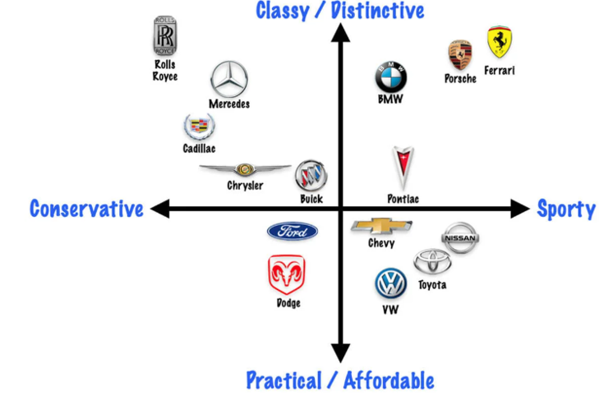
Figure 3 Perceptual Map of BMW
Source: (Jurevicius, 2024)
In the UK, BMW has higher prices with the higher quality and value in the markets. BMW has been competing with Ferrari and Porsche in the segments and the customers have perceived the value of the products of BMW as high quality with a higher price of the products.
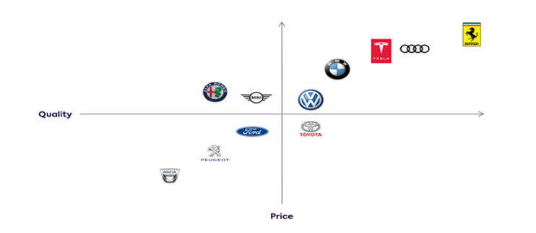
Figure 4 Perceptual map of BMW in Denmark
Source: (Bajra, 2021)
The figure represents the consumer perception of Denmark of BMW. The figure represents that BMW has been competing with Volkswagen, Tesla, Audi, and Mercedes-Benz, which has an impact on the mindset and preferences of consumers. However, BMW has been managing quality in products with higher pricing strategy in the markets. Compared to other markets such as Denmark, BMW has been able to strengthen its position in the UK through strong brand reputation, several localized strategies, a loyal customer base, and investment in electrification for the leadership, consistent brand experience and effective digital presence.

5. Marketing mix (7Ps) strategies in the UK and Denmark
The marketing mix is considered a strategic framework used by firms with controllable elements to market a product or service to the target customers by balancing these elements (Doole, Lowe and Kenyon, 2019). The Marketing mix 7Ps are applied by the companies as part of the business and marketing strategies and principles, considering the customer base and market types (Kotler et al., 2023). BMW has been operating in different countries while using marketing mix strategies based on the locations and customer groups. The marketing mix strategies of BMW in the UK and Denmark are as follows:
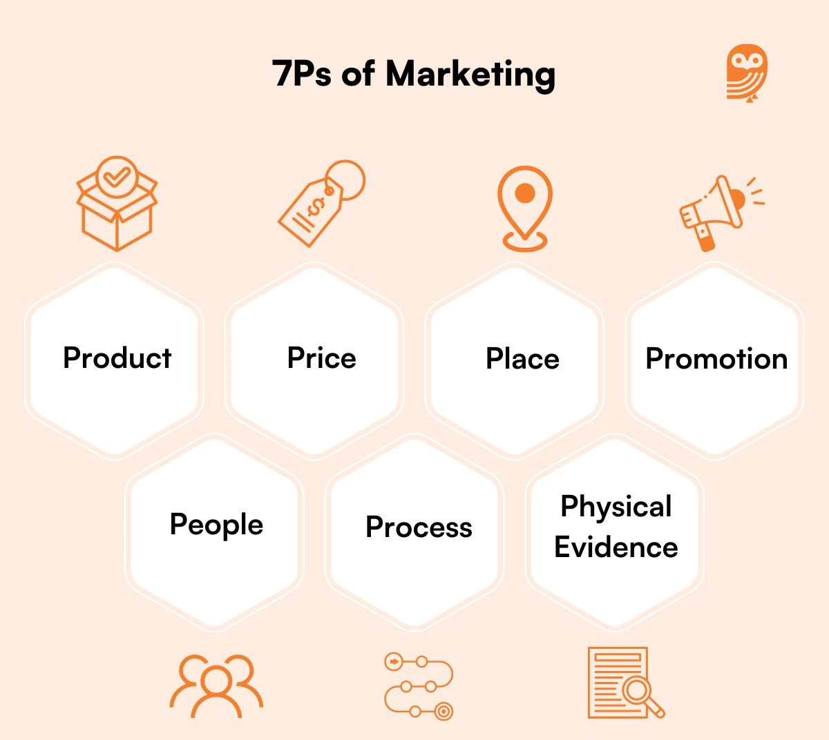
Figure 5 Marketing Mix
Source: (Goel, 2025)
Product of BMW in the UK and Denmark
Product ranges based on the customer groups are a significant element of the marketing mix (Hackley and Hackley, 2021). BMW is offering a range of luxury vehicles in the UK market with a strong priority on the innovative technology, design and performance of its business. The company focuses on the customization of the vehicles to meet individual needs and desires. BMW has reported the combined registration for vehicles totalling 172,240 units in the year 2024. There are strong demands available for BMW in the UK market (Press Release, 2025). On the other hand, in Denmark, BMW also offers a diverse range of cars and high-end vehicles such as luxury sedans, electric and hybrid models, and SUVs (X-series). The product strategy of BMW in Denmark mainly focuses on innovation, high-end technology, safety standards and working environment, while focusing on government policies and meeting the local demand of the customers and regulatory requirements.
Price of BMW in the UK and Denmark
Pricing strategy influences the sales volume, income level, and promotion of the organisations in the long run (Kotler et al., 2023). BMW is applying a premium pricing strategy for its products based on status, image, brand value, quality, and performance, where differentiated prices are managed based on models, features, and engine size. Similarly, BMW also employs a premium pricing strategy in Denmark and globally. In the Danish market, BMW has adapted to the tax structure, registration and rules that influence the car prices.
Place of BMW in the UK and Denmark
Place strategy allows organisations to deliver the services and products to the markets and customers (Kotabe and Helsen, 2022). The application of the place strategy also helps business organisations to enter into business markets. In the case of market entry mode in the UK, BMW has adopted a hybrid approach over time. It started with the exporting option and eventually, the entry model led to the establishment and management of wholly-owned sales and business (Kukkamalla et al., 2021).
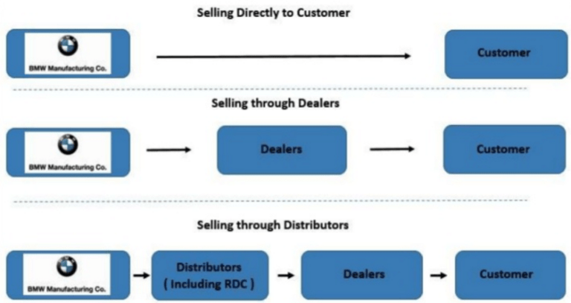
Figure 6 Distribution Channel strategy of BMW
Source: (The Marketing mix in the car industry, 2016)
On the other hand, BMW entered the Danish market with a dealership network and an independent importer. Gradually, BMW developed a dealership model, agency model, and sales subsidiaries. BMW handles distributions of the products and services through authorized franchised dealerships in both the UK and the Danish Market.
Market entry method: Internationally, in the UK and Denmark, BMW has been using different marketing strategies. Most of the time, BMW has focused on creating and managing a high-performance luxury brand image and positioning for the international marketing strategies (Kukkamalla et al., 2021). However, in the case of different markets, BMW has ensured to focus on different parts of the market, considering the market differences and customer groups. BMW has focused on the established brand value and position in the UK market with the larger and more established luxury car production (Kukkamalla et al., 2021). On the other hand, BMW has focused on more environmental policies, practices, and sustainability with customer support while dealing with Denmark’s market.
Promotion of BMW in the UK and Denmark
Business promotions help organisations to promote their brands and products and attract targeted customers (Kuraś, 2023). Effective promotional approaches influence the growth of business, performance level and opportunities for business in the new markets (Doole, Lowe and Kenyon, 2019). In the UK market, BMW uses a multi-faceted approach for the promotion and marketing of its products (Kukkamalla et al., 2021). Under multi-faced approaches, BMW uses traditional advertising, digital promotion, AR and high-profile brand sponsorships for the business promotion of the UK. In Denmark, BMW uses a mix of advertising strategies, digital marketing, public relation, and event marketing activities to focus on the luxury, quality, performance and brand equity. The company gives more importance to marketing activities to promote the brand and products globally.
People of BMW in the UK and Denmark
The manufacturing industries must have professionals and a skilled workforce to make changes in the business and marketing (Shtal et al., 2018). BMW has clearly focused on customer-centric service in both the UK and Danish market while working closely with retail partners. They invest in skills, knowledge and performance of the workforce to deliver high-quality products and services in markets. The BMW Group had a workforce of 159,104 employees globally (BMW Group, 2025).
Process of BMW in the UK and Denmark
The process in the marketing mix relates to the systems involved in the management and delivery of the products and services (Kotabe and Helsen, 2022). In the UK, BMW has always aimed for a better customer experience and a seamless customer experience journey. Thus, it integrates digital technologies into the business and marketing process for tailoring the available options for the customers. In the Danish market, BMW has managed streamlined processes and clear communication, customization and online appointment booking for the customers.
Physical Evidence of BMW in the UK and Denmark
The physical evidence represents the tangible aspects of the brand value and experiences for the business (Doole, Lowe and Kenyon, 2019). BMW has maintained quality, luxury, and design of the vehicles while reinforcing public image and brand value in both the UK and Danish markets. The sophisticated showrooms, physical and digital touchpoints and well-designed local dealerships have helped BMW to maintain its tangibility in the market.
Marketing mix | Similarities | Dissimilarities
Product | A diverse range of cars and high-end vehicles | In UK, BMW values customization and in Denmark, it values safety standards
Price | Premium pricing strategy | Less
Place | Less | BMW has adopted a hybrid approach with exporting option and wholly-owned sales in the UK and BMW entered the Danish market with a dealership network and an independent importer.
Promotion | Both online and offline marketing | BMW uses multi-faced approaches in the UK and mix of advertising strategies in Denmark
People | Investment in training | Less
Process | Customer experience and a seamless customer experience journey | Streamlined processes and clear communication
Physical evidence | Design, quality and luxury with well-design showrooms and dealership | Less

6. Evaluation of the performance of marketing strategies
Marketing strategies and activities of brands influence their growth, performance level and sale, profits and value in business markets (Kotabe and Helsen, 2022). BMW has applied quality and luxury in the product with premium pricing strategies to create and manage name and reputation. The application of marketing strategies globally has helped BMW to gain competitive advantages and higher revenue of business.
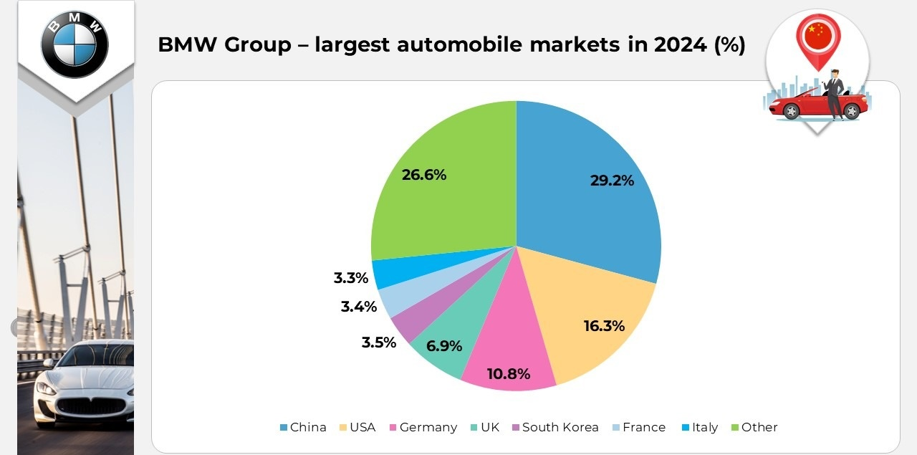
Figure 7 Largest markets of BMW
Source: (BMW, 2025)
The figure shows that the UK market has been the largest automobile market for BMW compared to other countries such as Germany, the USA, China and others.
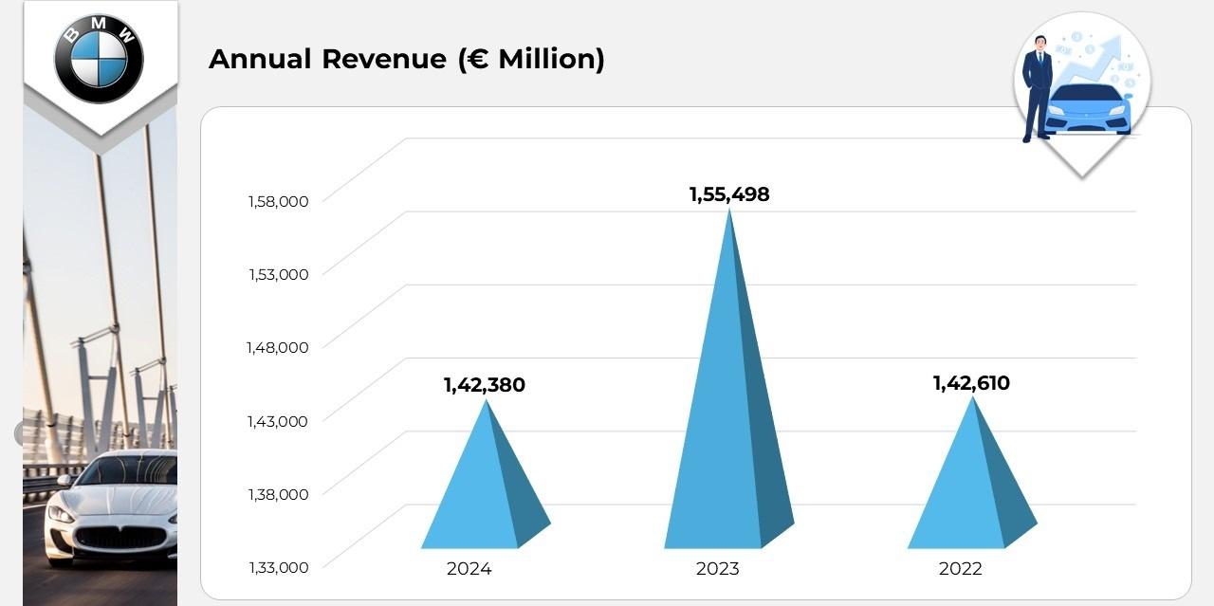
Figure 8 Annual revenue of BMW
Source: (BMW, 2025)
The figure represents that the annual revenue of BMW was higher in the year 2023. Based on the marketing of the brand, consumer spending patterns, GDP level and competitors’ products, the revenue of BMW has been influenced. However, marketing and promotional techniques and practices of BMW in the UK and Denmark have the impacts on the business performance and sale volume.
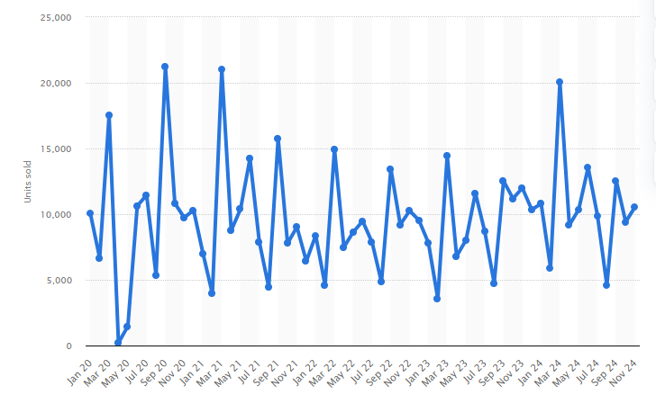
Figure 9 BMW Car sales of the UK from the year 2020 to 2024
Source: (Carlier, 2024)
The figure represents that BMW sold more than 1111,700 passenger cars in the UK in the year 2023 and the brand has been considered as the third most valuable automotive brand in the market. In the UK, the market share of the company was around 5.9 percent in the year 2023 and by the end of the year 2023, the market share had reached to 9.78 percent.

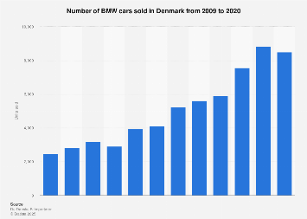
Figure 10 BMW car sales in Denmark
Source: (Carlier, 2025)
The figure shows that in the year 2020, the sales of cars from BMW in Denmark after having increased in sales. However, based on the marketing activities, sale and income level of BMW, the UK market has been highly profitable for the brand with effective marketing strategies and practices. The sale, income level, brand value, market share, consumer spending patterns and growth options of BMW have been effective in the UK with its marketing compared to the Danish market.

7. Ethical issues of the marketing mix
Ethical issues of the marketing mix and activities influence the brand value and performance in the long run (Arnold, 2009). Companies are expected to address ethical issues relevant to marketing and the marketing mix in the business (De Búrca et al., 2004). BMW has ensured to apply top-notch marketing strategies and marketing mix to promote the brand and improve sale of products. But the marketing mix of BMW in the UK has faced ethical issues.
The Unethical issue in the UK compared to Denmark
The ethical issues have been identified in the product ranges of BMW regarding product claims and advertising of the business. Compared to the Danish market, the UK has not given strict regulations for environmental protection and standards for the production and manufacturing of cars and vehicles. Misleading "Zero Emissions" Ads by the company have been censured under the ASA, or the UK's Advertising Standards Authority. The advertisements claimed certain vehicles had misleadingly "zero emissions". The emissions from the cars are still generated and hence, the advertisement has been censored. The organisations using misleading information or misinformation in the advertisement relates to the ethical issues in the marketing (Kaynak and Delener, 2019). The criticism has been faced again in the UK and Denmark for the broader marketing campaign of BMW, which claimed to be the world's most sustainable car producer in the markets. Without sufficient data and evidence, the promotional campaign again received criticism. In certain cases, the ethical issues in different business aspects can affect the marketing and business elements of brands. The significant legal and ethical issues in BMW have affected its market position and pricing strategies in the business markets.
The companies often deal with anti-competitive conduct under the rules and regulations in the business markets (Doole, Lowe and Kenyon, 2019). In the UK, BMW was fined by the UK's Competition and Markets Authority (CMA) for failing to act and provide evidence and information regarding the suspicion and during an investigation into the anti-competitive conduct. This is also related to the information and content in the marketing of BMW. Most of the time, BMW has faced ethical concerns and issues in its promotional and marketing mix areas. The organisations are expected to value data privacy and confidentiality while using them for marketing and promotional approaches (Murphy et al., 2017). The ethical issues have again been identified in BMW regarding data privacy and the use of customer information for business marketing purposes, where the data was gathered through e-commerce under UK law. However, the most common ethical issues in the marketing mix and activities of BMW involve a lack of transparency in environmental claims, conduct within the competition and consumer protection laws. The BMW has started to work on its responsibility while respecting environment-related standards, human rights and practices of the manufacturing. The standards and respect towards CSR and the environment have influenced the business activities and global supply chains with a wide range of different measures in the brands (BMW Group, 2025). Compared to findings, ethical choice for BMW has been Denmark where unethical has been the UK market.

8. Strategic Recommendations
BMW has already created its market position and value in the world despite facing different ethical issues and challenges. In both markets, BMW has gained its competitive advantages and market share. Still, BMW needs to work on different areas based on the available findings from the study. Some recommendations for the company are as follows:
STP Strategy: The organisation needs to position its brand value and market position as the leader in the sustainable car industry, green performance, quality full products, accessible luxury e-mobility, and local environmental commitments and supports. In both markets, BMW needs to improve its leadership while addressing and meeting the needs of locals. The positioning of BMW should shift towards the development of a premium electric car and mobility partner, while managing the environmental policies and aligning with rules and Denmark’s strong EV adoption.
New target market: In the UK market, BMW should focus on more target markets and demographics such as younger urban professionals who value innovation, technology, sustainability and status within affordable prices. In the meantime, the psychographic segmentation can also help BMW to target the growing group of consumers who value and have interests in sustainability and desire premium, quality, full and responsible vehicles. In Denmark, the automobile industry has to value and respect the green technology, environmental protection and sustainability in the markets. BMW should value sustainability and green technology while pursuing new market segments such as demographic and behavioural segmentation, such as mid- to high-income professionals, individuals and families who prefer eco-friendly products and innovation.
New Strategy: In the UK, BMW needs to work on a new strategy that includes the expansion of the business with flexible business models and financing. This can attract first-time luxury buyers while alienating inclusive audiences and promoting ethical marketing for the business. In the case of Denmark, BMW needs to work on the CSR while integrating practices and circular economy principles.

9. Conclusion
Business organisations in the automobile industry, while operating internationally, go through different issues and challenges where effective marketing strategies, practices and STP strategies, marketing mix and principles are needed (De Búrca et al., 2004). BMW has created its name and brand in more than 100 countries in the world while offering a range of products in markets. The findings have demonstrated different facts about BMW for managing the international business into the UK and Denmark. The PESTEL analysis findings have demonstrated the supportive business, legal, social and political business environment for BMW in both Danish and UK market. Most of the strategies of marketing and promotion, STP and others of BMW have been similar in the UK and Denmark. However, Denmark has been stricter on the environmental standards and practices for the automobile sector, where BMW has to face challenges and strict rules for marketing and manufacturing. On the other hand, the UK market has been a growing market with sales and income, market share, brand value and market positions of BMW compared to Denmark. Compared to Denmark, BMW has been able to target a diverse group of customers and maintain different types of advertising and marketing activities. Internationally, BMW has been working on CSR practice, respect towards environmental protection, and human rights while managing its manufacturing, production, operation, marketing and business.

References
Albrecht, M.G., Green, M. and Hoffman, L. (2023). Principles of marketing. OpenStax.
Arnold, C. (2009). Ethical marketing and the new consumer (1st ed.). Wiley.
Bajra, A. (2021). Using Perceptual Mapping for Competitive Analysis. [online] Medium. Available at: https://anupambajra.medium.com/using-perceptual-mapping-for-competitive-analysis-9aae239ec736. [Accessed 3 Nov. 2025]
BMW (2025). BMW AG Statistics and Facts. [online] Market.us. Available at: https://market.us/statistics/automotive-companies/bmw-ag/ [Accessed 3 Nov. 2025]
BMW Culture (2025). Our Culture. [online] Bmwgroup.jobs. Available at: https://www.bmwgroup.jobs/us/en/culture.html [Accessed 19 Nov. 2025].
BMW Group (2025). BMW Group. [online] Bmwgroup.com. Available at: https://www.bmwgroup.com/en.html. [Accessed 20 Oct. 2025]
BMW Group (2025). Respect for Human Rights at BMW Group. [online] www.bmwgroup.com. Available at: https://www.bmwgroup.com/en/sustainability/human-rights.html [Accessed 3 Nov. 2025].
Carlier, M. (2024). UK: BMW monthly sales volume | Statista. [online] Statista. Available at: https://www.statista.com/statistics/300405/bmw-car-sales-in-the-united-kingdom/?srsltid=AfmBOopxjQIyKsXx5AU4Ci7p7rodOUEf62fraqIrIPN70HQvQIJ1PaMf [Accessed 3 Nov. 2025].
Carlier, M. (2025). Denmark: BMW sales 2009-2020| Statista. [online] Statista. Available at: https://www.statista.com/statistics/413336/bmw-car-sales-in-denmark/ [Accessed 3 Nov. 2025].
De Búrca, S., Fletcher, R. and Brown, L. (2004). International marketing : an SME perspective. 1st ed. Harlow, England: FT Prentice Hall.
Doole, I., Lowe, R. and Kenyon, A. (2019). International Marketing Strategy: analysis, Development and Implementation. 8th ed. Andover: Cengage Learning.
Doole, I. and Lowe, R. (2012). International marketing strategy : analysis, development and implementation. Cengage Learning.
Goel, V. (2025). Mastering The 7 Ps Of The Marketing Mix For Your GTM Strategy - OrangeOwl. [online] Orange Owl - B2B Marketing Partner. Available at: https://orangeowl.marketing/gtm/7-ps-of-the-marketing-mix/. [Accessed 17 Dec. 2025]
Hackley, C. and Hackley, R.A. (2021). Advertising and promotion.
Hofstede, Geert (2001). Culture's Consequences: Comparing Values, Behaviors, Institutions and Organizations Across Nations. SAGE Publications.
Jurevicius, O. (2024). Perceptual Map Explained - SM Insight. [online] Strategic Management Insight. Available at: https://strategicmanagementinsight.com/tools/perceptual-map/ [Accessed 3 Nov. 2025].
Kaynak, E. and Delener, N. (2019). Ethical Issues in International Marketing. Routledge.
Keegan, W.J. and Green, M.C. (2013). Global marketing. 7th ed., global ed. Boston, Mass. ; London: Pearson.
Kotler, P., Armstrong, G. (Gary M.), Balasubramanian, S., & Kotler, P. (2023). Principles of marketing. (Nineteenth edition / Philip Kotler, Gary Armstrong, Sridhar Balasubramanian.). Pearson.
Kotabe, M.M. and Helsen, K. (2022). Global marketing management. John Wiley & Sons.
Kukkamalla, P.K., Bikfalvi, A. and Arbussa, A. (2021). The new BMW: business model innovation transforms an automotive leader. Journal of Business Strategy, 42(4), pp.268-277.
Kuraś, P. (2023). ENTRY MODES USED IN THE INTERNATIONALIZATION PROCESS OF AUTOMOTIVE ENTERPRISES. Scientific Papers of Silesian University of Technology. Organization & Management/Zeszyty Naukowe Politechniki Slaskiej. Seria Organizacji i Zarzadzanie, (180).
Murphy, P. E., Laczniak, E. R., & Harris, F. J. (Fiona J. (2017). Ethics in marketing : international cases and perspectives. (Second edition.). Routledge.
Nickerson, C. (2025). Hofstede’s Cultural Dimensions Theory & Examples. [online] Simply Psychology. Available at: https://www.simplypsychology.org/hofstedes-cultural-dimensions-theory.html. [Accessed 3 Nov. 2025]
Press Release (2025). BMW Group UK Leads the Premium Segment in 2024 with Strong Electric Growth. [online] BMW Group PressClub. Available at: https://www.press.bmwgroup.com/united-kingdom/article/detail/T0447261EN_GB/bmw-group-uk-leads-the-premium-segment-in-2024-with-strong-electric-growth?language=en_GB [Accessed 3 Nov. 2025].
Segura, E., Belmonte, L.M., Morales, R. and Somolinos, J.A. (2023). A strategic analysis of photovoltaic energy projects: The case study of Spain. Sustainability, 15(16), p.12316.
Shtal, T.V., Buriak, M., Ukubassova, G., Amirbekuly, Y., Toiboldinova, Z. and Tlegen, T. (2018). Methods of analysis of the external environment of business activities.
The Marketing mix in the car industry (2016). Place BMW. [online] The Marketing mix in the car industry. Available at: https://themarketingmixweb.wordpress.com/2016/11/23/blog-post-title-2/. [Accessed 3 Nov. 2025]
Worlddata.info (2025). Country comparison: Denmark / United Kingdom. [online] Worlddata.info. Available at: https://www.worlddata.info/country-comparison.php?country1=DNK&country2=GBR [Accessed 19 Nov. 2025].

