Project Management Plan
Managing Projects in the Workplace
BMSW5104
Student: Livia Monica Dragan (2130234)
Lecturer: Aderemi Ojebode

Executive summary:
This report outlines the proposal for a children's club within a gym premises, with the primary goal of providing convenient childcare for gym members. The target market includes families with young children, working parents, and parents with an interest in fitness. Key findings from the report indicate that the Kids’ Club is a viable venture, with the potential for strong financial performance. Recommendations for successful implementation include targeted marketing strategies, efficient operational planning, and a focus on future growth.

Table of Contents
Introduction 1
Project Description 1
Scope 2
Work Breakdown Structure 4
Quad Chart 5
Gantt Chart 6
Allocation of resources 7
Risk Analysis 8
Conclusion 9
References 11
Appendix 13

Introduction
A project serves as a vehicle for driving change within an organization, facilitating the transition from one state to another. Projects accomplish this shift by producing a clearly defined deliverable service that improves the organization's ability to operate in its new state. Project management encompasses a comprehensive framework of values, principles, processes, and techniques utilized by the project management team to ensure project success. This involves addressing five key questions throughout the project's lifecycle: who needs to be involved, what deliverables are required, when must they be delivered, how much investment is needed, and why the project is necessary. Establishing clear roles, responsibilities, and reporting structures is crucial for effective project direction. The project must deliver specified deliverables, with timelines and budgets clearly defined and integrated into the project plan. Justifying the project's necessity through a compelling business case is essential. According to Roberts (2011), commissioning, management, funding, specification, building, testing, and delivery are all made easier in a supportive corporate setting.
This report provides a detailed examination of the planning, execution, and impact of launching childcare services at XYZ Gym. It starts by evaluating the present market environment and trends to pinpoint preferences and competitive standards. This understanding helps XYZ Gym position itself effectively and offer distinct services. A subsequent needs assessment investigates the specific childcare needs of XYZ Gym's members, allowing for customized services that boost member satisfaction. The report further describes the strategic planning process, including facility layout, staffing, safety measures, and operational logistics. Effective planning across all aspects is crucial for the seamless integration and exceptional service of the XYZ Gym Kids Club. By addressing these aspects, XYZ Gym mitigates potential risks and capitalizes on growth prospects. Following project completion, the organization assesses the project's success in realizing its intended benefits.

Project Description
The XYZ Gym Kids Club project is an innovative response to shifting consumer preferences and declining membership rates at XYZ Gym. The XYZ Gym Kids Club project is strategically located within a busy mixed-use complex that includes retail, entertainment, and residential areas. This vibrant environment attracts families who value convenience, accessibility, and a diverse range of amenities. In the UK, XYZ Gym holds a unique position in the market as the only gym nationwide to offer childcare services. This absence of competition highlights the groundbreaking nature of the project and presents an opportunity for XYZ Gym to establish itself as a pioneer in providing inclusive wellness solutions to its members.
This initiative provides gym members with young children a reliable, engaging, and affordable childcare option, enabling them to concentrate on their fitness goals while ensuring their children receive quality care.

With a focus on addressing the needs of families, the Kids Club project will play a vital role in promoting member retention, attracting new members, and solidifying XYZ Gym's position as a leader in the UK's fitness industry.
Figure 1. Kids Club @ XYZ Gym - Logo

Scope
A comprehensive project scope outlines the tasks to be executed, their respective deadlines, and the budget assigned to them. The XYZ Gym Kids Club project objective is to establish a top-quality childcare service seamlessly integrated into the existing gym infrastructure.
The project's scope encompasses several critical components:
Renovation of a dedicated space within the gym premises to cultivate a secure, stimulating, and child-friendly environment. This includes the acquisition of age-appropriate equipment, toys, and furnishings, alongside the implementation of essential safety measures.
The Kids Club will enlist skilled and certified childcare professionals, ensuring the delivery of exceptional care and tailored activities for children. Comprehensive training programs will be developed and executed to equip staff with the necessary skills and knowledge.
Adherence to all pertinent local and state regulations governing childcare facilities, encompassing the procurement of requisite permits and certifications. Stringent policies and procedures will be established to maintain regulatory compliance.
Strategic marketing campaigns will be developed to increase awareness of the Kids Club among gym members and the broader community. Initiatives may include promotional events, targeted advertising campaigns, and collaborations with local organizations.
Staff evaluations and user feedback channels are used to continuously assess and improve services. The Kids Club maintains a high standard of care and is responsive to changing needs thanks to this iterative approach.
The project cycle overview for the XYZ Gym Kids Club project unfolds in several key phases:
Initiation: The project commences as a response to the identified necessity for accessible, cost-effective, and premium childcare amenities catering to gym members with young children. During this phase, clear project objectives, deliverables, and a project team are established to lead the project.
Planning: A meticulous project plan is created, outlining crucial milestones, resource allocation, role delineation, and a well-defined timeline. This phase also encompasses a comprehensive risk assessment and the formulation of strategies to mitigate potential challenges.
Execution: The project plan is put into action, with the project team undertaking various tasks and activities encompassing facility modifications, staff recruitment and training, compliance and licensing procedures, marketing initiatives, and the initiation of ongoing operations. Continuous monitoring ensures alignment with project objectives, with adjustments made as necessary to maintain the course.
Monitoring and Control: This phase is characterized by vigilant oversight, with the project team tracking progress, assessing performance indicators, and responding to any changes or emerging difficulties. Among the main aspects being examined are financial performance, customer happiness, and regulatory compliance.
Closure: After the project is successfully finished, the Kids Club facility is formally opened, marking the start of business operations. A thorough evaluation is carried out at the end of the project to determine its overall performance, record significant findings, and identify areas that could use improvement in the future.
The application of this project cycle overview ensures a systematic and thorough approach to the XYZ Gym Kids Club project, culminating in the establishment of a sustainable and highly effective childcare solution for the benefit of gym members and their families.

Work Breakdown Structure
Developing a Work Breakdown Structure (WBS) involves breaking down project deliverables and work into smaller, more manageable parts. As highlighted by Cerezo-Narváez et. al (2020) the primary advantage of this process is that it establishes a structured framework outlining the required activities and deliverables, ensuring the successful implementation of childcare services and the seamless integration of the Kids Club into the gym's operations.
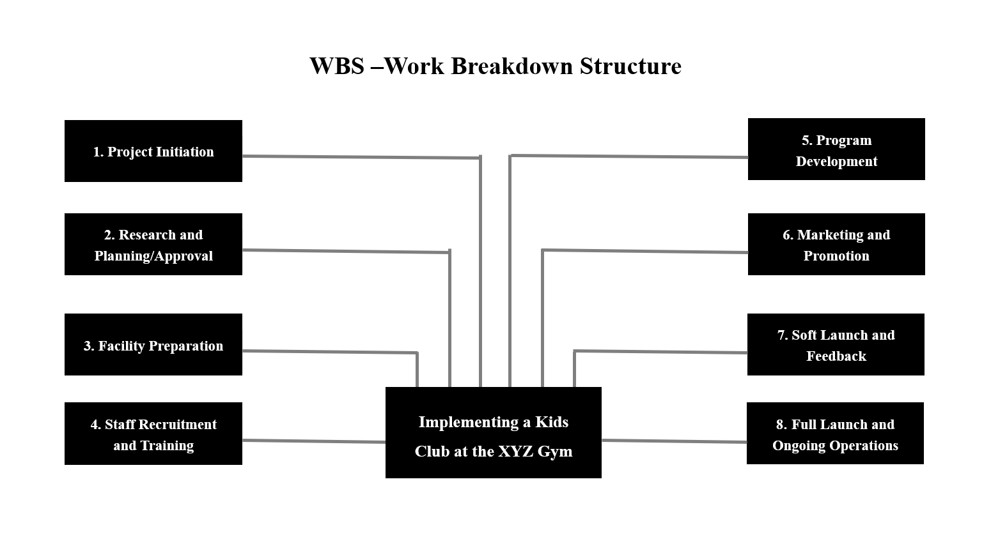
Figure 2. Work breakdown structure (WBS)
The Kids Club project begins with Project Initiation, where the project's overarching objectives and scope are defined, key stakeholders are identified, and a comprehensive project charter is developed to formalize project initiation. Following this, the Research and Planning/Approval phase involves conducting market research, analyzing existing childcare offerings, and obtaining necessary approvals and permits. Facility Preparation entails assessing gym facilities, renovating designated areas, and ensuring compliance with childcare standards. Staff Recruitment and Training involve defining staffing requirements, recruiting qualified professionals, and implementing a comprehensive training program. Program Development focuses on designing age-appropriate activities, establishing policies, and implementing health and safety protocols. Marketing and Promotion involve developing marketing materials, launching advertising initiatives, and fostering partnerships. The Soft Launch and Feedback phase includes conducting a trial run, gathering feedback, and making necessary adjustments. Finally, the Full Launch and Ongoing Operations phase involves officially unveiling the Kids Club, implementing ongoing management procedures, and continuously monitoring and evaluating its performance.

Quad Chart
A quad chart is a concise visual representation that divides a subject or project into four sections, each concentrating on a specific facet, enabling clear and efficient communication of complex information.
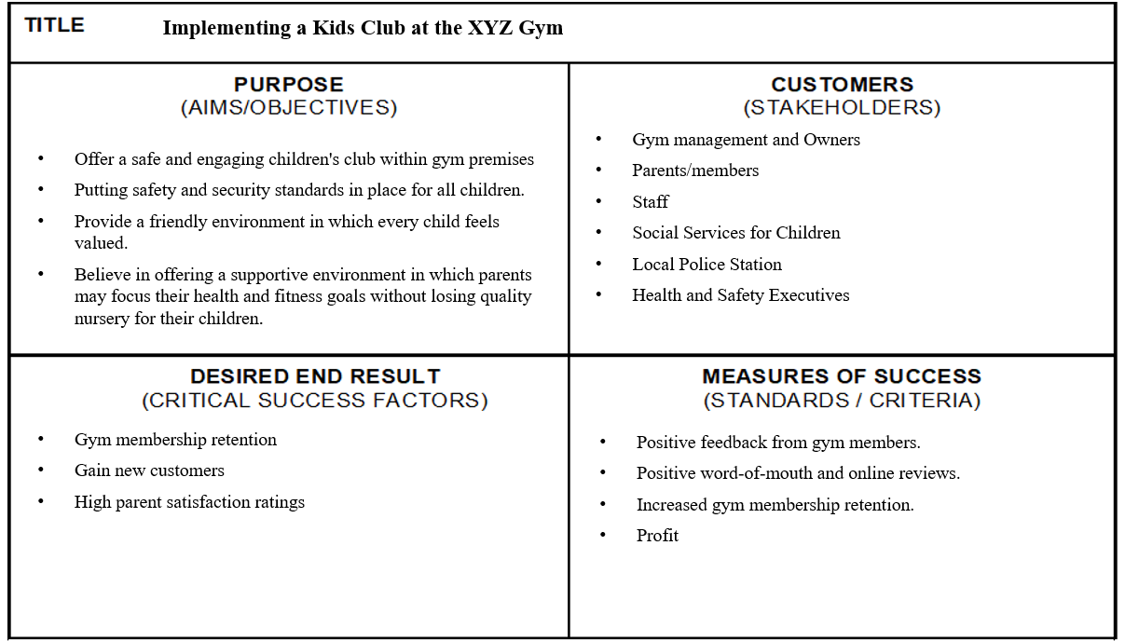
Figure 3. Quad Chart
The XYZ Gym Kids Club Project aims to establish a secure and engaging children's facility within the gym premises, meeting the growing demand for reliable childcare services among members. Emphasizing safety and inclusivity, the project strives to create a welcoming environment where every child feels valued while their parents pursue fitness goals. Key objectives include implementing rigorous safety standards, fostering social and emotional development, and providing parents peace of mind.
Stakeholders include gym management, parents, staff, social services, local authorities, and health and safety executives, each playing a crucial role in project success. Desired outcomes include high parent satisfaction, gym membership retention, and new customer acquisition, measured by positive feedback and increased profitability.

Gantt Chart
The Gantt chart, a widely used project management tool, presents project tasks and their durations in a bar chart format, simplifying the monitoring of activity progress and resource allocation. Its benefits include time savings, improved resource planning, and enhanced transparency for both team members and stakeholders (Kessler, 2013). This project starts on 1 March and ends on 1 July.
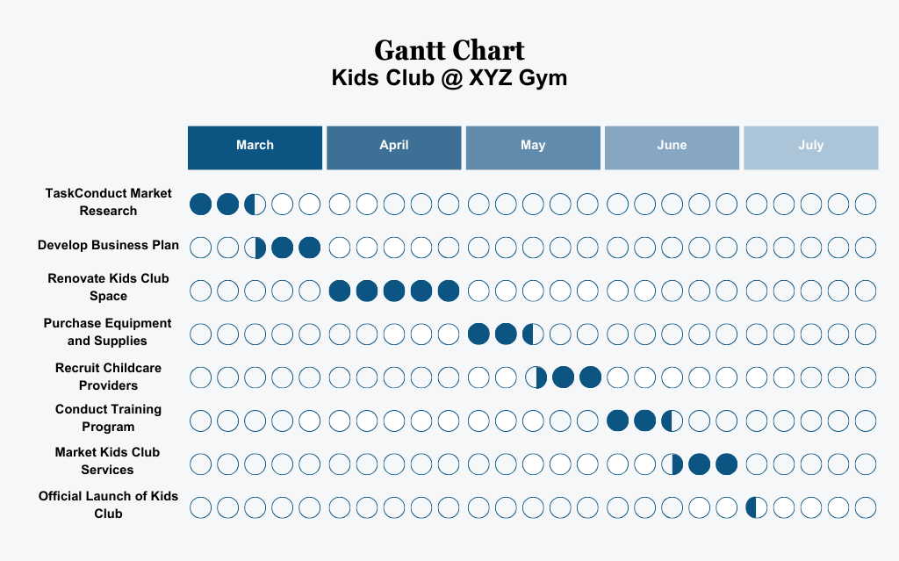
Figure 4. Gantt Chart
The Gantt chart for the XYZ Gym Kids Club Project offers a concise visualization of the project's timeline and milestones across its phases. It serves as a crucial planning instrument, facilitating progress tracking, resource allocation, and dependency management.
The project unfolds through five main phases, each represented in the Gantt chart. Firstly, the Planning and Research phase involves market analysis to inform the creation of a robust business plan. Following that, the Facility Setup phase entails renovating designated spaces and procuring necessary equipment for the Kids Club facility.
Subsequently, the Staff Hiring and Training phase focuses on recruiting qualified personnel and delivering comprehensive training programs. The Launch and Promotion phase follows, encompassing marketing efforts and the official Kids Club launch.
Lastly, the Ongoing Operations phase emphasizes continuous feedback gathering and operational refinement, ensuring sustained quality and efficiency. The Gantt chart's clarity aids in effective planning, coordination, and monitoring throughout the project's lifecycle.
Stakeholders' involvement
Stakeholder engagement should begin early in the project and continue throughout its lifecycle, ensuring that a clear vision for the Kids' Club is established and communicated (PMBOK guide, 2021).
For the successful implementation of the Kids’ Club at XYZ Gym, it is crucial to identify, analyze, and engage with a diverse range of stakeholders, both internal and external to the organization, as follows:
Gym Management and Owners: Strategic planning and decision-making for seamless alignment with gym operations.
Gym Staff: Enhance daily operations and service quality, including childcare provision.
Parents: Drive demand for accessible childcare services, influencing Kids' Club offerings.
Children: Their well-being is prioritized through tailored activities and programs.
Local Community: Benefits from family-friendly amenities, providing feedback on impact.
Planning Authority: Oversees regulatory compliance and permits for Kids' Club operations.
Social Services for Children: Safeguards children's welfare, guiding Kids' Club policies.
Local Police Station: Guides safety measures and emergency procedures for security.
Health and Safety Executives: Enforce regulations to protect children and staff.

Allocation of resources
Effectively managing the XYZ Gym Kids' Club to provide outstanding childcare services that cater to the needs of children, parents, staff, and the broader community necessitates comprehensive planning and strategic allocation of resources in several key areas. Financial resources are designated for initial setup costs and ongoing operational expenses. Human resources include trained childcare providers, administrative staff, and facility maintenance personnel. Physical resources entail dedicated space, age-appropriate furniture, toys, and learning materials. Technological resources support administrative operations and customer interactions. Marketing resources are allocated for promotional activities and materials to raise awareness about the Kids’ Club. Training and development programs ensure staff members are equipped with the necessary skills. Time resources are managed through established timelines and schedules for effective implementation.
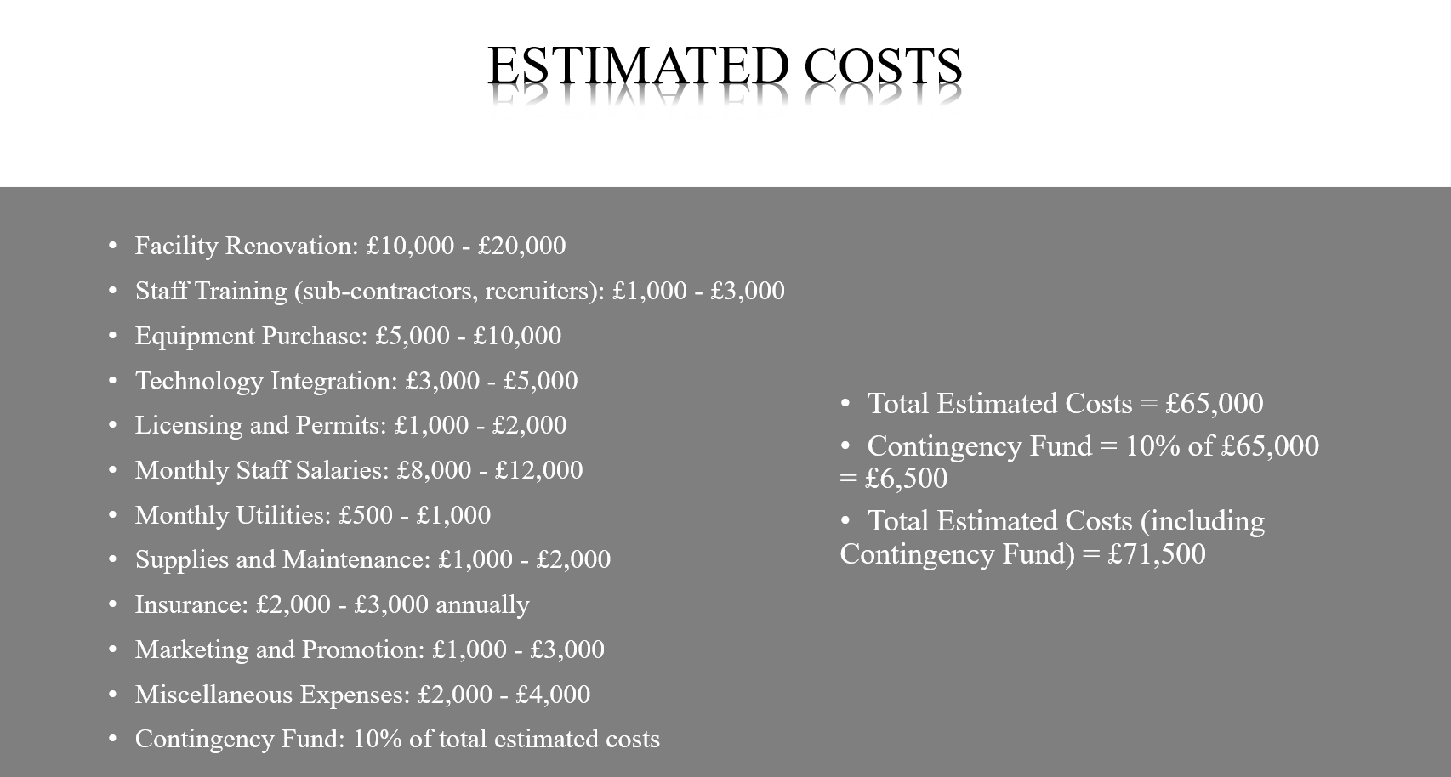
Figure 5. Allocation of the resources for the project

Risk Analysis
The process of risk management involves more than just detecting possible hazards; it also includes formal planning, risk analysis to evaluate impact and probability, response strategy formulation, and continuous monitoring and control. Adopting a consistent and systematic approach to risk management helps organizations actively manage potential challenges (Kerzner, 2009). The XYZ Gym Kids Club project, like any business venture, faces potential risks that must be proactively addressed to ensure success. Three key risks have been identified: low demand for services, employee retention, and regulatory compliance.
In the event of low demand for the Kids Club services, a contingency plan has been developed. This plan includes implementing trial promotions to attract new customers, identifying cost reduction strategies or securing additional funding, and introducing more family-friendly programs within the gym to create a more appealing environment and incentivize membership.
Retaining experienced childcare workers is essential to maintaining high-quality care. To mitigate the risk of employee turnover, a robust recruitment and retention plan has been established. This plan focuses on offering competitive compensation and benefits packages, providing opportunities for career advancement and professional development.
Compliance with regulations for operating a kids' club can be challenging, as it involves obtaining licensing, adhering to safety standards, and maintaining appropriate staff-to-child ratios. To ensure full compliance, the Kids Club will collaborate with legal and regulatory experts, allocate sufficient time and resources to obtain necessary permits and certifications, and regularly review and update policies and procedures to remain in line with any changes in legislation.
The Iron Triangle concept, comprising time, cost, and scope, forms the foundation of project management, illustrating the interdependent relationship between these three constraints. Time refers to the project's duration, cost represents the financial resources allocated, and scope outlines the project's objectives and deliverables. The success of the project depends on maintaining a balance between these limitations because adjustments to one often affect the others. Achieving a balance between time, cost, and scope by carefully managing compromises and upholding project quality is crucial for the Kids Club project's success.
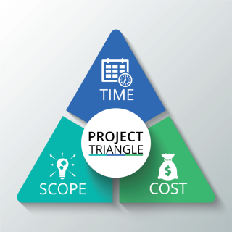
Figure 6. Iron Triangle

Conclusion
The XYZ Gym Kids Club project presents a compelling solution to address declining membership rates and cater to the evolving needs of families. By establishing a high-quality, conveniently located childcare service within the gym, the project offers significant benefits for both the gym and its members.
A comprehensive project scope has been outlined, encompassing key areas like facility renovation, staff recruitment and training, regulatory compliance, and marketing initiatives. The project lifecycle will be meticulously managed through well-defined phases, ensuring a systematic approach from initiation to ongoing operations.
Stakeholder engagement is paramount to project success. Open communication and collaboration with all relevant parties, including gym management, parents, staff, and regulatory bodies, will be instrumental in achieving project goals.
Resource allocation will be strategically planned, encompassing financial resources, human resources, physical resources, technological resources, marketing resources, training and development programs, and time management.
Potential risks, such as low demand, employee retention, and regulatory compliance, have been identified and mitigated through the development of contingency plans.
The project acknowledges the importance of the Iron Triangle – the interrelated aspects of time, cost, and scope – in project management. Careful consideration will be given to balancing these constraints to ensure project success within the established timeframe and budget while delivering on the project's objectives.
The XYZ Gym Kids Club project has the potential to position XYZ Gym as a leader in the fitness industry by offering a unique and in-demand service to its members. Through careful planning, execution, and ongoing monitoring, this innovative XYZ Gym can ensure that the Kids Club initiative not only meets its immediate objectives but also delivers lasting value to its members and the broader community, positioning it for long-term success and positive impact.

References
“The Essentials of Project Management - By Dennis Lock” (2008) British Journal of Educational Technology, 39(6), pp. 1147–1147. Available at: https://doi.org/10.1111/j.1467-8535.2008.00908_21.x.
A guide to the project management body of knowledge (PMBOK guide). 6th edition. (2017). Newtown Square, Pennsylvania: Project Management Institute.
Akintoye, A.S. and MacLeod, M.J. (1997). Risk analysis and management in construction. International journal of project management, 15(1), pp.31-38.
Buttrick, R. (2009) The project workout: the ultimate handbook of project and program management. 4th ed. Harlow, England: FT Prentice Hall.
Cerezo-Narváez, A. et al. (2020) “Integration of Cost and Work Breakdown Structures in the Management of Construction Projects,” Applied Sciences, 10(4), pp. 1386-. Available at: https://doi.org/10.3390/app10041386.
Frame, J.Davidson. (2002) The new project management tools for an age of rapid change, complexity, and other business realities. 2nd ed. San Francisco, CA: Jossey-Bass.
Heagney, J. (2016) Fundamentals of project management. Fifth edition. New York: AMACOM, American Management Association.
Jameson, Helen. and Watson, Madeline. (1998) Starting and running a nursery: the business of early years care. Cheltenham: Stanley Thornes.
Kerzner, H. (2009). Project management: A systems approach to planning, scheduling, and controlling (10th ed.). Hoboken, NJ: Wiley.
Kessler, E.H. (ed.) (2013) Encyclopedia of management theory. Thousand Oaks: SAGE Publications.
Kunreuther, H. et al. (2019) The Future of Risk Management. Edited by H. Kunreuther, R.J. Meyer, and E.O. Michel-Kerjan. Philadelphia: University of Pennsylvania Press. Available at: https://doi.org/10.9783/9780812296228.
McPhee, W. and Dias, S. (2020) Integrating sustainability on major projects: best practices and tools for project teams. 1st edition. Hoboken, New Jersey: Wiley.
Meredith, J.R., Shafer, S.M. and Mantel Jr, S.J. (2017). Project management: a strategic managerial approach. John Wiley & Sons.
Morris, P.W.G., Pinto, J.K. and Söderlund, Jonas. (2011) The Oxford handbook of project management. Oxford: OUP.
Müller, R. and Jugdev, K. (2012) “Critical success factors in projects: Pinto, Slevin, and Prescott – the elucidation of project success,” International Journal of Managing Projects in Business, 5(4), pp. 757–775. Available at: https://doi.org/10.1108/17538371211269040.
Project management: concepts, methodologies, tools, and applications (2016). Hershey, Pennsylvania: Business Science Reference. Available at: https://doi.org/10.4018/978-1-5225-0196-1.
Roberts, P. (2011) Effective project management. London; Kogan Page.
The standard for project management and a guide to the project management body of knowledge (PMBOK guide). 7th ed. (2021). Newtown Square, Pa: Project Management Institute.
Watson, M. (2006). Managing smaller projects: A practical guide. Multi-Media Publications Inc.
Wysocki, R.K., Kaikini, Sarah. and Sneed, Ryan. (2014) Effective project management: traditional, agile, extreme. Seventh edition. Indianapolis, Indiana: Wiley.
Zhang, Y. and Fan, Z.-P. (2014) “An optimization method for selecting project risk response strategies,” International Journal of Project Management, 32(3), pp. 412–422. Available at: https://doi.org/10.1016/j.ijproman.2013.06.006.

Appendix


