Camera Controls

Prep
- Battery – Full charge and consider taking a spare
- Turn the Dioptric Adjustment dial until the AF points in the viewfinder look sharp.
- Compact Flash cards – Label towards you, end with the small holes into the camera
- SD Cards – Unlock the write-protect switch to enable writing and erasing
- Format the SD or CF card

Image Quality
- RAW
- JPEG – Large, Medium, Small (all with high or lower quality)
- RAW plus JPEG
- If using Capture One in the studio you can save the images as DNG (Digital Negative Format) a universally read raw file format

Colour Space
- sRGB
- Adobe RGB

Exposure Modes
- Auto Modes
- Programme Mode – you can fine tune the exposure
- Shutter Priority – Freezing action / slowing down time
- Aperture Priority – Controlling depth of field
- Manual

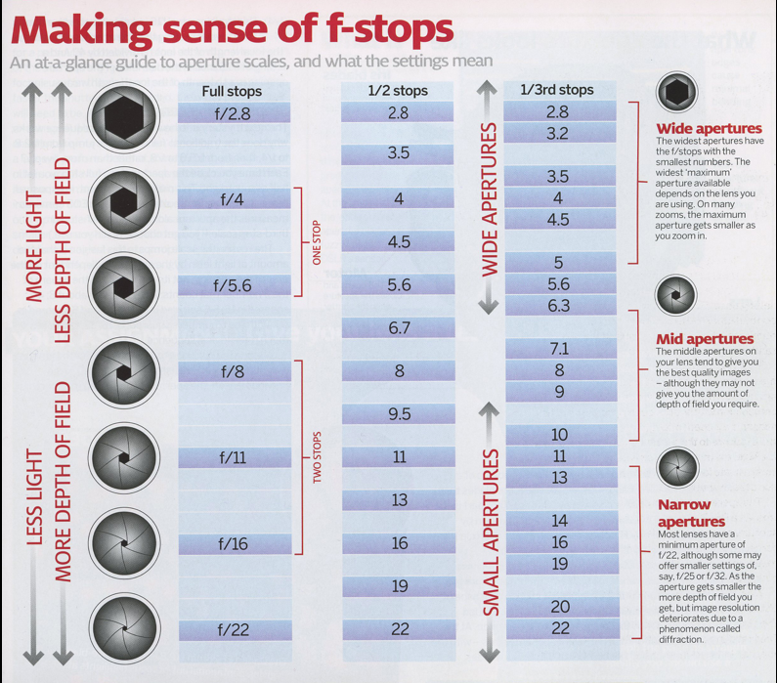
Camera Sensor Size
- The choice of lens is affected by the size of your sensor.
- The sensor is where your image is recorded before being processed and saved to the card.
- Canon for example produces cameras with 2 types of sensor, Full Frame in the professional range and APS-C in the rest of their cameras.
- The type of sensor affects the field of view and the focal length of the lens

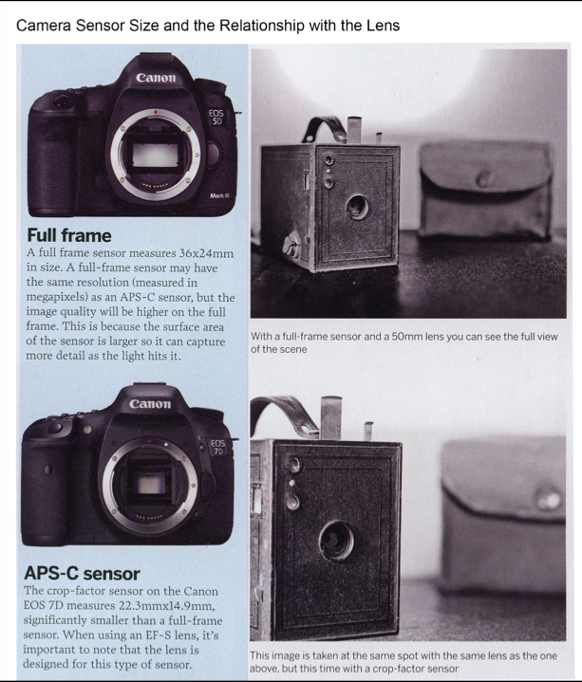
The top camera is Canon 5D MK lll, The bottom camera is Canon 7D both fitted with a 50mm lens. The 7D image is narrower because the sensor is smaller so cuts into the view of the lens. The 50mm lens becomes the equivalent of an 80mm lens on the cropped sensor.

Calculation of Equivalent View
- Take the focal length of the lens e.g. 50mm
- Multiply by the “crop factor” in this case 1.6 (the crop ratio of how much smaller the crop-factor sensor is compared to the full frame)
- So, 50 x 1.6 = 80mm equivalent view
- All canon APS-C cameras have a 1.6 crop factor.

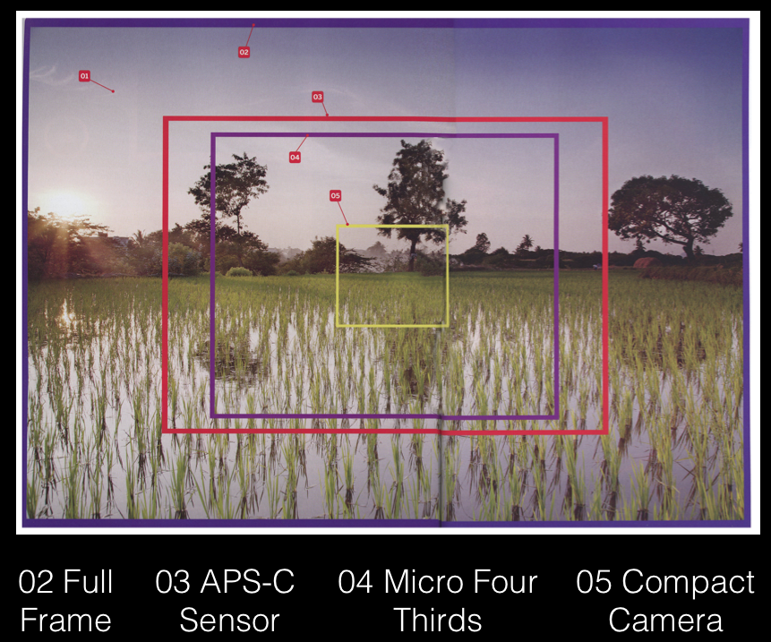

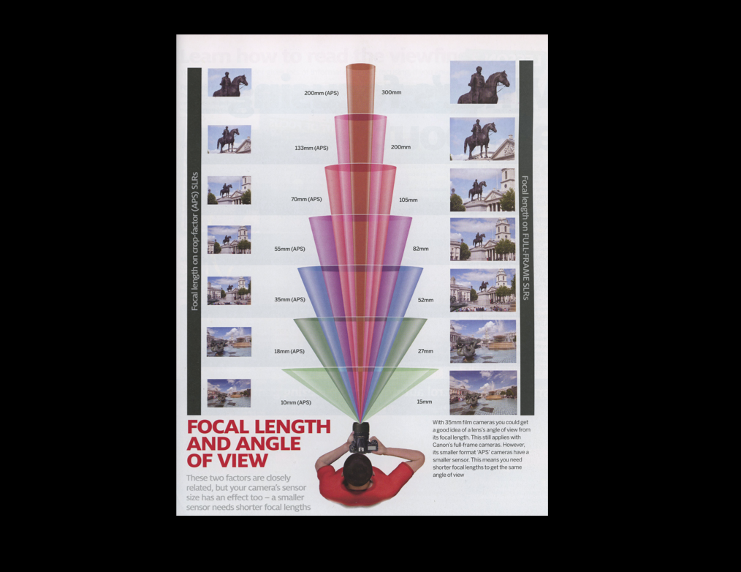

ISO
- The ISO relates to the cameras sensitivity to light.
- Digital advantage over film is the ISO can be altered for each shot.
- The minimum standard ISO is 100, the maximum depends on the camera.
- Generally, the higher the ISO the greater the amount of noise in your image.
- You only need to use a high ISO in low light if the camera is hand held or the subject moving. Otherwise use a tripod and lower ISO

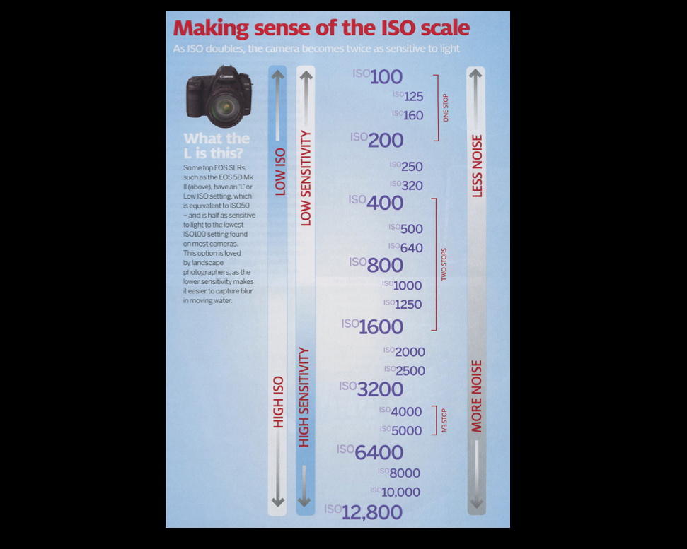

ISO Speed Guide
- L, 100-400 Sunny outdoors
- 400-1600 Overcast skies / Evening time
- 1600-25600, H1, H2 Dark indoors / Night

- FLASH – The higher the ISO speed the farther the flash will extend

White Balance
- Every type of light produces a colour temperature.
- The setting woks by adding another colour to remove the cast being created by the ambient light.
- The aim is to get a result where the scene appears neutral, as the eye would perceive it.
- Shooting in RAW will give more options later.

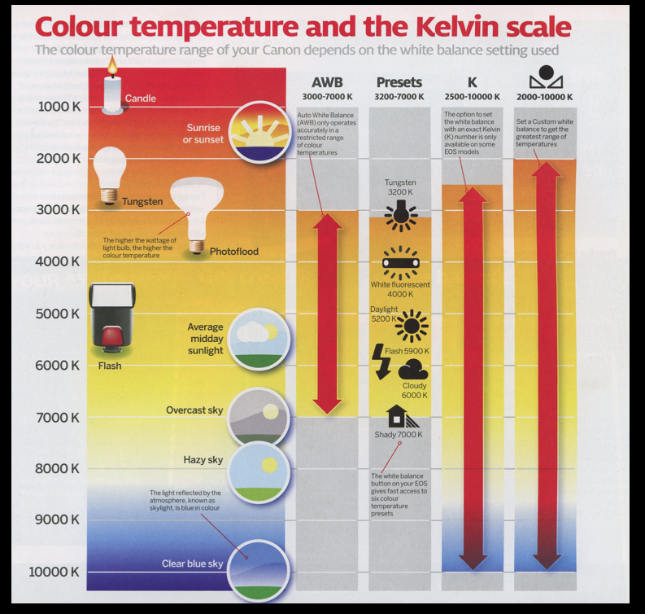

Custom White Balance
- Take a shot of a white piece of paper in the lighting you are working with, making sure the white fills the screen.
- Press the menu button and search for Custom White Balance and press SET
- The picture you have just taken will be shown on screen, now press SET
- Your new custom white balance is now created. To use this, set the white balance mode to the CUSTOM WHIT BALANCE option.

Histogram
- The standard histogram plots the brightness / luminosity of every pixel in the picture.
- The brightness is measured on a 256- step scale (the number of permutations available in a JPEG digital image)
- Avoid an image where the graph is stacked to the extreme left or right, indicating detail has been lost or clipped in the shadows or highlights


