Student Name: Shivani Bharatbhai Patel
Student ID:2508120
Programme:
MSc Public Health and Social Care in Practice
Module Code:
LCHS7003
Module Title:
Community Care and Management of Longer-term Conditions
Assessment Title:
Component 1 – Information Booklet of Long-Term Condition Management
Lecturer:
Raheela Shaikh
Submission Date:
27 February 2026

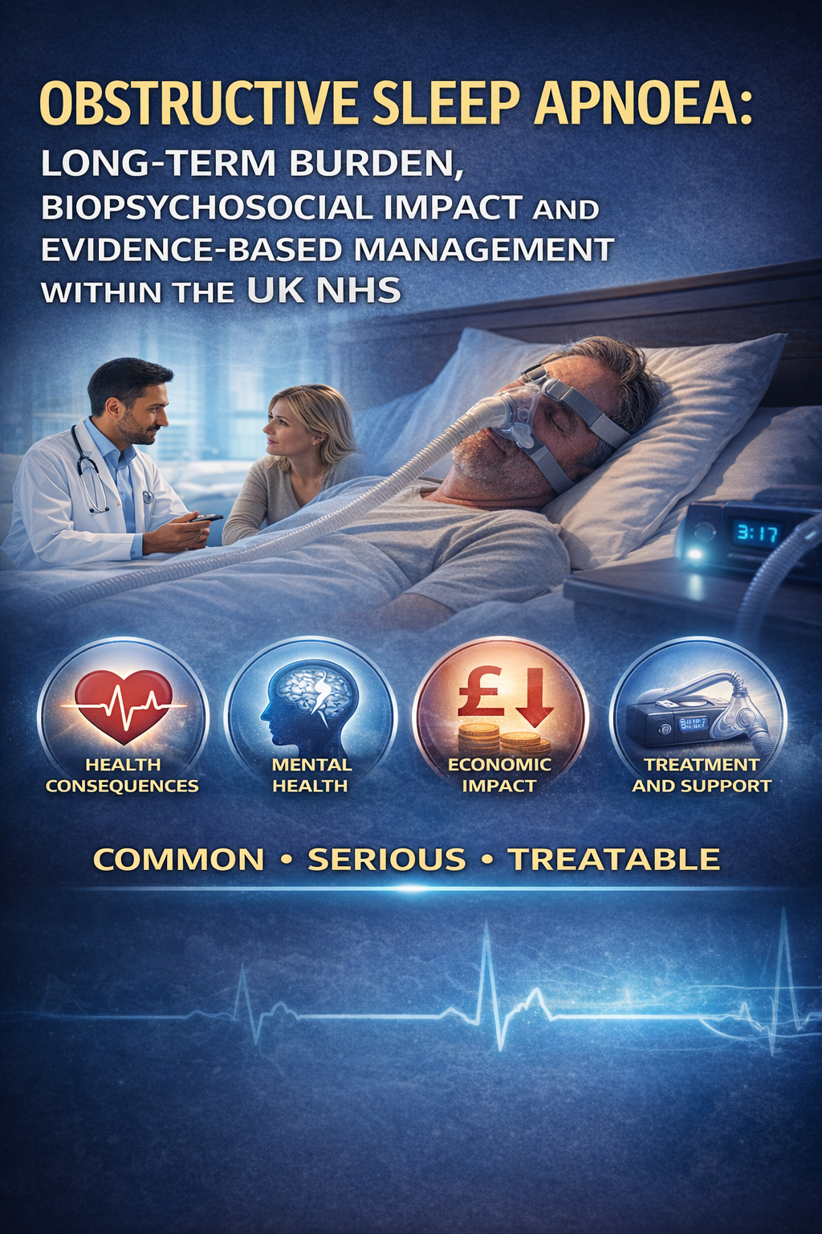

Table of Contents
1. Introduction 3
2. Definition of Obstructive Sleep Apnoea 3
3. Global and UK Burden and Prevalence 4
4. Aetiology 5
5. Types of Sleep Apnoea 5
6. Risk Factors 6
7. Signs and Symptoms 7
8. Physical, Psychological and Social Impact 7
9. Evidence-Based NHS Management 8
10. Summary 10
References 11

1. Introduction
Obstructive sleep apnoea (OSA) is a long-term and often underdiagnosed sleep-related breathing disorder that is marked by periodic blockage of the airways at the upper parts of the body while asleep and the proposition of nocturnal intermittent hypoxia and disrupted sleep patterns, accompanied by extensive systemic impacts (Lyons, 2020; Iannella et al., 2025).
It is estimated that the worldwide prevalence of OSA has been large and growing due to the ageing population and the rising prevalence of obesity, causing cardiovascular and metabolic and neurocognitive morbidity and broader socioeconomic burden (Zappalà et al., 2025; Lyons, 2020).
In the United Kingdom, a rising prevalence is evidenced by studies that show that population-based studies indicate a rise in incidence and on prevalence recorded in the primary care, which leads to both increased awareness and under-recognition of the condition in routine care (Strongman et al., 2026; Ali et al., 2025).
OSA is identified as a chronic illness that needs well-organized evaluation, intervention and follow-ups within dedicated sleep care services, which is acknowledged by national guidelines, such as NICE guidelines and NHS-based information pathways (NICE, 2021; NHS, 2022).
An additional economic and humanistic cost, which includes excessive drowsiness during the day and decreased productivity, adds additional pressure to NHS resources (Jennum et al., 2021).

2. Definition of Obstructive Sleep Apnoea
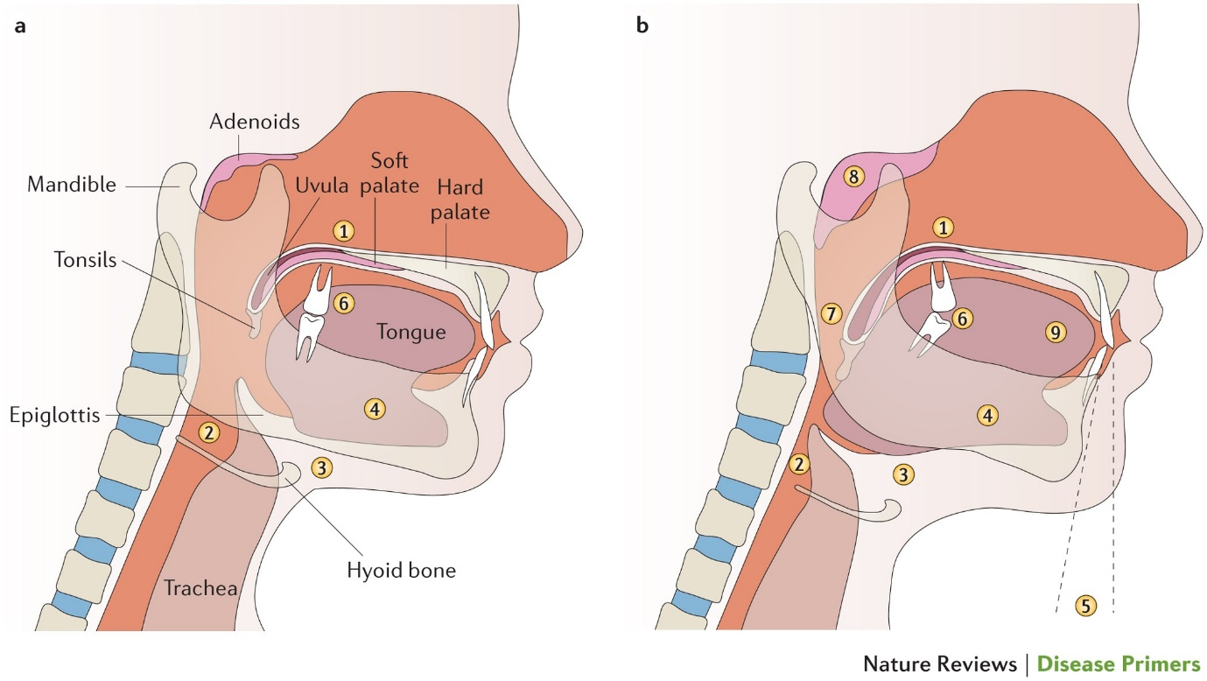
Figure 1: Obstructive sleep apnoea (OSA) is a chronic sleeping-related breathing disorder
Obstructive sleep apnoea (OSA) is a chronic sleeping-related breathing disorder that is characterised by multiple instances of partial (hypopnoea) or total (apnoea) blockage of the upper airway during sleep causes the intermittent lack of oxygen, hypercapnia, and fragmentation of sleep (Bikov & Dragonieri, 2020; Kim et al., 2021).
The pathophysiology is anatomical constriction of the pharyngeal airway, along with decreased neuromuscular tone during sleep, which leads to recurrent airway blocking and periodic hypoxia-reoxygenation injury with the inflammatory effects of the whole body (Bikov and Dragonieri, 2020).
A multidisciplinary approach acknowledges OSA as a compound with respiratory, cardiovascular, metabolism and neurocognitive components, which is important to examine using a unified method in clinical evaluation (Baptista et al., 2023; Chang et al., 2023).
According to the description of diagnostic criteria posted by NICE, the typical symptoms of the condition, including excessive daytime sleepiness and objective evidence in the form of sleep studies, are the characteristics of the condition, and the degree of its severity is categorized by the apnoea-hypopnoea index (AHI): mild (5-14 events/hour), moderate (15-29 events/hour) and severe (>30 events/hour) (NICE, 2021).
Declaratively OSA is growing as a chronic and progressive disease especially in cases where it is accompanied by obesity and cardiometabolic comorbidity (Kim et al., 2021; Chang et al., 2023).

3. Global and UK Burden and Prevalence
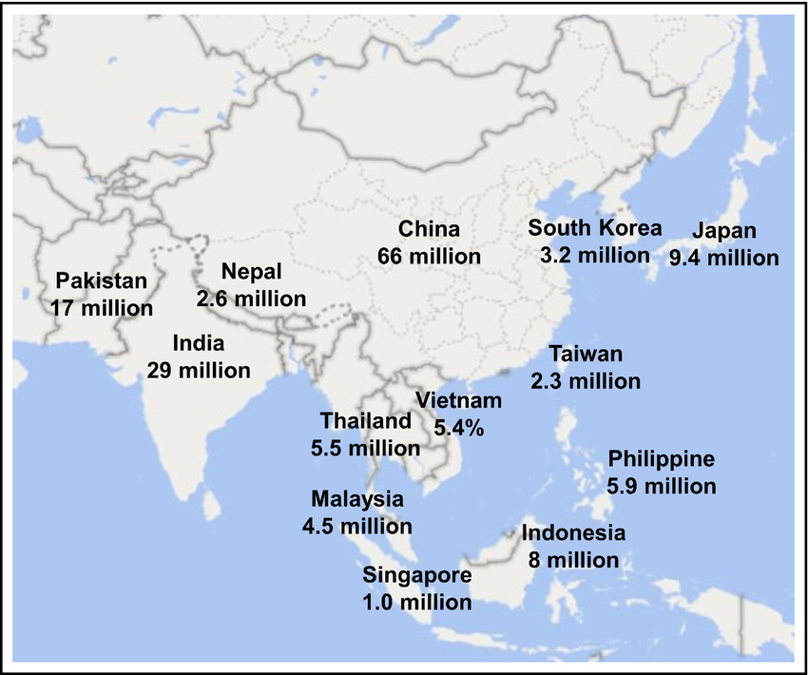
Figure 2: Global prevalence of Obstructive sleep apnoea (OSA)
Obstructive sleep apnoea (OSA) is a significant and increasing number of health issues in the world, where epidemiological reviews estimate millions of affected adults around the globe, to a large degree fueled by demographic ageing and the increased prevalence of obesity globally (Lyons, 2020; Iannella et al., 2025).
In the latest discussions, it is stressed that prevalence remains on the rise in both high-incomes and middle-income nations, and that it is disproportionately high in regions and under-recognized in low-resource environments (Zappalà et al., 2025).
There is emerging evidence on the environment indicating that climatic factors such as the increasing nocturnal temperatures and heatwave can increase the severity of OSA and the burden on the population meaning that environmental change can further amplify the prevalence of the disease (Lechat et al., 2025; Pinilla et al., 2025).
Massive meta-analytical data in China shows a prominent spatiotemporal increase in the prevalence of OSA between the years 2000 and 2024 which strengthens the worldwide trend of the advancing prevalence rates of various diseases (Niu et al., 2025).
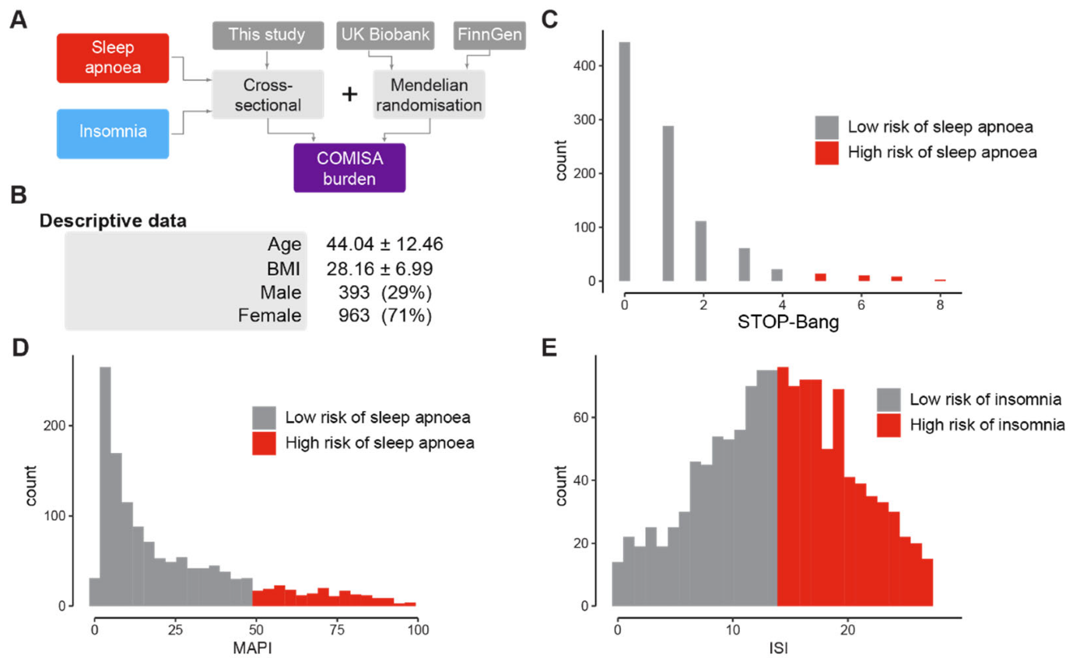
Figure 3: Prevalence of Obstructive sleep apnoea in UK
The United Kingdom has conducted population-based studies on increasing incidence and prevalence recorded in primary care databases with the improvement in detection but continued underdiagnosis in the community (Strongman et al., 2026; Ali et al., 2025).
In England, occupational studies demonstrate the diversity of estimates on prevalence of OSA by industry, which underscores differentials regarding risk on a socioeconomic and occupational-related factor (Kinoshita et al., 2024).
The NHS information pathways identify OSA as a major long-term condition that needs to be referred to specific sleep services in a structured manner (NHS, 2022).
COH studies identify untreated OSA as a risk factor to cardiovascular morbidity and mortality (Dodds et al., 2020), and UK primary care records find OSA to be a risk factor of future dementia (Wang et al., 2025).
Individual and system-level costs are further worsened by the socioeconomic cost of EDS, specifically decreased productivity and utilisation of healthcare services due to excessive daytime sleepiness (Jennum et al., 2021).
Fundamentally, there is still a significant issue of underdiagnosis with many people not being identified to provide an early intervention and weaken the backlogs of services and resulting pressures that are related to the ageing populations and obesity patterns.

4. Aetiology
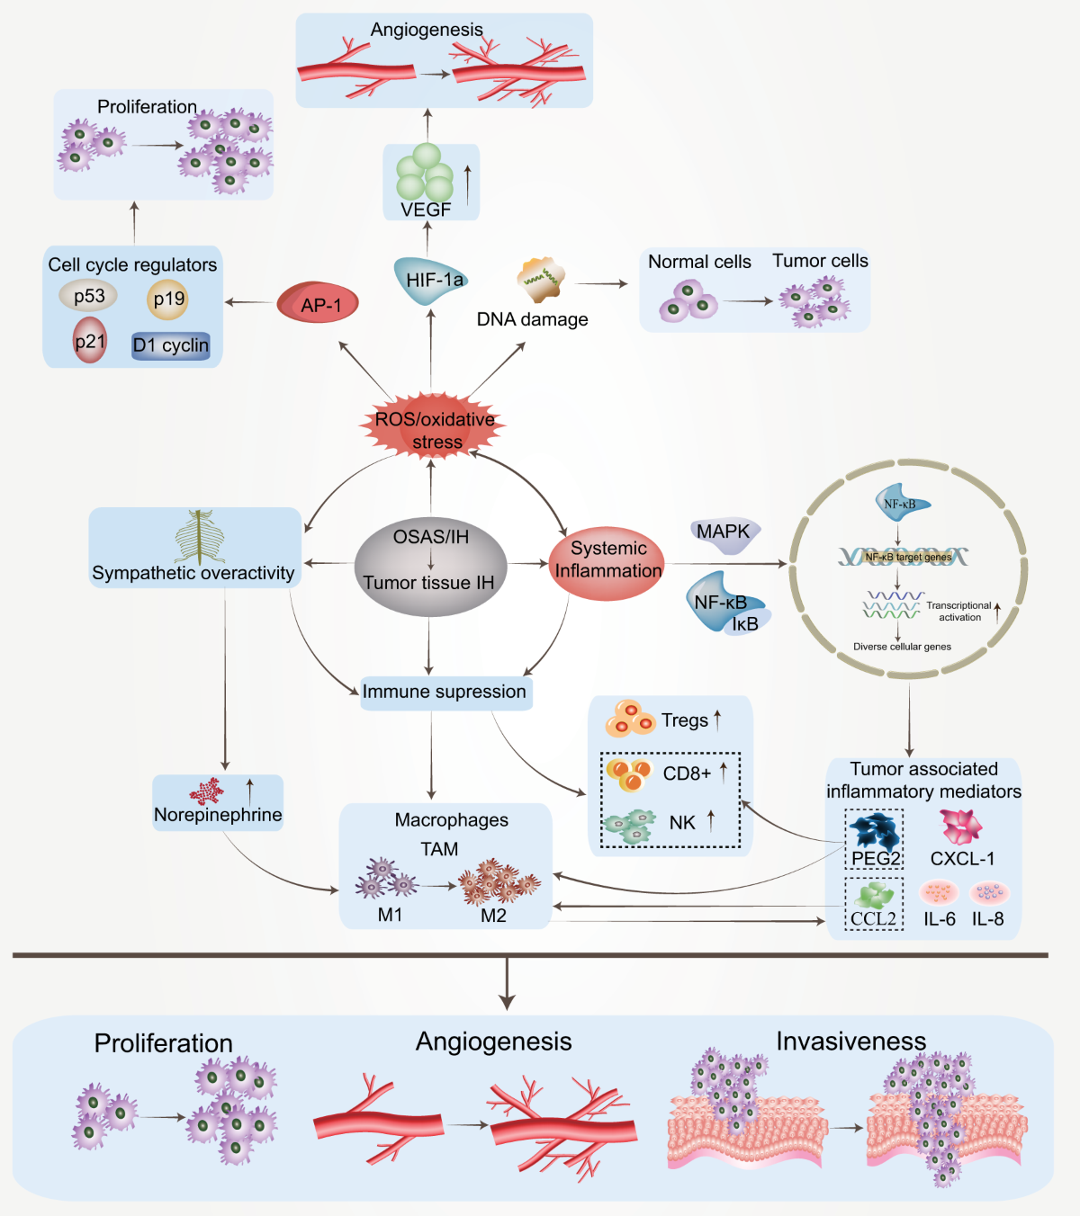
Figure 4: Aetiology of Obstructive sleep apnoea (OSA)
Obstructive sleep apnoea (OSA) has a multifactorial aetiology being an expression of complex interactions among anatomical, neuromuscular, metabolic and environmental pathways and not a single causative route (Bikov and Dragonieri, 2020).
The structural constriction of the pharyngeal airway caused by the decreased neuromuscular tone and periodic collapse of the upper airway occurs during sleep and results in repeated obstruction and repeated hypoxia-reoxygenation damage (Bikov & Dragonieri, 2020).
Fat deposition around the neck and upper airway, smaller lung volumes and higher airway collapsibility are other significant contributors to obstruction, but obesity is a potentiating instead of a causative factor (Young and Benjamin, 2023).
There are also neurocognitive and central regulatory processes involved in determining the stability of the airways, and it has been suggested that persons with cognitive impairment or with a disordered neural control might be more prone to the pathophysiology of OSA (Kirsh et al., 2023).
New studies show that environmental stress factors, such as increasing nocturnal temperatures in climatic change, could intensify airway instability and raise rates of apnoea, which suggest the role of the ecology in general in disease expression (Lechat et al., 2025).
Importantly, although OSA is closely related to obesity, it is a non-obese anatomically and neurologically mediated condition that is heterogeneously pathophysiologically mediated and thus needs to be assessed and managed individually (Bikov & Dragonieri, 2020; Young and Benjamin, 2023).

5. Types of Sleep Apnoea
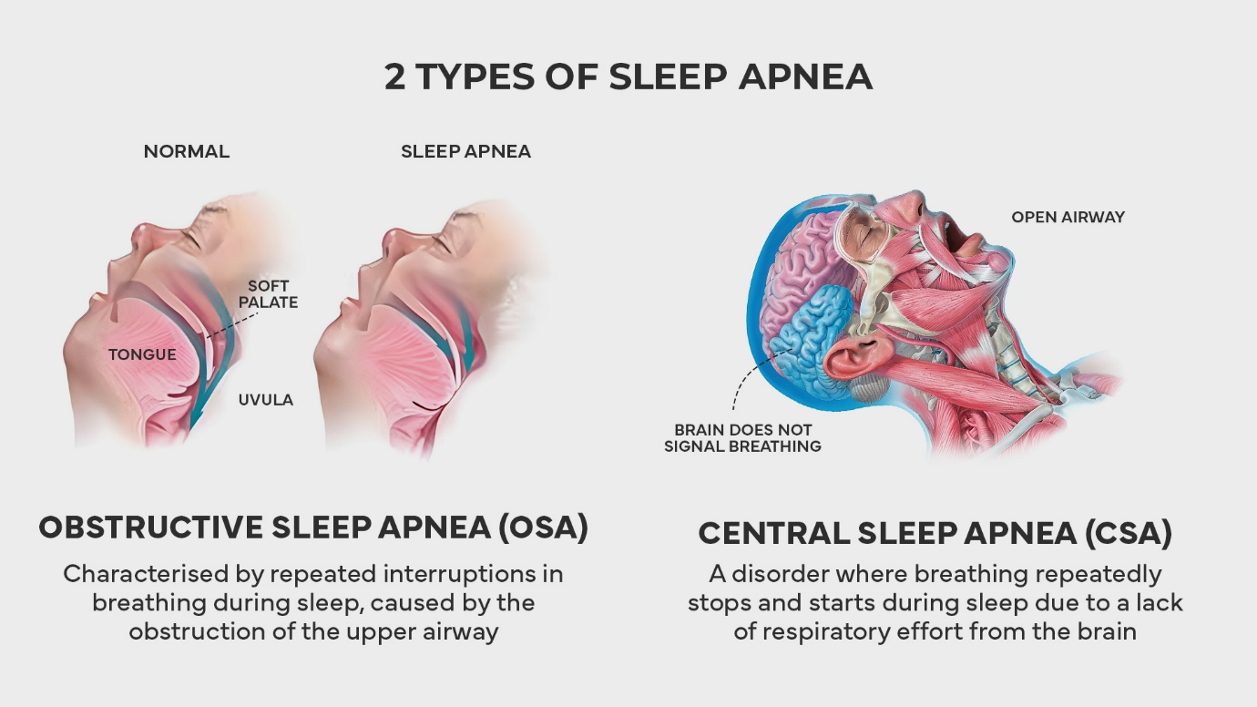
Figure 5: Types of Sleep Apnoea
Sleep apnoea is a continuum of sleep-related breathing disorders divided into broad categories such as obstructive sleep apnoea (OSA), central sleep apnoea (CSA) and mixed (complex) sleep apnoea with varying underlying pathophysiology, and management effects (Chang et al., 2023; Kim et al., 2021).
The most common, obstetric sleep apnoea, is marked by the frequent collapse of upper airways in the sleeping position despite the continued respiratory activity causing a resultant hypoxia and sleep discontinuity (Kim et al., 2021).
Instead, the causes and associated mechanisms of central sleep apnoea are a defective central respiratory drive, in which there is a short-term loss of respiratory activity because of instability in neural control of breathing, which is usually linked with heart failure, neurological or opioid dependence (Chang et al., 2023).
Mixed sleep apnoea is characterized by the characteristics of the combination of both obstructive and central processes during the same episode of apnoea and the complex pathophysiological overlaps (Kim et al., 2021).
This booklet is particularly on OSA as it takes into consideration most of the diagnosed cases of sleep apnoea in the world and in the UK, and because it is the main cause of the long-term cardiometabolic, neurocognitive and socioeconomic burden (Chang et al., 2023).

6. Risk Factors
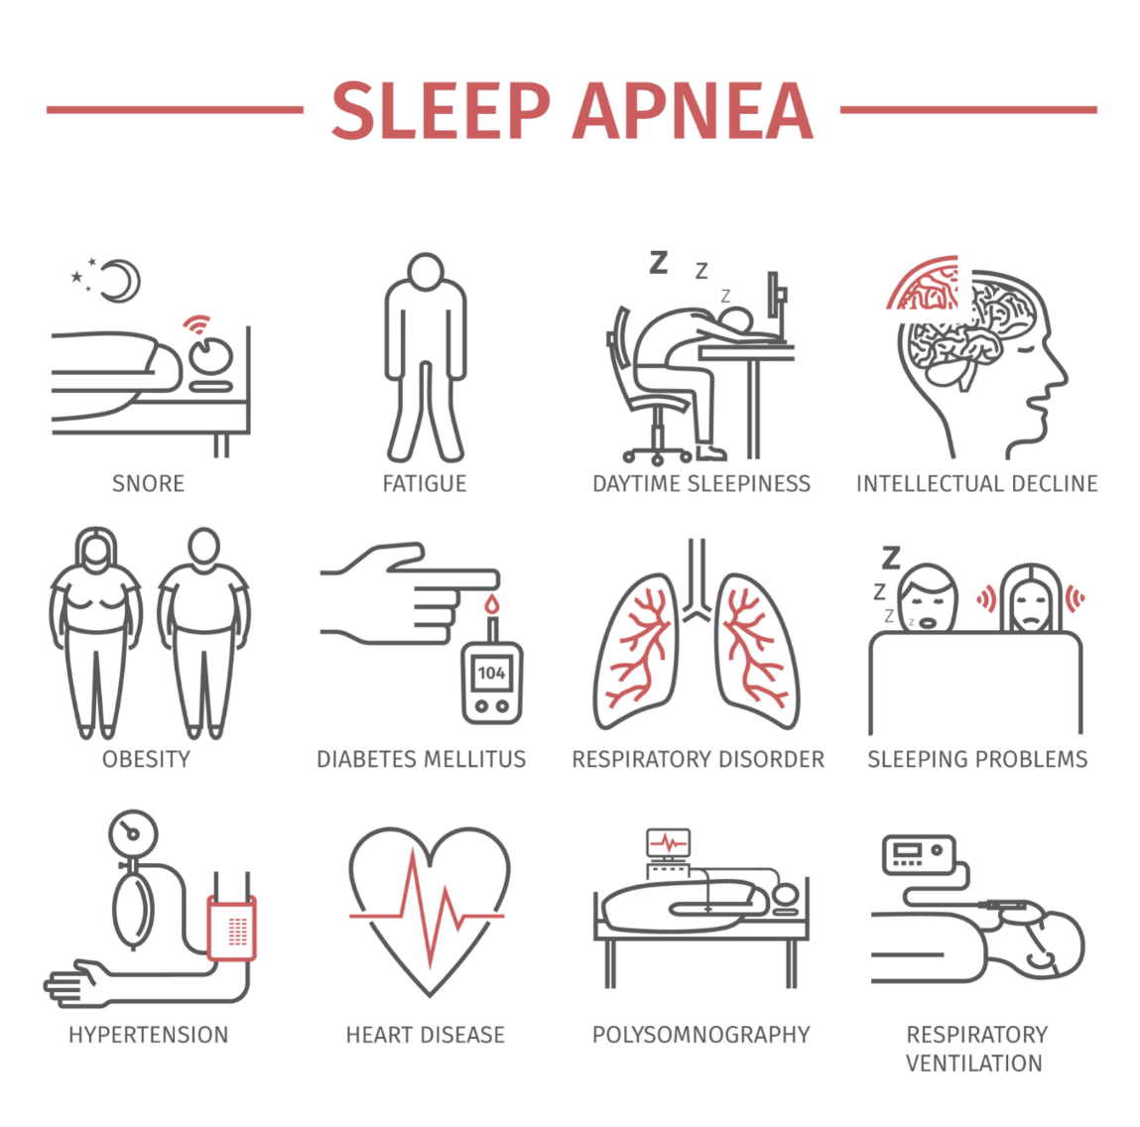
Figure 6: Risk Factors of Sleep Apnoea
The risk factors leading to obstructive sleep apnoea (OSA) development are a mixture of non-modifiable and modifiable factors indicating the heterogeneous nature of the condition and its interplay with demographic and social determinations of health.
Ageing and male gender are some of the non-modifiable determinants, and UK population-based statistics show that a higher prevalence has been recorded in older adults and males, which could be attributed to age-related changes in airway muscle tone and anatomical differences in sexes (Strongman et al., 2026).
Mandibular retrusion and maxillary constriction and small upper airway dimensions constitute craniofacial morphology, which is among factors that predispose individuals to airway collapsibility during sleep regardless of their body mass index (Gracco et al., 2021).
Additional risk factors include genetic predisposition and inherited features of the airway structure, neuromuscular regulation and respiratory stability, which highlights clinical paternal tendencies (Kim et al., 2021).
Obesity is the most pronounced of the modifiable factors, as the presence of excess adipose tissue around the neck and thorax raises the resistance of the upper airways and decreases the lung volumes, further increasing risk factors of obstruction (Young and Benjamin, 2023).
Cognitive impairment as part of neurocognitive vulnerability can affect the ability to recognize symptoms, help-seeking behaviour and physiological breathing control, which can worsen the severity of the disease (Kirsh et al., 2023).
There is also the variation in the estimated prevalence of OSA in industries in England based on occupational patterns indicating that shift work, sedentary occupation, and socioeconomic status can determine risk exposure (Kinoshita et al., 2024).
Importantly, the UK obesity crisis and enduring social deprivation augment OSA, with underprivileged groups having increased cardiometabolic risk and access to early cardiometabolic diagnosis, therefore, expanding health disparities and enhancing the prospective strain of services in the future.

7. Signs and Symptoms
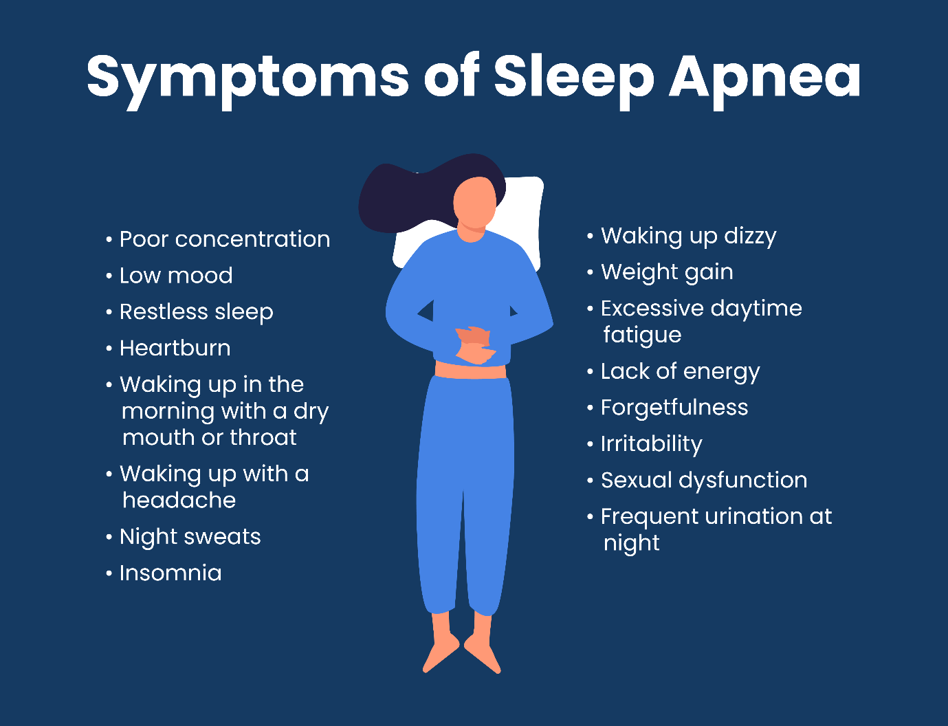
Figure 7: Signs and Symptoms of Sleep Apnoea
As a rule, the typical symptoms of obstructive sleep apnoea (OSA) have such typical nocturnal and daytime manifestations, which are the repetition of upper airway blockage and disrupted sleep structure (NICE, 2021; Kim et al., 2021).
Among the most frequently presenting features, loud and habitual snoring often goes unnoticed by the individual affected, often reported by their bed partners, it is usually accompanied by observed cessation of breathing, gasping or choking during sleep(NHS, 2022; Kim et al., 2021).
A fundamental symptom of frequent arousals and inappropriate sleep is excessive daytime sleepiness, which manifests itself in the loss of concentration, poor alertness and the tendency to get involved in occupational or road accidents (NICE, 2021; NHS, 2022).
Over time, cognitive impairment with the lack of attention and memory and executive function can arise under the influence of intermittent hypoxia and sleep fragmentation, which reduces the quality of life and functional impairment (Kim et al., 2021).
Headaches in the morning, a dry mouth and irritable stomach are also reported quite often and are associated with nocturnal hypoventilation and oxygen desaturation (NHS, 2022).
The Epworth Sleepiness Scale can typically be employed in assessing the client in the clinical setting as a method of quantifying subjective sleepiness index in the daytime, with concrete diagnosis comprising observable verification using sleep examinations like a polysomnography or approved home respiratory polygraphy equipment (NICE, 2021).

8. Physical, Psychological and Social Impact
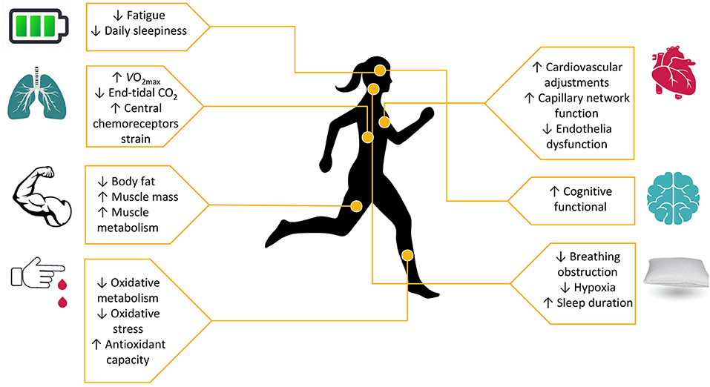
Figure 8: Physical Impact of Obstructive Sleep Apnoea
Obstructive sleep apnoea (OSA) has serious physical morbidity, repeatedly interrupted hypoxia and sympathetic response to hypertension, coronary artery disease and extended cardiovascular risk, which once again confirm the image of a systemic disorder but no longer nocturnal (Chang et al., 2023).
Cohort (long-term) evidence shows a higher all-cause mortality rate of people with untreated OSA, specifically in cases when moderate to severe disease is either not diagnosed or improperly addressed (Dodds et al., 2020).
The latest UK primary care data also implicate uninterrupted sleep patterns, indicating neurovascular and neurodegenerative effects that accumulate with cumulative receivers of chronic sleep discontinuity and hypoxia (Wang et al., 2025).
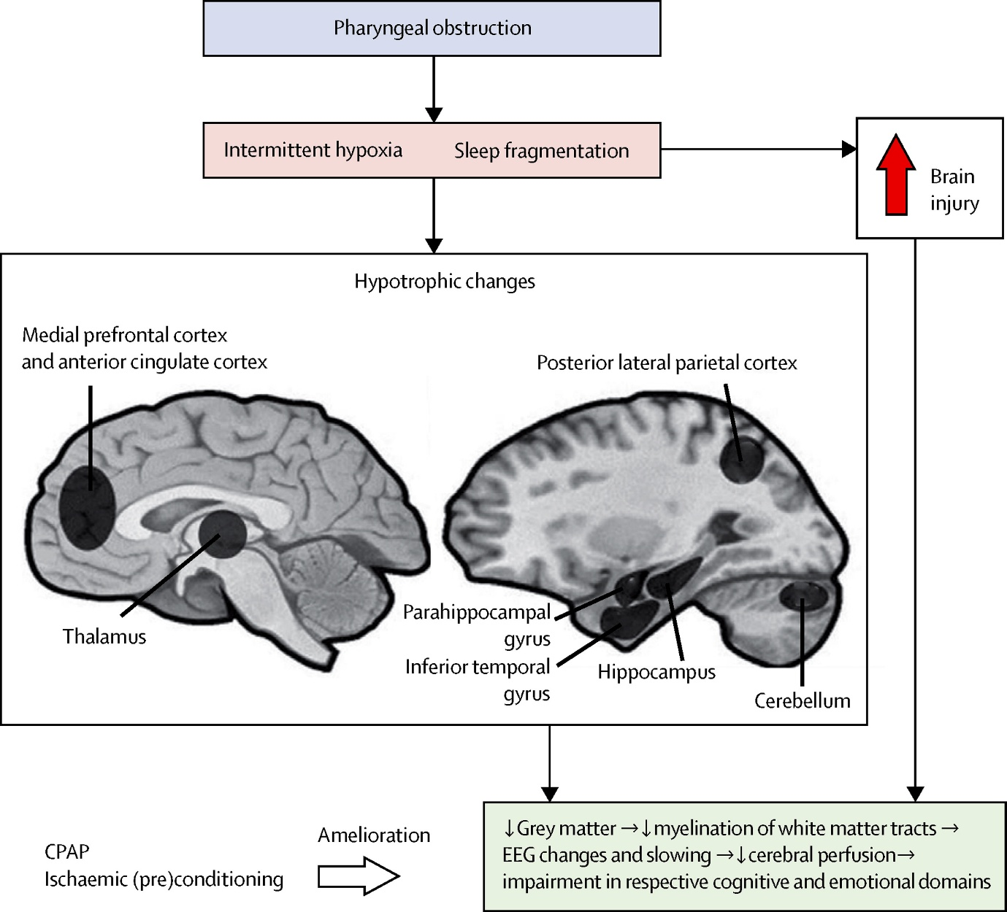
Figure 9: Psychological Impact of Obstructive Sleep Apnoea
Cognitively, suffering diseases may be further worsened by cognitive impairment characterized by deficits in attention and executive functioning, which can delay help-seeking or treatment compliance (Kirsh et al., 2023). Daily excessive drowsiness and disability are the factors that lead to significant declines in health-related quality of life and quality of life (Jennum et al., 2021).
Compliance with continuous positive airway pressure (CPAP), despite the effectiveness of the treatment, is not always well-tuned among the population of patients because of discomfort, intolerability of devices and psychological opposition, thus affecting the long-term outcomes (Oliver et al., 2024).

Figure 10: Psychological Impact of Obstructive Sleep Apnoea
Occupational outcomes affect society, and their prevalence differs depending on sectors and may have an effect on productivity and safety in the workplace (Kinoshita et al., 2024).
Healthcare utilisation, productivity loss and indirect societal costs are the wider aspect of the economic cost in addition to increasing national spending (Zappalà et al., 2025).
NHS directions emphasize the continuous service access issues and the necessity of organized pathways to serve the vulnerable groups (NHS England, 2023).
Most importantly, although it is evident required biopsychosocial load, the management of OSA is often heavily biomedical, and the psychological and social support are not fully incorporated into the regular care courses.

9. Evidence-Based NHS Management
Clinical Management
The NICE NG202 is a guide on how obstructive sleep apnoea (OSA) should be managed in the NHS; it provides a structured referral, diagnostic evaluation with sleep investigations and stratified treatment according to the level of symptoms and the classification of apnoea and hypopnoea index (NICE, 2021).
Continuous positive airway pressure (CPAP) is the first-line therapy of moderate-severe OSA and works by pneumatic airway splenic therapy during sleep and has been shown to have strong effects on symptom reduction and cardiovascular risk factors (Kim et al., 2021; Chang et al., 2023).
Nevertheless, compliance is still one of the biggest clinical pitfalls, and it has been reported to fluctuate over a long period based on the discomfort, mask intolerance, and psychological barriers (Oliver et al., 2024; Campos-Rodriguez et al., 2016).
Other or complementary treatments mandibular advancement appliances in selected patients with nocturnal oxygen therapy in certain situations though this provision demands a keen clinical assessment (Gracco et al., 2021; Phyu et al., 2024).
Applied validated home respiratory polygraphy devices are also now supported by NICE as a means to enhance accessibility to diagnoses and ease pressure on sleep labs (NICE, 2024).
NHS pathway advice focuses on referral calls and specific management of vulnerable populations, but there is a disparity in service provision among the Integrated Care Systems (NHS England, 2023; Remedy BNSSG, 2025).
Importantly, non-adherence to CPAP, shortage of the workforce, delays in making the diagnosis, and the presence of unequal distributions of specialists helps maintain the inequity of access and outcome.
House of Care Model (UK Model)
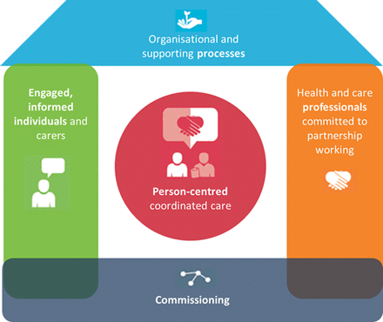
Figure 11: House of Care Model (UK Model)
The model of House of Care encourages joint decision-making, joint care planning and organised self-management education, which is consistent with CPAP implementation and adherence counselling in OSA pathways (NICE, 2021; NHS England, 2023).
A multidisciplinary approach to coordination of sleep specialists with allied health professionals and primary health care can help to manage holistically, however, implementation is still uneven across Integrated Care Systems because of the differences between commissioning and workforce.
Chronic Care Model (International)
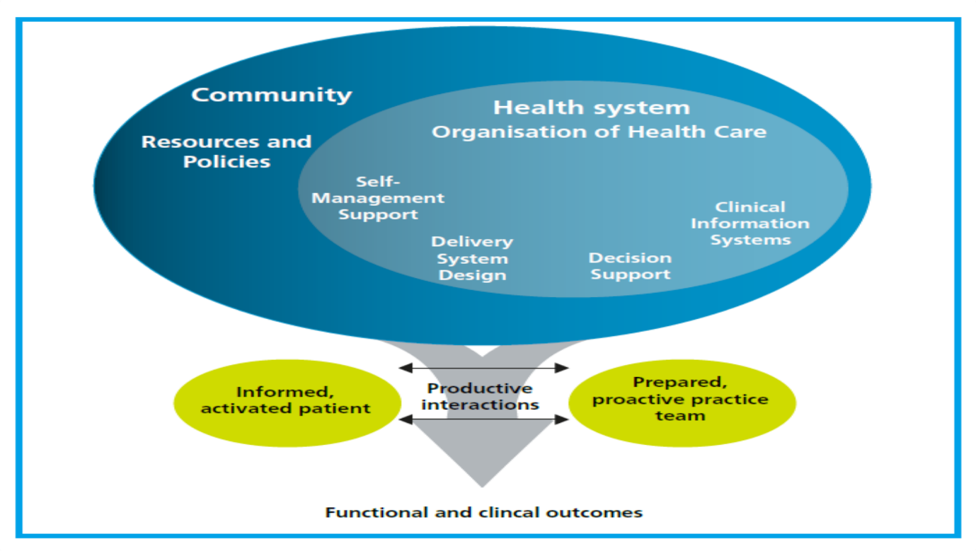
Figure 12: Chronic Care Model (International)
The Chronic Care Model focuses on proactive care, self-management supply and electronic clinical data, which directly apply to CPAP data monitoring, and the behavioural adherence intervention (Oliver et al., 2024; Chang et al., 2023).
Incorporation of community-based weight management services also goes in line with modifiable risk reduction strategies.
Structured systems-level support is provided at the CCM compared to the House of Care, yet approaching NHS funding and capacity limits, including where implementation may be feasible but contextually insensitive, the implementation is therefore required to be balanced and context sensitive.

10. Summary
Obstructive sleep apnoea (OSA) is a long-term condition that is becoming more and more common in the United Kingdom, and the current state of research based on the population proves the growing prevalence and incidence of sleep apnoea in the primary care that is recorded, and an increased number of people who are not diagnosed yet (Strongman et al., 2026).
The fact that underdiagnosis persists is a serious area of weakness in the health care approach of the populace, because left undiagnosed OSA leads to serial progression of cardiometabolic and neurocognitive adverse problems, which otherwise might be avoided through early diagnosis and treatment.
The disease is no longer viewed as disorder of disturbed sleep but as a global disorder in relation to hypertension, cardiovascular disease, metabolic dysfunction and cognitive impairment, making it more vulnerable to long-term mortality and healthcare exposedness (Zappalà et al., 2025).
The effect goes beyond clinical outcomes to include decreased effectiveness at their workplace, lower standards of life and broader impacts on the society and all of this, especially in communities that are disproportionately impacted by obesity and social deprivation.
National policies, such as elaborated diagnostic pathways and evidence-based treatment guidelines, offer an outline in which the provision of care is not inconsistent across the NHS (NICE, 2021). Nevertheless, inconsistency in service delivery, the ability to accommodate and appointment of specialist sleep services can be barriers to fair implementation.
To manage the increasing UK burden, it would also be necessary to adopt long-term care strategies using targeted, integrated, person-centred interventions of biomedical treatment and behavioural support, digital monitoring and coordinated care of the multidisciplinary team.
Empowerment of early detection plans, enhancing CPAP appropriation assist and low disparities in health will form the core of reducing future demand and improving patient outcomes.
Finally, there should be an integration of OSA to the wider long-term condition management models so as to make care across the NHS sustainable, fair and holistic.

References
Ali, A., Deger, M., Ghildiyal, A., Alpert, N., Hosnijeh, F.S. and Boult, S., Incidence., 2025. ‘Incidence, Characteristics, and Management Pathways of OSA in England: A 10-Year Retrospective Cohort Study’, CHEST Pulmonary. https://doi.org/10.1016/j.chpulm.2025.100221
Baptista, P.M., Saldaña, R.L. and Amado, S. eds., 2023. Obstructive Sleep Apnea: A Multidisciplinary Approach. Springer Nature.
Bikov, A. and Dragonieri, S. eds., 2020. Obstructive Sleep Apnea: Epidemiology, Pathomechanism and Treatment. MDPI.
Campos-Rodriguez, F., Martinez-Alonso, M., Sanchez-de-la-Torre, M., Barbe, F. and Spanish Sleep Network, 2016. Long-term adherence to continuous positive airway pressure therapy in non-sleepy sleep apnea patients. Sleep medicine, 17, pp.1-6. https://www.sciencedirect.com/science/article/pii/S1389945715020018
Carter, A. and Davenport-Jones, L., 2024. Obstructive sleep apnoea/hypopnoea syndrome: a feasibility study to review NICE guidelines. British Dental Journal, pp.1-5. https://www.nature.com/articles/s41415-024-7470-0
Chambers, T., Ruparelia, P., Ellis, G., Bishop, T., Gooneratne, M. and Singh, N., 2022. Obstructive sleep apnoea and perioperative medicine: a growing concern. British Journal of Hospital Medicine, 83(9), pp.1-9. https://www.magonlinelibrary.com/doi/pdf/10.12968/hmed.2022.0297
Chang, J.L., Goldberg, A.N., Alt, J.A., Mohammed, A., Ashbrook, L., Auckley, D., Ayappa, I., Bakhtiar, H., Barrera, J.E., Bartley, B.L. and Billings, M.E., 2023, July. International consensus statement on obstructive sleep apnea. In International forum of allergy & rhinology (Vol. 13, No. 7, pp. 1061-1482). https://pmc.ncbi.nlm.nih.gov/articles/PMC10359192/pdf/nihms-1836086.pdf
Dodds, S., Williams, L.J., Roguski, A., Vennelle, M., Douglas, N.J., Kotoulas, S.C. and Riha, R.L., 2020. Mortality and morbidity in obstructive sleep apnoea–hypopnoea syndrome: Results from a 30-year prospective cohort study. ERJ Open Research, 6(3). https://publications.ersnet.org/content/erjor/6/3/00057-2020?cpetoc=&utm_source=TrendMD&utm_medium=cpc&utm_campaign=ERJ_Open_Res_TrendMD_1
Gracco, A.L., Milano, F. and Di Giosia, M., 2021, February. Dental management of Obstructive Sleep Apnea (OSA): A practical manual. Edra.
Iannella, G., Pace, A., Bellizzi, M.G., Magliulo, G., Greco, A., De Virgilio, A., Croce, E., Gioacchini, F.M., Re, M., Costantino, A. and Casale, M., 2025. The global burden of obstructive sleep apnea. Diagnostics, 15(9), p.1088. https://www.mdpi.com/2075-4418/15/9/1088
Jennum, P., Castro, J.C., Mettam, S., Kharkevitch, T. and Cambron-Mellott, M.J., 2021. Socioeconomic and humanistic burden of illness of excessive daytime sleepiness severity associated with obstructive sleep apnoea in the European Union 5. Sleep Medicine, 84, pp.46-55. https://www.sciencedirect.com/science/article/pii/S1389945721002860
Kim, K.B., Movahed, R., Malhotra, R.K. and Stanley, J.J. eds., 2021. Management of obstructive sleep apnea: an evidence-based, multidisciplinary textbook. Springer Nature.
Kinoshita, R., Quint, J.K., Kallis, C. and Polkey, M.I., 2024. Estimated prevalence of obstructive sleep apnea by occupation and industry in England: a descriptive study. Sleep Advances, 5(1), p.zpae069. https://academic.oup.com/sleepadvances/article-pdf/5/1/zpae069/59598158/zpae069.pdf
Kirsh, L., Cox, R., Mongue-Din, H. and Lawrence, R., 2023. The prevalence of obstructive sleep apnoea risk factors in individuals with cognitive impairment: south London cross-sectional study. BJPsych Bulletin, 47(4), pp.203-207. https://www.cambridge.org/core/services/aop-cambridge-core/content/view/4BB785D6B35A7EE97108D4A81434F6DB/S2056469422000389a.pdf/the-prevalence-of-obstructive-sleep-apnoea-risk-factors-in-individuals-with-cognitive-impairment-south-london-cross-sectional-study.pdf
Lechat, B., Manners, J., Pinilla, L., Reynolds, A.C., Scott, H., Vena, D., Bailly, S., Fitton, J., Toson, B., Kaambwa, B. and Adams, R.J., 2025. Global warming may increase the burden of obstructive sleep apnea. Nature Communications, 16(1), p.5100. https://www.nature.com/articles/s41467-025-60218-1.pdf
Lyons, M.M., Bhatt, N.Y., Pack, A.I. and Magalang, U.J., 2020. Global burden of sleep‐disordered breathing and its implications. Respirology, 25(7), pp.690-702. https://onlinelibrary.wiley.com/doi/pdf/10.1111/resp.13838
National Health Service (NHS), 2022. Sleep apnoea, Available at: https://www.nhs.uk/conditions/sleep-apnoea/ (Accessed: 25 February 2026).
National Institute for Health and Care Excellence (NICE), 2021. Obstructive sleep apnoea/hypopnoea syndrome and obesity hypoventilation syndrome in over 16s, Available at: https://www.nice.org.uk/guidance/ng202 (Accessed: 25 February 2026).
National Institute for Health and Care Excellence (NICE), 2024. Home-testing devices for diagnosing obstructive sleep apnoea hypopnoea syndrome, Available at: https://www.nice.org.uk/guidance/dg62 (Accessed: 25 February 2026).
NHS England, 2023. Healthcare professionals guide to obstructive sleep apnoea (OSA) amongst people with a learning disability and autistic people’, Available at: https://www.england.nhs.uk/long-read/healthcare-professionals-guide-to-obstructive-sleep-apnoea-osa-amongst-people-with-a-learning-disability-and-autistic-people/ (Accessed: 25 February 2026).
Niu, Y., Sun, S., Wang, Y., Chen, L., Shao, Y. and Zhang, X., 2025. Spatiotemporal trends in the prevalence of obstructive sleep Apnoea across China: a multilevel Meta-analysis incorporating geographic and demographic stratification (2000-2024). Nature and Science of Sleep, pp.879-903. https://www.tandfonline.com/doi/pdf/10.2147/NSS.S525547
Oliver, C., Li, H., Biswas, B., Woodstoke, D., Blackman, J., Butters, A., Drew, C., Gabb, V., Harding, S., Hoyos, C.M. and Kendrick, A., 2024. A systematic review on adherence to continuous positive airway pressure (CPAP) treatment for obstructive sleep apnoea (OSA) in individuals with mild cognitive impairment and Alzheimer's disease dementia. Sleep Medicine Reviews, 73, p.101869. https://www.sciencedirect.com/science/article/pii/S1087079223001259
Phyu, S.L., Ercan, S., Harriss, E. and Turnbull, C., 2024. Nocturnal oxygen therapy in obstructive sleep apnoea: a systematic review and meta-analysis. European Respiratory Review, 33(171). https://publications.ersnet.org/content/errev/33/171/230173.full.pdf
Pinilla, L., Fitton, J., Lovato, N., Toson, B., Escourrou, P., Eckert, D.J. and Lechat, B., 2025. Rising prevalence of obstructive sleep apnoea during night-time heatwaves across Europe. European Respiratory Journal, 66(5). https://publications.ersnet.org/content/erj/66/5/2501631.full.pdf
Remedy BNSSG Integrated Care Board, 2025. Obstructive Sleep Apnoea (OSA), Available at: https://remedy.bnssg.icb.nhs.uk/adults/sleep-medicine/obstructive-sleep-apnoea-osa/ (Accessed: 25 February 2026).
Sleep Apnoea Trust, 2022. Research in Obstructive Sleep Apnoea (OSA), Available at: https://sleep-apnoea-trust.org/research/ (Accessed: 25 February 2026).
Strongman, H., Sykorova, M., Yu, Y.T.N., Belot, A., Mistry, H., Nolte, E., Eriksson, S.H., Miller, M.A., Bhaskaran, K., Smith, I.E. and Warren-Gash, C., 2026. Incidence and prevalence of obstructive sleep apnoea and narcolepsy in the UK: a population-based descriptive study. Thorax. https://thorax.bmj.com/content/thoraxjnl/early/2026/02/05/thorax-2025-223863.full.pdf
Wang, J., Subramanian, A., Cockburn, N., Xiao, J., Nirantharakumar, K. and Haroon, S., 2025. Obstructive sleep apnoea syndrome and future risk of dementia among individuals managed in UK general practice. thorax, 80(3), pp.167-174. https://research.birmingham.ac.uk/files/254719236/WangJ2024Obstructive_AAM.pdf
Young, R. and Benjamin, A., 2023. The assessment and management of obstructive sleep apnoea–hypopnoea syndrome and obesity hypoventilation syndrome in obesity. Clinical Medicine, 23(4), pp.372-379. https://www.sciencedirect.com/science/article/pii/S1470211824045858
Zappalà, P., Lentini, M., Ronsivalle, S., Lavalle, S., La Via, L. and Maniaci, A., 2025, August. The global socioeconomic burden of obstructive sleep apnea: A comprehensive review. In Healthcare (Vol. 13, No. 17, p. 2115). MDPI. https://www.mdpi.com/2227-9032/13/17/2115

