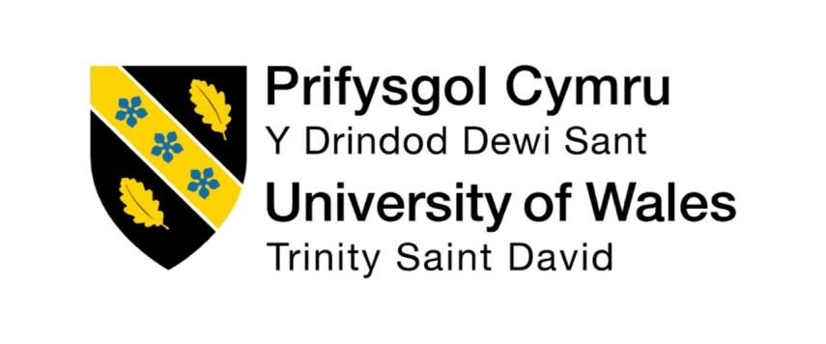

Programme: Master of Business Administration
Module: Human Capital Management
Module code: LCMB7023
Title: Assessment Component 1 - Individual Report
Word count: 2500
Lecturer: Ejike Udeogu
Student Name: Krinal Bhikhubhai Gandhi
Student ID: 250473
Submission Date- 17th October 2025

Table of Contents
Introduction 3
1: Technological advancement reshaping labour markets, and implications for HRM and IHRM 3
1.1 Technological Advancements and HRM/IHRM Strategies 3
1.2 Implications for HRM 4
1.3 Implications for IHRM 5
2: Demographic and geopolitical factors influencing employment markets and challenges for HR Professional 5
2.1 Demographic Factors 5
2.2 Geopolitical Factors 7
3: Organisations address persistent skills gaps and talent shortages in critical sectors through strategic HRM 8
3.1 Tackling Skills Gaps and Talent Shortages 8
3.2 HRM Strategies to Address Skills Gaps 8
4: Addressing personal reflection on working in an international context 9
4.1 Reflection on My Capabilities 9
4.2 Overall Reflection 10
Conclusion 11
References 12

Introduction
Labor markets of today are undergoing revolutionary shifts. Technological change, demographic change, political uncertainty and globalization have redefined how organizations recruit, develop and retain employees. Both National and international labour markets have become dynamic, competitive and less predictable than ever before. These changes are creating both challenges and opportunities that organizations must strategically address in order to remain successful. In such a rapidly evolving environment, firms that fail to adopt losing not only their market advantage but also valuable human capital. However, for Human Resource management and International Human Resource Management, these developments present both opportunities and complex challenges that require innovation and flexibility.
This report is structured into four key parts. First, it considers how technological advancement, including AI, automation, machine learning and digital platforms are reshaping employment and influencing HRM and IHRM strategies. Second, it examines the demographic and geopolitical factors that significantly influence employment markets like ageing populations, migration, urbanization and global political instability. Third, it addresses how organizations can deal with persistent skills gaps and shortages in critical sectors such as in technology, healthcare and hospitality. This also includes how HR professionals must design creative recruitment and learning strategies to ensure long-term success. Lastly, it presents a reflective analysis of my own capabilities for working in an international context, focusing on areas such as communication, leadership, teamwork, technology and self-directed learning.

1: Technological advancement reshaping labour markets, and implications for HRM and IHRM

1.1 Technological Advancements and HRM/IHRM Strategies
Technology has always impacted the workplace, but the pace of change in current times is unprecedented. Automation, artificial intelligence, robotics and cloud computing are rewriting the workplace landscape and bringing new models of work. The World economic Forum (2023) forecasts a net job shift by 2027, with automation eliminating millions of traditional roles but simultaneously generating new employment opportunities in fields such as data analysis, green energy and digital innovation. This dual effect means HRM strategies must both mitigate risks of job loss and actively maximise opportunities for new growth. In addition, HR professionals must learn to balance human creativity with technological efficiency, so that technology supports people but does not replace them. In addition, organisations must create a balanced human-tech environment, where digital technologies augment decision-making and staff experience without dehumanising work.

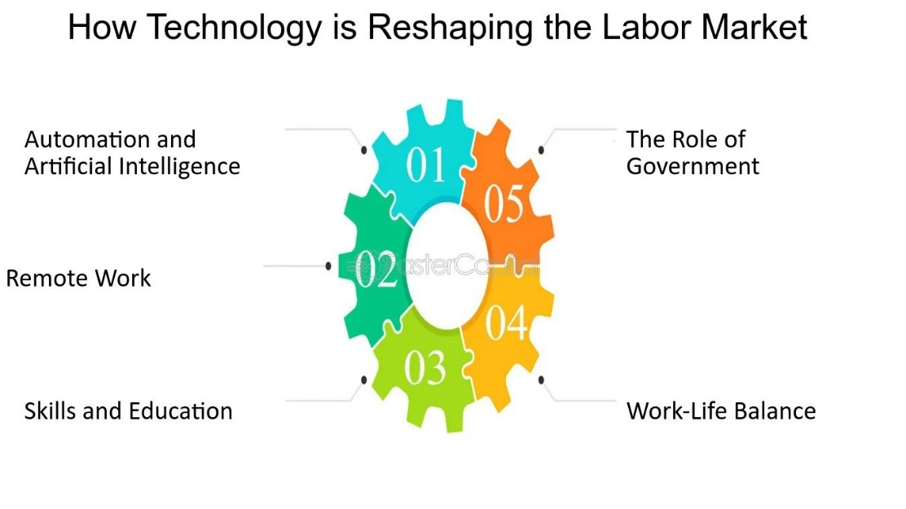

1.2 Implications for HRM
For HR directors on a national scale, technology transforms the recruitment of individuals, their training and management. The majority of organisations now utilize AI-based systems to filter through CVs, assess candidate fit and accelerate recruitment processes. But in the wrong hands, such systems have the potential to create discrimination. For managing fast-paced change, HR managers must focus on reskilling and upskilling workers, equipping them with new abilities necessary for work of the future. For example, Microsoft has trained their employees for digital roles. Amazon’s investment in robotics has reshaped its workforce, decreasing the need for manual warehouse labour while expanding opportunities for technically skilled staff such as engineers and IT professionals. This illustrates the way that HR must shift its focus away from traditional recruitment into more innovative workforce practices. Furthermore, HR departments must foster the culture of constant learning through virtual scholars and partnerships with providers of online learning. These employees stay up to date while making the firm more responsive to new technologies.

1.3 Implications for IHRM
On a worldwide scale, technology has made telecommuting and global teams possible. Companies can now hire individuals from everywhere in the world. This enhances diversity and introduces new skills but requires IHRM to deal with diverse legislations across different countries and manage cross-cultural communication. For example, a company that has employees in both the UK and India must comply with two systems of regulation around pay, taxation and working hours. IHRM must also keep employees working across time zones connected and motivated and they must be made to feel part of the corporate environment. Tools like Microsoft teams and slack have become central to sustaining collaboration and leadership across dispersed global teams. However, managing global virtual teams also require developing in cultural competence and strong online leadership skills. HR professionals must ensure that remote employees have equal access to resource, recognition and career opportunities, regardless of location.
In general, technology is revolutionizing labour markets by destroying previous jobs and creating new ones. For HRM and IHRM, this means strategies must focus on three main areas using technology in recruitment, investing in lifelong learning to close skills gaps and ensuring that employees remain healthy and engaged in digital workplace. Organizations that innovate quickly and responsibly will be best positioned to succeed in the future.

2: Demographic and geopolitical factors influencing employment markets and challenges for HR Professional

2.1 Demographic Factors
One of the most significant demographic changes facing the world today is the ageing population, especially in developed countries. OCED (2022) projects that by, over own-quarter of the populations in Europe and Japan will be aged above 65, signifying major demographic shifts. This means there will be fewer young people available to work, causing labour shortages in sectors like healthcare and social care as well as increasing pressure on pension and welfare systems. As a result, HR managers need to find innovative and effective ways to retain older workers and make better use of their experiences. This can include introducing flexible working hours, adapting jobs to make them less physically demanding, offering continuous training and creating mentoring opportunities so that older employees can keep their skills relevant. And this can include introducing flexible working hours, adapting jobs to make them less physically demanding and offering continuous training so that older employees can keep their skills relevant. This shows that demographic changes directly affect workforce planning and highlight the importance of inclusive HR strategies.
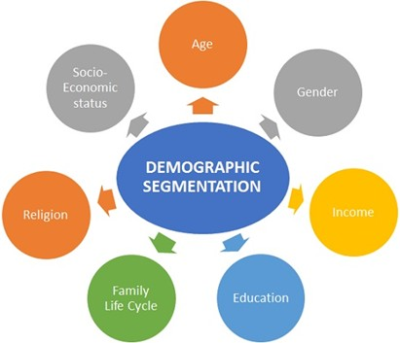
Nowadays, younger generations such as Millennials and Generation Z have different ideas about work compared to older generations. Ng, Schweitzer and Lyons (2010) found that millennial employees prioritise work-life balance, diversity and purposeful employment more strongly than previous generations. Therefore, HR managers need to create workplace policies, reward systems and recognition programs that suit both older employees who prefer stability and younger ones who want flexibility purpose and career development opportunities. Gender also makes a difference in the workplace. Even though things have improved, women still earn less than men on average and are not seen much in top positions. In many places, social and cultural barriers still make it harder for women to grow in their careers. So, HRM and IHRM should focus on gender equality by checking pay differences, supporting women in leadership role, and creating mentorship and sponsorship programs and making hiring fair for everyone. Additionally, embracing diversity is not only an ethical responsibility but also a source of innovation and better decision-making within global organisations.

2.2 Geopolitical Factors
Global politics have had a big impact on job markets. For example, after Brexit, the UK saw fewer workers coming from EU countries, especially in areas like hotels, farming and delivery work. The conflict in Ukraine has triggered significant displacement, reshaping European labour availability and migration dynamics. Migration has both positive and negative effects, but it helps when there are not enough workers like in the NHS, which depends a lot on nurses and doctors from other countries. But it can also bring challenges, such as cultural differences, job competition and unfair treatment. And because of that IHRM needs to manage a diverse workforce carefully and make sure international employees feel welcomed and valued and integrated into company culture.

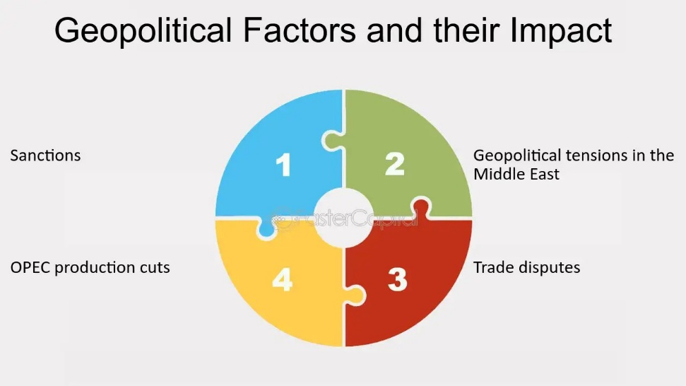

Thus, changes in population and global politics shows that HR needs to be flexible and ready to adapt. What works in one place might not work in another. For example, flexible working is common in western Europe, but in some countries, people prefer working in person. HR managers need to understand what’s happening around the world but also respect local traditions and ways of working. Therefore, global HR professional must think both globally and locally – a concept known as “glocalization” – balancing standardized policies with cultural sensitivity. I think that because of these changes and uncertainties, HR professional should not expect to always stay the same. They need to make strong plans so hat organizations can handle sudden worker shortages, political changes, or shifts in population.

3: Organisations address persistent skills gaps and talent shortages in critical sectors through strategic HRM

3.1 Tackling Skills Gaps and Talent Shortages
A big problem many organisations around the world facing today is the lack of skilled workers. This issue is most common in sectors like technology, healthcare and hospitality. Mc Kinsey (2022) reports that a majority of organisations nearly 87% are currently experiencing or anticipating critical skill shortages. In healthcare, WHO (2021) warns that by 2030 global healthcare systems could face an estimated shortfall of 18 million professionals. In the tech industry, there aren’t enough people with skills in areas such as AI, cybersecurity and data science. The hospitality sector also finds it hard to keep workers because of low pay, long hours and high staff turnover.

3.2 HRM Strategies to Address Skills Gaps
Skill shortages need requires a mix of both short term and long-term strategies.
1. Training and Development – Companies should help employees keep learning new skills throughout their careers. For example, Germany’s apprenticeship system is known for classroom study with real work experience. A similar idea could work in healthcare by linking practical training more closely with academic learning. Employers can also introduce micro-learning and online training to make learning more flexible and accessible.
2. Retention Strategies – Retention efforts are typically more cost-effective than constant recruitment, making employee engagement and career development essential. Boxall and Purcell (2016) found that people don’t leave their jobs only because of pay, but also because they don’t see career growth or recognition. HR managers should give chances for promotion, guidance and appreciation so employees feel valued and want to stay. Recognition programs, mentorship and employee wellbeing initiatives can significantly increase loyalty.
3. Talent Pipelines – Working with universities, colleges and training centres can help build a future workforce. Many tech companies do this by offering internships or supporting coding bootcamps to find new talent early.
4. Diversity and Inclusion – Companies can also reduce skill shortages by hiring more people from underrepresented groups, such as women in STEM, older workers pr people with disabilities.
5. International Recruitment – Hiring from other countries can help fill gaps too. But this needs to be done responsibly, because when rich countries take healthcare workers from poorer ones, it can cause problems there. HR professionals should balance the organisation’s needs with fairness and ethics. Ethical recruitment policies ensure sustainability and maintain a good global reputation.
Thus, I believe the best long-term way to deal with skill shortages is to focus on training and keeping employees. Hiring new staff might solve the problem for a short time, but without good plans for development and retention, the issue will keep coming back. HR should be more proactive by planning ahead, understanding what abilities are expected to be important and helping workers become more flexible and ready to change.

4: Addressing personal reflection on working in an international context

4.1 Reflection on My Capabilities
In today’s highly globalised and technology-based workplace, employees need to be flexible, open-minded and ready to keep learning. When I think about my own skills, I can see both strengths and areas I need to improve in five main areas like in technology, communication, teamwork, leadership and self-learning.
1. Technology – I am confident using digital tools like Microsoft Office, Teams and HR systems. Working in a multinational company has helped me get used to different digital processes. However, I do not have much experience with advanced HR tools like predictive analytics or AI-based recruitment systems. To improve, I plan to take online courses in HR analytics and learn how to use software such as Power BI.
2. Communication – Writing is one of my strongest skills. I am comfortable preparing reports, emails and other professional documents. I can also communicate well with people from different countries and cultures. My main weakness is speaking confidently in front of senior managers or large groups. To get better, I will keep practising, join workshops and ask for feedback to build my confidence. Participating in cross-cultural meetings at work has already helped me become more adaptable and respectful in international communication.
3. Teamwork – I enjoy working with others and learning from their ideas. I can easily get along with people from different backgrounds and build good relationships. Sometimes, I hesitate to share my thoughts in group discussion. To get better at this, I plan to speak up more often in meetings to build my confidence.
4. Leadership – Even though I don’t have an official leadership position right now, I’ve had chances to guide new staff and manages small projects. My approach is friendly and supportive, which matches the transformational leadership style. One thing I need to improve is making decisions quickly under pressure. I plan to work on this by taking on more responsibilities and learning from senior colleagues. Developing emotional intelligence will also help me lead diverse teams more effectively.
5. Self-Directed Learning – I’m good at setting my own learning goals and finding ways to improve my skills. However, I sometimes focus too much on short-term goals instead of thinking about my long-term growth. To improve, I’ll apply Kolb’s experiential learning model which will help me structure both immediate and long-term professional development.

4.2 Overall Reflection
My main Strengths are good writing, teamwork and staying motivated. I want to get better at public speaking, making quick decisions and using advanced HR technology. Working on these will help me become more confident and effective in global and fast-changing workplace. Continuous self-assessment and feedback from peers will guide my improvement journey.

Conclusion
In conclusion, today’s job market is changing because of technology, ageing populations and worldwide challenges. HR professionals now need to focus on training staff, helping them grow and creating fair and inclusive workplaces – not just hiring new people.
Companies that can adapt to these changes will be more successful in the future. The ability to manage both human and technological factors will define which organizations thrive in the next decade. For me, being successful means staying open-minded, flexible and always learning. My reflection shows I still need to improve my communication, leadership and HR technology skills. Both people and organizations must keep learning and adapting to do well in today’s world.

References
Amazon (2024) Amazon robotics: Innovation in operations. Available at: https://www.aboutamazon.com/news/tag/robotics (Accessed: 8 October 2025).

Boxall, P. and Purcell, J. (2016) Strategy and human resource management. 4th ed. London: Palgrave Macmillan.

Cascio, W.F. and Montealegre, R. (2016) ‘How technology is changing work and organizations’, Annual Review of Organizational Psychology and Organizational Behavior, 3, pp. 349–375. doi:10.1146/annurev-orgpsych-041015-062352.

CIPD (2023) Technology, the labour market and the future of work. Available at: https://www.cipd.co.uk/knowledge/work/technology/emerging-future-work-factsheet?utm_source=chatgpt.com Accessed: 8 October 2025).

European Commission (2023) Digital economy and society index (DESI). Available at: https://digital-strategy.ec.europa.eu/en/policies/desi?utm_source=chatgpt.com (Accessed: 7 October 2025).

ILO (2023) Global employment trends 2023. Geneva: International Labour Organization. Available at: https://www.ilo.org (Accessed: 7 October 2025).

Kolb, D.A. (1984) Experiential learning: Experience as the source of learning and development. Englewood Cliffs, NJ: Prentice-Hall.

McKinsey & Company (2022) The State of AI and the future of work. Available at: https://www.mckinsey.com (Accessed: 8 October 2025).

Microsoft (2023) Skills for jobs: Global skilling initiative. Available at: https://news.microsoft.com (Accessed: 8 October 2025).

Ng, E.S., Schweitzer, L. and Lyons, S.T. (2010) ‘New generation, great expectations: A field study of the millennial generation’, Journal of Business and Psychology, 25(2), pp. 281–292. doi:10.1007/s10869-010-9159-4.

OECD (2022) OECD employment outlook 2022. Paris: OECD Publishing. Available at: https://www.oecd.org/en/publications/oecd-employment-outlook-2022_1bb305a6-en.html (Accessed: 7 October 2025).

PwC (2023) Workforce of the future: The competing forces shaping 2030. Available at: https://www.pwc.com (Accessed: 7 October 2025).

Schwab, K. (2017) The Fourth Industrial Revolution. Geneva: World Economic Forum.

SHRM (2022) Harnessing technology for the modern workplace. Available at: https://www.shrm.org (Accessed: 7 October 2025).

Stone, D.L. and Deadrick, D.L. (2015) ‘Challenges and opportunities affecting the future of human resource management’, Human Resource Management Review, 25(2), pp. 139–145. doi: 10.1016/j.hrmr.2015.01.003.

Tung, R.L. (2016) ‘New perspectives on human resource management in a global context’, Journal of World Business, 51(1), pp. 142–152. Doi: 10.1016/j.jwb.2015.10.004.

UNESCO (2022) Reimagining our futures together: A new social contract for education. Paris: UNESCO. Available at: https://unesdoc.unesco.org (Accessed: 8 October 2025).

World Bank (2023) World development report 2023: Migrants, refugees, and societies. Washington, DC: World Bank. Available at: https://www.worldbank.org (Accessed: 7 October 2025).

World Economic Forum (2023) The Future of Jobs Report 2023. Available at: https://www.weforum.org/reports/the-future-of-jobs-report-2023 (Accessed: 7 October 2025).

World Health Organization (2021) Global strategy on human resources for health: Workforce 2030. Available at: https://www.who.int/publications/i/item/9789241511131 (Accessed: 7 October 2025).

