DS 1 Template

My Screenshots/Photos

Screenshot/Photo 1
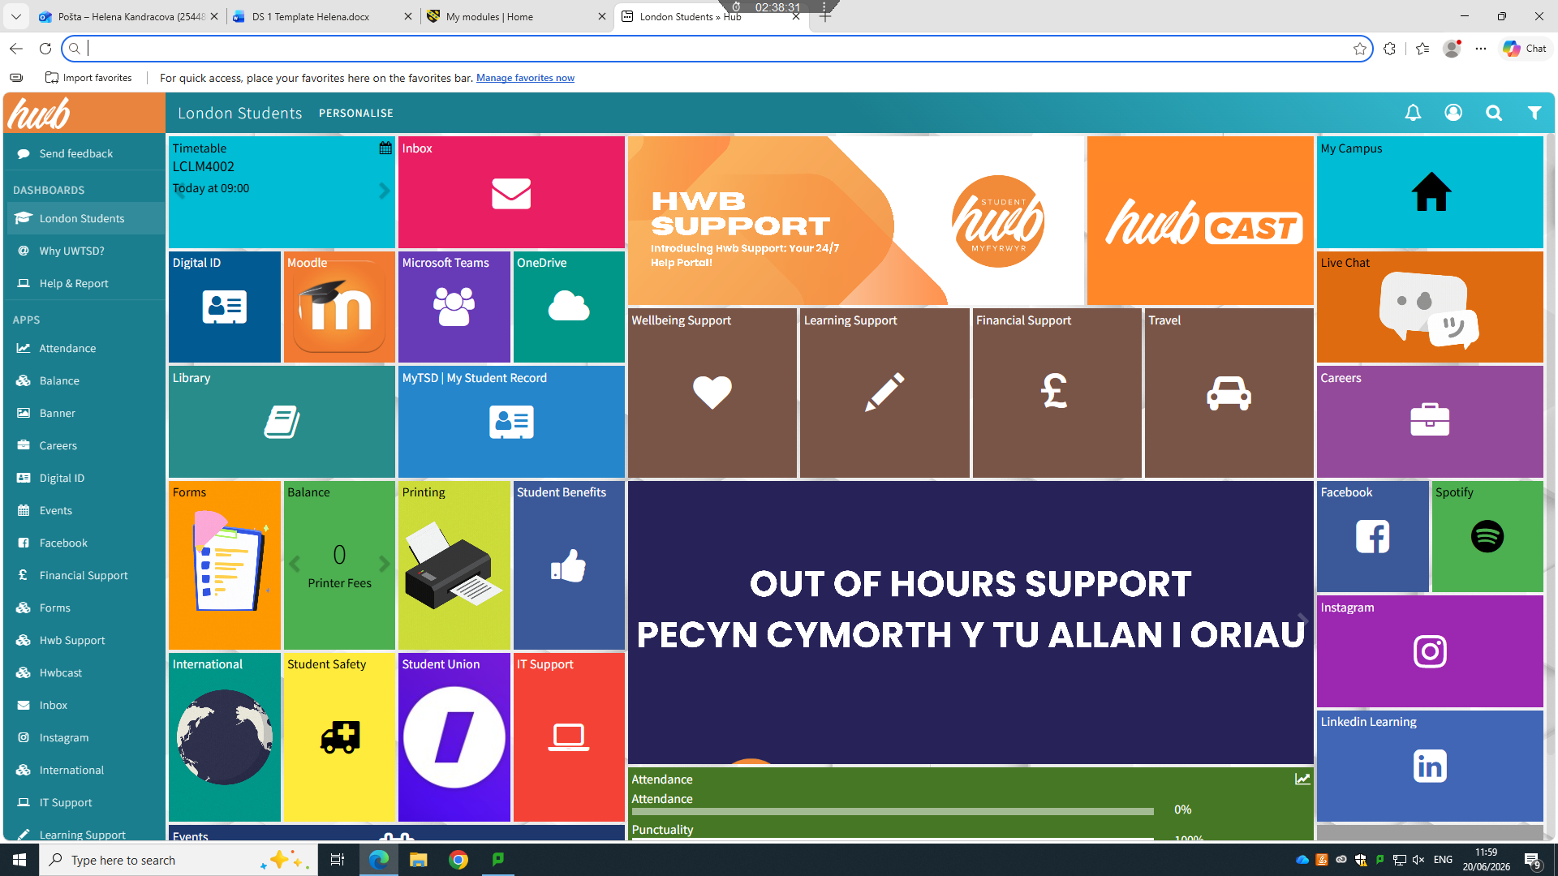
This is main page of moodle page for class

Screenshot/Photo 2
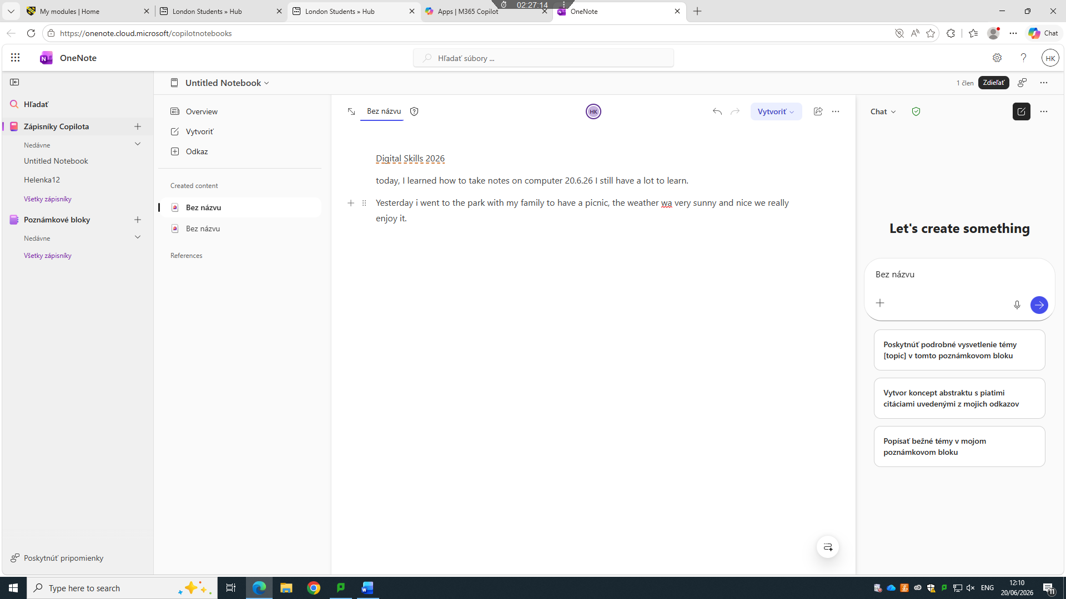

This is page one note where I write my note

Screenshot/Photo 3
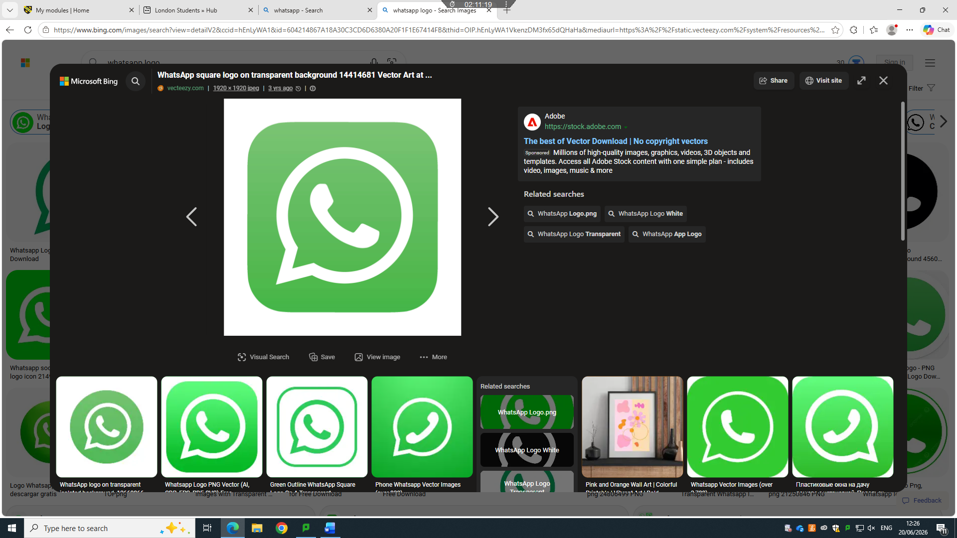
I Use Wattsapp to send short messages to my friends and family and to also receive short messages

Screenshot/Photo 4
[Insert Photo/Screenshot below]
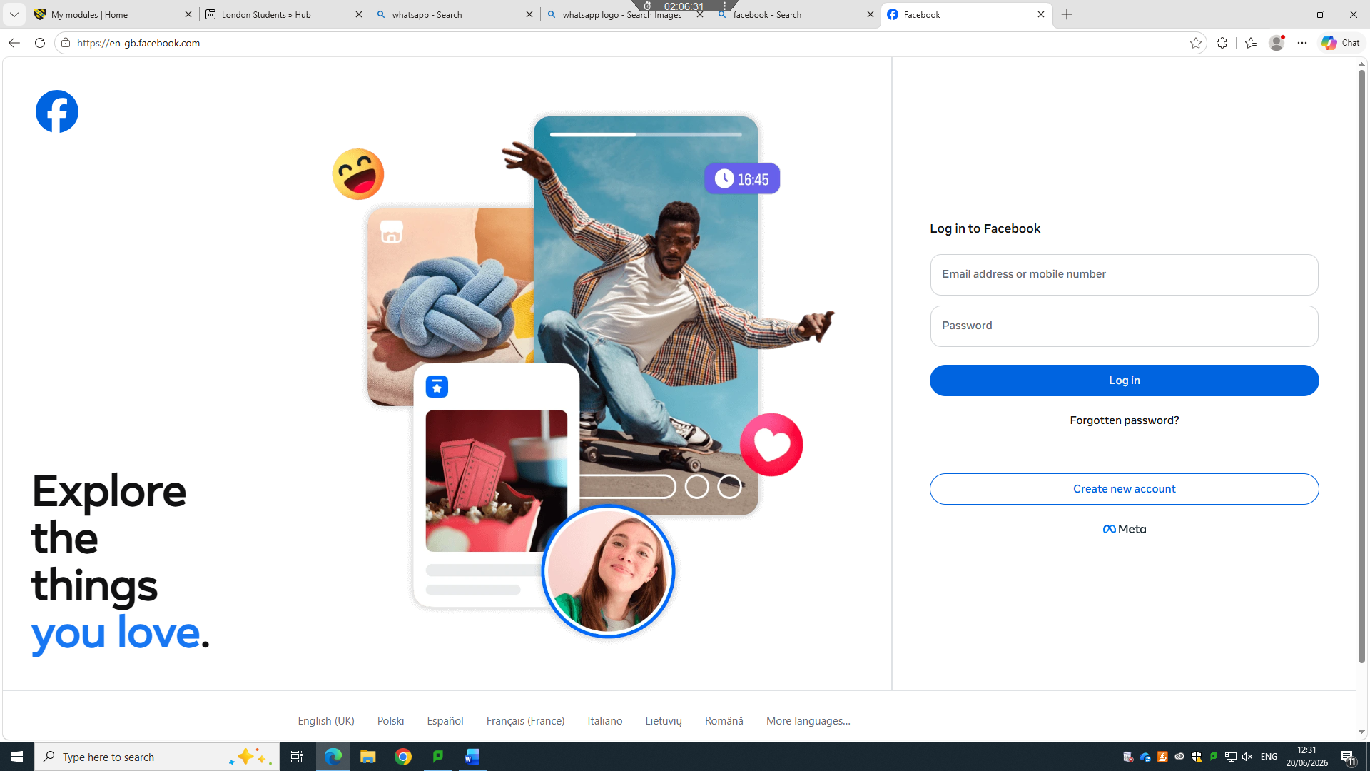
I regularly check facebook to stay connected with my friends and friends friends, sometimes I find nice videos, I shop , I check other people profile

My Short Reflection
I joined digital skills class in June 2026 at UWTSD, in my first class I learnt about digital technology and digital techniques such as using moodle, one note, outlook, print screen, log in with my student ID . This is the second week and my assignment is ready

