Module name: Health, Wellbeing and Sustainable Development
Module code: BMHP6021
Student name: Andreea Florina Bogdan
Student id: 1907865
Lecturer name: Diola Bijlhout

Health, Wellbeing and Sustainable Development

Table of Contents
Introduction 3
Discussion on 17 Sustainable development goals 3
Analysis of the 3 goals 5
Goal 3: Good Health & Wellbeing 5
Goal 4: Quality Education 6
Goal 17: Partnerships to achieve the Goals 7
Policies of the UK government in meeting these goals 8
Goal 3: Good Health & Wellbeing 8
Goal 4: Quality Education 9
Goal 17: Partnerships to achieve the Goals 11
Identification of the city and benefits it has achieved for these SDGs 12
Recommendations 13
Conclusion 14
References 15

Introduction
All nations, no matter their wealth, have come together under the umbrella of Sustainable Development Goals. This appeal aims to protect the natural world and the well-being of people, animals, and other species. It is a principle that is generally agreed that attempts to reduce poverty must coexist with initiatives to boost economic growth. Rapid action must be taken to address issues about climate change and environmental protection and those of education, health, social security, and employment. This report aims to examine the impact of the three effective sustainable development goals within the UK as well as the actions taken by the governments to meet the goals.

Discussion on 17 Sustainable development goals
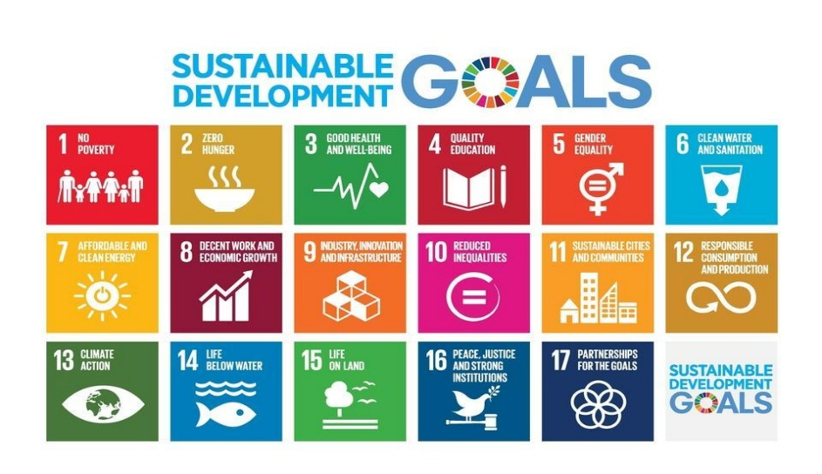
Figure: Sustainable Development Goals
Source: Sustainable Development (2022)
The UK aims to meet all SDG deadlines (Sustainable Development, 2022). Incorporating the Goals into each government agency's strategic plan is the most efficient way to achieve this goal. Departmental planning is most effective for coordinating plan implementation. The 2030 Agenda aims to abolish extreme poverty, eliminate inequality and injustice, and leave no one behind. The UN approved the SDGs in 2015 to continue the MDGs' efforts (MDGs). Each country that accepts the SDGs must work toward them internationally and domestically. As it did throughout negotiations, the UK will lead SDG implementation. The UK worked hard to ensure the SDGs justified the continuation of the MDGs (MDGs). The UK government produced a report in June detailing its progress toward the 17 Sustainable Development Goals (2019). Preliminary plans call for an announcement at the July 2019 UN High-Level Political Forum. (ESCAP, 2020). The United Nations, or UN, is an international organization that promotes international cooperation by fostering goodwill among nations. UN abbreviated United Nations. SDGs are the foundation for a better future for all. These goals strive to reduce inequality, poverty, environmental degradation, climate change, injustice, and lack of peace. 2030 has been chosen to achieve 17 UN objectives.
Bettering people's health and lengthening their lives is a secondary goal. This goal can be accomplished by expanding access to healthcare, lowering baby and child mortality rates, and treating underlying causes. This goal can be accomplished by reducing the prevalence of water-borne diseases like hepatitis and malaria and eradicating those spread by tuberculosis and the HIV/AIDS virus, as well as by combating tropical diseases like malaria. Fourth, making sure that all children, from new-borns to high school seniors, have access to the same high-quality, gender-neutral care and education. Gender inequalities must be eradicated, and there should be equal access to a college education that is both affordable and of excellent quality.
Sixth, reduce pollution and chemical releases to guarantee everyone gets clean water. Reduce water waste by 50% and double recycling/reuse efforts. Seventh, provide contemporary, economical, and sustainable energy. Technology and infrastructure investment might give all growing nations access to eco-friendly energy services. To reach goal 8, one must support economic growth and offer enough jobs. The eighth goal is to promote innovation through communication and information technologies (Bexell and Jönsson, 2019). This will increase industrial sector GDP and employment, assuring industrialization's continuation. Eleventh, promote economic, political, and social inclusion for all people, regardless of ethnicity, age, or religion, to decrease state-to-state inequality. Discriminatory laws, regulations, and practices must be eliminated to level the playing field and limit outcome variance. Preserving natural and cultural resources and providing reliable transportation would make communities more resistant to natural and man-made calamities. No. 12 promotes eco-friendly production and consumption. Halving global food waste could help achieve this goal. The twelfth objective focuses on climate change and its repercussions, such as improving public awareness and incorporating relevant actions into national policies and plans (Persons, 2018).
The thirteenth goal is marine resource conservation and use. All forms of marine pollution must be eradicated or significantly reduced, as must ocean acidification and fishing sector subsidies. One wants to reduce desertification, improve forest management, and stop land deterioration. Degraded soil and land restoration and mountain ecosystem protection are two approaches. Goal 16 aims to eradicate child exploitation, abuse, trafficking, and torturing and reduce bribery and corruption, resulting in an inclusive, peaceful, and equal society (BETTER, 2020). The 17-point strategy aims to promote sustainable development through revitalizing international cooperation. To boost financial resources, domestic resource mobilization, and aid underdeveloped nations.

Analysis of the 3 goals

Goal 3: Good Health & Wellbeing
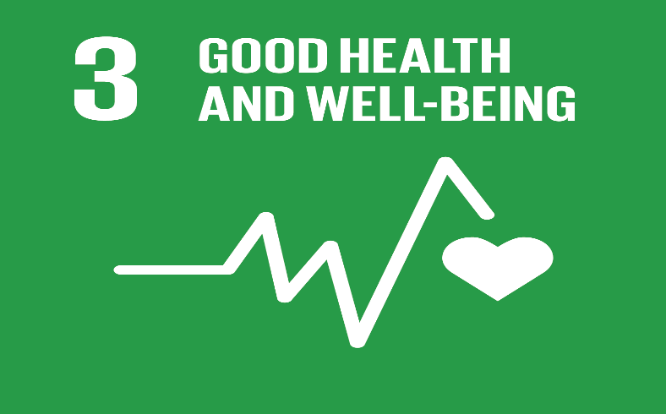
Figure: Goal 3: Good Health and Well- Being
Source: Martin (2022)
Infant mortality has dropped by half in the past 15 years. Dated as of Martin 2022 As a result, there is a solution to every health problem. Spending time, energy, and resources on easily avoidable health problems is absurd. The new global health goal emphasises research and development, improved pharmaceuticals, and disease prevention. Volunteer work is a powerful tool for accomplishing the Global Goals. Put into action these thirteen steps to boost community wellness. By 2030, the rate of maternal mortality must be reduced to below 70 deaths per 100,000 live births. Deaths among children under the age of five should be less than 25 per 1,000 people by the year 2030. The Martin 2022). It's a goal shared by the developed and the developing world. Eradicate AIDS, tuberculosis, malaria, and other tropical diseases by the year 2030; combat hepatitis and other water-borne infections. By the year 2030, no communicable disease mortality can be reduced by one-third and mental health and well-being can improve via prevention and treatment. There needs to be more support and prevention for alcoholism and drug misuse. Make it a goal to halve traffic-related deaths and injuries by the year 2020. By the year 2030, all people should have access to sexual and reproductive health services, family planning, information and education, and reproductive health as a result of national policies and initiatives.
Be sure that everyone can afford and receive basic health care, immunizations, and medication. Chemical-related mortality and morbidity must be reduced by at least half by the year 2030. The WHO's Framework Convention on Tobacco Control must be put into effect everywhere in the world (Hoffman et al., 2019). Increased funding for vaccines and medicines for communicable and non-communicable diseases affecting primarily developing countries is called for in the Doha Declaration on the TRIPS Agreement and Public Health, which affirms the right of developing countries to fully implement TRIPS provisions on patenting, pricing, and other intellectual property rights. The Doha Declaration states that even the poorest States can meet their TRIPS commitments in full. Healthcare spending and recruitment, development, training, and retention rates need to rise in developing countries, especially the least developed and small island developing states. Help governments everywhere, but especially those in underdeveloped countries, better spot and counteract health crises.

Goal 4: Quality Education
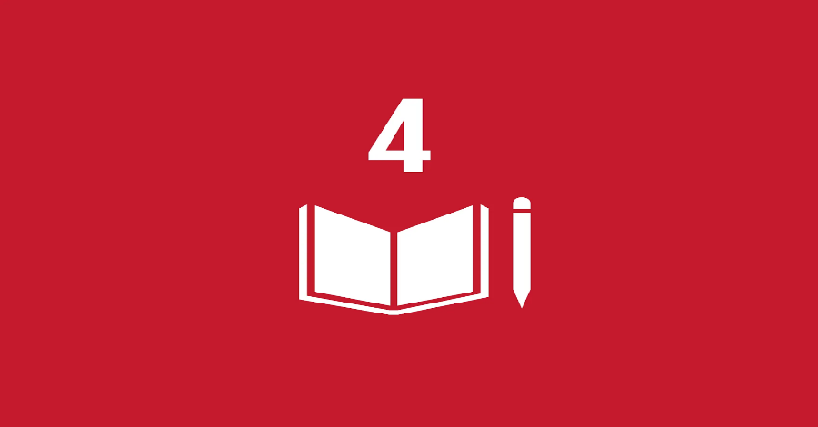
Figure: Goal 4: Quality education
Source: Goal 4: Quality education - The Global Goals (2022)
An effective education helps one reach his or her full intellectual and creative potential and boosts confidence. By reaching the targets, one can blossom into their fullest potential and make meaningful contributions to society. Every person should be able to take advantage of educational opportunities. All are welcome to back the Global Goals. All kids will receive a world-class education if they meet these ten standards. Assure that all children, males and girls alike, attend and complete primary and secondary education by the year 2030 (Saini et al., 2022). Early childhood education, care, and development must be of the greatest quality if children are to be ready for primary school by the year 2030. Men and women alike must be able to afford to go to college by the year 2030, whether it be at a technical, vocational, or academic institution. Adolescents and adults alike will need improved technical and vocational skills before the year 2030 if they are to find decent work or start their own businesses. Increased size is a necessity for both advanced and emerging nations. By the year 2030, all people, including those with disabilities, native peoples, and kids from disadvantaged backgrounds, will have access to a safe, inclusive, and well-resourced learning environment. By 2030, the world's population as a whole should be literate and numerate. All learners can acquire the knowledge and skills necessary to promote sustainable development by 2030 through an emphasis on human rights, gender equality, promoting a culture of peace and nonviolence, global citizenship, appreciating cultural diversity, and culture's contribution to sustainable development. These examples fit into this class. Increases in global scholarship funding for developing nations are needed to help pay for programmes that provide higher education, vocational training, and information and communications technology to the world's most economically disadvantaged people. Particularly in low and middle-income Small Island developing states, international cooperation in teacher education can boost the number of educated teachers by 2030 (Bengtsson et al., 2020).

Goal 17: Partnerships to achieve the Goals
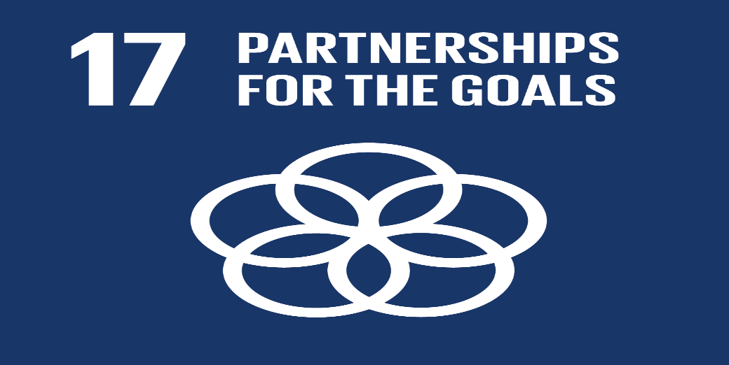
Figure: Goal 17: Partnerships for the goals
Source: Goal 17: Partnerships for the goals - The Global Goals (2022)
Everyone must work to attain global goals. Developing nations need foreign help and investments to foster technological advances, free and equitable trade, and market access. Only mutual aid, compassion, innovation, zeal, and teamwork can enhance the planet. Anyone may support Global Goals. Improve tax and revenue collection by mobilizing domestic resources, including through foreign aid to underdeveloped nations. ODA suppliers should allocate 0.20 percent of ODA/GNI to LDCs. Rich nations should fully implement their ODA pledges, particularly the commitments of some wealthy nations to give 0.7% of GNI to developing nations and 0.15 to 0.2% to the least developed states (The Global Goals, 2022). Donate money from various sources to poor countries. Coordinating debt financing, debt relief, and debt restructuring programmes to reduce the external debt of heavily indebted developing nations and help them achieve financial stability. Develop investment promotion programmes for LDCs.
Coordinating current systems, especially at the United Nations level, and setting up a global technology facilitation system will improve North-South, South-South, and triangular regional and international cooperation. Make it easier for developing countries to acquire and use environmentally friendly technologies by offering them financial incentives and preferential treatment. Implement a strategy for strengthening LDCs' scientific, technological, and innovative capacities by 2017. Collaboration between developed and developing countries, as well as between the North and South, should be bolstered in order to help developing nations reach the Sustainable Development Goals. In order to create a global, rules-based, open, non-discriminatory, and fair international trading system, it is imperative that the WTO Doha Development Agenda negotiations come to a successful conclusion. Increasing exports from developing countries is crucial if LDCs are to double in size by 2020. Help the WTO achieve permanent duty-free and quota-free market access for all LDCs by making sure that the preferential rules of origin for LDC imports are easy to understand and implement.
The coordination of policies can strengthen the stability of the macro-economy. Increase policy consistency to promote sustainable expansion. Recognize and respect national sovereignty when developing anti-poverty and long-term growth policies. Support the SDGs in all countries, but especially the impoverished ones, by bolstering multi-stakeholder alliances like the Global Partnership for Sustainable Development that mobilise and share information, expertise, and resources. Partnership expertise and resources can be used to boost public, public-private, and civil society cooperation. Disaggregated data on income, gender, age, race/ethnicity, migration status, handicap, and location are expected by 2020. Include MDGs and SIDS. As the deadline for the Sustainable Development Goals (SDGs) approaches in 2030, we must step up our efforts to produce SDG progress evaluations that boost GDP and assist developing countries in improving their statistical skills.

Policies of the UK government in meeting these goals

Goal 3: Good Health & Wellbeing
The UK aspires to improve domestic and international healthcare. The government invests in global health crisis prevention and response and sexual and reproductive health. The government ensures mental healthcare and treatment access, funds research and innovation, and publishes personal well-being indicators. Everyone should work together to tackle the most significant health challenges. Healthy people work more and earn more, which boosts the economy. By preventing and managing health crises, the UK can stop Ebola. The UK enhanced world health. This included immunizing 1 million children, giving 9.9 million girls and women voluntary family planning, and facilitating 5.6 million deliveries with skilled birth attendants (Martin, 2022). The UK will fund emergency health care. Progressive nations must handle these concerns. By 2020, immunizing 76 million British children might save 1.4 million deaths (Martin, 2022). The government is leading a global effort to research vaccines and cures for infectious diseases, prevent malaria, and reduce mother and new-born mortality. The UK keeps contributing to the Global Fund to fight tuberculosis, malaria, and AIDS, allowing us to treat 1,300,000 HIV patients with life-saving medication. The UK battles lymphatic filariasis and trachoma and create health systems (Martin, 2022). It worked with the UN and G20 on antibiotic-resistant microorganisms (AMR). The UK supports sexual and reproductive health and rights internationally (SRHR). By 2020, the UK wants 24 million more people to accept free, modern family planning. The positive effort by the UK to minimize mortality. The UK ranked 31st internationally in 2015 with 9.02 maternal deaths per 100,000 births. England and Wales's neonatal mortality rate was 2.5 per 1,000 live births in 2014. 14 Infant mortality was 3.6% per 1,000 live births in 2014, ranking 15th worldwide (Martin, 2022). Even if the death rates are low, the UK can improve healthcare. The UK want American hospitals and clinics to be the safest. The government of the UK assure all English hospitals have 24/7 staff. The nations prioritizes medical breakthroughs. The UK continue funding cancer research. The government encourages large-scale trials of novel health services and technology, especially at the Francis Crick Institute, to deploy cost-effective new drugs and technologies. The government also revamped the Cancer Drugs Fund, in which the UK invest. The UK sequence 100,000 rare disease and cancer patients' genomes. 19072 genomes were sequenced (Martin, 2022). The government aids everyone with mental disease. By 2020/21, England's mental health treatment will receive £1 billion. Through IAPT, those who need mental health care can get it nationwide. The government also strictly enforcing new access and waiting-time standards for mental illness patients of all ages, including children and teens. ONS collects annual well-being statistics from 10 survey variables. The ONS created an online tool in 2016 that lets people compare their neighbourhood's quality of life to the UK's and track its five-year growth.

Goal 4: Quality Education
British education law, policy, and accountability are complex. This endeavour encourages strong schools, three million new apprenticeships, and the education of disadvantaged children and women. To eradicate poverty, improve global education. Raising education levels raises salaries, opportunities, and educated labour for economies. Education is a moral and financial investment. The government of the UK trained 380,000 teachers and enrolled 11,300,000 elementary and middle schoolers, including 5,300,000 girls (Zulieta et al., 2020). The UK government will educate 11 million children and keep 6.5 million girls in school by 2020. The UK recently announced increased funding for the Girls Education Challenge (GEC), bringing the total to one million disadvantaged girls. Education Cannot Wait has a five-year goal of teaching 13.6 million youngsters in disaster-stricken countries (Zulieta et al., 2020). It helps special-needs children. The UK has pledged to enhance classrooms and track impaired children's development with UNICEF and the Global Partnership for Education. This should increase support for handicap-accessible schools, teacher training in inclusive pedagogies, and community leaders and parents' awareness of racism. The UK Department of Education is extending. RISE will improve educational systems to boost student achievement. Happy childhoods are for everyone.
All 3- and 4-year-olds in England get 15 hours per week of high-quality early education to prepare them for school. 2016 enrolment for 2-year-olds climbed from 58% to 68%. The British government wants to double the number of working 3- and 4-year-olds who receive free day-care. Improving preschool teachers (Zulieta et al., 2020). 91% of babysitters are good or exceptional. The British government believes every child deserves a great education and a caring teacher. Under the free school concept, successful schools can convert to academies and thrive across England. 1.8 million students have attended "excellent" or "exceptional" schools since 2010 (Zulieta et al., 2020).
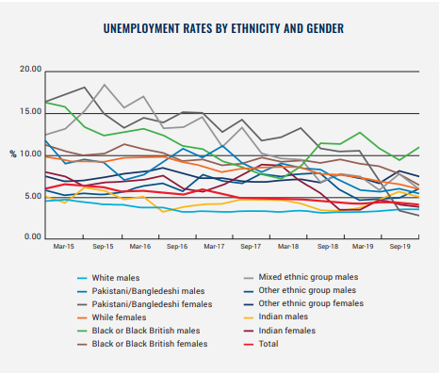
Figure: Unemployment Rates by Ethnicity and Gender
Source: Our Sustainable Development Goals and Young Londoners work (2019)
The government of the UK is building equitable national finance methods better to match money to children's needs and schools, boosting their education and future possibilities. Underfunded English communities and schools will soon receive funding hikes. Low-income students of all abilities benefit from the pupil premium. In high-social-mobility Opportunity Areas, The UK investing £60 million to help young people succeed. The College of Teaching and a teaching and leadership innovation fund will invest £75 million over three years to aid teachers and school leaders in disadvantaged communities (Henehan, 2020). High school graduates should be ready for the world, meaningful work, and the economy. Lord Sainsbury's team proposes streamlining postsecondary education and training to provide all English youth with clear, high-quality technical pathways to skilled jobs. These classes’ help students compete for tech-savvy jobs. To help young people find employment and education, the government wants 3 million extra apprenticeships by 2020, 2015/16 started 503,700 apprentices and funded 904,800 (Henehan, 2020). Since 2010, economically disadvantaged college students have tripled. The UK can do more if the government make higher education financially self-sufficient, innovative, and accessible. The Higher Education and Research Act helps. The government strengthening instruction with the Teaching Excellence Framework and extending kids' postsecondary options to provide them with the needed skills. Through programmes like the "transparency revolution," it improves social mobility, life chances, and opportunity for everyone.

Goal 17: Partnerships to achieve the Goals
The UK seeks long-term international development partnerships. According to the UN, the U.S. has vowed to spend 0.7% of its GDP on international development. British legislation codified 0.7% in 2015 (Brien & Loft, 2022). The UK will lead in sustainable development and worldwide trade despite leaving the EU. DIT and DID will cooperate to boost UK trade with developing nations (DFID). DFID partners with the FCO and BEIS through the amalgamated DIT and DFID Trade for Development Team to boost UK and developing-nation growth. The UK has advanced Agenda 2030 through international partnerships, and its officials are involved in international venues where the plan will be discussed. Economic progress, stability, and security abroad are in the national interest.
Conventional development approaches won't achieve the Goals. The UK is a big donor for statistical capacity. It will continue to invest in partner countries' ability to use digital technologies for data generation, and dissemination so new private and civil society data sources may be used more effectively. The UK will also lead the Global Partnership for Sustainable Development Data in mobilizing and coordinating institutions and initiatives to achieve the SDGs. The Addis Tax Initiative (ATI) aims to quadruple their support for tax reform in poor countries by 2020, as articulated in the Addis Ababa Action Agenda at the 2015 UN Financing for Development Conference (Forstater, 2018). The government has pushed for more nations to join at the G20 and elsewhere. Through the WTO, the UK supports an open, multilateral trading system. The government has encouraged the UK and LDCs to reduce trade barriers. The government keeps pursuing new global collaborations for sustainable development by strengthening private-sector ties and directing aid to create more revenues.

Identification of the city and benefits it has achieved for these SDGs
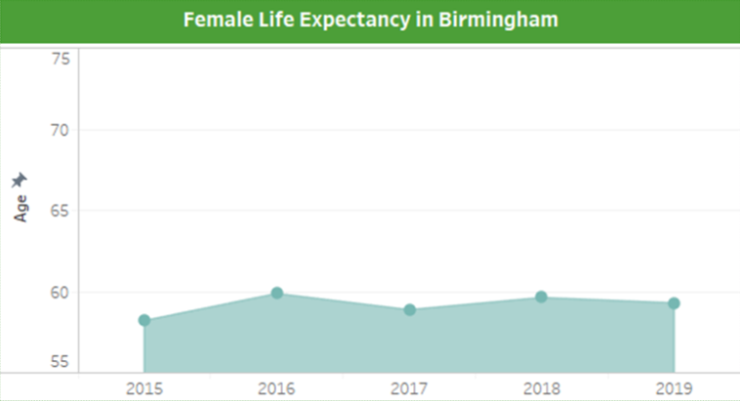
Figure: Female life expectancy in Birmingham
Source: Using Sustainable Development Goals as Indicators for Levelling Up – City REDI Blog (2022)
Increasing one's standard of living may involve enhancing one's financial status, broadening one's access to resources, or making changes to one's way of life that are designed to make it healthier. Goal: 3 focuses on a population's overall health as well as their level of happiness, which is measured by the Healthy Life Expectancy indicator (HLE). The HLE is a projection of how long a person might live if they were to maintain their current level of health throughout their whole life. This handy tool allows for the performance of Birmingham to be compared to that of other cities, as well as the identification of new patterns and trends in the underlying data. Between the years of 2015 and 2019, the female HLE in Birmingham has consistently ranged between the ages of 58 and 59 (Using Sustainable Development Goals as Indicators for Levelling Up – City REDI Blog 2022). A pattern that is remarkably similar to this one is followed by male HLEs in Birmingham. The population of people aged 58 and 59 remained the same between the years of 2015 and 2019, with no significant change.
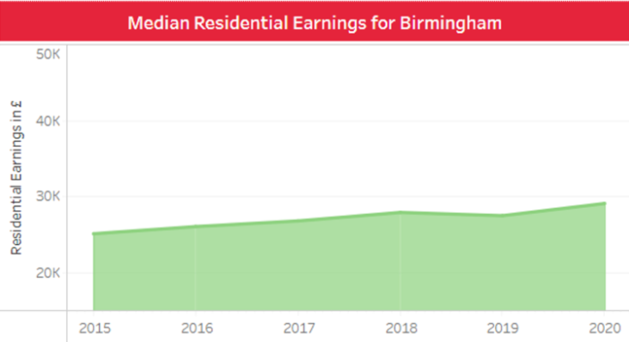
Figure: Residential earning development in Birmingham
Source: Using Sustainable Development Goals as Indicators for Levelling Up – City REDI Blog (2022)
In addition, the Key Performance Indicators (KPIs) for Goal 4: Quality Education analyse the number of new apprenticeship programmes, educational attainment, and levels of proficiency. For the 2019-2020 academic years, the number of people commencing their training as apprentices in Birmingham has decreased by 23.9%, which is equivalent to 1,820 less people (Using Sustainable Development Goals as Indicators for Levelling Up – City REDI Blog 2022). Because of the potential for adverse effects of COVID-19, firms may have been dissuaded from taking on new apprentices, which has resulted in a scarcity of accessible apprenticeship places. This would explain why there are fewer apprenticeships available. When deciding what to level up, another consideration that is frequently taken into account is the cost-effectiveness of each option. The city of Birmingham came in sixth place among the eleven major cities in terms of residential pay, with a median of £29,040 (Excluding Belfast). In terms of growth from one year to the next, Birmingham ranks fifth and is expected to experience an increase of 5.8% between 2019 and 2020 (Using Sustainable Development Goals as Indicators for Levelling Up – City REDI Blog 2022). It is essential to keep in mind that the Sustainable Development Goal dashboards were designed to function as a source of information for the research of data as well as supplementary materials for a variety of publications, so that readers may delve deeper into the information that is currently available. The issues brought out were never meant to be resolved by the Sustainable Development Goals dashboards in any way. On the other hand, comparable dashboards can be used to track the development of a Local Authority in comparison to that of others, as well as against a variety of parameters. The Sustainable Development Goals (SDGs) contain a wider array of policy concerns than the Local Urban Work Plan (LUWP), which means that they may provide a method of evaluating the quality of life in a community that is more comprehensive than the LUWP. On the other hand, in the case of Goal 17, this fact has been seen that the city has acquired effective stakeholders for the development of the city. Effective incorporation of the NGOs and other social service stakeholders, the city has the potential to enhance the well being of the people in various ways.

Recommendations
- Based on Goal 3, this fact can be seen that the use of effective health and wellbeing measures are necessary for the development of the cities. According to the above analysis it can be seen that although the male life expectancy rate is in a stable position within the city of Birmingham, the life expectancy rate for the females have reduced effectively during the last few years (Using Sustainable Development Goals as Indicators for Levelling Up – City REDI Blog 2022). Therefore, the city council needs to focus in developing the health and wellbeing measures for the females living within the city.
- Additionally, it has also been seen that the residential earning in Birmingham has developed during the last few years. However, it can be seen that the city needs to focus on enhancing the earning of the individuals as it is highly connected to the emotional wellbeing of the people. As the housing rates are highly developing within the UK, it is necessary to enhance the earning of the people effectively. This approach can eventually help the city council to enhance affordability of the housing for the people.
- The number of NGOs and other social stakeholders needs to be effectively developed within Birmingham to enhance the ability of the city to meet the Goal 17. It has been seen that the incorporation a huge number of stakeholders develop the economy of a region as well as reducing the issues within the lives of the people.
- Although, the number of educational institutions as well as the literacy rate is effective within the city of Birmingham, the affordability of the education cost needs to be increased. It has been seen that the slow growing housing income of the city may outdate the highly increasing educational expenses within the city. Therefore, the city council needs to focus on reducing the cost of education for the local people to enhance the ability of the city to meet the Goal 4, more effectively.

Conclusion
The United Kingdom has made progress on Sustainable Development Goals 3, 4, and 17 because of the efficient application of the government's policies regarding finance, social issues, and the environment. In recent years, the government of the United Kingdom has undertaken a variety of programmes with the goal of improving the lives of its citizens and ensuring the social and economic stability of the country as a whole. It has also been shown that London, as one of the most productive cities in the United Kingdom, has made substantial strides toward attaining the three sustainable development goals. This was found to be the case when London was compared to other cities in the United Kingdom. Housing costs and resident hourly salaries, for example, have been recognised as issues that need to be improved in London in order for the city to accomplish its goals. In the case of specific cities, this fact has been observed that Birmingham has effectively met the mentioned gaols. However, it has been suggested that the city council needs to develop the life expectancy rate of the females as well as the housing income of the people living within the city to meet the goals in a more effective way.

References
Assembly, L. and Parliament, U.K., 2019. Settled by Romans. City, 5, pp.14-257. Available at: https://sapientiada.com/london. Accessed on(15.11.2022).
Bengtsson, S., Kamanda, M., Ailwood, J. and Barakat, B., 2020. Teachers Are More Than ‘Supply’: Toward Meaningful Measurement of Pedagogy and Teachers in SDG 4. In Grading Goal Four (pp. 214-237). Brill. Available at: https://library.oapen.org/bitstream/handle/20.500.12657/53875/9789004430365.pdf?sequence=1#page=241. Accessed on(17.11.2022).
BETTER, I., 2020. BELIEVE. Available at: http://www.un.org/youthenvoy/wp-content/uploads/2020/05/Believe-in-Better.pdf. Accessed on (18.11.2022).
Bexell, M. and Jönsson, K., 2019. Country reporting on the sustainable development goals—the politics of performance review at the global-national nexus. Journal of Human Development and Capabilities, 20(4), pp.403-417. Available at: https://www.tandfonline.com/doi/pdf/10.1080/19452829.2018.1544544. Accessed on(19.11.2022).
Brien, P & Loft, P 2022, The 0.7% aid target, House of Commons Library, viewed 2 November 2022, https://commonslibrary.parliament.uk/research-briefings/sn03714/.
Cojocaru, T.M., Ionescu, G.H., Firoiu, D., Cismaș, L.M., Oțil, M.D. and Toma, O., 2022. Reducing inequalities within and among EU Countries—assessing the achievement of the 2030 agenda for sustainable development targets (SDG 10). Sustainability, 14(13), p.7706. Available at: https://www.mdpi.com/2071-1050/14/13/7706/pdf. Accessed on (1.12.2022).
ESCAP, U., 2020. Accelerating SDG7 achievement in the time of Covid-19: policy briefs in support of the high-level political forum 2020. Available at: https://repository.unescap.org/bitstream/handle/20.500.12870/922/ESCAP-2020-PB-Accelerating-SDG7-achievement-covid-19.pdf?sequence=4. Accessed on (1.01.2022).
Forstater, M., 2018. Tax and development: New frontiers of research and action. Center For Global Development. Disponível em:. Acesso em, 24. Available at: https://www.cgdev.org/sites/default/files/tax-and-development-new-frontiers-research-and-action.pdf. Accessed on (1.12.2022).
Ghadikolaei, M.A., Wong, P.K., Cheung, C.S., Zhao, J., Ning, Z., Yung, K.F., Wong, H.C. and Gali, N.K., 2021. Why is the world not yet ready to use alternative fuel vehicles?. Heliyon, 7(7), p.e07527. Available at: https://www.sciencedirect.com/science/article/pii/S2405844021016303. Accessed on(2.12.2022).
Goal 17: Partnerships for the goals - The Global Goals 2022, The Global Goals, viewed 1 November 2022, https://www.globalgoals.org/goals/17-partnerships-for-the-goals/. Accessed on (5.12.2022).
Hakiminejad, A., 2018. Measuring cities: a study of the development of Iranian urban sustainability assessment mechanisms from a UK perspective (Doctoral dissertation, University of West London). Available at: https://repository.uwl.ac.uk/id/eprint/4757/1/Ahmadreza%20Hakiminejad%20-%20Thesis%20Final%20%28Feb%202018%29.pdf. Accessed on (5.12.2022).
Henehan, K., 2020. Class of 2020: Education leavers in the current crisis. Available at: https://dera.ioe.ac.uk/35542/1/Class-of-2020.pdf. Accessed on (6.12.2022).
Hoffman, S.J., Poirier, M.J., Van Katwyk, S.R., Baral, P. and Sritharan, L., 2019. Impact of the WHO Framework Convention on Tobacco Control on global cigarette consumption: quasi-experimental evaluations using interrupted time series analysis and in-sample forecast event modelling. Bmj, 365. Available at: https://www.bmj.com/content/365/bmj.l2287. Accessed on (5.12.2022).
Martin 2022, Health - United Nations Sustainable Development, United Nations Sustainable Development, viewed 1 November 2022, <https://www.un.org/sustainabledevelopment/health/.
Our Sustainable Development Goals and Young Londoners work 2019, LGOV, viewed 2 November 2022, <https://www.london.gov.uk/who-we-are/city-halls-partners/london-sustainable-development-commission/our-current-work-and-priorities/our-work-un-sustainable-development-goals/our-sustainable-development-goals-and-young-londoners-work>.
Persons, U.C., Artificial Intelligence for the UN 2030 Agenda. Available at: https://www.esf.edu/es/sonnenfeld/documents/2018IEPCSynthesisReport.pdf. Accessed on (7.12.2022).
Saini, M., Sengupta, E., Singh, M., Singh, H. and Singh, J., 2022. Sustainable Development Goal for Quality Education (SDG 4): A study on SDG 4 to extract the pattern of association among the indicators of SDG 4 employing a genetic algorithm. Education and Information Technologies, pp.1-39. Available at: https://link.springer.com/article/10.1007/s10639-022-11265-4. Accessed on(1.12.2022).
THE 17 GOALS | Sustainable Development 2022, Un.org, viewed 1 November 2022, <https://sdgs.un.org/goals>.
Thomson, H. and Bouzarovski, S., 2018. Addressing energy poverty in the European Union: state of play and action. EU Energy Poverty Observatory, Manchester. Available at: https://www.precarite-energie.org/IMG/pdf/paneureport2018_final_v3.pdf. Accessed on(2.12.2022).
Using Sustainable Development Goals as Indicators for Levelling Up – City REDI Blog 2022, Bham.ac.uk, viewed 3 November 2022, <https://blog.bham.ac.uk/cityredi/using-sustainable-development-goals-as-indicators-for-levelling-up/>.
Yumashev, A., Ślusarczyk, B., Kondrashev, S. and Mikhaylov, A., 2020. Global indicators of sustainable development: Evaluation of the influence of the human development index on consumption and quality of energy. Energies, 13(11), p.2768. Available at: https://www.mdpi.com/1996-1073/13/11/2768/htm. Accessed on(15.11.2022).
Zulieta, N.B., Sudarsana, I.K., Arrieta, G.S. and Ancho, I.V., 2020. Trends In School Enrollment And Graduation: The Experience Of Educational Management Students In The Graduate School. Jurnal Penjaminan Mutu, 6(01), pp.88-98. Available at: http://ojs.uhnsugriwa.ac.id/index.php/JPM/article/download/1232/657.
‌

‌
‌

