

EXAMINATION PAPER
MARKS AND COMMENTS SHEET

PROGRAMME | OME Degree Apprenticeship
LEVEL | 4
MODULE | ACDB4011 HNC Chemistry
STUDENT I.D. | 2308276
EXAMINER | Ewa Kazimierska | INTERNAL VERIFIER
Once completed marks only should be transferred onto the front of the examination paper (no comments other than ticks or crosses on the examination paper)

Question  Number | Comments | Marks available | Marks awarded | 2nd marker (sample) | 3rd marker (where necessary)
1 | Bohr model correct; correct identification; correct electron configuration | 13 | 13
2 | Wavelength correctly calculated and the colour recognised; incorrect order of radiation; incorrect description of absorption-emission process | 10 | 6
3 | Incorrect calculations | 6 | 0
4 | Correct equation; correct calculations | 7 | 7
5 | Ox and Red properly recognised but oxidation numbers not shown; correct Lewis structure of nitrogen; errors in Hess law; no comparison to TNT | 14 | 6
6 | Molar volume correct; errors in calculations | 14 | 2
7 | Vague definition of OB; errors in calculations of OB; K-W rules correctly used | 10 | 5
8 | Good understanding of phase diagram except melting and boiling points; some transitions are incorrect; good discussion of safe storing; vague discussion of intermolecular forces | 12 | 7
9 | Clear energy profile; heat of reaction and Ea calculated but with error; collision theory not discussed | 9 | 6
10 | Heat of calorimeter not necessary | 5 | 3
 |  |  | 55

1st Marker Name | Ewa Kazimierska | 1st Marker Signature | 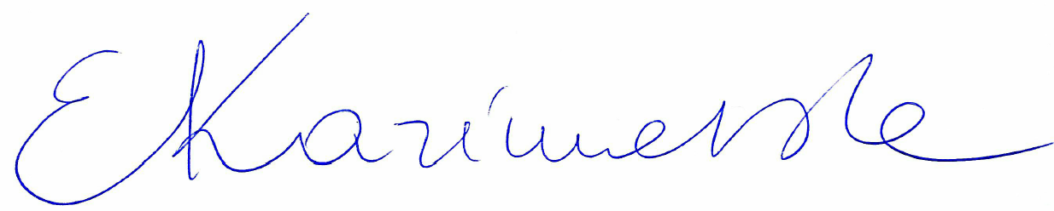
2nd Marker Name |  | 2nd Marker Signature
3rd Marker Name |  | 3rd Marker Signature
Reasons for awarding the final mark where there is more than one marker
Notes:
- The 3rd marker may be used where there is more than a 10 percentage point difference (in the TOTAL mark) between markers 1 and 2 OR when it is not possible to get agreement between markers 1 and 2. Reasons must be given where an agreed mark is given.
- This form is for internal use only and is NOT to be returned to the student. The final agreed marks must be transferred to the student feedback sheet in the assignment specification.
- The external examiner MUST be shown this form.

