Contents
1. ABSTRACT 2
2. INTRODUCTION 2
3. RESEARCH INTO SECURITY FRAMEWORKS AND MODELS 3
3.1 ISO 27000 Series (ISO/IEC 27001) 3
3.2 The ITIL (Information Technology Infrastructure Library) 5
3.3 COBIT 6
4. COMPARISON OF ISO 27001 AND ITIL 7
5.INTEGRATION OF FRAMEWORKS 7
5.1Key Elements of Integration 8
6.PROPOSED APPROACH FOR NATURES GARDEN 10
6.1Governance Framework 10
7.RISK MANAGEMENT 12
8.IMPORTANCE OF UPDATED REGULATIONS AND STANDARDS 14
9.DISCUSSION AND CRITICAL ANALYSIS 16
10.CONCLUSION 17
11. REFERENCES 17

1. ABSTRACT
In today's rapidly evolving digital landscape, ensuring robust information protection, data governance, and compliance is critical for organizations to safeguard assets and maintain stakeholder trust. The security issues that NG, a well-known worldwide brand that depends significantly on wireless networks and cloud settings, is facing are discussed in this paper. Data and intellectual property vulnerabilities are increased by BYOD activities and the lack of defined security standards.[1],[2].
This study suggests an optimal approach to improving information system security, governance, and compliance by referencing well-known security frameworks such as ITIL and ISO 27000. Through the use of risk analysis tools and illustrations, it illustrates how these frameworks reduce risks, guarantee policy compliance, and enhance catastrophe response.[5].[6].
The research concludes by highlighting the significance of revising laws and guidelines to combat new cybersecurity risks and help businesses keep up with developing technologies[3]. While guaranteeing company continuity, the suggested solutions give NG a sustainable security model in line with international best practices.

2. INTRODUCTION
Data security, governance, and compliance are critical to preserving the resilience and integrity of corporate information systems in the current digital era. Businesses are exposed to sophisticated cyber threats as a result of their growing reliance on wireless networks, cloud services, and BYOD policies. As a result, they require established security frameworks to reduce risks, guarantee compliance, and provide governance.[1].[2]
The well-known worldwide brand NatureGarden (NG) has serious security issues. Since NG uses a lot of cloud services and 95% of its network is wireless, it is susceptible to data breaches, illegal access, and intellectual property theft. The absence of a clear security policy makes these risks worse and leaves the business vulnerable to new threats.[5],[6].
Through an evaluation of frameworks such as ITIL and ISO 27000, this research suggests a methodical solution to NG's security problems. It highlights the necessity of updating rules to accommodate changing cybersecurity risks and illustrates how they can be applied to enhance security, governance, and compliance. The parts that follow go over important ideas and offer methods for safeguarding private information, making sure that regulations are followed, and preserving resilience.[8],[9].

3. RESEARCH INTO SECURITY FRAMEWORKS AND MODELS
Security frameworks and models are structured ways of managing information security, assuring compliance, and aligning security practices to organizational objectives. It then looks at how two widely used frameworks, namely the ISO 27000 series and ITIL, which have the potential to tackle some of the unique challenges which NG faces. Each of the key components are examined, along with their advantages, and how they are practically implemented, with diagrams for clarification.[1],[2]

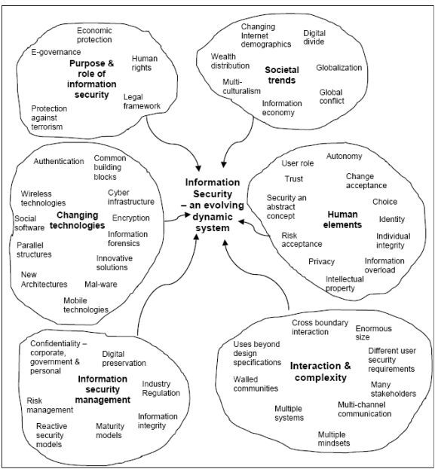
Fig 1: Information Security Framework
An Holistic View of Information Security: A Proposed Framework,2011.[7]

3.1 ISO 27000 Series (ISO/IEC 27001)

The ISO 27000 series, particularly ISO 27001, is a globally recognized standard for establishing and maintaining an Information Security Management System (ISMS). This standard provides a comprehensive approach to managing security risks and ensuring the confidentiality, integrity, and availability (CIA) of organizational information.[1]
- Key Components
- Assess threats to the integrity of information.
- Evaluate risks and address them according to the risk analysis matrix: likelihood and consequence.
- Put into practice controls like Authorization, encryption, and incident Detection around the firm.
- Vulnerabilities and prioritize based on likelihood and impact.
- Control Implementation
- Apply security measures such as access control, encryption, and incident management.
- Plan-Do-Check-Act (PDCA) Cycle[7]
- Plan: The timely setting up of security objectives and policies should be done.
- Do: Put control and policy in place.
- Check: To assess the performance of the controls.
- Act: Improve and update the ISMS.

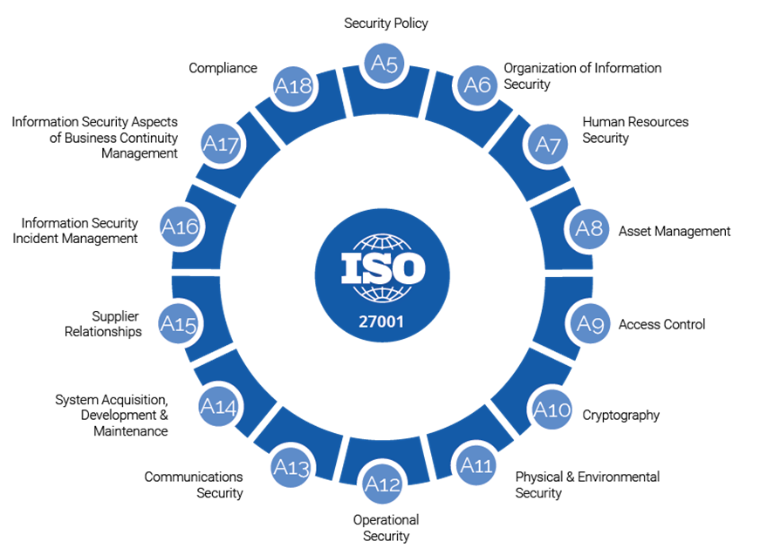
Fig 2: Iso 27000 series.[5]

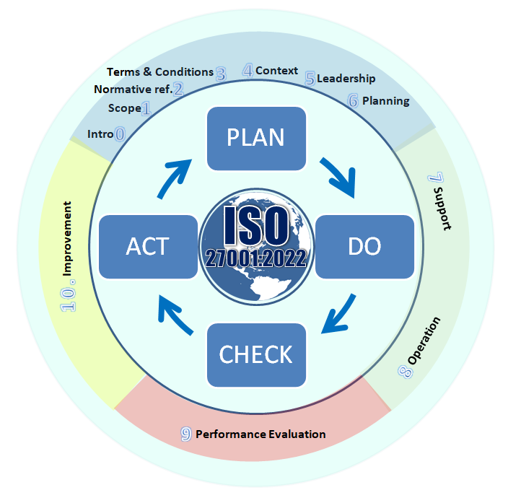
Fig 3: ISO 27001 PDCA Cycle [8]

3.2 The ITIL (Information Technology Infrastructure Library)
ITIL defines a set of best practices for IT Service Management (ITSM) within which security considerations are incorporated across the entire IT service life cycle. Focusing on the business should not be confused for a specific security framework; however, ITIL does improve security processes by integrating them with company goals. It incorporates security with it processes, permits proactive threat handling, fosters continuity during disruptions, and encourages consistency based on comments from security staff and procedures. These activities enhance the organizations ‘preparedness and ensure that the security measures are relevant to business requirements.[5]
Key Stages:
1. Service Design.
Embed security into IT architecture and policies.
Design secure systems to support organizational goals.
2. Service Operation.
Monitor for threats and respond to incidents in real-time.
Ensure continuity of IT services during disruptions.
3. Continual Service Improvement.
Evaluate and improve security processes based on feedback and performance.
Example: When a NatureGarden employee has a team ‘device’ compromised, ITIL’s incident management process offers the structure. This includes; establishment of the breach, containment and recovery.[6]
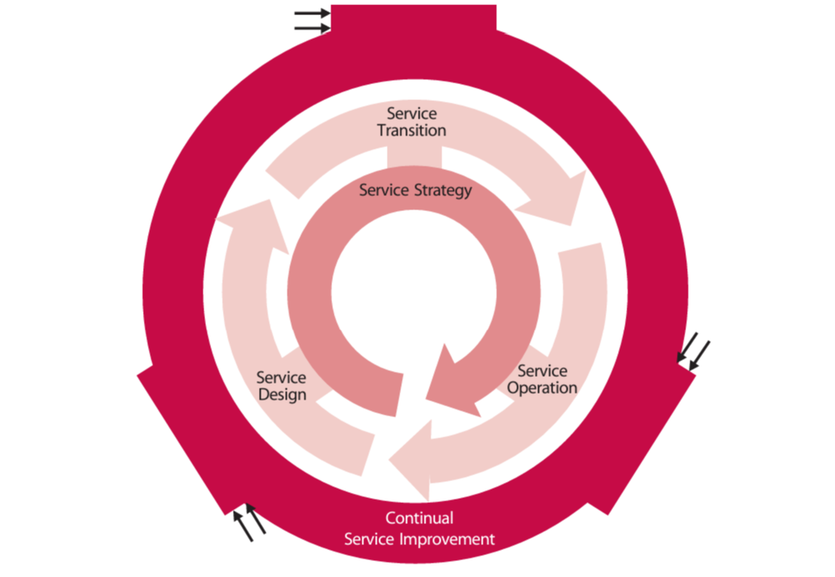

Fig 4: ITIL Service Lifecycle [2]
(The Official Introduction to the ITIL Service Lifecycle
PDF (www.kornev-online.net)

3.3 COBIT
COBIT: Control Objectives for Information & related Technologies is an international method designed by ISACA and aimed at guiding organizations to establish, clarify and administer technique and protocols related to Information technology. COBIT offers a framework of governance to aid in the establishment of the correlation between IT strategies and overall enterprise plans and objectives, therein enforce optimize utilization of the IT resources while preventing risks within the process.[10]
Key Features of COBIT
Governance and Management: A landmark difference between governance (providing overall direction) and management (responsibility for the operation of the organisation).
Alignment: Maps IT business to have better performance and avert risks that are affiliated to the business operations.
Framework Goals: It backs up compliance, risks, and value within the investment information technology presents.
Processes and Domains: Arranges IT practices into areas for instance the EDM, a four letter acronym comprising of Evaluate, Direct, and Monitor or the BAI as a four letter acronym that involves Build, Acquire, and Implement.
Benefits of COBIT
Risk Mitigation, Compliance, Efficiency, Transparency.

4. COMPARISON OF ISO 27001 AND ITIL

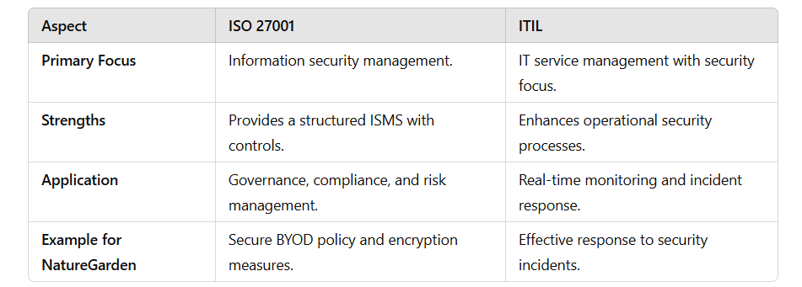

5.INTEGRATION OF FRAMEWORKS
ISO 27001 enhances an adequate management system with set regulatory framework.
ITIL demonstrates that these policies are implemented through IT service management processes.ing both strategic and operational aspects of security:
- ISO 27001 ensures a robust governance framework with defined policies and controls.
- ITIL operationalizes these policies through IT service management processes.
ISO 27001 framework coupled with the IT Infrastructure Library will offer NatureGarden a strategic and an operational solution to address information security issues. Whereas, ISO 27001 is centered on the issues of management, regulation, and risk, ITIL addresses strategies, methods, and procedures for IT services provision. In combination, these frameworks provide comprehensive security solution for NatureGarden.[8]
Purpose of Integration
The integration of ISO 27001 and ITIL aims to:
1. This must also ensure that the governance and operation of compliance and security management within the organisations is consistent.
2. Improve overall risk control, response to occurrences and compliance in the organization.
3. Develop an unbroken link between the defined top management goals and tactical IT plans.

5.1Key Elements of Integration
1.Governance and Compliance (ISO 27001)
Instead, ISO 27001 offers the framework of governance, thus outlining the roles and responsibilities with the help of Information Security Management System (ISMS).p Non compliances with such legislation as GDPR and norms of ISO 27017 help Nature Garden adjust to the international regulation of data protection and cloud security. Formation Security Management System (ISMS).[9]
- Compliance with regulations like GDPR and ISO 27017 ensures NatureGarden adheres to global standards for data protection and cloud security.[3].[4]
Operation Implementation is also known as Operational Support and Recovery (ITIL).
- ITIL operationalizes ISO 27001’s policies through its lifecycle stages.
Service Design.
- Applying ISO 27001 controls in the course of systems and processes implementation.
Service Operation.
- Real time monitoring, investigation and response, and service management and continuity.
Continual Service Improvement
- Specialized correction of processes and their adaptation to changes in ISO standards.

Risk Management
  - ISO 27001’s risk management framework identifies threats and implements mitigation strategies.
  - ITIL complements this by ensuring these strategies are integrated into day-to-day IT operations, such as incident and problem management.[1]
Incident Management
  - ISO 27001 provides the guidelines for incident response policies, while ITIL ensures these policies are operationalized through defined workflows.
  - Example: When a security breach is detected, ISO 27001 governs the response, while ITIL’s incident management ensures swift detection, containment, and recovery.
Benefits of Integration
- Strategic Alignment: ISO 27001 ensures strategic governance and compliance, while ITIL aligns operational processes with these strategies.
- Improved Efficiency: ITIL’s operational workflows streamline the implementation of ISO 27001 controls, reducing redundancies and delays.
- Comprehensive Risk Management: Combining ISO’s risk assessment with ITIL’s service management ensures both proactive and reactive measures are in place.
- Scalability and Flexibility: The integration supports NatureGarden’s expansion by enabling scalable governance structures and adaptable IT processes.
Challenges in Integration
- Resource Intensity: Implementing both frameworks requires significant resources, including time, skilled personnel, and financial investment.
- Cultural Resistance: Employees may resist changes in processes or additional compliance requirements.
- Coordination: Ensuring alignment between strategic governance (ISO 27001) and operational execution (ITIL) requires strong leadership and collaboration.
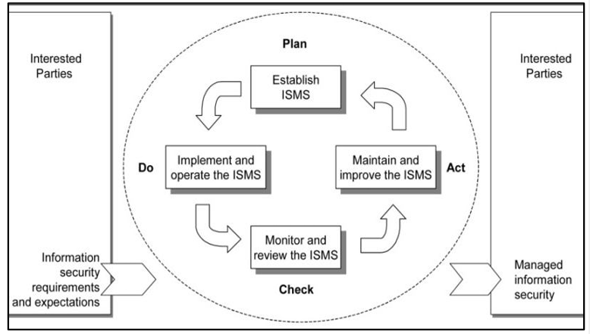
Fig 5 : A best practice approach for integration of ITIL and ISO/IEC 27001 services for information security management Razieh Sheikhpour1* and Nasser Modiri2,2012.

6.PROPOSED APPROACH FOR NATURES GARDEN
Based on the problems faced by NatureGarden in protecting its information systems, compliance as well as its Intellectual Property, the following comprehensive and systematic recommendations are made. This approach combined the governance, risk management controls, security measures, information security controls, and business continuity and disaster recovery plans, and follows best practices of ISO 27001 and ITIL.[9]

6.1Governance Framework
Aligned to business objectives and with accountability such structures are also known to provide for a robust governance structure. There will be a Chief Information Security Officer (CISO) who takes charge of running all security-related activities and supervise all the others.
Roles and Responsibilities:

- CISO: Serves on the governance committee and establishes the security sights and plans.
- IT Team: Includes technical controls as well as measures for security incidents.
- Legal and Compliance Officers: Here it is crucial to follow various regulatory requirements such as GDPR.
Security Roadmap
- They wrote down the strategic and operational objectives.
- Consequently, priority should be given to security initiatives according to risk analysis.
- Policies should be reviewed at least once in a year depending on the changing threat and business environment.
Governance Framework
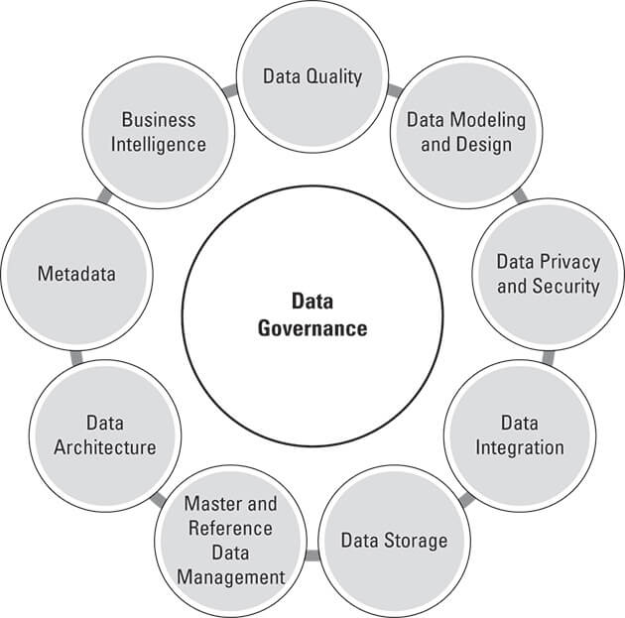
Fig 6 : By: Jonathan Reichental,Updated:12-07-2022,From The Book:Data Governance For Dummies

Compliance
As for customers, NatureGarden must follow the requirements of the international legislation and adhere to ethic norms such as GDPR and ISO 27001. Legal conformance makes certain that an organization follows the law and maintains its stakeholders ‘ confidence.[3],[4]
Integration into SLAs:
- Collaborate with cloud providers to include compliance clauses in Service Level Agreements (SLAs).
- Specify responsibilities for data protection, breach reporting, and recovery.

Regular Audits:
- Conduct internal and external audits to evaluate the effectiveness of security measures.
- Use audit findings to identify gaps and improve compliance.

7.RISK MANAGEMENT
The process of recognizing, evaluating, and reducing any risks to an organization's resources, activities, and goals is known as risk management. It entails assessing risks, ranking them according to their significance and likelihood, and putting plans in place to lessen or completely eradicate their consequences. Information security is concerned with safeguarding the availability, confidentiality, and integrity of data.[1]
Key components of Risk Management
Risk Identification
Identifying risks and threats to an organisation.
Example: Risk assessment of possibilities as unauthorized user from BYOD devices, malware, or invaders from within.
Risk Assessment
The ability to identify the potential of a risk event to occur and the possible consequence that this may have.
Example: The risk assessment matrix as a way to categorise risks.
Risk Mitigation
The measures involving planning and putting in practice methods or operations to manage, minimize or exclude losses.
Example: Putting use in firewalls, encryption and use of multiple factors when doing the data protection.
Risk Monitoring
Ongoing identification of risks and assessment of the suitability of implemented risk control.
Example: Controls should be periodically reviewed through audit, as well real-time monitoring of security systems.
Risk Review and Update
The mitigation process of risk entails reviewing risks’ likelihood periodically so that a firm can adjust to risks or the business environment that has evolved.
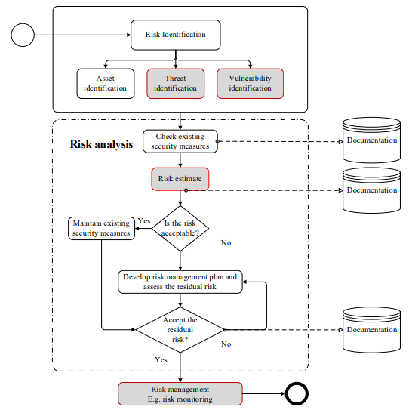
Fig 7: A Preliminary SWOT Evaluation for the Applications of ML to Cyber Risk Analysis in the Construction Industry (2021). Journal of Construction Risk Management, Vol. 7
Security Policies
A security policy is a thorough set of regulations, standards, and practices intended to safeguard the information assets of an organization. It establishes guidelines for the management, use, and security of networks, systems, and data. Security policies are crucial for reducing risks, guaranteeing legal compliance, and encouraging uniform procedures throughout the company.[5]
Important Components of a Security Policy
Access control
Specifies how users can access data and systems; multifactor authentication and role-based permissions are frequently used.

BYOD Policy
Specifies guidelines for utilizing personal devices, such as the need for antivirus software and limited access to systems that are sensitive.
Data classification is the process of classifying data (public, confidential, etc.) and implementing suitable security measures, including encryption.
Protection Mechanisms
Technical controls will secure NatureGarden’s IT infrastructure:
- Wireless Security: Deploy WPA3 encryption and network segmentation.
- Cloud Security: Follow ISO 27017 guidelines for securing cloud environments.
- Endpoint Security: Require antivirus software and Endpoint Detection and Response (EDR) solutions.

8.IMPORTANCE OF UPDATED REGULATIONS AND STANDARDS
In order to keep organizations safe, compliant, and resilient in the face of changing cybersecurity threats, updated rules and standards are essential. Following the most recent guidelines is crucial for NatureGarden to safeguard its data, uphold stakeholder confidence, and keep its competitive edge.
Handling Changing Cybersecurity Risks
Ransomware, phishing, and zero-day vulnerabilities are just a few examples of the ever-evolving cyberthreats. Organizations such as NatureGarden are able to proactively secure their networks because to updated rules that incorporate best practices to counter these attacks. For example, implementing WPA3 for wireless security guarantees improved defense against unwanted access to its vast wireless network.
Keeping Up with Technological Developments
New standards like ISO 27017 offer detailed instructions on protecting these settings as technologies like cloud computing and the Internet of Things become more and more integrated into corporate processes. NatureGarden can successfully protect consumer data and reduce the dangers related to its reliance on cloud-based services by putting these guidelines into practice.

Ensuring Legal and Ethical Compliance:
Adhering to laws such as the CCPA and GDPR is crucial for fulfilling legal requirements and upholding moral standards. In order for NatureGarden to stay out of trouble and win over customers, these frameworks require openness in data management and the usage of encryption for sensitive data.
Increasing Stakeholder Trust:
NatureGarden's dedication to data security and privacy is demonstrated by its adherence to the current regulations. This promotes trust and enduring loyalty by assuring all parties involved—including clients, staff, and partners—that their data is secure.
Increasing Organizational Resilience:
New rules frequently highlight procedures like incident response planning, disaster recovery testing, and routine audits. During emergencies, such data breaches or system breakdowns, these steps assist companies like NatureGarden in swiftly recovering from setbacks and preserving uninterrupted operations.
Getting a Competitive Edge:
By demonstrating their dedication to strong security procedures, companies that adhere to updated standards, like ISO 27001, get a competitive edge. This improves NatureGarden's standing with consumers who respect robust data security protocols.
Minimizing Liability:
Failure to adhere to the most recent rules may result in fines, damage to one's reputation, and monetary losses. Updating security procedures on a regular basis reduces liability and guarantees NatureGarden stays clear of penalties and other dangers related to data breaches.
Advantages of the Suggested Method
The suggested method is in line with international security best practices, including ITIL and ISO 27001, guaranteeing a thorough and methodical approach to dealing with NatureGarden's particular difficulties. Important advantages include:
Alignment with International Standards:
Including ISO 27001 guarantees a methodical approach to governance, risk management, and compliance. By incorporating security into the IT service lifecycle, ITIL improves operational efficiency.
Comprehensive Risk Management:
NatureGarden can prioritize important risks and implement focused mitigation techniques, including multifactor authentication and data encryption, to reduce vulnerabilities by using a risk assessment matrix.
Strong Security Procedures:
Unambiguous BYOD, incident response, and data classification policies offer an organized framework for uniform security procedures throughout the company.
Possibilities for Ongoing Enhancement:
Adaptability to changing threats is ensured by routine audits and policy revisions.
A culture of security awareness is fostered by employee training.

9.DISCUSSION AND CRITICAL ANALYSIS
The suggested strategy for NatureGarden makes use of internationally accepted frameworks, such as ITIL and ISO 27001, to successfully handle its security issues. A strong governance framework for risk management, compliance, and sensitive data protection is offered by ISO 27001. This is enhanced by ITIL, which makes sure that the controls outlined in ISO 27001 are smoothly applied in day-to-day operations by operationalizing security measures through incident management, service continuity, and real-time monitoring.
Strengths
This approach strengthens NatureGarden's security posture by combining governance, risk management, and backup plans. Prioritizing risks is made possible by the use of risk assessment matrices, and standardizing processes throughout the company is achieved by explicit security rules including incident response protocols and BYOD standards. Operational resilience during disruptions is ensured by contingency planning, which includes business continuity and catastrophe recovery strategies.
Challenges
It may need a lot of resources to implement, including money and qualified staff. Maintaining employee productivity requires finding a balance between user ease and strict security requirements. Adoption may also be hampered by cultural opposition to new regulations, which calls for awareness and training campaigns.

Rationale for Framework Selection:
ITIL guarantees operational effectiveness and real-time security management, whereas ISO 27001 was selected for its structured governance, risk management, and compliance approach. When combined, they provide NatureGarden a comprehensive solution. NIST could be too resource-intensive for urgent requirements, while alternatives like COBIT concentrate on governance but lack ITIL's operational depth.
Effect on interested parties:
Workers: Safe access is made possible by secure BYOD policies without interfering with work.
Consumers: Increased data security fosters loyalty and confidence.
Business Partners: Reliability and reputation are enhanced by GDPR compliance.
Possibilities for Enhancement:
Adopting AI-driven tools, conducting regular policy reviews, and providing continuous training can improve agility, monitoring, and reaction to new threats.

10.CONCLUSION
By combining ITIL and ISO 27001, the suggested method successfully tackles NatureGarden's security issues and provides a thorough framework for governance, compliance, and operational effectiveness. It ensures stakeholder confidence and regulatory alignment while offering strong solutions for risk management, data protection, and contingency planning. Even though training and resources might be needed for implementation, the long-term advantages of improved security, resilience, and reputation exceed the early difficulties. By using this tactic, NatureGarden puts itself in a position to protect its assets, adjust to changing threats, and keep its competitive advantage in the worldwide market.

11. REFERENCES
[1]. ISO/IEC. (2022). ISO/IEC 27001:2022 Information Security Management Systems Requirements.
[2].ISO/IEC. (2015). ISO/IEC 27017:2015 - Guidelines for Information Security Controls for Cloud Services.
[3]. GDPR.eu. (2020). General Data Protection Regulation (GDPR) Overview.
[4]. California Consumer Privacy Act (CCPA). (2020). Overview.
[5]. AXELOS. (2019). ITIL Foundation, ITIL 4 Edition. AXELOS Global Best Practice.
[6]. Kornev Online. (n.d.). The Official Introduction to the ITIL Service Lifecycle.
[7]. Sahoo, Jyotiprakash. (2023). ISO 27001 PDCA Cycle, Information Security Enthusiast.
[8]. Sheikhpour, R., & Modiri, N. (2012). A Best Practice Approach for Integration of ITIL and ISO/IEC 27001 Services for Information Security Management. Journal of Information Technology.
[9]. Reichental, Jonathan. (2022). Governance Frameworks in Data Governance for Dummies. Wiley Publishing.
[10]. ISACA. (2020). Control Objectives for Information and Related Technologies (COBIT).

