

How effective is intelligence led policing within neighbourhood policing teams

Scott Tatchell
2124933
BSc (HONS) Professional Policing Practice
Word count 6819

Acknowledgements
I wish to say thank you to my supervisor Michelle Hill for all her consistent support and advice throughout the research of this dissertation.
I would also like to thank my family, friends and colleagues with all their support throughout this dissertation and the previous three years of the start of my career and university adventure. Without everyone support this would have been extremely difficult I cannot thank them enough.

Declaration
This work has not previously been accepted in substance for any degree and is not being concurrently submitted in candidature for any degree.
Signed: Scott Tatchell
Date: 06/10/24

STATEMENT 1
This dissertation is being submitted in partial fulfilment of the requirements for the degree of BA.
Signed: Scott Tatchell
Date: 06/10/24

STATEMENT 2
This dissertation is the result of my own independent work/investigation, except where otherwise stated.
Other sources are acknowledged by footnotes giving explicit references. A bibliography is appended.
Signed: Scott Tatchell
Date: 06/10/24

STATEMENT 3
I hereby give consent for my dissertation, if accepted, to be available for photocopying and for interlibrary loan, and for the title and summary to be made available to outside organisations.
Signed: Scott Tatchell
Date: 06/10/24

STATEMENT 4
I hereby give consent for my dissertation, if accepted, to be available on the university’s IT system to those who have consent to use the system.
Signed: Scott Tatchell
Date: 06/10/24

Contents page
Chapter one – Introduction . . . . . . . . . . . . . . . . . . . . . . . . . . . . . . . . . . . . . . . . . . . . . . . . . . . .6
Chapter two – Literature Review . . . . . . . . . . . . . . . . . . . . . . . . . . . . . . . . . . . . . . . . . . . . . . . .7
2.1. Introduction . . . . . . . . . . . . . . . . . . . . . . . . . . . . . . . . . . . . . . . . . . . . . . . . . . . .7
2.2. An exploration as to why some people are anti police or why they may dislike the police. . . . . . . . . . . . . . . . . . . . . . . . . . . . . . . . . . . . . . . . . . . . . . . . . . . . . . . . . . . . . . . . . . . . . .7
2.3. To explore the impact that anti police attitudes can have on community policing . .9
2.4. To explore how relationships can be improved by the police and the community. . 10
2.5. An evaluation on the impact polices views on the police can have on the community and the police who police its community . . . . . . . . . . . . . . . . . . . . . . . . . . . . 11
2.6 Conclusion . . . . . . . . . . . . . . . . . . . . . . . . . . . . . . . . . . . . . . . . . . . . . . . . . . . . . . . . . . . . . 11
Chapter three – Methodology . . . . . . . . . . . . . . . . . . . . . . . . . . . . . . . . . . . . . . . . . . . . . . . . .13
3.1 Introduction . . . . . . . . . . . . . . . . . . . . . . . . . . . . . . . . . . . . . . . . . . . . . . . . . . . . . . . . . . . . 13
3.2 Data collection method . . . . . . . . . . . . . . . . . . . . . . . . . . . . . . . . . . . . . . . . . . . . . . . . . . 14
3.3 Ethical practice . . . . . . . . . . . . . . . . . . . . . . . . . . . . . . . . . . . . . . . . . . . . . . . . . . . . . . . . . 14
3.4 Informed consent . . . . . . . . . . . . . . . . . . . . . . . . . . . . . . . . . . . . . . . . . . . . . . . . . . . . . . . 15
3.5 Sampling technique . . . . . . . . . . . . . . . . . . . . . . . . . . . . . . . . . . . . . . . . . . . . . . . . . . . . . 15
3.6 Conclusion . . . . . . . . . . . . . . . . . . . . . . . . . . . . . . . . . . . . . . . . . . . . . . . . . . . . . . . . . . . . .15
Chapter four – Analysis of results . . . . . . . . . . . . . . . . . . . . . . . . . . . . . . . . . . . . . . . . . . . . . . 6
4.1 introduction . . . . . . . . . . . . . . . . . . . . . . . . . . . . . . . . . . . . . . . . . . . . . . . . . . . . . . . . . . . . 16
4.2 participants views . . . . . . . . . . . . . . . . . . . . . . . . . . . . . . . . . . . . . . . . . . . . . . . . . . . . . . . 16
Chapter five – Conclusion and recommendations . . . . . . . . . . . . . . . . . . . . . . . . . . . . . . . 22
5.1 introduction . . . . . . . . . . . . . . . . . . . . . . . . . . . . . . . . . . . . . . . . . . . . . . . . . . . . . . . . . . . . 22
5.2 Summary of primary findings . . . . . . . . . . . . . . . . . . . . . . . . . . . . . . . . . . . . . . . . . . . . . 22
5.3 Objectives . . . . . . . . . . . . . . . . . . . . . . . . . . . . . . . . . . . . . . . . . . . . . . . . . . . . . . . . . . . . . 22
5.3.1An exploration as to why some people are anti police or why they may dislike the police. . . . . . . . . . . . . . . . . . . . . . . . . . . . . . . . . . . . . . . . . . . . . . . . . . . . . . . . . . . . . . . . . . . . . 22
5.3.2 To explore the impact that anti police attitudes can have on community policing . . . . . . . . . . . . . . . . . . . . . . . . . . . . . . . . . . . . . . . . . . . . . . . . . . . . . . . . . . . . . . . . . . . . . . . . . . . . 23
5.3.3 To explore how relationships can be improved by the police and the community . . . . . . . . . . . . . . . . . . . . . . . . . . . . . . . . . . . . . . . . . . . . . . . . . . . . . . . . . . . . . . . . . . . . . . . . . . . . . .24

5.4 Recommendations . . . . . . . . . . . . . . . . . . . . . . . . . . . . . . . . . . . . . . . . . . . . . . . . . . . . . . 24
5.5 Final thoughts . . . . . . . . . . . . . . . . . . . . . . . . . . . . . . . . . . . . . . . . . . . . . . . . . . . . . . . . . . 26
Chapter six – Bibliography . . . . . . . . . . . . . . . . . . . . . . . . . . . . . . . . . . . . . . . . . . . . . . . . . . . 28

Chapter 1 Introduction

This dissertation will discuss the overall relationship between the police and the community, and how their relationship affects neighbourhood policing teams when attempting to develop intelligence from the general public they serve and protect.
Three main objectives were established to be researched; an exploration as to why some people are anti-police or why they may dislike the police, to explore the impact that anti-police attitudes can have on community policing, and to explore how relationships can be improved by the police and the community.
It is important to understand what intelligence is, the Cambridge Dictionary (2024) states, intelligence is "the ability to learn, understand and make judgments or have opinions that are based on reason". Intelligence is paramount as Ramos, Pérez-López and Abreu (2020) reported intelligence is a tool utilised by the police to help improving the service in which they provide to a better quality of service for the general public.
The literature review in this paper will research the set objectives to highlight the three main areas for improvement within police forces and use evidence-based practice to obtain further intelligence from the public and also influence improvements when implementing new proposals or adapting current ones. Schmidt and Brown (2024) discuss how applying research is essential for teaching students how to apply the knowledge they have researched into practice. This is relevant for this dissertation as it shows how students can use research tasks such as this one, to aid new techniques or policies by evidence-based research.
The survey conducted to ask the general public ten questions regarding community engagement with the police, attitudes towards the police and reasons as to why some people may be anti-police. Analysis of these results has led to several recommendations for areas where the police can improve with regards to relationships with the general public and throughout communities.
The findings section of this dissertation also displays the limitations of this research, areas where further research needs to be carried out, and suggests how the survey could be improved for if a similar research task was conducted again in the future.

Chapter 2 Literature review
2.1. Introduction
This chapter will provide a brief overview outlining why some people may dislike or are anti police. It will then go on to address a further two main research objectives individually by exploring the available literature on the topic of how the police force are impacted by the support of the community. The chapter will then proceed to explore the how the community and police cohesion can be improved. This research is being conducted to identify areas in which the police can improve to aid community cohesion thus allowing the police to have a better relationship with the public, allowing for more intelligence. This dissertation has discussed the following three objectives:

- An exploration as to why some people are anti police or why they may dislike the police.

- To explore the impact that anti police attitudes can have on community policing.

- To explore how relationships can be improved by the police and the community.

2.2. An exploration on why some people are anti police or dislike the police.
Some people may be anti-police or dislike the police because of some officers betraying the oath they swore to uphold, to protect and serve the community in which they police. An extreme example of this is the Wayne Couzens and Sarah Everard case. This is where Wayne flashed his warrant card to Sarah stating he was a police officer and arrested her for breaching COVID-19 regulations during the lockdown restrictions. Wayne then proceeded to, kidnap, rape, murder and hide Sarah’s body from the authorities. Bhattacharyya (2023) suggests that this case has an underlying culture of misogyny and questions how as a police force will they tackle misogyny within the workplace. This shows severe failing from colleagues who should have noticed his behaviour, demeanour and never acted on the allegations that were brought up within the workplace but not reported as Cunningham (2024) reports that Wayne “had been seen to have been exposing himself to members of the public from 2015-2020”. This case also suggests that the vetting process may need to be improved to further investigate candidates applying to join the force. Despite Horne (2017) explaining that candidates who lack integrity or are found to be incapable in their current positions, are removed from these and are prevented from progressing further through the ranks and are encouraged to confess involvement with certain cases to be held accountable, however, there are still individuals such as Wayne that have managed to pass the vetting process and become a serving police constable.

Canning (2021) reports that “North Yorkshire Police Commissioner Philip Allott said women need to be streetwise about when they can be arrested and when they can’t be arrested”. This was after Sarah was arrested by Wayne, this caused uproar within the public as a police officer should be a person who you look to for guidance, reassurance, and help. This was completely taken away by this comment as this would go on to leave people worried about going to the police for help. It could be argued that Sarah was at fault for her decision to trust Wayne on the night she was kidnapped however, she believed she was trusting a law-abiding police constable, this would lead to make women not trust the police and be anti-police.
There was another incident in May of 2020 where an African American male by the name of George Floyd was unfortunately killed, as a result of an arrest whereby officers had to restrain him to the floor. One officer known as Derek Michael Chauvin was the officer responsible for his death due to him leaning on George’s neck for a prolonged period, despite him stating he could not breathe. Newman and Reny (2021) discusses that since 2014 there has been a political social movement known as Black Lives Matter (BLM) which has formed due to the reoccurring incidents of police violence against black civilians. This civil rights and racial justice movement erupted straight after Eric Garner and Micheal Brown were killed in 2014. This made the movement massive as “specific subpopulation can push event-relevant issues to the top of the public agenda and provoke shifts in public opinion” (Newman, Reny 2021). They also reported this caused a large decrease in the confidence of the public in the police after Eric Garner and Micheal Brown were killed in 2014 however, this survey was completed over many of years and relied on snapshots of the public’s opinions therefore, this may not be an accurate account of the public’s perception at this time. This provides more justification for up-to-date research on this topic.
Bowling, Parmar and Phillips (2008) have done research with evidence to suggest that White people are more likely to have a more satisfactory experience when liaising with the police in comparison to people of an ethnic minority background, such as being Black, Asian and African. This evidence suggests that these statistics will impact how likely people from an ethic minority background are to report crime or comply with the police as they will feel they will not be treated as fairly as a White person. This will cause them to dislike or be anti-police.
Learning why the public have formed judgements against the police is very important to improve policies because there is evidence that shows “people obey laws and cooperate with authorities when they see laws as legitimate” (Jackson, Bradford, Hohl and Farrall, 2009). This suggests that some people have lost respect or are anti-police as they may have reported crimes and witnessed crimes however, no lawful action may have been taken against said individual breaking such laws. This would infuriate the public as this is what the police signed up to do, protect and serve, if they are not prosecuting offenders this will cause the public to dislike the police.

2.3 To explore the impact of anti-police attitudes can have on community policing
Farrow (2022) reports that in England and Wales, there are approximately 138,000 police officers responsible to maintain the law and the safety for approximately 56 million people. This is a very uneven number meaning that the police are in fact outweighed Leigh, Dunnett and Jackson (2019) discuss that due to the fund cuts police are targeting areas of great concern and impact on the police however, they may still not attend every call due to the increase in demand. This would suggest another reason why some persons might be anti-police is due to them reporting crimes and it taken so long to deal with, causing them to think some crimes will not be worth reporting as nothing will be done. This will also have a knock-on effect for the community policing teams as there will be less intelligence provided to the police from the public for any action to be taken. If the community are less willing to provide the relevant and credible information, then this will also affect their safety. Innes et al (2020) has backed this up as they suggest evidence lead policing is one of the most effective policing methods that was introduced to the United Kingdom (UK) police.
The police Code of Ethics which was published in 2001 contains several factors that are vital to tackle issues related to anti-police attitudes within the community, this is explained by Neyroud (2008). The first example is that this code has an important role in when it comes to safeguarding the public. This involves all members of the police force having integrity and treating everyone equally as they have to be impartial. The second example is that the police have close contact with the public as the police rely heavily on the community to provide public support for many cases. Thirdly, it is important that the police attitude towards the public is respectful and that the police remember the fundamental rights of the public. The Code of Ethics enables the police force to have a better cohesion with the public as Jackson and Gau (2019) find authorities can be trusted by the public, should they follow the appropriate rules and regulations that they are set to follow.
Farrow (2022) has stated that the main purpose of the police is for the detection and prevention of crime. This is outlined by the Peelian principle which has been named after Sir Robert Peelian. Without the publics consent the police cannot continue serving as a lawful officer as the public’s attitudes towards the police can have a drastic impact on everything that the police do and will continue to do. Shannon (2022) backs up this claim as she reports this is policing by consent when the police follow the Peelian principles.
Peyton, Sierra-Arévalo, and Rand (2019) have suggested that over many decades there has been a declining crime rate however, there has still been mass tensions between the police and members of the public. This continuation of public tension has continued to prevent cooperation between the public and police causing a dip in vital intelligence being provided to the police. This will have a knock-on effect for the function of the police and the prevention of crime within the community, causing further risk to the public in the local area. Thus highlighting the need to explore why there may be tensions, and to discover resolutions for this in order to aid community collaboration and trust in the police.

2.4. To explore how relationships can be improved by the police and the community.
There has been a wide verity of reasons as to why some members of the public are anti police or have a disliking to the police, some are to do with how certain people are mistreated and with the lack of repercussions to the officers who dealt with them so poorly. The police attempted to combat the hatred towards the police by forming the Independent Police Complaints Commission (IPCC), which was put together on the 1st of April 2004, this went onto replace the Police Complaints Authority. Just prior to the IPCC being formed there was the Police Reform Act of 2002. “This provided the Home Secretary with powers to determine policing objectives for all forces. Under David Blunkett, these powers were exercised fully in conjunction with HM Inspectorate of Constabulary (HMIC) and the Police Standards Unit (PSU) in identifying both ‘failing forces” (Loveday, 2010).
Another way all police forces can improve the relationship between themselves, and the community is to get out in the public and engage with them as, Harkin (2018) reported that if there is a lack of cohesion between the community and the police then this will lead to more crime as there isn’t enough credible intelligence to allow community policing teams to act upon the criminals. This leads to less safety for the community. It was suggested that to improve the cohesion then the police had to held accountable for their mistakes and come up with alternative ways to rectify their mishaps. This would allow the public to see they are willing to make changes to not only better themselves but because they know they need to, for them to have a better relationship with the community.
Quinton and Tuffin (2007) state relationships can be improved by neighbourhood policing teams which were brought into all police forces in 2005 to help build cohesion between the community and the police. This programme was known as The National Reassurance Policing Programme (NRPP). The neighbourhood officers show a clear presence in the community. Quinton and Tuffin (2007) suggest, higher visibility rates by the police have increased public confidence as there is an authority figure present and this allows for more engagement between the community and the police. This has also shown to reduce crime within the neighbourhood as the community know what criminal activities are going on within the community, this allows for them to provide vital intelligence to police to act on to reduce crime and restore public confidence. This will restore the confidence as the community will see their contributions do not go unsee, unheard and are indeed being acted upon allowing them to feel safer within their place of residence.

As a result of the BLM protests police forces have attempted to have a more diverse force, by employing a larger number of persons from all ethnic backgrounds. This helps with community cohesion as the members of the public who are from ethnic minority backgrounds will be more likely to have a better relationship with the police. O’Neill and Holdaway (2007) suggest that chief officers are working to improve diversity across the forces by improving the recruitment process and informal meetings with senior management to improve training and mentoring for new recruits.

2.5. An evaluation on the impact polices views on the police can have on the community and the police who police its community.
At current the data collected would suggest there has been a decrease in the confidence in the police from the public, as Hobbs and Brown (2023) reported that the Crime Survey of England and Wales (CSEW) found in their research, from 2017/2018 to 2021/2022 there was a big percentage decrease from the public who thought the police are doing “good” or “excellent”. This number dropped from 62% to 52%. They also run further tests for public confidence in the police which had also fallen from 78% to 69%. This current data consists of thirty-five thousand participants which is a large proportion of participants however, as this was conducted across forces within England and Wales. There are 43 police forces in England and Wales. This would equate to approximately eight hundred and fourteen people per force. At first glance this would appear to be a substantive number of participants however, now it has been broken down this is a limited amount with minimal views. The survey does not allow for any expenditure on the reason for which they say the police are no longer doing good or excellent. These words used may also make people question what they think as they make think the police are doing better however, not excellent this does not allow for a proper reading. This is also done across many different forces therefore, there will be higher and lower opinions across the board.
Jackson, Bradford, Hohl, Farrall (2009) have researched and found there has been a similar study from the British Crime Survey (BCS) from 1982, where they asked, ‘How good or bad a job do you think the local police are doing?’ This research was carried out from 1984 to 2005/2006 and it suggests there has been a decrease in police confidence from the public over the years. 1980s and early 1990s saw a clear increase in public dissatisfaction with local policing.
These studies show that there is a clear need for a new and more in-depth survey to be conducted in order to see the current views of the public and to see if they can provide any ways in which they would like to see the police change for the better. This could improve public and police cohesion along with public confidence as this will show the police are willing to hear what the public have to say.

2.6 Conclusion
The research shows that people are anti-police or dislike the police due to massive failings from police forces with some of their employees, as members of public have been lied to and in some cases even murdered because they put their trust into the police. To combat this, the code of ethics were implemented to make sure officers have a set of rules and policy to follow to ensure everyone is treated fairly, equally and respectfully, however, the cases discussed show this has not made every police constable follow these rules. The IOPC was also brought into effect, again the research shows this has not improved the community cohesion with the police as once thought. The lack of community engagement from the police has also played its role in effecting the publics proception of the police, thus limiting the intelligence provided to the police. All police forces have also tried to be more diverse in their police constables to improve cohesion with other ethnic and religious backgrounds.

Chapter 3 Methodology
3.1 Introduction
This chapter will present an overview of the research methods that have been utilised for conducting the relevant research around neighbourhood policing. The beginning of the methodology will discuss the ethical commitment followed by a detailed explanation and justification for such research methods being used.
When undertaking research, it is important to understand what research is, the Oxford Leaners Dictionary (2024) has provided the description of research as a thorough examination of a given topic, particularly to uncover new facts and relevant information around a given topic. At current there is little insight into what the public actually think about the police within their respective neighbourhoods and how much engagement they have with the police.

3.2 Data collection method
To conduct this research a mixed method approach will be employed. This is also known as a quantitative and qualitative research method, quantitative have been described by Manmeet (2016) as deductive and qualitative as inductive. This research will be done by the participants completing a survey which will be sent out to them via social media, such as Facebook and X (twitter). This is due to this being more practical and efficient as Gubrium et al (2012) reports face to face interviews were the most dominate means of surveys, until the 1970s as more households acquired telephones allowing the interviewer to increase the amount of people they were interviewing due to no travel time. Now researchers can complete online surveys allowing them to be sent out to a vast array of people within seconds allowing shorter waiting times for people to answer and more people can be sent this at once allowing for more participants. Further justification for this research method is due to the time constraints that this paper has, Ongena and Dijkstra (2020) suggest that studies that have been conducted face to face can improve response accuracy however, this is at the cost of additional interviewing time. This will gather the general public’s perception of the police allowing them to provide in detail their thoughts and feelings, they will also be able to provide ways in which they believe the police can change to have more of a thorough engagement with the community.
Quantitative research will allow for actual figures based on the amount of people asked, to show accurate statistics around the questions asked. Pugliese, and Recker, (2017) report takes out the personal thoughts and shows accurate areas for improvement based on facts. Due to the topic being around the public’s perception on the police force and how community cohesion can be improved it will be more beneficial to allow them to provide their own thoughts rather than scales of how they believe the police work, as this will be more accurate. Bianchi, et al. (2019) also reports that people who think opposite to each other benefit one another therefore, people providing their own thoughts would benefit this research for more insights.

3.3 Ethical practice
This research proposal has been through an ethics board at the University of Wales Trinity St David (UWTSD) discussing how the research will be conducted, who will be asked to participate, the general data that will be stored as part of this and has received approval for the continuation for the research as the criteria outlined have been met. This is to ensure the research methods used have had ethical approval from an ethics board after analysing the aims of the research, the methods of data collection and the information regarding how the volunteers involved have a minimal risk of harm under data protection laws.
When conducting any research, it is compulsory and vital to ensure it is conducted ethically, as reported by Vanclay et al (2013), there are multiple ethical principles to abide by when doing research involving humans, these have been covered in various national statements by the professional associations, international agencies, and ethical guidelines in social research method textbooks. The ethical guidelines involve maintaining respect for the people involved in the research by demonstrating informed consent, also meaning that no individual is coerced into responding and always giving them the right to withdraw as it is under voluntary participation. There can be no deception involved within the questions which also means showing full disclosure of the sources used. Data protection must be followed at all times meaning there is a responsibility to maintain anonymity and confidentially of the answers given.

3.4 Informed consent
When conducting research informed consent is important as the human participants are entering into the research voluntarily knowing this research must be conducted fairly as Josephson and Smale (2021) reports all persons who sign up to be a participant are to be informed of all their rights that follow from being a subject along with any risk that may be present. The participants are also to be made aware that their consent is voluntary they are not forced to take part in the research, and they are able to withdraw at any time should they feel as if they need to, this will be outlined in the survey disclaimer.
Josephson and Smale (2021) also suggested that should any confidential information be taken from the participants such as name, age, address or anything else that is personal, the research may need to complete a consent document. This will not be required for this research as the only questions that will be asked is if the participant is over 18 years of age to help keep this ethically practicable. These authors also describe something known as ‘The Common Rule’ which is the standards enforced on any procedure needing consent. This requires the individual conducting the research to inform the participants of any potential risks of harm involved before proceeding.

3.5 Sampling technique
For this research the participants will be members of the public who reside within the Newport area of Wales and are over the age of 18. These participants have been chosen as they are directly linked to the research due to this focusing on how the community policing teams within this area have an impact on them. To enlist said participants the survey will be sent out via social media, such as Facebook due to its inherent capability for hosting surveys. Kosinski et al (2015) reports that Facebook is now being recognised for the benefits it has when conducting surveys. This is due to the large and diverse number of participants there are out there for research. Facebook also allows for online and offline studies along with the fact it already holds a lot of information about the user therefore, it will be able to link persons with this research who have a common interest, thus helping this research meet the target audience.

3.6 Conclusion
This chapter discussed quantitative and qualitative research and how this paper will utilise both when researching the proposed topic. It has shown the positives of this research, how consent will be required from the participants of the research, the consent from the university to allow this paper to be completed and the sampling technique used.

Chapter 4 Analysis
4.1 introduction
This chapter will discuss the results of the questionnaire, helping to provide a methodical presentation of the findings. This questionnaire consisted of eighteen participants who completed all the questions. The reason for this research is to investigate the publics perceptions of the police and how their thoughts may influence policing strategies.
4.2 participants views
Question 1) Do you like the police?
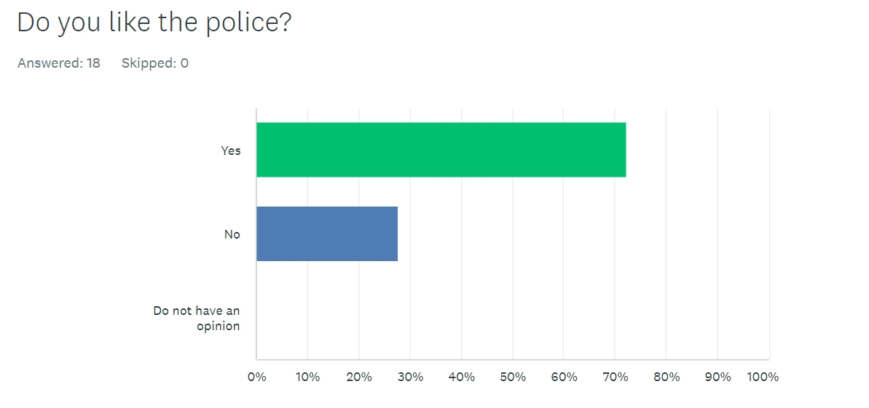
72.22% of the participants stated that they did in fact like the police, however, 27.78% stated they did not like the police. Awan, et al. (2018) reported that the survey they carried out between Black and Minority Ethnicities (BME) and non BME communities demonstrated that satisfaction levels within the BME group were significantly less than the non-BME participants. The survey that was carried out for this project did not take into account ethnicity which may have impacted these results.

Question 2) would you say you trust the police?
61.11% answered yes and 38.99% answered no. Dodd (2024) reported that in England four out of ten members of the public voted that they trust the Metropolitan police which is the lowest record of lack of trust. This does not take into account other areas and police forces within the United Kingdom; therefore, this could be the reason why the survey carried out for this project resulted in a higher score regarding trust within the police.
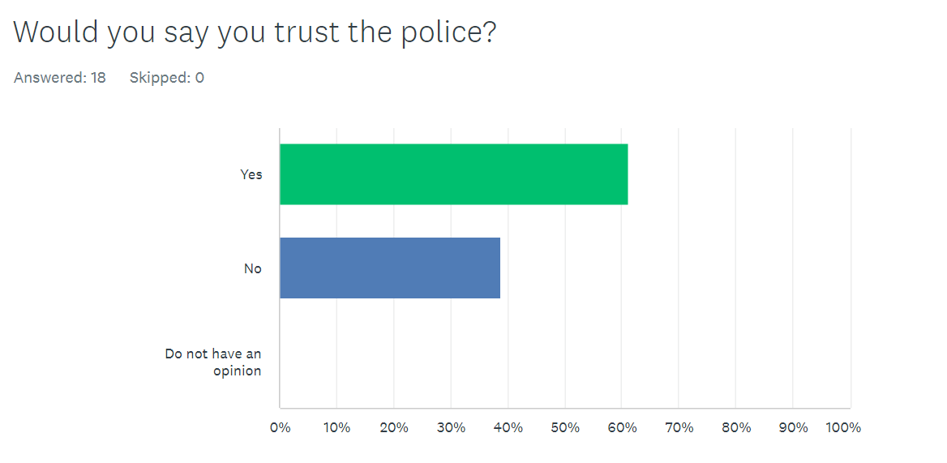
Question 3) Why do you think that some people do not trust the police?
50% of the participants felt that the media is the main reason for people not trusting the police, 27.28% felt it is personal preference and 22.22% felt it was due to history with the police. The participants that voted media named cases such as the Sarah Everard case and described how the media spins the narrative against the police in cases and others had personal experiences where they felt that the police did not help them or give them confidence.
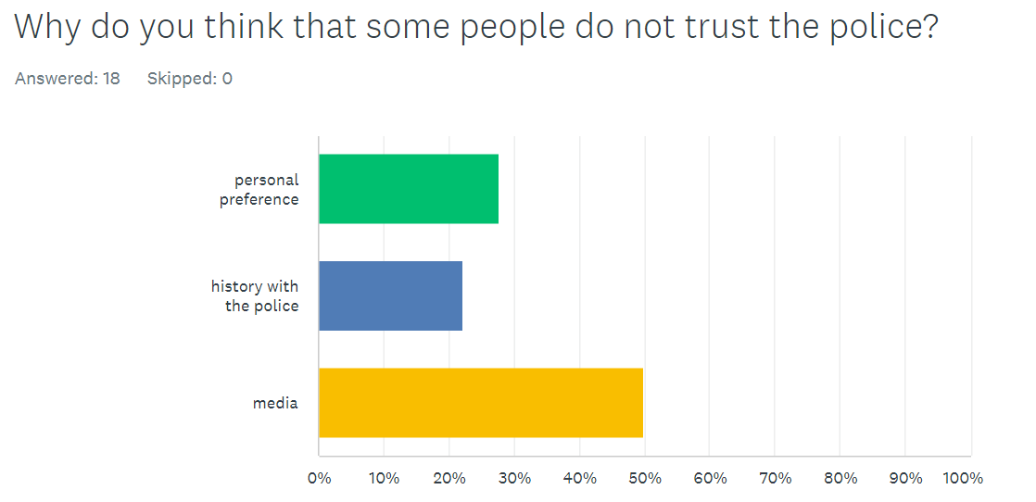
Question 4) How do you think the attitude of individuals within your community effects the police?
33.33% of participants stated their communities had a positive effect on the police as one suggested “my community run emergency response days to help promote the emergency services”. 55.56% felt the community have a negative impact on the police, for example one person wrote that “the increase of individuals using electric bikes and scooters in and around my community. These individuals seem to be able to do what they want without any consequence from police”. 11.11% reported they did not know.
This research suggests that the police are understaffed and due to this they have to respond to areas where crime is more prevalent. Due to this some members of the public may feel neglected.
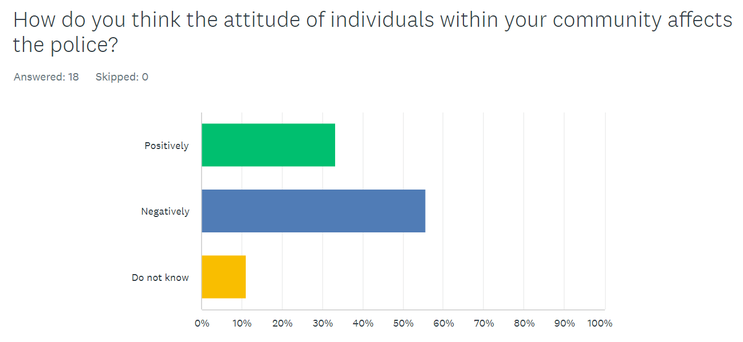
Question 5) Do you feel the community you reside in has built a better relationship with the police in the last 10 years?
The questionnaire went onto establish if the participants felt they had built a better relationship with their local policing team within the last 10 years. 38.89% answered yes, 11.11% answered do not know and 50% of the participants stated they have not built a better relationship with their neighbourhood team.
Myhill and Bradford (2011) suggested it is important how officers interact with members of public. They explained that only 23% of their participants had an encounter with officers in the last 12 months.
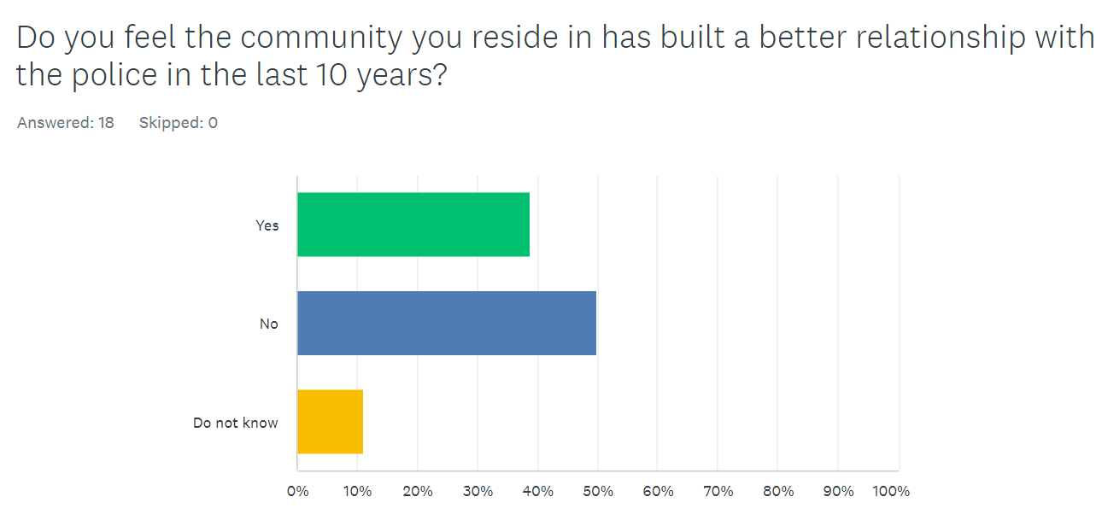
Question 6) Do you feel the Independent office for Police Complaints has improved the police in your area?
Only 16.67% felt as if they had, 38.89% reported the IOPC had not changed the quality of the police and 44.44% stated they did not know.
Smith (2009) reported that is crucial for an independent committee in securing public confidence. The results indicate not many people are aware of the IOPC and if they are they do not think they have improved the police. More education on the IOPC needs to be provided to the public for more accurate results however, this research does not take into account that people may not have made complaints about the police therefore, they will not know who the IOPC are or what they do.
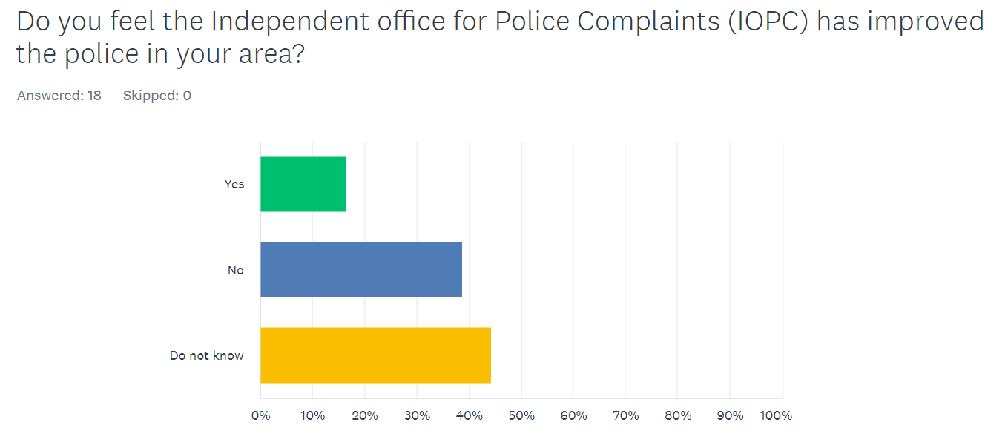
Question 7) Would you say that you have much engagement with your local community policing team?
The participants were then asked if they had much or any engagement with their neighbourhood policing team. 22.22% answered they did have engagement with their local policing team, whereas 77.78% reported they did not have any engagement. Cosgrove and Ramshaw (2013) proclaimed over the last decade in England and Wales they have been mass efforts to build stronger relations between the local communities and the police which has gained momentum. The research conducted from this survey would suggest otherwise as the participants are reporting a serious lack of engagement.
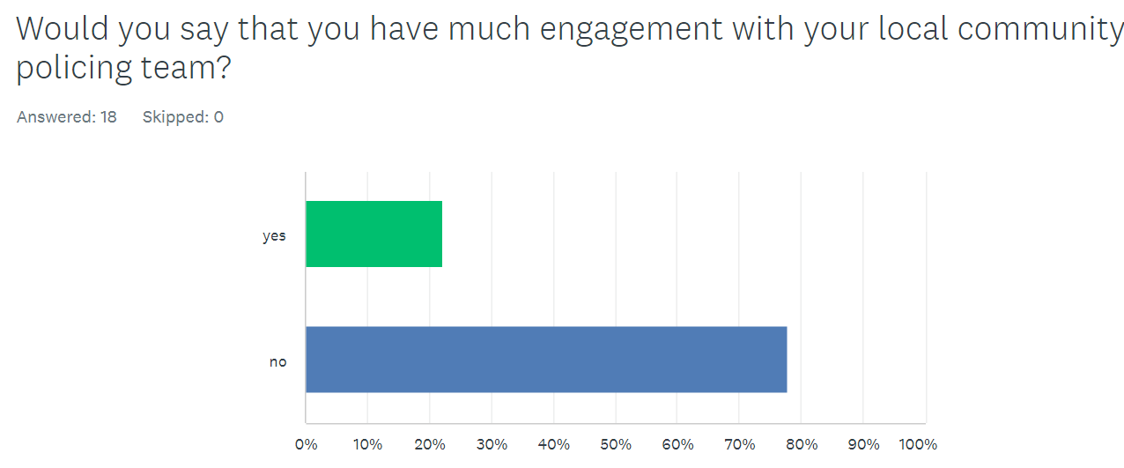
Question 8) Do you feel that there is tension between your community and the local police?
44.44% reported there is tension, 50% answered there is not and 5.56% do not know. Manganm et al. (2017) suggest that the police and the community have divergent interests as such it has proven difficult to improve public relationships with the police over the recent years. This indicates more research and time needs to go into developing community cohesion.

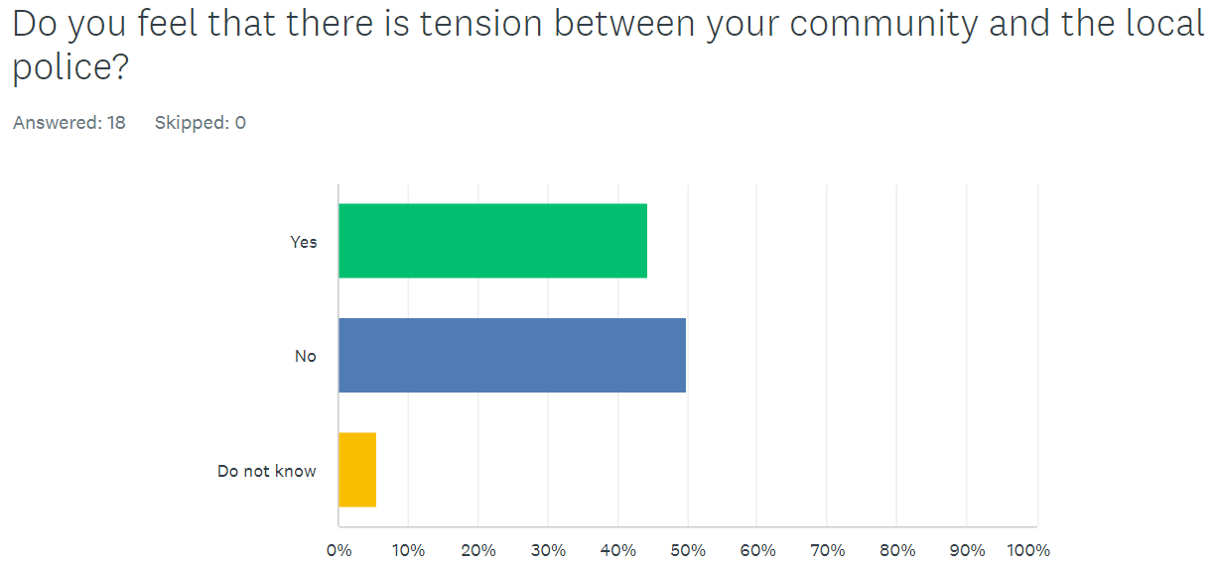
Question 9) Would you know how to report relevant information to the police? (people suspected to be dealing/taking drugs, dangerous dogs, people committing crime)
Following on from the previous question the participants were asked if they knew how to report relevant information to the police. 83.33% of the participants stated they would, 16.67% stated they did not know how to. Boateng (2016) illustrated that the study carried out indicated the citizens willingness to report crimes is based on the attitudes the individual who witnessed said intelligence, rather than them not knowing how to report the crime. This shows there is research that could have been done around the participants personal views on whether they want to report the information and the possible repercussions of reporting it.
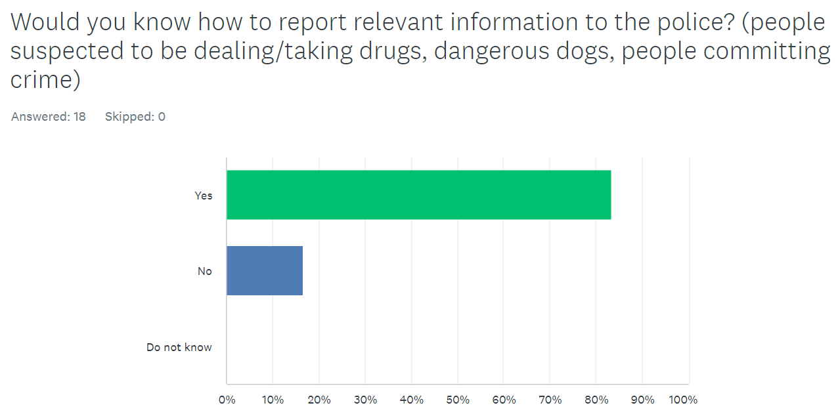
Question 10) Would you know how to make a complaint about the police?
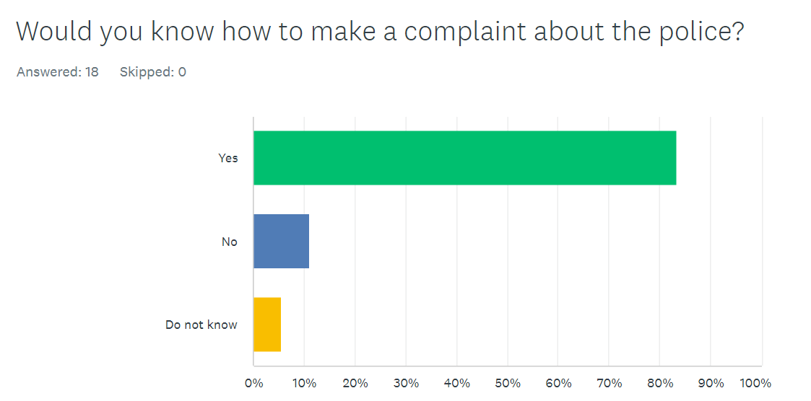
The last question of the survey was if the participants knew how to make a complaint about the police with 83.33% answering yes, 11.11% answering no and 5.56% answering do not know. However, research suggests that despite the public knowing how to make a compliant, the complaints are not dealt with in a good way. Prenzler et al. (2010) displayed how some surveys have shown considerable dissatisfaction of the public with how their complaints have been managed.
Chapter 5 Findings and Conclusion
5.1 introduction
The conclusion section of this dissertation will summarise the research discussed in this paper and display if the objectives were answered. This chapter will also determine if the results of the survey conducted supports the research discussed in the literature review.
The chapter will then conclude with suggested recommendations of how the police can improve in relation to community cohesion based on the research conducted and recommendations on how the questionnaire could also be improved.

5.2 Summary of Primary findings
The aim of this dissertation was to explore how the public’s perception and engagement with the neighbourhood policing team would affect neighbourhood policing in relation to intelligence led policing. An investigation into current research was conducted and a questionnaire was sent out in which eighteen people answered. The findings of this questionnaire support the research, such as Quinton and Tuffin (2007) stating relationships can be improved by neighbourhood policing teams and Harkin (2018) reporting how relationships can be improved by the police being held accountable for their mistakes and rectifying them.

5.3 Objectives

5.3.1 An exploration as to why some people are anti police or why they may dislike the police.
When asked if the participants liked or disliked the police, thirteen of the participants said they like the police however, the survey went onto ask if the participants trust the police and their reasons as to why, whether it be through personal preference, media or history with the police. The response then changed to only eleven people saying they trust the police, with nine participants stating that this was as a result of how the media displays the police. Cunningham (2024) reported there were failings within the police, for example, Wayne Couzens was reported multiple times for exposing himself, yet nothing was done. This incident was recent as it occurred in 2021 and It is evident, due to the mass media attention on the case, that this remains an area of contention for the public and their overall trust in the police

5.3.2 To explore the impact that anti police attitudes can have on community policing.
To meet this objective the participants were asked if how they felt their communities’ attitudes affected the community policing teams. The majority of the participants felt the attitudes of the individuals negatively impacted the police and that they have not built a better relationship with the police in the last 10 years. The participants were asked if they felt the Independent Office for Police Complaints (IOPC) had improved the relationship, yet a lot of the participants did not know what the IOPC did for them. This would support the research by Peyton, Sierra-Arévalo, and Rand (2019) who reported despite the crimes going down there are still mass tensions between the community and the police, causing a reduction in intelligence which could be crucial the police investigations.

5.3.3 To explore how relationships can be improved by the police and the community.
To meet this objective the participants were asked if they felt the Independent Office for Police Complaints (IOPC) had improved the relationship between the community and the police. Eight participants said they do not know, seven said no and three said yes. The participants were also asked if they felt they had much engagement with the police in their community and if the tension between their community and the local police affected the relationship between them both. It is apparent within the survey that the participants do not really know what the IOPC have done for the public. Despite the research by Loveday (2010) describing how the IOPC was brought in for ‘failing forces’ to help them improve, the public are unaware of this.

5.4 Recommendations
Since concluding this dissertation, it has highlighted areas for further research. The survey conducted could have asked more questions to gain a deeper understanding of how the public feel about the topics asked and could have had more detailed multiple-choice answers rather than ‘yes’, ‘no’ and ‘do not know’. This would have given more detailed answers to be analysed for the results section and given a broader image of what areas the police need to improve on. However, due to the time restrictions of this dissertation, this was not possible for this research but could be carried out in future if a similar study was conducted.

Similarly, the way that some of the questions are written for the questionnaire could be improved. For example, question seven asks ‘would you say that you have much engagement with the local community policing team?’ the word ‘much’ is a very broad term, and participants could interpret this word very differently to each other. A recommendation for this is to ask questions that give definitive answers where all individuals would visualise it the same away to result in more accurate answers that can be compared to each other more precisely.

Following this research, it has also indicated areas for how the police can improve with regards to relationships with the public and throughout communities. For example, police officers can part take in workshops that teach and advise on how to improve engagement between the police and the general public. As this questionnaire has identified that the public are not aware of what the IOPC does and relationships have not been improved within the last ten years, the recommendation for this is more police officers on the beat again within the community. There are difficulties that come with this as this would mean increasing the intake when recruiting police officers which costs more money through wages and training, but the benefits could potentially outweigh the costs if community engagement increases then more intelligence could be reported to the police, the public may then have a better relationship with the police and the negative attitudes within the community could switch to positive attitudes.

A further recommendation for this topic is to further progress social media presence, by displaying to the public the good work of the police then this makes people more aware of this. This is also a way to showcase who and what the IPOC do in each area to make the public more aware. On the other hand, it also gives the police a platform for that if something was not handled correctly then it is an opportunity to send out an apology and an explanation within seconds that is very widespread across the world.

5.5 Final Thoughts
This dissertation was successful in answering the three main objectives of this research. Overall, it was found that the public do like and trust the police but there are reasons why they believe other members of the community would not which is mainly due to media influence. Many individuals think that attitudes in the community can have negative impacts on the police so therefore they believe that the relationship between the public and the police has not improved within the last ten years. The majority of participants either did not know or answered ‘no’ to whether the IOPC has improved the police in their area, as well as the police not having much engagement with the local policing team. It was split almost 50-50 as to if participants felt that there is tension between the community and the local police. Impressively, most individuals know how to make a complaint regarding the police and how to report relevant information potentially linked to crime to the police.

The findings of this questionnaire support the original research conducted in the literature review such as how media is a very influential aspect as to why the public may be anti-police, despite a declining crime rate there is still tension between the police and members of the public and that the lack of cohesion between the police and the community can be improved by officers getting out in the public and engaging such as through neighbourhood policing teams.

This research has highlighted areas where the police need to focus on. This includes improving attitudes of individuals within communities which could be aided by displaying to the public ways in which relationships have been improved within the last ten years. Also, more needs to be done so the public are aware of who and what the IOPC does. Having more police officers on the beat again in the community would improve community engagement with local police and reduced tension. As described in the recommendations section, having an increased social media presence can assist with improving these areas. But this research also indicates the negative aspects of media which the police cannot control with the technology today, the police will be negatively impacted by the media across a range of areas which unfortunately is out of their control.

There are areas within this research that portray elements where the police have improved on in recent times. For example, most participants knew how to make a complaint or report relevant information to the police which displays how the police have revised how people can report crime, even through social media accounts which has made it easier and more accessible for people to do so.

This research has limitations due to the time restraints of the dissertation which therefore has limited the number of participants that were able to take part in the survey and has also influenced the multiple-choice answers of the questionnaire. However, it has been discussed the changes that could be made on how this survey could be improved if conducted again in future.

6.6 Bibliography
Awan, I. et al. (2018) ‘Understanding the public perception and satisfaction of a UK police constabulary’, Police Practice and Research, 20(2), pp. 172–184. doi: 10.1080/15614263.2018.1428098. (Accessed on the 22nd of July 2024)
Bhattacharyya, R., (2021) Sarah Everard & Nirbhaya: Comparisons and Commonalities. https://papers.ssrn.com/sol3/papers.cfm?abstract_id=3833038 (accessed on the 25th of April 2024)
Bianchi, I. et al. (2019) ‘Overtly prompting people to “think in opposites” supports insight problem solving’, Thinking & Reasoning, 26(1), pp. 31–67. doi: 10.1080/13546783.2018.1553738. (accessed on the 2nd of June 2024)
Boateng, F. D., (2018) “Crime Reporting Behavior: Do Attitudes Toward the Police Matter?” Journal of Interpersonal Violence, 33(18), pp, 2891-2916. doi: 10.1177/0886260516632356. (Accessed on the 22nd of July 2024)
Bowling, B., Parmar, A. and Phillips, C., (2008) “Policing minority ethnic communities”. Handbook of policing, 2, pp.611-641. (accessed on the 24th of April 2024)
Brown, R. and Hobbs, A., (2023) “Trust in the police” https://www.researchgate.net/profile/Richard-Brown-69/publication/370266238_Trust_in_the_police_-_POSTnote_693/links/6448ee70a57a53554f45d727/Trust-in-the-police-POSTnote-693.pdf (Accessed on the 23rd of April 2024)
Cambridge Dictionary (2024) (online) available at INTELLIGENCE | English meaning - Cambridge Dictionary (accessed on the 20th of September 2024)
Canning, P., (2021) “Police reporting can undermine domestic violence victims, language analysis shows” The Conversation https://nrl.northumbria.ac.uk/id/eprint/50265/1/Police%20reporting%20can%20undermine%20domestic%20violence%20victims%2C%20language%20analysis%20shows.pdf (accessed on the 25th of April 2024)
Cosgrove, F. and Ramshaw, P. (2013) “It is what you do as well as the way that you do it: the value and deployment of PCSOs in achieving public engagement,” Policing & Society, 25(1), pp. 77–96. doi: 10.1080/10439463.2013.802787. (Accessed on the 22nd of July 2024)
Dodd, V. (2024) 'Only 40% of people in England trust their police force, research reveals,' The Guardian, https://www.theguardian.com/uk-news/2024/apr/18/only-40-of-people-in-england-trust-their-police-force-research-reveals#:~:text=Only%20four%20out%20of%2010,confidence%20score%2C%20research%20has%20found. (Accessed on the 22nd of July 2024)
Farrow, K., (2022) “Legitimacy and Confidence on Policing” https://www.cumberlandlodge.ac.uk/wp-content/uploads/2023/12/Legitimacy-and-Confidence-in-Policing-SCREEN.pdf (accessed on the 23rd of April 2024)
Gubrium, J., et al. (2012) “Survey interviewing”. The SAGE handbook of interview research: The complexity of the craft, pp.77-98. https://books.google.co.uk/books?hl=en&lr=&id=_hp1AwAAQBAJ&oi=fnd&pg=PA77&dq=why+is+a+survey+better+than+an+interview+for+research&ots=tYOhgKJp0e&sig=T-9IGW-y7cAQu-HvH2Oy7-J1ZbQ#v=onepage&q&f=false (accessed on the 10th of June 2024)
Harkin, D., (2018) “Community safety partnerships: The limits and possibilities of ‘policing with the community’.” Crime prevention and community safety, 20, pp.125-136. doi:10.1057/s41300-018-0042-y (Accessed the 25th of April 2024)
Horne, C, M. (2017). “Transitional justice: Vetting and lustration” In Research handbook on transitional justice, pp. 424-442 doi:10.4337/9781781955314.00030 (accessed on the 25th of April 2024)
Innes, M., et al (2020) “Neighbourhood policing” The rise and fall of a policing model doi:10.1093/oso/9780198783213.003.0001 (Accessed on the 25th of April 2024)
Jackson, J. et al (2009) “Does the fear of crime erode public confidence in policing?” Policing: a journal of policy and practice, 3(1), pp.100-111 doi:10.1093/police/pan079 (Accessed on the 24th of April 2024)
Josephson, A., Smale, M. (2021) “Applied Economic Perspectives and Policy” What Do you Mean by “Informed Consent”? Ethics in Economic Development Research, 43(4) pp. 1305-1329. doi:10.1002/aepp.13112 (accessed on the 2nd of June 2024)
Jackson, J. and Gau, J.M., (2016) “Interdisciplinary Perspectives on Trust” Carving up concepts? Differentiating between trust and legitimacy in public attitudes towards legal authority (pp. 49-69). doi 10.1007/978-3-319-22261-5_3 (Accessed on the 25th of April 2024)
Kosinski, M., et al (2015) “Facebook as a Research Tool for the Social Sciences: Opportunities, Challenges, Ethical Considerations, and Practical Guidelines.” American Psychologist, 70(6) pp. 543–556. doi 10.1037/a0039210 (accessed on the 16th of June 2024)
Loveday, B., (2005) “The challenge of police reform in England and Wales” Public Money and Management, 25(5), pp.275-281 doi:10.1111/j.1467-9302.2005.00484.x. (Accessed on the 23rd of April 2024)
Leigh, J., Dunnett, S. and Jackson, L., (2019) “Predictive police patrolling to target hotspots and cover response demand”. Annals of Operations Research, 283, pp.395-410. doi 10.1007/s10479-017-2528-x (accessed on the 23rd of April 2024)
Mangan, A. et al. (2017) ‘The challenges of police-community collaboration: identity manoeuvres and power struggles in a neighbourhood based meeting’, Public Management Review, 20(9), pp. 1353–1373. doi: 10.1080/14719037.2017.1383718. (Accessed on the 22nd of July 2024)
Manmeet, K. (2016) “Application of Mixed Method Approach in Public Health Research” Indian Journal of Community Medicine Vol 41(2) pp.93-97 doi:10.4103/0970-0218.173495 (accessed on the 2nd of June 2024)
Mertens, W., Pugliese, A. and Recker, J., (2017) “Quantitative data analysis” A companion, pp.1-8. doi 10.1007/978-3-319-42700-3 (accessed on the 2nd of June 2024)
Myhill, A. and Bradford, B. (2011) ‘Can police enhance public confidence by improving quality of service? Results from two surveys in England and Wales’, Policing and Society, 22(4), pp. 397–425. doi: 10.1080/10439463.2011.641551. (Accessed on the 22nd of July 2024)
Neyroud, P. (2008) Policing and Ethics, https://www.taylorfrancis.com/chapters/edit/10.4324/9780203118238-29/policing-ethics-peter-neyroud?context=ubx (accessed on the 25th of April 2024)
O'Neill, M.E., Holdaway, S. (2007) Black Police Associations and the police occupational culture. In The Police Occupational Culture: file:///C:/Users/408286/Downloads/ONeill_and_Holdaway_2007_final_pre-print%20(1).pdf (Accessed on the 25th of April 2024)
Ongena, Y. P. and Dijkstra, W. (2020) “Advances in research on survey interview interaction”, International Journal of Social Research Methodology, 24(2), pp. 177–179. doi: 10.1080/13645579.2020.1824625. (accessed on the 10th of June 2024)
Oxford Learning Dictionary (2024) “definition of Research noun from the Oxford Advanced Leaner’s Dictionary” (online) available at https://www.oxfordlearnersdictionaries.com/definition/english/research_1 (accessed on the 2nd of June 2024)
Peyton, K., Sierra-Arévalo, M., Rand, D.G., (2019) “A field experiment on community policing and police legitimacy” Proceedings of the national Academy of sciences, 116(40), pp.19894-19898. doi:10.1073/pnas.1910157116 (Accessed on the 24th of April 2024)
Prenzler, T, et al. (2010) Complaints against police: The complainants’ experience. The Journal of Criminal Justice Research, 1(1), pp.1-18. file:///C:/Users/408286/Downloads/PDF%20-%20Published%20Version%20(1).pdf (Accessed on the 22nd of July 2024)
Quinton, P. and Tuffin, R., 2007. Neighbourhood change: The impact of the national reassurance policing programme. Policing: A Journal of Policy and Practice, 1(2), pp.149-160 doi:10.1093/police/pam024 (Accessed on the 24th of April 2024)
Reny, T.T. and Newman, B.J., (2021) “The opinion-mobilizing effect of social protest against police violence: Evidence from the 2020 George Floyd protests” American political science review, 115(4), pp.1499-1507 doi:10.1017/S0003055421000460 (accessed on the 24th of April 2024)
Shannon, I. (2022) “Policing by Consent” Chief Police Officers’ Stories of Legitimacy: Power, Protection, Consent and Control, pp.129-173. doi 10.1007/978-3-030-85879-7_5 (Accessed on the 25th of April 2025)
S. Ramos, J. Á. Pérez-López and R. Abreu (2020) "An Analysis of the Importance of the Artificial Intelligence on the Information System of Police Forces," 15th Iberian Conference on Information Systems and Technologies (CISTI), pp. 1-7, doi: 10.23919/CISTI49556.2020.9141006. (accessed on the 20th of September 2024)
Schmidt, N.A. and Brown, J.M., (2024) “Evidence-based practice for nurses” Appraisal and application of research. Jones & Bartlett Learninghttps://books.google.co.uk/books?hl=en&lr=&id=E7XnEAAAQBAJ&oi=fnd&pg=PP1&dq=evidence+based+practice+schmidt+and+brown&ots=FOwxAExaZb&sig=SivPaRPvQZF3XhRILbjsDI4EW8M#v=onepage&q=evidence%20based%20practice%20schmidt%20and%20brown&f=false (accessed on the 20th of September 2024)
Smith, G. (2009). “Why Don’t More People Complain against the Police?” European Journal of Criminology, 6(3), pp 249-266. doi: 10.1177/1477370809102167. (Accessed on the 22nd of July 2024)
Vanclay, F., et al (2013) “Principles for Ethical Research Involving Humans: Ethical Professional Practice in Impact Assessment Part 1” Impact Assessment and Project Appraisal, 31(4), pp. 243-253. doi:10.1080/14615517.2013.850307 (accessed on the 2nd of June 2024)

