Assessment Component 1 BMHP5015
This assignment reflects on the knowledge and skills that I have developed throughout unit1: brand you and how they have influenced my professional and personal development. The purpose of the portfolio is that I explore the importance of personal and career planning and personal branding while reflecting on the key topics covered during the unit. These units include unit which brand you, unit 2 it’s a small world, unit 3 opportunity knocks and lastly unit 4 the pursuit of happiness. Each of the topic in all the units has helped me to understand the value of having set a clear career goal, identifying my motivations and developing skills that are essential in todays changing workplace. As a health and social care student, these concepts have encouraged me to think more about the qualities, behaviours and values that are needed to build a meaningful and successful career. This will also reflect on how all the units have shaped understanding of this module personal branding and employability which is supported by academic literature. It will also include evidence of my learning through screenshots of online activities completed during the unit which also shows the development in the progress I have made in my professional identity and career.
Task 1 Unit 1: Brand You
This portfolio reflects on what I have learned in Unit 1: Brand You. The topics covered in the lectures have shaped my understanding of personal branding and career development in Health and Social Care. The purpose of this portfolio is to show my involvement with the online learning activities on Moodle and to reflect on how these activities have helped me build the knowledge, skills, and behaviours needed for lasting employment. In this reflection, I will discuss the key concepts of Ambition is Critical, What Drives You, Boundaryless Career, and Boundaryless Skills. I will explain how they have influenced my professional identity and future career goals. I will also include screenshots of the online activities and forum discussions as evidence of my learning.

One of the most valuable topics I learned about was Ambition is Critical. Before studying this unit, I saw ambition as simply wanting to be successful. Now, I understand that ambition involves setting realistic goals, staying motivated, and being willing to grow professionally throughout my career. Roy (2008) describes ambition as the desire for success and personal growth. Maddux (2016) points out that ambitious people are more likely to overcome challenges and keep working toward their goals. This has encouraged me to focus on my ambition of building a successful career in Health and Social Care by continually improving my knowledge and skills. Another topic that changed my thinking was What Drives You, which introduced Self-Determination Theory. Deci and Ryan (2000) explain that motivation is influenced by competence, autonomy, and relatedness. Reflecting on this theory helped me see that developing my skills, making responsible decisions, and fostering positive relationships are vital for becoming an effective healthcare professional. I believe understanding what motivates me will help me maintain a positive attitude toward lifelong learning and professional growth. The concept of a Boundaryless Career also transformed my view of employment. I learned that a boundaryless career isn’t limited to one organization or role but can span different sectors and settings. The lectures also discussed the gig economy, where professionals like agency nurses, locum healthcare workers, and support staff work flexibly across organizations. This helped me recognize the importance of being adaptable and open to various career opportunities in Health and Social Care. Lastly, learning about Boundaryless Skills and emotional intelligence emphasized the need to develop both technical and interpersonal skills. Emotional intelligence means understanding, using, and managing my own emotions while also recognizing the emotions of others. In Health and Social Care, this skill is crucial for building trusting relationships, communicating well, and providing compassionate, person-cantered care. Overall, Unit 1 has taught me that creating a strong personal brand requires ambition, motivation, adaptability, and emotional intelligence, all of which will support my future career in Health and Social Care.
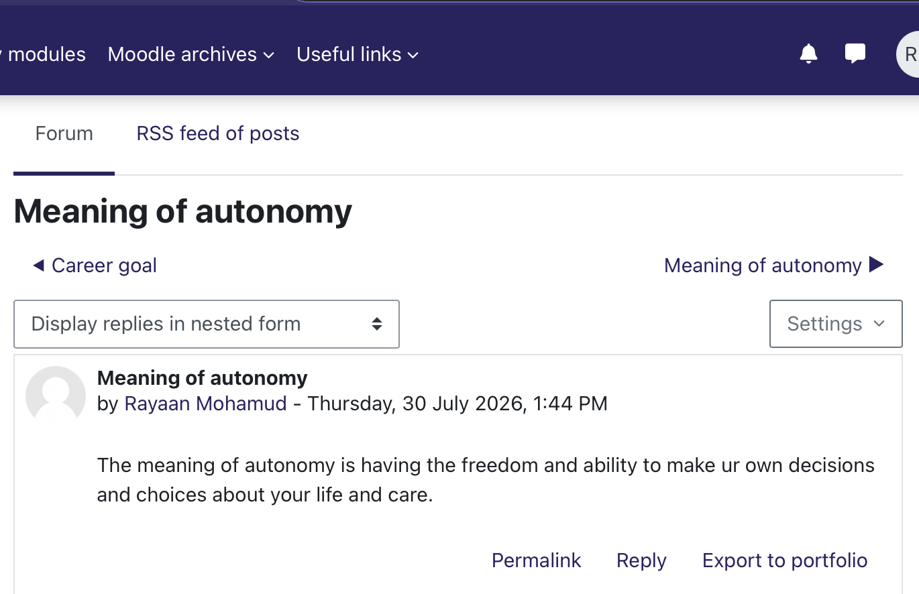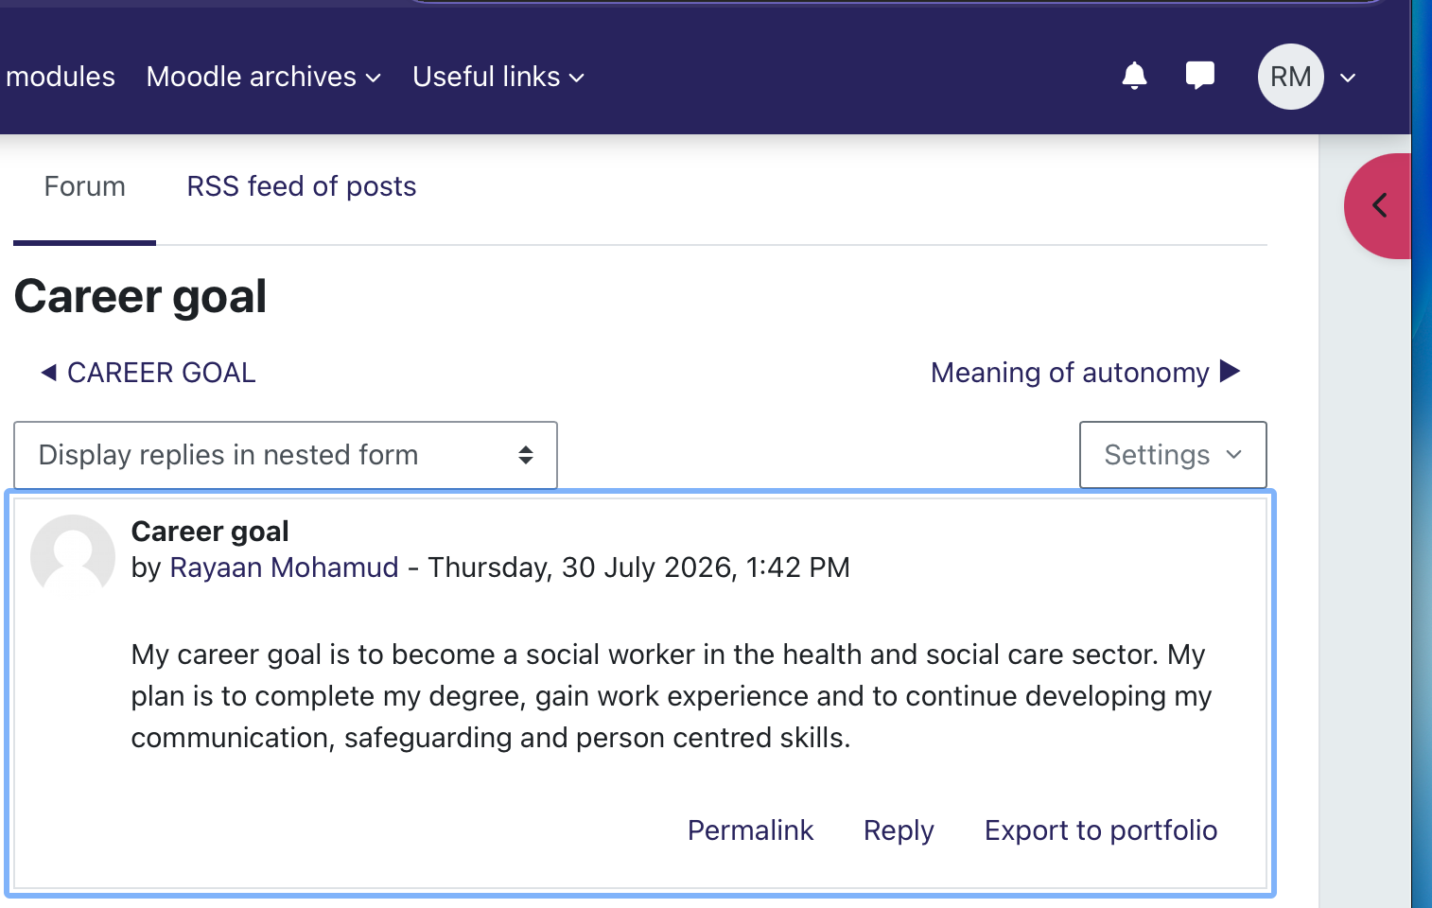

Task 2 – Reflection on Unit 2: It’s a Small World
This section of my portfolio reflects on what I learned during Unit 2: It’s a Small World and how the topics explored have developed my understanding of networking and professional relationships within Health and Social Care. Before studying this unit, I thought networking was mainly about meeting people to find employment. However, I now understand that networking is about building meaningful relationships that support personal growth, professional development and improved outcomes for individuals. The key topics covered included It’s a Small World, Variety is the Spice of Life, Network Society, and Making Connections, all of which have influenced how I view my future career.

The topic It’s a Small World introduced the concept of small-world networks and the idea of six degrees of separation, which suggests that people are connected through a small number of social links. This helped me understand that professional opportunities can often come through the relationships we build. Reflecting on this topic made me realise that creating positive connections with lecturers, and colleagues could benefit my future career in Health and Social Care.
Another important topic was Variety is the Spice of Life, which highlighted the value of developing diverse networks rather than only interacting with people who are like us. Barabási (2003) explains the idea of “birds of a feather flock together”, where individuals naturally connect with people who share similar interests and experiences.

The lectures explained that heterogeneity creates creativity, meaning that connecting with people from different backgrounds and professions encourages new ideas and different ways of thinking. This reflection encouraged me to step outside my comfort zone by meeting new people and learning from different perspectives, which will further help me become a more adaptable Health and Social Care professional.
The concept of the Network Society also helped me understand how technology has changed professional communication. Digital platforms allow healthcare professionals to share knowledge, collaborate across organisations and build professional relationships more easily. I now recognise that using these platforms professionally can strengthen my personal brand and create future career opportunities.

Finally, the topic Making Connections reinforced the importance of networking within Health and Social Care. it was also highlighted that effective networking is about building genuine relationships rather than simply collecting contacts. NHS England (2022) also recognises that partnership working, and collaboration improve health outcomes and community wellbeing. Reflecting on this unit has shown me that stepping outside my comfort zone, building diverse networks and maintaining professional relationships will help me grow personally and professionally. Overall, Unit 2 has increased my confidence and shown me that networking is an essential skill for building a successful and sustainable career in the Health and Social Care sector.
Task 3 – Reflection on Unit 3: Opportunity Knocks
In this unit I found out that opportunities in the field of health and social care don't always occur by chance; rather, individuals can make their own opportunities by being proactive, acquiring new skills, and establishing professional relationships. The concept of creating your own luck had a significant effect on me since I came to see that success is not solely due to luck but also depends on preparation, networking, and making the most of opportunities when they come up.

A key point that I picked up on was the concept of a serendipity mindset. This refers to coming across valuable opportunities by chance, but it also requires being open to new experiences and setting up situations in which such opportunities are more likely to arise (Heinström and Sormunen, 2020). In the field of health and social care, this might be achieved by attending networking events, talking to seasoned professionals, or offering to volunteer, as these actions could result in future job opportunities. Moreover, I realised that it is important to change one's point of view since the health and social care sector is always changing; professionals must adjust to new challenges, work towards reducing health inequalities, and improve the quality of care given to patients (Bury, 2013).

A major point that was discussed was about finding career opportunities. I discovered that having talks about your career, knowing your strengths, and setting stretch goals can all assist you in moving towards your future career. Stretch goals are objectives which are challenging and prompt people to go beyond their comfort zone to §achieve more than is expected (Pina e Cunha et al., 2017). Since I am a student in the field of health and social care, setting goals like obtaining work experience, improving my communication skills, and keeping up my professional development will help me to become more employable.

The unit also showed me how to open doors to job opportunities. I discovered that possessing a CV isn't always sufficient. Employers also place importance on practical experience, networking, references, and ongoing learning. Forming connections by using LinkedIn, volunteering, taking up placements, and attending professional events can enhance your chances of getting a job. Furthermore, I learned the importance of identifying my work values, which include intrinsic values such as helping other people and feeling respected, extrinsic values such as receiving fair pay and having opportunities for career advancement, and lifestyle values such as achieving a healthy work-life balance.

In summary, this unit has helped me to realise that if you are to build a successful career in the field of health and social care you need to have a plan, show resilience, network and engage in lifelong learning. I will put these lessons into practice by keeping on developing my skills, widening my professional network and staying open to new opportunities throughout my career.

Task 4 – Reflection on Unit 4: The Pursuit of Happiness and Conclusion
The fourth unit enabled me to realise that to become a successful health and social care professional one needs more than just academic knowledge. It made me think about my future career and the personal qualities necessary if I am to reach my aims. My understanding of limiting beliefs, grit, resilience, technology, social learning theory and mentoring has improved both my personal and professional growth. A highly valuable subject was that of limiting beliefs. I have found that negative thoughts could lower self-confidence and stop people from achieving their full potential (Meadows, 2015). This has caused me to consider how important it is to identify self-doubt and substitute it with positive self-talk. Furthermore, I now realise that one's personal attitudes can affect their professional behaviour and the quality of care given (Moore, Parsons and Jessup, 2019). The thing I picked up from studying grit is that both passion and perseverance are necessary if you want to achieve long-term goals (Duckworth et al., 2017). Moreover, I discovered that setbacks should be seen as chances to learn and improve, which in turn has made me more resilient for my future career (Ullsperger, Nittono and Von Cramon, 2007).The report also pointed out the increasing importance of technology in the fields of health and social care. Digital systems and artificial intelligence are altering the method by which care is provided, at the same time requiring workers to keep developing their digital abilities and to adjust to changes (Sheikh et al., 2021; Redeker et al., 2012).

In the end, my study of social learning theory and the role of mentoring taught me how important it is to learn from experienced professionals. According to Bandura's Social Learning Theory, people learn by watching others (Pratt et al., 2010), and mentors offer guidance, confidence and career advice which in turn promote professional growth (Hyams-Ssekasi and Caldwell, 2019). As a result, this unit has boosted my confidence and has prepared me for a career in the health and social care field.
Overall Conclusion
In summary, this module has enabled me to gain the knowledge, skills and confidence that are necessary for a career in health and social care. While studying the four units I have considered emotional intelligence, networking, employability, resilience, mentoring and professional development. Experience of these subjects has taught me that to achieve a successful career it is necessary to engage in continuous learning, to communicate effectively, to be adaptable and to be willing to challenge oneself. Because I have completed this portfolio, I now have a better understanding of how important it is to reflect on my own experiences and to identify areas in which I can improve. I have also realised the value of building up professional relationships, accepting change and keeping a positive attitude towards lifelong learning. The knowledge and skills that I have acquired in this module will assist me in my future career by enabling me to communicate effectively, to work collaboratively with others, to adapt to changes in the health and social care sector, and to give compassionate, person-centred care. Altogether, this module has provided me with a solid basis for reaching my future career objectives. 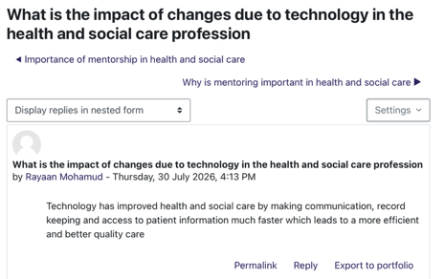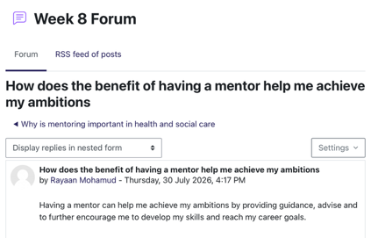

REFRENCES
Barabási, A.-L. (2003) Linked: How Everything Is Connected to Everything Else and What It Means. London: Plume.

Bury, M. (2013) Health and Illness in a Changing Society. London: Routledge.
Deci, E.L. and Ryan, R.M. (2000) ‘The “What” and “Why” of goal pursuits: Human needs and the self-determination of behaviour’, Psychological Inquiry, 11(4), pp. 227–268.
Duckworth, A.L., Peterson, C., Matthews, M.D. and Kelly, D.R. (2007) ‘Grit: Perseverance and passion for long-term goals’, Journal of Personality and Social Psychology, 92(6), pp. 1087–1101.

Heinström, J. and Sormunen, E. (2020) ‘Serendipity as chaos or discovery – Exploring the role of personality and sense of coherence’.
Hyams-Ssekasi, D. and Caldwell, E.F. (2019) Mentoring in higher education: The importance of supportive relationships for student development.
Klinge, C.M. (2015) ‘A conceptual framework for mentoring in a learning organisation’, Adult Learning, 26(4), pp. 160–166.

Legislation.gov.uk (http://legislation.gov.uk/) (2022) Health and Care Act 2022. Available at: https://www.legislation.gov.uk/ukpga/2022/31/contents (Accessed: 30 July 2026).

Maddux, J.E. (2016) Subjective Well-Being and Life Satisfaction. New York: Routledge.
Meadows, C. (2015) How to Overcome Your Limiting Beliefs. London: Watkins Publishing.
Moore, L., Parsons, J. and Jessup, P. (2019) How do nurses manage to cope with their work? A qualitative study. Journal of Clinical Nursing.

NHS England (2022) Working in Partnership with People and Communities: Statutory Guidance. Available at: https://www.england.nhs.uk/long-read/working-in-partnership-with-people-and-communities-statutory-guidance/ (Accessed: 30 July 2026).

Pina e Cunha, M., Giustiniano, L., Rego, A. and Clegg, S. (2019) ‘Mission impossible? The paradoxes of stretch goal setting’, Management Learning, 50(2), pp. 140–157.
Pratt, C.W., Wilson, M.O. and Associates (2010) Psychiatric Rehabilitation. 3rd edn. London: Academic Press.
Redeker, C., Leis, M., Leendertse, M., Punie, Y., Gijsbers, G., Kirschner, P.A., Stoyanov, S. and Hoogveld, B. (2012) The Future of Learning: Preparing for Change.
Roy, B. (2008) The Ambition Principle. London: Pearson.

Sheikh, A., Anderson, M., Albala, S., Casadei, B., Franklin, B.D., Richards, M., Taylor, D., Tibble, H. and Mossialos, E. (2021) ‘Health information technology and digital innovation for national learning health and care systems’, The Lancet Digital Health, 3(6), pp. e383–e396.
Ullsperger, M., Nittono, H. and Von Cramon, D.Y. (2007) ‘When goals are missed: Dealing with errors and failure’.

