Component 2 - Research Report
Jordana baylis
2125426
Robert Nartowski
LCHS4002_BIRM
Digital Skills and Research Methods.

Contents
- Introduction………………………………………………………………………….
- Research design…………………………………………………………………….
2.2 What will be researched?
2.3 Why is it important?
2.4 How and when will it be carried out?
2.5 Who will be involved?
- Method and ethical considerations………………………………………....................
- Ethical considerations …….……………………………………………………………..
- Environmental factors ….…………………………………..…………………………....
- Conclusion…………………………………………………………………………………
- References………………………………………………………………………………...
- Appendix (blank copy of questionnaire) ……………………………………………….

Introduction
Research design is the overall collection from different components within a chosen question or design, this is to collect, measure and to analyse with. (Robert Labaree, 2005).
Research design is using data, collection and analysing the overall approach also what type of design with different methods on how it is collected and what components, measure to get a hypothesis to the researched question. (Pritha Bhandari, 2022).
Within this research of ‘how well do you know technology’. Students across the universities need to understand the use of technology to collaborate, discuss, analyse, and understand how to use different components for the overall conclusion. Technology researchers have been trying to document the impacts of flowing 1:1 for students, teachers, schools, and communities to find the information n order to review the research and outcomes of the student practices. This will be supported by the teaching and learning of different levels od technology accessed. (Lemke & Martin 2003); Zucker (2004): Penuel (2005).
Why is it important?
This is important for the students and teachers across the educational learning industry, because this will help them prepare for the future and helps them with their forthcoming plans for working or further education over the twenty-first-century society. (Voogt & Pareja 2010).
This helps the demands of future education, not only the technologies is supported but it helps with the literacy skills and to help from the earliest of primary schools right the way through education to the work industry.
In this research a questionnaire was carried out evaluating and understanding of students and how technology is understood by them. This will also give a clear answer to whether the students need further collaboration to technology, or it is understood effectively.
Who will be involved within the survey?
Within the research there was a completion from 4 students within UWTSD. This survey had a series of 21 questions in which was completed to their acknowledge of understanding to technology and students. This is a variety of questions in which students need to answer honestly, because this will help the discussion and the evaluating from the surveys and answers to be correct and to have an appropriate outcome. These questions were designed to see whether the students know about technology, and how they answer these questions. There was a series of questions, ranking between options, likert scale and a rating, also yes and no questions, agreed and disagree.
What are the key theories of students and technology?
Dr. Joan Hughes developed a model call R.A.T, this helps the students and teachers across the learning industry know the usage of accurate self-assessment for the technology within the classrooms.
Replacement – technology does change just the instructional end is different to the instructional practices.
Amplification – Practices, efficiency, productivity, and effectiveness ensures an extension, although the task remains the same.
Transformation – The different from the learning curriculum, method, and solutions to modification of instructing different outcomes.
This helps the students understand how the end can change from the hypothesis at the start of the survey, so with this the structural practice from the research is changed by different students because not everyone will have the same outcome as another. The productivity and effectiveness of the outcome will come to some sort of extension as the tasks and the questions stay the same the answers always differ depending on the student who is taking the survey. Within the difference between from different surveys can differ because of age and what their acknowledgement from understanding the methods and solutions to the outcome.
How and when will this be carried out
This is carried out by the students within UWTSD. This was developed with a survey to understand their knowledge on technology. This was created and sent out 26/07/2022.
4 students have complied with this survey, and this will be evaluated and carried out within a table. This will be created within Xcel.

Methods and ethical considerations
In this research student were asked a series of questions to gather enough information to understand the student knowledge of technology. The behaviour from the 4 responses were acceptable considering only 4 students answered, it was shown form what they understand on ‘how well do you know technology?’.
These questions start from what their name and age, to whether they believe technology is good or whether it needs improving within the UWTSD.
The students that have participated within the survey have shown the confidence and where they need improvement. The students that undertook the survey has shown the differences from what type of educational requirements that have met and needs to be met.
This survey had a variety of 21 questions on ‘How well do you know technology’. The 4 students that participated in this survey shows the different levels of education and where they are at with their knowledge and understanding for the use of technology within the UWTSD. These questions were designed to understand what the students understand with how to use technology, how well does it work within the classroom and whether they understand the use of different apps and technologies.

Environmental factor
The fact that technology is increasingly advancing with the younger generation its also having a major impact to the economy and wildlife, as it’s causing more pollution, carbon footprints and waste. This is causing the nature to defect and lose the touch, causing animal extinction and other global factors that humanity is generating on the planet. The omnipresence term “Global Change” recently illustrated the billion-dollar research. (OECD,1994). In 1957-1958 international Geophysical was the first to mark the 25th anniversary of scientific planning. (Malone,1995). Elon Musk who has created electric vehicle manufacturing company in 2003. Tesla is one of his greatest accomplishments as this helps humanity to evolve and enhance their abilities to reduce the fossil fuels and go electric. This is helping the planet by reducing the carbon footprint and helping the evolution to progress in a sustainable environment.
Problems and limitations
A problem is unsupportive information that can be accessed easily. Accessing information when learning limits, the actual acknowledgement from a student. This can bewilderment to the learning of a student. (Hodand, 2008).
Studies have shown how students expeditiousness of communication between themselves and lecturers’ effects from the online learning this gives a disturbance of students frustration and will proceed to defect their motivation to continue to learn. (Logan, Augustyniak and Rees, 2002).

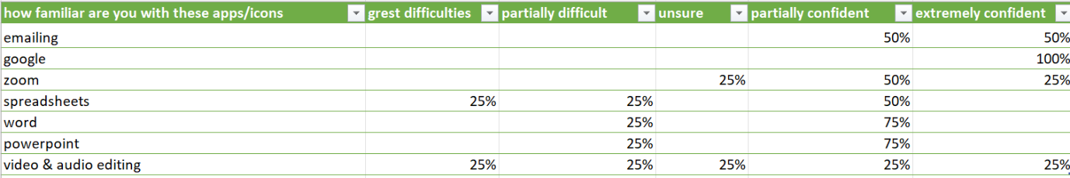
This is one of the questions within the survey ‘how familiar you with are these app/icons. I have chosen this as the students did understand some of the apps that are displayed on the computers for university and some of the students were familiar with google, emailing, but need work with word and PowerPoint. The students needed the most work spreadsheets and video & audio editing. This was a good question because this shows where the students want more practice with, and this could help the university understand where the students find confident and where they lack confidence.
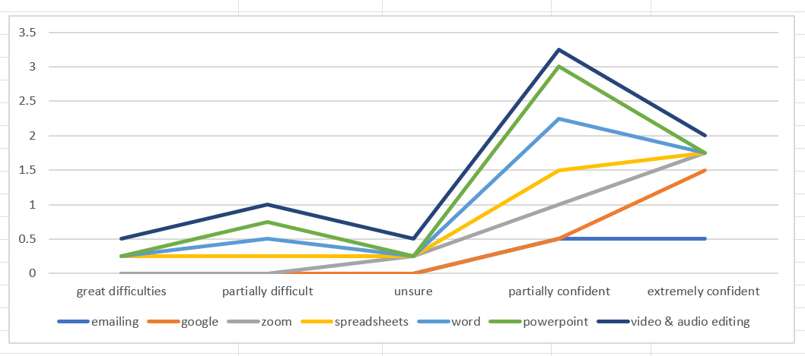
In this graph it shows where the students find most confident to great difficulties. The most common was emailing and google as every student is extremely confident and familiar with these as they are used within education and outside education. The areas that need improving is spreadsheets and video and audio editing, the students aren’t very confident and familiar with these apps, so this indicates that the universities and students need to work on them. The understanding of this is that the student know how to use PowerPoint and Word, this is important because the students understand how to use these and what needs improving on.
Overall, all 4 students that participated in this question indicates their knowledge when using technology within university.
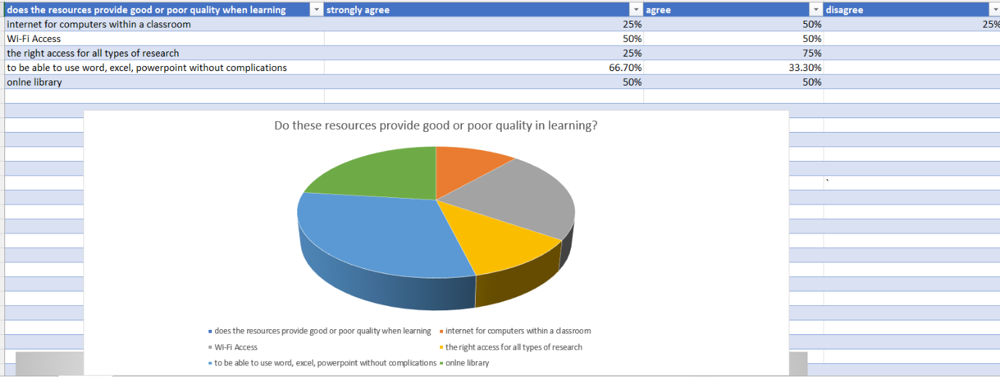
Do these resources provide good or poor quality when learning? In this the 4 students that participated shows their strengths and areas of improvement, as on this Pie chat the students that the internet within a classroom and being able to access all resources when learning has an impact on the students ability of learning as the students have provided the answers of needed more work on, so this indicated that the education need to provide more abilities and more research in order for students to access the right resources. The most common was to be able to use PowerPoint, word and excel without complications the majority of students had strongly agreed to this as the more students know how to use this tool when learning as it is used in nearly everyday of the academic environment. Finally in addition to this the research that was provided can be accessed with the student and staff to evolve by using the online library, this helps the students learn and be able to access the right information to succeed with their learning.
66.6% of students strongly agreed that using these icons/apps when learning is a good quality as they understand how to use within their educational purpose. The characteristics of finding useful information for the academic and digital learning is required to need more learning towards as the information that can be provided can possibly be false and neglect the fact of understanding the actual use of technology. Even though they are agreed that it provides good quality it still has the factors of finding information with no evidence to back up. Internet access shows how strongly a wide range of information in relation to students understanding of technology.
Hypothesis
Technology has helped students understand the outcomes through the survey. All of the participants that undertook the survey shows their characteristic and the final result of their understanding to technology. Based on the results it shows the from acknowledgment from what they know and what can be improved in order for student to progress further with technology. In addition to this the students that understand the use of technology has proven their overall grades as the more familiar the further the more student’s ability of use of technology. Finally, this helps the institutions progress and help the student understand new and evolved technology that is helping with workshops and different learning platforms and approaches. (Wang, 2013).
Conclusion
The overall for this is that student’s knowledge and understand helps evolve and greater the minds of students globally academically and digitally with technology, as students absorb more information when finding more variable resources that is available from online library to in a classroom. Technology will increasingly progress and students’ knowledge to enhance their minds and abilities is powerful and is only going to progress further.

Referencing
Berkner, L.V., (1954). International scientific action: The international Geophyscial year 1957-58 science, (3096), pp 569-575.
De Vaus. (2001), William T. (2006). Research design in social research. Current urban studies, Volume 8. No 2.
Hodavand, S. (2008): Analysing E-learning in Iran. Information and communication technology (ICT) in higher education: advantages, disadvantages, conveniences and limitations of applying e-learning to agricultural students in Iran. Procedia-Social and Behavioral Sciences, Retrieved 23/05/2014.
Ivy Panda,. (2021); Ethical considerations in technology. 3rd October. https.//Ivepanda.com/essays/ethical-considerations-in-technology.
Lemke C. and Martin c. (2003)., One to one computing in Maine: a slate profile. Metin Group, Culver City, CA.
Pritha, Bhandari. (2022)., Revised 21st July 2022.
Penuel, W.R., (2008) Research; What it says about 1-1 learning. Apple computer, Cupertino, CA.
Mathew. L (2022); Digital learning theories and models you should know. https.//.www.theteachedvocate.org/digital-learning-theories-and-models-you-should-know/
OECD (1994). Organisation de cooperation et de development economics. Forum megascience, megascnience, the OECD forum, megascience and the OECD forum. Global change planet earth. Organisation for economic.
Shona, Mc. (2021)., What is a research design. Types, Guide and examples. Publishes June 7. Revised July (2022).
Voogt, J. and Roblin, N.P, (2010); 21st century skills discussion paper. University of twenty, 10.
Wang, C.H, Shannon, D.M and Ross M.e. (2013): Students characteristics distance education, 34(3). Self-regulated learning, technology, self-efficacy and course outcomes in online learning. Pp 302-323.
Zucker a. (2004)., Developing research agenda for ubiquitous computing in schools. Journal of educational computing research. 30, 371.



