  Component One:  What are the key skills required when working in the housekeeping team? 750 words (+/- 10%)  Contribution to Overall Module Assessment: 25% | Student No: | 2128038
 | Module Title: | Operating Hotel Facilities
 | Module Code: | BMIH4006
 | Lecturer: | Tristan Hawkins
When working as a part of the Housekeeping team it is essential that staff have numerous skills in order to work effectively and achieve brand standards as required.

One skill required is time keeping skills as staff are expected to complete cleaning on an assigned number of rooms in a certain timeframe. Not keeping up with this can result in rooms not being serviced in time for check in as well as inconsistency in cleaning when under added pressure towards shift finish time. While working within the housekeeping department on placement I noticed that each cleaner averaged around 7-9 rooms per shift which was usually from 9am-1pm however during school holidays there were numerous more family rooms to set up therefore allocations of these rooms would increase expected finish time, if the allocated housekeeper did not manage their time effectively then rooms would not be ready for check-in which leads to unhappy guests, leading to a negative reputation therefore time management skills are vastly important as a member of the housekeeping team.

Another skill which is important within Housekeeping is team working skills. Ingram and Hayden (2000) carried out a report which suggested that team working in hotels needs more development. Due to large teams working together within hotels, housekeepers need to be able to work as a team with other housekeepers, room strippers, room checkers and reception staff in order to ensure that all daily tasks are carried out as effectively as possible. Front of House staff will need housekeepers to work together in order to make rooms ready for check in time and inform duty managers of any issues faced. Leading on from this, communication skills are another important skill required to work within housekeeping as in order to run effectively housekeepers need to communicate with front of house staff and duty managers to ensure that rooms are prepared for check in and that there are no faults within the rooms.

Furthermore, ‘the definition of the term “brand”, is quite often limited to a distinctive sign developed by the seller to identify its offer and differentiate it from that of competitors’ Andreis, F and Carioni, M (2020). This relates hugely to housekeeping as the heart of any guests’ hotel stay is the room therefore to be recognised within a brand you must comply with brand standards as set to be able to be recognisable as the same brand and quality of other hotels within the chain. Therefore this requires housekeeping to follow specific standards and ensure quality is the same throughout all rooms all the time. This means housekeeping staff must have the skill of attention to detail and take pride in their work ensuring quality and brand standards are maintained throughout the hotel. While on placement at the premier inn, I had noticed that everything from bed making to the tea and coffee station had to meet the brand standards as set out and every housekeeper in the brand would follow the same standards therefore guests would recognise the brand at first sight.

Alongside these one important skill is the ability to handle machinery such as carpet cleaners, hoovers etc. Also to be able to move laundry and their cleaning trolley can be strenuous therefore should be physically able to handle equipment required to carry out their job. Also for working in a housekeeping team this often requires flexibility as often hours are varied from week to week including weekend work and sometimes early morning or evening shifts depending on the needs of the site.

Another major skill required for a Housekeeper includes communication skills. This is because Housekeepers are required to communicate with guests, colleagues and management to ensure the expectations and brand standards of cleaning are understood. Without this, they may not meet the needs or expectations of the guest. This means that for brand standards to be met the housekeeping team need to communicate and keep in touch with management of any new brand standards, for example during covid in 2020 it was introduced within the Premier Inn that 30 minutes before the housekeeping team would enter the room a team member would enter the room to open windows and strip room to allow for sanitisation. This has carried on now in order to keep down infections and to air the rooms out as in my hotel I would enter the room to open windows and doors and strip rooms to allow fresh air to circulate the room ready for servicing.

In conclusion, in order to work in the housekeeping team a person must have various skills in order to complete their job to the expected standards of both the guest and the brand.

Word Count | 780

Component Two:
Contribution to Overall Module Assessment: 25%
In this scenario – You have just been promoted to team leader for a floor within the hotel. A guest complains that on their arrival, their room had not been properly cleaned. Create an action plan and answer the following questions.

Problem | Why did it happen? | What are you going to do? | How will you prevent this from happening in the future? | What measures would you introduce to improve team effectiveness?
Hair in the bath | Housekeeping failed to check for hairs | Speak to the team member and retrain where applicable | Ensure room checkers are checking properly and sending team member back when not done properly | Employee engagement and recognition and rewards
Tea and Coffee station unclean | Housekeeping member did nor remove items from tray to clean | Speak to team member responsible and send them back to the room to clean properly | Ensure staff are retrained and reminded of their cleaning responsibilities | Communicate effectively and delegate where necessary
Heater not working in room | Electrical fault / general wear and tare | Inform maintenance team of the issue and change guests room where possible or provide portable heater | Regularly check heating and ensure service schedule is adhered to | Daily tasks for members of staff to check heating
Stain on the bed | Room checkers and Housekeeping had failed to notice stain | Apologise and offer to change bedding for them and inform team members of the mistake | Ensure more thorough checks are completed and report unclean linen to the linen company | Recognition and rewards for housekeeping where they are spotless
Rubbish under the bed | Deep clean not completed | Ensure that all housekeepers are pulling out furniture and cleaning under and behind | Daily tasks for housekeeping to clean different hard to reach areas of the room | Delegation of tasks to housekeeping team

Component Three:
Contribution to Overall Module Assessment: 50%
Your task is to create and prepare a presentation following the detailed scenario provided below.

As the floor housekeeping manager and given the recent guest complaints you need to put together a basic training presentation for your colleagues within the housekeeping team to get the best out of them, ensure that brand standard is being achieved and that Health and Safety procedures are also being followed.

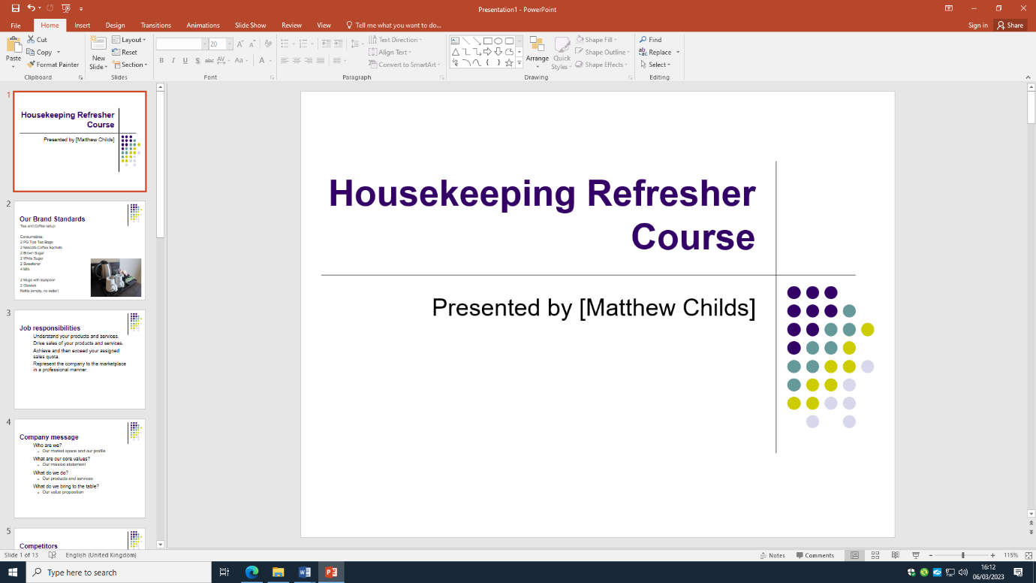
Training Notes:

- Welcome to the Housekeeping Refresher Course
- Introduction to myself
- Reason for course…. Complaints require retraining
- Any questions please raise your hand
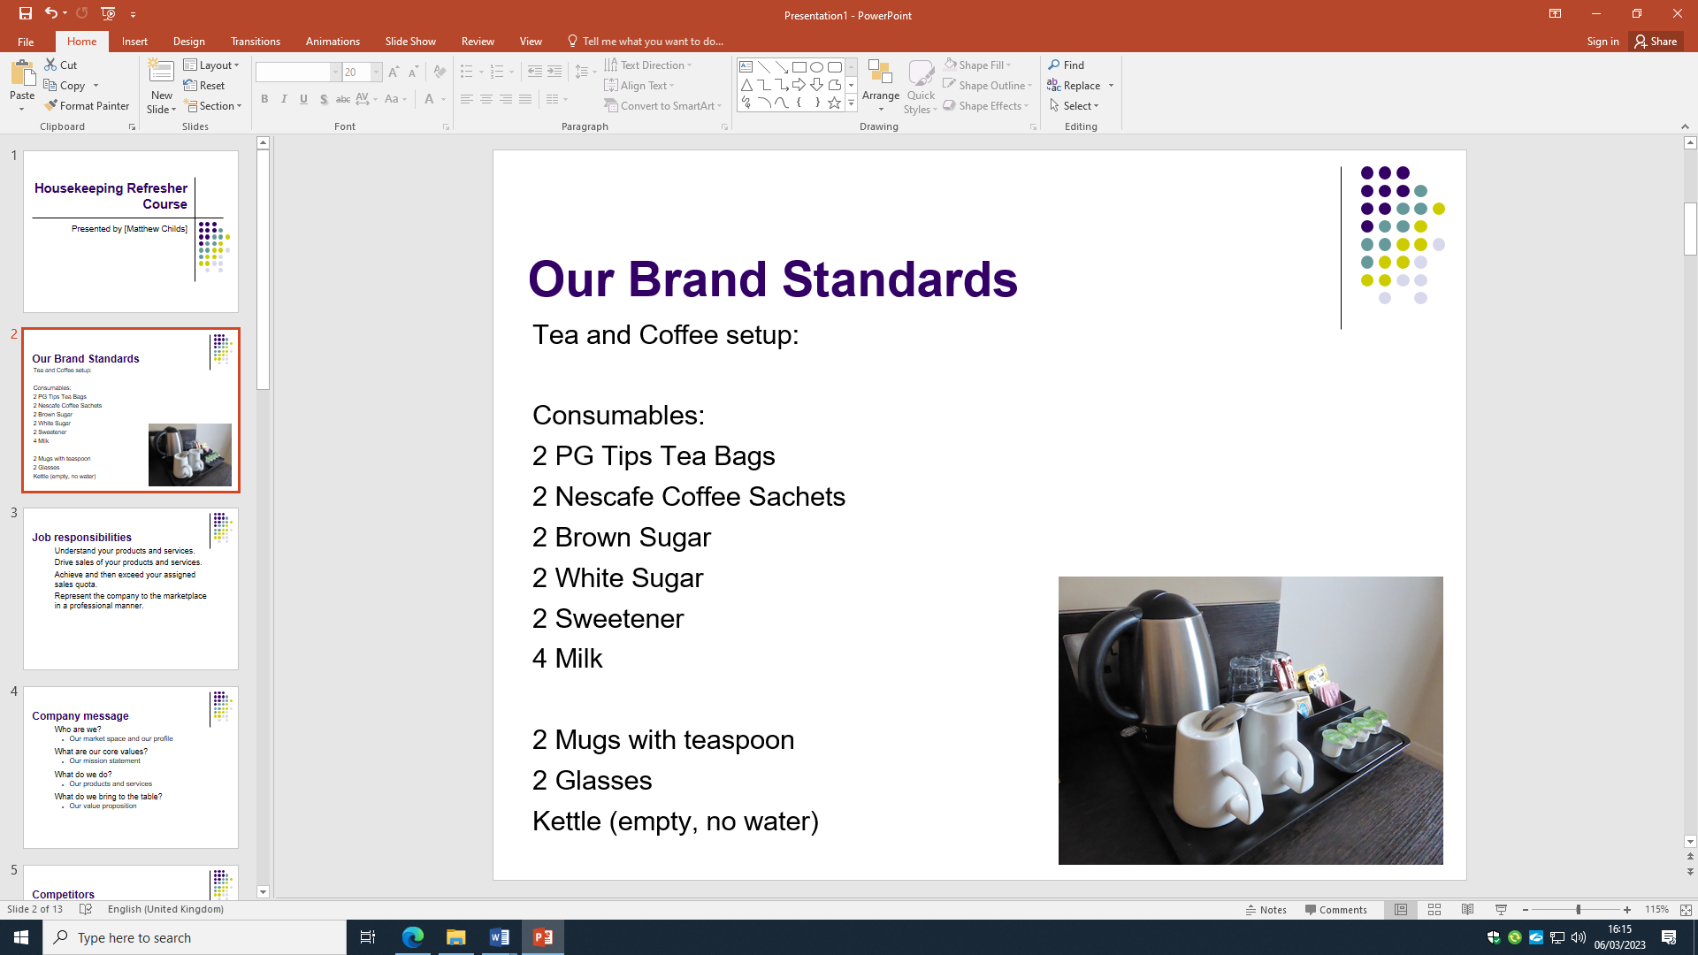
Training Notes:

- We have numerous brand standards which we must follow when working within the housekeeping team
- Our tea and coffee station within rooms are shown on the image
- This must include the following… (read list)
- Ensure that all mugs, spoons and glasses are clean from stains and watermarks
- In order to achieve brand integrity and consistency, a balanced approach is suggested- Forgacs, G (2003)
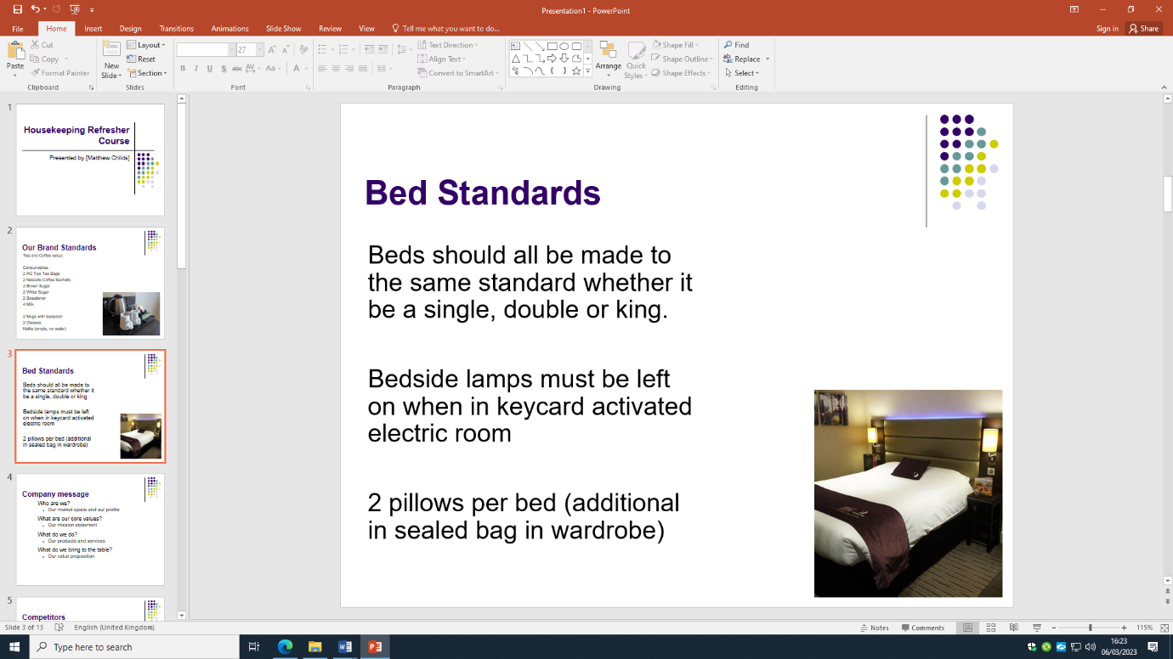
Training Notes:

- We have bed standards when making our beds within the brand
- All beds should be made the same
- The beds are seen as above with ends tucked in and corners flapped over
- Extra bedding and pillows should be with clean laundry on and sealed for next guest
- Bedside lamps on for entering room
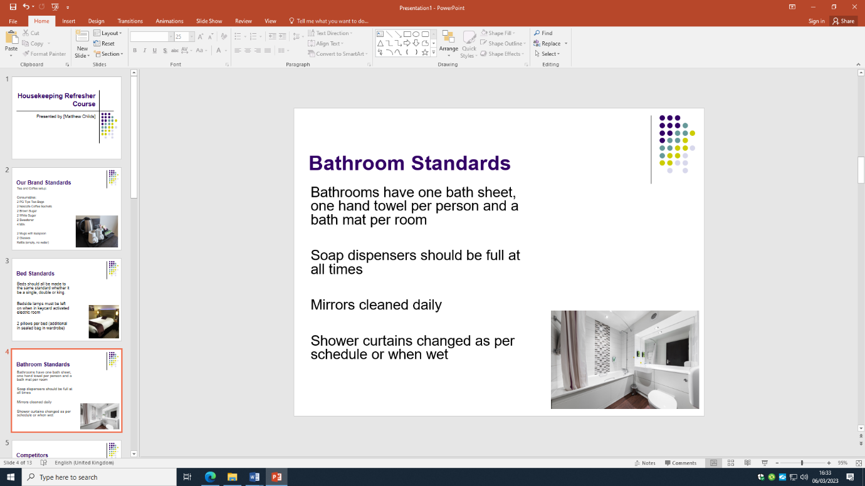
Training Notes:
- Bathrooms must have 1 bath sheet 1 hand towel per person
- 1 bath mat per room
- Soap dispensers should be full at all times
- Mirrors cleaned daily
- Shower curtains changed as per schedule or when wet
- Floor and toilet cleaned daily with correct chemicals
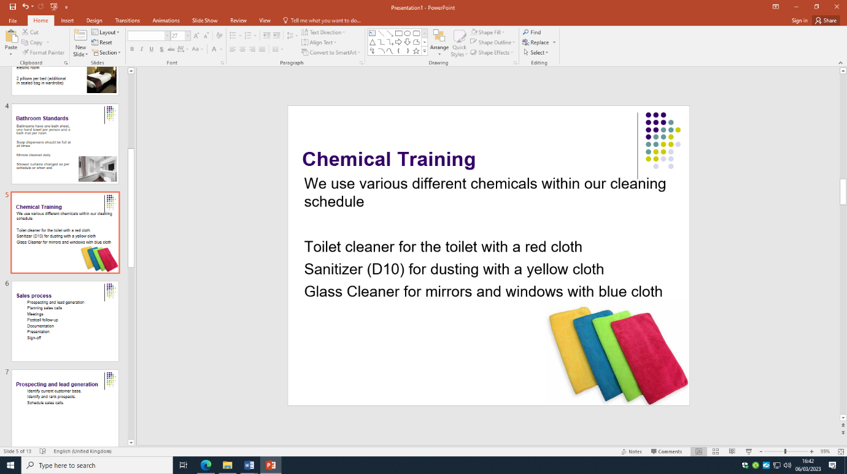
Training Notes:

- YOU MUST OBSERVE RULES BASED ON WHICH CLOTHN TO USDE WITH EACH CHEMICAL
- Health and safety are risked with cross contamination of cloths
- Toilet cleaner for the toilet with a red cloth
- Sanitizer (D10) for dusting with a yellow cloth
- Glass Cleaner for mirrors and windows with blue cloth

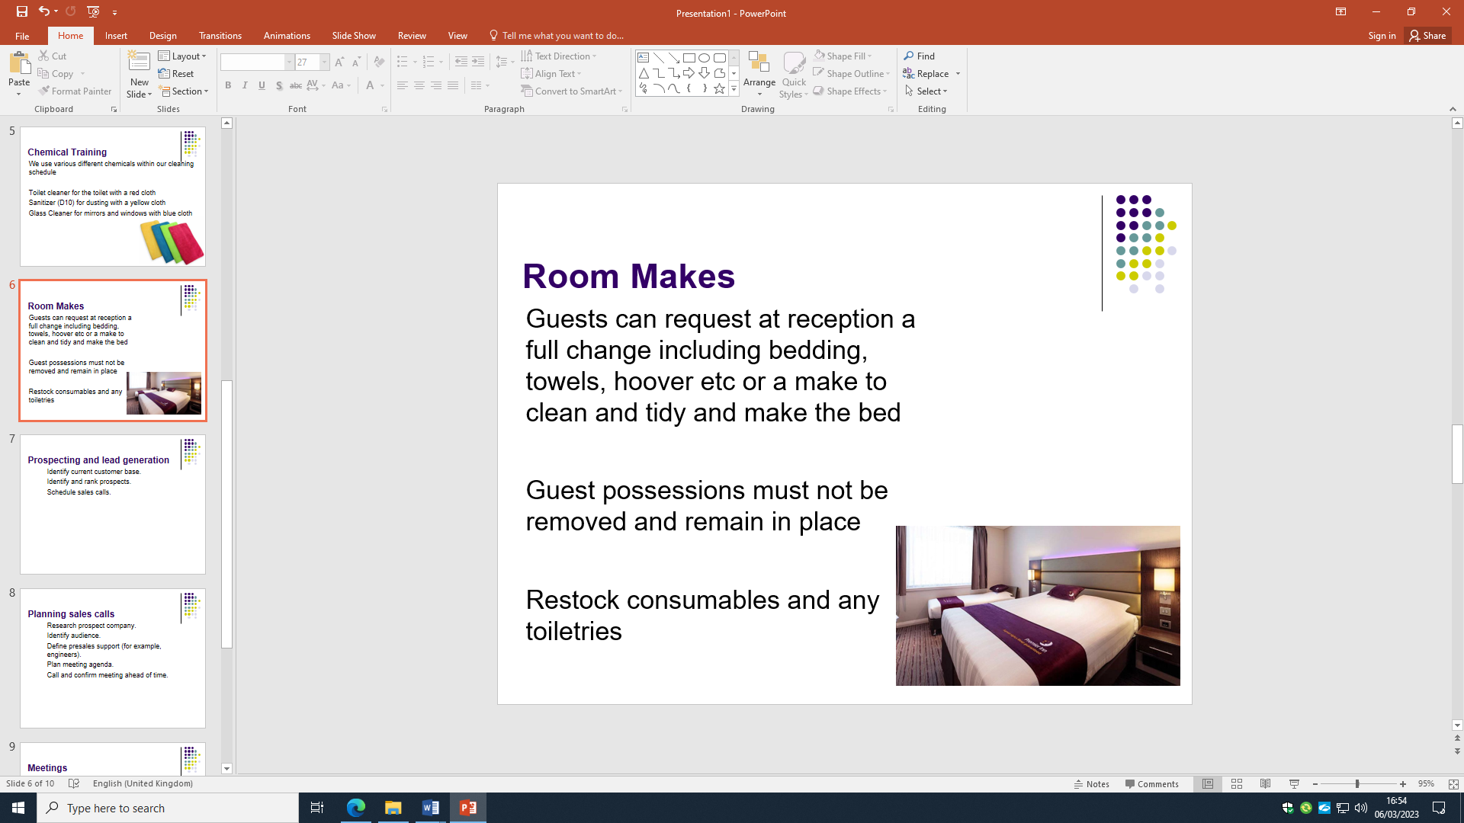
Training Notes:

- Guests can request at reception a full change including bedding, towels, hoover, bathroom clean
- Or it could be a make to clean and tidy and make the bed
- Guest possessions must not be removed and remain in place
- Restock consumables as per training above
- Refill toiletries
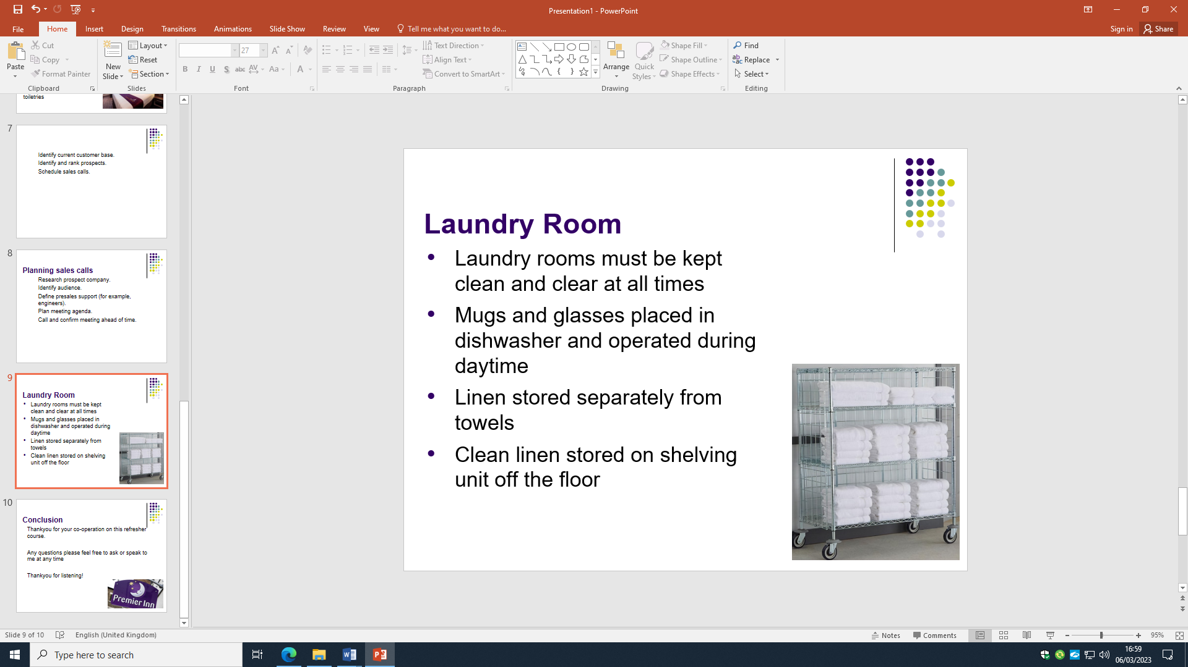
Training Notes:

- Laundry rooms must be kept clean and clear at all times
- Mugs and glasses placed in dishwasher and operated during daytime
- Linen should be stored separately from towels
- Clean linen stored on shelving unit off the floor

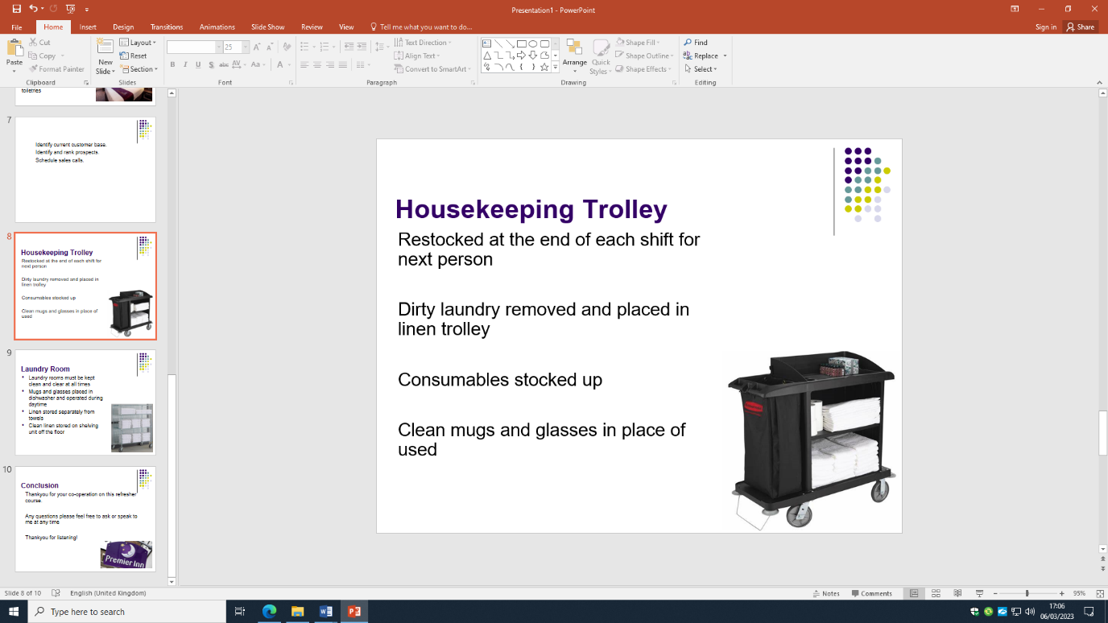
Training Notes:

- Trolley must be restocked at the end of each shift for next person
- Dirty laundry must be removed and placed in linen trolley
- Consumables stocked up ready for next shift
- Clean mugs and glasses in place of used
- Place used mug and glass in dishwasher
- Place all cloths in washing machine
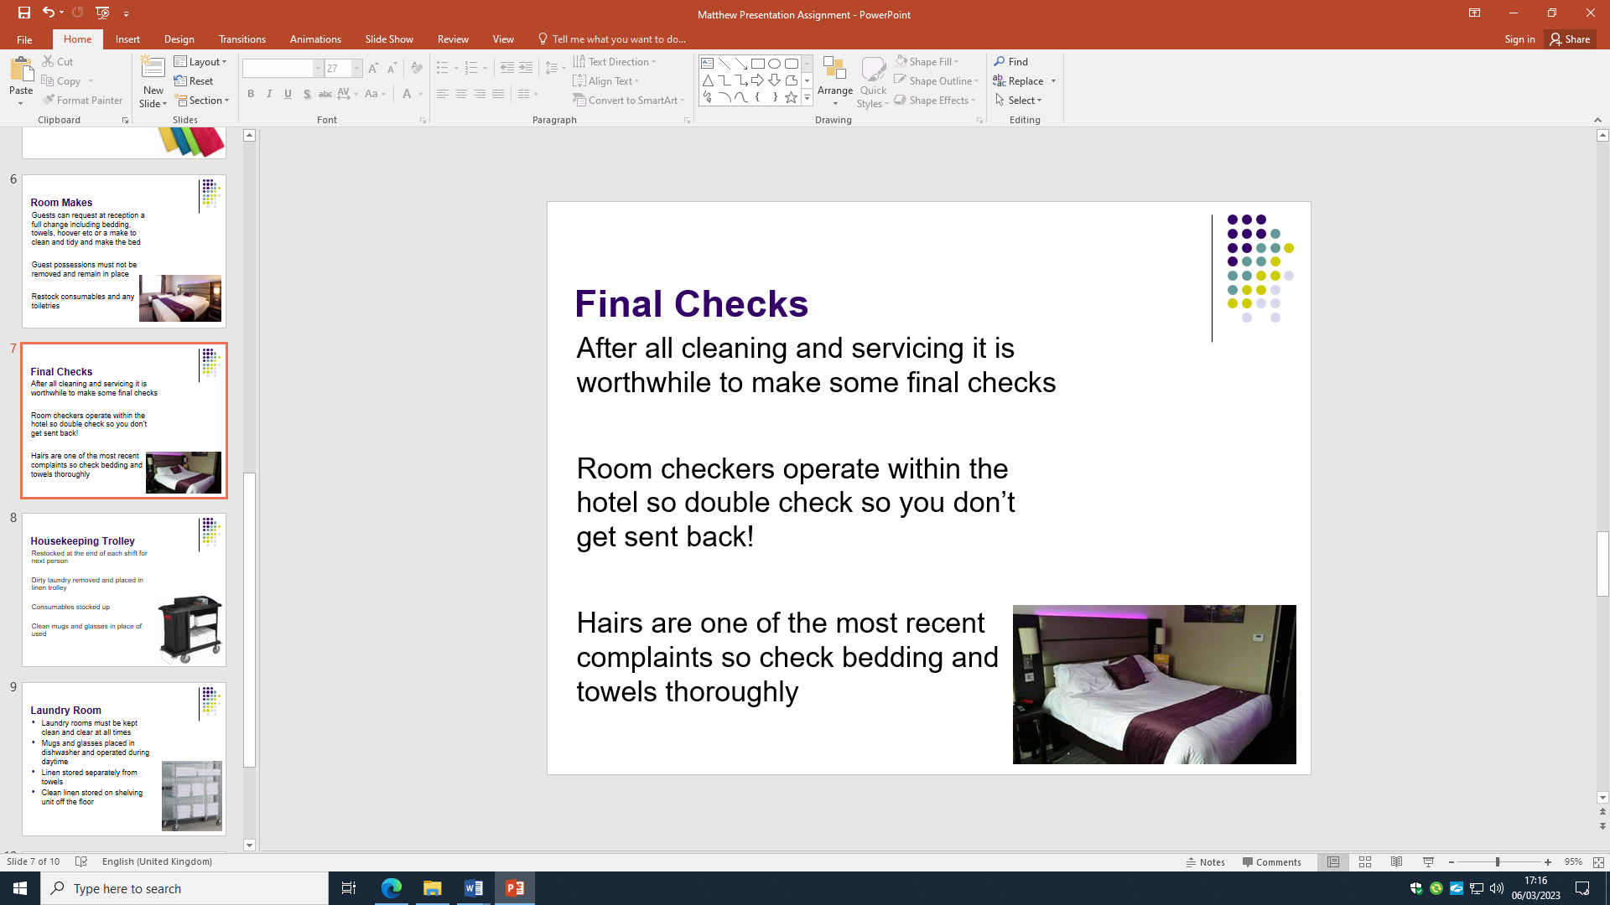
Training Notes:

- After all cleaning and servicing it is worthwhile to make some final checks
- Room checkers operate within the hotel so double check so you don’t get sent back!
- Hairs are one of the most recent complaints so check bedding and towels thoroughly
- Also check all carpet
- Check surfaces for dust

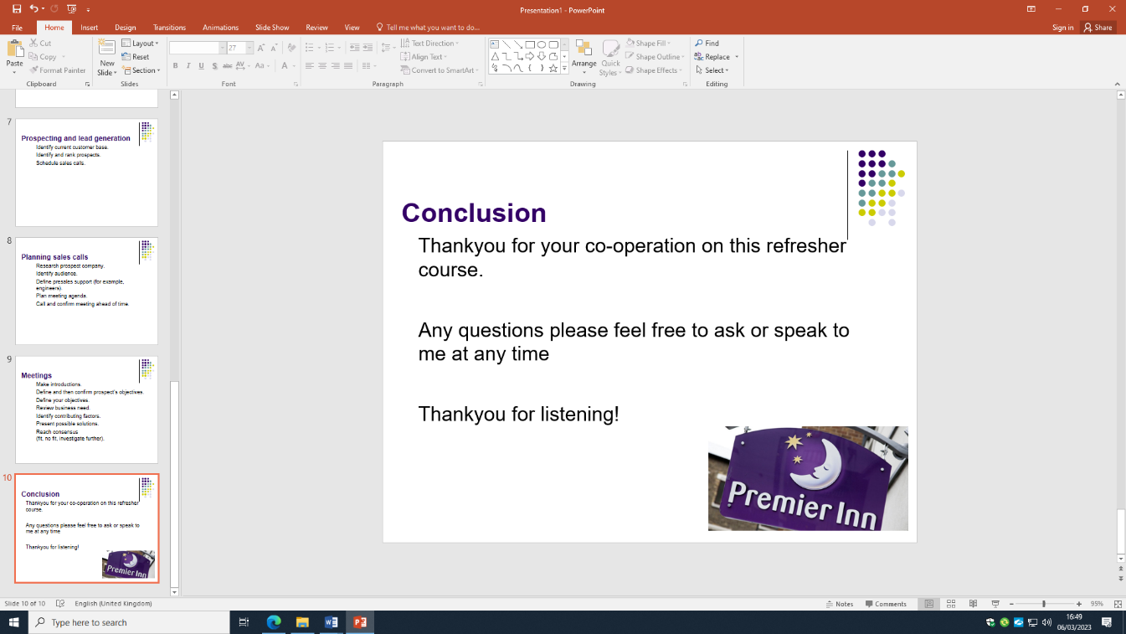
Training Notes:

Thank you for listening, as always I’m here if you need any questions answering or any help

Thankyou

References

Component 1 References:
de Andreis, F. and Carioni, M., 2020. BRAND CONSISTENCY AS AN EFFICENT STRATEGY OF HOTEL MANAGEMENT. In Education, Law, Business (pp. 50-54).
Forbes Article on Brand Standards. Accessed on 8/3/2023. Available at: 5 Ways To Maintain Brand Consistency As You Grow Your Business (forbes.com).
Indeed Career Advice for housekeeping. Accesed on 1/03/2023. Available at: Guide to Housekeeping Skills (With Tips and Examples) | Indeed.com .
McConalogue, T., 1984. Developing the skill of time management. Leadership & Organization Development Journal, 5(1), pp.25-27.
Premier Inn Cleaning During Covid 2020. Accessed on 7/3/2023. Available at: Coronavirus (COVID-19) information | Premier Inn
Ingram, H. and Desombre, T., 2000. Teams and teamworking in hotels. Tourism and Hospitality Research, 1(4), pp.351-368.
Jawabreh, O., Al Fayoumi, T. and Bareya, A., 2022. CUSTOMER SATISFACTION TOWARDS COMMUNICATION SKILLS OF FRONT OFFICE STAFF AT THE HOTEL (CASE STUDY FIVE STARS HOTELS IN AQABA). Geo Journal of Tourism and Geosites, 44(4), pp.1312-1318.

Component 2 References:
Sanon, M.A., 2013. Hotel housekeeping work influences on hypertension management. American journal of industrial medicine, 56(12), pp.1402-1413.
Manickas, P.A. and Shea, L.J., 1997. Hotel complaint behavior and resolution: A content analysis. Journal of Travel Research, 36(2), pp.68-73.
Ekiz, E., Khoo‐Lattimore, C. and Memarzadeh, F., 2012. Air the anger: investigating online complaints on luxury hotels. Journal of Hospitality and Tourism Technology.
Lee, C.C. and Hu, C., 2005. Analyzing Hotel customers' E-complaints from an internet complaint forum. Journal of Travel & Tourism Marketing, 17(2-3), pp.167-181.
Vermeulen, I.E. and Seegers, D., 2009. Tried and tested: The impact of online hotel reviews on consumer consideration. Tourism management, 30(1), pp.123-127.
Phillips, P., Barnes, S., Zigan, K. and Schegg, R., 2017. Understanding the impact of online reviews on hotel performance: an empirical analysis. Journal of Travel Research, 56(2), pp.235-249.
Component 3 References:
Ambardar, A., 2015. Occupational safety and health of laundry employees in hotel industry. International Journal of Hospitality & Tourism Systems, 8(1), pp.32-39.
Fletcher, K., 2009, October. Adobe Presenter, Microsoft PowerPoint, and Blackboard Vista: tools that work together for creating and presenting online instructional content. In Proceedings of the 37th annual ACM SIGUCCS fall conference: communication and collaboration (pp. 243-248).
Foroudi, P., 2019. Influence of brand signature, brand awareness, brand attitude, brand reputation on hotel industry’s brand performance. International journal of hospitality management, 76, pp.271-285.
Forgacs, G., 2003. Brand asset equilibrium in hotel management. International journal of contemporary hospitality management.
Improving Employee Effectiveness. Accessed on 17/02/2023. Available at: Top 10 Ways to Improve Employee Effectiveness (icehrm.com) .
Olimovich, D.I., Bakhtiyorovich, T.M. and Salimovna, N.G., 2020. Improving of personnel training in hotel bussines. Academy, (2 (53)), pp.18-19.
Premier Inn Beds. Accessed on 6/3/2023. Available at: premier inn bed - Bing images
Sherlock, O., O'Connell, N., Creamer, E. and Humphreys, H., 2009. Is it really clean? An evaluation of the efficacy of four methods for determining hospital cleanliness. Journal of Hospital Infection, 72(2), pp.140-146.
Tra, T., 2020. Action plan for training new Housekeeping Employee: case: Hotel Indigo Helsinki.
Tripadvisor image. Accessed on 17/02/2023. Available at: premier inn tripadvisor tea and coffee - Bing images
Tripadvisor Reviews of Premier Inn Hartlepool. Accessed on 8/3/2023. Available at: PREMIER INN HARTLEPOOL MARINA HOTEL - Updated 2023 (tripadvisor.co.uk)

