UNIVERSITY OF WALES TRINITY SAINT DAVID
LONDON CAMPUS
Assignment 2
Learning in the Digital Era
Video Link:
https://youtu.be/FN8WHdQGXWM

https://www.youtube.com/watch?v=FN8WHdQGXWM

Module Name: Learning in the Digital Era
Module Code: ACCA 4025

Student Name: Ersal Nezhdet Rashid
Student ID: 2025 3042 51
Group: 2

Lecturer’s Name: Koushik Modak

Table of Contents
Introduction 2
Main Body 2
Conclusion 9
References 9

Introduction

This report is prepared to meet the requirements of 'Learning in Digital Era' module. It centres on an individual self-assessment and describes a structured Professional Development Plan (PDP), which is directly aligned with my future career objectives. It also contains a more in-depth summary of the 'Learning to Learn' topic, that looks at some of the main metacognitive strategies and concepts.

Main Body
The following sections describe the slides from the video assignment in detail. Each of the parts elaborates on the aspects discussed in my self-evaluation and professional development plan, and the academic topic summary with relevant theoretical frameworks.

Video Link: https://youtu.be/FN8WHdQGXWM

Slide 1 COVER PAGE
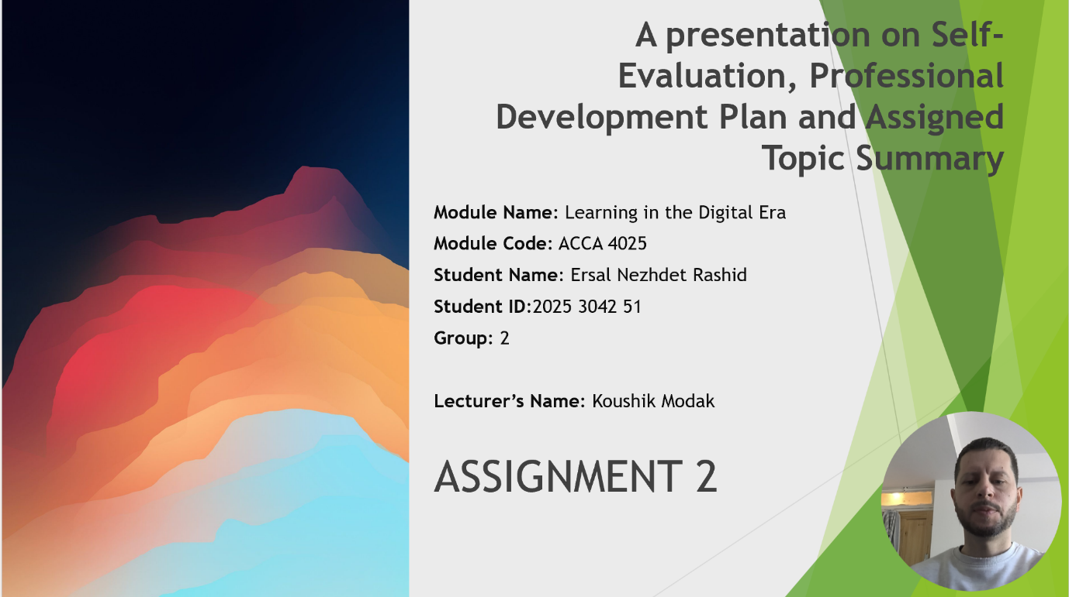
Slide 2 CONTENTS

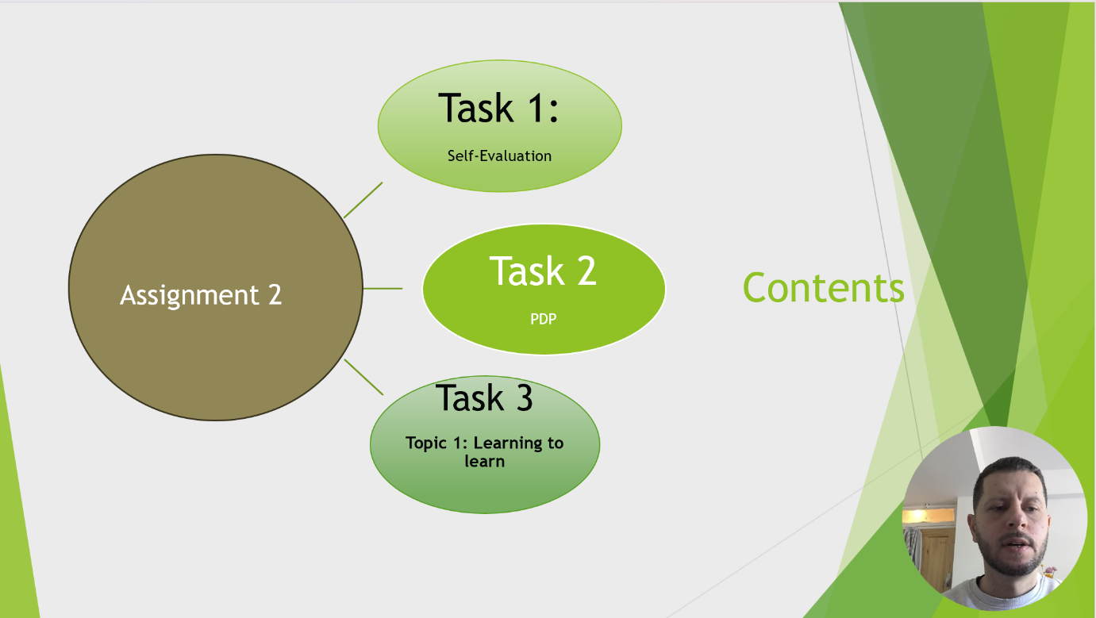

Slide 3 INTRODUCTION
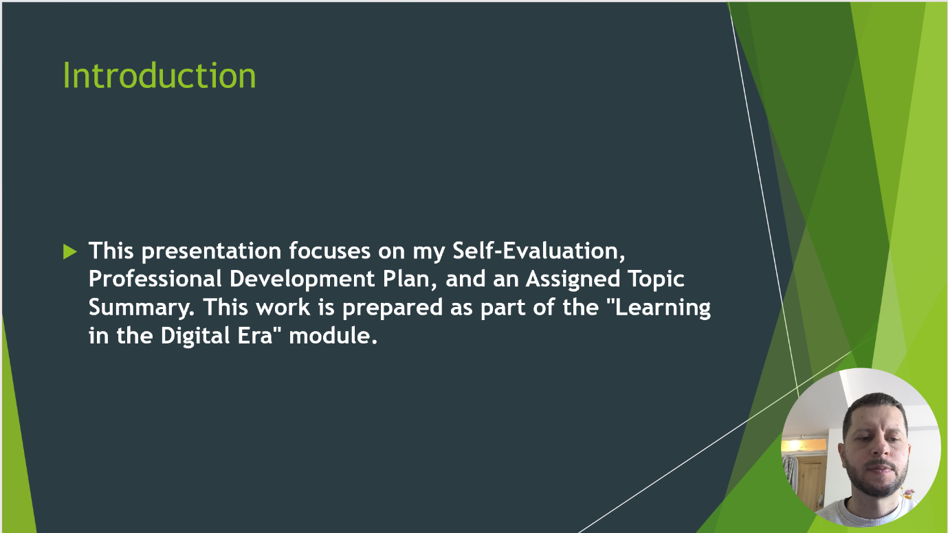

Slide 4 MAIN BODY

Slide 5 GIBB’s REFLECTIVE MODEL
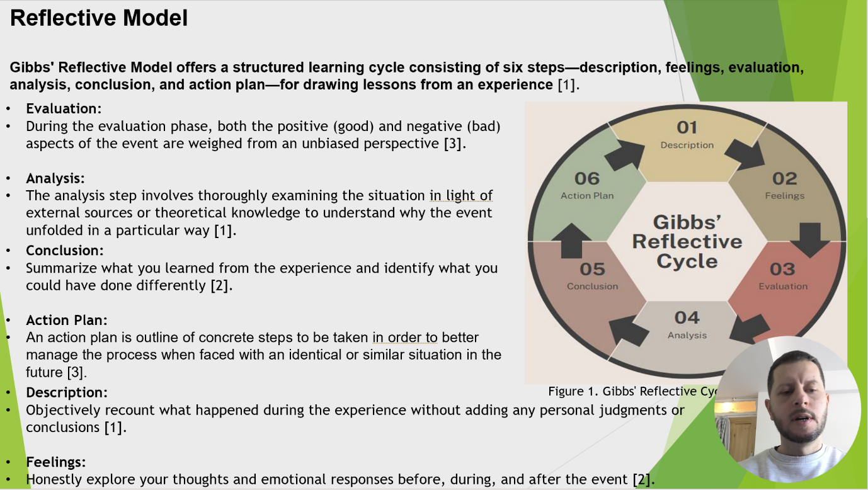
Brief explanation: Gibbs’ Reflective Model is a thematic framework that helps in learning from experiences following six stages; description, feelings, evaluation, analysis, conclusion and action plan [1]. My Learning Journey during the 'Learning in the Digital Era' module I use this model to critically reflect on my learning journey during this course. By taking these steps, I hope to assess how far along I am and plan the next stages in my professional path [2], [3].

Slide 6 TASK 1: SELF EVALUATION
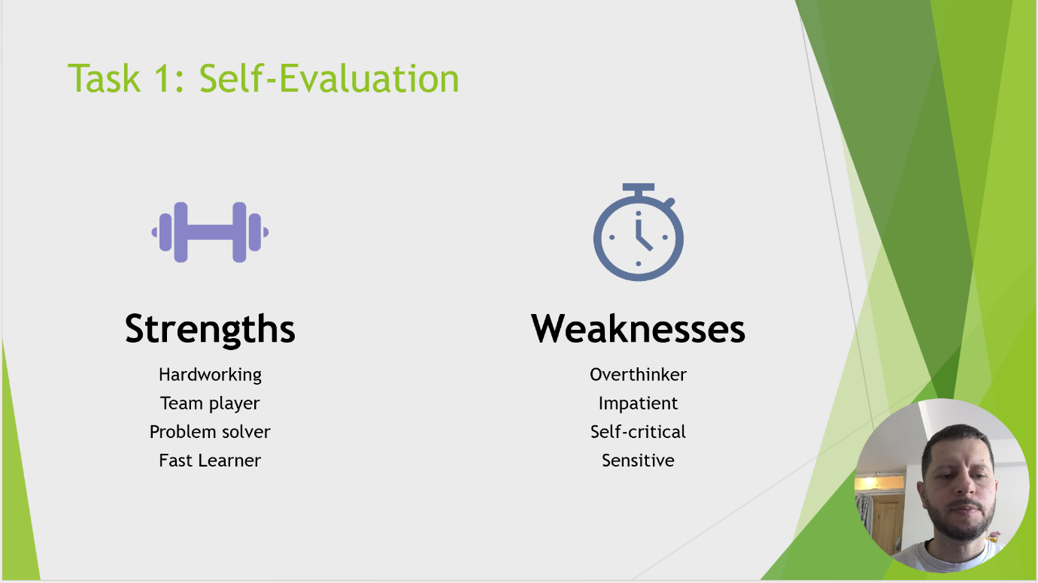
Brief explanation: After going through the self-evaluation and individual SWOT analysis, I have summarized a few internal factors that influence my personal development and studies as well. I am committed to lifelong learning and approach things with a critical lens. The analysis also reveals some weaknesses to work on, actually too self-critical and sensitive, impatient sometimes. Recognising these weaknesses is the first step in the cascade, for it gives me clear avenues of where my Professional Development Plan (PDP) can convert all of these challenges into opportunities.

Slide 7 TRAITS GAINED FROM THE SELF EVALUATION
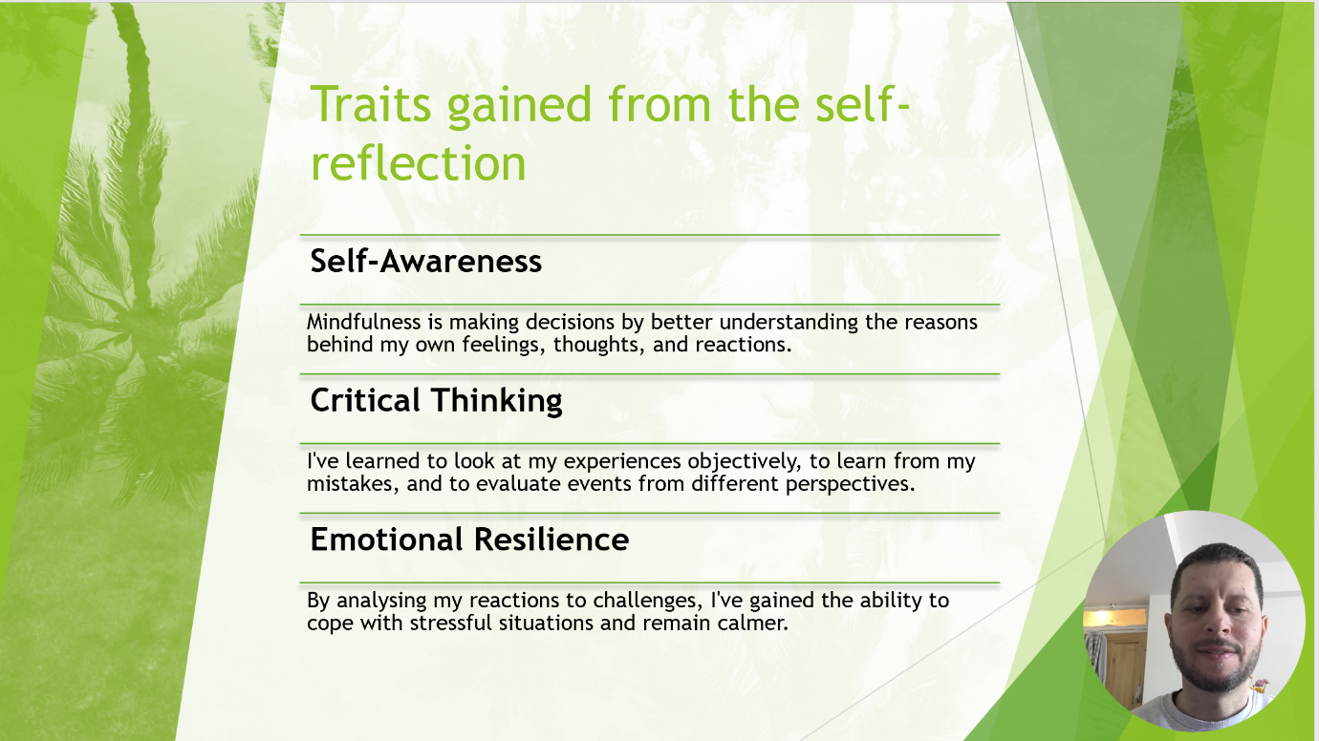

Brief explanation: In the process of self-assessing, I have learned more about my strengths & weaknesses as an individual and professional. This introspection has helped me to not only identify what I already have, but what it is that I should further develop. Recognizing traits like hypersensitivity, impatience, or self-criticism have emerged as more prominent features in my life giving me a greater sense of awareness of myself. This being specific is important in my professional growth as this allows me to work towards building emotional intelligence and better time management in the future.

Slide 8 PROFESSIONAL DEVELOPMENT PLAN
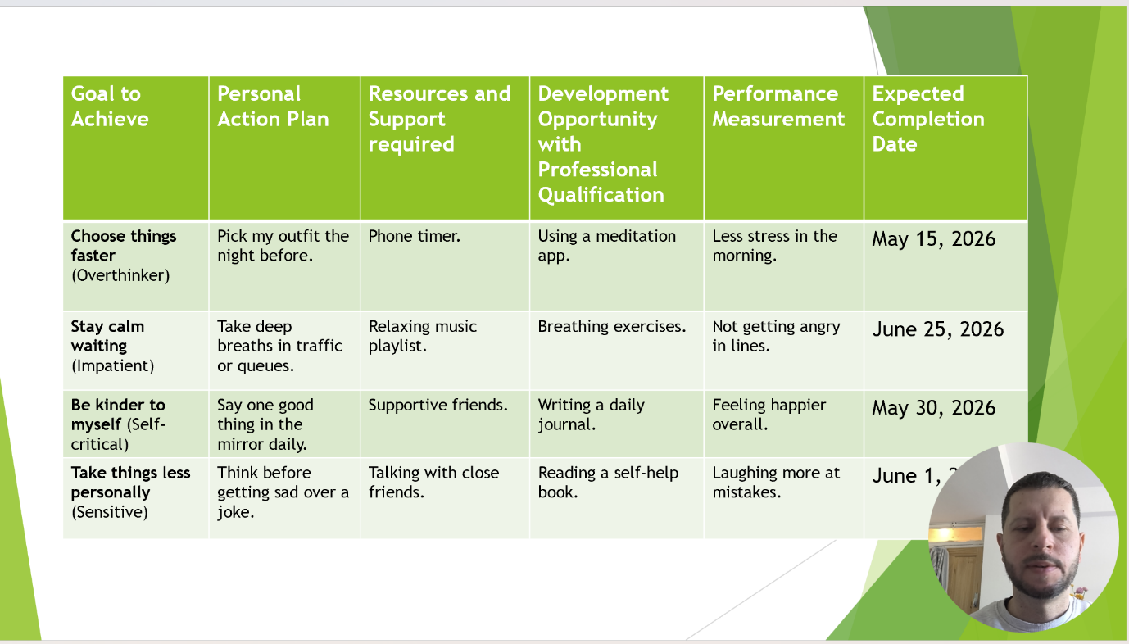
Brief explanation: My Professional Development Plan mapped from my self-examination into a timed schedule. Overcoming my weakness: To improve the way I conduct myself in a professional manner, subscriptions to techniques approaches such as putting on relaxing music whilst standing in lines (to avoid going into work mode and stressing out people around me) or seeking positive suggestions from peers when addressing sensitive topics. I want to set clear markers for 2026, and I hope that will let me be less dismissive of positive energy and emotional feeling. These improvements are crucial to my career as they empower me to deal with the pressures of a digital-era workplace without losing patience or confidence in myself.

Slide 9 UNIT 4 TOPIC SUMMARY
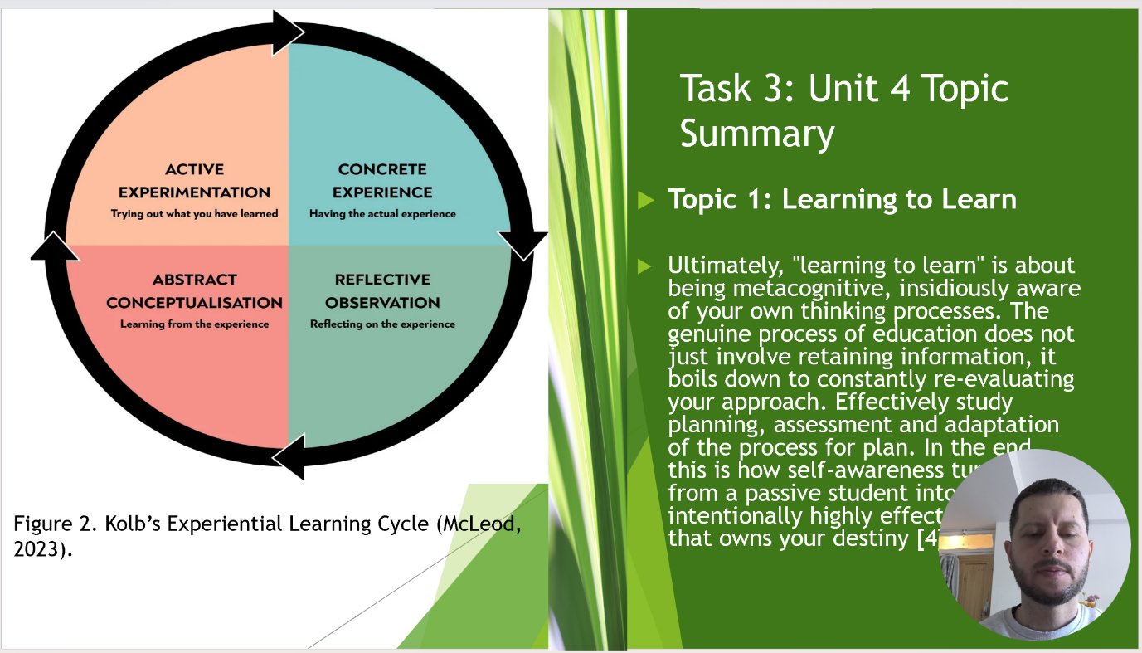
Brief explanation: For this summary, I have chosen the topic 'Learning to Learn'. This concept is fundamentally about metacognition—being consciously aware of one's own thinking and learning processes. Real education is not about memorization; it involves the systematic reassessment of how you study to effectively organize what you learn and adapt techniques or methods. Experiential Learning Cycle Ensures Learning: With the framework of Kolb’s Experiential Learning Cycle, learners comprehend how experiences convert into knowledge that can be practically applied. This degree of self-awareness is the key to transforming a passive student into a transformative, aspirational and strategic learner. [4]

Slide 10 CONCLUSION

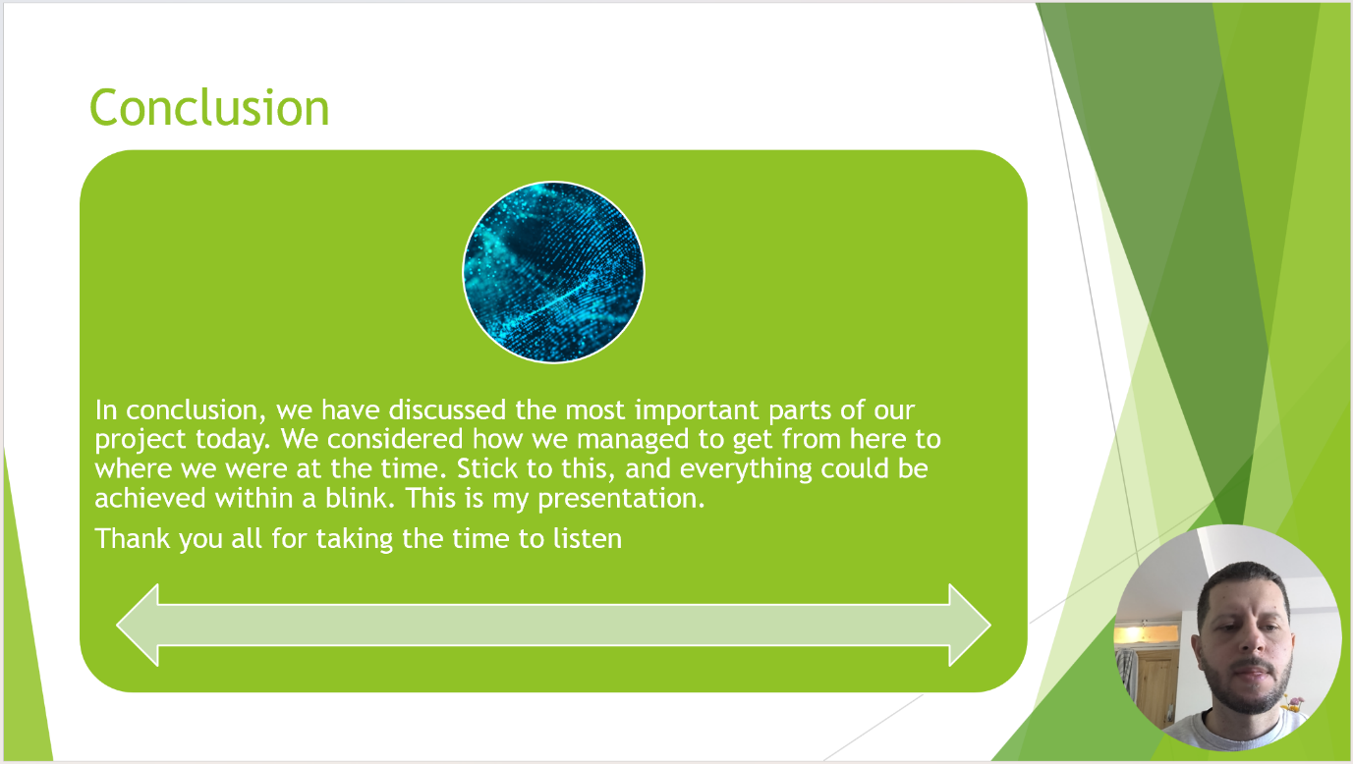

Brief explanation: The last slide in this presentation summarises the main results from my self-assessment and professional development plan. It shows how the combination of reflective practice with a systemic learning design will help me grow within this digital age. Now that I have accepted my current state and set concise, time-bound goals, I can take the necessary steps to becoming a more active professional who is better prepared to bounce back and respond.

Slide 11
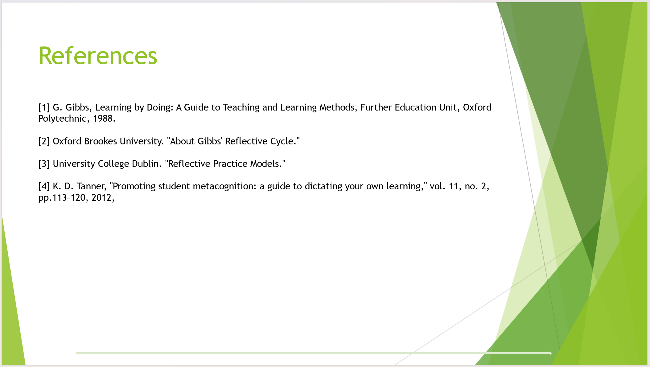

Conclusion

To conclude, this report has given a complete picture of my journey through growth in both me and my career. By utilising Gibbs’ Reflective Model and undertaking an extensive SWOT analysis, I have highlighted areas of development — particularly impatience with myself. This is what the Professional Development Plan results in, clarity towards emotional intelligence and better learning habits. Moreover, in 21st century context metacognition is an important area and summary of 'Learning to Learn' focuses on that importance. All these reflections together are the foundations for my success in 'Learning in the Digital Era’ and moving forward.

References

[1] G. Gibbs, Learning by Doing: A Guide to Teaching and Learning Methods, Further Education Unit, Oxford Polytechnic, 1988.
[2] Oxford Brookes University. "About Gibbs' Reflective Cycle."
[3] University College Dublin. "Reflective Practice Models."
[4] K. D. Tanner, "Promoting student metacognition: a guide to dictating your own learning," vol. 11, no. 2, pp.113–120, 2012,

