University Of Wales

Trinity Saint David

Introducing The Modern Workplace

(LCBB4003)
Assessment 2

Names:
Diana Velikova (1916908) – Introduction
Ivan Medarev (1920485) Goals and Objectives
Diyana Shapshalova (1907713) – Leadership and Management
Renata Petrova (1921704) – Group and Team Behaviour
Vanya Nikolova (1920484) – Motivation and Perception
Module Title: Introducing The Modern Workplace
Module Lecturer: Dr. Gregory Cowan
Assignment Title:
Behaviour Analyses of Employees and Management in Nike UK

Table of Contents
Introduction 3
History of Nike 3
Current State of Nike Management 5
Goals and Objectives 6
Why Goal is important for Nike UK 6
How Goals and Objectives of Nike UK are established within organisation 7
Leadership and Management Behaviours at Nike 9
Group and Team Behaviour 12
Importance of group and team behavior 12
Benefits of group and team behavior 13
Motivation and Perception in an organisation 15
Motivation in Nike UK 15
Perception in Nike UK 16
Conclusion 18
Reference List 19
Appendix 22

Introduction

Established as a merchant of Japanese shoes, NIKE, Inc. (Nike) has become the world's biggest advertiser of athletic footwear, holding a g lobal piece of the pie of around 37 percent (CNN Business, 2020). In the United States, Nike items are sold through around 22,000 retail accounts; around the world, the organization's items are sold in excess of 160 nations. Both locally and abroad Nike works retail locations, including Nike Towns and plant outlets. Almost the entirety of the things are made by self-employed entities, principally found abroad, with Nike associated with the plan, advancement, and advertising. Notwithstanding its wide scope of centre athletic shoes and attire promoted under the leader Nike brand, the organization additionally sells footwear under the Converse, Chuck Taylor, All Star, and Jack Purcell marks through completely possessed auxiliary Converse Inc. also, sells under the brands Starter, Shaq, and Asphalt in the rebate retailer channel through another auxiliary, Exeter Brands Group LLC. The firm additionally sells Nike and Bauer brand gear; Hurley surfing, skateboarding, and snowboarding clothing and footwear; and Cole Hana brand dress and easy-going footwear.
Nike has depended on steady development in the plan of its items and hefty advancement to fuel its development in both U.S. furthermore, unfamiliar business sectors . The omnipresent nearness of the Nike brand and its Swoosh brand name prompted a reaction against the organization by the late twentieth century, especially corresponding to claims of low wages and helpless working conditions at the organization's Asian agreement producers.

History of Nike
These days, Nike is a brand that could almost be found in everybody's home. It has become a pioneer in the wellness business for various decades and become the world's biggest advertiser of athletic footwear and offer.
Nike started by Philip H. Knight, an American businessperson in 1962 during his investigation business at Stanford University. He headed out to Japan after his graduation at Stanford University and began his new investigation at the University of Oregon. Nike is a task which required him to assembling a high innovation however minimal effort shoes than can contend with German shoes showcase. In this procedure, Phil Knight connected with a Japanese firm that made athletic shoes, the Onitsuka Tiger Co. This enlivened him to import these shoes and sell them. He even sent a portion of these shoes to his previous track mentor, William Bowerman to rate, according to Britannica (2020).
Knight and Bowerman chose to come out with a new brand as opposed to selling for Tiger. As of now, the organization presented another image which is Swoosh brand name with a spic and span name, Nike implies goddess of triumph from Greek. Following one year later, BRS broke with it old organization, Onitsuka Tiger Co after contradiction over circulation at 1972. In the main year of circulation, their activity extended to Canada, which is the principal unfamiliar market and followed by Australia in 1974. The organization started to develop quickly at 1976 in light of the fact that there is a blasting in ubiquity of moderate sprinters in US. To keep up the interest, the organization opened new processing plants, including a sewing plant in Maine and extra abroad creation offices in Taiwan and Korea (Britannica, 2020). Nike likewise had propelled publicizing effort and the main advert was classified "There is no end goal". No lone that, Nike likewise came out with lighter weight preparing shoes that had a sole with a waffle appearance to give competitor more footing. This advancement made Nike contrasted the opposition that previously existed.
Nike development through universal extension and forceful market in the 1980s. With the incomes produced by the stock deal, the organization arranged proceeded with its extension, especially in the European market. The organization is very much protected from the deteriorating interest for running shoes, anyway, it likewise increased generous portion of different shoes like ball shoes and sneakers. Nike proceeded with spread its item into far off nation, for example, Europe and Japan in 1981. In Europe, Nike needed to contend with Adidas and Puma which previously had a solid hang on soccer showcase. In Japan, Nike participated with Nissho Iwai to shape Nike-Japan Corporation. In Europe,
In 1985, the organization marked a ball player, Michael Jordan to support another variant of Air shoes and its shoes were named as "Air Jordan". Along these lines, the organization recovers a piece of the pie from rival Reebok International in a few zones, including b-ball and broadly educating. Later that year, the organization propelled about $ 10 million TV crusade around that topic "Do what needs to be done." The organization proceeded with its forceful promoting, utilizing advertisements including Michael Jordan and entertainer chief, Spike Lee in continuous crusade which states JUST DO IT (Interesting Engineering, 2019).

Current State of Nike Management

As indicated by Companies History (2020), more than 2019, most news on Nike has rotated around its political positions. Days before the Fourth of July, the organization dropped the arrival of a tennis shoe bearing the 13-star American banner of Betsy Ross on the shoe's heel. Allegedly, this choice came after Colin Kaepernick secretly voiced his reactions of the plan to Nike, seeing as the 13-star banner spoke to America during a period of subjection and has been utilized couple with the Confederate banner by scorn bunches including the Ku Klux Klan. The decision to drop the shoe by the by started a media firestorm with traditionalist savants and web-based media pundits reprimanding Nike for its absence of nationalism.
Outside of the political circle, Nike has additionally divulged plans for a membership administration for kids. This comes when clothing organizations are progressively looking toward membership based models to draw in clients. It'll be Nike's first trial of this and opens the entryway for kids 2 through 10 to have differing access over a choice of around 100 shoes for a month to month charge.
What's more, likewise with numerous organizations in 2019, Nike's destiny has been intently attached to the progressing theory over duties in the current China-U.S. exchange war. Given that Nike fabricates generally 27% of its attire in China, the possibility of expanding taxes represents a genuine issue to its gracefully chain. The organization has been proactive in managing this issue, gradually moving a greater amount of its tasks from China into Vietnam.

Goals and Objectives
Successful businesses are always largely based on the setting of goal and the objectives of any organisations. An organisation is needed to be very precise and specific regarding the goal and objective of its organisation. In this context, Goal and Objective of Nike UK will be identified.

Goals and objectives are the two sides of a coin. In order to sustain its business in the market every organisation is needed to be cleared regarding the goal needed to be achieved. And in order to achieve that goal, objective should be very specific. Goals and objectives helps in recognising and classifying needed action as the purpose of the business becomes clear to the workforce of the company. Goal is known to be the account of preferred accomplishment. On the other hand, objective is known to be the particular steps or course of action that are needed to be taken to reach the goal that has been set. It is very important that both the Goal as well as objectives depending on the needed to be very specific (Dey et al., 2015). Nike UK sets its business goal depending on various prospects such as the profitability, customer services, growth of the business and many more. A range of objectives are to be set to meet these goals effectively and successfully.

Why Goal is important for Nike UK
There is a huge difference between the operation of a successful business and an unsuccessful business. One of the most common reasons that can be identified for any small or large business to fail at sometimes is because the organisation fails to set clear goals and objectives accordingly. However, it is not possible to overstate the important of setting of the goals of the business. Organisations such as Nike UK has set some of the clear goals for its business which makes clear the priorities of the organisation for its workforce as well as the others who are involved with the organisation. By setting goal, the organisation makes it clear to its workforce to identify the most necessary priorities that they need to focus for the duration of the upcoming quarter. This will help the workforce to prioritize their work significantly and efficiently (Kim, 2015). The managers in the organisation will be able to analyse the major project that are needed to be focused depending on the goal of the organisation. The managers of the organisation also become capable to their best to and out diverse job to the team under them. Some of the aspects that endorse the importance of setting of Goal to Nike UK are given below:
- Keeping motivated – Goals keep motivating the people in the organisation present. There are certain times when people understand the value of setting goal as it helps people pointed and motivated for doing work effectively.
- Promotes Team work – As the company such as Nike UK set the goal in order to achieve a certain success it helps its workforce to work together as a team in order to achieve the goal. When the goal is common people tends to give effort together in order to achieve them (Vuković et al., 2019).
- Helps in measuring success – The organisation Nike UK sets the clear goal for its business which helps them measure their success in terms of the efforts given to achieve the goal and the objective set to attain the successful goal.

How Goals and Objectives of Nike UK are established within organisation
Goal is known to be the aspect that keeps the workforce of the organisation motivated, efficient, clear as well as competent towards their work. Setting the goal is a perfect way helps in increasing the productivity and growth of the company. The organisation Nike UK has set a very clear Goal within its organisation to achieve the success in its business.
The goals of Nike UK are
- To carry out the heritage of innovative thinking in order to develop products that would help every level of athlete in reaching their potential (Rose and Smith, 2018).
- To run profitable operation and to create the opportunity in its business that will set the organisation apart from its revelry company which will provide significance to their shareholders.
The mission of Nike UK is
- To bring motivation, enthusiasm, innovation and inspiration in the life of every athlete around the world.
The founder of the Nike UK Bill Bowerman states that everybody in this world is athlete as they have a body and this mission statement symbolizes the strategic goal of the company of reaching out to the equipment market, sports footwear, apparel and leisure through globally.
Objectives taken to attain goal
Organisation Nike UK has attained some of the objectives in order to meet the goal and mission set by them. Some of the objectives are given below:
- Business profitability – The main objective of the organisation is to run a profitable operation and function in the market (Levack et al., 2015). In order to reach the profitability and to create a different dimension in the market among its rivalry the organisation is need to set the objective of diverse operation facilities. The organisation set its objective to limit the expenses, increase annual sale through innovation and increase revenue.
- Customer Service – In order to achieve the goal, the company set the objective of better customer services in order to increase in the base of the customers. This can effectively include the reduction in the complaints of customer by becoming a proactive organisation rather than reactive.
- Retention of Employee – In order to work effectively the organisation takes the objective of reducing the retention of employee which significantly increases the efficiency in their business operation and leads the organisation toward a growth success Chadwick et al., 2015.

Goals and objectives are the most important aspects in organisation in order to attain the growth and success in the business. Ever organisation set a clear goal so that the employee can analyse their priorities and concern of doing their job. In this context, the importance of setting of goal for the Nike UK has been analysed. Additionally, how the organisation has established goal and objectives in the organisation has been discussed briefly.

Leadership and Management Behaviours at Nike

Force is characterized as the capacity to impact others (Sullivan, 2018). Similarly as with numerous different ideas recently talked about, for example, inspiration and authority, power in a business comes in sure and negative structures. With more than 62,000 representatives and 30 billion dollars in income, the significant level heads of Nike realize that they have the ability to contact an immense crowd from their workers to their business sectors. With that information Nike, on numerous events, has decided to utilize their capacity in a positive way. Nike's CR report that is distributed online gives various models on how Nike utilizes their capacity to impact the individuals. One way they utilize their capacity to contact a huge crowd is through a development respect child's movement. Despite the fact that right now we are managing the most latent age of child's ever, Nike sees a future where children are running, hopping and kicking to arrive at their most prominent potential.
In 2011, The Access to Sport group started working with in excess of 70 master associations to create Designed to Move (see designedtomove.org) Aside from this development, they have additionally made their representatives an objective of their capacity. Nike fellow benefactor Bill Bowerman's states "On the off chance that you have a body you are a competitor." In their CR report they guarantee they have betrayed NIKE and moved our representatives to get going and raise physical action levels in the working environment. NIKE has a drawn out pledge to help illuminate this earnest, worldwide pandemic. We've contributed vigorously to arrive at where today, in excess of 100 associations internationally have officially received Designed to Move and are effectively teaming up to advance and convey far and wide.
Nike has various pioneers who add to their organization. With endless pioneers, one may believe that it's almost difficult to keep up similar style and qualities from individual to individual. While every individual is entitled and normally has their own style of initiative, one of Nike's basic belief is a promise to their workers. Since Nike minds such a great amount to see their representatives flourish and progress nicely, various cycles and approaches in the organization expect pioneers to hold comparative procedures. Normally, there are two sorts of initiative styles, worker situated which is connoted by close to home enthusiasm for representatives, and an accentuation on relational relations; and creation arranged, implied by centre around specialised or task parts of a vocation, each with advantages of their own (Nike Leadership, 2016).
Regularly, one initiative style or the other is intrinsic inside one's character. In any case, through exploration I have discovered the Nike supports the entirety of their pioneers to be more worker arranged in their authority nature. In an online article current CEO and President Mark Parker discusses his qualities in initiative and what he might want to see all through the organization. Parker discusses his incentive for worker interest and assessments. To maintain a strategic distance from micro overseeing or domineering initiative he doesn't educate his workers' every move, but instead questions them to discover more concerning why they're doing what they're doing. He trusts that this will pick up his regard as a pioneer and his discernment as a good example for different pioneers in the organization (Nike Leadership, 2016).
Nike started with a deeply unfriendly authoritative style when it moved on to its assembly tasks. Throughout the initial experience with workshops and individual workers, the organization continued to have a free style of power. This is perfectly reasonable, as the organization has redirected these tasks, but they join these manufacturers in professional interactions as well as from an advertising point of view. This is something that seems to have left Nike with a lot of effort to understand. Nike's administrative style did not progress until it was forced to do so. Nike did not distort the weight of the analysis of their exercises, it really was the weight of money related to money. After such a significant number of long periods of growing interest and stocks that developed at the same time, Nike began to observe a change in 1998. This change can be mainly related to the picture of the organization. The initial phase in this development for Nike was the use of Ernst and Young to direct autonomous verification. Other work with the Fair Labour Association and various endeavours have prompted Nike to improve its image. It is possible to go far even now, but it looks like Nike is on the right track right now.
According to Truscore (2020), inside, Nike may seem like a solid authority culture, but its external counterparts had an extremely unwelcome hierarchical culture. These outsiders from the Nikes chain have had exquisite working conditions that have caused transient, harmful synthetic compounds and many different problems. These problems have caused terrible resolution and have even led to strikes in certain areas. Representatives were so disappointed in one case that they released negative data about the organization.
The weight of those who insist on changes in Nikes 'tasks worldwide has further passed on the unfortunate authoritative culture to Nikes' home representatives. Her research expanded the weight of her first-class VIP competitor and other people who supported the brand, which was supposed to be really uncomfortable and could cause some internal problems and controversy among Nikes Centre staff. In general, Nike does not seem to think about its representatives and their well-being. The association's way of life seemed undesirable both intellectually and truly to its workers.
There has been a lot of political influence over Nike and its procedures over the years. Nike is using nearby governments to give solid power to nations that have decided to set assembly tasks. The strong links between the organization, its founders and these administrations have allowed Nike to run the business in an operational way most of the time (Hyun-Jung Lee, 2013).
Over the years, Nike has had many external influences. Most of these impacts have been a dissident struggle against Nike and companies like it that hire professionals insufficient working conditions. These external influences include distribution, battles like those at Brown and Duke Universities, and people like Jeff Bollinger.

Group and Team Behaviour

This report highlights the meaning of group and team behavior with its importance and benefits to Nike and how it helps the company to achieve their goals and objectives in the market.
Group or team behavior can be defined as more than two people interacting for the completion of the task so that they can achieve their objectives. There are different forms of group involved such as formal groups and informal groups.
- Formal groups-
These groups are formed by the company and they are assigned tasks which are as per their area of interest. This is done so that they can achieve the goals for the company (Taylor, 2019).
- Informal groups-
These groups are formed among people who are friends or those individuals who have the same level of interest on same issues.

Importance of group and team behavior

- Work Efficiency-
It is the behavior of the team that helps Nike to achieve their results of the task more effectively. They cooperate and work in coordination on many tasks which reduces the load of work by the employees so that they can share the responsibilities with each other. With the help of this they are able to reduce the pressure off them through which they are able to invest more of their time on the roles that they have to play for the company. Every employee in the team of Nike must have a special area of interest where their performance is higher than the others so that they can help the other members of the team (Kim, 2017).
- Increased Accountability-
If the behavior of team and group is up to the mark then they will be able to improve the accountability of everyone who is a part of the team. Members of the team work with all of their efforts as any mistake will let the whole team down and it will be their name which will be affected. If they work individually they will have to work with more pressure so that morale of the company stays in the same position. Managers of Nike will have the benefit of gaining more efficient and effective results with the help of members of their team.
- Learning opportunities-
This aspect helps those members who are new in the group so that they can assess the pattern of working of everyone as every individual has a different way of working and the talent with the area of interest differs from everyone. It benefits the members those who are new to open up the gates and grasp new opportunities. This way they share the ideas with the team that helps to overcome the problems in the completion of the task.

Benefits of group and team behavior

- Pushed by the group dynamic-
Members in the team who have a strong position knows the importance of objectives of the company which needs to be complied with strategies that will help them in long term and short term. One of the important benefits of the team is that members of the team will work on a approach that helps to achieve goals that are common for the company by fulfilling their daily duties. This forms a dynamic for the team so that they can work up to the set mission and when they work together in a group then it has been observed that the results are more productive.
- Buoyed by Mutual Support-
If the behavior of team reflects support to each other instead of nagging or criticizing each other then they will work more openly instead of being defensive for their performance. Managers of Nike can make sure that at working at this rate and with collaboration they will be able to offer products of high quality in the market (Harris and Sherblom, 2018).
- Goals are met with collective efforts-
When the members of team have goals that are collective which can be either for a specific project assigned or for the whole department then Nike can assure that goals will be easily met. The members of the group are aware about their role so that there is no confusion in attempting the task. This way the level of disputes which affects the flow of work are reduced. The work assigned will be distributed equally so that they do not feel that some of them are doing less work than others. It is important that members in the group have helping nature so that help is taken in order to never miss the deadline. Nike has made sure that their team gets incentives for that (Akmalia, Siahaan and Mesiono, 2020).
- Diversity in teams-
The diversity which is in the people of the society is also noticed in the members of the team. As many of the members of the team come from different background, different race etc. are on the team of Nike which is beneficial for the company as they will help them to get different ideas that will be unique and useful in there areas of dealing. Ideas that are new and creative tend to get more acceptance from the consumers in the market.
From the above studies it has been concluded that if the behavior of team and group is positive and they tend to work in cooperation then they will be able to achieve their goals and enhance their share in the market.

Motivation and Perception in an organisation

Motivation is known to be the stimulation, agitation and the enticement that are needed to work or to act in the organisation. On the other hand, perception is known to be the logical procedure of renovating and altering sensory stimuli of the organisation in to the consequential information. In this context, the motivation and perception of Nike UK will be analysed.
Motivation is known to be the inducement or incitement in order to act or perform accordingly and significantly. It is the procedure of induce the workforce of the employee so that they are being able to act in a prearranged and preferred way in order to attain the goal of the organisation. On the other hand, Perception is highly known to be the procedure of the transformation of the sensory motivation to some of the meaningful and purposeful and resourceful information. It is known to be the procedure of interpreting various aspects that people hear, see and understands which can be used afterwards in order to judge and produce verdict accordingly on some of the situation in an organisation.

Motivation in Nike UK
Motivation can be defined as the inner force that affects the intensity, endurance and intensity of the voluntary preference of the behavior of work of workforce within the organisation such as Nike UK (Rahman et al., 2015). Motivation encompasses directions that are largely focused by goals and objectives. Various types of motivations an organisation such as Nike UK can have in their people in order to perform their job. Significantly, four types of motivation can be found and they are:
- Extrinsic Motivation – The extrinsic motivation comes from the outside of the people. Through this motivation people get driven by the manager or leader to act efficiently in the organisation. Some of the employee in the organisation follows the extrinsic motivation. This motivation is useful while performing any kind of simple work. However, it is not of much use when the organisation needs people who will work through self-driven motivation.
- Intrinsic Motivation – Intrinsic motivation are done in order to serve the reason internally. This motivation aligned very well when people do task of their own choice or simply to gain pleasure of doing work. People get intrinsically motivated to perform work under an inspiring manager or leader (Johnson et al., 2015).
- Introjected Motivation – This motivation is as similar to the intrinsic motivation. However, this motivation is internalised. The only difference of the Introjected motivation is that if any employee is not being able to perform any work, then they grow a feeling of guilt in themselves.
- Identified Motivation – In identified motivation, the employee is motivating in order to perform work but is not clear about the objective that the person is needed to be built in themselves to perform any job within organisation.
Importance of motivation
Motivation plays a significant role for the organisation such as Nike UK to achieve the desired goal. Some of the importances of motivation in the organisation Nike UK is given below:
- Motivation helps in improving the performances level of the employee in the organisation and helps in changing the unresponsive attitude towards the work of any employee.
- It helps in the lessening of conflicts in the organisation and lessens the high turnover of the employee in the organisation (Rožman et al., 2017)
- It creates a healthy image of corporate of the organisation
- As the workforces are highly motivated it uses the resources productively and increasing the output as well as the efficiency of the organisation and attains the desired and successful goal
- The organisation experiences the progression of Friendly Relationships as well as stability among the workforce

Perception in Nike UK
In an organisation it is very important for a manager or a leader to be highly perspective in nature. The manager of the organisation such as Nike UK goes through the diverse stages of perceptual processes which are widely known to be the stages of perception. The different stages of the perceptual process of Nike UK are given below:
- Receiving
Receiving is the most significant stages defined in the procedure of the perception. It is known to be the initial stage in which the manager or leader collects as well as receives the information through their sense organ (Hasson et al., 2016).
Selecting
It is known to be the second stage in the procedure of the perception among which the leader of the organisation receives the data very selectively. They choose the information in accordance to their need and interest. The data which has been selected is dominated through internal as well as external factors.
- External factors – familiarity, movement, intensity, novelty, contrast, repetition and size are known to be the external aspects that influence perception largely.
- Internal factors – experience, learning, self-acceptance, interest, background and psychological requirements are the internal aspects perception largely.
Organising
Arranging things in a synchronised way is known to be the organising. The data received are needed to be organised well so that the leader or the manager can make sense out of the data.
Data can be synchronised accordingly −
- The data can be grouped in accordance to their proximity, continuity and similarity.
- The basic procedure of perception is figure ground in which figure mean the main focus of the data and ground means the backdrop stimuli, the data which have not considered (Bridgeman, 2016).
- The constancy of Perception which means the inclination to stabilise perception so that the changes related to contextual don’t influence them.
Interpreting
This is the stage where ideas are formed about the particular data or object in terms of the interest or need of the managers or the leaders. Interpretation gives meaning to the information that have been sensed as well as organised by the leaders or managers by turning into the aspects that can be broadly categorised.
Advantages of Perception
- Need and requirement of workforce can be determined by leaders or managers.
- It is important for managers and leaders while dealing with the subordinates effectively as they need to comprehend perceptions of workforce properly for avoiding errors (de-Wit et al., 2015)
- It performs observation and manufactures a transformed certainty augmentation with earlier experiences.
In this context, various aspects of motivation and perception have been analysed. Additionally, the importance of motivation and perception has been defined briefly. It has been analysed that having a motivated workforce and good perception of manager is vital for the success of the organisation.

Conclusion
As a conclusion we can say that for company like Nike to work proper and innovate for almost sixty years they have to rely on all of their workers. From the managers to every single staff member, as an individual or as part of a team, the company is pursuing the goals they are established.

Reference List
Akmalia, R., Siahaan, A. and Mesiono, M., 2020. THE EFFECT OF INDIVIDUAL, GROUP AND TEAM WORK BEHAVIOR TOWARD TEACHER PERFORMANCE IN SMAN 3 MEDAN. JURNAL TARBIYAH, 27(1).
Bridgeman, B., 2016. Wagemans, J. (Ed.). The Oxford Handbook of Perceptual Organization. Perception, 45(6), pp.715-717.
Britannica (2020). Nike Inc. Britannica [online]. Available from: https://www.britannica.com/topic/Nike-Inc [Accessed: 11/08/2020].
Chadwick, I.C. and Raver, J.L., 2015. Motivating organizations to learn: Goal orientation and its influence on organizational learning. Journal of management, 41(3), pp.957-986.
CNN Business (2020). Nike. CNN Business [online]. Available from: https://money.cnn.com/quote/profile/profile.html?symb=NKE [Accessed: 10/08/2020].
Companies History (2019). Nike. Companies History [online]. Available from: https://www.companieshistory.com/nike/ [Accessed: 10/08/2020].
de-Wit, L. and Wagemans, J., 2015. Individual differences in local and global perceptual organization. The oxford handbook of perceptual organization, pp.713-735.
Dey, P., Bhattacharya, A., Ho, W. and Clegg, B., 2015. Strategic supplier performance evaluation: A case-based action research of a UK manufacturing organisation. International Journal of Production Economics, 166, pp.192-214.
Harris, T.E. and Sherblom, J.C., 2018. Small group and team communication. Waveland Press.
Hasson, H., von Thiele Schwarz, U., Nielsen, K. and Tafvelin, S., 2016. Are We All in the Same Boat? The Role of Perceptual Distance in Organizational Health Interventions. Stress and Health, 32(4), pp.294-303.
Hyun-Jung Lee (2013). How consistency of brand image and advertising image for parent and extended brands affects brand attitude. The Research Journal of the Costume Culture, 21(4), pp.546–561.
Interesting Engineering (2019). The Extraordinary History of Nike. Interesting Engineering [online]. Available from: https://interestingengineering.com/the-extraordinary-history-of-nike [Accessed: 11/08/2020].
Johnson, S.M. and Nandy, S., 2015. Leadership skills, job satisfaction, and motivation in the workplace: a phenomenological research study. Journal of Perspectives in Organizational Behavior, Management, & Leadership, 1(1), pp.10-14.
Kim, M., 2017. Effects of team diversity, transformational leadership, and perceived organizational support on team-learning behavior. Social Behavior and Personality: an international journal, 45(8), pp.1255-1269.
Kim, S., 2015. Learning goal orientation, formal mentoring, and leadership competence in HRD. Journal of European Industrial Training, 31(3), pp.181-194.
Levack, W., Weatherall, M., Hay-Smith, E., Dean, S., McPherson, K. and Siegert, R., 2015. Goal setting and strategies to enhance goal pursuit for adults with acquired disability participating in rehabilitation. Cochrane Database of Systematic Reviews,.
Nike Leadership (2016). Keys to Success. Wordpress [online]. Available from: Leadership at Nike [Accessed: 10/08/2020].
Rahman, M., Osman-Gani, A., Momen, M. and Islam, N., 2015. Testing knowledge sharing effectiveness: trust, motivation, leadership style, workplace spirituality and social network embedded model. Management & Marketing, 10(4), pp.284-303.
Rose, G. and Smith, L., 2018. Mental health recovery, goal setting and working alliance in an Australian community-managed organisation. Health Psychology Open, 5(1), p.205510291877467.
Rožman, M., Treven, S. and Čančer, V., 2017. Motivation and Satisfaction of Employees in the Workplace. Business Systems Research Journal, 8(2), pp.14-25.
Sullivan, E.J. (2018). Effective leadership and management in nursing. New York, Ny: Pearson.
Taylor, M., 2019. Evidence Based Marketing: Using Principles from the Profit Impact of Market Strategies (PIMS) Project by Benchmarking UK Firms and Global Sportswear Manufacturers (GSMs) Marketing Expenditure (Nike, adidas, VF Corp, Under Armour, Puma, Anta and BasicNet SpA). www. thecasecentre. org, (CASE-).
Truscore (2020). A Participatory Leadership Style: Nike’s CEO Mark Parker. Truscore [online]. Available from: https://www.truscore.com/resources/leadership-style-nikes-ceo-mark-parker/ [Accessed: 16/08/2020].
Vuković, D., Hunjet, A. and Kozina, G., 2019. Environmentally sustainable tourism as a strategic determinant of economic and social development. Turizam, 23(3), pp.145-156.

Appendix
Appendix 1: Introduction

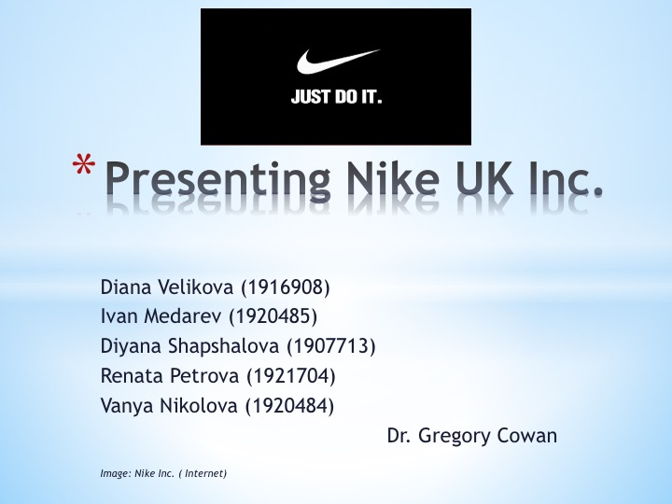

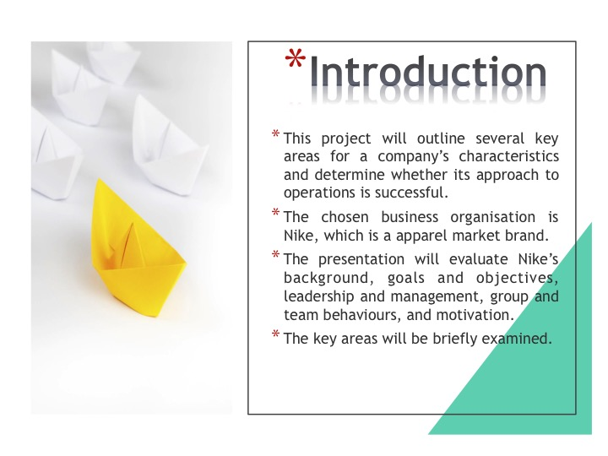
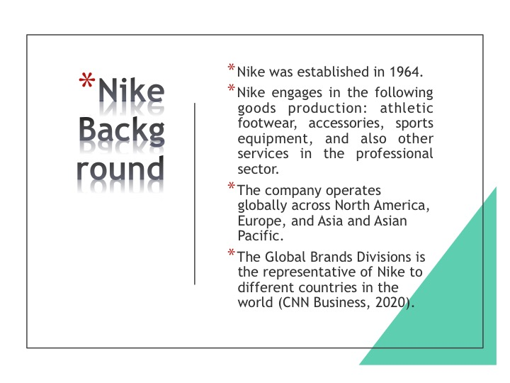

Appendix 2: Goals and Objectives
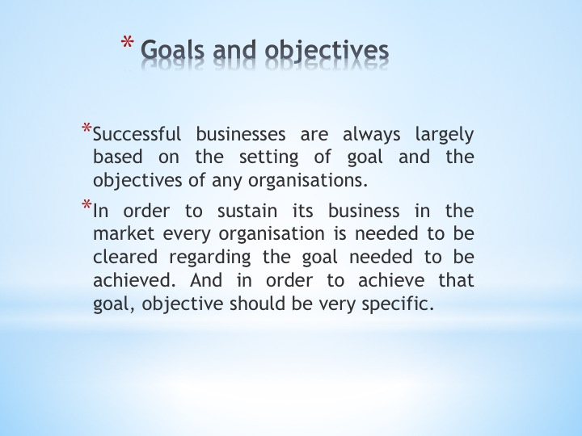

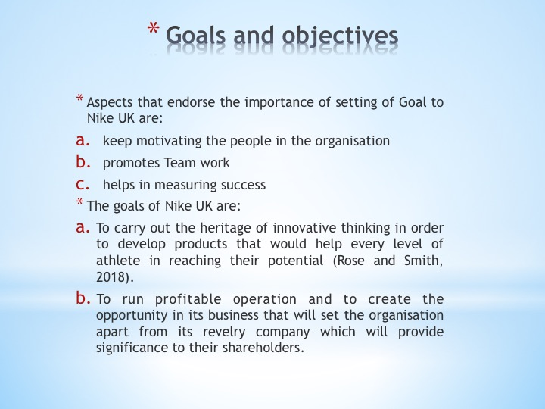
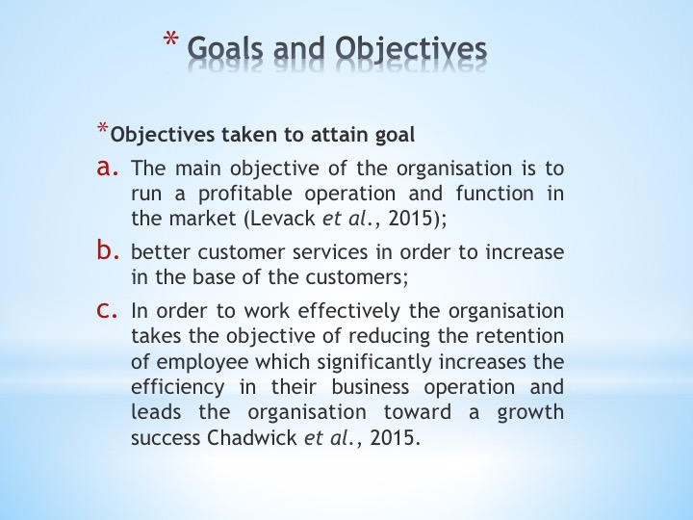

Appendix 3: Leadership And Management
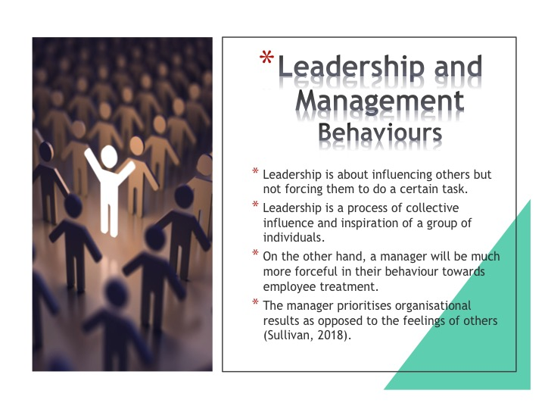

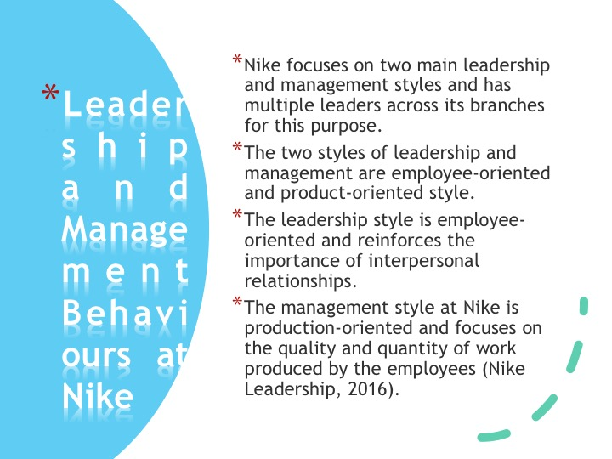

Appendix 4: Group and Team Behaviour
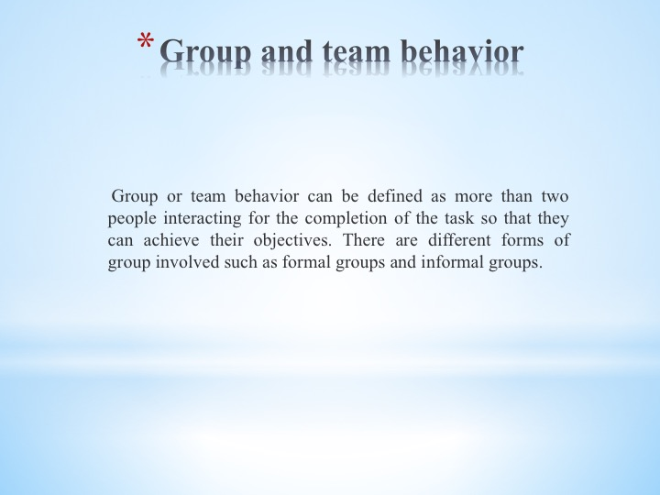

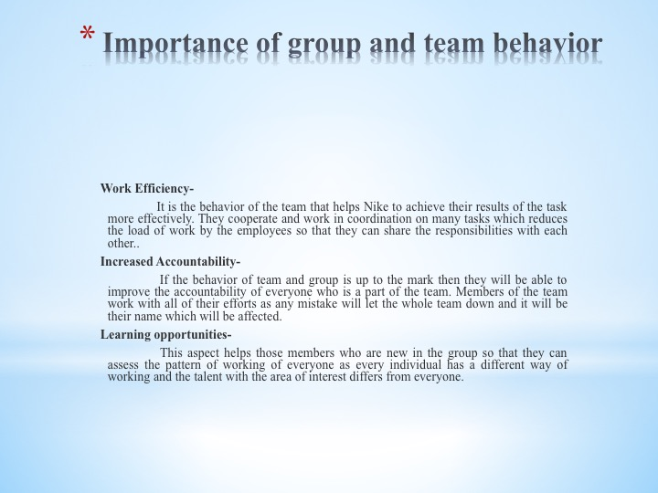
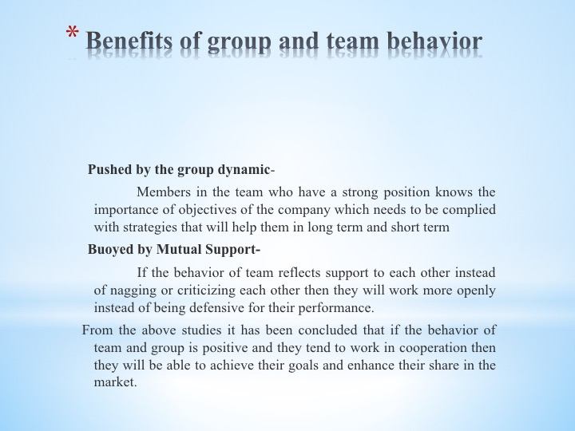

Appendix 5: Motivation and Perception
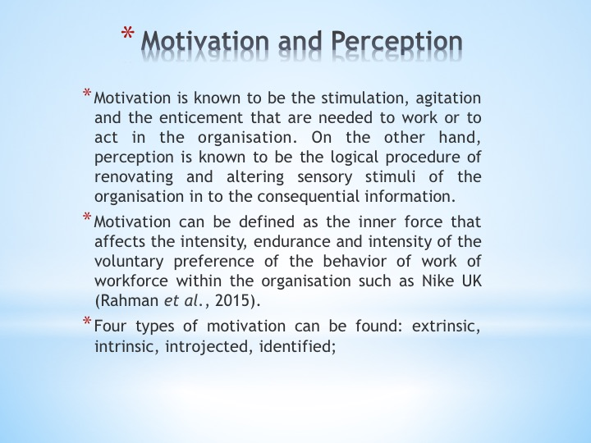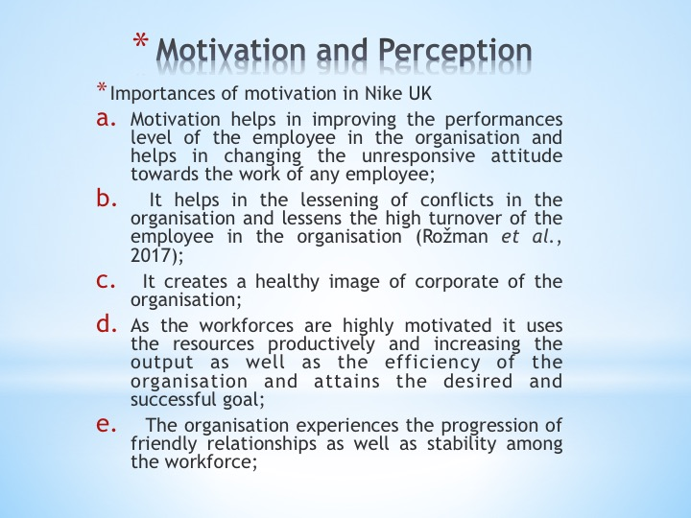
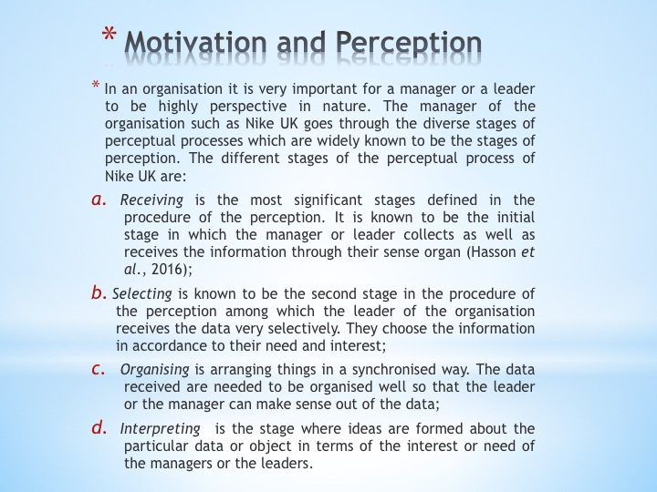

Appendix 6: Reference List



