Daniela-Elena Zota (2240973)
Management & Organisational Behaviour (BMIH5006)
Lecturer: Antoinette Milne
Word count: 2108
Leadership Styles in Hospitality: Their Role in Team Effectiveness and Employee Morale, With A Focus on Autocratic Leadership
Essay
I confirm that I have not used any AI tools in the research and creation of this
assignment. I confirm that I have not presented any AI generated materials as my own work. I confirm I have copies of my drafts, notes, and other resources I used, which I may be asked to provide in evidence.

  - Executive Summary
Hilton Hotels & Resorts, a key brand under Hilton Worldwide Holdings Inc., is one of the most prominent names in the global hospitality industry. Renowned for its innovation and strong reputation, Hilton plays a key role in shaping guest experiences worldwide. This report takes a closer look at Hilton’s corporate structure, focusing on how the company is organized and operates on a global scale. It also examines the company’s organizational culture, highlighting the values, practices, and mindset that drive the success of the brand. Additionally, the report explores the strategies and initiatives Hilton uses to manage change, such as adapting to industry trends or economic challenges. Using well-established management and organizational behaviour theories, this analysis evaluates how Hilton achieves its goals at both corporate and individual hotel levels. The focus is on identifying strengths and areas for improvement, ensuring Hilton continues to perform successfully across different markets. The report concludes by offering practical recommendations to help Hilton sustain its competitive position in hospitality. Suggestions focus on innovation, employee engagement, customer satisfaction, and sustainability. These strategies aim to secure a long-term advantage while addressing emerging challenges in the ever-evolving hotel industry. This ensures Hilton remains a leader in providing exceptional service worldwide.
Table of Contents
Introduction 4
Organisation Structure, Culture, and Goals 4
Structure 4
Culture 6
Goals 6
Recent Change Initiatives 7
Strategic Direction 8
Conclusion 9
Recommendations 10
Reference list 11

Introduction
Hilton aims to spread hospitality and has welcomed over 3 billion guests in its 100-year history. They are known for being innovative, honest, and excellent in service to both guests and property owners. No matter where people travel, Hilton is prepared to provide exceptional service. They have 24 brands, over 1.25 million rooms, 8,400 properties in 140 countries and territories as per their Hilton (2025A) platform and are ranked 2nd place as the World’s Best Workplace by Great Place to Work and Fortune (Hilton, 2025B). Known for luxury and excellent service, Hilton has pioneered several initiatives such as digital check-in and keyless room access, positioning itself as a leader in the competitive hospitality industry. This report aims to analyse Hilton's corporate strategies and hotel-level operations through established organizational and management theories. Key areas of focus include the company’s structure, culture, and objectives, along with its approach to change management and strategic direction. By examining these elements, the report seeks to identify areas for improvement and develop practical recommendations to improve Hilton's market presence. Ultimately, the analysis will aid to a deeper understanding of how Hilton can maintain its competitive edge while adapting to the evolving demands of the hospitality sector. Future strategies may involve benefiting more from technology, augmenting guest experiences, and fostering a strong corporate culture to drive growth and sustain profitability.

Organisation Structure, Culture, and Goals

Structure
Organisational structure is defined by Mullins (2019) as the official setup of tasks and authority that guides how people work together and use resources to meet the organization's goals. Hilton operates using a hierarchical organizational structure that clearly defines its chain of command. An organization chart shows how power is shared and information flows, helping employees understand their roles (Raga, 2019). At the highest level is the Board of Directors, which ensures governance and strategic direction. The Chief Executive Officer (CEO), currently Christopher J. Nassetta, leads the executive leadership team, which includes key executives like Laura Fuentes, Danny Hughes, Katherine Lugar, Simon Vincent, and Alan Watts. Each executive manages specific areas such as finance, human resources, marketing, and operations, contributing to the overall success of the company. According to Alblas and Wijsman (2021) as organizations become bigger and more complicated, they need to adopt a divisional structure. Hilton’s structure is further divided into geographical regions and distinct brands, enabling localized strategies that cater to the unique needs of different markets while aligning with Hilton's wider corporate goals. This regional focus empowers individual properties to adhere to Hilton's brand standards while customizing guest experiences based on local preferences, thus enhancing customer satisfaction. Additionally, Hilton employs a matrix structure that promotes collaboration across various departments. Team members from marketing, sales, and operations frequently work together on projects, fostering innovation and responsiveness to changing market conditions and customer preferences, supporting Mullins’ (2019) statement that culture shapes organisational structure through internal practices as well as external influences. This dynamic approach allows Hilton to stay agile and competitive in the hospitality industry.
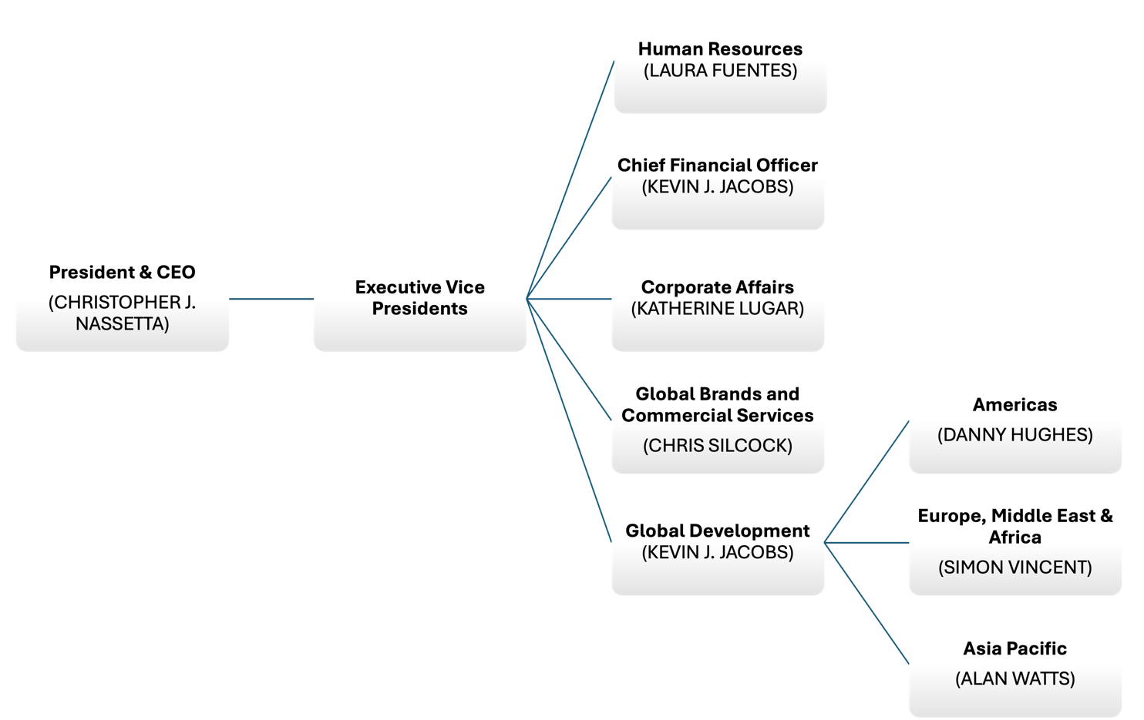

Culture
Organizational culture, as defined by Buchanan and Huczynski (2019), is the collection of shared values and practices that are passed down within a workplace, shaping the behavior and mindset of its employees. Unique to each organization, as suggested by Elsworth (2024) and Alblas and Wijsman (2021), a strong culture significantly influences employee actions and thoughts (Alblas & Wijsman, 2021). Hilton Hotels & Resorts exemplifies this through a culture rooted in hospitality, integrity, leadership, teamwork, and ownership, treating its employees as valued "Team Members" to foster respect, trust, and collaboration, thereby improving service quality. The company champions innovation, encouraging employees to suggest ideas that enhance guest satisfaction and operational efficiency, evident in initiatives like digital check-in and keyless entry, showcasing Hilton's commitment to technology and its leadership in hospitality. Moreover, Hilton's dedication to diversity and inclusion among its workforce through comprehensive programs showcases the importance of varied perspectives in enriching service delivery and workplace harmony. Feedback from Team Members highlights the positive aspects of Hilton's culture, including career opportunities, brand pride, and meaningful work, contributing to a cohesive environment aimed at shared goals. Gemtrain (2015) emphasizes how culture clarifies employee roles and objectives, fostering a sense of unity, while Peetz (2019) notes that some large firms, including Hilton, shape their organizational culture to align employee attitudes with corporate goals, reducing conflicts and enhancing operational effectiveness.

Goals
Armstrong (2022) discusses that goals represent broad aspirations, setting a long-term direction for both individuals and organizations, which Iranmanesh et al. (2020) believe should be in harmony with an organization's structure, particularly to foster innovation and efficiency. This interplay is emphasized by Bryson et al. (2022), who point out the bidirectional relationship between an organization's goals and its structure—each shapes the other. Hilton operates with dual-focused objectives: at the corporate level, it aims for financial growth and market expansion, illustrating this through plans to open 300 hotels in the Caribbean and Latin America within three years (Hilton, 2024). Marketing efforts to enhance brand loyalty and recognition across its diverse portfolio cater to varying customer needs. Sustainability emerges as a core goal, with Hilton's ambitious Travel with Purpose program targeting net-zero emissions by 2030, appealing to eco-conscious consumers. At the individual hotel level, the emphasis is on exceptional guest experiences and adhering to brand standards, goals supported by KPIs such as guest satisfaction and occupancy rates. Training for employees ensures alignment with Hilton's overarching aims, while local initiatives, such as partnerships in community projects like the accommodation support for victims of the Los Angeles Wildfires with American Express (Hilton, 2025C), underline Hilton's commitment to community integration and sustainability.
Recent Change Initiatives
As specified by Ferguson (2019), organizations are interconnected systems where changes in one area affect others, and for successful change to happen, it must be led from the top yet encouraged and implemented throughout every level and part of the organization. Burnes (2017) believes that change in organizations is constant, whether imposed, chosen, or unexpected. Hilton has actively embraced a wide range of impactful change initiatives to address the evolving demands of the hospitality industry and respond to pressing global challenges. These efforts reflect a forward-thinking approach aimed at enhancing guest experiences, promoting sustainability, and fostering inclusivity. For example, digital advancements have played a critical role in reimagining customer interactions. The introduction of innovative tools like the Hilton Honors app has significantly transformed the guest journey by enabling seamless and convenient features such as contactless check-ins, digital key access via smartphones, and real-time booking management. These technological developments elevate the level of service while aligning with the growing guest preference for convenience and heightened safety.
Simultaneously, Hilton has placed sustainability at the core of its operations with its Travel with Purpose program, a bold strategy focused on achieving energy and resource efficiency across its properties. By integrating energy-saving technologies and committing to net-zero emissions by 2030, Hilton has strengthened its reputation as a leader in the sustainable hospitality movement (Hilton, 2024C). This ambitious goal not only positions the brand as a frontrunner in environmental responsibility but also resonates with eco-conscious travellers who prioritize sustainable travel options.
In addition to advancing sustainability, Hilton has prioritized diversity and inclusion, embedding these principles into its corporate culture. The company has improved its hiring practices by fostering equitable opportunities and nurturing an engaged, diverse workforce, being rated one of the best companies to work for, for eight years in a row (Hilton, 2024B). Through a variety of inclusive programs, Hilton has enhanced collaboration, encouraged innovation, and nurtured an environment where different perspectives are celebrated and valued. These efforts not only drive internal growth and workforce satisfaction but also reflect Hilton’s broader commitment to creating positive social impact.
The Hilton CleanStay program, which was launched in direct response to the COVID-19 pandemic, is another example of the company’s adaptability in the face of adversity. This comprehensive hygiene initiative is designed to reassure guests with stringent cleaning practices and advanced safety protocols, instilling a renewed sense of confidence in travellers. By addressing health and safety concerns head-on, Hilton effectively mitigated the challenges posed by the pandemic and played a key role in regaining guest trust, which has been vital to recovering occupancy rates.
Hilton's success is largely due to its effective leadership, active employee participation, and adaptability to change, excelling in innovation, sustainability, and inclusivity to surpass stakeholder expectations and remain a leader in the hospitality industry.

Strategic Direction
An organization's structure, systems, technology, and management style limit its strategic options, meaning daily decisions on capability development guide its strategic direction (Burnes, 2017). Cousins et al. (2019) state that strategic direction can be achieved by three main methods: developing internally, growing through acquisitions, or forming joint ventures. Hilton Hotels & Resorts is strategically expanding its global presence and enhancing operational and environmental practices, focusing on entering emerging markets to harness growth opportunities. The opening of Hilton Nairobi in Kenya exemplifies this ambition, targeting regions with fast-growing economies to establish a strong market presence. Innovation through digital means, such as Digital Key technology and the Connected Room concept, showcases Hilton's commitment to leveraging technology to improve guest experiences by offering convenience and customization, distinguishing Hilton in the competitive hotel industry.
Sustainability forms a key pillar of Hilton’s strategy, illustrated by its Travel with Purpose initiative aimed at halving its environmental impact by 2030 through water and energy reduction, recycling, and sustainable sourcing. These actions showcase Hilton's dedication to environmental responsibility, setting it as a sustainability frontrunner in hospitality. Enhancing the Hilton Honors loyalty program is another strategic focus, enriching it with exclusive benefits and personalized services to build loyalty and encourage repeat visits, with innovations like Points Pooling and points redemption for Amazon purchases, expanding the program's appeal.
Moreover, Hilton prioritizes strategic partnerships and alliances to broaden and enrich guest experiences. Collaborations, including a notable one with Uber to integrate ride services through the Hilton Honors app, demonstrate Hilton’s approach to enhancing guest convenience through partnership synergies. Collectively, Hilton's strategic initiatives—expansion into new markets, digital innovation, sustainability efforts, loyalty program enhancements, and strategic partnerships—position it for substantial growth, operational excellence, and increased market share in the hospitality sector.

Conclusion
Hilton Hotels & Resorts is known for its efficient and adaptable structure, which, along with a culture focused on hospitality and innovation, ensures that all employees work towards the company’s goals. This clear focus has helped Hilton grow and uphold outstanding guest services and sustainability practices, creating a strong foundation for ongoing success. The company regularly checks and tweaks how it operates, which helps it stay ahead in the fast-paced hotel industry. Hilton is dedicated to maintaining high standards and growing in an environmentally friendly way. By introducing new digital tools, focusing on being eco-friendly, promoting diversity, and ensuring health and safety, Hilton has improved how guests and employees view the brand. The company manages changes well by keeping everyone informed and involved, which helps tackle challenges efficiently. Moving forward, Hilton's ability to quickly adapt and lead is key to its future success. Its broad strategy for growth and overcoming obstacles not only gives it a competitive advantage but also aligns with evolving trends and customer preferences. Hilton remains committed to being innovative and providing excellent service, making it a leader in hospitality, always ready to deliver memorable experiences to guests and stakeholders.

Recommendations
To improve its position in the hotel industry, Hilton Hotels & Resorts could concentrate on three main areas: getting better at handling changes, reporting more on its sustainability efforts, and offering digital services tailored to local needs. First, Hilton could enhance how it handles changes by training its managers worldwide through workshops and seminars led by experts in change management, aiming to start in early 2024. This would help the company's culture become more open to change, drawing lessons from businesses like IBM that are good at managing changes.
Secondly, Hilton could highlight its sustainability efforts, tied to its “Travel with Purpose” program, through regular reports and updates online, making its progress and goals more known to the public. This step would boost its image and show its commitment to eco-friendly practices, much like Patagonia does.
Lastly, Hilton has an opportunity to stand out by customizing its digital offerings for specific markets, starting with countries like China and India. This would make the guests' experiences better by respecting local cultures and preferences, inspired by how Marriott has successfully done this in China.
Implementing these ideas would require teamwork across Hilton, with clear instructions from higher-ups. Success depends on understanding what different markets need, being open about sustainability efforts, and maintaining a culture that can adapt to changes, setting Hilton up as a forward-thinking leader in hospitality.

Reference list
Alblas, G. and Wijsman, E. (2021) Organisational Behaviour. 2nd edn. Routledge. Available at: https://www.perlego.com/book/2489562 (Accessed: 4 March 2025).
Armstrong, M. (2022) Armstrong’s Handbook of Performance Management. 7th edn. Kogan Page. Available at: https://www.perlego.com/book/3149649. (Accessed: 4 March 2025).
Bryson, J. M., George, B. and Seo, D. (2022) ‘Understanding goal formation in strategic public management: a proposed theoretical framework’. Public Management Review. 26(2), pp. 539–564. DOI: 10.1080/14719037.2022.2103173.
Buchanan, D.A. and Huczynski, A.A. (2019) Organizational Behaviour (10th Ed.), Harlow: Pearson.
Burnes, B. (2017) Managing change. 7th ed. Harlow: Pearson.
FERGUSON, B. (2019) ‘Adjusting to change: The role of innovation’. In Competing for Influence: The Role of the Public Service in Better Government in Australia (pp. 353–376). ANU Press. Available at: http://www.jstor.org/stable/j.ctvp2n3pr.14. (Accessed: 4 March 2025).
Gemtrain, R.-S. (2015) Personnel Management N4 SB. Macmillan. Available at: https://www.perlego.com/book/2306433. (Accessed: 4 March 2025).
Hilton (2024A) Hilton Set to Reach 300 Hotels in the Caribbean and Latin America, with More than Half of its Pipeline Under Construction. Available at: https://stories.hilton.com/releases/hilton-set-to-reach-300-hotels-in-the-caribbean-and-latin-america-with-more-than-half-of-its-pipeline-under-construction. (Accessed: 4 March 2025).
Hilton (2024B) Hilton Celebrates Eighth Consecutive Year as the Best Hospitality Company to Work For in the World as Recognized by Great Place to Work and Fortune. Available at: https://stories.hilton.com/releases/hilton-celebrates-eighth-consecutive-year-as-the-best-hospitality-company-to-work-for-in-the-world-as-recognized-by-great-place-to-work-and-fortune. (Accessed: 4 March 2025).
Hilton (2024C) 2023 Hilton Year in Review. Available at: https://stories-editor.hilton.com/wp-content/uploads/2024/04/Hilton2023AnnualReport.pdf. (Accessed: 4 March 2025).
Hilton (2025A) Welcome to Hilton. Available at: https://www.hilton.com/en/corporate/ (Accessed 5 March 2025)
Hilton (2025B) A GREAT PLACE TO WORK FOR ALL. Available at: https://jobs.hilton.com/us/en/inclusion-culture. (Accessed: 4 March 2025).
Hilton (2025C) Hilton, American Express to Provide 20,000 Hotel Rooms to Support Los Angeles Wildfire Relief. Available at: https://stories.hilton.com/releases/hilton-american-express-to-provide-hotel-rooms-to-support-los-angeles-wildfire-relief. (Accessed: 4 March 2025).
Iranmanesh, M., Min, N. H., Foroughi, B., Mavi, R. K., & Kumar, K. M. (2020) ‘The impacts of organizational structure on operational performance through innovation capability: innovative culture as moderator’. Review of Managerial Science. 15(7), pp. 1885–1911. https://doi.org/10.1007/s11846-020-00407-y.
Mullins, L. (2019) Mullins: Organisational Behaviour in the Workplace. Harlow: Pearson Education, Limited.
PEETZ, D. (2019) ‘Management, culture and control’. In The Realities and Futures of Work (pp. 113–140). ANU Press. Available at: http://www.jstor.org/stable/j.ctvq4c16w.10. (Accessed: 5 March 2025).
Raga, J. (2019) Strategic Management for Hospitality & Tourism Sector. Society Publishing. Available at: https://www.perlego.com/book/2041606. (Accessed: 4 March 2025).

