AHAC6009
Morgan 1501469
Part 2

Index
Introduction………………………………………………………………………………… 4
Test pit 1………………………………………………………………………………………………………. 4
Test pit 2………………………………………………………………………………………………………. 4
Test pit 3………………………………………………………………………………………………………. 5
Test pit 4………………………………………………………………………………………………………. 5
Test pit 5………………………………………………………………………………………………………. 6
Test pit 6………………………………………………………………………………………………………. 6
Test pit 7………………………………………………………………………………………………………. 6
Test pit 8………………………………………………………………………………………………………. 7
Test pit 9………………………………………………………………………………………………………. 7
Test pit 10…………………………………………………………………………………………….………. 7
Test pit 11…………………………………………………………………………………………………..… 7
Test pit 12……………………………………………………………………………………………..……… 8
Test pit 13…………………………………………………………………………………………………..… 8
Test pit 14…………………………………………………………………………………………………….. 8
Test pit 15………………………………………………………………………………………………….…. 8
Finds
Contexts 101………………………………………………………………………………………………… 9
102………………………………………………………………………………………………… 9
201………………………………………………………………………………………………… 9
202………………………………………………………………………………………………….9
203………………………………………………………………………………………………… 9
301………………………………………………………………………………………………… 9
401………………………………………………………………………………………………… 9
501………………………………………………………………………………………………… 10
502………………………………………………………………………………………………… 10
601………………………………………………………………………………………………… 10
701………………………………………………………………………………………………… 10
702………………………………………………………………………………………………… 10
801………………………………………………………………………………………………… 10
802………………………………………………………………………………………………… 10
805………………………………………………………………………………………………… 10
901………………………………………………………………………………………………… 10
902………………………………………………………………………………………………… 10
904………………………………………………………………………………………………… 10
909………………………………………………………………………………………………… 10
1001………………………………………………………………………………………………… 10
1101………………………………………………………………………………………………… 11
1102………………………………………………………………………………………………… 11
1201………………………………………………………………………………………………… 11
1301………………………………………………………………………………………………… 11
1401………………………………………………………………………………………………… 11
1402………………………………………………………………………………………………… 11
1403………………………………………………………………………………………………… 11
1501………………………………………………………………………………………………… 11

Site development………………………………………………………………………. 11

Discussion of finds……………………………………………………………………… 12

Conclusion…………………………………………………………………………………. 14

List of figures
Figure 1…. Glass bottle stopper……………………………………………………… 4
Figure 2…. Bottle neck, pipe base and pottery sherds……………………. 4
Figure 3…. Nail/fixing type piece of corroded metal………………………. 5
Figure 4…. Stone, Dyfed gravel tempered ware, Buckley ware………. 6
Figure 5…. Three pieces of green glass…………………………………………… 6
Figure 6…. Test pit 15 finds……………………………………………………………. 8

Special thanks to Dr Louise Steele for specialist help with ceramics, along with Dr Martin Bates and Dr Ros Cord

Introduction
The excavations carried out at Llanllyr were carried out over two years 2016-2017 by students under the supervision of staff from Lampeter University. Finds found here were cleaned and sorted in the archaeology laboratory in Lampeter University. Dr Louise Steele gave her expert opinion on helping identify many of the finds. Finds excavated at Llanllyr included pot sherds ranging from possibly 16th century to modern day, pieces of glass and corroded metal, clay pipe pieces and organic material including charcoal and wood. All test pits were excavated by hand to a depth to suit ground conditions. Where possible test pits were dug to a depth of 2 metres and measured 2 metres square in size. Test pit locations were chosen for various reasons including choice by students and results from an electromagnetic survey along with visual inspection of the topography of the site.

Test Pit 1

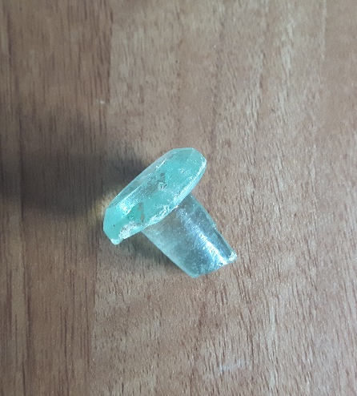
Test pit 1 was excavated on the 10th of June 2016 in dry conditions, it was taken down in eight contexts to a depth of 196cm. Context 101 to a depth of 20cm consisted of a moderately compact silty clay light grey in colour. Pottery sherd finds in this level included, Dyfed Gravel tempered ware which was non-diagnostic a small glass bottle stopper weighing 11 grammes, a small piece of transfer printed ware approximately 2 grammes and 1 piece of blue glazed earthen ware. Context 102, between 20cm and 63cm consisted of a silty clay mid reddish brown in colour. In this context further sherds were found, which included a piece of Dyfed gravel tempered ware which was again non-diagnostic along with a piece of a tankard base. A further 6 contexts were recorded, but there were no more finds. Section 103 was approximately 79cm and made up of a compact red silty clay, section 104 was approximately 32cm of pale grey silty sand, 105 was 6cm of clay silt brown in colour, 106 was 8cm of grey coarse sand, 107 was 8cm of orange red brown fine gravel with the test pit bottoming out on section 108 which was a brown fine gravel. No dates were ascertained from any finds in this test pit.
Figure 1. Glass bottle stopper weighing 11g.
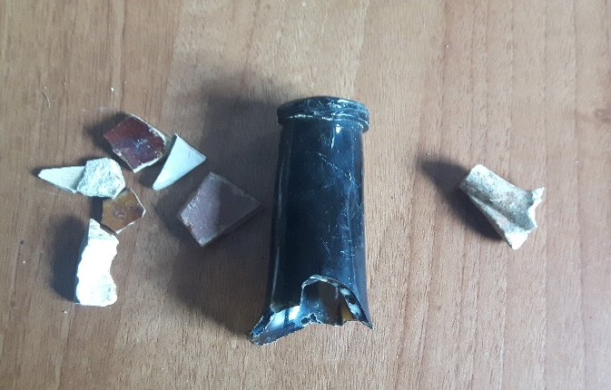
Test pit 2.
Test pit 2, excavated on the 16th June 2016, to a depth of 189cm in 9 contexts. Finds were recorded in the top 3 contexts to a depth of 85cm. Section 201 to a depth of 28cm was made up of a grey brown silty clay. Context 201, contained a piece of banded ware from the 19th century, a small piece of brown slipware, pieces of Buckley black glazed ware dating between the 17th and 19th century and also part of a base from a container which was either Staffordshire or Bristol ware, these pieces weighed in at 28 grammes in total. Pieces of rusted metal weighing 36g were also excavated. Other identifiable artifacts found here included pieces of a Staffordshire/Bristol tankard dating from the 19th century a pipe base and a neck of a bottle weighing 51g. context 202, dug to a depth between 28-50cm and made up of a moderately compact brown grey silty clay contained various pieces of rusted metal weighing 382 grammes with a piece of 19th-20th century blue burred ware. Context 203, between 50cm and 85cm was moderately compact light brown silty clay. This context contained 22 grammes of assorted ceramics including 19th-20th century modern pottery, Staffordshire/Bristol ware and 2 pieces of North Devon ware. Pieces of glass were found and a further 130g of metal were excavated from this section. No finds were recorded in the following six sections. Contexts, 204, 34cm of moderately compact grey clay, 205, 34cm of moderate red, yellow and grey clay silt, 206, 10cm of a red, yellow and brown clay silt which was hard at the top but soft at the bottom. 207, 9cm sandy silt pale grey in colour, 208, 17cm of dark grey sand before bottoming out on gravel. Finds found in this test pit date in range from the 17th to the 20th century.
Figure 2. Bottle neck weighing 51g, with pipe base and pottery sherds
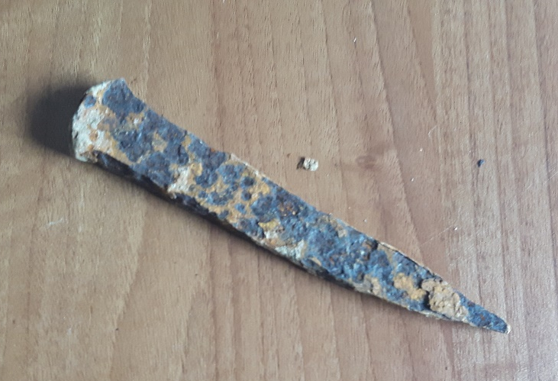
Test Pit 3.
Test pit 3 was excavated to a depth of 191cm in 10 contexts. Finds were only recorded in the first context 301, which was made up of silty sand, light grey in colour. Pottery finds in context 301, included 2 pieces of Staffordshire type tankard weighing 28 grammes and 10 grammes of green pottery dated between the 16 and 18th century. There were two pieces of clay pipe dating from the 18th century weighing 6 grammes and a piece of metal (Nail? Fixing of some type) weighing 12 grammes. The following 3 contexts were made up of silty clay, 302, grey brown 18cm thick, 303, grey 40cm thick, 304, dark grey 38cm thick. The following 5 contexts were all silt, 305, grey brown 19cm, 306, grey 8cm, 307, pale grey 8cm, 308, grey 11cm, 309, grey 7cm, before bottoming out on gravel which was at least 20cmm thick. Finds found in this test pit date from possibly the 16th century.
Figure 3. Fixing type piece of corroded metal 12g
Test pit 4.
Test pit 4 was taken down in 13 contexts. Finds were found in context 401, which had 2 small pieces of gravel weighing 14 grammes on the surface. A piece of worked stone was found along with small pieces of glass weighing 2 grammes. 7 grammes of brown earthenware were found along with small pieces of china. The following contexts were made up of clay varying in colour from pale grey to pale yellow, which varied from compact to firm, to loose to firm, to dense. no depths for these contexts were available. The test pit bottoms out on a grey dense clay. No dates were given for any finds excavated from this test pit.

Test pit 5.
Test pit 5 was excavated to a depth of 202cm on 16/6/2016. This test pit compromised of 13 contexts and finds were found in context 501 and 502 only. Context 501 was taken down to a depth of 25cm in grey silty clay conditions, finds in this context were 113 grammes of brown Staffordshire ware, dark brown to black in colour with some Dyfed gravel ware, which were al post medieval. There was also 25 grammes of assorted rusted metal objects. Context 502, contained a base of a Bristol/ Staffordshire ware tankard base weighing 19 grammes, pieces of glass weighing 3 grammes and 31 grammes of North Devon gravel tempered ware, all post medieval in date. The following 11 contexts did not contain any finds, the conditions varied from silty clay to clay, to silty find sand bottoming out on a yellowish-brown silt.
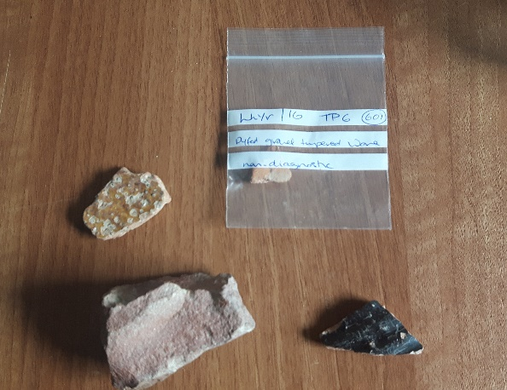
Test pit 6.
Test pit 6 was excavated on the 17/6/2016, this test pit was taken down in two contexts. Finds were found in context 601 to a depth of 38cm, which was made up of a greyish brown sand. The finds discovered here were made up of one large piece of stone weighing 107 grammes, one piece of black glazed Buckley type ware weighing 7 grammes and one piece of Dyfed gravel tempered ware weighing 9 grammes. Context 602 at a depth of 8cm was made up of a cobbled floor. This section was not taken down any further.
Figure 4 ..Stone, Dyfed gravel tempered ware and black Buckley ware.
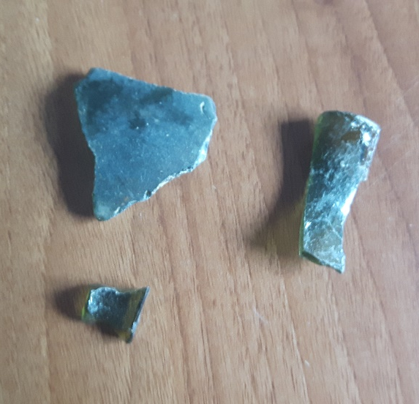
Test pit 7.
Test pit 7 was dug out on the 26th of May 2017 to a depth of 137cm’s in dry conditions. Context 701 was a light grey silty clay which was taken down to a depth of 20cm. contexts 701 contained two pieces of Buckley type blacked glazed pottery, 1 large piece and one small piece. There was also 14 grammes of charcoal found in this context. Context 702, at a depth between 20cm and 46cm was an orange brown clay soil. Finds here were 2 pieces of either North Devon or Dyfed ware along with 140g of metal pieces and 3 pieces of green glass weighing 24 grammes. Finds were not recorded in any of the further 5 contexts, these were made up of a grey to dark grey gravel soil which bottomed out on firm gravel (colour not recorded).
Figure 5… 3 pieces of green glass

Test pit 8.
Test pit 8 was excavated on the 7th of July 2017 in variable wet conditions to a depth of 113.5cm’s, finds in this test pit were found in contexts 801, 802 and 805. Context 801 excavated to a depth of 20cm contained a large piece of black Buckley ware weighing 48 grammes with a selection of English stoneware weighing 29 grammes. Context 802 at a depth between 20 cm and 36cm, was found to include a few stones, nothing was recorded in context 803, 36cm-74cm and a large piece of stone weighing 235 grammes was discovered in 805, 101cm-113.5cm. Test pit 8 bottomed out at a depth of 113.5cm on grey silty gravel.
Test Pit 9.
Test pit 9, was excavated on the 6 of July 2017, in dry conditions to a depth of 88cm. Context 901 to a depth of 26cm was made up of compact brown/grey top soil. Finds recorded in context 901 included, mixed glass, pottery and a pipe stem weighing in at a total of 43 grammes, 6 grammes of charcoal and a piece of rusty curved metal in the shape of a hook, that weighed 4 grammes. Context 902, excavated at a depth between 26cm and 50cm, which was a loose orange brown sandy material contained 62 grammes of charcoal and 116 grammes of wood. Context 903, excavated to a depth between 50cm and 59cm was made up of a compact dark grey clay, no finds recorded. Context 904, excavated at a depth of 59cm-68cm in dark grey very loose gravel stone conditions contained 62 grammes of wood material and 2 grammes of charcoal. Context 909, contained a large piece of wood, 210 grammes but this was not recorded, just excavated. This test pit was excavated to a depth of 88cm on to a grey compacted clay surface, a further 60cm was augered out until it bottomed out at 148cm on an orange compacted silty clay.
Test pit 10.
Test pit 10, was back filled and not recorded, any finds here were found in the top soil, context 1001. Charcoal weighing 38 grammes was recorded along with a piece of possible tile. One piece of black Buckley type ware was found a large stone weighing 762 grammes was also discovered along with 2 pipe stems, a piece of plate and a part of a vase from the 19th-20th century.
Test pit 11.
Test pit 11, excavated on the 6 July 2017, was recorded in 6 contexts, 1101, was taken down to a depth of 24cm in loose silty clay conditions brown in colour. Finds recorded in this test pit included pieces of a 19th – 20th century coffee or tea pot which weighed 23 grammes, blue and white pottery weighing 3 grammes, glass weighing 25 grammes and pieces of corroded metal weighing 65 grammes were also recorded. 22 grammes of charcoal were also recovered. Context 1102, at a depth of 24cm- 45cm in firm reddish-brown clay contained 11 grammes of glass and one small piece of green pottery, which could from a vase were found. The following 3 contexts, which were all in firm clay, with varying colour from grey to yellow brown contained no further finds. This test pit bottomed out on firm compact grey gritty clay.
Test pit 12.
Test pit 12 was recorded in 5 separate contexts to a depth of 101cm, 1201 was recorded to a depth of 24cm, in grey brown loose sandy soil conditions. Corroded metal weighing 14 grammes was recorded in context 1201 along with a red piece of plastic which was from the light of a modern vehicle, presumably agricultural machinery. No other finds were recorded in test pit 12. The following contexts were made up of either loose of firm clay grey in colour bottoming out on black brown firm clay at a depth of 101cm.
Test pit 13.
Test pit 13 was excavated in dry conditions in July 2017. Finds here were all found in context 1301. A depth of context 1301 was not recorded, the ground conditions were grey brown sand soil which was loose in compaction. Looking at the rest of the site these conditions are normally found in the first 30cm of depth, there is no reason to think these would be any deeper. Finds recorded here were a piece of black ribbed pottery which is typical of Buckley ware weighing 11 grammes, one piece of mocha ware weighing 36 grammes and corroded metal pieces weighing 12 grammes. No depths are recorded on this test pit, conditions of the contexts varied from brown black loose silt to compact clay yellow in colour.
Test pit 14.
Test pit 14 has no recorded data, although there are finds for this test pit. Finds bags indicate there were at least three contexts were dug. Context 1401, contained broken pottery fragments weighing 27 grammes in total, these are all post medieval in date. Context 1402 contained a large quantity of mixed pottery, earthenware, glass and some printed transfer ware weighing approximately 2 kilos. There was also 1970 grammes of corroded metal ware found in context 1402. Context 1403 contained a piece of pottery rim which is of Buckley type, post medieval in date.
Test pit 15.
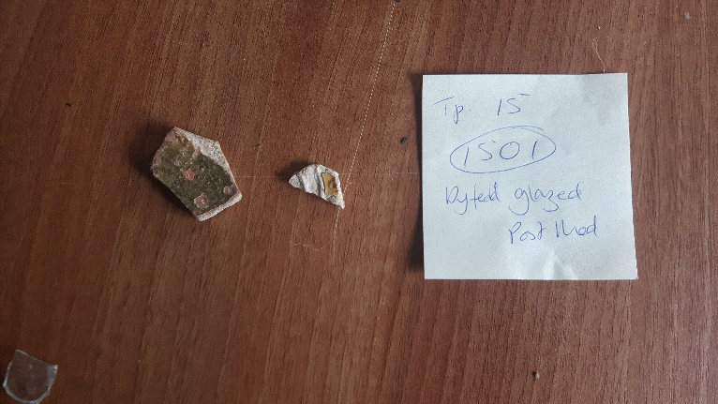
Test pit 15 contains 3 contexts with finds being found in the first context 1501 only. Context 1501 to a depth of 23cm was made up of loose brown sandy soil, contained a piece of Dyfed glazed ware post medieval in date and a small piece of glass. Test pit 15 bottoms out at a depth of 110cms on loose orange clay.
Figure 6… finds from test pit 15

Finds
101. Dyfed gravel tempered ware
Glass bottle stopper 11g
Transfer printed ware 2g
Blue tin glazed earthenware
102. Dyfed gravel tempered ware
Tankard sherd
201. Banded ware 19th century
Brown slipware
Buckley black glazed ware 17th-19th century
Staffordshire/Bristol ware tankard sherd 19th century
Pipe base
Bottle neck 51g
Metal 51g
202. Blue burred ware, 19th-20th century
Metal 382g
203. 19th-20th century pottery
North Devon ware
Staffordshire/Bristol ware pottery sherds
Glass
Metal 130g
301. Staffordshire ware type tankard sherd 28g
16th-18th century pot sherd 10g
18th century Clay pipe 6g
Iron nail/fixing 12g
401. Brown earthenware 7g
Small sherd of china
Glass 2g
2 small pieces of worked stone 14g
501. Staffordshire ware dark brown – black in colour, Dyfed gravel ware 113g
Metal 25g
502. Staffordshire/Bristol type ware tankard base 19g, post medieval
Glass 3g
North Devon gravel tempered ware, 31g, post medieval
601. Large stone 107g
Black glazed Buckley type ware, 7g
Dyfed gravel tempered ware, 9g
701. Black glazed Buckley type ware, 2 pieces, one large one small
Charcoal 14g
702. North Devon/Dyfed ware 2 pieces
3 pieces of green glass, 24g
Metal 140g

801. English stoneware sherd 29g
Black Buckley type ware, large piece, 48g
802. Few stones
805. Large stone, 235g
901. Pottery sherds
Pipe stem
Mixed broken glass, 43g
Hook shaped piece of metal, 4g
902. Charcoal 62g
Wood 116g
904. Charcoal 2g
Wood 62g
909. Wood 210g
1001. Black Buckley type possible tile
Plate sherd
19th-20th century vase sherd
2 pipe stems
Large stone 762g
1101. Coffee/tea pot, 19th century onwards, 23g
Blue and white ceramic, 3g
Glass 25g
Metal 65g
Charcoal 22g
1102. Small piece of green pottery 1g
Glass 11g
1201. Part of a vehicle light lens, red in colour, modern
Metal 14g
1301. Black Buckley ware, ribbed, 11g
Mocha ware, 36g
Metal 12g
1401. Pottery, post medieval, 27g
1402. Quantity of mixed pottery, earthenware, transfer printed ware & glass 2kg
Quantity of metal, including ironmongery, 1970g
1403. Buckley type ware rim, post medieval
1501. Dyfed glazed ware post medieval
Small piece of glass.

Site development
Llanllyr is situated in a green and fertile valley by where the river Aeron makes its way towards the sea (Gee 2010:9). Llanllyr and its local area is very significant to the history of Wales, a Cistercian nunnery was founded on this site in c.1180 by a Rhys ap Gruffudd, before being dissolved in 1535 (Bezant 2014:1). Although the location of the nunnery is unknown it is believed that the mansion house made use of some of the monastic buildings when the dissolution of the monasteries occurred (Bezant 2014:2). The current mansion built in 1830 is constructed from the previous mansions stone, after it was demolished sometime after 1768, according to estate maps of the time which show it with formal gardens and parkland just to the north west of where the current house is now (Bezant 2014:3).
The earliest written record of Llanllyr are in the writings of Gerald of Wales in the last ten years of the twelfth century. There are however references to there being the possible founding of an earlier shrine to a Celtic Christian saint that preceded the nunnery which was founded here c.1180 (Gee 2010:13). Further evidence of earlier activity on this site is to be found on an inscribed stone which was found in the farmyard here in 1859, this inscribed stone records the gift of a piece of land to an Irish Saint Madomnuc and has been dated to between the sixth and ninth century (Gee 2010:15).
The monastery founded here in c.1180 is important to Wales because it is 40 years earlier than the first nunnery in England to be recognised by the Cistercian order, at Tarrant in Dorset (Gee 2010:17). Although there are no remains above ground of the nunnery buildings, widespread man-made watercourses and give good indication to where some of the main buildings of the nunnery may be (Gee 2010:20).
The gardens found at Llanllyr are thought to of been created in the period of its greatest prosperity, sometime between 1577 and 1637, when the house was in the possession of the Lloyds family (Gee 2010:31). After then Llanllyr is said to have had a turbulent time with the house changing hands numerous times Gee 2010:31). In 1696 the house at llanllyr was described as being ‘a decayed house in the hands of a tenant’ (Gee 2010:37), and it was not until 1826 when a William Lewes took hold of the possession of the property and decided to erect a newer house for him and his family (Gee 2010:39), which still stands there today.

Discussion of finds
Of the finds here, the earliest which can indicate any concrete date so far is a pot sherd weighing 10 grammes which is dated to the 16th-18th century found in context 301. Worked stone found in context 401 could indicate prehistoric activity on this site, there are no depths recorded for this test pit so the depth of what they were found at is unknown.
A quantity of Dyfed gravel tempered ware and North Devon ware were found across the site, 101, 102, 203, 501, 502, 601, 1501 and with 702 containing either Dyfed gravel tempered ware or North Devon ware. The appearance of Dyfed gravel tempered ware is very similar to that of North Devon ware, large red inclusions are to be found in Dyfed gravel tempered ware and North Devon ware containing more quartz. Because of this similarity it is thought by many archaeologists and pottery experts from Devon, that much of the Dyfed gravel tempered ware that is found in wales may actually be from North Devon originally (O’Mahoney 1995:8). Although no dates have been given for the Dyfed gravel tempered ware or North Devon ware it could be possible that these date from the time of the Cistercian nunnery, with Dyfed gravel tempered ware dating from possibly the twelfth century being found in Llanegwad in 2007 which is 31 miles to the south of Llanllyr (Dyfed archaeological Trust 2008).
Buckley ware, found in 201, 601, 701, 801, 1001, 1301, and 1403 has been dated only from context 201 and this is from the 17th-19th century. Buckley ware from Flintshire in north Wales had been produced for at least 600 years from the medieval period up until the mid-nineteenth century, Buckley ware was mainly exported either to Ireland or sold to towns along the coast of Wales (Clwyd Powys Archaeological Trust 2014:3).
Staffordshire or Bristol ware, found in sections 201, 203, 301, 501 and 502, was dateable in 201 which was a 19th century tankard sherd. Pottery sherds were found in 203 and 501 had not been dated. Staffordshire/Bristol ware tankard sherd weighing 28g was found in context 301, undated but found with 16th-18th-century pot sherds and an 18th century clay pipe. Context 502 contained tankard sherds (base) and this was post medieval in date. Trailed and combed pottery which is typical of Bristol or North Staffordshire type ware was manufactured in several locations and is very similar in appearance and fabric, they are both very hard to tell apart even by experts (Historic England:21).
Other dateable pottery or ceramics were found in 201, banded ware 19th century. 202, blue burred ware dating from the 19th-20th century. 203, contained pieces of 19th-20th century pottery. 1001, 19th-20th century vase sherd and 1101, a coffee or tea pot no earlier than the 19th century.
Clay pipe sherds were found in contexts 201, 301, 901 and 1001, the pipe sherd from context 301 was dated from the 18th century.
Glass items were found in contexts 101, 201, 203, 401, 502, 702, 901, 1101, 1102 and 1501. Context 101 contained a glass bottle stopper weighing 11 grammes, context 201 contained a bottle neck weighing 51 grammes. Context 901, contained mixed broken glass weighing 43g and context 702, contained 3 pieces of green glass weighing 24 grammes. Contexts 203, 401, 502, 1101, 1102 and 1501 contained small pieces of glass with weights varying from 2 grammes to 25 grammes being recorded for each context.
Pieces of corroded metal were found in contexts, 201 51g, 202 382g, 203,130g,301 12g, 501 25g, 702 140g, 901 4g, 1101 65g, 120 14g, 1301 12g and 1402 1.97kg. None of the metal retrieved had been dated but all the pieces excavated were heavily corroded. The metal finds in these test pits are typical to what may be found on agricultural land with exception of test pit 14. Test pit 14 contained 1970 grammes of mixed corroded metal which appeared to be 19th century ironmongery, these were found with a large quantity, 2 kilos, of mixed pottery including transfer printed ware and glass.
Organic material was found which has not been dated. Charcoal was collected from contexts 701 14g, 902 62g, 904 2g and 1101 22g. Pieces of wood were collected from contexts 902, 904 and 909, these were carefully excavated by hand and taken to the laboratory.
A piece of plastic light lens was found in context 1201, this and a piece of metal weighing 14 grammes was all that was excavated from this test pit. The light lens is very modern in date and may be from the 21st century.

Conclusion
The earliest finds that could be dated, found on this site in the two excavation periods recorded date to possibly the 16th century, the latest finds could date to the 21st century with the majority of the finds coming from the 18th – 19th centuries. Dyfed gravel tempered ware, which was found in several of the test pits, if dated could possibly date back to the time of the beginning of the Cistercian nunnery. The majority of the dateable pottery that was found was from the 19th and 20th century. There was only one test pit, 301 which had a date that could be from the time of the dissolution of the Cistercian nunnery 1535 and this was a pot sherd weighing 10 grammes.
The excavations here do show that the land has had a continued use, the artifact recovered range from worked stone to modern day lighting. Test pit 14 had medieval pottery in a context above a large quantity of mixed pottery, earthenware, transfer printed ware, glass and metal indicating that this is a location where people may have buried their rubbish in the past. There is clear indication of continued use of this land which could possibly date back to the twelfth century, further dating would be beneficial.

References
Bezant, J. 2014. Llanllyr, Ceredigion, Archaeological Evaluation 2014: Interim report. Dyfed Archaeological Report. Report 2014/42
Clwyd Powys Archaeological Trust. 2014. The Buckley Potteries: An Assessment of Survival and Potential. Report 1246
Dyfed Archaeological Trust. 2008. Land at Llanegwad, Carmarthenshire: Archaeological Excavation 2007. Report 2008/70
Gee,L,L. 2010. A Very Small Corner of Paradise. The Story of Llanllyr: A Garden in Wales. Y Lolfa. Ceredigion
O’Mahoney, C. 1995. Pottery Ridge Tile and Ceramic Pipe. Excavations at Carmarthen Greyfriars 1983-1990. Dyfed Archaeological Trust Occasional Papers. (2)
Historic England. https://content.historicengland.org.uk/images-books/publications/archaeological-and-historic-pottery-production-sites/heag019-pottery-production-sites.pdf/ [accessed 3/6/2018]

Images.
1. J. Morgan
2. J. Morgan
3. J. Morgan
4. J. Morgan
5. J. Morgan
6. J. Morgan

