PROJECT MANAGEMENT
(LCBB5005)

Assessment 2
( 2500 words)

Student name: Lecturer name:
Angela Celac (2023256) DR. Molly Jack

Submission date:
14.09.2022

Table of Contents
1. Introduction 3
2. Lessons learnt from the project 4
2.1. Initial success of the project 4
2.2 Significant Project Management steps 7
2.3 Issues leading to project failure of Crossrail 8
3. Conclusion and Recommendation 11
Reference 13

Introduction

Project management can be defined as the series of processes contributing to developing a project while maintaining its criteria. Crossrail project is the longest project being planned and executed in London connecting a wider range of places. In this report, certain factors that lead to its initial success, most significant project management steps and issues that led to considering it a failure and nightmare will be discussed. Different successful aspects of project management have been mentioned along with failure factors. Lastly, a recommendation has been provided detailing necessary steps that might prevent the failure of Crossrail project.
Crossrail is a major construction project that is being planned and executed in London connecting a wider range of places. The Crossrail project is the longest project ever covering 73 miles and 41 stations along its way. Crossrail is going to cover the area from Heathrow airport to Reading to Shenfield and Abbey wood. This project has been associated with several factors. Crossrail aimed to connect 200 million passengers yearly through business districts of the country. This project is being publicly funded with major contributions from Transport of London or TfL and the Government of UK. The project has been associated with different factors such as innovation, and sustainability that make to project a dream project (Crossrail.co.uk, 2022). However, in a project, project management is the important aspect that contributes to its determination of success or failure. As the project progressed, it got associated with different events leading to its setback.
Project management can be defined as the series of processes contributing to developing a project while maintaining its criteria. Different aspects are involved in the project management steps such as maintaining ongoing activity and resource management such as personnel, finances, intellectual property and technology. Every project has its demand for a specific outline that will define activities from start to finish. Project management is associated with different approaches to be followed based on risks and uncertainties in developing a project. Crossrail is certainly a giant project associated with different risk factors. This dream project has been subjected to different management techniques. In this report, I will be discussing certain factors that lead to its initial success, most significant project management steps and issues that led to considering it a failure and nightmare.

2. Lessons learnt from the project

2.1. Initial success of the project
Innovation in project development
Crossrail has been associated with traditional/construction management methods that include detailing the project design and construction bids for specific packages. Contingency cost has been managed by the company, which resulted in managing and mitigating risk and paying more attention to the procurement costs. Responsible Company of the Crossrail project has also set up different expert committees, which comprise experts related to a specific issue. Exception committees are responsible for activities such as procurement, tunnelling and railway systems. Procurement of the project has been done over a period of six months. This assessment is known as the "Performance Assurance Framework" resulting in the measurement of drive collection, measured performance and shared knowledge. The framework worked upon major six deliverables of the project such as health and safety, commercial, quality, community relations, social sustainability and environment (Medeossi, 2019). A Digital version of the project was created resulting in exploration of construction, design and subsequent operations along with physical methods. Therefore, this approach was named ‘digital twin’. In order to ensure smooth operation of the Crossrail project Crossrail Ltd's strict standards and guidelines are set so that every contractor associated with the project has the access to different Crossrail and software processes.
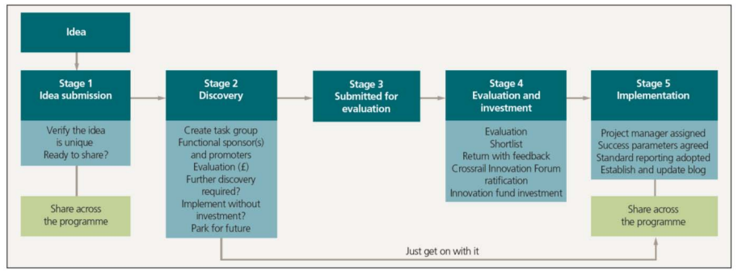
Figure 1: Innovate 18 Process
(Source: Nao.org.uk, 2022a)
Some of the significant innovations that have been developed are Crossrail-Bentley Information Academy, Innovate 18 and learning legacy. The processes have contributed to streamlining operations of different processes. Crossrail-Bentley Information Academy has been successful in creating a synergy between physical model and digital model for boosting innovation in the operation process. This association is set between Crossrail ltd and Bentley Systems. It has been stated that Crossrail has a clear vision in getting both physical and virtual vision of the project parallelly. This vision will help in gaining the objective of improved delivery of projects. Through this association, Crossrail has implemented Building Information Modelling (BIM) and Common Data Environment (CDE). This has encouraged in development of innovative engineering design contribution minimisation of waste and reduction of future cost of railway maintenance. Brentley ensures the fact that Crossrail has been following, developing and capturing best practices associated with digitalization and information technology (Lobo and Abid, 2020). Furthermore, BIM has contributed to linking different project bases along with construction review and briefing sessions. This digital twin contributed to the effective decision-making process.
Innovate 18 and learning legacyhas a major role in the project. I have noted that Innovate 18 works on the idea of sharing and exchanging ideas and knowledge across diverse communities. I have interpreted that this program is successful in connecting different representative bodies of civil engineers, construction Leadership councils and multinational business organisations. Innovate 18 has helped guide innovators through health and safety, digital-physical integration, suitable solution and delivery efficiencies aspects. “Crossline Learning Legacy” has been developed that shares insights from the project (Crossrail.co.uk, 2022). This includes different information from the project backgrounds such as planning and procedures usage of different tools, case studies, good practise documents
Sustainability of the project
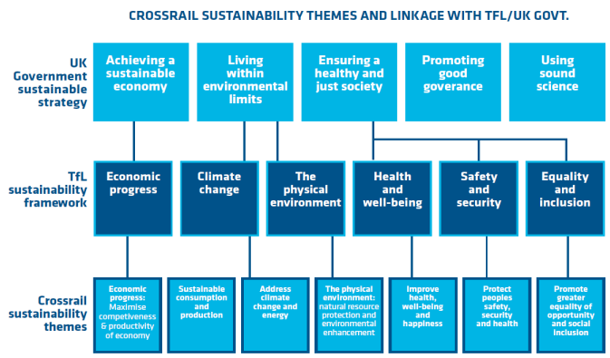
Figure 2: Sustainable approaches
(Source: Nao.org.uk, 2022a)
A major success of the project initially is its sustainability. It has a significant contribution to economic and environmental sustainability factors. Considering the economic sustainability, it has been estimated that it will generate £42 billion over the span of 60 years. Furthermore, it has been highlighted that it will add £10.6 billion to property value of London. Crossrail construction projects have supported over 55000 job profiles in the UK resulting in engagement of local suppliers contributing to economic development of the country. Crossrail Ltd has set the target to raise 99% of waste generated from an excavation in developing recreational reserves and wetlands. Project operation has been successful in 39% recycled and minimum impact on air as 83% emissions are filtered through emission control equipment fitted. The project aimed at reducing carbon emission footprints rate to 8%, however, it has achieved up to 18% (Nao.org.uk, 2022a). This has been possible through the development of a tool that contributes to the decision mining of contractors of selecting target instruments to reach the set target. The project has also focused on reducing energy consumption. Use of LED light fittings has led to significant carbon setting benefits and life cycle costs. CO2 emission has been reduced by 32% through the operational process of construction.

2.2 Significant Project Management steps
Project management is associated with significant steps defining the cycle of a project and is continuous from its start to end. At the base of any project management, project managers play a crucial role in defining the deliverables of the project. I will be highlighting different stages of the project management life cycle. Five phases of project management are initiation, planning, execution, maintenance and Closure. Project initiation is the primary and significant step in defining the deliverables of the project. This step will be associated with feasible testing and research work. Project initiation documents and requirements of the project are generally documented in this step. This step further includes stakeholder analysis, business needs and business care (San Cristóbal et al. 2018). Secondly, project planning defines the success of the project and develops the roadmap of a project. In this step, a major focus is to organise teams and collaborate resources. Significant goals of a project can be achieved through certain frameworks such as SMART goals. Additionally, it also includes project scope, work breakdown structure, communication plan and risk assessment.
Thirdly, project execution contributed to the development of the team and competition of deliverables. It includes assessment of different reports, transitions and updates that assist in monitoring and performance. Tasks involved in this step are introduction of the project, team development, assigning of resources, execution of project plan, procurement management, setting tracking systems, scheduling tasks and modification of plan if needed. Project monitoring and assessing its performance is a significant step determination of Key Performance Indicators. These indicators are project objectives, quality deliverables, cost and efficiency tracking and project performance. Lastly, the step of project closure is considered where meeting evaluates failure and success. This step includes an identification of whether the project went well and necessary areas of improvement. A final project report is prepared and documented. Crossrail Ltd's strict standards and guidelines are set so that every contractor associated with the project has the access to different Crossrail and software processes (Larsson, 2020). Crossrail has a clear vision of getting both physical and virtual vision of the project parallelly. Innovate 18 has helped in guiding innovators.
Successful project management is noted to have certain characteristics. I have assessed that a project can be considered successful if it has achieved business requirements, delivered on time and maintained as per schedule, delivered and maintained as per scheduled budget, and expected value is delivered. Different factors contribute to the success of the project and it has been noted that the step toward successful project management is critical. I have highlighted certain factors that will contribute to the success of a project. Some of the most important and considerate factors are setting clear and articulate goals and comprehensive and detailed planning. Deliverability should be determined with early criteria, carefully planned implementation, concise technical requirements, realistic estimates and scheduling of the process are the major requirements of any project (Lauer, 2021). Standard software infrastructure and the development of a formal system methodology are needed to make project successful. Lastly, manpower is the significant criterion consisting of a competent team and committee to gain success.
I have also identified certain factors that may contribute to project failure. Most prime factors are lack of input from stakeholders and incomplete requirements. The stakeholders need to have significant contributions and have information on every process that has been developed or followed during project development. Insufficient planning, insignificant quality control or quality assurance measures contribute to project failures. Technology has an important reason for putting a project on success. However, technological incompetence, insignificant resources and unrealistic expectations may lead to the crippling of a project and its association with different purposes (Antony, 2018). Furthermore unclear objectives, unrealistic time frames and untested technology will significantly affect failure of a project.

2.3 Issues leading to project failure of Crossrail
Increasing Cost and sleeping schedule
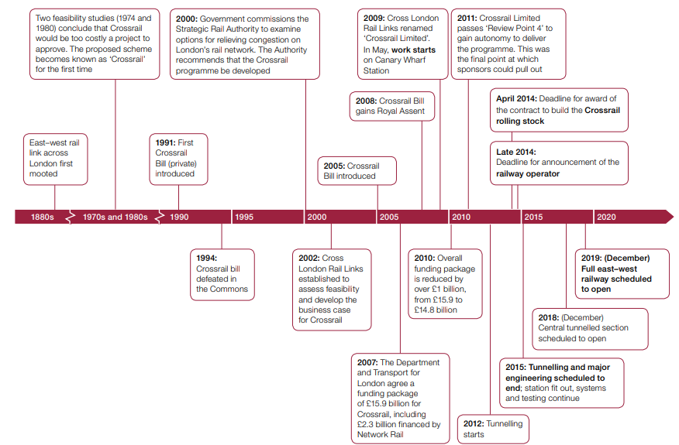
Figure 3: Expected schedule of Crossrail project
(Source: Nao.org.uk, 2022b)
The project was decided to be completed by 2018. However, it was further delayed. Therefore, a newer schedule of work and budget has been sanctioned by Crossrail Ltd and sponsors. A new management team has come to the work field and started the management from scratch. It has been said that the project repeatedly missed its scheduled milestones in the year 2019 and 2020 (Ting, 2021). This is because Crossrail Ltd continues to uncover and identify different setbacks and issues in the working design. Crossrail Ltd continued to implement a new approach to execute plans with more optimistic productivity levels. In August 2020, the organisation continued to set a cost estimation and schedule set to execute further sets of actions. It resulted in a significant delay in the project. Lockdown has resulted in both delay and increase in the cost of the project.
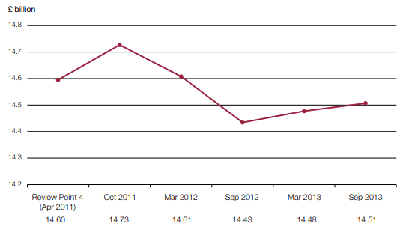
Figure 4: Increase in Budget
(Source: Nao.org.uk, 2022b)
It has been noted that there has been a 15% increase in the cost of the project. Furthermore, after the announcement of the official lockdown, construction activity closed for nine weeks. Another aspect being identified is broiling different systems and assets into synchronised work. More than 500000 digital and physical assets are set to be worked effectively. The major drawback being identified is that Crossrail Ltd did not have commercial levers with contractors to stop cost increase and delay in schedules. After 2019, there has been an increase of 19 contracts by £1.3 billion (Nao.org.uk, 2022b). As I have identified previously, manpower is the major driving force of a project committee to its success. In the Elizabeth line, Crossrail failed to fill in vacancies of some critical posts. It created a hindrance in rebuilding capability and capacity of the working team.
Bringing the project to service
In order to bring the Elizabeth line into service different factors are responsible and have to work simultaneously bringing in more complexity. Responsibilities for the Elizabeth line have been shared within different organisations such as Network rail, MTRL, and RfLi and are assigned with specific purposes. I have identified that change in responsibility, within organisation results in a significant delay in the service. However, Crossrail has started trail running, remaining work after trial running and operation start to complicate and result in unveiling newer risks. Mitigation of the risk results in an additional cost to the estimated budget of the project. Noted increase in the cost has ranged from £800 million and £1.1 billion (Nao.org.uk, 2022a). Different activities are still pending that can contribute to the increase in cost. Operational testing resulted in identification of significant problems that need to be solved increasing cost expenditure.
Achieving value for money
I have identified in my previous findings that the project will have return value adding to the cost benefits of the country. However, the cost benefits were from the study in 2011-2015 and increased demand for the railways. After the pandemic situation and recent statistical data that has been provided, it has been noted that travelling pattern and long-reaching travel has reduced. It has been stated that current trends can have an approximate revenue risk of £150 million per year (Gsd.harvard.edu, 2022). More economic benefits need to be deciphered from this project. Strategic approaches need to be utilised such as environmental benefits, economic growth and regeneration by building an easily accessible railway.

3. Conclusion and Recommendation
It can be concluded that project management is critical with different considerate approaches that need to be taken according to the situation to deliver successful projects. In this report, different successful aspects of project management have been mentioned along with failure factors. a project can be considered successful if it has achieved business requirements, delivered on time and maintained as per schedule, delivered and maintained as per scheduled budget, and expected value is delivered. Most prime factors are lack of input from stakeholders and incomplete requirements. In the case of Crossrail projects, initial success and related creatures of failure have been mentioned. However, the project was decided to be completed by 2018 and got further delayed. 15% increase in the cost of the project is further noted.
It can be recommended that a strategic approach needs to be followed to reduce the cost increase, delays and increased risk of the project alike HS2, a massive project intended to create high-speed rail links between London and major cities in the Midlands and North of England. Also necessary lack of communication has been noted. Department responsible should have written to the committee for encouraging more openness and transparency across the delivery bodies. Project should have considered revisiting major programmes to be completed within the scheduled time. Additionally, the responsible department should have updated at regular intervals for ensuring key development is done within the scheduled time. In many cases, the department has failed to identify the root cause of issues. All the stakeholders associated with the project should have indulged in assessing the situation after 2019 leading to a more compact and considerate action plan. It has been estimated that the cost of the project rose to three billion. Programme of value for money set in the project is at risk. Therefore, during the cost increase, noticeable importance to taxpayers should have been given. Furthermore, different actions such as assessing different risk factors, and assessing cost-benefit analysis should be made based on the current situation.

Reference
Journals
Antony, J. and Gupta, S., 2018. Top ten reasons for process improvement project failures. International Journal of Lean Six Sigma.
Larsson, J. and Larsson, L., 2020. Integration, application and importance of collaboration in sustainable project management. Sustainability, 12(2), p.585.
Lauer, T., 2021. Success factor project management: managing complexity correctly. In Change Management (pp. 185-201). Springer, Berlin, Heidelberg.
Lobo, S. and Abid, A.F., 2020. The role of social media in intrastakeholder strategies to influence decision making in a UK infrastructure megaproject: Crossrail 2. Project Management Journal, 51(1), pp.96-119.
Medeossi, G. and Nash, A., 2020. Reducing Delays on High-Density Railway Lines: London–Shenfield Case Study. Transportation Research Record, 2674(7), pp.193-205.
San Cristóbal, J.R., Carral, L., Diaz, E., Fraguela, J.A. and Iglesias, G., 2018. Complexity and project management: A general overview. Complexity, 2018.
Ting, C., Gilson, B. and Black, M., 2021. Developing the 3D geological model for Crossrail 2, London, UK. Quarterly Journal of Engineering Geology and Hydrogeology, 54(2).
Website
Crossrail.co.uk, 2022 Crossrail Review Available at: https://learninglegacy.crossrail.co.uk [Accessed on 28th July]
Gsd.harvard.edu, 2022 Crossrail -Elizabeth Line London, UK Available at: https://research.gsd.harvard.edu [Accessed on 28th July]
Nao.org.uk, 2022a Crossrail – a progress update (Summary) - National Audit Office Available at: https://www.nao.org.uk [Accessed on 28th July]
Nao.org.uk, 2022b Crossrail - National Audit Office Available at: https://www.nao.org.uk [Accessed on 28th July]

