
AGENT AI SEARCH ALGORITHMS


By Andrew Ridgeway
P148551
Computer Games Development
Agent AI
Gordon Dickers
Table of Contents
Introduction 1
User Guide 2
Screenshots 2
Script 3
• searchAlgorithms.h 3
• searchAlgorithms.cpp 4
• Main.cpp 7
Testing Table 7
References 7

Table of Figures
Figure 1 - The Command Prompt 2
Figure 2 - The Programme is Running 3
Figure 3 - The position of AI, exit and key 3

Introduction
This user guide will be explaining how the end-user will be able to use the AI of this program. There will be screenshots that will show how this program works and a code section in that was used to get this program running. There will be a testing section to show what type of test that was used to see how well the program works. The maze was created in a programme known as Notepad++.

User Guide
The program works by reading a file known as Maze1.maz to generate the maze for the programme and this is mostly used to see how the AI goes through the maze. The type of algorithm for the program uses is DFS (Depth First Search) to solve the maze and there will be other two files known as Maze2.maz and Maze3.maz[1][2][3].
For the end user to use any one of these files all they must do is typing the name of the file in the prompt screen and this will allow for end-users to watch how the AI solve the Maze. There will be item in the maze for the AI to search its location. The AI will be the symbol o while the item will be the symbol k and the exit will be the symbol x.
While the program is running the AI will be giving off its position every time it's searching through the Maze and it will be indicated underneath the maze this is what the AI position looks like "The AI located: (0, 0)". Once the AI is finished going through the Maze the program will tell the end user where the item (The key position is: (0, 0)) and exit (The exit position is: (0, 0)) is located.
This program only uses as a 16 by 16 size for the Maze because if the end-user tries at 8 by 8 the code will look very Glitchy, if the end-user tries a smaller maize but this can be solved by changing the height and width size.
this is the same if the end user tries a lodger maze size file such as a 32 by 32 because this could make the program crash, but the end-user can change the height and the width to allow the program to use larger maze file size.

Screenshots
- The Command Prompt
here is a screenshot of the prompts screen given the end user a choice of profiles to pick.
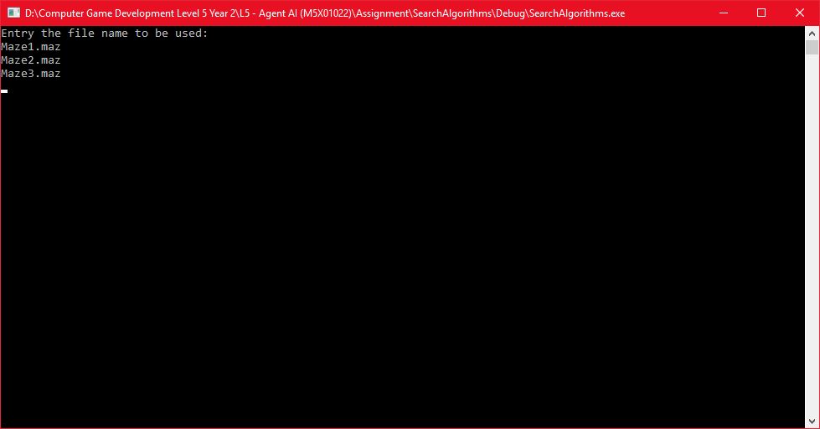
Figure 1 - The Command Prompt
- The Programme is Running
Here is a screenshot of the AI searching through the Maze to search for the item and the exit.
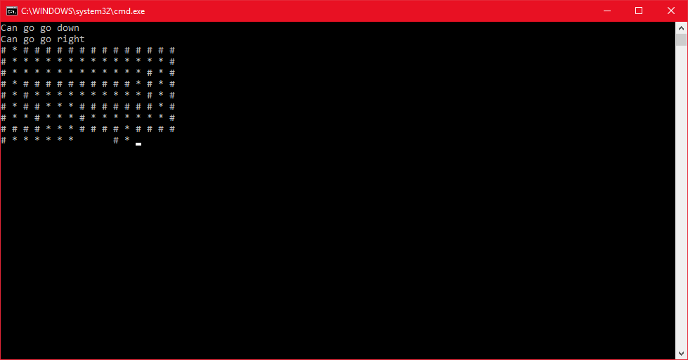
Figure 2 - The Programme is Running

- The position
here is a screenshot of the AI completing the Maze and showing the location of the item and exit.
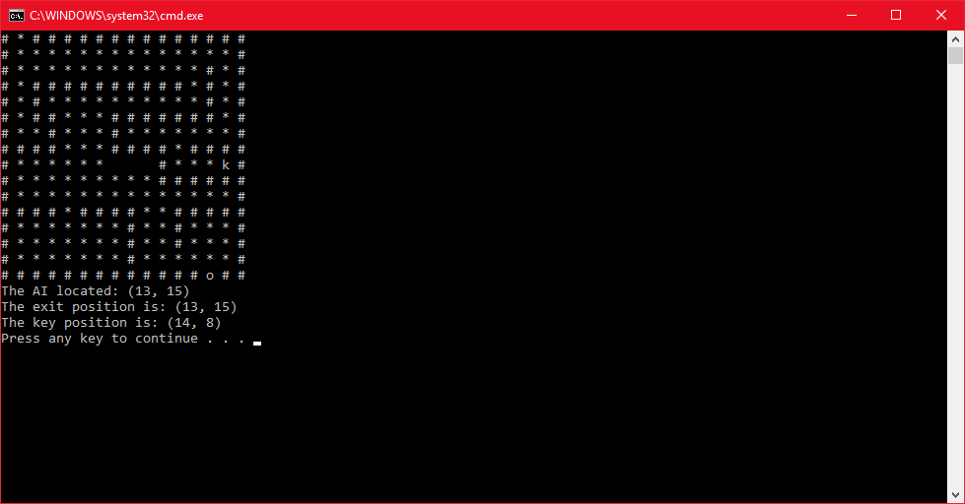
Figure 3 - The position of AI, exit and key

Script

searchAlgorithms.h
This part of the program is the header what stores the names, numbers and x y position.
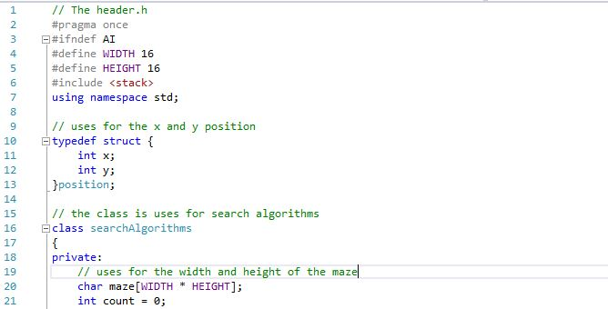
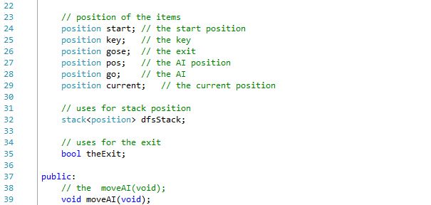
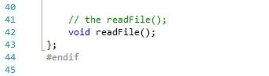

searchAlgorithms.cpp
This part of the program is the body what allows the AI to work[1].
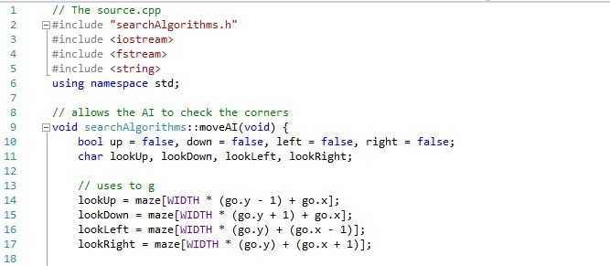
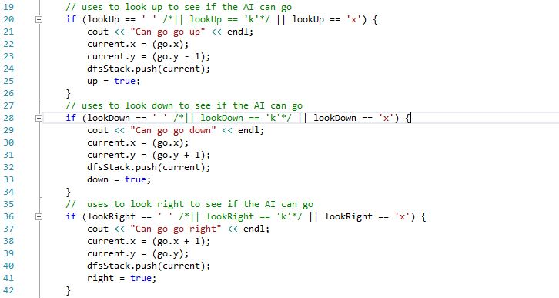
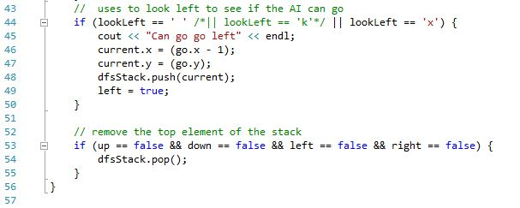
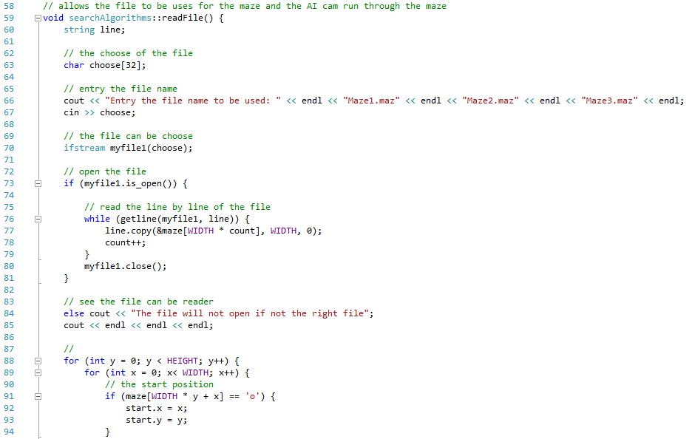
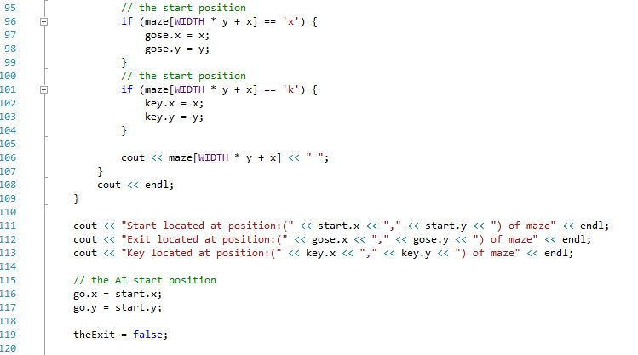
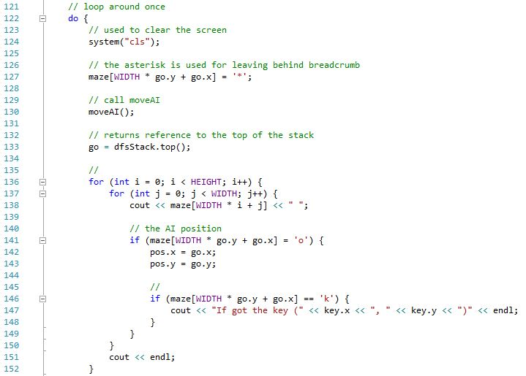
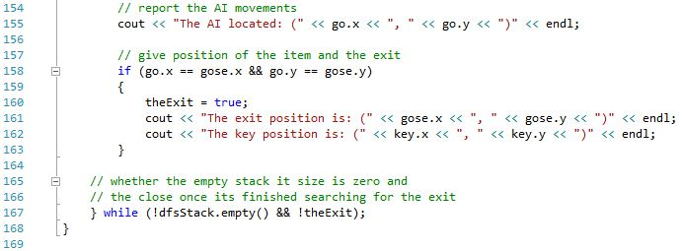

Main.cpp
This is part of the program this part of the program is the main what allows the program to run.
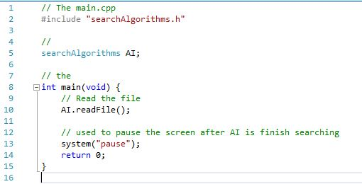

Testing Table
Here is the test table that will be testing the AI that how well it works in a maze.
Test No | Test | Expected Result | Actual Result | Pass/Fail
1 | reading the file once the end user has typed it in | seeing the file is chosen by typing in the name of the file | typing in the name of file and the program shows the Maze | pass
2 | the AI moves up | seeing if the AI moves up while in the maze | the AI is moving up | Pass
3 | the AI moves down | seeing if the AI moves down while in the maze | the AI is moving down | Pass
4 | the AI moves left | seeing if the AI moves left while in the maze | the AI is moving left | Pass
5 | the AI moves right | seeing if the AI moves right while in the maze | the AI is moving right | Pass
6 | the AI location while moving | expected to see the AI location change every time the AI moves | the location keeps changing every time the AI moves | Pass
7 | the items location | expected to see the location of the item once the AI is finished searching | the location of the item was shown once the AI is finished searching the maze | Pass
8 | the exit location | expected to see the location of the exit | the location of the exit was shown once the AI is finished searching the maze | Pass

References
[1] G. Dickers, “L5 - Agent AI (M5X01022),” Moodle UWTSD, 2018. [Online]. Available: https://moodle.uwtsd.ac.uk/course/view.php?id=2266. [Accessed: 29-Mar-2018].
[2] K. Moore and K. Jennison, “Depth-First Search (DFS),” brilliant.org, 2002. [Online]. Available: https://brilliant.org/wiki/depth-first-search-dfs/. [Accessed: 29-Mar-2018].
[3] J. Reif, “Graph Algorithms Using Depth First Search,” Duke Univ.

