Project Report
Little To Nothing Project
Introduction
For my final Major Music project, I have been creating a “concept album” or more so a story based album.
The end aim was to create a 10-12 track album, and I have been successful in creating a 10 track album, which for a first album, I believe is a sufficient, considering some of the tracks are a little bit longer than the standard or commercial track would be.
The project itself is called the Little To Nothing Project; “Little To Nothing” being the artist name I go by, which to me holds the meaning of, that sometimes the happiest you can feel is only the very smallest amount and the scale of happiness can feel like it only ranges from that one feeling to absolutely nothing, with nothing in between. The purpose of my songwriting, artist name and general ideas is that I can keep it all quite broad while still having a very specific meaning to myself. I always make sure that my ideas have a solid purpose, every line in my lyrics have a very specific meaning, down to the song or project titles, but by keeping them initially broad, it allows listeners to produce their own stories around each and every word and create their own personal meanings.
For example; If I wrote a song about experiencing grief, or heart ache, or mental health, I would make it clear that that is the general topic is based around that, but to me, there would be a very detailed account of my personal life if you were to, almost read between the lines.

For this project, I wanted to take a different approach to my usual style and formula of songwriting.
I wanted to create a story and tell it through the course of the album from the perspective of a character talking about their life.
The story has continued to change through the course of the writing process.
The initial idea was a character explaining how they overcame and recovered from attempting suicide, the road that lead them to that place to begin with and where they are now.
I decided to change that though, although the album consists of songs that discuss dealing with day to day battles with mental health, the story comes from a different place. I took the idea from a very real place, I looked back at one of the lowest points in my life where I lost a loved one, a time where around that tragic event, I was also leaving an emotionally abusive and manipulative relationship on top of a number of other factors.

The premise of the album is the character experiencing the separation of his parents and the divide of his family, later having to deal with the loss of his farther due to illness and expressing the grief of the situation which leads to him shutting off from his friends and family but eventually finds hope and passion for music. I have made a point to reference throughout the album, “Promise in the simplicity of sound” from having written a poem, to referencing that line in other songs. So from that i decided to name the album “Promise In The Simplicity Of Sound” as it gives the story a direct purpose, I feel. As much as I like the idea still of having the album be self titled, It is not a story directed to myself, it is a brand new piece of work that I have adapted and experimented with my songwriting style completely, so associating the title directly to myself seems inappropriate for the purpose of the project at this point.

Background Research and Inspiration
A lot of my research stemmed from wanting to make a point of this project being completely different and out of my comfort zone from what I was used to creating and releasing.
The general background idea of creating a concept based album came from looking at the works of multiple different artists;
Firstly the artist Dan Campbell, more well known as the front man/vocalist “The Wonder Years”, where Campbell is known widely for his songwriting and unique use of lyric writing to tell a story as well as showing emotion and letting it be expressed through music and use of wording. However I looked more at his music project “Aaron West and the Roaring Twenties”. This project is based around an entire concept where Campbell plays the role of Aaron West, going far enough to create a family, life, past, present and future for this non-existent character, even to the point of telling stories as West at live shows. He makes this project so believable that if you didn’t know Campbell’s true identity, he could easily be passed off as Aaron West.
I took a huge interest in this way of looking at project, creating endless possibilities as a musician and a writer, something I never gave much though, but I made an effort to write my project as, a musician, a lyricist, a poet and a writer. I found it important to keep in mind that you can make a project whatever you want and thinking from these different perspectives proved useful in finding a general and consistent feel through the duration of the work from start to finish.
The perspective idea was taken from advice given by the artist Mitch Welling, also known as Flat Sound; Welling goes by a few different outlooks for different projects, he is known as a sound artist, a writer, poet, musician, sometimes for separate projects and sometimes using them all together. This showed me the importance of perspective, not just thing outside the box as a musician but as an artist, as a creative, and thinking from these perspectives truly opened up a scope to work with for the general direction of the album as a piece of work.

Musically, for this project I wanted to better myself, in the way i think musically, my singing, general writing and production; I looked into and researched Robin Skinner, a young, self-made musician who goes by the name of Cave town, having a successful online presence and following, especially on the platform YouTube. Skinner self produces all of his projects, so after studying them and the evolution of his mixing and production skills I was able to comfortably test it for myself and experiment with a way that works for me, and it was successful for my purpose of giving the album a specific feel for the listener to experience, almost like a journey from the start to the end.

When I started songwriting, I took heavy influence in artists such as Jesse Lacey and his old band Brand New, but I think that, looking back on my previous work, there is definitely a clear evolution of my own songwriting, due to new found inspiration and finding my own preferred sound. This stemmed from Cave town and since then, the artist Bruno Major, who is a solo artist that uses heavy, jazz influences in his work. I started by looking at Major’s songs and playing around with variants of his chord structures, composing of suspended and addition chords as well as diminished and major 7th/9th chords; experimenting with this new insight to songwriting that I took an interest in, as well as my experimenting with tunings with my guitar, I settled on a new sound I was comfortable with, the tuning being a variant on the open F tuning; F, A, C, G, C, E.
As well as finding influence in Major’s work, I looked a lot into John Mayer and some workshops and talks he has given on songwriting, the influences of all of these artists helped to shape was I was to create as well.

Project
When it came to actually writing the album, I didn’t write it in the final running track order, as the story started to piece together and adapt the more I wrote.
I started with the song “Please”. Even as the first written song in this new style I was, almost test running at this point, it is still evident that the style in my writing has taken a dramatic turn.

This track [Please] made me really sit down and put a lot of effort into the way I worked around my own tracks, recording and even the writing process were very different from what I was used to. I started by recording a voice memo of the basic structure I had written of me singing the lyrics and playing the chords on my guitar, I then later transferred this to piano, and after that was done I began to map out the structure on Logic using a MIDI keyboard, building on to it with raw sounds of other MIDI instruments and voicing, including, synths, pads, bass, drum pads, and drum kits. I went back over all of the MIDI tracks I created for all of my recorded songs and humanised them using EQ’s, compression and velocity changes as well as slightly un-synching the the playing to the mapped out beats in the bar, to replicate the way a human would play it, it wouldn’t be perfectly on every single beat and i wanted to, not emphasise but give the feeling that it was a real, live recorded piano. With the piano sound especially, I wanted to create a very close and warm, almost intimate feeling. I achieved this by using the EQ to give the Piano much more presence on the low end, which gave it a very natural and close feeling. I used this method throughout the rest of the albums recordings during the post production stage of the project.

“Please” is the story of two people being so low in self confidence but they each see the other person as much more than they think of themselves. The chorus of this song says “Please let me love you how I wish I loved myself”; a bit element to this project is that the story is full of relatable stories, to the right audience, The album goes into great detail of experiencing mental health and as a whole, the purpose of the project is to spread mental health awareness, wether that’s people who have experienced, or do experience mental health to feel like they can talk more openly about it, or for those who don’t understand it or have never experienced mental health to gain an understanding of the realness of it. Either way, it is an album that promotes unity and togetherness, it is a message that tells people that they are not alone, and that they have so much love and support from everyone around them; mental health has a huge stigma surrounding it that was places there by society, but the more it is spoken about and made aware of, the more people can be saved and helped from it, and that is the ultimate goal here, not to break the stigma because that is just not practical, but to spread the awareness about it.

Further down the line of the writing and recording process, I started to discover and develop my sound more and more. It all comes back to my influences from Flat Sound. I started looking for some of the sound art I could implement into my tracks. Now i started thinking about the best way to open the album. To me, the first and the last track are very important to think about, beyond just writing a successful or commercial track. The first song in particular, creates the atmosphere and lets the listener know what they’re getting themselves into. I decided to keep it simple but enticing. Theres not so much going on so that it doesn’t seem too overwhelming for the audience, the main focus is the atmosphere and the lyrics, which are delivered through focused harmonies creating the main melody over a very simple piano part. The first track is titled “Where Does It Hurt? How Does It Work?” this gives the whole story its start point. The song itself talks of understanding mental health and even over coming it, but also being there for others who are going through mental illness or mental health, it promotes togetherness. I then wrote a poem titled “Promise in the Simplicity of Sound” which is featured under the first track. This sets a tone for the story line of the upcoming songs so that they may be listened to as a journey, or read as a book.

Throughout the duration of the album, I have added sounds that have the purpose of feeling familiar to the listener, such as; traffic, the traffic is an indication to this character living their day to day life like everyone else, giving it a natural feel, a comfortable feel really. It also serves the purpose referring to the poem in the first track, the line that states “I have always found promise in sound, but not by how manic the traffic car horns are as we run for our lives in the chaos driven streets”. This line is meant to signify that on the outside everything seems peaceful but when you delve in to the harshest reality, there is chaos outside, surrounding everything, its not as perfect as it seems for someone who really thinks about it. but there is always redemption and promise in the simpler things in life. Background static, almost replicating placing an empty vinyl on a record player, and a phone dial that goes to answer phone each time. These sounds playing in strategised points i the album are there to keep the atmosphere and immersion of the story relating to reality, as they are based on real life.
The end of the album is the only part where it may slightly break character, as I recorded three studio session songs which will feature as bonus tracks and it will be made clear that they do not directly contribute to the flow of the album but as songs they are related. These songs were recorded with Dan O’Brien in the university recording studios, so the whole recording and capture of the songs is a different feel to the rest of the album, but also makes for a nice conclusion for the project. They will still, however, feature the background noise to continue the feel as such as possible while it being made known they are studio session versions of these songs. Dan O’Brien also mixed these songs as a test run for his project, this does give the album a very realistic feel though, it is all made to be connected in one way or another. The story line continues but the atmosphere takes a new turn.

This project was meant to challenge my songwriting and production skills, and it definitely has challenged me successfully, as well as allowing me to find a brand new, but comfortable style for myself to continue and pursue. The aim is to self release and promote the album, I have already been playing numerous shows for this project and will continue to do so as well as working behind the scenes with artists in design for merchandise which has had an interest already based on polls set up on social media.

I was limited in the making of this project by it being all recorded from a home set up studio and having no producer to work with, but that was the purpose of the project and it has taught me a lot about my way of working and improved my out look on music in many different ways. I have had experience in distribution and working alongside producers but with a group and never by myself so this was a good was to experience and learn this way myself.
In the future from this project, I will continue to set tasks for myself and think for than just a musician, I aim to show a full spectrum of my work capabilities as I pursue in furthering my career in the music industry. I will work more with writing and poetry in music, as well as exploring ways to expand my songwriting further.

So to conclude this report on my album project, I have learned a lot about my musicianship and achieved the goal I set out to achieve. The premise and main story of my concept album changed multiple times from my original vision, but it worked together to create something more practical and something that as a whole piece of work makes more sense, it also introduces a start to the spectrum of my work as wells opening up a whole new horizon of opportunity for myself as a songwriter. If I am to continue pursuing a life and career specifically as a songwriter then this is a very positive start down that road and has only made me that much more appreciative of music as a craft and a creative in its industry.
I will promote and advertise this project on it’s release myself and build it up slowly, through sending it to contacts I have of promoters, PR companies and further distribution businesses.
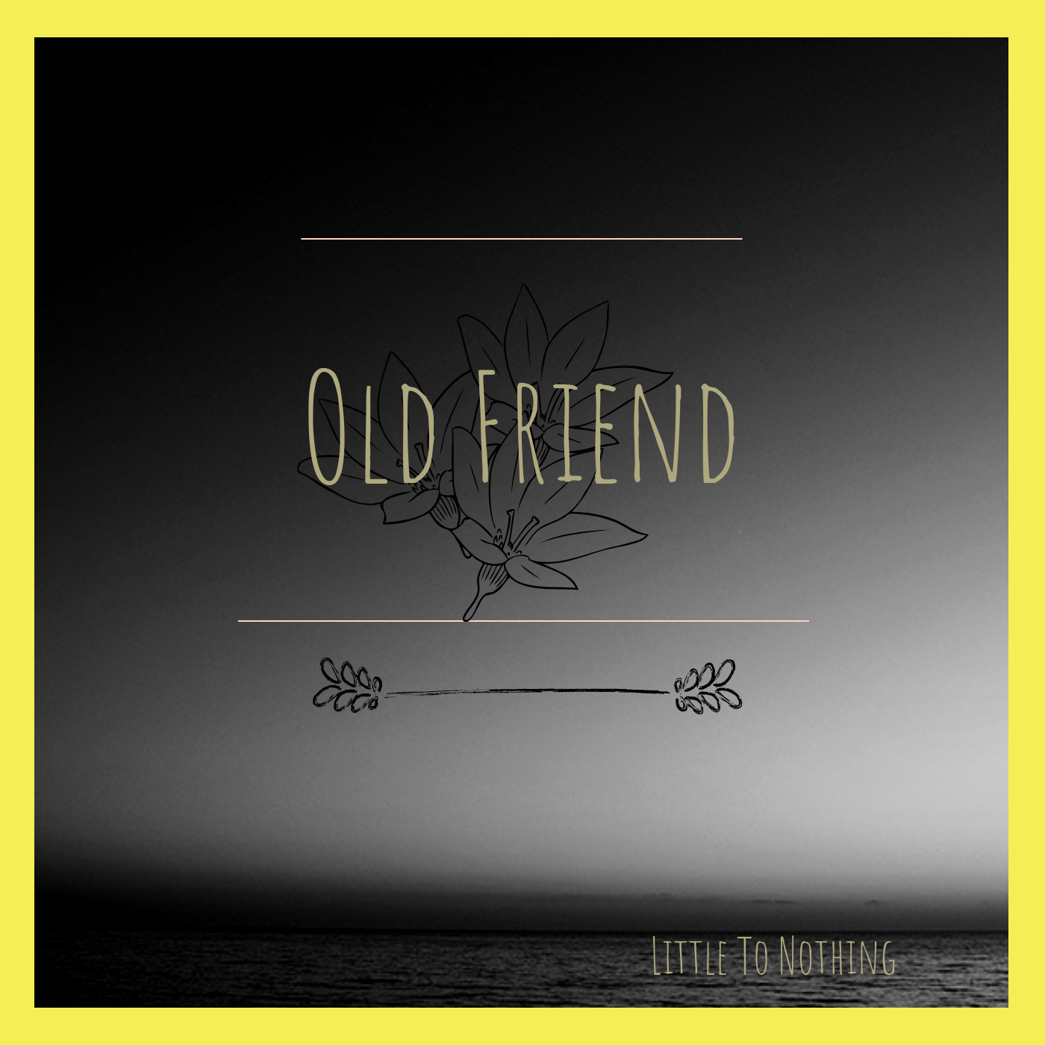
I have already released a single for the upcoming album titled “Old Friend” in January of 2019, which received positive feedback and anticipation for the upcoming release. The album as a whole will be scheduled to be released on the 7th of May 2019, but may be delayed due to distribution confirmation time to certain streaming platforms.

